Equity Frontiers Trial  
Protocol

“Enhancing Academic Preparedness: A Comprehensive Trial of Individualised Digital Pedagogy for Literacy and Numeracy Test for Initial Teacher Education Readiness”

Table of Contents

1. Trial overview 2

2. Background and objective 4

2.1. Background 4

3. Trial Design 7

3.1. Outcomes 7

3.2. Trial design 8

3.3. Detailed trial process 8

3.4. Participants 10

3.5. Participant withdrawal criteria and procedures 11

4. Data management and statistical analysis 12

4.1. Statistical methods 12

4.2. Sample cleaning 13

4.3. Sample inclusion/exclusion 14

4.4. Data management 15

4.5. Additional analyses 16

4.6. Quality control and quality assurance 16

5. Publication 18

5.1. Plans for publication and dissemination of trial results 18

5.2. Limitations 18

5.3. Future research 18

6. References 19

7. Appendices 20

7.1. Literacy and numeracy pre- and post-tests 20

7.2. LANTITE 24

7.3. Surveys and interview protocols 25

# Trial overview

|  |  |  |  |
| --- | --- | --- | --- |
| **Trial title:** | Enhancing Academic Preparedness: A Comprehensive Trial of Individualised Digital Pedagogy for Literacy and Numeracy Test for Initial Teacher Education Readiness | | |
| **Trial start date:** | October 2024 |  | November 2025 |
| **Principal Investigator name:** | Dr. Robert Vanderburg | | |
| **Principal Investigator contact details:** | [r.vanderburg@cqu.edu.au](mailto:r.vanderburg@cqu.edu.au) | | |
| **Sponsor:** | CQUniversity | | |
| **Trial summary:** | This trial investigates the effectiveness of an Individualised Digital Pedagogy (IDP) intervention designed to enhance literacy and numeracy skills among first-year Initial Teacher Education (ITE) students. The focus is on students from low socioeconomic status (SES) backgrounds and regional or remote areas, addressing their unique challenges in preparing for the Literacy and Numeracy Test for Initial Teacher Education (LANTITE).  Using a pragmatic Randomised Controlled Trial (RCT) design, the study evaluates the impact of the IDP compared to traditional support provided by the Academic Learning Centre (ALC). The IDP integrates diagnostic assessments, adaptive questioning, and personalised learning plans to meet the diverse needs of participants. Additionally, the intervention includes digital tools for real-time feedback and a collaborative online environment to foster community support.  The trial will measure primary outcomes, including literacy and numeracy skills improvements and higher LANTITE performance in ITE students. Secondary outcomes include increased confidence, self-efficacy, and engagement among participants, alongside qualitative insights into the usability and effectiveness of the intervention.  Data will be collected through pre- and post-tests, platform analytics, surveys, and focus groups, ensuring a robust mixed-methods approach. The results will inform best practices for scaling and adapting the IDP to other universities, aiming to create more equitable pathways in teacher education. This trial seeks to empower underrepresented student groups and contribute to systemic improvements in higher education by addressing critical equity gaps. | | |
| **Funding (total, and funding sources)** | **Total Funding**: $199,883 **Funding Sources**:   * $179,883 from the Australian Centre for Student Equity and Success (ACSES). * $20,000 cash contribution from CQUniversity | | |
| **Ethics approval (grantor, date, reference ID)** | CQU Human Research Ethics Committee approval granted 19/11/2024 (0000025167) | | |

# Background and objective

## Background

Equity in teacher education remains a critical challenge, particularly for Initial Teacher Education (ITE) students from low socioeconomic status (SES) backgrounds and regional or remote areas. Research indicates that these groups face substantial barriers to accessing and succeeding in higher education, including limited resources, feelings of isolation, and misalignment between university norms and their needs (Jury et al., 2017; Vanderburg et al., 2023). Such disparities result in lower academic achievement and decreased retention rates among these students (Thomas, 2014).

Preservice teacher preparation, which combines theoretical coursework and practical teaching experiences, is crucial for developing effective educators (Darling-Hammond, 2006). However, the high-stakes Literacy and Numeracy Test for Initial Teacher Education (LANTITE), introduced to ensure baseline competencies, has presented additional challenges. Students from disadvantaged backgrounds often struggle with the financial, emotional, and academic pressures associated with LANTITE, potentially exacerbating inequities and deterring diverse candidates from pursuing teaching careers (Hilton & Saunders, 2023).

Technology-enhanced learning, particularly adaptive systems, has shown promise in addressing these challenges. Studies have demonstrated the effectiveness of personalised learning tools that adjust content difficulty based on student performance, fostering engagement and promoting skill development (Hillmayr et al., 2020; Fitzgerald et al., 2018). Such systems also create opportunities for equitable access to high-quality educational resources, overcoming geographic and financial barriers.

Building on this foundation, the Individualised Digital Pedagogy (IDP) approach leverages diagnostic assessments, adaptive questioning, and tailored learning activities to support underrepresented students. This trial aims to evaluate the impact of the IDP intervention in preparing ITE students for LANTITE, addressing both immediate academic needs and systemic equity gaps in teacher education. By integrating insights from prior research, the study seeks to contribute actionable knowledge for improving educational access and outcomes for disadvantaged student groups.

### Intervention

IDP is a personalised, technology-driven educational program designed to enhance literacy and numeracy skills among first-year ITE students, focusing on those from low SES and regional or remote backgrounds. The program leverages adaptive learning tools, diagnostic assessments, and tailored learning plans to provide targeted support and foster academic success.

The intervention begins with a diagnostic pre-test to assess each student’s strengths and weaknesses. Based on the results, students receive personalised learning plans that include interactive activities, instructional videos, and practice quizzes tailored to their needs. Adaptive digital tools adjust the difficulty of questions in real time to ensure an appropriate challenge level. Immediate feedback, hints, and explanatory resources are provided to support learning.

Students engage with the program through an online platform that facilitates access to learning materials and promotes interaction through discussion forums and peer collaboration. Tutors are available to provide additional support, answering questions, and guiding participants as needed. The program includes optional remediation activities for areas requiring extra attention to help students overcome specific challenges.

The study employs a trial design with two groups:

* **Intervention group**: Students in the intervention group receive the full IDP program, including access to diagnostic assessments, adaptive tools, personalised learning plans, and tutor support.
* **Control group**: Students in the control group access the existing support services provided by the university’s Academic Learning Centre (ALC). The ALC offers general academic advice, workshops, and resources but lacks the adaptive components of the IDP. Students in the intervention will not have access to ALC, as students must be referred to ALC by academic staff.

### Procedures for implementation

#### Pre-test administration

Both groups complete a standardised internal pre-test designed by the research team measuring literacy and numeracy skills. Every participant will take the same pre-test.

The intervention group engages with the IDP over a 12-week period. Students follow their personalised plans, participate in online forums, and complete tasks on the LMS.

#### Post-test administration

There will be two post-tests. The first post-test is designed by the research team and will be used in the pre-test and post-test analysis. The second post-test is the LANTITE and will be used in the post-test analysis.

#### Internal post-test

Both groups complete a post-test to measure changes in literacy and numeracy skills. Every participant will take the same post-test.

#### LANTITE exam post-test

All participants take the LANTITE, and their scores are compared to evaluate the effectiveness of the IDP relative to the ALC support.

### Objectives

The trial aims to evaluate the effectiveness of an IDP intervention in enhancing literacy and numeracy skills among ITE students. The IDP targets students from low SES backgrounds and regional or remote areas facing unique academic success barriers. The overarching purpose is to bridge equity gaps in education by providing tailored support that prepares these students to meet the LANTITE.

The trial's primary objectives are to improve participants' literacy and numeracy skills, as measured by the internal pre- and post-intervention assessments designed by the research team and the LANTITE, as well as to enhance their performance on the LANTITE, ensuring they meet the required literacy and numeracy standards for teacher registration.

The secondary objectives include increasing the students in the IDP group's confidence and self-efficacy in their academic abilities, fostering greater engagement and motivation through adaptive and interactive learning tools, and gathering qualitative insights into the usability and effectiveness of the IDP tools for future scaling and adoption.

#### Hypotheses

The trial hypothesises that participants in the IDP group will demonstrate significant improvements in literacy and numeracy skills compared to the control group, as measured by pre- and post-tests. It is further expected that participants in the IDP group will achieve higher scores on the LANTITE than those in the control group, with an effect size over Cohen’s d = 0.40. Additionally, it is anticipated that participants in the IDP group will report positive feedback on the usability and effectiveness of the digital tools, increased confidence and self-efficacy in their academic abilities, and higher levels of engagement and motivation. Qualitative analysis is also expected to identify best practices and key components of the IDP intervention that contribute most significantly to its success.

#### Theory of change

The theory of change for this trial is grounded in addressing educational inequities by leveraging adaptive technology and personalised learning to remove barriers for disadvantaged students. The intervention begins with diagnostic assessments that identify individual skill gaps. Adaptive digital tools adjust question difficulty based on performance, while tailored learning activities and remediation options provide targeted support. Online forums and tutor support foster collaboration and a sense of community among participants.

These activities increase access to high-quality, adaptive learning resources and provide real-time feedback to promptly reinforce learning and address challenges. Participants interact with the platform and tutors, creating engagement metrics to assess the effectiveness of the intervention. The expected outcomes include measurable improvement in literacy and numeracy skills, leading to higher LANTITE pass rates and enhanced confidence, self-efficacy, and motivation among participants. Actionable insights from qualitative feedback will inform the scaling of the intervention.

The broader impact includes a more equitable teacher education pathway, reduced dropout rates, and improved access for low SES and regional or remote students. Ultimately, the intervention aims to produce data-driven recommendations for integrating personalised pedagogy into broader education systems, ensuring systemic changes in equity and support for underrepresented student groups.

# Trial Design

## Outcomes

### Primary outcomes

#### *Improvement in literacy and numeracy skills*

* Measurement: This outcome will be assessed using standardised pre- and post-intervention tests.
* Instrument: A sample LANTITE test designed specifically for the study will be administered at both the beginning and the end of the intervention period.

#### *Enhanced academic performance on LANTITE*

* Measurement: This outcome will be assessed using post-intervention tests. This will be evaluated by analysing participants' actual scores on the LANTITE exam.
* Instrument: The official LANTITE exam results the testing body provides will serve as the measure.

### Secondary outcomes

#### *Positive feedback on usability and effectiveness of IDP tools*

* Measurement: This will be gauged through post-intervention surveys completed by participants.
* Instrument: A custom-designed feedback survey will measure user satisfaction with the IDP tools, focusing on their usability, accessibility, and perceived effectiveness.

#### *Higher levels of engagement and motivation*

* Measurement: Engagement and motivation levels will be determined using participation metrics and qualitative feedback.
* Instruments: Analytics from the digital platform will capture interaction data (for example, logins, time spent on activities, completion rates), while focus group discussions will explore participant motivation and experiences.

#### *Identification of best practices and effective components*

* Measurement: Key intervention elements will be identified through analysis of qualitative feedback.
* Instruments: Thematic analysis of responses from focus groups, interviews, and survey open-ended questions will highlight successful strategies and areas for improvement.

### Data collection and integration

Quantitative measures such as test scores, survey responses, and participation analytics will be triangulated with qualitative data from interviews and focus groups to comprehensively understand the intervention’s impact. This mixed-methods approach ensures robust evaluation and meaningful insights into how the IDP intervention achieves the desired outcomes.

## Trial design

The study employs a randomised controlled trial (RCT) design. This type of trial involves two groups running simultaneously: an intervention group that receives the IDP and a control group that accesses individualised personal support from the ALC. This design directly compares the intervention’s effectiveness against the baseline educational support.

### Randomisation to minimise bias

Randomisation assigns participants to either the intervention or control group, ensuring that each participant has an equal chance of being placed in either group. A stratified randomisation approach balances key characteristics such as socioeconomic status, geographic location (regional/remote), and gender across the two groups. This ensures that these variables do not confound the results.

A randomisation schedule is generated using computerised software to eliminate selection bias. The schedule is managed by an independent research assistant not directly involved in participant interaction or data analysis, ensuring objectivity.

### Blinding

Although complete blinding is not feasible due to the nature of the intervention, efforts are made to blind the data analysts to group assignments. Participants' data will be anonymised and coded during the analysis phase. This reduces the potential for bias in interpreting results.

### Managing likely confounders

To address potential confounders, baseline assessments (pre-tests) are conducted for all participants before the intervention begins. These pre-test results allow adjustments in the analysis phase using statistical techniques such as analysis of covariance (ANCOVA) to account for initial differences between groups. Additionally, stratified randomisation helps balance demographic and academic factors, reducing the likelihood of confounding variables influencing the outcomes.

By employing rigorous randomisation and blinding strategies, detailed monitoring and statistical controls, this trial ensures a robust evaluation of the IDP intervention’s effectiveness while minimising biases and confounding effects.

## Detailed trial process

### Randomisation procedures

Participants will be randomly assigned to the intervention group (IDP) or the control group (ALC support). Stratified randomisation ensures that critical characteristics such as socioeconomic status, geographic location, and gender are evenly distributed across the groups. SES will be determined using the Australian governmental definition of SES. Randomisation codes will be generated using computerised software and managed by an independent research assistant to prevent selection bias.

The randomisation schedule and participant assignments will be securely stored and accessible only to the independent research assistant. A unique participant ID will be used to anonymise data during the trial, maintaining confidentiality.

### Data extraction and measurements

#### Pre-trial setup

Diagnostic assessments will be developed and tested for reliability and validity to accurately measure literacy and numeracy.

The IDP platform will be configured with diagnostic tools, adaptive questioning systems, and learning resources. Staff training will be conducted to ensure consistent implementation and monitoring.

#### Baseline

All participants will complete a pre-test to establish their literacy and numeracy skills before commencing the intervention.

Demographic and background data will also be collected to inform stratified randomisation and ensure balance across groups.

#### Intervention period

The intervention group will engage with the web-based IDP platform, which includes personalised learning plans, adaptive questioning tools, and interactive forums. This is a closed-source software, and access will only be provided to participants in the intervention group. The control group will access individualised personal tutoring from the ALC, including workshops and general academic resources. Students in the intervention will not have access to ALC, as students must be referred to ALC by academic staff.

#### Monitoring

A monitoring progress review will be conducted every two weeks to assess engagement levels and address technical issues. Regular emails will be sent to the control and intervention groups, reminding them to stay engaged in the study.

#### Post-test

All participants will complete a post-test to measure improvements in literacy and numeracy.

Qualitative feedback will be gathered through focus groups and interviews with a sample of participants from both groups.

#### LANTITE examination

Participants will take the official LANTITE exam. Scores will be collected as a key outcome measure for academic performance.

#### Sequence and Duration of Assessments

* Pre-Test: Approximately 60 minutes to assess baseline skills.
* Post-Test: Approximately 60 minutes to evaluate learning outcomes.
* Focus Groups/Interviews: 40–60 minutes per session, depending on participant availability.

### Quality Control and Assurance Measures

The IDP platform will be continuously monitored for technical issues, with support available to address challenges promptly. Pre-tests and post-tests will follow identical formats to maintain consistency in measurement. All participants will take identical pre- and post-tests. Data will be securely stored and regularly backed up to prevent loss. Anonymised identifiers will ensure participant confidentiality. Biweekly reviews will ensure adherence to the protocol, with adjustments made as necessary to address unforeseen challenges.

By following this detailed trial process, the study ensures robust data collection and analysis, maintaining high standards of quality and reliability throughout. This approach supports a comprehensive evaluation of the IDP intervention’s effectiveness.

## Participants

The trial will focus on ITE students enrolled at Central Queensland University (CQUniversity), a university known for its commitment to supporting diverse student populations. Participants will include students from Bachelor of Education (Early Childhood, Primary, and Secondary) and Master of Teaching (Early Childhood, Primary, and Secondary) programs, which will be equally balanced in the control and intervention groups. This population represents a mix of students studying face-to-face, online, or in a hybrid mode.

### Settings and locations

The trial will be conducted across CQUniversity’s regional campuses and online platforms. Participants will engage with the intervention remotely through the IDP platform or access control group resources via the ALC.

### Inclusion and exclusion criteria

#### Inclusion criteria

* Students enrolled in CQUniversity ITE courses (Bachelor or Master levels).
* Students preparing to sit for the Literacy and Numeracy Test for Initial Teacher Education (LANTITE).
* Students from low SES backgrounds and/or residing in regional or remote areas.
* Students who are willing to complete the pre-test, post-test, and participate in the LANTITE.

#### Exclusion criteria

* Students who are not enrolled in ITE programs.
* Students who have already passed the LANTITE.
* Students not from low SES backgrounds or regional or remote areas.
* Students who are unwilling to participate in assessments or provide informed consent.

### Required sample size

A power analysis was conducted to determine the required sample size to detect an expected effect size of Cohen’s d = 0.40, representing a moderate intervention effect. Using a significance level (α) of 0.05 and power (1-β) of 0.80, the trial requires approximately 64 participants per group for an ANCOVA design. To account for potential attrition (estimated at 20%), the study will recruit 300 participants, with 150 assigned to the intervention group and 150 to the control group.

### Parameters used to estimate power

* Effect size (Cohen's d): A moderate effect size (0.40) was chosen based on prior studies evaluating technology-based learning interventions.
* Significance level (α): Set at 0.05 to ensure a 95% confidence level.
* Power (1-β): Set at 0.80 to detect meaningful differences with high confidence.
* Attrition rate: Estimated at 20% to ensure sufficient sample size at the conclusion of the trial.

This sampling framework ensures that the study is adequately powered to evaluate the effectiveness of the IDP intervention while maintaining generalisability to other ITE student populations.

## Participant withdrawal criteria and procedures

Participants will only be part of the trial if they meet the inclusion criteria and sign a consent form. However, participants may be withdrawn from the trial under the following conditions:

* Voluntary withdrawal at any stage without providing a reason.
* Inability or unwillingness to complete key assessments, including the pre-test, post-test, or LANTITE.
* Non-compliance with the trial protocol, such as failure to engage with the intervention or control group activities.
* Adverse circumstances (for example, health issues, technical challenges) that prevent meaningful participation.

### Procedures for withdrawal notification process

Participants wishing to withdraw must inform the research team via email or phone. The research team will confirm receipt of the withdrawal request and provide support if needed.

#### Recording withdrawal

The participant’s withdrawal will be documented, including the reason (if provided), the timing of the withdrawal, and any incomplete assessments or activities.

#### Handling data for withdrawn participants

Data collected before withdrawal will be retained and included in the analysis unless the participant explicitly requests its removal. All students who withdraw from the trial will have their data removed from the study.

No further data will be collected from the participant after withdrawal.

This withdrawal process respects participant autonomy while maintaining the integrity of the trial’s data and objectives. Clear communication and support mechanisms ensure that all participants, including those who withdraw, are treated equitably and with consideration.

# Data management and statistical analysis

## Statistical methods

The statistical analysis will evaluate the effectiveness of the IDP intervention by comparing the primary and secondary outcomes between the intervention and control groups. Descriptive and inferential analyses will be employed to assess changes in literacy and numeracy skills, LANTITE performance, and qualitative feedback.

### Primary analysis

#### Comparison of pre-test and post-test scores

A paired sample t-test will be used to evaluate within-group improvements in literacy and numeracy skills. An ANCOVA, adjusting for baseline scores, will compare post-test results between the intervention and control groups.

#### Analysis of LANTITE scores

Independent t-tests will compare the mean LANTITE scores between groups.

### Secondary Analysis

#### Student confidence and engagement

Descriptive statistics (for example, means, frequencies) and independent t-tests will compare self-efficacy survey scores between groups. Qualitative feedback from focus groups will be analysed thematically to explore participant experiences and perceptions. Thematic analysis will identify recurring patterns and insights from open-ended survey responses, interviews, and focus group discussions.

### Level of significance and effect size

* Significance level (α): 0.05 (two-tailed) to ensure a 95% confidence level for hypothesis testing.
* Effect size: A moderate effect size (Cohen’s d = 0.40) is expected based on previous studies of adaptive learning interventions. Sample size calculations account for this expected effect size.

### Handling missing data

Missing data will be addressed using multiple imputation techniques, assuming data are randomly missing. Sensitivity analyses will compare imputed and complete-case datasets to evaluate the robustness of the findings.

All analyses will be conducted using SPSS statistical software, ensuring reproducibility and transparency in the data analysis process.

## Sample cleaning

Ensuring data integrity is a critical component of the trial. The following steps outline how the sample will be cleaned, addressing missing, unused, and spurious data.

### Identifying missing data

All collected data will be reviewed for missing entries at individual and variable levels. Missing data points will be identified through initial checks during data entry to flag incomplete records and automated scripts in statistical software (SPSS) to highlight missing values.

### Handling missing data

Efforts will be made to retrieve missing data, such as contacting participants to clarify or complete incomplete responses. Multiple imputation techniques will be employed to estimate missing values if data are missing completely at random (MCAR). Regression-based imputation will be applied for data missing at random (MAR), using other variables as predictors. Sensitivity analyses will be performed to compare results from imputed datasets with complete-case datasets.

### Accounting for unused data

Data deemed inapplicable or redundant (for example, test submissions not meeting inclusion criteria) will be excluded from the main analysis but retained in a separate archive for transparency. A record of all exclusions will be maintained, along with reasons for exclusion, to ensure accountability.

### Detecting spurious (false) data

Spurious data are entries that appear inaccurate, inconsistent, or fabricated. These will be identified through:

* Logical consistency checks: Identifying entries that do not align with expected ranges or logical sequences (for example, extremely high or low test scores beyond plausible thresholds).
* Outlier analysis: Statistical tests such as Z-scores or interquartile range (IQR) methods to identify extreme outliers. Extreme outliers will be evaluated to determine if they should be removed from the study.
* Duplicate entries: Automated checks to detect and remove duplicates that could arise from repeated submissions.

### Handling spurious data

Flagged entries will be reviewed manually to determine if they are errors or valid outliers.

Spurious data confirmed as errors will be corrected if supporting evidence exists (for example, verifying with the participant). If no correction is possible, the data will be excluded from the analysis. All data cleaning steps will be documented in a cleaning log, including the rationale for excluding, imputing, or correcting data. This ensures transparency and reproducibility of the cleaning process.

### Quality assurance measures

A subset of the data will be re-entered to verify accuracy and consistency. Data collection tools will include validation checks to minimise errors during data entry (for example, preventing invalid ranges or empty fields). Every modification to the dataset will be tracked, noting the date, reason, and person responsible for the change. By implementing these procedures, the study ensures a robust and reliable dataset, reducing the likelihood of bias or inaccuracies due to missing, unused, or spurious data. This will provide a solid foundation for accurate and meaningful analysis.

## Sample inclusion/exclusion

### Inclusion in analyses

The trial will adopt an intention-to-treat (ITT) approach, ensuring that all participants randomly assigned to either the intervention or control group are included in the primary analyses, regardless of their level of adherence to the intervention. This approach maintains the benefits of randomisation and provides a more realistic evaluation of the intervention's effectiveness.

### Eligible participants

Participants who meet the inclusion criteria and consent to participate in the trial will be randomly assigned to one of two groups:

* Intervention group (IDP): Approximately 150 participants.
* Control group (ALC): Approximately 150 participants.

### Stages of inclusion and exclusion

#### Recruitment and randomisation stage

* Target sample size: 300 participants (to account for expected attrition of 20%).
* Eligibility screening: Participants must meet inclusion criteria, including ITE enrolment, low SES or regional/remote background, and LANTITE readiness.
* Exclusions at this stage: Ineligible participants identified during recruitment will not proceed to randomisation. Expected exclusions: ~10 participants.

#### Intervention stage

All 150 randomised participants will be included in the intervention, with adherence monitored. Participants who withdraw voluntarily or fail to engage in the trial activities will remain part of the ITT analysis but will be excluded from per-protocol analyses.

#### Post-test and LANTITE stage

Data from all randomised participants, including those who withdrew, will be included in ITT analyses. Only participants who completed the intervention as intended (approximately 300 participants after accounting for withdrawal and non-adherence) will be included in this secondary analysis. Participants who do not complete the post-test or provide valid LANTITE scores will be excluded from per-protocol analyses. Expected exclusions: ~10 participants (5% of the original sample).

Exclusions are limited to participants who:

* Explicitly request withdrawal from the trial for any reason.
* Fail to meet inclusion criteria during screening.
* Do not provide valid data (for example, incomplete post-tests or missing LANTITE scores).

By following this framework, the trial ensures a robust sample size for ITT and per-protocol analyses, accounting for expected attrition while maintaining the integrity of the randomised design.

## Data management

All participant data will be assigned a unique alphanumeric identifier (for example, IDP001) to anonymise records. Collected data will be coded consistently using predefined templates for quantitative data (for example, test scores, engagement metrics) and thematic labels for qualitative data (for example, focus group transcripts).

Standardised variable names and data formats (such as, CSV and Excel) will be used to ensure compatibility across statistical software, SPSS and R.

### Data handling processes

Quantitative data (such as, test scores, survey responses, engagement metrics) will be collected via secure online platforms (for example, university learning management software and survey software) and logged directly into a centralised database until it is extracted for data analysis. Qualitative data (such as, interview and focus group recordings) will be transcribed and anonymised using software such as NVivo for thematic analysis.

Data will be stored on a secure university server with restricted access granted only to authorised research team members. The CQUniversity's research office will keep physical copies of consent forms and other documentation in a locked cabinet.

### Maintenance

Regular data audits will be conducted to ensure accuracy and completeness.

Automated backups of the digital database will occur nightly, with weekly snapshots archived to prevent data loss.

### Security

Digital data will be encrypted both at rest and during transmission using AES-256 encryption.

Secure login credentials and multi-factor authentication will be required for accessing the database.

Identifiable information (for example, consent forms) will be stored separately from the main dataset to minimise re-identification risks.

### Archiving

Data will be retained for a minimum of five years post-publication, in accordance with university and ethical guidelines. Archived data will be stored in a secure, long-term repository managed by the CQUniversity’s library. Data will be encrypted before transmission using Secure File Transfer Protocol (SFTP) or encrypted USB drives. Only de-identified datasets will be shared with external parties.

### Quality assurance and compliance

All data handling processes will comply with institutional policies and ethical standards, including the Australian Code for the Responsible Conduct of Research. Training sessions for the research team will ensure adherence to these protocols. To maintain accountability and traceability, an audit trail will document all data transactions, including collection, access, and modifications. By following this robust data management framework, the trial ensures the collected data's security, integrity, and longevity while minimising risks associated with data breaches or mismanagement.

## Additional analyses

Secondary analyses will explore additional outcomes beyond the primary objectives to provide a more comprehensive understanding of the intervention’s impact.

### Student confidence and self-efficacy

To evaluate changes in participants’ confidence and self-efficacy related to literacy and numeracy, qualitative data from focus groups and surveys will be analysed thematically to complement quantitative findings.

### Socioeconomic status

To assess whether students from low SES backgrounds benefit differently compared to those from middle SES groups, interaction terms in ANCOVA models will evaluate differences in literacy and numeracy gains between SES groups.

### Geographic location

To determine if students from regional or remote areas experience benefits similar to those in urban settings, separate analyses for regional or remote and urban participants will be conducted, with independent t-tests or ANCOVA comparisons.

ANCOVA will adjust for baseline literacy and numeracy scores to account for initial differences between groups. Multiple imputation techniques will address missing data, ensuring that analyses include as much information as possible without introducing bias. Covariates such as age, prior academic performance, and study mode will be included in regression models to control for their potential influence on outcomes.

By incorporating these secondary and subgroup analyses, the study aims to deepen understanding of the IDP intervention, identify specific areas of strength or limitation, and generate insights that can guide future adaptations and scaling efforts.

## Quality control and quality assurance

Robust quality control (QC) and quality assurance (QA) measures will be implemented throughout the study to ensure the integrity and reliability of the analysis. QC focuses on preventing and detecting errors during data collection, entry, and processing. All assessments (that is, pre-tests, post-tests, and surveys) will be conducted using consistent procedures and instructions. Researchers and facilitators will undergo training to ensure uniformity in administering tests, supporting participants, and managing data. The digital tools used for data collection, including the IDP platform and survey software, will be tested to ensure functionality and reliability.

### Data entry and validation

To reduce input errors, online platforms will include built-in validation rules (for example, range checks and mandatory fields). A second researcher will re-enter a random subset of data to check for discrepancies, with error rates documented and corrected. Any identified errors will be logged, including the nature of the error and the corrective action taken.

### Real-time monitoring

Real-time monitoring of participant engagement (for example, logins, activity completion) will identify anomalies or non-adherence to the protocol. Biweekly reviews will assess data completeness and consistency, allowing early detection of issues.

### Quality assurance procedures

Quality assurance focuses on ensuring the overall reliability and validity of the analysis. Procedures will include addressing missing data, identifying outliers, and ensuring logical consistency. Data analysts will remain blinded to group assignments until the primary analysis is complete to minimise bias. A second analyst will independently replicate initial analyses to confirm results.

### Adherence to the analysis plan

Analyses will follow a pre-registered statistical plan, ensuring transparency and reducing the risk of post hoc changes. Statistical analyses will be conducted using validated software (SPSS) with documented workflows to ensure reproducibility.

### Audit trails

Every step in the data handling and analysis process will be documented, including decisions made during data cleaning and transformation. Data and analysis scripts will be version-controlled to track changes and maintain transparency.

### Reporting standards

Reports and publications will comply with established standards, such as CONSORT for randomised trials, ensuring clarity and completeness. De-identified datasets and analysis scripts will be available in a secure repository for independent verification. By implementing these QC and QA procedures, the study ensures that all data handling, analysis, and reporting processes are conducted rigorously and transparently, maintaining the highest standards of research integrity.

# Publication

## Plans for publication and dissemination of trial results

### Journal publications

The trial results will be published in peer-reviewed journals focused on education, educational technology, or equity in higher education, such as the Journal of Educational Psychology, Educational Researcher, or Computers & Education. The primary outcomes (literacy and numeracy improvements, LANTITE performance) and secondary findings (confidence, engagement, and qualitative insights) will be presented in separate manuscripts to maximise their impact. Each publication will follow the appropriate reporting guidelines, such as CONSORT for randomised controlled trials, ensuring clarity and transparency.

### Conference presentations

Findings will be presented at national and international conferences, including the Australian Association for Research in Education (AARE) Conference, ASCILITE Conference, and the American Educational Research Association (AERA) Annual Meeting.

### Institutional dissemination

The trial results will be shared within CQUniversity through internal research forums and seminars to engage faculty and administrative staff. In addition, an executive summary will be provided to leadership to inform them of institutional policies and resource allocation for supporting at-risk students.

### Public access and outreach

A plain-language summary of the findings will be available on the CQUniversity website to ensure accessibility to students, educators, and the broader community. Open-access publication options will be pursued whenever possible to maximise reach.

## Limitations

In publications and presentations, the limitations of the trial will be clearly acknowledged. Results may be specific to CQUniversity’s context, particularly its student demographic and institutional support structures. The nature of the intervention prevents full blinding, which may introduce bias. Any impact of participant attrition on results will be transparently reported and discussed.

## Future research

The findings will inform grant applications for larger-scale trials, including multi-institutional studies to validate the intervention across diverse settings. Feedback from this trial will also guide refinements to the IDP for broader implementation.

Employing a multi-channel dissemination strategy aims to influence practice, policy, and future research, ensuring the findings reach key stakeholders and contribute meaningfully to the advancement of equitable education.

# References

Darling-Hammond, L. (2006). Powerful teacher education: Lessons from exemplary programs. Jossey-Bass.

Fitzgerald, E., Jones, A., Kucirkova, N., & Scanlon, E. (2018). A literature synthesis of personalised technology-enhanced learning: What works and why. Research in Learning Technology, 26. <https://doi.org/10.25304/rlt.v26.2095>

Hillmayr, D., Ziernwald, L., Reinhold, F., Hofer, S. I., & Reiss, K. M. (2020). The potential of digital tools to enhance mathematics and science learning in secondary schools: A context-specific meta-analysis. Computers & Education, 153. <https://doi.org/10.1016/j.compedu.2020.103897>

Hilton, A. L., & Saunders, R. (2023). LANTITE’s impact on teacher diversity: Unintended consequences of testing pre-service teachers. The Australian Educational Researcher, 1–20.

Jury, M., Smeding, A., Stephens, N. M., Nelson, J. E., Aelenei, C., & Darnon, C. (2017). The experience of low-SES students in higher education: Psychological barriers to success and interventions to reduce social-class inequality. Journal of Social Issues, 73, 23–41. <https://doi.org/10.1111/josi.12202>

Thomas, G. (2014). Closing the policy–practice gap for low-SES students in higher education: The pedagogical challenge. Higher Education Research & Development, 33, 807–820. <https://doi.org/10.1080/07294360.2013.863850>

Vanderburg, R., Harris, L., Dargusch, J., & Richardson, S. (2023). Low socioeconomic status students transitioning from vocational education and training (VET) to university: Examining definitions of success. Higher Education Research & Development, 42(3), 742–756. <https://doi.org/10.1080/07294360.2023.2204569>

# Appendices

## Literacy and numeracy pre- and post-tests

### Item 1 - Literacy pre-test/post-test sample questions

Sample grammar question:

In each of the sentences below four portions are underlined and lettered. Read each sentence and decide whether any of the underlined parts contains a grammatical construction, a word use, or instance of incorrect or omitted punctuation or capitalisation that would be inappropriate in carefully written English. If so, select the correct answer from the options available. No sentence has more than one error.

*A galley, a type of ancient ship,* was propelled **principally** by a crew at oars, but **their** sail could augment any human power by **harnessing** the force of the wind. **No error**

**SELECT ONE:**

a. , (comma)

b. principally

c. their

d. harnessing

e. No error

Sample reading passage & question:

**CHANGE IN SCHOOLS**  
This text is taken from the introduction to *Dancing on a Shifting Carpet: Reinventing traditional schooling for the 21st century* (2010).

The contemporary context for schools is often referred to as ‘the knowledge era’ or ‘the knowledge society’, characterised by the constant creation and recreation of knowledge; the speed, complexity and interactivity of innovation; and the need for openness to new learning and new ways of thinking about and doing things.

The level of change brought about by the knowledge era, and the pressures of other global and technological changes mentioned earlier, inevitably have an impact on schools. These pressures originate from both external and internal sources. There are external pressures on schools to fix the many social problems caused by rapid change, and to prepare students to live and work in the knowledge society. There are also internal pressures within schools because their clientele – students and families – have changing expectations and needs.

Within the wider external context, schools are seen as instruments of social change and are frequently expected to cure or avert many societal ills by, for example, providing sex and drug education; increasing students’ environmental awareness; educating young people in matters of health and engaging them in physical and emotional activities to improve their wellbeing and reduce obesity; and enhancing students’ commitment to social justice.

Within schools, the formal academic curriculum has been expanded to meet the social and psychological needs of students. In increasingly fragmented societies, schools are expected to have themes of peace, safety, and stability, while still meeting the academic standards set by governments and the social and psychological expectations of families and communities. Teachers and other school leaders are expected to be constantly available and responsive to parents and their concerns, and schools are often held accountable for matters occurring outside regular school hours, which were traditionally the domain of parents and families. When mistakes happen at school, there is a tendency for parents to blame teachers and other school personnel, and to seek legal redress.

All these factors have numerous implications for schools, not the least of which is that they need to change their forms of educational delivery to meet the needs of, and be relevant to, 21st-century young people. Back in the late 1980s, Papert and Freire (n.d.) clearly foresaw the need for schools to change rapidly, even radically, if they were to remain vital to society:... it is inconceivable that school as we’ve known it will continue. Inconceivable. And the reason why it’s inconceivable is that little glimmer with my grandson who is used to finding knowledge when he wants to and can get it when he needs it, and can get in touch with other people and teachers, not because they are appointed by the state, but because he can contact them in some network somewhere. These children will not sit quietly in school and listen to a teacher give them predigested knowledge. I think that they will revolt. (Part 2)

The revolt may not have happened as yet, but the Australian Government is now talking about the need for a revolution in education and schools (Department of Education, Employment and Workplace Relations, 2008). The core of this ‘revolution’ focuses on the quality of teaching, the quality of learning, and the quality of student outcomes. Conventional teaching and learning modalities are under widespread critique.

Source: Leoni Degenhardt & Patrick Duignan, *Dancing on a Shifting Carpet: Reinventing traditional schooling for the 21st century*. ACER Press, 2010.

**How does the quotation from Papert and Freire relate to the rest of the text?**  
**SELECT ONE:**

a. It summarises the text’s main position.

b. It documents the origin of the text’s main idea.

c. It suggests a solution to a problem raised in the text.

d. It provides a more extreme point of view than the text.

### Numeracy pre-test/post-test sample questions

The image below shows a street map with Beckett Primary School located at grid reference D3. It provides directions for Angela, driving south along Bruce St, to determine the correct route to reach the school based on three options.

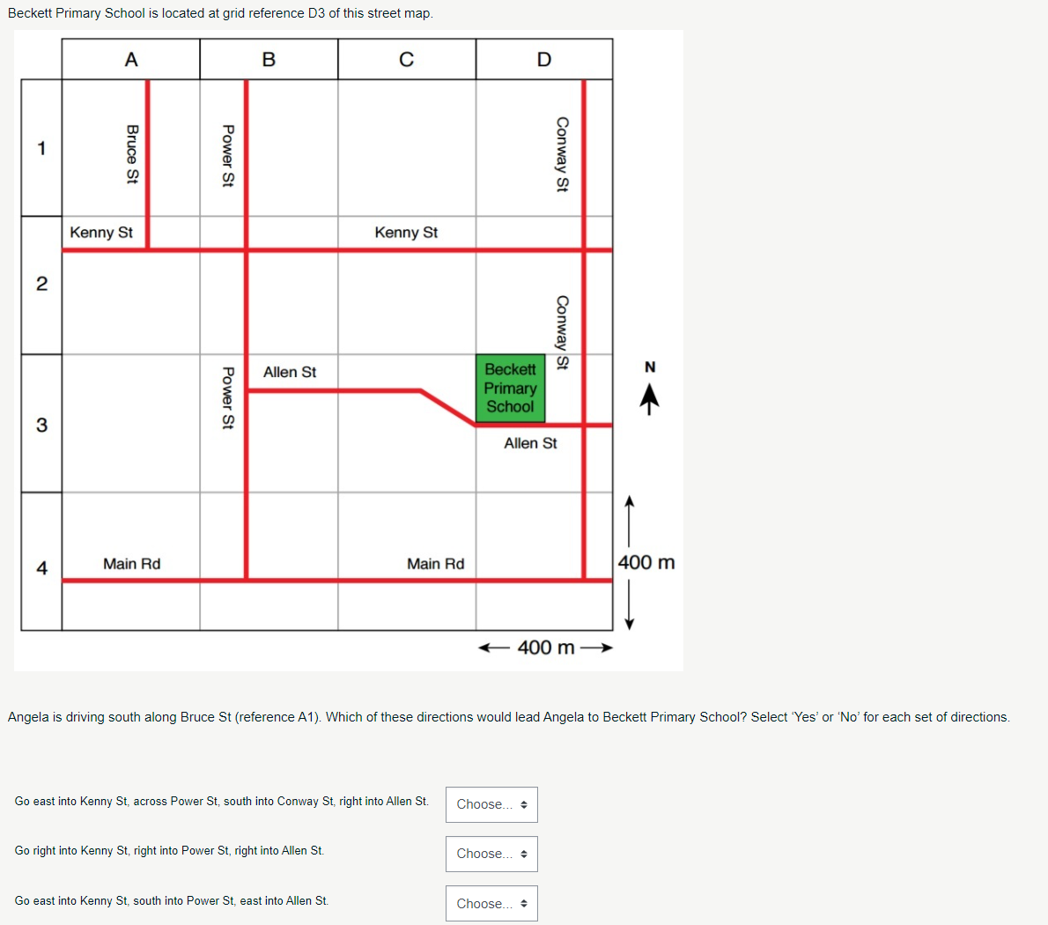

The image below shows a bar graph comparing the percentage of Year 3 students in six reading achievement bands at a selected school, statistically similar schools, and all Australian schools. Below the graph, there are statements that require the user to evaluate whether they are true or false based on the data shown.

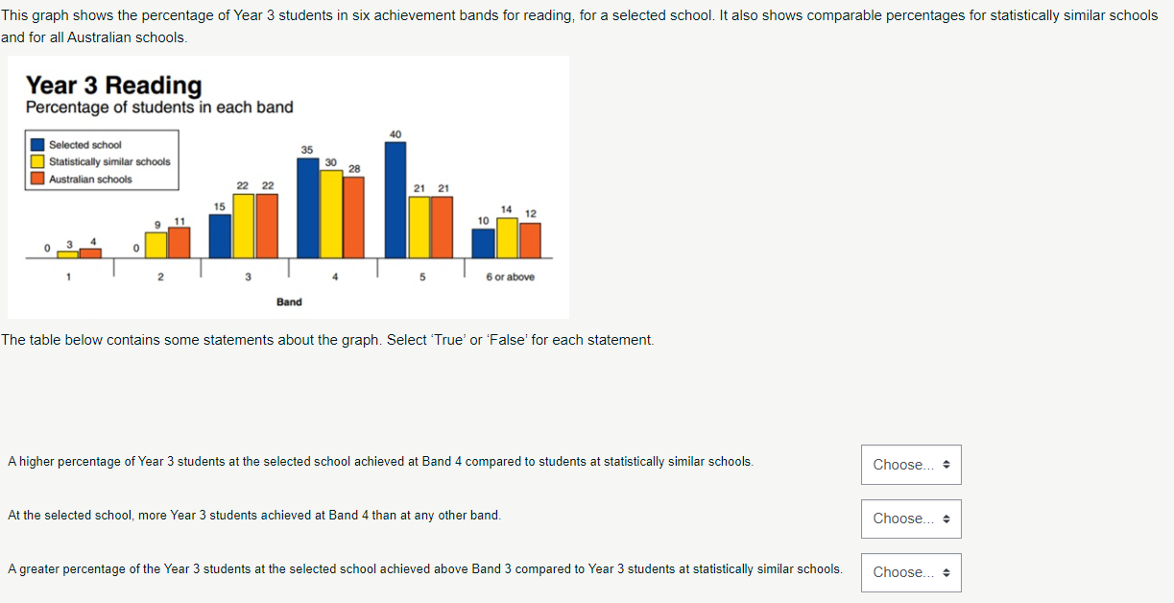

The image below provides a problem involving unit conversions to calculate the speed of an object in meters per second. The user is given the speed of the object in feet per second (32 ft/sec) and must choose the correct computation to convert this into meters per second using the provided conversion factors.

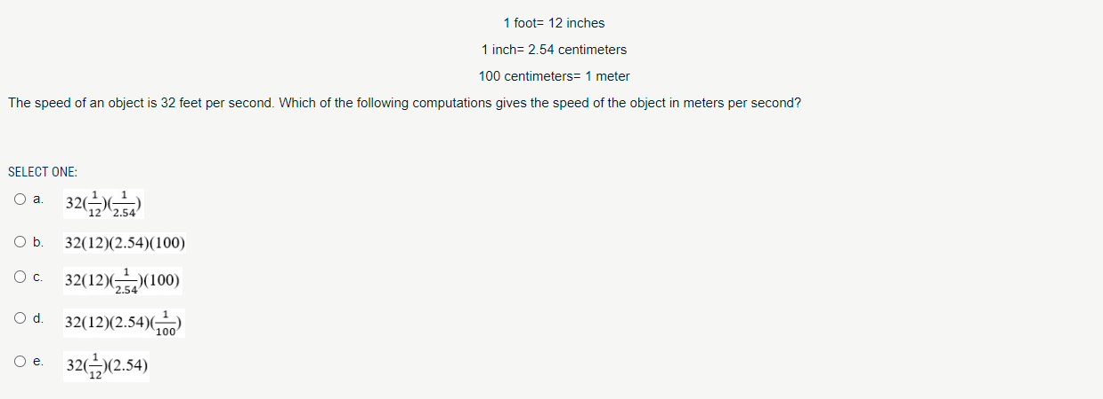

## LANTITE

More information about the LANTITE can be found on the ACER website: <https://teacheredtest.acer.edu.au/>

The website also provides practice material, including sample test questions for both the Literacy and Numeracy sections of the test: <https://teacheredtest.acer.edu.au/prepare/practice-material>

## Surveys and interview protocols

The following are drafts of the surveys and interview protocols that will be used for Qualitative data collection. The surveys will be revised in the initial team meeting to align with project objectives.

**Participant Survey Draft**

Thank you for participating in our survey. Your feedback is essential to help us understand the effectiveness of the Individualised Development Pedagogy (IDP) program and improve its content, structure, and overall impact on literacy and numeracy skills. Please answer the following questions as thoroughly as possible.

**Survey Questions**

***Content Relevance:***

* How relevant did you find the content of the IDP program to your needs and goals in preparing for the Literacy and Numeracy Test for Initial Teacher Education (LANTITE)?
* Were there specific topics or materials that you found particularly useful or not useful? Please explain.

***Difficulty Level:***

* How would you describe the difficulty level of the materials provided in the IDP program?
* Did you find the materials challenging enough to enhance your skills without being overwhelming? Please provide examples.

***Overall Satisfaction:***

* Overall, how satisfied are you with the IDP program?
* What aspects of the program did you like the most? Why?
* What aspects of the program did you find the least effective? Why?

***Impact on Literacy Skills:***

* How has the IDP program influenced your literacy skills?
* Can you provide specific examples of improvements or challenges you faced in literacy through the program?

***Impact on Numeracy Skills:***

* How has the IDP program influenced your numeracy skills?
* Can you provide specific examples of improvements or challenges you faced in numeracy through the program?

***Program Structure:***

* What do you think about the structure of the IDP program (e.g., the organisation of modules, the sequence of topics)?
* How effective was the structure in helping you progress through the learning materials?

***Adaptive Tools and Activities:***

* How effective were the adaptive digital tools and activities in tailoring the learning experience to your needs?
* Did these tools help you stay engaged and motivated? Please explain.

***Support and Resources:***

* How helpful were the interactive forums and digital materials in providing support and resources?
* Did you feel adequately supported by tutors and peers throughout the program? Please elaborate.

***Suggestions for Improvement:***

* What changes or improvements would you suggest for the IDP program?
* Are there any additional resources or support mechanisms you think should be included?

***Additional Comments:***

* Please share any additional comments or insights you have about your experience with the IDP program.

**Numeracy/Literacy Tutor Survey Draft**

Thank you for participating in our survey. Your feedback is critical in helping us understand the design and effectiveness of the Individualised Development Pedagogy (IDP) program from the tutor’s perspective. Please answer the following questions as thoroughly as possible.

**Survey Questions**

***Program Design:***

* How would you describe the overall design of the IDP program?
* Were there any design elements that you found particularly effective or ineffective? Please explain.

***Participant Outcomes:***

* Based on your observations, how did the IDP program impact participants’ literacy skills?
* How did the program impact participants’ numeracy skills?

***Content Relevance and Difficulty:***

* How relevant did you find the program’s content to the participants' needs?
* Was the difficulty level of the materials appropriate for the participants? Please provide examples.

***Adaptive Tools and Activities:***

* How effective were the adaptive digital tools and activities in supporting participants’ learning?
* Did these tools help in maintaining participant engagement and motivation? Please explain.

***Support and Resources:***

* How effective were the support mechanisms (e.g., forums, digital materials) provided in the program?

***Program Impact:***

* How would you assess the overall impact of the IDP program on participants’ preparation for the LANTITE?
* Can you provide specific examples of participants who benefited significantly from the program?

***Suggestions for Improvement:***

* What changes or improvements would you suggest for the IDP program?
* Are there any additional resources or support mechanisms you think should be included?

***Additional Comments:***

* Please share any additional comments or insights you have about the IDP program and your experience.

Your responses will be invaluable in refining and improving the IDP program to better support our students. Thank you for your time and valuable input.

**Interview Protocol Draft**

***Purpose:***

To collect in-depth, personal narratives and feedback from individual participants on their experiences with the IDP program.

***Participants:***

Selected participants who represent the broader group, ensuring a range of perspectives.

***Procedure:***

1. Introduction:

* Welcome the interviewee and explain the purpose of the interview.
* Reiterate the voluntary nature of participation and assure confidentiality.
* Outline the session structure and expected duration (45-60 minutes).

1. Background Information:

* Briefly discuss the participant's background (e.g., academic history, role in the program).

1. Discussion Topics:

* Impact on Literacy and Numeracy Skills:
  + How has the IDP program affected your literacy skills?
  + What changes have you noticed in your numeracy skills?
* Engagement with Material:
  + Describe your engagement with the program's materials and activities.
  + Were there any elements that particularly motivated or demotivated you?
* Challenges and Personal Experiences:
  + What were the main challenges you faced while using the program?
  + Can you provide specific examples of your experiences?
* Suggestions for Improvement:
  + What improvements would you suggest for the program?
  + Are there any new features or activities you think should be added?

1. Conclusion:

* Summarise the key points discussed.
* Thank the interviewee for their time and valuable insights.
* Provide information on how the feedback will be used.

**Focus Group Protocol Draft**

***Purpose***:

To gather detailed feedback from a diverse group of participants on their experiences with the Individualised Development Pedagogy (IDP) program, focusing on literacy and numeracy skills, engagement with the material, and suggestions for improvement.

***Participants***:

A select portion of participants representing the broader group, chosen to ensure diversity in terms of SES background, regional/remote locations, and academic performance.

***Procedure:***

1. Introduction:

* Welcome participants and explain the purpose of the focus group.
* Emphasise the voluntary nature of participation and assure confidentiality.
* Outline the session structure and expected duration (1.5-2 hours).

1. Ice-Breaker:

* Begin with an introductory question to ease participants into the discussion (e.g., "Can you briefly share your initial thoughts about the IDP program?").

1. Discussion Topics:

* Impact on Literacy and Numeracy Skills:
  + How has the IDP program influenced your literacy skills?
  + Can you describe any changes in your numeracy skills since starting the program?
* Engagement with Material:
  + How engaging did you find the program's materials and activities?
  + Were there any specific features that helped you stay motivated?
* Challenges and Personal Experiences:
  + What challenges did you face while using the program?
  + Can you share any specific experiences that stood out to you?
* Suggestions for Improvement:
  + What aspects of the program do you think could be improved?
  + Do you have any suggestions for new features or activities?

1. Peer Interactions:

* How did interactions with peers through the program influence your learning experience?
* Did you find the social interaction tools helpful? Why or why not?

1. Conclusion:

* Summarise the key points discussed.
* Thank participants for their time and valuable insights.
* Provide information on how the feedback will be used.