Students with disability in Australian higher education: Analysis of 2023 data
(2024 update)

  - ACSES Data Insights Series

Introduction
This report is an update to the earlier report ‘Students with disability in Australian higher education: an overview’. It focuses on the participation of students with disability in higher education in 2023. For further information on various aspects of students with disability performance, and those of equity students more generally—access; participation; success; retention; six- and nine-year cohort completion—please see the ACSES Student Equity Data Program webpage: https://www.acses.edu.au/data/interactive-tool/
This Data Update was prepared by Gemma Cadby, Tim Pitman, and Paul Koshy of the Australian Centre for Student Equity and Success (ACSES) at Curtin University.
The authors would like to acknowledge the staff at ACSES for their comments and assistance in the production of this publication and extend thanks to the Australian Government Department of Education for the provision of student equity data.
The report may be cited as: Cadby, G., Pitman, T., & Koshy, P. (2024). Students with disability in Australian higher education (Nov 2024 update). Australian Centre for Student Equity and Success (ACSES), Perth: Curtin University.
Copyright ownership of this material resides with ACSES.
ISBN - 978-0-646-70241-4

Data Explanatory Notes
All student data reported in this document are sourced from a customised request to the Australian Government Department of Education (Australian Government Department of Education, 2024a).
In preparation of this report:
- For the purposes of aggregation and presentation and results, cell counts of less than 5 were replaced with
the value ‘2’.
- Higher education institutions were identified but have been anonymised in this report.
- Analysis was restricted to Table A institutions (Higher Education Support Act 2003).

Caution must always be exercised in analysing data on students with disability:
- As not all students with disability choose to identify for personal reasons, it is a reasonable assumption that the raw numbers in this report under-report the actual instance of students with disability.
- The extent of underreporting may also differ across institutions.
- The disability categories were updated in 2020. This has effectively caused a break in series, meaning any comparative analyses of categories of disability that use both pre- and post-2020 categories are problematic.

Overall representation of students with disability in higher education
The enrolment of domestic undergraduate students with disability has increased in 2023, compared to 2022. In 2023, 91,726 students identified as having a disability, equating to 12.7% of the undergraduate headcount. This is an increase from 11.6% in 2022.
Figure 1: Students with disability as a percentage share of enrolments (%), 2011 to 2023. Percentage is calculated as the total number of domestic undergraduate students reporting at least one disability in each year divided by the total number of domestic undergraduate students enrolled at Table A Providers in that year.
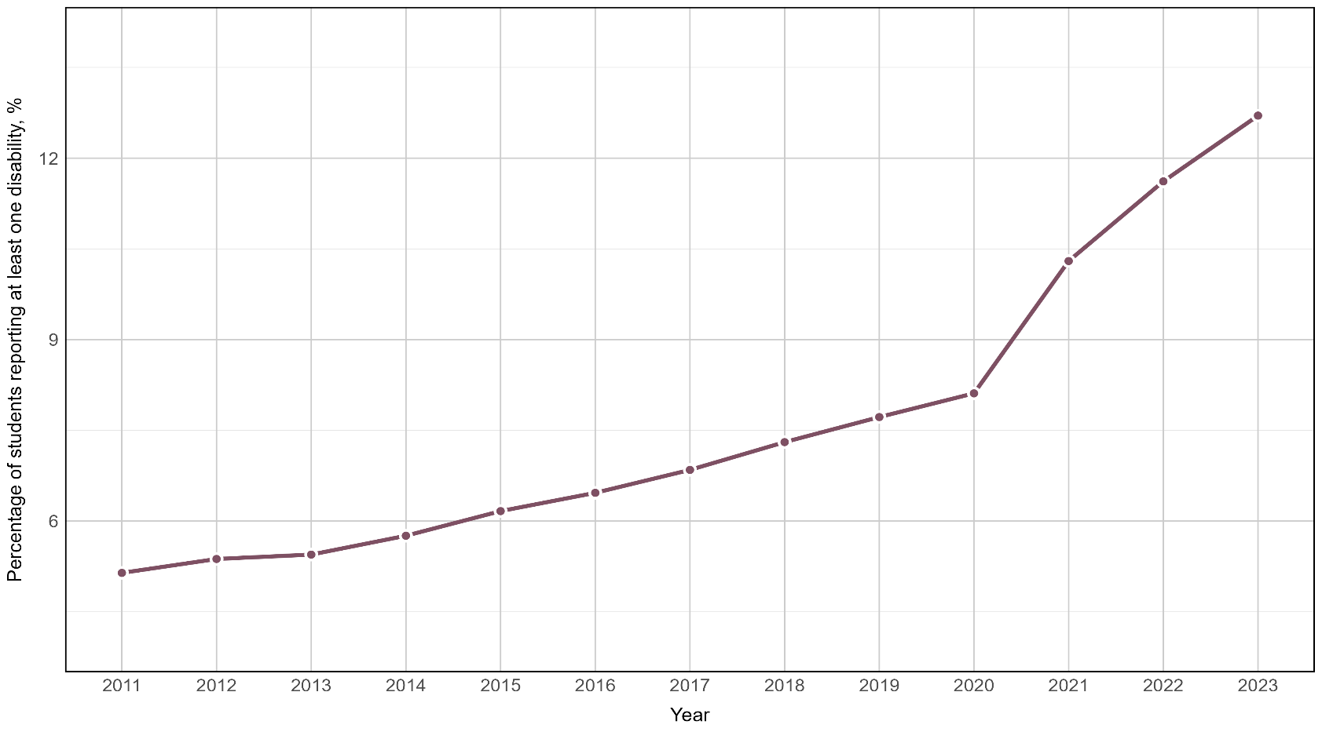

The representation of students with disability across the sector
Among institutional groupings, universities in the Innovative Research Universities (IRU) and non-aligned providers tend to have lower rates of disability participation compared to other groups, although rates of disability have increased for all groupings.
There are noticeable differences between the states and territories in terms of overall participation rates – for instance, South Australia’s relatively high participation share (16.3% participation rate in 2023) – which are likely to reflect some combination of demographic factors and local factors affecting student recruitment.

Table 1: Students with Disability, percentage share of enrolments (%), by Institutional Groupings and State and Territory, Table A Providers, 2017–23. These percentages have been calculated by summing the number of students with disability within each of the groupings or states/territories and dividing by the total number of students within each of the groupings or states/territories.
 | 2017 | 2018 | 2019 | 2020* | 2021 | 2022 | 2023
National — Table A Providers | 6.9 | 7.3 | 7.7 | 8.1 | 10.3 | 11.6 | 12.7
Group of Eight (Go8) | 6.6 | 7.0 | 7.7 | 9.7 | 11.3 | 12.9 | 14.1
Australian Technology Network (ATN) | 6.7 | 7.2 | 7.7 | 8.0 | 12.4 | 13.7 | 15.0
Innovative Research Universities (IRU) | 7.1 | 7.4 | 7.9 | 8.0 | 8.8 | 9.9 | 10.9
Regional University Network (RUN) | 7.5 | 8.0 | 8.5 | 7.9 | 11.3 | 12.6 | 13.7
Non-aligned | 6.7 | 7.2 | 7.3 | 7.0 | 8.2 | 9.4 | 10.1
New South Wales | 7.0 | 7.4 | 7.8 | 7.4 | 9.9 | 11.1 | 12.0
Victoria | 6.8 | 7.3 | 7.9 | 7.5 | 10.7 | 11.9 | 12.6
Queensland | 5.5 | 6.0 | 6.4 | 8.6 | 9.9 | 11.1 | 12.3
Western Australia | 6.5 | 7.1 | 7.4 | 7.8 | 9.1 | 11.5 | 13.4
South Australia | 9.9 | 10.3 | 10.7 | 12.7 | 14.0 | 15.0 | 16.3
Tasmania | 7.6 | 7.5 | 7.4 | 7.0 | 8.0 | 10.9 | 12.4
Northern Territory | 5.5 | 5.8 | 7.4 | 5.0 | 10.6 | 12.8 | 15.1
Australian Capital Territory | 9.1 | 9.8 | 10.3 | 10.1 | 12.8 | 13.2 | 15.0
Multi-State | 6.9 | 7.6 | 7.5 | 7.3 | 8.0 | 9.2 | 9.9
Note:* The figures for 2020 are subject to some degree of under-reporting.

Types of disability reported by higher education students: 2023
In 2023, the 91,726 students identified as having disabilities collectively reported 127,386 categories of disability, an average of 1.4 categories per student (see Figure 2). Listing a ‘Mental health condition’ was the most common form of disability disclosed (45,935 cases), being listed by almost half of all students with disability (49.5%). More than a quarter of students with disability reported a ‘Medical condition’ (23,596 or 25.7%). In 2023, ‘Neurological condition’ became the third most commonly reported disability (17.0%), overtaking ‘Other disability’ and ‘Specific Learning Disability’.
It is noteworthy that the percentage of students reporting ‘Other disability’ decreased from 18.2% in 2022 to 14.3% in 2023. Whilst this is down markedly from the 45.9% figure reported under the older categories of disability, it is still a significant proportion of students. This may indicate either that the new categories are still not sufficient to accurately report types of disability or that institutional reporting mechanisms remain confusing to many students with disability.

Figure 2: Count of disability category reported, 2023. The left most bar (darkest bar) is the total number of disabilities reported and is larger than the total student population reporting any disability as students can report more than one disability. The second bar from the left is the total number of students reporting disability (where a student has reported more than one disability, in this count they will appear only once). Disability categories are ordered by prevalence in 2022, to allow for comparison.
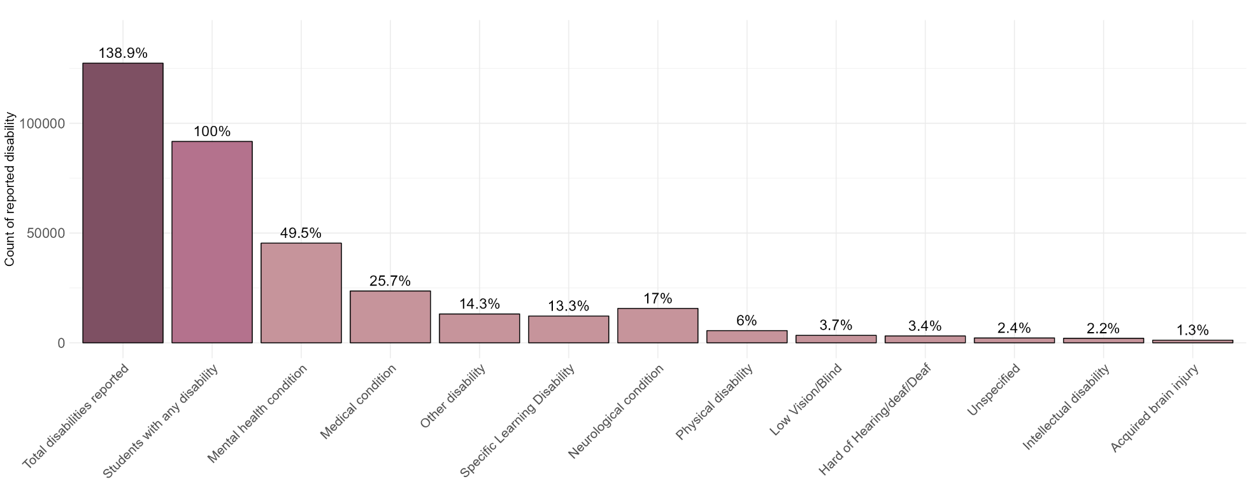

Further, these sector-wide rates hide a significant degree of variance at the institutional level, as illustrated by Figure 3. This shows clearly that there is substantial variation in the percentage of students from each institution that reported an overall disability, and for each type of disability. For example:
- Overall, in 2023, 12.7% of undergraduate students reported having a disability. However, this percentage varied across institutions, with the range spanning from as low as 5.1% to as high as 21.2% of the student cohort.
- The largest variability (range) in institutional rates across disability types was for students reporting a ‘Mental health condition’, with estimates ranging from 1.3% to 14.1% across institutions.
- There was also significant variability (range) in the ‘Neurological’ category, with estimates ranging from 0.4% to 8.4% across institutions.
- The smallest variability (range) was in the ‘Hard of Hearing/deaf/Deaf’ category, with estimates ranging from 0.2% to 1.1% across institutions.
One interpretation of the data is that the demographic profile varies significantly across institutions. Another is that the collection and reporting of data varies, rather than the students. Without further investigation it is not possible to say, definitively, the reason for the variance. However, this is an area of inquiry that is deserving of attention, for example:
- If the variance is explained by actual difference in student profile, then is this because certain institutions are known as exemplars in supporting particular types of disability requirements or for other (e.g. external) factors?
- If the variance is a consequence of differences in how data are reported or differences in institutional processes, then this would almost certainly be unbeneficial to wider efforts to support students with disability.

Figure 3: Percentage of students with each disability type in 2023, showing institutional spread. Dots represent individual institutions, while the black line represents the weighted average percentage of students with each disability type across all institutions. The weighted incorporates institution size, meaning that the percentage from a larger institution contributes more to the weighted average than that from a smaller institution. Disability categories are ordered by prevalence in 2022, to allow for comparison.
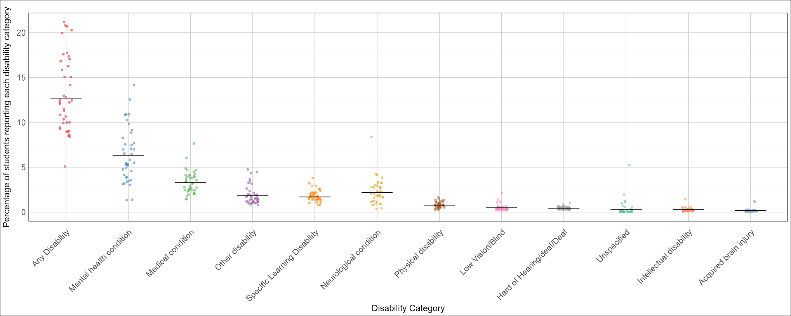

Appendix

Institutional groupings
Australian Technology Network (ATN): The University of Newcastle, University of Technology Sydney, University of South Australia, Deakin University, RMIT University, Curtin University.
Group of Eight (Go8): The Australian National University, University of New South Wales, The University of Sydney, The University of Queensland, The University of Adelaide, Monash University, The University of Melbourne, The University of Western Australia.
Innovative Research Universities (IRU): University of Canberra, Western Sydney University, James Cook University, Griffith University, Flinders University, La Trobe University, Murdoch University.
Regional Universities Network (RUN): Charles Sturt University, Southern Cross University, The University of New England, CQ University, University of Southern Queensland, University of the Sunshine Coast, Federation University Australia.
Non-aligned: Australian Catholic University, University of Wollongong, Macquarie University, Charles Darwin University, Queensland University of Technology, University of Tasmania, Swinburne University of Technology, Victoria University, Edith Cowan University, The University of Notre Dame Australia.

Cadby, G., Pitman, T., & Koshy, P. (2024). Students with disability in Australian higher education: an overview. Australian Centre for Student Equity and Success (ACSES), Perth: Curtin University. Available at: https://www.acses.edu.au/publication/data-insights-students-with-disability/
Australian Government Department of Education (2024a). Equity Group Statistics, Private Request (October 2024). Canberra: Department of Education.

