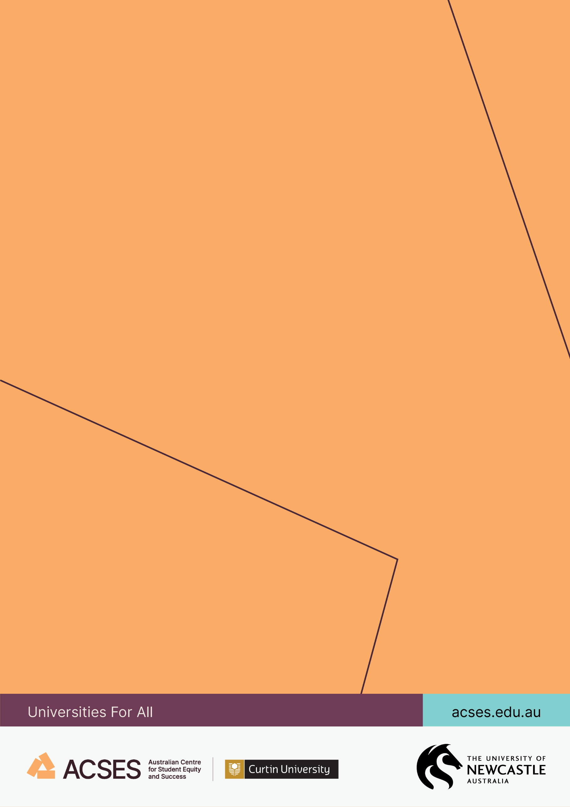
SMALL GRANTS RESEARCH PROGRAM REPORT

Understanding school students’ aspirations in uncertain times

Leanne Fray, Sally Patfield, Kristina Sincock, Jenny Gore, and Courtney Rubie
2026
Understanding school students’ aspirations in uncertain times

3 February 2026

Dr Leanne Fray, The University of Newcastle
Dr Sally Patfield, The University of Newcastle
Dr Kristina Sincock, The University of Newcastle
Laureate Professor Jenny Gore, The University of Newcastle
Ms Courtney Rubie, The University of Newcastle

Suggested citation: Fray, L., Patfield, S., Sincock, K., Gore, J., & Rubie, C. (2026). Understanding school students’ aspirations in uncertain times (Small Grants Research Program final report). Australian Centre for Student Equity and Success, Curtin University.

Australian Centre for Student Equity and Success
Tel: +61 8 9266 1573
Email: acses@curtin.edu.au
Web: www.acses.edu.au
Building 100
Curtin University
Kent St, Bentley WA 6102 | GPO Box U1987, Perth WA 6845

DISCLAIMER
Information in this publication is correct at the time of release but may be subject to change. This material does not purport to constitute legal or professional advice.
Curtin accepts no responsibility for and makes no representations, whether express or implied, as to the accuracy or reliability in any respect of any material in this publication. Except to the extent mandated otherwise by legislation, Curtin University does not accept responsibility for the consequences of any reliance which may be placed on this material by any person. Curtin will not be liable to you or to any other person for any loss or damage (including direct, consequential or economic loss or damage) however caused and whether by negligence or otherwise which may result directly or indirectly from the use of this publication.
COPYRIGHT
© Curtin University 2026
Except as permitted by the Copyright Act 1968, and unless otherwise stated, this material may not be reproduced, stored or transmitted without the permission of the copyright owner. All enquiries must be directed to Curtin University.
CRICOS Provider Code 00301J
ISBN 978-1-7642138-8-2

Acknowledgement of Country
The Australian Centre for Student Equity and Success acknowledges Indigenous peoples across Australia as the Traditional Owners of the lands on which the nation’s campuses are situated. With a history spanning more than 60,000 years as the original educators, Indigenous peoples hold a unique place in our nation. We recognise the importance of their knowledge and culture, and reflect the principles of participation, equity, and cultural respect in our work. We pay our respects to Elders past, present, and future, and consider it an honour to learn from our Indigenous colleagues, partners, and friends.

At a glance
What we did
Today’s young people confront an age shaped by climate change, a succession of natural disasters, geopolitical conflicts, energy crises, and rising inflation. The COVID-19 pandemic further disrupted post-school transitions—heightening stress and anxiety and amplifying equity gaps.
Drawing on multiple datasets involving secondary students, parents/carers, teachers, and community members in New South Wales collected over the last twelve years, we examined how current circumstances are shaping post-school aspirations and explored changes over time in how young people articulate their hopes for the future. We conducted new surveys, interviews, and focus groups with teachers, parents, and students in six high schools and one central school from the original study conducted in 2012–15. The schools were located in regional and metropolitan areas, with a majority placed low on the Index of Community Socio-Educational Advantage (ICSEA).
What we found
- Interest in university in general remains high. However, vocational education is gaining value, especially in communities with strong trades-based employment links. Educational aspirations are increasingly pragmatic; students are making calculated choices based on perceived return on investment, financial risk, and community expectations.
- Uncertainty is being experienced both emotionally and materially by young people as they think about their post-school futures. Young people express fear, stress, and doubt about their futures, often shaped by economic and material constraints, housing insecurity, and changing job prospects. Mental health has increasingly become a critical barrier to students’ futures—students across all communities report heightened anxiety about post-school transitions, with some communities seeing pandemic-related spikes in stress and performance pressure.
- Disadvantaged students are increasingly concentrated in under-resourced public schools, compounding their exposure to instability and reducing access to future opportunities.
What we recommend
- Governments and schools should promote and celebrate vocational and hybrid pathways, and universities need to build flexible, blended access models.
- Career education needs to be strengthened through partnerships with local employers and tertiary education and vocational education providers.
- There needs to be greater focus on student wellbeing throughout their school and post-school lives, by better integrating mental health programs into schooling and addressing mental health in tertiary education settings.
- More support is needed for community infrastructure including transport, housing, and digital connectivity, and more investment is needed in public schools, particularly in rural, regional, and low socio-economic status areas.

Acknowledgements
We are most grateful to the teachers, students, and parents who gave their time to complete a survey and/or participate in an interview or focus group for this study.
We also thank: Jacquie Briskham, Julie Cowan, Tim Dean, Matthew Harper, Tim Kelso, and Skye Gibson for their support with data collection and analysis.
This study was funded by the Australian Department of Education through the Australian Centre for Student Equity and Success (ACSES). Data for this project were also drawn from: the Aspirations Longitudinal Study (2012–2015), which was funded by the Australian Research Council and the NSW Department of Education; the Unlocking Capacity and Empowering Choice project (2016) and the Locating Aspirations Study (2017), both funded by the Australian Government Department of Education Higher Education Participation and Partnerships Program within the National Priorities Pool scheme; the Girls in Maths project (2017) funded by John and Margaret Bowers; the Choosing University project (2015) and the Community Influence on University Aspirations study (2018), both funded by ACSES (then known as the National Centre for Student Equity in Higher Education). The views and opinions expressed in this report are those of the authors and do not necessarily reflect the views of the funding bodies.

Table of contents

Acknowledgement of Country ii
Acknowledgements iv
Table of contents v
List of tables vii
List of figures vii
Abbreviations viii
1. Executive summary 1
2. Recommendations 3
2.1 Schools 3
2.2 Higher education providers 3
2.3 Government 3
3. Introduction 5
4. Background 7
4.1 Why is university important? 7
4.2 Why isn’t everyone choosing university? 7
4.3 Higher education in uncertain times 9
4.3.1 The economic landscape 9
4.3.2 The digital landscape 11
4.3.3 The health landscape 11
4.3.4 The environmental landscape 12
4.3.5 Complexity and uncertainty 13
5. Methods 14
5.1 Research design 14
5.1.1 Methods 14
5.1.2 Analysis 18
6. Survey findings 19
6.1 Educational aspirations 19
6.2 Occupational aspirations 21
6.3 Summary: Quantitative findings 23
7. Longitudinal case studies 24
7.1 Ironbark Plains High School 25
Ironbark Plains High School: Overview 26
7.1.1 Diversity, equity, and community 26
7.1.2 Socio-economic pressure and the value of work 28
7.1.3 Influences on student post-school futures 29
7.1.4 Conclusion 31
7.2 Oldfields Central School 32
Oldfields Central School: Overview 33
7.2.1 A community and school in decline 33
7.2.2 The more things change… 34
7.2.3 …the more things stay the same 36
7.2.4 Conclusion 37
7.3 Banks Hollow Secondary College 38
Banks Hollow Secondary College: Overview 39
7.3.1 Growth and diversity 39
7.3.2 Aspirational young people and families … with consequences 40
7.3.3 New worries in contemporary times 42
7.3.4 Conclusion 44
7.4 Riverbend College 45
Riverbend College: Overview 46
7.4.1 From mining to “McMansions” 46
7.4.2 Valuing vocational futures 47
7.4.3 Navigating conflicting pressures 49
7.4.4 Conclusion 51
7.5 Murrindah High School 52
Murrindah High School: Overview 53
7.5.1 A community marked by both affluence and structural inequality 53
7.5.2 Challenges in accessing paid work 55
7.5.3 Navigating uncertainty 56
7.5.4 Conclusion 58
8. Discussion 59
8.1 Aspirations in an age of uncertainty 59
8.1.1 Uncertainty as a driver of mental ill-health 60
8.1.2 The value of university and TAFE in an age of uncertainty 60
8.1.3 The residualised public school: Students left behind in an age of uncertainty 61
9. Conclusion 63
9.1 Recommendations 64
9.1.1 Schools 64
9.1.2 Higher education providers 64
9.1.3 Government 64
10. References 66
11. Appendix 79

List of tables
Table 1: Sample description by school, 2025 17
Table 2: Career aspirations, all students, 2025 (n = 154) 22

List of figures
Figure 1: Educational aspirations, all students, 2025 19
Figure 2: Educational aspirations by ICSEA, 2025 20
Figure 3: Educational aspirations by location, 2025 21

Abbreviations
ABS Australian Bureau of Statistics
ACARA Australian Curriculum and Assessment Reporting Authority
AI Artificial intelligence
ANZSCO Australian and New Zealand Standard Classification of Occupations
ATAR Australian Tertiary Admission Rank
FIF First-in-family
FIFO Fly-in, fly-out
HEPPP Higher Education Participation and Partnerships Program
HECS Higher Education Contribution Scheme
HSC Higher School Certificate
ICSEA Index of Community Socio-Educational Advantage
IPCC Intergovernmental Panel on Climate Change
LBOTE Language Background Other Than English
NSW New South Wales
SEA Socio-educational advantage
SERAP State Education Research Approval Process
SES Socio-economic status
STEM Science, technology, engineering, and mathematics
TAFE Technical and Further Education
VET Vocational Education and Training
VUCA Volatile, Uncertain, Complex, and Ambiguous

Executive summary
This project, Understanding school students’ aspirations in uncertain times, explores how evolving economic, political, and social conditions are shaping young people’s aspirations. More than a decade after the first data wave of the Aspirations Longitudinal Study, both higher education pathways and the labour market look very different. Today’s young people confront an age of precarity shaped by climate change, a succession of natural disasters, geopolitical conflicts, energy crises, and rising inflation. The COVID-19 pandemic has further disrupted post-school transitions—heightening stress and anxiety, lowering wellbeing, and amplifying equity gaps in the sector. Now, more than ever, it is essential to help young people chart this complicated education and work landscape, and to recognise that those who face cumulative disadvantages may feel its pressures most acutely.
Focusing on targeted equity groups and students who would be first-in-family (FiF) to go to university, the key questions addressed in this study were:
- What are the educational and occupational aspirations of secondary school students today and how do they differ (if at all) by equity group?
- How has the current economic and social climate influenced young people’s thoughts and plans about their post-school futures?
- Given the findings from questions 1 and 2, how might recent environmental, health, and economic crises shape institutional efforts to ensure more equitable participation in higher education?
Drawing on multiple datasets involving secondary students, parents/carers, teachers, and community members in New South Wales (NSW) collected over the last twelve years, our aim was to generate timely insights into how current circumstances are shaping post-school aspirations, and to explore changes over time in how young people articulate their hopes for the future. Five longitudinal case studies were developed to shed light on the nuances and contexts of aspiration formation over time: Ironbark Plains High School, an outer regional, low-ICSEA (Index of Community Socio-Educational Advantage) school with many students from ethnically diverse backgrounds; Oldfields Central School, a low-ICSEA school, located in an outer regional community with a large proportion of students who would be first-in-family to finish Year 12; Banks Hollow Secondary College, a high-ICSEA school located in a major city with the majority of students from ethnically diverse backgrounds; Riverbend College, a low-ICSEA school situated in an outer suburb of a large regional city; and Murrindah High School, a low-ICSEA school located on the fringes of a major city bordered by seaside communities.
Major findings from the project were as follows:
- Uncertainty is currently being experienced both emotionally and materially by young people as they think about their post-school futures—young people express fear, stress, and doubt about their futures, often shaped by economic and material constraints, housing insecurity, and changing job prospects.
- Educational aspirations are increasingly pragmatic; students are making calculated choices based on perceived return on investment, financial risk, and community expectations.
- Interest in university in general remains high. However, vocational education is gaining value, especially in communities with strong trades-based employment links—interestingly, this trend was also evident among students located in school communities that have traditionally devalued vocational pathways.
- In high-achieving urban schools, university remains a symbolic marker of success—though concerns about Higher Education Contribution Scheme (HECS) debt and the value of a university education (and the value of certain degrees) are growing.
- Mental health has increasingly become a critical barrier to students’ futures—students across all communities report heightened anxiety about post-school transitions, with some communities seeing pandemic-related spikes in stress and performance pressure.
- The residualisation of public schools is deepening inequity—disadvantaged students are increasingly concentrated in under-resourced schools, compounding their exposure to instability and reducing access to future opportunities.

Recommendations
We offer several important recommendations for schools, higher education providers, and governments. These are largely drawn from participants’ insights as conveyed in their interviews.

Schools
- Embed future-oriented wellbeing supports: Mental health programs must be integrated into everyday schooling, not offered as add-ons. This includes training staff to support students experiencing stress about future pathways and foster conversations about diverse futures.
- Strengthen career education: Offer early, community-connected, and culturally responsive career support, especially in schools facing residualisation. Partner with local employers, VET providers, and universities to expand real-world exposure.
- Celebrate vocational and hybrid pathways: Challenge the academic/vocational binary by elevating trades and TAFE as valuable and respectable options. Include alumni stories from varied post-school routes to build local aspiration narratives.

Higher education providers
- Build flexible, blended access models: Expand regional campuses, study hubs, hybrid learning options, and bridging programs that alleviate cost-of-living pressures and work-study demands.
- Address mental health and belonging: Prioritise initiatives that support transition, mental wellbeing, and community for students from underrepresented backgrounds. This includes culturally safe spaces, mentoring, and inclusive pedagogies.
- Co-design outreach with communities: Shift from aspiration-raising to co-creating pathways. Engage families, schools, and local leaders in outreach and recruitment efforts that respond to community-specific needs and values.

Government
- Tackle school funding inequity: Reverse the trend of residualisation by investing in public schools, particularly in rural, regional, and low socio-economic status (SES) areas. This includes adequate staffing, infrastructure upgrades, and targeted support for careers education.
- Reform higher education and VET funding models: Ensure affordability and accessibility by expanding fee-free TAFE and offering more scholarships and income support to students in key equity groups.
- Invest in regional and commuter infrastructure: Improve transport, housing, and digital connectivity to enable rural students to access education and training beyond their immediate community without relocation pressure.
- Elevate the standing of TAFE and vocational pathways: Adopt policies that highlight their social value, acknowledge that healthy societies rely on all kinds of work, and ease the blanket expectation that every young person must attend university.
- Expand mental health support for youth: Guarantee free, bulk-billed access to mental-health professionals—an urgent need as young people today navigate significant economic, social, and environmental pressures.
- Subsidise affordable student housing: Provide support for those who must move away from home to study, offsetting the extra financial load of university attendance.

Introduction
Australian governments, like those in many other Western nations, have long seen university education as essential to building a strong society in a rapidly changing world (Bradley et al., 2008; Department of Education, 2024; McMahon, 2009; Pee & Vulhulleh, 2020; Scott, 2024). A major approach to increasing university enrolment has been to encourage those from underrepresented groups to attend university (Bennett et al., 2015; Bradley et al., 2008; Department of Education, 2024). However, while higher education enrolments have increased dramatically in recent decades, participation rates still fail to reflect the broad diversity of Australian society (Bennett et al., 2015; Department of Education, 2024; Fray et al., 2020; Gore et al., 2017; Naylor et al., 2015).
Prompted by the 2008 Review of Australian Higher Education (colloquially known as the “Bradley Review”), new targets were set and new initiatives put in place to increase the proportion of students from underrepresented groups who access higher education. Specifically, the Commonwealth created a (now defunct) demand-driven funding system in which university places in most undergraduate degrees were uncapped. Alongside this system, it proposed that, by 2020, 40% of Australians aged 25 to 34 should hold a bachelor’s degree and 20% of all undergraduate students should come from lower SES backgrounds (Bradley et al., 2008). The Higher Education Participation and Partnerships Program (HEPPP) was also established to provide funding to universities to support the enrolment, retention, and completion of students from low SES backgrounds, prompting a wide range of new institutional programs implemented by universities (ACIL Allen Consulting, 2017).
Although these initiatives contributed to increased enrolment, Aboriginal and Torres Strait Islander peoples, people with a disability, people from regional, rural, and remote areas, and people from low SES backgrounds continue to be underrepresented in Australian higher education (Department of Education, 2024a). The Universities Accord, a 2022–2023 review of the sector aiming to drive university reform in Australia, seeks to tackle these ongoing challenges (Department of Education, 2024a), demonstrating the Commonwealth’s longstanding commitment to achieving equity in higher education. Importantly, the Accord final report also acknowledges the “rapid technological, social, political and environmental change” occurring in Australian society, recognising the need for the tertiary education system to respond to these mounting complexities (Department of Education, 2024a, p. 1).
Since the global financial crisis of 2008, the nature of employment has changed, with casual positions increasingly common and job insecurity deepening (Jaremus et al., 2022). In 2020, the COVID-19 pandemic had a further destabilising impact on many industries, leading to changes in workplace practices (Galanti et al., 2021; Kramer & Kramer, 2020; Vyas & Butakhieo, 2021) and leaving many, often those in face-to-face positions or already insecure employment, with little or no work (Cotofan et al., 2021; Montenovo et al., 2022). The education, health, and trade sectors all now face labour shortages (Department of Education, 2024a). Events such as the pandemic, the ongoing war in Ukraine, and high rates of inflation have also contributed to increases in the cost of living worldwide. In Australia, casualisation and the “gig” economy, combined with the effects of the pandemic, have disproportionally impacted young people (Cuervo & Chesters, 2019; O’Keeffe et al., 2021). Persistent periods of drought (Alston, 2010; Lester et al., 2022), the bushfires during the summer of 2019–20 (Fray et al., 2023), the flooding in 2021 and 2022, and the increasing prevalence of artificial intelligence (AI) have all exacerbated these challenges. Complicating these circumstances is uncertainty about the jobs that will emerge in the future and are likely to dominate our economies (Ansell et al., 2022). For those young people transitioning from school into further education and employment, these circumstances have created a complex set of challenges; even more so for those from underrepresented equity groups who tend to be disproportionately impacted by these global megatrends (Garretsen et al., 2025).
Amid these ongoing economic, socio-political, and environmental changes, this project set out to examine how such conditions are affecting the aspirations of young people. By going back to schools in NSW that we first worked with in 2012, our aims were to generate timely insights into how current circumstances are shaping post-school aspirations and to explore any changes in how young people articulate their hopes for the future. Focusing on targeted equity groups and students who would be first-in-family to go to university, the key questions addressed in this study were:
- What are the educational and occupational aspirations of secondary school students today and how do they differ (if at all) by equity group?
- How has the current economic and social climate influenced young people’s thoughts and plans about their post-school futures?
- Given the findings from questions 1 and 2, how might recent environmental, health, and economic crises shape institutional efforts to ensure more equitable participation in higher education?

Background

Why is university important?
The government’s aim to widen participation in university is rooted in the premise that education is key to social mobility and that education “develops skills, attitudes and attributes that are essential for creating active, engaged and productive citizens” (Perry, 2018, p. 57). Higher education is linked to higher income and higher standards of living (Department of Education, 2019; OECD, 2023). Empowering young people to achieve their educational potential strengthens both the social and the economic fabric of society (Salmi & D’Addio, 2021).
While a university education is valued in terms of the economic outcomes it might provide, happiness, life satisfaction, and social capital are also often counted amongst its benefits (McMahon, 2009; Salmi & D’Addio, 2020). Indeed, long-term trends indicate that students are more likely to choose courses based on interest rather than improving their job prospects (Baik et al., 2015), with the Morrison government’s failed Job Ready Graduates package evidence of this inclination (Department of Education, 2024a). In 2020, this package increased government investment in national priority areas by subsidising (for students) areas such as teaching, nursing, and STEM that were believed to lead to strong employment prospects, while students were required to contribute more for courses believed to not benefit the labour market, such as in the arts, social sciences, and humanities (Norton, 2020). Just four years later, the Universities Accord pointed out that only 1.5% of students applying for courses would not have previously selected their degree prior to the Job Ready Graduates reforms, signalling that the pricing of courses generally has little impact on student choice (Department of Education, 2024a).

Why isn’t everyone choosing university?
Deficit narratives about the aspirations of young people from disadvantaged backgrounds are well established in research and policy, with calls to “raise” student aspirations integral to the federal government’s agenda to widen participation (Cunninghame et al, 2020; Prodonovich et al., 2014). This narrative is reflected in the more than 15 years during which policymakers have positioned certain groups of students as “lacking” in aspiration. For example, in Australia, the Bradley Review (2008) claimed that those from low SES backgrounds had “little aspiration to participate” in university (p. 13). Similarly, in Britain, Prime Minister David Cameron suggested a “toxic culture of low expectations” was holding the country back (Cameron 2012 cited in Wintour, 2012, np.). More recently, while the Universities Accord final report acknowledges the structural barriers to accessing higher education, the “raising aspirations” rhetoric persists, with the review committee claiming that “increasing equity in tertiary education requires raising aspiration levels among currently under-represented groups” (Department of Education, 2024a, p. 4).
This longstanding reliance on “potentially unfounded assumptions and conventional understandings” of aspirations has since been disrupted (Gore et al., 2015, p. 157). Research has shown that young people in equity groups do aspire to higher education at a similar rate to the broader population (Croll, 2008; Gore et al., 2019; Prodonovich et al., 2014), but that they are underrepresented due to structural, rather than individual, barriers (Gale, 2015; Prodonovich et al., 2014; Rainford, 2023; Zipin et al., 2015). At a theoretical level, Appadurai’s (2004) concept of the “capacity to aspire” supports this understanding of aspiration formation and realisation. Appadurai reminds us that aspirations are “always formed in interaction and in the thick of social life” (p. 67), meaning that aspirations do not simply deliver someone from a starting point to an end point but, instead, exist amidst a set of beliefs and understandings that constitute the local life of individuals (Prodonovich et al., 2014). In particular, aspirations are formed through young people’s relationships with their broader social context, including home and school (Archer et al., 2014), which ultimately means that the capacity to aspire is unevenly distributed across society (Appadurai, 2004). While advantaged groups can more easily access valued experiences and opportunities that expand their capacity to navigate the path from school to university, those from disadvantaged groups might not be exposed to the kinds of experiences and knowledge necessary to reading and following the aspiration “map” (Bok, 2010).
In this light, the failure of the widening participation agenda to produce parity in higher education participation across Australian society suggests the challenge is much more complex than policymakers might have assumed (see, for example, Dollinger et al., 2022; Gibson et al., 2022). Some scholars have suggested this may be due to the conflation of social justice and social mobility in policy and political commentary (Cunninghame, 2022; Zipin et al., 2015). While social justice can be described as a “quest for the correction of past and ongoing harms resulting from structural injustices” (Cunninghame, 2022, p. 1229), social mobility is based on the notion that individuals will develop socially valuable attributes that enable them to “fulfil their potential” (Cunninghame, 2022, p. 1230). Rather than actively redistributing opportunity by correcting inequitable power dynamics (a social justice approach), neoliberal policies for higher education tend to utilise “equal opportunity-based financial support” such as the Higher Education Contribution Scheme (HECS) (Cunninghame, 2022, p.1229). This approach employs a neoliberal rationale to facilitate social mobility in a model that “stimulates and rewards individual entrepreneurialism” (Sellar et al., 2011, p. 43; Zipin et al., 2015). However, creating equitable capacity to realise aspirations is a murkier and more complicated terrain than attempting to remove financial barriers (Reay, 2021). Moreover, not all young people perceive university as a means to achieve social mobility, with many seeking economic security, but not necessarily an “escape” from their social class, locality, and community (Coleman, 2022). Attachments to place and social commitments can mean graduates desire a return to home, to “a good life” (Coleman, 2022, p. 72, emphasis added) rather than “the good life” narrowly envisioned by policymakers.
It should also be noted that many individuals have aspirations that do not include university. While aspirations considered “socially desirable” are often those dependent on a university education (Rainford, 2023), there are many understandings of the “good life” (Appadurai, 2004) and what might be required to achieve it. Aspirations that do not include higher education might be better described as “different” rather than “lower” (Prodonovich et al., 2014). This perspective unsettles rhetoric that devalues non-university pathways (Sellar et al., 2011) or positions vocational education pathways as second-rate (Gleeson et al., 2022; Walker, 2019). The Universities Accord final report acknowledges the need for VET to be supported for the complementary strengths it brings to tertiary education (Department of Education, 2024a). In fact, the Accord calls for a system in which students can “more seamlessly navigate between VET and higher education” (Department of Education, 2024a, p. 3) and which allows for “cross-provision” between VET and higher education (Department of Education, 2024a, p. 7). This opens the door to a more interconnected and perhaps less hierarchical tertiary education system in the future.

Higher education in uncertain times
Within this context, questions have been raised about whether it remains reasonable, in today’s changing economic and employment climate, to assume that university participation provides a guaranteed pathway into secure, well-paid employment (Sellar et al., 2011). For some young people, the concept of a “graduate waiting room” (Coleman, 2022, p. 98) reflects the challenges graduates can face when seeking employment as they leave university. Young people face an emerging “divergence between [their] aspirations and the opportunities in front of [them]” (Rayner, 2016, p.77), with traditional, predictable pathways from university to a career now less stable (Ansell et al., 2022; Raciti, 2019). Calls for “wider conversations as to what higher education represents” (Tham et al., 2023, p. 10) challenge the “simple reductive model” (Rainford, 2023, p. 412) that links a lack of aspiration to lack of achievement and assumes employment is dependent on university qualifications. This oversimplification of the pathway from education to work is inadequate in an employment environment in which most people are likely to change jobs frequently during their working life, often requiring them to upskill as they transition into new roles throughout their adulthood (LeBlanc, 2018; Sinha, 2024).
The idea of a volatile, uncertain, complex, and ambiguous (VUCA) world is becoming increasingly relevant. First coined by the US military post-Cold War, this acronym summarises the overlapping challenges facing the world today (Stein, 2021) including “climate change, societal and political turmoil, and enormous and growing wealth inequity” (LeBlanc, 2018, p. 23). Interestingly, some scholars take a positive approach to these challenges, claiming that engagement with the challenges and uncertainty of a VUCA world can lead to greater vision and opportunity (Johansen & Euchner, 2013). Uncertainty can be viewed as motivating, generative, and productive as some young people find new ways to face a changing world (Ansell et al., 2022). In terms of higher education, VUCA emphasises the need for innovative approaches, including lifelong learning opportunities from diverse providers, personalised education tailored to individual needs, and awareness of the impact of technology on certain job roles (LeBlanc, 2018). Current working conditions might also be the push needed by school leaders, career practitioners, and even governments to reconsider and reform contemporary attitudes towards careers and post-school pathways more broadly (Walsh et al., 2021).

The economic landscape
In many nations, the economic landscape impacts young people in their day-to-day experiences as students. Nascent research on the current cost-of-living crisis in the United States and United Kingdom, for example, acknowledges that university students are feeling the burden of increasing financial pressures, impacting their access to food, daily travel, healthcare (National Union of Students [UK], 2024), and affordable housing (Higher Education Policy Institute, 2023; Wood & Schuch, 2021), especially if they were already economically disadvantaged (Wicklow, 2023). In Australia, the National Union of Students (2022) reported that, post-COVID-19, seven out of 10 young people studying full-time struggled with high rent and cost-of-living pressures and cannot find enough work to support themselves. Many of these young people were not eligible for Youth Allowance as they were under 22 years old, Centrelink’s “age of independence” (National Union of Students, 2022). For such students, it is expected that their parents will support them, unless there are exceptional circumstances which mean that they must live away from home (Services Australia, 2022).
The financial burden of studying at university is felt in different ways, but for students in multiple equity groups, the challenges in both entering and completing higher education can compound (Devlin & McKay, 2018). Many students are obliged to work to support themselves financially, with the latest Universities Australia student finance survey revealing that almost a third of full-time students in Australia work more than 20 hours per week and a quarter regularly miss classes because they need to work (Universities Australia, 2017). Students who have caring commitments often have reduced capacity to work, which contributes to psychological distress (Larcombe et al., 2016). Regional students experience diverse contexts and influences, but many face financial barriers such as the cost of relocating and limited access to affordable accommodation as obstacles to university (Fray et al., 2020). Course choice is also influenced by financial concerns, with those from low SES backgrounds more likely than their higher SES peers to choose university courses that lead directly to employment (Cunninghame et al., 2020). In this way, higher education can be positioned as a means to overcome disadvantage, with students making deliberate choices to navigate towards financial security (Devlin & McKay, 2018).
Financial pressures are compounded for students with compulsory internships in degrees such as social work, nursing, and education (Cassidy, 2024; Morley et al., 2022), some of whom have to sacrifice paid work or relocate to complete this requirement (Department of Education, 2024a). Students in equity groups are particularly vulnerable to this “placement poverty” as they may already face financial stress and/or live in regional or rural areas where accessing suitable workplaces is challenging (Universities Australia, 2019). The unpaid status of most internships suggests the government assumes university students can rely on financial support from their families (Oke et al., 2023). However, research suggests this is not the case; even prior to the current “cost-of-living crisis,” more than 70% of full-time undergraduate students were employed during the semester (Universities Australia, 2018). Working while studying is exacerbating student stress levels (Ross, 2023). The Universities Accord final report directly addressed “placement poverty,” with the recommendation that universities and government work to provide financial support for these students (Department of Education, 2024a). As a result, in May 2024, the Commonwealth announced that the budget would include a means-tested $320 per week “prac payment” for teaching, nursing, midwifery, and social work students (Department of Education, 2024c). This payment might go some way towards supporting some students for whom placements—and therefore completing their degree—might otherwise pose too great an economic challenge (Oke et al., 2023).

The digital landscape
The changing digital landscape also has implications for access to post-school pathways. The COVID-19 pandemic accelerated trends towards the use of digital technologies in higher education, transforming the “educational ecosystem” and altering learning environments, pedagogy, and management processes (Matsieli & Mutula, 2024, p. 2). This new “panic-gogy” required sudden and often un-prepared changes (Price et al., 2022, p. 19), some of which had the potential to make higher education more inclusive, improving opportunities for regional and remote students and those with disabilities (Matsieli & Mutula, 2024), and to teach students digital skills (Filho et al., 2023). Post-pandemic, some students now prefer blended learning options—perhaps because they reduce travel time and provide more flexibility to engage in paid work (Mehta et al., 2024). However, it is important to note the digital gap experienced by those with limited access to information and communication technology infrastructure and skills (Matsieli & Mutula, 2024). During the pandemic, this challenge was particularly great for those in low SES communities or living away from metropolitan areas (Catalano et al., 2021; Drane et al., 2020; O’Shea et al., 2021). As trends towards digitalisation have often not been reversed post-pandemic (Pham & Chau, 2024; Price et al., 2022), these challenges must be addressed.
AI also has an increasing presence in all aspects of society, with many fearing that it may replace human workers (Mabungela, 2023; Mirbabaie et al., 2022). AI has been found to threaten workers’ sense of professional identity and self-esteem as they feel their livelihoods are threatened (Mirbabaie et al., 2022). One study, for example, found that while many people are confused about AI, and more than 60% of respondents believed AI will increase efficiency and make life easier, around half worried that unemployment will rise and social inequities will deepen (Bozkurt & Gursoy, 2023). Interestingly, the study also found those who were trying to enter, or had just entered, the workforce held more anxiety regarding AI’s impact on employment compared to those who were slightly older but already employed, with the authors suggesting the greater awareness of AI in young people might exacerbate their fears (Bozkurt & Gursoy, 2023).

The health landscape
In the current climate, young people are also disproportionately impacted by mental ill-health, with more than 60% of those who experience mental ill-health during their lifetime experiencing symptoms before the age of 25 (Ramadan et al., 2023). Even before the COVID-19 pandemic, youth mental ill-health was impacting young people’s ability to complete high school, with further impacts on educational and employment outcomes leading to severe levels of disadvantage (Bowman et al., 2017). With at least 50% of young Australians experiencing mental ill-health, this trend has serious implications (McGorry, 2021). The situation was worse in rural populations in Australia, where there is less access to services and mental ill-health can go undiagnosed for longer periods of time (Bowman et al., 2017). There are also indications that student mental health has deteriorated since the pandemic (Jehi et al., 2023), with social isolation, uncertainty and emotional issues around change all contributing (O’Shea et al., 2021). Some scholars have called this a “shadow pandemic,” with a 25% global increase in anxiety and depression during 2020 (McGorry, 2021). The impact across demographic groups is unequal, with pre-pandemic inequalities exacerbated, especially for young people (McGorry, 2021).
Climate change has also been identified as impacting the mental health of young people. This trend occurs in two key ways: first, via exposure to events such as floods and cyclones, which can lead to depression or post-traumatic stress; and second, due to anxiety and worry about climate change (often referred to as climate anxiety), which have been associated with panic attacks, insomnia, and obsessive thinking (Ramadan et al., 2023; Wu et al., 2020). Indigenous people and those connected to the natural world, many of whom reside in non-Western countries, are most impacted by climate anxiety (Cowley-Cunningham et al., 2023). For example, one Australian study indicated that climate anxiety can be more pronounced for people in First Nations communities as they experience loss of place, culture, and identity when Country is impacted (Godden et al., 2021).
Other factors similarly impact young people’s mental health, with academic stress so common as to have become normalised (Jiménez-Mijangos et al., 2023). Sometimes this stress serves to motivate students but, conversely, stress often negatively affects performance and can even lead students to leave school or university early (Jiménez-Mijangos et al., 2023). One Australian longitudinal study found that anxiety increased over the final year of schooling, with 20-30% of students experiencing clinical levels of stress (Wuthrich et al., 2021). In another study on post-school pathways, mental ill-health was common among participants who reported feeling pressure to achieve highly in the final years of secondary school (Jaremus et al., 2022). The study found that anxiety and stress were exacerbated by the belief that a high ATAR and university entry were often seen as the only pathway to the “good life,” with other pathways deemed less worthy (Jaremus et al., 2023).

The environmental landscape
Much of the literature on the impact of climate change on employment considers the influence of mitigation factors on current employment (see, for example, Chateau & Saint-Martin, 2013; Godinho, 2022). The Intergovernmental Panel on Climate Change (IPCC), a body of the United Nations, observes that climate change has already affected livelihoods, with the poorest and most vulnerable most at risk because of the intersection with other social structures that shape inequality (IPCC, 2022).
In Australian, those living in low-lying coastal areas such as the Torres Strait, are particularly vulnerable to climate change, with severe consequences for traditional livelihoods (IPCC, 2022). With rising sea-levels and extreme weather events such as cyclones, fires, and floods due to global warming, agriculture and tourism will be impacted in many regions, with knock-on effects for employment (Head et al., 2014). In the Hunter Valley of NSW, for example, which is close to the where our current study was mainly conducted, mining has long been a major employer. A shift towards alternative sources of energy will see a progressive decline in this industry with significant impacts on employment, sense of community, and way of life, unless alternative modes of employment are developed (Holmes et al., 2024).

Complexity and uncertainty
In sum, uncertainty and social change can have a large and destabilising influence on how young people imagine their futures (Walsh & Black, 2022). The evolving effects arising from the high cost of living, climate change, and AI create a complex environment for today’s young people as they plan their educational and career pathways. Rapid change is transforming the world of work (Ansell et al., 2022) and young people must navigate uncertainty “based on the capacity to understand the options available, avoiding immobility and failure to recognise opportunities or to promote and create them” (Colombo & Rebughini, 2019, pp. 8–9). This capacity will depend on young people’s contexts and the material and cultural resources available to them (Ansell et al., 2022; Colombo & Rebughini, 2019), with those who have limited resources most at risk of being left behind.
To achieve and fulfil their aspirations, young people need to draw on as many resources as possible. Schools play a potentially important role (Schoon & Henseke, 2023). For example, for many young people from disadvantaged backgrounds, in-school career advice can compensate for the more limited forms of information and resources available through their homes (Bennett et al., 2022; Smyth, 2023). Career education that focuses on “collaboration with employers, facilitating social networks, exposure to real-life challenges and opportunities, and providing relevant skills of how to manage new social roles” (Schoon & Henseke, 2023, p. 16) is likely to be more useful than simply guiding students on practical tasks, such as how to apply to university. Universities also play a crucial role by offering opportunities to high school students for learning skills, meeting role models (Baines et al., 2024), and other activities that normalise university, making it a more comfortable and familiar option (Ravulo et al., 2020).
The Universities Accord acknowledges that tertiary education is at a critical moment, with change and innovation required to meet the need for essential skills (Department of Education, 2024a). Australia’s tertiary education system will play a key role in producing research, knowledge, and innovation to build resilience through climate change and associated weather events, and to continue to compete globally (Department of Education, 2024a). Young people from across society are central to these goals and must be armed with the tools to manage “complexity, plurality, uncertainty and variability” (Colombo & Rebughini, 2019, p. 4). In turn, attempts to widen participation must evolve to better meet this contemporary landscape.

Methods

Research design
Drawing on multiple datasets involving high school students, parents/carers, teachers, and community members in NSW collected over the past twelve years, our study was designed to analyse how post-school aspirations are influenced and shaped by rapidly changing political, economic, and social conditions. Using a longitudinal case study design (Sena, 2024), we examined changes in students’ career and educational aspirations, and shed light on how current circumstances are shaping thoughts about their futures. A three-step process was utilised:
- Step 1: New student survey data were collected. All schools (n = 32) that had participated in our original Aspirations Longitudinal Study (2012–2015) and the Locating Aspirations Study (2017) were invited to participate in a survey designed to understand student aspirations today (in 2024–2025). These data set the scene for the development of the in-depth cases studies.
- Step 2: New focus group data were collected. A sub-sample of teachers, high school students, and parents/carers from school communities involved in the initial research were invited to participate in interviews and focus groups.
- Step 3: Longitudinal case studies were developed. A series of five longitudinal case studies was developed to examine how shifting economic, socio-political, and environmental changes are affecting the aspirations of young people today.
These steps are elaborated below.

Methods

Existing data
Our existing database on students’ aspirations was developed as part of two foundational research projects: the Aspirations Longitudinal Study (see, for example, Gore, Holmes, Smith, Lyell, et al., 2015; Gore, Holmes, Smith, Southgate, et al., 2015) and the Locating Aspirations Study. These studies provided a robust empirical basis for understanding the formation and development of student aspirations over time, collectively underpinning the current study. In the present study, given the nature of the research questions, we narrow our attention to secondary school students.
The Aspirations Longitudinal Study involved school students from 64 NSW government schools. Schools were located east of the Great Dividing Range, from north of Sydney to the Queensland border. Four cohorts of students took part in the study over four years of their schooling (2012–2015), commencing when they were in Years 3, 5, 7, or 9 and concluding when they were in Years 6, 8, 10, or 12.
Student surveys were administered annually using SurveyMonkey. The survey focused on students' educational and career aspirations after high school, along with questions about their background and home environment. Primary and secondary student surveys differed slightly, with some questions modified to account for age. A total of 3,675 individual secondary students completed the survey in one or more waves of the study, generating 5,640 secondary student surveys overall.
Between 2013 and 2015, focus groups were also held in a subset of 30 schools to gain deeper understanding of students' aspirations. Students were purposively sampled in relation to SES, prior academic achievement, and the prestige of their stated occupational aspirations, based on the answers they provided during the first year of the survey. In total, 424 secondary students participated in interviews and focus groups over the course of the study. These conversations focused on: post-school plans; job interests; who they discussed future plans with; and thoughts about university and/or TAFE. In addition, focus groups were conducted with 30 parents/carers and 89 teachers (including careers advisers and school principals) to gain their perspectives on students’ aspirations.
The Locating Aspirations Study extended the Aspirations Longitudinal Study into 33 additional government schools situated in Local Government Areas across regional, remote, and very remote areas of NSW during 2017. A total of 843 secondary students completed the survey. Focus groups were similarly conducted with students, some of their teachers, and parents/carers to gain a deeper understanding of the formation of post-school educational and occupational aspirations in these contexts. In total, focus groups and interviews were conducted with 27 secondary students, 12 teachers, and 20 parents.
Building on the Aspirations Longitudinal Study and the Locating Aspirations Study, several supplementary projects were conducted between 2014 and 2018, partnering with a sub-sample of the same school communities depending on the nature of the research. These studies expanded the interview sample to include focus group and interview data from an additional 53 secondary students, 49 teachers, 18 parents/carers, and nine community members. The studies were:
- Choosing University: The Impact of Schools and Schooling (2014)
- Unlocking Capacity and Empowering Choices: Indigenous Students’ Aspirations for Higher Education (2016)
- Girls in Maths (2017)
- Community Influence on University Aspirations: Does it Take a Village? (2018)
Details of the additional studies are available in the Appendix.

New data: Investigating school students’ aspirations in uncertain times
The Aspirations in Uncertain Times study invited each of the 32 secondary and central schools involved in the original Aspirations Longitudinal Study and the Locating Aspirations Study to participate in a new round of research in 2024–2025.
This research aimed to replicate the methodology used in the original two projects, drawing on both survey and interview/focus group data. However, several significant factors influenced recruitment and data collection for this project. First, the collection of data was hampered significantly by the changing educational landscape. Abrupt funding cuts to schools and the redeployment of school leaders into classrooms (Kennedy et al., 2024) affected teacher and school leader morale and trust in leadership, building on pre-existing low levels of professional morale across the teaching workforce (Australian Education Union, 2025). In addition, the ongoing casual teacher shortage, and teacher shortages more broadly, continued to disrupt scheduled teaching and non-teaching periods (McPherson & Lampert, 2025). Many teachers and school leaders simply did not have time or capacity to take part in research.
Second, delayed approval for conducting the research in schools significantly hampered recruitment and data collection. Notably, the project was impacted by an extensive delay in receiving State Education Research Approval Process (SERAP) approval from the NSW Department of Education, which disrupted the planned schedule of research activities and impacted the success of the project. In 2024, the NSW Department of Education was continuing to work through a backlog of SERAP approvals caused by the COVID-19 pandemic and had also begun to implement new procedures for approving research in schools in light of the current educational climate. Despite receiving ethics approval for the conduct of this research in February 2024, approval to recruit schools and collect data for this project was only granted in late September 2024. As a result, recruitment and data collection commenced in Term 4 of 2024, just as Year 12 were commencing their HSC examinations. Recruitment and data collection were completed in Term 1 of 2025.
Third, and relatedly, substantial changes to ethical considerations surrounded the collection of survey data from students in NSW government schools since our initial research began. In our original two studies, the Aspirations Longitudinal Study (2012–2015) and the Locating Aspirations Study (2017), we were able to gain approval for opt-out consent. This meant that students could take part in the research based on a process of “standing consent” implemented by each school, with parents/carers able to withdraw their child from the study at any time. To support data collection, lesson plans linked to the NSW curriculum were developed by the research team so that surveys could be administered by a classroom teacher as part of a normal lesson during class time. This process yielded exceptionally high response rates and, notably, facilitated the inclusion of a substantial number of students from marginalised and disadvantaged backgrounds who may otherwise have been underrepresented. By comparison, in the current study, students and their parents were required to opt-in to the research (the NSW Department of Education no longer allows opt-out consent). This meant that written, informed consent from both parents and their children was required for a student’s data to be included in the research; an onerous process for teachers and school leaders in the current educational climate. While more than 300 students completed a survey, the dual consent process (needing to secure permission from both students and their parents) led to a final survey sample of just 78 students. This study highlights the impact of such consent processes compared with the original study’s opt-out consent, which generated many more usable responses.

Current sample
Overall, seven schools (six secondary schools and one central school) were recruited from the original research. As shown in Table 1, participating schools had a range of ICSEA values, representing different socio-economic backgrounds. A majority of schools had low-ICSEA values (<950) (Ironbark Plains, Murrindah, Riverbend, Oldfields), reflecting a lower SES region. Two schools (Wattlebrook and Southvale) had mid-ICSEA values (950-1000) and one school (Banks Hollow) had a high-ICSEA value (>1050).
Table 1: Sample description by school, 2025
School | Location | ICSEA | School  enrolments | Student surveys | Interview and focus group participants
 |  |  |  |  | Student | Teacher | Parent
Ironbark Plains High School¹ | Regional | <950  (low) | 500-750 | 9 | 20 | 3 | 0
Oldfields Central School¹ | Regional | <950  (low) | <250 | 3 | 3 | 1 | 0
Wattlebrook High School | Major Cities | 950-1000  (mid) | 136 | 15 | 11 | 2 | 1
Banks Hollow Secondary College¹ | Major Cities | >1050  (high) | >1000 | 16 | 10 | 2 | 2
Southvale High School | Major Cities | 950-1000  (mid) | 500-750 | 11 | 17 | 2 | 4
Riverbend College¹ | Major Cities | <950  (low) | 500-750 | 24 | 18 | 4 | 5
Murrindah High School*¹ | Major Cities | <950  (low) | 500-750 | 0 | 19 | 0 | 4
* Murrindah High School elected only to participate in the qualitative component of the study
¹ Longitudinal case study schools

In terms of location, the majority of the schools are located in major cities, with Wattlebrook, Banks Hollow, Southvale, Riverbend, and Murrindah all situated in urban areas. Ironbark Plains and Oldfields are located in regional areas.
As shown in Table 1, the student survey sample consisted of 78 participants. Within this overall sample, 66 students were located in major cities and 12 in regional areas. Most students (n = 36) were from low-ICSEA schools (ICSEA <950), 26 were from mid-ICSEA schools (ICSEA 950-1050), and 16 were from high-ICSEA schools (ICSEA>1050). The survey was conducted online, taking between 10–15 minutes to complete. It contained the same questions as the original studies, largely focusing on students’ educational and occupational aspirations with some minor amendments to account for social and technological changes. One school (Murrindah High School) elected to participate only in the qualitative component of the study.
Overall, focus groups involving 98 students and interviews with 16 parents/carers and 14 teachers were conducted. Interviews and focus groups were designed to understand student aspirations today, the impact of contemporary political, economic, and social conditions, and feelings about the present and future. Interviews and focus groups took between 30–60 minutes. Student focus groups were conducted in schools during normal school hours, in person by a member of the research team. Teacher and parent interviews and focus groups were conducted in person or via telephone or Zoom.
To ensure a diverse representation of school communities and voices in the longitudinal case studies (by ICSEA and geographic location), the following five schools were identified for inclusion: Ironbark Plains High School, Banks Hollow Secondary College, Oldfields Central School, Riverbend College, and Murrindah High School.

Analysis
To gain an overall picture of the post-school educational and occupational aspirations of students, survey data were analysed in SPSS using descriptive statistics. Responses related to occupations were obtained through open-ended survey questions and were coded according to the Australian and New Zealand Standard Classification of Occupations (ANZSCO) (ABS, 2022), the national standard for classifying occupations based on all jobs in the Australian workforce.
Data from focus groups and interviews conducted in the wider Aspirations program of work, along with additional interviews with students, teachers, and parents from participating schools in 2024–2025, were analysed using thematic coding that combined inductive and deductive approaches using the NVivo software program (Creswell, 2013). The findings from these analyses directly informed the development of the longitudinal case studies in order to delve more deeply into the context and nuances of aspiration formation over time, integrating insights from diverse perspectives (Simons, 2009; Yin, 2018).
Longitudinal case studies were chosen as the design for analysis given that they can provide a rich, in-depth understanding of changes and developments over time, revealing the lived experiences and complex factors that influence individuals, schools, and communities (Yin, 2018). While most longitudinal case studies in education focus on individuals, following them over an identified period of time (see, for example, Levin, 2001; Martin et al., 2007; Rose & Shevlin, 2016), in this study longitudinal case studies placed schools at the centre of analysis. Each case study draws on focus groups and interviews with teachers, parents, students, and, in some cases, community members, along with MySchool data (ACARA, 2025) and ABS census data (ABS, 2022) to provide additional contextual insights.

Survey findings

Educational aspirations
Students who completed the survey in 2025 were asked, “What is the highest level of education you plan to complete?” As shown in Figure 1, university was the most commonly selected form of educational attainment, with 43% of students (n = 32) choosing this option. The second highest response was “I don’t know yet”, with 25% of students (n = 19) indicating uncertainty regarding their future educational trajectory. TAFE was selected by 19% of students (n = 14), while 13% of students (n = 10) indicated that they intend to complete their education at the end of high school. These findings suggest a strong inclination toward higher education among the cohort, despite the uncertainty and social change characterising contemporary society. Notwithstanding this preference, one quarter of the cohort expressed considerable indecision about their educational futures.
Figure 1: Educational aspirations, all students, 2025
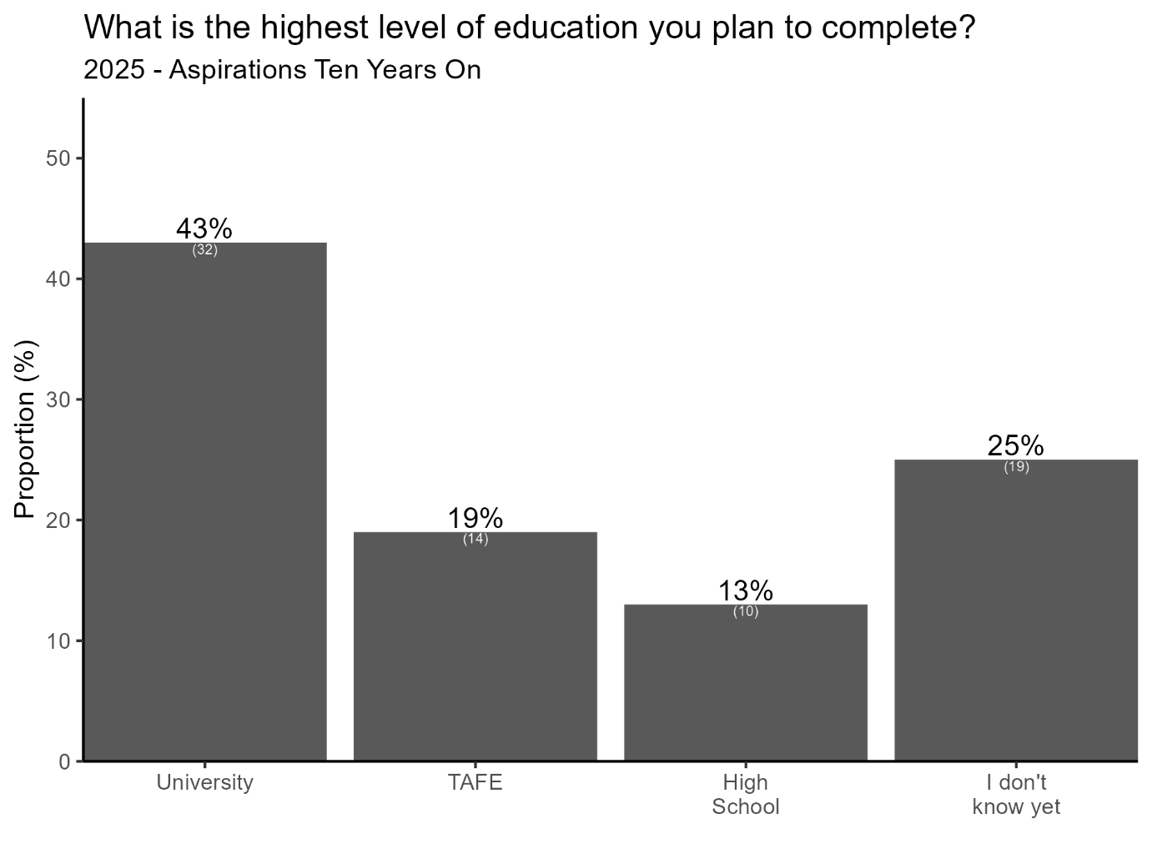
Given our focus on equity, we were also interested in understanding if educational aspirations varied by school ICSEA. Here, students’ intended highest level of educational attainment was disaggregated by school ICSEA, categorised into below 950 (low ICSEA), between 950–1050 (mid ICSEA), and above 1050 (high ICSEA).
As shown in Figure 2, for students who attend low-ICSEA schools, educational aspirations are relatively evenly distributed, with 25% (n = 9) of students indicating university and high school completion respectively, 17% (n = 6) selecting TAFE, and 33% (n = 12) reporting uncertainty. For those students attending mid-ICSEA schools, there is a notable shift in aspirations, with 50% (n = 7) of students aiming for university. TAFE and uncertainty are reported by 21% (n = 3) and 29% (n = 4) of students respectively, while no respondents in this category selected high school as their final level of education. For students who attended the highest ICSEA schools, university aspirations dominate, with 73% (n = 11) of students planning to complete university. This group reports the lowest levels of aspiration for TAFE (13%, n = 2), high school (7%, n = 1), and uncertainty (7%, n = 1). These patterns suggest a positive relationship between ICSEA and the intention to pursue university education, with students attending the lowest ICSEA schools more likely to express uncertainty or opt for vocational or secondary pathways. However, these findings must be interpreted in the light of the small samples in each category.
Figure 2: Educational aspirations by ICSEA, 2025
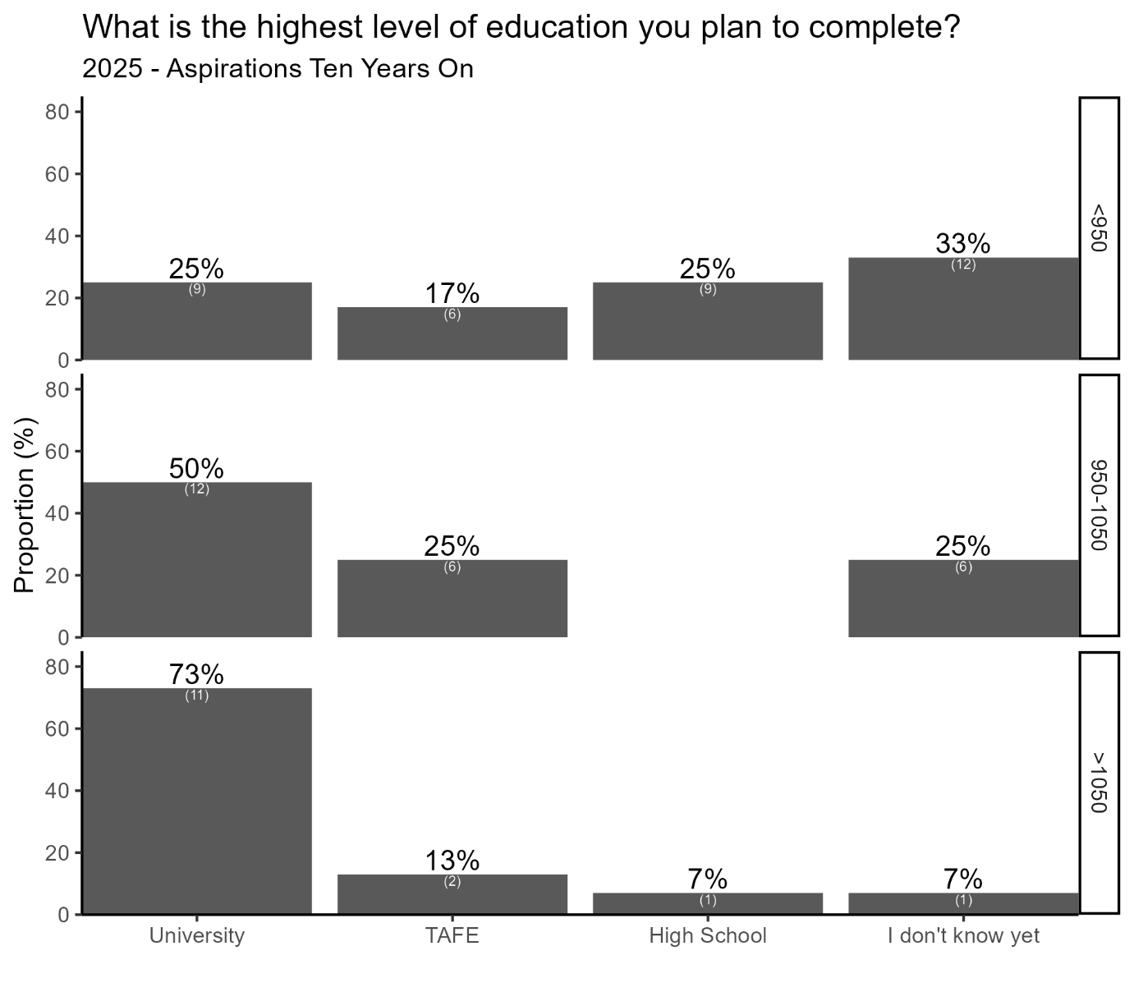
Educational aspirations were also disaggregated by geographic location—specifically between those residing in major cities and those in regional areas. As shown in Figure 3, among students in major cities, 46% (n = 29) reported plans to complete university, making it the most frequently selected option within this subgroup. This was followed by 24% of students (n = 15) who expressed uncertainty about their future educational trajectory, 19% (n = 12) who intended to complete TAFE, and 11% (n = 7) who indicated high school as their final level of education.
By contrast, students from regional areas displayed more variance in their educational aspirations. University and high school completion were each selected by 25% of students (n = 3), while 17% (n = 2) indicated plans to attend TAFE. Notably, a larger proportion—33% (n = 4)—expressed uncertainty about the level of education they wish to pursue. These data suggest a geographic disparity in educational aspirations, with urban respondents demonstrating a stronger inclination toward university education. However, these findings must again be interpreted in the light of the small sample in each category.

Figure 3: Educational aspirations by location, 2025
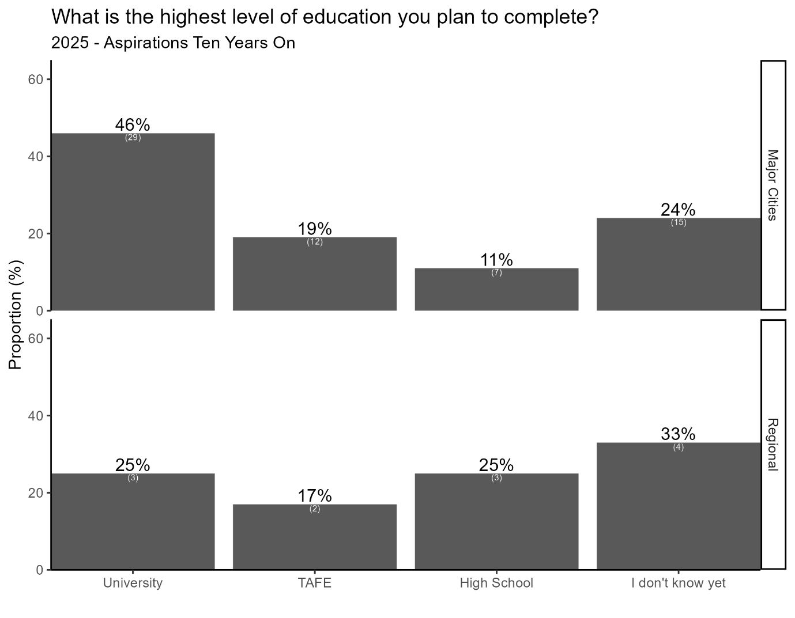

Occupational aspirations
The survey data revealed a diverse range of career aspirations among students, with certain professions emerging as particularly prominent. As shown in Table 2, school teachers represent the most frequently cited aspiration, accounting for 6.32% of responses (n = 11), followed closely by registered nurses at 5.75% (n = 10), with notable interest also shown in legal professions and motor mechanics (each 4.02%, n = 7). Careers in science, healthcare, and design—including veterinarians, psychologists, architects, and graphic designers—featured prominently, indicating a strong interest in both STEM and the creative industries. A number of respondents also expressed aspirations for trades and vocational roles, such as electricians, plumbers, and beauty therapists. Additionally, a small proportion were either unsure (2.87%, n = 5) or provided inconclusive responses (1.15%, n = 2), suggesting some uncertainty or evolving career interests. Overall, the data highlights a broad spectrum of occupational aspirations, with a particular emphasis on education, healthcare, and creative professions.
Table 2: Career aspirations, all students, 2025 (n = 154)
Career aspiration | n | Proportion (%)
School teachers | 11 | 6.32
Registered nurses | 10 | 5.75
Judicial and other legal professionals | 7 | 4.02
Motor mechanics | 7 | 4.02
Life scientists | 6 | 3.45
Veterinarians | 6 | 3.45
Defence Force members – Other ranks | 5 | 2.87
Psychologists | 5 | 2.87
Unsure | 5 | 2.87
Advertising and marketing professionals | 4 | 2.3
Architects and landscape architects | 4 | 2.3
General practitioners and resident medical officers | 4 | 2.3
Interior designers | 4 | 2.3
Other natural and physical science professionals | 4 | 2.3
Police | 4 | 2.3
Sportspersons | 4 | 2.3
Beauty therapists | 3 | 1.72
Child carers | 3 | 1.72
Fashion, industrial, and jewellery designers | 3 | 1.72
Graphic and web designers, and illustrators | 3 | 1.72
Other medical practitioners | 3 | 1.72
Other miscellaneous technicians and trades workers | 3 | 1.72
Sales assistants (general) | 3 | 1.72
Visual arts and crafts professionals | 3 | 1.72
Actors, dancers, and other entertainers | 2 | 1.15
Artistic directors, and media producers and presenters | 2 | 1.15
Carpenters and joiners | 2 | 1.15
Electricians | 2 | 1.15
Inconclusive | 2 | 1.15
Librarians | 2 | 1.15
Plumbers | 2 | 1.15

Summary: Quantitative findings
Overall, the quantitative findings illustrate clear aspirations among many students for higher education, with university emerging as the most frequently cited goal. However, levels of aspiration vary notably by both school ICSEA and geographic location, with students from lower-ICSEA schools and regional areas more likely to express uncertainty or lean toward vocational or secondary pathways. These patterns highlight the ongoing influence of socio-economic and geographic factors on students’ educational trajectories (Cooper et al., 2017; Marks, 2017; Webb et al., 2015). The diversity of career aspirations further reflects a broad range of interests, though many are clustered around professions requiring post-secondary qualifications. Given the limited sample size of the survey data, the longitudinal case studies provide deeper insights into these trends, while also bringing to light how economic, socio-political, and environmental changes are affecting the aspirations of young people today.

Longitudinal case studies
Each case study begins with a “snapshot” of the school and its broader community, highlighting any changes over time. The data sources drawn on here align with the dates of data collection from the whole of the Aspirations program of work, with MySchool data (ACARA, 2025) used for each relevant year of data collection at the school level, and the most recent ABS census data (ABS, 2022) used to reflect community characteristics over the same period of time.
In terms of the census data, information is presented on the educational attainment levels of community members, along with their distribution across occupational categories, classified according to ANZSCO (ABS, 2022). The occupational categories include:
- labourers
- machinery operators and drivers
- sales workers
- clerical and administrative sales workers
- community and personal service workers
- technicians and trades workers
- professionals
- managers.
Finally, the top industries of employment are listed, to provide a finer grained account of employment in each community.

Ironbark Plains High School
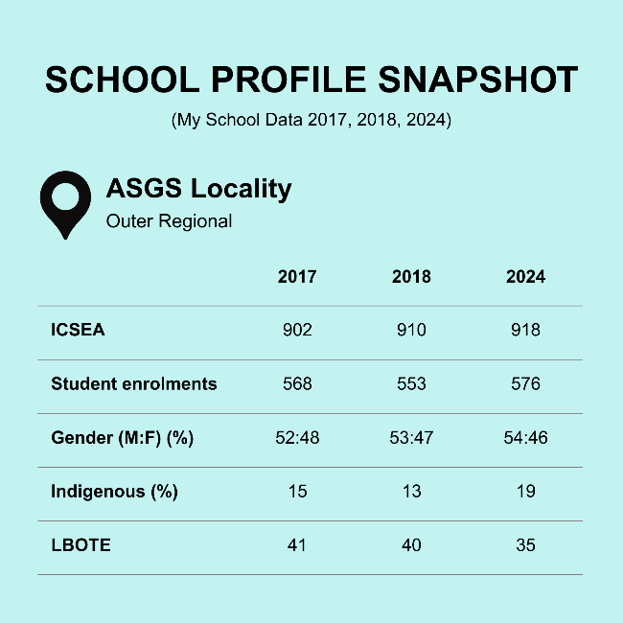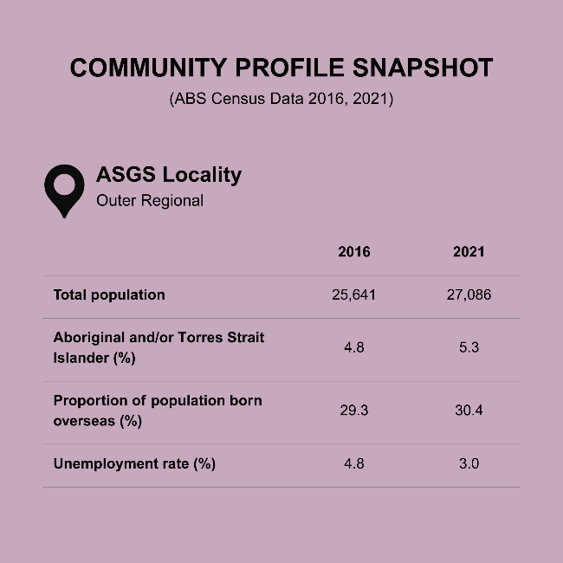

Top 5 industries of employment, Ironbark
 | 2016  (%) | 2021  (%)
Poultry processing | 6.4 | 7.3
Wine and other alcoholic beverage manufacturing | 6.2 | 5.9
Supermarket and grocery stores | 2.7 | 3.4
Hospitals (except psychiatric hospitals) | 2.6 | 3.0
Primary education | 2.4 | 2.5

Ironbark Plains High School: Overview
Ironbark Plains High School is located in the outer regional community of Ironbark. Our first visit to the school took place in 2017 as part of the Locating Aspirations Study. We returned in 2018 to collect additional data for the Community Influence project and again in 2025 for the Aspirations in Uncertain Times project. With a current ICSEA of 918, Ironbark Plains High falls within the lowest 15% of Australian schools in terms of socio-educational advantage. As of 2024, 35% of the student population identified as coming from a language background other than English (LBOTE) and 19% were Indigenous, highlighting the school’s substantial cultural diversity. Another notable feature of the school is that, in 2019, Ironbark Plains merged with another local government high school; however, due to declining enrolments, the schools demerged in 2024. With an abundance of employment opportunities in the local community, many students at Ironbark Plains choose pathways into well paid work, rather than pursuing a university education.

Diversity, equity, and community
Ironbark Plains High School is a large regional secondary school situated in an agriculturally prosperous area. It is particularly distinguished by its culturally diverse student population compared to other schools in the region:
It's very unlike a lot of other places in the [region], especially because we have a lot of refugee [students], a lot of Pacific Islander, a lot of Hindi, Indian. I think at one time in the last eight years, we had something like 57 different nationalities going through Ironbark Plains High School. (Ursula, teacher, 2017)
Although the percentage of students from culturally diverse backgrounds declined from 41% in 2017 to 35% in 2024, Ironbark Plains High School continues to celebrate its multicultural identity as a cornerstone of its school community. This commitment to inclusivity persists alongside significant socio-economic challenges:
We've got quite a low socio-economic basis for a lot of our kids. So, they come from poor, working class [backgrounds], or they come from families where they don't really value higher education. (Ursula, teacher, 2017)
Despite a slight increase in school ICSEA—902 in 2017 to 918 in 2024—more than 80% of the students at Ironbark Plains are in the bottom two socio-educational advantage (SEA) quartiles. Ursula's statement thus reflects the very real material challenges faced by schools serving low socio-economic communities, highlighting the interplay between socio-economic status and educational aspirations.
During our visit to Ironbark Plains in 2018, teachers emphasised how school zoning policies reinforced entrenched social divisions within the community, compounding the marginalisation of Ironbark Plains High School. They highlighted the connection between the school’s perceived quality and the socio-economic status of the surrounding community. Kathleen explains:
We've got [an area] just over there which is all housing [commission] ... Over there we've got everybody who owns their own homes. So, for years and years and years Mount Yarran High was the school to be. Ironbark Plains High was scum. That’s what people called it. (Kathleen, teacher, 2018)
These longstanding social divides were underpinned by reputational issues for Ironbark Plains High School, which has long battled a “bad reputation” (Charlene, parent, 2018) rooted in socio-economic stigma, or being from “the wrong side of the tracks” (Charlene, parent, 2018).
By 2025, the growing shift of students moving from public to private education was also impacting enrolments at Ironbark Plains High School. While the school has historically produced high achievers, many were dismissing this school as a viable education prospect:
We've had people at our school that, you know, fly jets for Jetstar. We've had people at our school that have won Oscars. And people who have built these amazing businesses get 20 years down the track—our school's the same school that they went to. [But now] it’s not good enough for their kids. That's, I think, a really huge thing with aspirations in schools, in some schools. Especially in public schools and the way… people are feeling to get a good education you have to pay for it. So, this move away from public schools and the problem with that is, what sort of society does Australia want to be? (Roberta, teacher, 2025)
Roberta's observations reveal a deepening crisis of confidence in public education, with many previous students now rejecting the school for their own children, leading to a changing school demographic and the school “becoming residualised” (Roberta, teacher, 2025). Her comments point to a broader societal shift where aspirations for success are increasingly linked to private education, regardless of the outcomes in public schools.
In an effort to bring the two public high schools in the community together and improve outcomes, Ironbark Plains High School was merged with Mount Yarran High School in 2019. However, the merger was largely unsuccessful, leading to significant angst among both students and teachers. A demerger was approved in 2024. Ruben, a Year 11 student, reflected on his experience with the merger:
With the merger/demerger, I just feel it was a big waste of money ... I don't think we could ever have two separate schools come together and have the students want to get along because teenagers, they're always like bickering. (Ruben, Year 11 student, 2025)
Ruben also went on to highlight the practical and emotional difficulties of navigating between campuses:
If I took a STEM class, I had to go to the Mount Yarran site ... having to assume to get along with these kids from the Mount Yarran side that I've never known before ... I just found it really uncomfortable because I didn't know the layout of that school ... I had to rely on these kids I'd never met before to show me around. (Ruben, Year 11 student, 2025)

Socio-economic pressure and the value of work
In the Ironbark Plains community, socio-economic pressures have long played a strong role in shaping student choices. Many students work long hours in fast food or seasonal picking jobs to support their families, affecting attendance and performance:
Kids … do their McDonald's shift … then go home and clean the house … then get up and stuff mailboxes before school. (Elissa, teacher, 2017)
Here, teacher Elissa illustrates the heavy workload students manage, balancing part-time jobs, household responsibilities, and other tasks like delivering mail. For some students, balancing part-time work results in significant absenteeism from school as many “kids go missing at certain harvest times” (Jim, teacher, 2018). This situation reflects the socio-economic realities of many students who must contribute to their families financially or through domestic labour, limiting their capacity to fully engage in education.
In this light, a persistent theme across all the years we visited Ironbark Plains High School has been the connection between students’ family employment in agriculture or factories and the aspirations of their children. These jobs often shape what students believe is possible for themselves. For example, Elissa said:
I had a beautiful kid from Samoa, a lovely girl, 100 per cent attendance, is quite capable. Their aunty works at a pumpkin factory, and I said, "what do you want to do when you grow up" and the kid said to me "my aunty said there'll be a job for me at [the chicken factory]." Well no. So that's that chicken processing plant. So that's what some of the kids perceive. (Elissa, teacher, 2017).
This quote starkly illustrates how some students are locked into narrow occupational futures—shaped not by personal ambition or skill, but by familial precedent and economic stability. The teacher’s response—"well no"—is both an intervention and an expression of concern over how normalised limited aspirations have become.
Despite such challenges, students at Ironbark Plains High School display a broad range of aspirations. There is a notable divide between those pursuing academic pathways and those entering the workforce immediately after school, often in agriculture or local industry:
The kids who come to us are more of the people who work for the wineries, and work for the farmers, and who work in town as part of the community. (Ursula, teacher, 2017)
However, by 2025, another teacher, Glen, was highlighting the strong financial viability of local careers in agriculture:
In regard to agriculture and primary industries, which I teach, there is so many opportunities in the area … Students can leave and go out to a $45 per hour job … $55/$60 with qualifications. (Glen, teacher, 2025)
Challenging the perception of agriculture as a low-income field, Glen’s comment highlights how agricultural education equips students with skills that can lead to high-paying jobs, especially when paired with qualifications. The shift here is toward reframing vocational success not as a fallback, but as a legitimate, well-paying career path. While local employment was once framed simply as abundant, by 2025 a shift has occurred toward linking education with better local economic outcomes, rather than seeing education and employment as separate or competing choices.

Influences on student post-school futures
Within this context, cultural, familial, and economic factors intertwine to play a major role in the post-school decisions of students who attend Ironbark Plains High School. Financial hardship is a persistent and intensifying theme in the student experience across all years we visited the school. Students from Ironbark Plains consistently face barriers to post-school options due to affordability issues:
Money to do extracurricular. Money to do even subjects that require fees. Money to do training or TAFE or any extracurricular non-school based training. Money to go to university. Basically, if it needs money outside of government funding, a lot of our kids will never be able to access it unless they fund it themselves and they are often supporting their families. (Ursula, teacher, 2017)
This situation speaks to the insidious ways financial strain limits access to broader learning experiences. Not only do students quietly opt out of school subjects, but access to university is also seen as a significant financial strain by families:
We are disadvantaged because the nearest [university is] two hours away and you still have to ... I think you would find a lot more kids would probably go to university, because you're talking about forking out a lot of money and there's a lot of families can't afford that money, so they don't see university as an option because of that. (Charlene, parent, 2018).
The nearest university being “two hours away” illustrates the geographic isolation of rural communities like Ironbark. This distance imposes significant logistical challenges, such as long commutes or relocation, which can deter students from pursuing higher education. For students such as Ruben, who are negotiating both geographic isolation and a cost-of-living crisis, access to stable employment could significantly influence their ability to attend university:
I'm a bit worried about the cost of living but I have been reassured by one of the jobs I'm working at they have several branches around Australia. And so, they said that if I wanted to move somewhere that had a branch there, they could put in a referral. And give me a higher chance to be able to work there. And be able to cover the costs of either a university dorm or having my own apartment and just things like that. Being able to have more of an opportunity to have more money. (Ruben, Year 11 student, 2025)
Ruben’s experience underscores the importance of financial stability and supportive employment in enabling students to pursue higher education. Yet many students will not have access to a supportive employer and will not have the same opportunity, highlighting disparities in access to resources that facilitate university attendance. Such quotes reflect a shift from general affordability concerns (2017–2018) to acute pressures linked to the rising cost of living and economic instability (2025). Students are increasingly navigating complex trade-offs between education and immediate financial needs.
In Ironbark, many students are also deeply connected to their families, often taking on caregiving or financial responsibilities. Elissa, for example, said:
Those are the ones [with caregiving responsibilities] who [will] disappear, and they'll disappear for a week, two weeks, a month and they'll either be, “what's the point in coming back, I have too much to do”, or “I got a job picking because I got better money”. (Elissa, teacher, 2017)
Elissa’s observation underscores the critical need for systemic reforms to support students with caregiving responsibilities. Without targeted interventions addressing absenteeism and financial pressures, these students are at heightened risk of disengagement and dropout, limiting their future opportunities:
Her grandmother had—was bedbound and had dementia and so she'd come home from school, she'd care for her grandmother with dementia until her mum came home from night shift and then she would sleep. She'd get up, she'd come back to school the next day … She was translating for her family as well. That's not all of our families. But it’s not an insignificant number of families who have very strong family commitments as well. Which is why staying home or close to home or having options when it comes to study are actually really important for some of our kids. (Cassy, teacher, 2025).
Such obligations may force students to prioritise immediate family needs over long-term educational goals, limiting their ability to pursue opportunities like university or vocational training.
Students we spoke to in 2025 also expressed deep anxiety about global instability, technological change, and future opportunities. The impact of AI was a particular concern for some young people like Aabida:
I don’t really think it’s going to be that good. Like, all the consequences that’s happening right now because of AI and stuff. It’s going pretty bad. Like, it will take people’s jobs and not give anyone opportunities to do anything. Although it will be efficient, it won’t be useful for anyone else. (Aabida, Year 8 student, 2025)
Aabida’s statement underscores the tension between the efficiency of AI and its potential to disrupt employment and societal equity, especially for those in more precarious social positions. While acknowledging AI’s efficiency, Aabida questions its societal benefit, reflecting a degree of scepticism about whether AI-driven productivity gains will translate to equitable outcomes.
For other students, such as Lottie, uncertainty about the future is grounded in generalised anxieties fuelled by the COVID-19 pandemic:
I’m actually really scared, ’cause I don’t know, you never know, like something could happen tomorrow and like with COVID it happened. Like one day it just happened out of nowhere and it became a world problem. It was just insane … I just feel like there’s going to be a lot—like a lot more things that will happen in the future, especially when I’m going to be older and by myself without parents. And I don’t know how I’m going to be able to—too much pressure, I guess. (Lottie, Year 11 student, 2025)
Lottie’s concerns mirror wider youth anxieties about inheriting a world marked by climate change, political instability, and technological disruption. The emotional toll of "not knowing" reflects increased mental ill-health among youth, possibly exacerbated by constant exposure to dystopian narratives through media and social platforms.

Conclusion
Students at Ironbark Plains High School navigate a complex landscape of socio-economic challenges, familial obligations, and the reverberating impacts of a failed school merger, all of which significantly shape students’ present circumstances and future aspirations. Despite facing persistent material challenges in the community, shifting enrolment patterns, and reputational stigma, the school continues to foster cultural inclusivity and student resilience. While financial strain, caregiving responsibilities, and systemic barriers limit some students’ access to post-school opportunities, others are finding new pathways through vocational success and supportive local employment.

Oldfields Central School
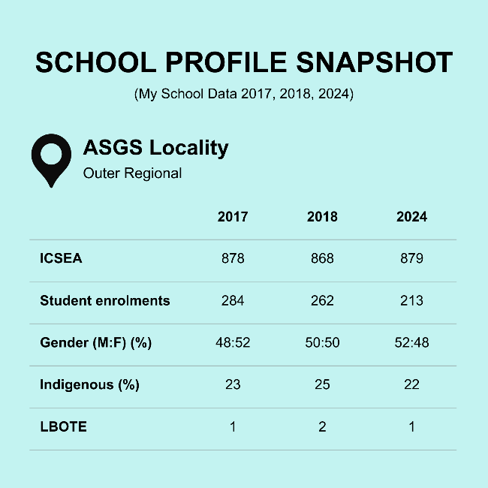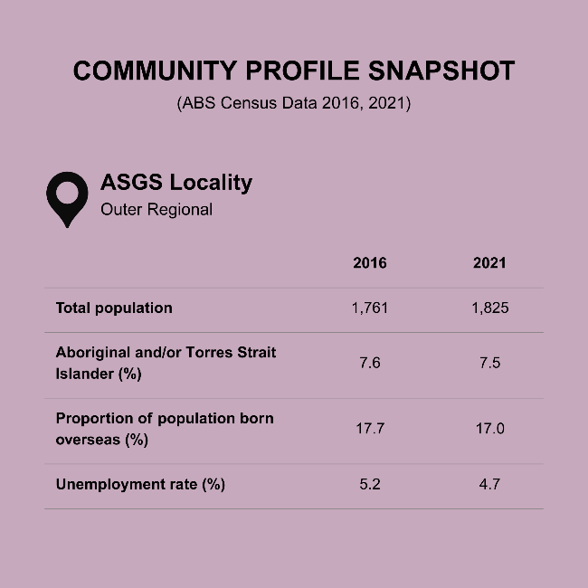

Top 5 industries of employment, Oldfields
 | 2016  (%) | 2021  (%)
Beef cattle farming (specialised) | 16.1 | 15.4
Coal mining | 9.3 | 6.5
Local government administration | 6.2 | 4.9
Combined primary and secondary education | - | 3.3
Supermarket and grocery stores | 4.3 | 3.0
Hospitals | 4.2 | -

Oldfields Central School: Overview
Oldfields Central School is located in the outer regional community of Oldfields. We first visited Oldfields in 2017 as a part of the Locating Aspirations Study. We returned to Oldfields again in 2018 to collect additional data for the Community Influence project and for a third time in 2025 for the Aspirations in Uncertain Times project. During this timeframe, the ICSEA of the school stayed relative stable, and with a current ICSEA of 879, Oldfields Central School falls within the lowest 10% of Australian schools in terms of socio-educational advantage. According to staff at the school, most students at Oldfields are the first in their families to complete the HSC and finish Year 12, let alone aspire to, or go to, university. Slightly less than one quarter of students are Indigenous.

A community and school in decline
Oldfields Central School caters to the town and surrounding areas of Oldfields, a small regional township situated along a major highway in NSW. Across all three years we visited the school, the town was described as “isolated” by both young people and adults despite being only a two-hour drive from the coast, a mental attitude linked to a lack of public transport and severe community decline. In the last two decades, this decline has been driven by a range of societal and environmental impacts, most notably economic rationalist policies, drought, and interrelated changes to local industry. Robert, a teacher at the school, who has lived in the community for most of his life, has been a firsthand witness to this decline:
There have been significant changes in the community. When I lived here and went to school here, the community was considerably larger, greater focus on agriculture, farming. More services within the town, banking services, and a range of other services. But like most country towns, those services have moved out. So skills and occupations have gone. Probably now, our community is dominated by people on welfare, as well as by the mining industry. (Robert, teacher, 2018)
As Robert alludes to, Oldfields was traditionally an agricultural community with a strong focus on cattle, sheep, horses, and wheat. While farming has long been one of the main employers in the town, technological advancements have recently transformed the local employment landscape, greatly diminishing the number of people employed in these areas:
Oldfields is still an agricultural community, but the difference of course now is technology has changed, so there’s not as many people working on farms … Farming today is a pretty high-tech industry. For example, when you’re driving large machines, most today are on GPS … You can also sell a lot of livestock online—you can just go direct to a processor. So we’ve had to learn how to breed our stock and our lambs, our cattle, to meet that specific market. Because if they don’t fall into that market, they don’t want them … So in terms of jobs, instead of [employing] five people, now you’ll have two. So that means that three jobs have gone. (Peter, farmer, 2018)
Alongside this decline, Oldfields Central School has also experienced a decrease in student numbers. When we first visited the school in 2017, 284 students were enrolled. More recently, in 2024, this number had decreased to 213. This trend was already noticeable during our visit in 2018, with teachers like Robert commenting on the way local parents were increasingly choosing to send their children to non-government schools in other towns nearby, fueling an exodus from Oldfields Central:
There are two buses that leave town each day that go to private schools. So we have one bus that goes to [catholic school in nearby town] and we have one bus that goes to [independent school in nearby town]… We’re the second-class option. Lots of that has to do more with social status and their parents’ occupations rather than the quality of education in the different schools. That’s just the reality, really. But it does mean that the bulk of the low SES kids are in the public system and the bulk of kids with disabilities are in the public system. So we open the door to anyone who wants to walk in and we provide the best that we can, and that’s our challenge. (Robert, teacher, 2018)
By the time of our last visit in 2025, this situation had become a vicious cycle. Staff numbers had also declined, the school had become “hard-to-staff,” lessons were sometimes unstaffed, and the school was unable to offer certain subjects to students:
We lose a lot of numbers coming up to secondary. I'm not sure whether that's [due to] the perception of our staffing issues, which have been very public and very dire up here. Like kids out in the playground and parents thinking, “I don't want that for my kids,” so they’ll send them elsewhere. We then can’t offer courses like English Advanced, English Extension, because we just don't have the numbers or the teachers. So for those higher-level kids with those aspirations, we're probably not the educational destination for them, which is a shame. (Breanna, teacher, 2025)

The more things change…
While the agricultural industry has visibly weakened in the region, coal mining by contrast has exploded—epitomised in the physical landscape by over 40 coal mines dotted around the broader valley within a one-hour radius, inclusive of the largest coal mine in NSW. While no mines are located in the actual township of Oldfields, they exercise an extreme form of control over the town and its residents, creating a sense of anxiety:
The mines have bought a few properties around Oldfields. A lot of them have been with the option to lease back to families … hopefully one day our land won't be dug up around here like it has been in [neighbouring town]. When I used to go to [neighbouring town] when I was young, there was nothing dug up and now it's dug up everywhere which is sad. (Tanja, parent, 2017)
Experiencing a drought in 2018, the mines have, however, also come to represent a form of hope for some residents, a saviour in difficult economic times:
Oldfields is a little rural town and up until the last ten years, there really wasn’t much influence from anything else. The mining industry in the area has made a bit of an impact … A lot of people, they say, “Oh we’ll just get a job in the mines,” and they think that’s the answer to everything, because it’s big money. But it’s like a pipedream … and it’s that term, it really grates on me—“the mines”. It’s like they’re going to save us. (Michelle, parent, 2018)
In the context of these changes, the town is facing a looming problem of generational renewal when it comes to the agricultural industry, with young people not having seen “the land as something to aspire to for years” (Michelle, parent, 2018). This stance was particularly evident in the views of Emil, a Year 12 student we spoke to in 2017 who had shifted his aspirations from farming to mining. While Emil spoke favourably of his dad’s job working for the local land service, he had become enticed by the prospect of economic security offered by the mines:
We had a mine talk where the mines came into the school and spoke to us about it and then I spoke to them a little bit and yeah, I was sort of set on going into farming, but I like the more machinery side of things and mines is a lot of machinery … The mines will also give me a bit more security, I think. (Emil, Year 12 student, 2017)
From the perspective of adults, however, such aspirations may not necessarily be informed by contemporary circumstances. As teacher Robert explained, young people tend to be reliant on information gleaned from the experiences of parents or relatives, which can often be outdated and not grounded in reality:
Whilst we have lots of kids that think, “Yes, I would go and work in the mines,” they may not necessarily understand the selection process for the mines and what the level of competition is. Most of the kids picking up apprenticeships in the mines, they’re completing their HSC, getting good results in maths and English. Whereas from our kids’ perspective, their dad or uncle or such might have gone to Year 10, picked up a trade, and had a trade pathway that way … They’re still using the same framework as their parents or uncles might have used 10, 15 years ago. (Robert, teacher, 2018)
More recently, continuing a family tradition of farming has also been impacted by the loss of family farms to large mining corporations, as noted earlier by Tanja. Coupled with the technological advancements re-shaping the farming industry, the level of experience and form of credential needed to secure a job in farming has subsequently changed:
There are many places, larger corporations, that really won’t have people on unless they’ve got these agronomy degrees. (Peter, farmer, 2018)
However, with few adults in the community having a university qualification, higher education is largely a foreign place to many young people and adults. As a result, if students aspire to a career in farming, their options have become more limited if they don’t pursue and attain a university qualification, likely funnelled into lower skilled work:
I guess you have to look at the proportion of parents that went to university … In communities like this, to work in agriculture, you don’t necessarily need degrees from university. You can get them but you don’t necessarily need them. So if dad worked on a farm all his life and the son comes along and he wants to work on a farm all his life, the chances are, he’s just going to stay here. He won’t go off to university and study agriculture. (Iola, teacher, 2017)
A lot of kids when they're doing farmwork, it's doing like fencing and shearing and slashing work and those kind of manual labour physical jobs. (Byron, teacher, 2025)

…the more things stay the same
Despite some of the immense changes impacting the town, many young people still aspire to the known and familiar, particularly influenced by what is already available in the community and the careers of those around them. Recognisable, identifiable aspirations were evident during all of our visits to the school:
I think I want to be either a vet nurse or a hairdresser. [Because I like] animals for vet nursing, and I think hairdressing comes from horses as well, from like plaiting their tails and stuff like that, from since I was little. (Marie, Year 10 student, 2017)
I did my work experience at [the Base Hospital], and a lot of them told me if I wanted to move away, because I’d move to [city name] and go to university there, working in a bigger hospital I’d be able to do midwifery just as midwifery. But, if I want to come back here, I have to be a nurse as well … because there's not enough births here to just be a midwife … That helped me actually make the decision to be a primary teacher and ideally come back here. (Heike, Year 11 student, 2017)
I want to just do what my father’s currently doing—carpentry. So you get to build ramps, sheds, renovations, bathrooms, decks … I’m already doing it now. I’m not a proper apprentice; I just do it for the fun of it. (Briggs, Year 7 student, 2025)
In some regards, aspiring to the known and familiar might be due to a degree of isolation from the wider world, with physical remoteness and a lack of access to services meaning that students tend to look inwards towards their rural identity and community:
A lot of our kids live out of town, so on properties, remote areas—little phone service, little internet. A lot of our kids are into rodeos, horse riding, that sort of thing, hunting, football. (Breanna, teacher, 2025)
However, particular ideological beliefs also appear to impact how young people construct their aspirations and see their futures in the current social and economic climate. Certain views about global megatrends such as climate change are formed in interaction with parental and community views, with the dominant political persuasion of the community leaning towards a political party that has openly derided the science of climate change:
I think a lot of our kids still very much think that climate change isn't real and that kind of thing and that's ingrained from, I think, you know, from their parents who are very National [Party]. The Nationals are the party out here and so climate change doesn't really exist and the mines aren’t gonna stop, solar’s all a farce … There's a development of a solar farm a few kilometres from here, and the uproar is crazy even though it's going to bring so many jobs. (Byron, teacher, 2025)
During our visit to the school in 2025, these political views were subtly manifest in young people’s talk about the current social-political and economic climate:
The government’s not spending money on the right things—there’s other things that need to be done first [before addressing climate change]. Like, they need more houses and doctors and there’s a tonne of people getting—like, millions of people are getting cancer every day. (Briggs, Year 7 student, 2025)
In contemporary times, climate change might therefore not feature highly on residents’ agendas, with the perceived monetary rewards of mining—and even still farming—outranking what education and formal schooling are seen to offer in these times:
There's a lot of parents who didn't go to school, didn't enjoy school. Oh, now I work in the mines, now I work in the farm, I make lots of money, and I didn't need school so why would you? And that attitude translates to a lot of the students, not a lot of them, but a vast majority, especially in the senior years. (Breanna, teacher, 2025)

Conclusion
Students at Oldfields Central School have been left behind in an educational climate increasingly characterised by school choice and workforce shortages. With the agricultural industry in the town declining and opportunities in mining increasing, “the mines” have come to offer a sense of both apprehension and hope for residents, with some young people coming to see this pathway as the most economically viable option for their future. However, pathways into various local careers have changed due to the immense social and environmental changes in the community, and young people may not be adequately informed about how to achieve their goals in the current climate, eventually streamed into lower skilled work. Regardless of such change, many students tend to aspire to the known and familiar, with careers available in the community popular among young people who want to follow in their parents’ footsteps and/or pursue careers aligned with their rural identity. Given the lure and dominance of mining in the town, issues like climate change don’t feature highly in residents’ agendas, largely overlooking the fact that jobs in these areas might not exist in the near future.

Banks Hollow Secondary College
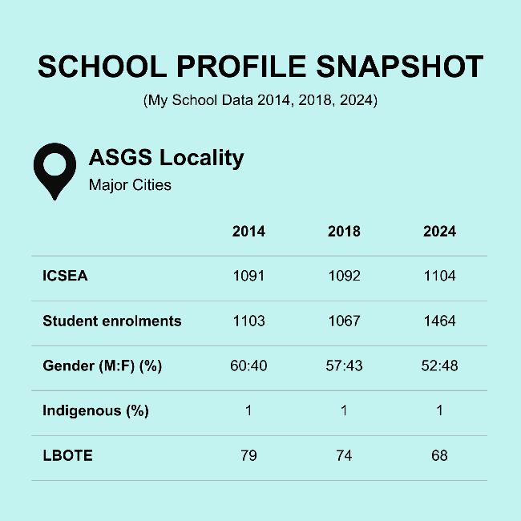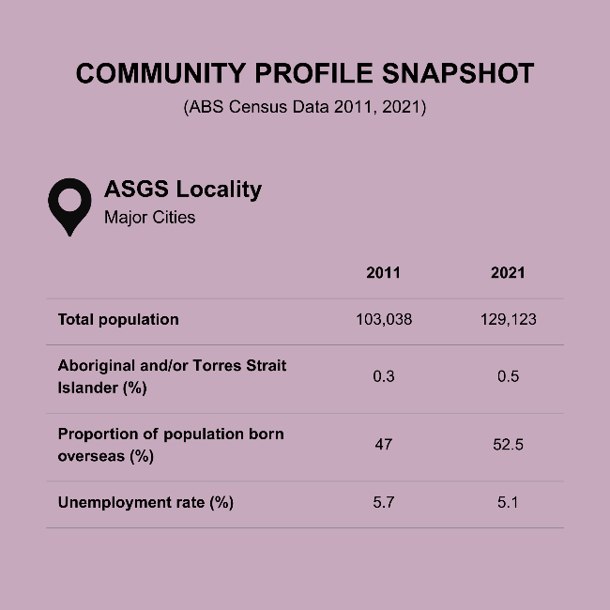

Note: ¹Educational attainment was not collected in the 2011 Census.

Top 5 industries of employment, Banks Hollow
 | 2011 (%) | 2021 (%)
Computer system design and related services | 4.0 | 4.7
Hospitals (except psychiatric hospitals) | 3.4 | 3.7
Banking | - | 3.3
Accounting services | - | 2.3
Cafes and restaurants | - | 2.3
Cafes and restaurants and takeaway food services | 4.0 | -
School Education | 3.8 | -

Banks Hollow Secondary College: Overview
Banks Hollow Secondary College is a partially selective secondary school located in an inner-city suburb of the state’s capital. We first visited Banks Hollow in 2014 as a part of the Aspirations Longitudinal Study. We returned to the school again in 2018 to collect additional data for the Community Influence project and for a third time in 2025 for the Aspirations in Uncertain Times project. Banks Hollow Secondary College is ethnically diverse, with 68% of students in 2024 being from a language background other than English. Likely due to the school being partially selective, the current ICSEA of the school is 1104, which means it falls within the top 15% of Australian schools in terms of socio-educational advantage. With the broader Banks Hollow population increasing by 33% between 2006 and 2021, one of the school’s most pressing challenges has become its struggle to accommodate a rapidly expanding student body. Hemmed in on all sides, it has limited room to expand.

Growth and diversity
Banks Hollow Secondary College is an inner-city, partially selective secondary school serving a diverse, multicultural population of students. In 2024, 68% of students at the school were from a language background other than English, a figure that is similarly reflected in 55.3% of households in the broader community speaking a language other than English—well above the NSW average of 29.5%. This diversity is the direct result of immense change to the local area, with the community undergoing significant demographic shifts in the last two to three decades, largely initiated by the sell-off of numerous public assets and new housing developments being built in these spaces:
[The community was] previously very WASPish [White Anglo-Saxon Protestants]. But now, with the advent of high-rise apartments, which are really growing dramatically, the demographics have changed dramatically. I've actually seen the data and I think it's about 50 per cent Asian background now in the area. And our school has a very high percentage of students from non-English-speaking backgrounds, largely Chinese, Korean, Indian, Armenian, which is a nice mix. And a sprinkling of many other cultures. (Melanie, teacher, 2018)
Both young people and adults value this diversity. The school and the community are seen as welcoming to all, with comments often emphasising the high degree of acceptance and sense of belonging people have in the community, regardless of their background:
It’s very accepting. Like no matter where or what country or what part of Australia you’re from you can feel very accepted here because of the diversity of races. (Henry, Year 9 student, 2014)
I think, just for kids in general just to see yes, there are differences, but at the same time you can all still belong to the same place. (Lia, community member, 2018)
However, the continued growth of the school and the broader population has been a cause for concern. During one of our first visits to the school, it was described as “busting at the seams” (Mary, parent, 2018), with enrolments already sitting at 1,067. Negativity was directed at the lack of foresight into the impact of high density living:
The Department of Education has had very poor planning around this area. When they announced the building of the 812 dwellings, I thought, "Has anyone contacted the Department of Education? It's a block away from the school." And the Department of Education back then said that it would only—once contacted—that there would only be an increase of a hundred students over a period of 10 years after it [the apartment complex] opened. I was like, "What, are they going to market it to all the infertile couples in the country?" You know, 812 dwellings, they didn't think people with children lived in flats? They have no idea. (Mary, parent, 2018)
By 2024, school enrolments had continued to rise to 1,464. Housing and infrastructure development had persisted in the area, with students like Neal focusing on this point when asked in 2025 about any recent changes to the community:
Recently, there's been a lot of high-rises going up towards the south end of [the community]. And I feel like there's also been big major developments in the business park. (Neal, Year 12 student, 2025)
By 2025, the school had become a high-rise itself, bordered in on all sides by existing infrastructure and nowhere else to go but up to accommodate the growing number of students. Both teachers and students lamented the cramped physicality of the school as its biggest downfall:
We're a school built for less than 800, that's how it was built in the ‘50s. And, you know, you would never build a building like this now with all the stairs. And so it's quite dangerous, we have to watch where we're going … the Department for some reason has decided to put all of its money into this school rather than build the promised schools out at [nearby suburb] which would take a huge number of our students. So they've decided that this is going to be the school, so it's very crowded. (Susanna, teacher, 2025)
The biggest drawback I see to this school is that we just don't have enough space to accommodate everybody, because it's like 1,500 kids and it's not big enough. It’s been difficult to expand as well, in terms of our location. It can only really go up. (Neal, Year 12 student, 2025)

Aspirational young people and families … with consequences
Set against this backdrop of growth, the Banks Hollow school community is characterised by a culture of high expectations and aspirations for high-ranking professional careers pursued through higher education. According to teacher Debra, during our most recent visit to the school, “usually about 80% [of students] will go to university.” This trend appears to have endured for many years, with Melanie, another teacher, noting the exact same proportion of university entrants back in 2018: “80% of them going to university … our outcomes are very good”. In large part, these expectations and aspirations stem from the cultural background of students, with parents placing a great amount of hope on young people’s shoulders to pursue successful academic futures and better their social position:
All of the Asian kids would be forced to go to, expected to go to university, regardless of which one, they'd be expected to do that. That's just an expectation of migrant children. (Mary, parent, 2018)
We have a lot of, um, if I'm okay to say, Asian sort of tiger parents. And also parents who are migrants who have great expectations on [sic] their children. (Susanna, teacher, 2025)
Indeed, during all of our visits to the school, most students described aspirations for careers such as medicine, law, architecture, and business, and were often able to identify their desired university in the broader city area:
At one point I wanted to be an architect because I really liked art and all that sort of stuff and designing things. But later on it wasn’t really something for me, I thought. So I’m thinking medicine because a lot of people in my family have gone into dentistry or medicine and that seems like a really good aspiration. (Asher, Year 9 student, 2014)
I think I might want to be something to do with finance and maybe trade between Indonesia and Australia because we're learning Indonesian in classes and I quite enjoy it. (Sunshine, Year 7 student, 2014)
I've always dreamed of becoming a veterinarian ever since I was a little kid. And I'd love—after high school, I'd love to go to Sydney Uni. (Phillip, Year 11 student, 2025)
These aspirations do not come without their costs, however, with mental ill-health a serious concern within the school community. These concerns were briefly noted during our visit to the school in 2018:
One of the biggest barriers is their parents, trying to live their dreams through their children and creating terrible anxiety. (Melanie, teacher, 2018)
By 2025, these concerns had worsened, with teachers pinpointing the COVID-19 pandemic as a catalyst for the exacerbation of mental ill-health. Pressure and anxiety were still, nevertheless, spurred on by the attitudes—and aspirations—of parents:
I think there’s been a shift since COVID. There’s certainly more students now with mental health issues than there have been, certainly it's much higher. I can't tell you statistics, but noticeably there are kids who just put themselves under enormous pressure … like there's a girl who's a chronic cheater at the moment and, you know, her parents have told her, “You go to Sydney”—well the father is, “Sydney University or bust.” (Susanna, teacher, 2025)
Another consequence of these expectations and aspirations has been the devaluing and stigmatisation of vocational pathways. With university largely seen as the only legitimate aspiration, TAFE and vocational careers are usually dismissed as not good enough:
My son is a sheet metal worker. He got discrimination when he left school to a point his friends wouldn't talk to him because he’d started a trade. He was an academic at school, but then things didn't work out for him and he didn’t end up finishing school. But then he became a tradie and he's working full-time now. I'm just surprised at the comments I even got as a parent and I actually witnessed him get the same comments as a child, like, “I thought you'd do better than that,” or “get a better job.” And I'm like, he earns $40 an hour now as a sheet metal worker, he's gone to TAFE, he's doing his Advanced Diploma in Engineering and he got two uni offers this year which he's deferred, and he did this all by himself. (Debra, teacher, 2025)
Despite this attitude, some young people at Banks Hollow Secondary College still express interest in vocational pathways. In the case of Colby, a student we spoke to in 2025, aspirations for these kinds of pathways are strategic in the current climate. Colby indicated he was knowledgeable about employment demand and did not want to waste time pursuing an unnecessary or unwanted qualification just for the sake of it:
I’ve thought about doing a trade, maybe like an electrician. It just seems more interesting, to be honest, than sitting in an office job … One of the main reasons why I don’t want to go to university is that I feel I'll spend all my time doing a degree that I'm not going to use or don't really want. It would just be a complete waste of time and only send me further back … You don't get much as an apprenticeship but once you start making your way up …. There's also a decline in tradies and that so you kind of need them more. (Colby, Year 11 student, 2025)

New worries in contemporary times
While aspirations for university and professional careers have remained steady in the Banks Hollow Secondary school community, new doubts and worries have materialised for young people. During our visit in 2025, new forms of anxiety appeared to have materialised linked to a belief that a university degree has lessened in value, with competition for jobs no longer necessarily directly linked to an individual’s credentials:
A lot of workplaces right now, like they say, “oh, a university degree doesn't really matter. If you've got the skills then we'll still take you anyways”. I think that has definitely increased the anxiety of people who go to university, saying like, “oh, what if I get this degree and I still can't compete with other people?” That's a really concerning factor for people looking for jobs. (Tarnie, Year 11 student, 2025)
While these new anxieties haven’t deterred young people at Banks Hollow Secondary College from being interested in university as an institution, it has shaped their perceptions of particular degrees, with some degrees now seen as having little to no value to their future or society at large:
If I wasn't going to do architecture, I would do a degree in business. But a lot of people have told me that it's useless. Like they said if you do a business degree it's not going to make you rich, it's not going to help you start your own business. It's just going to be a waste of time and money and that's definitely scared me off of it. (Katy, Year 11 student, 2025)
In a similar vein, the rising cost of living has noticeably manifested in the way young people now make choices about their future career pathways. With all the young people we spoke to in 2025 wanting to remain living in the Banks Hollow community or the broader city when they finish school, choosing a career that offers strong financial security has become a critical consideration, attempting to balance personal interest with income:
Just the other day she [my daughter] said something about “teaching doesn’t earn enough; you can’t afford to live in Sydney as a teacher” … but at the same time, I’ve been saying to her, “do what you are interested in.” (Hua, parent, 2025)
I'm worried about finding a job that I am interested in and have a passion for, but also one that has security, like a salary and how much it's gonna pay with cost of living, prices going up in housing. So, trying to find a balance between a job that will pay decently, but also one that I'm actually interested in and want to pursue. (Belle, Year 12 student, 2025)
Given the current economic landscape, the debt that comes with a university degree also weighs heavily on both young people’s and adults’ minds. Back in 2018, a local parent used the analogy of a “noose” to describe the severe nature of the inescapable burden of a HECS debt, particularly in cases where a young person might swap degrees or not finish university:
When I was working last year for a media company, there was a girl there who's the sales rep. She had had some mental health problems. She was in her late 20s. Since she'd left school, she'd done two years in one degree, realised she didn't like it, and then went and worked. Then she went to do another degree and didn't like it. She's got a $42,000 HECS debt and she doesn't have a degree. And she's in a job that probably pays about $35,000 a year, at the age of 30. It's a noose around your neck. (Mary, parent, 2018)
By 2025, this analogy rang true for many students. Here, Year 12 student Josie speaks about the heightened level of anxiety she feels when thinking about the debt that she will face by going to university and how this might impact her future more broadly:
I get very, very overwhelmed by the idea of how much money you have to pay for university. I remember one of my co-workers was talking about how her sister had almost a hundred thousand dollars of HECS debt, and that's not an uncommon thing, which is crazy. And it's like, no wonder we won’t be able to afford a house when we're having to spend thousands and thousands and thousands of dollars on our education … It won’t put me off [university], but it may potentially put me off seeking further university education. Like I would love to get a Masters in something, but I won't. (Josie, Year 12 student, 2025)
Nevertheless, for some students, the financial outlay of going to university is just part of what happens in society; a necessity to get to where you want in life:
I think it's just part of education, if you want to do any sort of learning you're going to have to pay some sort of fees. I think it's just given. (Neal, Year 12 student, 2025)

Conclusion
As an inner-city government school, Banks Hollow Secondary College is physically overpopulated and crowded. This shortcoming, however, doesn’t appear to stop young people from following their hopes and dreams, with the vast majority of students pursuing university upon graduation. Many young people are encouraged to go to university and aspire towards professional careers by their parents, who are often first- or second-generation migrants and see education as key to a better future. On the one hand, these expectations place a high degree of pressure on students, with anxiety noticeably worsening since the COVID-19 pandemic. On the other hand, the level of confidence in university has wavered among young people, who have begun to question its value—and the value of certain degrees—in the current economic and social climate. The rising cost of living also looms large, with students feeling more overwhelmed about the debt that comes with a university education, the need for financial security, and the likelihood of ever affording a place to live in or near their community when they are older.

Riverbend College
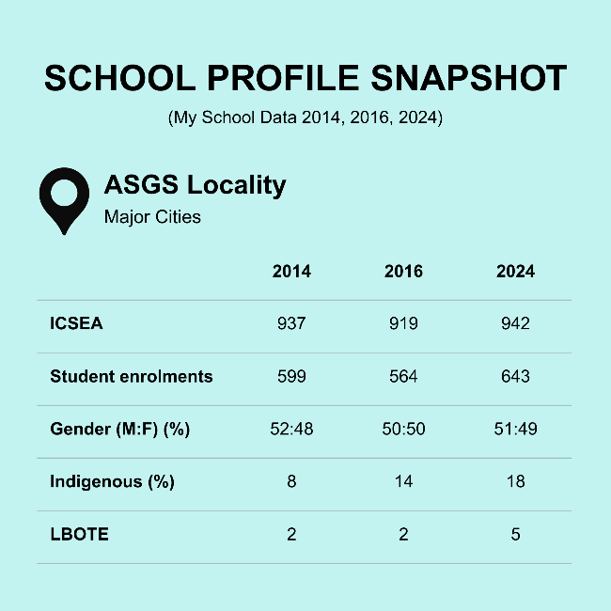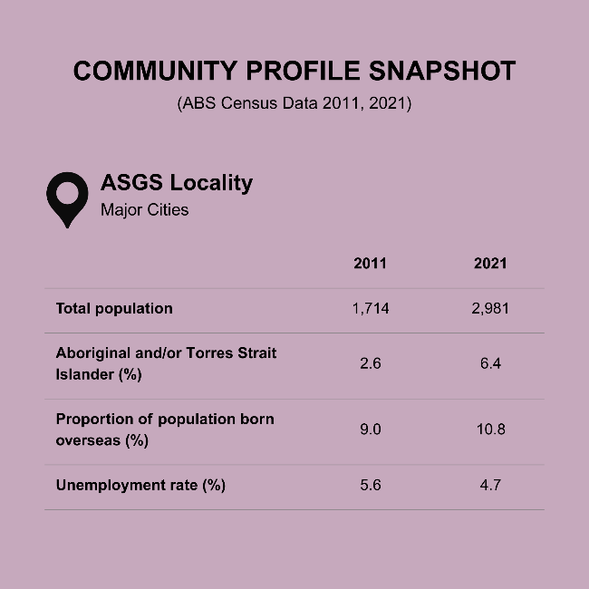

Note: ¹Educational attainment was not collected in the 2011 Census.

Top 5 industries of employment, Riverbend
 | 2011  (%) | 2021  (%)
Other social assistance services | - | 5.2
Hospitals (except psychiatric hospitals) | 3.8 | 4.6
Supermarket and grocery stores | 3.0 | 4.2
Coal mining | - | 3.2
Aged care residential services | - | 3.0
Residential care services | 4.1 | -
Cafes, restaurants, and takeaway food services | 3.7 | -
School education | 3.0 | -

Riverbend College: Overview
Riverbend College is situated in an outer suburb of a large regional city. Our first visit to the school took place in 2014 as part of the Choosing University study. We returned in 2016 to collect additional data for the Unlocking Capacity and Empowering Choices study and again in 2025 for the Aspirations in Uncertain Times project. With a current ICSEA of 942, Riverbend College is categorised as a low-ICSEA school. As of 2024, 18% of the student population were Aboriginal and/or Torres Strait Islander and 5% identified as coming from a language background other than English. Riverbend has traditionally identified as a working-class community, shaped by working-class economic roots and occupational structures. However, it has begun to undergo significant social change over the past decade.

From mining to “McMansions”
Riverbend College is located in the suburb of Riverbend on the outskirts of a large regional city in NSW. Originally serving a tight-knit, mining-based community, the school’s culture, student demographics, and aspirations have transformed in recent years. A historically working-class community, the town’s identity has long been tied to trade-based careers, with deep-rooted generational ties to mining. When we visited the school in 2014, teachers recognised the beginnings of major changes in the community. Guinevere explains:
It’s been a coal mining town, but we’re on the cusp of significant change … You’ve got parents who have children, and then you’ve got grandparents that have kids, and the kids have kids here … You have people [realising that their] child can’t get a job in the mines because the mine is no longer there … the importance they have laid on education hasn’t necessarily been important in the past, but … we are on the cusp of change … it is our role to ensure that these students leave us, who are globally competitive because the world, what Riverbend is, is changing and has changed. (Guinevere, teacher, 2014)
Guinevere’s reflection captures the beginning of Riverbend’s transformation from a coal mining town to a community grappling with economic and cultural change. She acknowledges the deep-rooted generational ties to mining and how its decline has forced families to reconsider the role of education in their children’s futures. Her emphasis on the school’s role in preparing “globally competitive” students underscores the tension between traditional local identities and emerging global aspirations.
By 2025, the transformation Guinevere described had taken the form of urban development. Notably, growth in nearby areas had increased the population of Riverbend by more than 70% since the early 2010s, changing the character of the area:
With the housing development out here ... there's a lot of new McMansions ... it's drawn different people to this area. And whether those people have brought with them different aspirations and expectations on education and life post school, whether that has kind of spilled over into the community, I don’t know. That's a possibility as well. (Elisa, teacher, 2025)
Elisa’s reflection highlights the impact of housing development on the social and cultural dynamics of Riverbend, suggesting that the influx of residents into “McMansions” may be shifting community values and educational aspirations. However, a widening gap between students from disadvantaged backgrounds and those from more affluent families was also evident in Riverbend by 2025. Social and economic shifts have contributed to growing inequality within the school population:
We’ve got a big gap … [from] parents [who] don’t work, [are] renting, or on verge of homelessness to that dad [who] works in the mines, or he’s a FIFO worker. (Terina, teacher, 2025)
Terina’s comments highlight stark contrasts in living conditions and economic security. However, financial advantage does not always translate to emotional or practical support. Alina, another teacher, points out that even students from well-off households face challenges:
They come to school and they’re totally well off, but they might not bring lunch. ‘Cause mum’s left, you know, at 6.30 or six o’clock, dad’s on fly-in fly-out. (Alina, teacher, 2025)
Comments from Terina and Alina suggest that financial stability does not always guarantee consistent care or healthy family routines, both of which are crucial for student wellbeing. While FIFO work arrangements may provide economic advantages, they also create distinct social and emotional challenges for families—challenges that can be just as impactful as those experienced by families facing financial hardship.
Financial pressures and limited parental availability thus shape family dynamics in Riverbend, where time and money can be scarce resources. This situation can sometimes leave students without supervision or access to extracurricular activities:
They don’t often actually have the opportunity to try and get on buses or trains anyway, because they just don’t have the funds to go and do stuff … They’re kind of isolated a little bit. (Alina, teacher, 2025)
Alina’s comment underscores the compounding effect of economic hardship on social participation. The inability to afford transportation becomes a barrier not just to recreation, but potentially to cultural experiences, educational excursions, and broader community engagement.

Valuing vocational futures
Despite changes to the Riverbend community wrought by an increasing population and a change in community demographics, aspirations for careers have remained fairly steady across all our visits to the school. Students articulated interest in a range of careers, from hair and beauty, and fitter machinists to teaching, psychology, and marine biology. However, many students at Riverbend College aspire to careers tied to the mining industry, likely linked to the working-class roots of the community:
Because it’s on the outskirts of [a major regional city] and closer to the valley ... there is a lot of kids that gravitate ... towards the valley jobs, which would be mostly mining or support mining jobs. (Adriana, parent, 2025)
Adriana’s comment highlights the lingering influence of geographical and economic positioning on student aspirations in the community. By noting that students “gravitate ... towards the valley jobs,” particularly in mining or mining-adjacent industries, she underscores how proximity to traditional employment corridors continues to shape career expectations, even as the broader community transitions away from its coal-based heritage.
Across the time span, many students also articulated aspirations aligned with trades and vocational training, particularly through TAFE and apprenticeships. In 2014, Perdita (student, Year 11) voiced frustration that while students were surrounded by trade-preferred career norms, the school continued to push academic pathways:
There’s a lot of people that love trades around here, it’s a much preferred thing. [The school] still advertises a lot more academic sort of pathways, when there’s a lot of kids that are really interested more in getting apprenticeships and stuff. … they’re downgrading it by not advertising it as much and not showing the need for it. (Perdita, Year 11 student, 2014)
This critique suggests not just neglect but a hierarchisation of educational options—academic routes are implicitly positioned as more prestigious or valid. By 2025, however, TAFE was regarded as a faster and more practical route to work by young people, often with more clarity than university:
TAFE’s kind of like more practical I feel … I feel that TAFE you kind of just go there and you'll finish it quicker than uni at times because you can leave in Year 10 and get it, while uni usually have to go to Year 12. (Layla, Year 9 student, 2025)
None of my family ... went to uni … I don’t know how you would go about even applying. (Emma, Year 10 student, 2025)
These quotes highlight a longstanding divide between institutional messaging and the lived realities of students in trade-oriented communities like Riverbend. They underscore a critical and enduring divide between what students in trade-heavy regions want and need versus what is often valued in formal schooling.
Indeed, trade pathways are highly valued in the broader Riverbend community. Jobs in the mining industry, in particular, are seen as aspirational not only for the stability and security provided, but because of a range of tangible lifestyle outcomes:
They all earn ridiculous amounts of money. And so my kids have seen the sort of lifestyles that they have. The amount of toys that they have, like motorbikes and going out and you know, they'll go out and I'll drop $600 for us all to go out for dinner and they don't bat an eye at it … and I'm like, “Well, we can have this too, but for you to earn that sort of money, you've got to go and learn. You've got to go and get your certificates. You've got to go to school. You've got to go to TAFE. You've got to go and get the qualifications to go and do it.” (Raina, parent, 2025)
Raina’s quote exemplifies how, in Riverbend, TAFE and vocational trades are not only valid but idealised, especially when tied to lucrative industries like mining. Her message reflects a pragmatic, lifestyle-driven view of education and work, where vocational pathways are aspirational, and academic prestige is secondary to financial independence and social mobility. At the same time, there are signs of changing attitudes at the school. Adriana, a parent, notes a shift in how non-university pathways are now being supported:
They have steered away from it [a sole focus on university pathways] and they are now offering more opportunities for the children that don’t really necessarily want to pursue university. (Adriana, parent, 2025)
University is no longer seen as the sole high-status route, and vocational education or TAFE pathways are no longer the fallback. The shift reframes pathways as intersecting rather than mutually exclusive.

Navigating conflicting pressures
Despite significant changes to the community, students at Riverbend College face enduring and persistent barriers to navigating their post-school futures. In 2014, educators like Drake noted how low levels of parental education and a lack of familiarity with tertiary pathways created significant barriers for students:
The parents haven’t been well-educated, so the students don’t expect to do it … near enough is good enough and mediocrity is acceptable for the parents. (Drake, teacher, 2014)
This statement highlights how values, dispositions, and beliefs shaped by social conditions can act as a constraint on student aspirations. The phrase “near enough is good enough” encapsulates a resigned, pragmatic mindset, suggesting that striving for excellence may feel unnecessary or even out of reach in families where higher education has not been modelled. This creates a self-perpetuating cycle: without role models or lived experience of academic success, students may not perceive university as a realistic or relevant goal. Teacher Warren builds on this point by identifying a lack of family support and understanding as the biggest challenge to students’ post-school success:
There is a real lack of understanding in terms of what is expected to get a good ATAR mark to get into university. (Warren, teacher, 2014)
This lack of awareness creates a barrier that goes beyond motivation—it’s also about access to accurate information. When families don’t understand how the system works, students are often left without the support they need to navigate it. This makes the process of aiming for university particularly difficult, as noted in 2025 by teacher Elisa, who acknowledges the limited reach of schools:
Parents haven't—they haven't shot for the stars themselves. And so, they really don't feel equipped to provide their kid with the information or support from a home perspective … We only have them for six hours a day ... the other 18 hours they’re at home in an environment that might not be overly supportive. (Elisa, teacher, 2025)
Such situations are not about lack of care, but rather a lack of knowledge, confidence, or access. Without lived experience of navigating certain post-school pathways, families often struggle to provide the academic encouragement or career advice that students need—particularly for higher education routes. The intergenerational reproduction of educational disadvantage remains a core challenge.
By 2025, young people from Riverbend College are navigating a complex and often conflicting set of pressures when planning their post-school futures. While various kinds of aspirations remain, they are increasingly shaped—and in some cases, constrained—by broader economic realities, lifestyle concerns, and growing anxieties about global instability and personal sustainability. The high cost of living and housing insecurity have become key concerns influencing young people’s choices after school. For many families, the dream of higher education is not weighed purely by aspiration, but by affordability. Rania, a parent, illustrates this concern bluntly:
They have Buckley's chance of getting a deposit together, buying a house. Um, even, renting a house … There's no way that, you know, my kids, even, even once they leave school, and they're working and they're earning money. There's no way they'd be able to afford that … so, education wise, super important. You need a good education, so you can get a good job, so you can get paid well, so you can afford to live. (Rania, parent, 2025)
Rania’s comment reflects growing doubt about young people’s ability to achieve financial independence, even with full-time work, due to soaring living and housing costs. It reveals how economic pressures are driving a more pragmatic view of education as a pathway to secure, well-paid employment and basic stability.
While some students report a sense of anticipation about adulthood describing it as “hopeful,” “exciting” but also “scared to be an adult”, there is also an undercurrent of cynicism. Layla, a student, articulates a sense of futility:
You’re working for something that’s not really gonna pay off ... I just think, “I don’t want to have to struggle my entire life.” (Layla, student, 2025)
This expression is more than teenage pessimism—it captures a generational mood of disillusionment, shaped by lived observation and media messaging. The “payoff” of education and hard work no longer feels guaranteed and, in many ways, this scepticism is rational.
During our most recent visit to the school in 2025, the combined impact of global and national crises were also taking a toll on student wellbeing:
There has been a higher level of anxiety and—at best—and despondency at worst … fears about whether they'll be able to cope. (Elisa, teacher, 2025)
Post-pandemic fatigue, climate anxiety, cost-of-living concerns, and a constant stream of negative media appear to be playing a role in eroding young people’s sense of optimism. Elisa goes on to recount how even global political tensions are creeping into the classroom:
I’ve got a Year 10 student ... clearly was anxious … she’d read news reports about the Chinese boats in the ocean. (Elisa, teacher, 2025)
This heightened exposure to global instability—coupled with limited tools for emotional regulation—contributes to a sense of precarity, overload, and distrust in the future. Students are not just worried about their own futures; they are questioning the world they live in and are inheriting.

Conclusion
Riverbend College’s journey from a mining-centric, working-class school to a more diverse and transitional educational community reflects broader shifts in regional Australia. While the school and its staff have made strides in recognising and supporting a range of post-school futures, students continue to face significant and intersecting challenges. Economic precarity, housing insecurity, limited familial experience with higher education, and rising mental health pressures complicate the path from school to adulthood. Although vocational education remains a strong and respected choice within the community, especially due to its practical and financial appeal, access to higher education is still uneven—often shaped by knowledge gaps and systemic disadvantage. As Riverbend changes, the school’s role becomes even more critical—not only as an academic institution but as a site of care, connection, and possibility for students navigating an uncertain world.

Murrindah High School
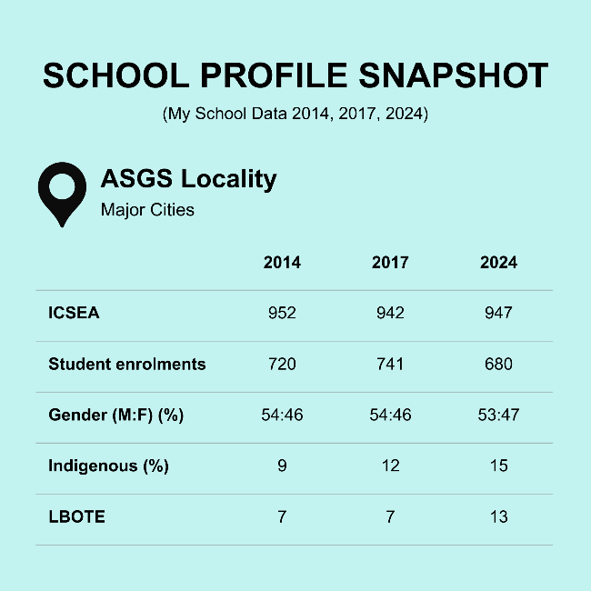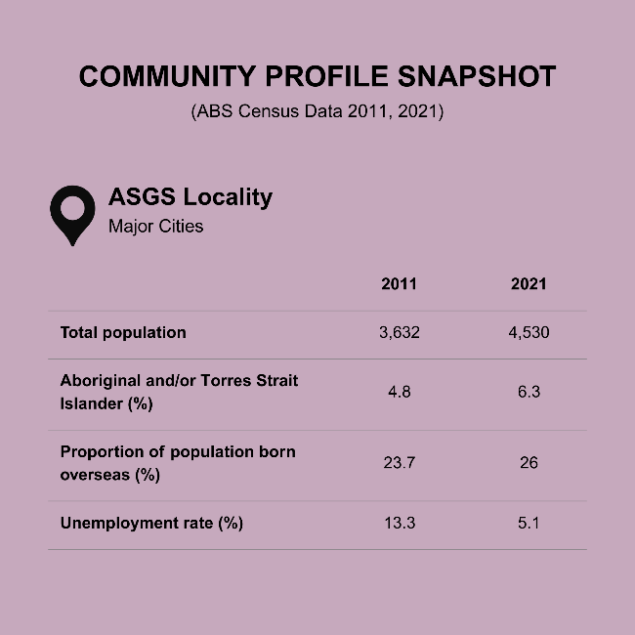

Note: ¹Educational attainment was not collected in the 2011
Census.

Top 5 industries of employment, Murrindah
 | 2011  (%) | 2021  (%)
Cafes, restaurants, and takeaway food services | 6.8 | -
Hospitals (except psychiatric hospitals) | 3.3 | 3.3
Supermarket and grocery stores | 2.9 | 3.1
Aged/residential care services | 3.8 | 5.1
Building cleaning, pest control, and gardening services | 2.5 | -
Other social assistance services | - | 3.8
Takeaway food services | - | 2.9

Murrindah High School: Overview
Murrindah High School is a mid-sized high school located on the fringes of a major regional city near the coast. We first visited Murrindah High in 2014 as a part of the Choosing University study. We returned to Murrindah again in 2017 to collect additional data for the Unlocking Capacity and Empowering Choices study and for a third time in 2025 for the Aspirations in Uncertain Times project. With a current ICSEA of 947, Murrindah High falls within the lowest 25% of Australian schools in terms of socio-educational advantage. The school serves a diverse population of students, with the proportion of Indigenous students and those from language backgrounds other than English increasing in recent years. The broader Murrindah community is also diverse, but faces longstanding economic and material challenges, with limited access to local employment and opportunities for youth.

A community marked by both affluence and structural inequality
Murrindah High School is located in a large suburb on the very outer fringes of a major regional city, bordered by seaside towns and the ocean to the east and hinterland to the west. The Murrindah community is a place of contrasts. Pascal (teacher, 2014) described the community as "sort of the land that time forgot," reflecting both nostalgia and disenchantment. Although infrastructure like the local youth centre and local sporting clubs still anchor the community, broader socio-economic shifts have altered its identity:
Murrindah used to be a vibrant centre ... but it's all changed … it's not what it was. (Pascal, teacher, 2014)
This sense of decline is echoed by students, particularly in the contrast between different neighbourhoods:
There's this really posh area and then there's the slums down the bottom of the hill. I moved over the hill in my life, like, I grew up in the sheltered area and then had to move to the scary area. (Jo-Lee, Year 12 student, 2014)
Jo-Lee uses a physical description—"the posh area" versus "the slums down the bottom of the hill"—to map out class divisions in her community. The hill becomes a symbol of social hierarchy, where those "on top" enjoy privilege and safety, while those "down the bottom" face hardship and risk. This spatial contrast mirrors broader socio-economic divides often found in urban and regional settings. Similarly, Keira’s observations reflect a sense of discomfort with public disorder and perceived neglect:
Some people are derros … it’s like really weird, like walking around drunk … not brushing their hair. (Keira, Year 7 student, 2014)
By 2025, parents such as Adeline and Laney underscored how Murrindah remains marked by economic hardship and limited recreational infrastructure for youth:
There’s a lot of people in this area that struggle; full stop. Mental illness, you know, homelessness, you name it. (Laney, parent, 2025)
There’s not actually an awful lot for children and teenagers to do themselves in Murrindah unless the parents are willing to pay money. (Adeline, parent, 2025)
These two quotes offer a compelling look at the intersection of youth opportunity, economic precarity, and systemic disadvantage in Murrindah. They highlight different aspects of how structural inequality plays out in everyday life, particularly for families and young people.
By and large, Murrindah High School mirrors the diversity of the community. Reg (teacher, 2014) characterises the school as “in every way possible a comprehensive high school.” The student body spans public housing communities, middle-class estates, rural valleys, and out-of-area selective stream applicants:
Here in our context ... they're not all tarred with the same brush (Reg, teacher, 2014)
This heterogeneity contributes to both richness and complexity. Rachel (teacher, 2014) notes a shift from rural to suburban enrolments over time, hinting at changing demographics and a possible narrowing of regional identity:
There are some people who are quite well off and others who are not. There are some people that have really high standards of education and others who don’t. I think the difference between now and when I first started working here was, I think, there were a lot more students from … sort of rural areas that also attended, and there’s not that strong representation from those rural areas in the school now. (Rachel, teacher, 2014)
Despite the challenges of serving a community marked by social and economic diversity, the school remains a central hub where families with vastly different "mental attitude[s]" (Reg, teacher, 2014) and expectations converge. In 2025, parents Lainey and Adeline reflected on the school’s growing capacity to support a wide range of learners. This includes initiatives like a selective “advanced learning class for STEM” (Adeline, parent, 2025) and targeted systems to address the complexities of supporting students with complex or vulnerable backgrounds:
More so—more so than when my eldest child was there. They—the [student’s] first year they did every single thing in their power to engage and enhance the kids. To create relationships to head off issues—improve the issues, that come with disadvantage. They just—it was extraordinary, really extraordinary what they did in that first year. (Lainey, parent, 2025)

Challenges in accessing paid work
Across the decade, student educational and occupational aspirations have remained relatively consistent at Murrindah High School. Structural barriers such as limited local job markets, and social factors like peer influence and family culture, play a critical role in shaping students' post-school outcomes. When we spoke to teachers in 2014, they frequently pointed to student effort and social groups as strong predictors of student achievement and access to post-school destinations:
It's the effort and it's the social group that they're in and if the social group is not prepared to work then they don’t work. A lot of—it's not what school you go to, what teachers you have, it's the social group you're in and if they are prepared to work and work as a group or if they're not. (Laura, teacher, 2014)
While Laura’s comment emphasises the significant influence of social dynamics on students’ motivation and work ethic, for other students, welfare dependence appears as both a symptom and a reinforcement of structural disadvantage. Teachers describe students gearing themselves toward a life on Centrelink—normalised and even accepted within their social spheres:
Here's these people getting ready for their life both on Centrelink and they've moved in together and these are nicer kids. These don't bong on or anything like that. They’re gearing themselves for a life and Centrelink’s the paymaster. (Pascal, teacher, 2014)
Pascal’s phrase "Centrelink’s the paymaster" suggests a resignation to a future of financial dependence, where these students may not aspire to careers that offer financial independence, but instead accept a life supported by government assistance. This situation reflects broader issues such as limited opportunity, economic insecurity, or a lack of pathways to sustainable employment, shaping how some students view their future prospects. For some students, their choices for post-school pathways can be narrowed by such internalised limitations:
I guess one of the sad events I can think of is a Year 11 student, female student, “What do you want to do?”, “I want to do nursing.” Getting brilliant marks; could just as easily have focused on medicine as nursing. But no. “Oh no, I couldn’t do medicine, I'm only good enough to be a nurse”. (Jimmy, teacher, 2014)
Some students, however, show early motivation and goal-setting, aiming for university, TAFE, or work pathways. Notwithstanding these aspirants, a significant portion remain disengaged from future planning:
Some have [plans] … university or TAFE or whatever else. But there seems to be a good portion that really don’t have any plan at all … There's also a good portion of students who feel as though they'll just leave school and find work and that'll be easy and that's what you do. I think there's a bit of misconception of how difficult it is to find work. Working at Maccas probably isn’t going to suit you for most of your life … there’s a bit of a struggle for some kids who think that’s fine. (Charlie, teacher, 2014)
Charlie’s quote highlights the divide between students with clear post-school plans and those who underestimate the difficulty of entering the workforce. It reflects a misconception that low-skilled jobs, like those at McDonald's, offer long-term solutions, ignoring the challenges of securing meaningful, sustainable employment.
When we returned to Murrindah in 2025, there was an acknowledgment that wide-ranging career opportunities continued to be limited in the community, reinforcing the importance of planning and education for mobility:
Look, my first initial gut reaction was dim … You’d probably not have the option of higher-level jobs … unless you can further advance yourself … there’s not a lot here; no, that would serve them well, get them enough money to buy a house etc. (Lainey, parent, 2025)
Lainey’s quote underscores a common regional experience—that students must look beyond their immediate environment to fulfill aspirations, often requiring them to pursue higher education or relocate. Indeed, commuting for work or study remained common, with the state’s capital offering broader options:
It is very much a commuter [community]. A lot of people still move, out and back, to come to Sydney every day of the week. (Adeline, parent, 2025)
I think it’s more travelling to the city [for work] … Yeah, I feel like, well, just off personal experience, my family travels to—down to Sydney a lot to trade there. I feel like there’s a lot of offices and warehouses based around here. (Carissa, Year 11 student, 2025)

Navigating uncertainty
As early as our first visit to Murrindah in 2014, students were grappling with emotional and informational uncertainty about the future. Bhim, a student, described an ongoing internal conflict:
I actually do think about [the future] a lot, every single time [when] I get home from school every day. But then I like to block it out because it just scares me a lot … but it would actually really help if I actually had much more clearer knowledge. (Bhim, Year 7 student, 2014)
This sense of fear and the absence of clear pathways point to a broader issue: students are unsure of how to access or interpret information related to careers and education. This point is echoed by teachers like Pascal, who highlight entrenched patterns of educational disengagement in some parts of the school community:
We have a large percentage that come from up in the [local] housing commission area ... like we’re talking our third generations you know what I mean? They haven’t flowed through. (Pascal, teacher, 2014)
Pascal’s comments point to entrenched poverty and housing insecurity, passed down through generations. There's an acknowledgement that individuals in these communities "haven’t flowed through," possibly referring to the lack of social or economic mobility and, by extension, the lack of sufficient systemic support or change.
By 2025, these challenges had both intensified and diversified. While some students like Sasha demonstrated logistical awareness of how to access higher education:
It’s pretty easy [to get to university in Sydney] … I'd probably catch a bus from my house to one train station and ... get a train to like Central and then walk or like catch like another train. (Sasha, Year 8 student, 2025)
Many others expressed psychological barriers and confusion:
I want to go to uni, but I don't know what for or what I'm going to do. Like I know what I want to do as a career, but I don't know like what to do to get there … you need like a deep conversation with someone to fully just like identify what you need to do. (Lyra, Year 11 student, 2025)
Lyra’s comments reveal a growing need not just for access to information, but for guidance about the future—deep, personalised support to navigate increasingly complex educational and employment systems.
During our last visit to the school in 2025, financial insecurity had also become a dominant theme. As the cost of living rises and housing becomes increasingly unaffordable, students like Sasha and Jaz articulate a sense of loss and limitation:
Just like that, everything's getting like more expensive ... by the time that I'm ready to buy a house, I won't be able to because it'll be way too expensive for me. (Sasha, Year 8 student, 2025)
We used to go on Sunday drives and have a Sunday roast, but ... I think back to just a couple years ago and I think “How has things changed so drastically?” (Jaz, Year 11 student, 2025)
Collectively, these quotes reveal a shared experience of young people feeling overwhelmed by rapid, often negative change—whether it's the financial barriers to future goals or the erosion of familiar social practices. Indeed, such economic pressure appears to not only be reshaping students' aspirations but also their strategies. Carissa, for example, explains:
Once you get a little bit older, you’re thinking about, like, “Do I have to get a job that’s going to able to provide for me?” Because if everyone just done [sic] the job that they wanted to do, it’s not necessarily going to bring in the same income as a salary paying job. So, I think that definitely comes into play as well when you’re choosing what you want to do. (Carissa, Year 11 student, 2025)
Carissa's quote reflects the tension between pursuing a career out of passion or interest and choosing a path that ensures financial stability. As she nears adulthood, she is becoming more aware of the need to choose a job that can provide for her, acknowledging that passion-driven careers may not always offer the same financial rewards as more traditional, salaried positions.
Similarly, parents too are deeply concerned about the current economic and social climate. Adeline notes that many are unsure whether young people will be “set up in life” with long-term stability. Lainey’s two comments below are most striking:
I look at what society is today and I’m … I’ve put him into a horror movie really. (Lainey, parent, 2025)
The homeless problem in Murrindah now is extraordinary ... kids with bikes ... living in a tent … I am very, very, very sorry for any young person these days. (Lainey, parent, 2025)
Here, Lainey views society as increasingly threatening ("horror movie"), particularly for youth in the community who face challenges like homelessness and economic insecurity. Both quotes highlight a perception of rapid, concerning social changes that are deeply troubling for parents. This sense of doom reflects not only economic realities, but also a moral and emotional reckoning with the future parents feel they’ve passed on.

Conclusion
The Murrindah High School community continues to navigate the challenges of structural inequality and economic hardship. The stark contrast between affluence and poverty in the area also continue to influence students' outlooks on their futures, with many facing significant barriers to social mobility due to intergenerational material disadvantage. While some students are driven by goals of higher education and stable careers, others struggle with psychological and financial obstacles. The tension between following personal passions and securing financial stability stands out as a key factor in their decision-making. Despite these challenges, the resilience of both students and educators is evident.

Discussion

Aspirations in an age of uncertainty
While there have been many tumultuous and turbulent times in history, young people today face a world increasingly characterised by uncertainty and instability. For example, a young Australian born in 2010 will have already experienced a global health pandemic, disrupted schooling, social isolation, a worsening climate crisis, environmental catastrophes, a cost-of-living crisis, transformations to the world of work, and the onslaught of rapid technological advancements, not to mention exposure to geopolitical conflicts in Europe and the Middle East. Arguably, today’s youth are growing up in an era of “compounded crises” (Uhls, 2025) that some have labelled “unprecedented, unpredictable and exceptional” (Grint, 2022, p. 1522), creating new existential threats that reshape how young people feel and act, not to mention how they orient themselves towards the future (Ansell et al., 2022; Malone, 2018).
At a theoretical and empirical level, uncertainty can be thought of as a “structure of feeling—the lived experience of a pervasive sense of vulnerability, anxiety, hope, and possibility mediated through the material assemblages that underpin, saturate, and sustain everyday life” (Cooper & Pratten, 2015, p. 1). In our research, uncertainty was not necessarily manifested in young people feeling less sure about what will happen in the future, but about the “dimming of imagined futures” (Cairns et al., 2014, p. 1058). For example, in places such as Banks Hollow, the high cost of living and the likelihood of owning a house weigh heavily on the minds of young people, even shaping the kinds of careers they are interested in so they can attempt to remain living in the community into adulthood. Similarly, in Murrindah, lingering financial insecurity is evident in the way young people’s thoughts about their present and future are imbued with a sense of loss and constraint, with home ownership a distant reality and tensions clearly emerging around pursuing a career out of passion versus monetary reward. These vulnerabilities are encapsulated by parent Lainey, whose analogy of a “horror movie” underscores the fear currently being experienced, the moral injuries of uncertainty, and how this feeling is passed on to young people both implicitly and explicitly.
Clearly, however, our research also shows that young people’s responses to uncertainty differs, shaped in part by individual background, social structures, and community context (Ansell et al., 2022). For example, both young people and adults in Oldfields latch onto “the mines” as a viable pathway in increasingly precarious times, with the other options in the community having significantly declined due to drought and technological advancements. By comparison, in Ironbark Plains, students like Ruben adopt a strategic mindset to get to university, drawing on his existing networks to alleviate any concerns about needing to relocate to attend higher education in a cost-of-living crisis. Here, uncertainty acts as a kind of resource for Ruben to negotiate his future (Cooper & Pratten, 2015). However, this situation also brings to light the way neoliberal policies have tended to frame young people as needing to respond to uncertainties in productive ways and take control of their futures (Ansell et al., 2022), rather than actively alleviate the institutional and structural constraints they operate within. This stance has long been evident in the “aspiration-raising” agenda in federal policy (see, for example, Bok, 2010; Prodonovich et al., 2014), reflecting a “politics of aspirational citizenship” (Mendick et al., 2018; Raco, 2009) that has encouraged young people to build entrepreneurial futures for themselves—and the nation—through self-reliance, individual responsibility, and meritocratic ideals (Patfield et al., 2024).
However, as Ansell et al. (2022) remind us, “the idea that one can control the future is very problematic in places where most people feel powerless” (p. 798). In our research, we heard stories of young people already working long hours to support themselves and their families at Ironbark Plains, a lack of knowledge, confidence, and access to information in communities such as Riverbend, and a struggle to escape intergenerational welfare dependence and a limited local job market in Murrindah. Here, the work of Rajak and Dolan (2022) rings true. They highlight that the gap between aspiration and opportunity is continuing to widen, as is the gap between the neoliberal expectations placed on youth and the material realities of their lives.

Uncertainty as a driver of mental ill-health
While uncertainty is arguably now a dominant feature of the material world, it can also be thought of as a “mental state” (Jenkins & Mitchell, 2010, p. 404). Research has shown that heightened levels of uncertainty and instability can lead to adverse impacts on mental health and wellbeing, including feelings of stress and anxiety, a sense of loss of control, fatigue, and distress (Kienzler et al., 2025). Some researchers in the psychological sciences have gone so far as to argue that greater uncertainty has been a key driver of the global rise in youth depression and anxiety in recent years, spurred on by the COVID-19 pandemic that introduced a multitude of novel uncertainties and equally by adolescents' increasing use of social media (Schweizer et al., 2023). In turn, young people can feel less confident in their ability to apply for a job and even to achieve future goals (Headspace: National Youth Mental Health Foundation, 2023).
In our research, young people’s thoughts about the future were increasingly imbued with language indicating stress and anxiety. In Ironbark Plains, students described feeling “worried” and “scared” when contemplating their futures. In the most extreme, however, at the partially selective Banks Hollow Secondary College, the COVID-19 pandemic was a catalyst for the exacerbation of mental ill-health, with young people—often from first- or second-generation migrant families—being put under enormous pressure to reach the heights of successful professional careers and top-tier universities in the city. Interestingly, however, new anxieties have been created about the value of a university education in a landscape where the world of work has changed, creating new sources of tension in the aspirations of those firmly set on a higher education pathway.

The value of university and TAFE in an age of uncertainty
In this light, our research also shows that students are increasingly making pragmatic decisions about post-school pathways, balancing aspirations with financial risk, local job markets, and the perceived value of qualifications. The COVID-19 pandemic accelerated these shifts, with significant drops in university attendance among disadvantaged students (Tomaszewski et al., 2022), and a broader questioning of the return on investment in university education, with some young people questioning if a HECS debt is now worth the risk (Hare, 2023). By 2023, domestic undergraduate commencements had fallen to their lowest in a decade (Australian Government Department of Education, 2024). By comparison, VET enrolments surged to 5.1 million (NCVER, 2023).
Such trends are now manifested in the aspirations of young people. In places like Riverbend—a former coal town turned commuter hub—vocational pathways have become highly valued. Students and families are drawn to the security and speed of trades-based careers. As Layla (student, 2025) explained, “you can leave in Year 10 and finish quicker than uni,” while her mother pointed to six-figure mining career incomes enabled by TAFE certificates. Such thoughts mirror national data highlighting how rising HECS debt, graduate underemployment, and dissatisfaction with career outcomes are driving many toward vocational options (Hare, 2023; Norton, 2023).
Conversely, in high-performing, inner-city Banks Hollow, university degrees remain highly coveted, particularly among migrant families who view higher education as a key to upward mobility (Cunninghame & Trinidad, 2017). As students aspire to careers in medicine, law, and architecture, degrees are seen as essential professional gateways. Even here, rising HECS debt and concerns about credential inflation loom large in the changing world of work. Year 11 student Tarnie (2025) fears that a degree “won’t compete” if employers value skills over qualifications.
As such, the traditional hierarchy of university over vocational education appears to be softening. Teachers in Riverbend continue to encourage students to pursue tertiary study alongside trades, while students in the partially selective Banks Hollow, like Colby, are considering electrical apprenticeships amid noticeable trade shortages. However, persistent barriers remain, including limited parental knowledge of pathways, mental health concerns, and cost-of-living pressures (The Smith Family, 2022). In uncertain times, the challenge is no longer choosing between TAFE or university but creating systems that allow young Australians to navigate both, building resilient and meaningful futures.

The residualised public school: Students left behind in an age of uncertainty
Within this increasingly complex economic, socio-political, and environmental landscape, our research also offers timely insights into how young people’s futures are equally impacted by the changing educational landscape. In Australia, enrolments in independent schools have grown significantly in recent years (Independent Schools Australia, 2024), with the proportion of students enrolled in government schools notably declining (ACARA, 2023). There are now more independent schools than ever in the country, while state governments have generally been slow to build new schools, particularly in booming metropolitan areas like our research area of Banks Hollow (Larsen, 2024). In turn, this process has created what has been increasingly referred to as the “residualisation” of schooling (linking with the idea of a “residue”), with students experiencing disadvantage being left behind in local government schools after their middle- and upper-class peers have shifted to better-funded schools (Australian Council for the Defense of Government Schools, 2024; Campbell, 2018).
In the starkest example of residualisation in our research, we first encountered the flight of students from Oldfields Central School during one of our initial visits in 2018. Back then, teachers spoke of their students witnessing two large buses entering the small town each weekday morning to take other young people to two other schools—one independent and one Catholic—in nearby towns. By 2025, a domino effect was evident at Oldfields, with declining staff numbers, difficulty attracting staff to the school, unstaffed lessons, and reduced capacity to offer academic subjects. As a result, teachers felt that the “higher-level kids with aspirations” (Breanna, teacher, 2025) wouldn’t even be considering Oldfields as an option. However, as another teacher mentioned, the key challenge the school faces is to “provide the best that we can” (Robert, teacher, 2018) to those who come, highlighting how these schools persist in the struggle to support their students despite residualised schools tending to face greater instability (Windle, 2009). As such, in the current age of uncertainty, young people in residualised schools are likely to experience more volatility and unpredictability at a day-to-day level, shaping their current opportunities as well as the possibilities for their futures. Indeed, in Oldfields, many young people aspire to the known and familiar pathways of their family and community, which might be their way of coping with uncertainty both in the school and in the world more broadly (Ansell et al., 2022).

Conclusion
This research has traced how young Australians are navigating an increasingly uncertain and volatile world—one shaped by overlapping environmental, health, social, political, and economic crises. These intersecting disruptions are not only altering the conditions of young people’s lives but are also reshaping how educational institutions and systems must respond in their efforts to ensure equitable participation in higher education. As our research shows, today’s youth are coming of age in an era of “compounded crises” (Uhls, 2025), where uncertainty is no longer episodic but an enduring feature of everyday life. In this context, aspirations are being reimagined and even dimmed—not because young people lack motivation or ambition, but because structural barriers have grown more formidable.
Crucially, these crises have exposed and deepened existing inequities within Australia’s education system. In places like Banks Hollow and Murrindah, we observed how young people’s aspirations are increasingly shaped by financial constraints, mental health challenges, and a decreasing faith in the value of university qualifications. Meanwhile, in residualised schools such as Oldfields and Ironbark, declining enrolments, staffing shortages, and limited curriculum offerings are constraining students’ options before they even leave the school gates. These patterns suggest that the effects of recent crises are not evenly distributed; they are profoundly mediated by geography, social class, culture, and the capacity of institutions to adapt.
From these findings, an important implication arises: if equitable participation in higher education is to remain a national priority, institutional responses must evolve beyond narrow aspiration-raising agendas, as recently seen again in the Universities Accord final report (Department of Education, 2024a). Rather, they must confront the growing mismatch or “fantasy rhetoric” (Bathmaker et al., 2016, p. ix) between the promise of higher education and the lived experiences of young people in a climate increasingly characterised by uncertainty and instability. This includes addressing cost-of-living pressures, investing in under-resourced schools, genuinely supporting student mental health, and valuing vocational and hybrid pathways alongside university options. It also means revisiting the assumptions embedded in neoliberal education policy—particularly the idea that young people can simply overcome adversity through personal effort and self-belief.
At a time when traditional pathways to success are increasingly questioned and the returns on university education appear less certain, institutions must shift toward models that recognise complexity, support diverse trajectories, and respond meaningfully to local contexts (Gore et al., 2022). As our research illustrates, young people today are responding pragmatically to the risks and realities they face—ultimately making choices shaped as much by constraint as by aspiration.
Recent environmental, health, social, political, and economic crises are not only reshaping the future for young Australians; they are also providing a critical lens through which we must reassess what equity in higher education really means. Ensuring genuine access to and participation in higher education will require more than pathways and policies—it will demand structural change, sustained investment, and an unwavering commitment to social justice.
Based on the findings of our research, we make the following recommendations.

Recommendations
We offer several important recommendations for schools, higher education providers, and governments. These are largely drawn from participants’ insights as conveyed in their interviews.

Schools
- Embed future-oriented wellbeing supports: Mental health programs must be integrated into everyday schooling, not offered as add-ons. This includes training staff to support students experiencing stress about future pathways and foster conversations about diverse futures.
- Strengthen career education: Offer early, community-connected, and culturally responsive career support, especially in schools facing residualisation. Partner with local employers, VET providers, and universities to expand real-world exposure.
- Celebrate vocational and hybrid pathways: Challenge the academic/vocational binary by elevating trades and TAFE as valuable and respectable options. Include alumni stories from varied post-school routes to build local aspiration narratives.

Higher education providers
- Build flexible, blended access models: Expand regional campuses, study hubs, hybrid learning options, and bridging programs that alleviate cost-of-living pressures and work-study demands.
- Address mental health and belonging: Prioritise initiatives that support transition, mental wellbeing, and community for students from underrepresented backgrounds. This includes culturally safe spaces, mentoring, and inclusive pedagogies.
- Co-design outreach with communities: Shift from aspiration-raising to co-creating pathways. Engage families, schools, and local leaders in outreach and recruitment efforts that respond to community-specific needs and values.

Government
- Tackle school funding inequity: Reverse the trend of residualisation by investing in public schools, particularly in rural, regional, and low socio-economic status (SES) areas. This includes adequate staffing, infrastructure upgrades, and targeted support for careers education.
- Reform higher education and VET funding models: Ensure affordability and accessibility by expanding fee-free TAFE and offering more scholarships and income support to students in key equity groups.
- Invest in regional and commuter infrastructure: Improve transport, housing, and digital connectivity to enable rural students to access education and training beyond their immediate community without relocation pressure.
- Elevate the standing of TAFE and vocational pathways: Adopt policies that highlight their social value, acknowledge that healthy societies rely on all kinds of work, and ease the blanket expectation that every young person must attend university.
- Expand mental health support for youth: Guarantee free, bulk-billed access to mental-health professionals—an urgent need as young people today navigate significant economic, social, and environmental pressures.
- Subsidise affordable student housing: Provide support for those who must move away from home to study, offsetting the extra financial load of university attendance.

References
ABS. (2022). 1220.0 - ANZSCO - Australian and New Zealand Standard Classification of Occupations, 2022. https://www.abs.gov.au/AUSSTATS/abs@.nsf/mf/1220.0
ACARA. (2013). ICSEA 2013 generation report. https://docs.acara.edu.au/resources/ICSEA_2013_Generation_Report.pdf
ACARA. (2023). National report on schools and schooling: Student numbers. https://www.acara.edu.au/reporting/national-report-on-schooling-in-australia/student-numbers
ACARA. (2025). MySchool. https://www.myschool.edu.au/
ACIL Allen Consulting (2017). Evaluation of the HEPPP. https://www.education.gov.au/heppp/resources/heppp-evaluation-final-report
Alston, M. (2010). Gender and climate change in Australia. Journal of Sociology, 47(1), 53-70. https://doi-org.ezproxy.newcastle.edu.au/10.1177/1440783310376848
Ansell, N., Froerer, P. & Huijsmans, R. (2022). Young people’s aspirations in an uncertain world: Taking control of the future? Sociological Research Online, 27(4), 795-802. https://doi.org/10.1177/13607804221133116
Archer, L., DeWitt, J., & Wong, B. (2014). Spheres of influence: What shapes young people’s aspirations at age 12/13 and what are the implications for education policy? Journal of Education Policy, 29(1), 58-85. http://doi.org/10.1080/02680939.2013.790079
Australian Council for the Defence of Government Schools. (2024). Can the public education system survive residualisation? https://www.adogs.info/press/can-public-education-system-survive-residualisation
Australian Education Union. (2025). Students and teachers need better wellbeing support. https://www.aeufederal.org.au/news-media/news/2025/students-and-teachers-need-better-wellbeing-support
Baik, C., Naylor, R. & Arkoudis, S. (2015). The first year experience in Australian universities: findings from two decades, 1994-2014. https://melbourne-cshe.unimelb.edu.au/__data/assets/pdf_file/0016/1513123/FYE-2014-FULL-report-FINAL-web.pdf
Baines, L., Gooch, D. & Ng-Knight, T. (2024). Do widening participation interventions change university attitudes in UK school children? A systematic review of the efficacy of UK programmes, and quality of evaluation evidence. Educational Review, 76(3), 628-647. https://doi.org/10.1080/00131911.2022.2077703
Bathmaker, A., Ingram, N., Abrahams, J., Hoare, A., Waller, R., & Bradley, H. (2016). Higher education, social class and social mobility: The degree generation. Palgrave Macmillan.
Bennett, A., Naylor, R., Mellor, K., Brett, M., Gore, J., Harvey, A., Munn, B., James, R., Smith, M., & Whitty, G. (2015). Critical interventions framework part two. Equity initiatives in Australian higher education: A review of evidence of impact. https://www.voced.edu.au/content/ngv%3A73898
Bennett, D., Coffey, J., Bawa, S., Carney, D., Dockery, A. M., Franklyn, K., Koshy, P., Li, I. W. Parida, S. & Unwin, S. (2022). Ameliorating disadvantage: Creating accessible, effective, and equitable careers and study information for low socioeconomic students: Final report. https://www.acses.edu.au/publication/ameliorating-disadvantage/
Bok, J. (2010). The capacity to aspire to higher education: 'It's like making them do a play without a script'. Critical Studies in Education, 51(2), 163-178. https://doi.org/10.1080/17508481003731042
Bowman, S., McKinstry, C. & McGorry, P. (2017). Youth mental ill health and secondary school completion in Australia: Time to act. Early Intervention in Psychiatry, 11, 277-289. https://onlinelibrary.wiley.com/doi/pdf/10.1111/eip.12357
Bozkurt, V. & Gursoy, D. (2023). The artificial intelligence paradox: Opportunity or threat for humanity? International Journal of Human-Computer Interaction, 41(1), 174-187. https://doi-org.ezproxy.newcastle.edu.au/10.1080/10447318.2023.2297114
Bradley, D., Noonan, P., Nugent, H., & Scales, B. (2008). Review of Australian higher education: Final report. http://hdl.voced.edu.au/10707/44384
Cairns, D., Growiec, K., & de Almeida Alves, N. (2014). Another ‘missing middle’? The marginalised majority of tertiary-educated youth in Portugal during the economic crisis. Journal of Youth Studies, 17(8). https://doi.org/10.1080/13676261.2013.878789
Campbell, C. (2018). Residualised public schooling: The case of Mount Druitt High School. DENANZ. https://dehanz.net.au/entries/residualised-public-schooling-the-case-of-mount-druitt-high-school/
Cassidy, C. (2023, March 5). Urgent calls to end compulsory unpaid internships as students forced to quit due to cost of living. The Guardian. https://www.theguardian.com/australia-news/2023/mar/05/urgent-calls-to-end-compulsory-unpaid-internships-as-students-forced-to-quit-due-to-cost-of-living
Catalano, A. J., Torff, B. & Anderson, K. S. (2021). Transitioning to online learning during the Covid-19 pandemic: Differences in access and participation among students in disadvantaged school districts. International Journal of Information and Learning Technology, 38(2), 258-270. https://doi.org/10.1108/IJILT-06-2020-0111
Chateau, J. & Saint-Martin, A. (2013). Economic and employment impacts of climate change mitigation policies in OECD: A general-equilibrium perspective. International Economics, 135-136, 79-103. https://doi.org/10.1016/j.inteco.2013.08.001
Coleman, A., (2022). Class, place, and higher education: Experiences of homely mobility. Bloomsbury Collections.
Colombo, E. & Rebughini, P. (2019). A complex uncertainty: Young people in the riddle of the present. In E. Colombo & P. Rebughini (Eds.), Youth and the politics of the present: Coping with complexity and ambivalence (pp. 1-16). Routledge.
Cooper, E., & Pratten, D. (2015). Ethnographies of uncertainty in Africa: An introduction. In: E. Cooper & D. Pratten (Eds.), Ethnographies of Uncertainty in Africa (pp. 1-16). Palgrave Macmillan. https://doi.org/10.1057/9781137350831_1
Cooper, G., Baglin, J., & Strathdee, R. (2017). Access to higher education: Does distance impact students' intentions to attend university? https://www.ncsehe.edu.au/publications/access-to-higher-education-does-distance-impact-students-intentions-to-attend-university/
Cotofan, M., De Neve, J. Golin, M., Kaats, M. & Ward, G. (2021). Work and well-being during Covid-19: Impact, inequalities, resilience and the future of work. In J.F. Helliwell, R. Layard, J.D. Sachs, J. De Neve, L.B. Aknin & S.Wang (Eds.), World Happiness Report (pp. 153-190). https://worldhappiness.report/ed/2021/
Cowley-Cunningham, M., Carey, A. & Rogers, E. (2023). The climate crisis, climate anxiety and children’s rights: A psychological perspective on human health and security. Irish Studies in International Affairs, 34(1), 111–123. http://doi.org/10.1353/isia.2023.a918358
Creswell, J. W. (2013). Qualitative inquiry and research design. Sage. https://au.sagepub.com/en-gb/oce/qualitative-inquiry-and-research-design/book246896
Croll, P. (2008). Occupational choice, socio‐economic status and educational attainment: A study of the occupational choices and destinations of young people in the British Household Panel Survey. Research Papers in Education, 23(3), 243-268. https://doi.org/10.1080/02671520701755424
Cuervo, H. & Chesters, J. (2019). The [im]possibility of planning a future: How prolonged precarious employment during transitions affects the lives of young Australians. Labour & Industry: A Journal of the Social and Economic Relations of Work, 29(4), 295-312. https://doi.org/10.1080/10301763.2019.1696654
Cunninghame, I. (2022). Influence of policy discourse on student choice in Australian higher education. International Journal of Inclusive Education, 26(13), 1227-1242. https://doi-org.ezproxy.newcastle.edu.au/10.1080/13603116.2020.1791980
Cunninghame, I., & Trinidad, S. (2017). The role of higher education in facilitating social mobility. International Studies in Widening Participation, 4(1), 74-85. https://www.acses.edu.au/publication/the-role-of-higher-education-in-facilitating-social-mobility/
Cunninghame, I., Vernon, L. & Pitman, T. (2020). To be seen and heard: Enhancing student engagement to support university aspirations and expectations for students from low socioeconomic status backgrounds. British Educational Research Journal, 46(6), 1487-1506. https://doi.org/10.1002/berj.3659
Department of Education (2019). Benefits of educational attainment: Wealth. https://www.education.gov.au/integrated-data-research/resources/wealth
Department of Education (2023). Australian universities accord interim report. https://www.education.gov.au/australian-universities-accord/resources/accord-interim-report
Department of Education (2024a). Australian universities accord final report. https://www.education.gov.au/resources/australian-universities-accord
Department of Education (2024b). Key findings from the 2023 higher education student statistics. https://www.education.gov.au/higher-education-statistics/student-data/selected-higher-education-statistics-2023-student-data/key-findings-2023-student-data
Department of Education (2024c). Commonwealth prac payment. https://www.education.gov.au/higher-education/commonwealth-prac-payment
Devlin, M. & McKay, J. (2018). The financial realities for students from low SES backgrounds at Australian regional universities. Australian and International Journal of Rural Education, 28(1), 121-136. https://doi.org/10.47381/aijre.v28i1.152
Dollinger, M., D’Angelo, B., Naylor, R., Harvey, A. & Mahat, M. (2021). Participatory design for community-based research: A study on regional student higher education pathways. The Australian Educational Researcher, 48, 739–755. https://doi.org/10.1007/s13384-020-00417-5
Drane, C., Vernon, L. & O’Shea, S. (2020). The impact of ‘learning at home’ on the educational outcomes of vulnerable children in Australia during the COVID-19 pandemic. https://www.ncsehe.edu.au/app/uploads/2020/04/NCSEHE_V2_Final_literaturereview-learningathome-covid19-final_30042020.pdf
Filho, W. L., Salvia, A., L. Beynaghi, A., Fritzen, B., Ulisses, A., Avila, L. V. Shulla, K., Vasconcelos, C. R. P., Moggi, S., Mifsud, M., Anholon, R., Rampasso, I. S., Kozlova, V., Iliško, D., Skouloudis A. & Nikolaou, I. (2024). Digital transformation and sustainable development in higher education in a post-pandemic world, International Journal of Sustainable Development & World Ecology, 31(1), 108-123. https://doi.org/10.1080/13504509.2023.2237933
Fray, L., Gore, J., Harris, J. & North, B. (2020). Key influences on aspirations for higher education of Australian school students in regional and remote locations: A scoping review of empirical research, 1991–2016. The Australian Educational Researcher, 47, 61–93. https://doi.org/10.1007/s13384-019-00332-4
Fray, L., Jaremus, F., Gore, J. & Harris, J. (2023). Schooling upheaval during Covid-19: Troubling consequences for students’ return to school. The Australian Educational Researcher, 50, 1533–1550. https://doi.org/10.1007/s13384-022-00572-x
Galanti, T., Guidetti, G., Mazzei, E., Zappalà, S. & Toscano, F. (2021). Work from home during the COVID-19 outbreak: The impact on employees’ remote work productivity, engagement, and stress. Journal of Occupational and Environmental Medicine, 63(7), 426-432. http://doi.org/10.1097/JOM.0000000000002236
Gale, T. & Parker, S. (2015). Calculating student aspiration: Bourdieu, spatiality and the politics of recognition. Cambridge Journal of Education, 45(1), 81-96. http://dx.doi.org/10.1080/0305764X.2014.988685
Gale, T. (2015). Widening and expanding participation in Australian higher education: In the absence of sociological imagination. Australian Educational Researcher, 42, 257-271. http://doi.org/10.1007/s13384-014-0167-7
Garretsen, H., Kitson, M. & Yang, C. (2025). Global forces and local impacts: Megatrends in regional development. Cambridge Journal of Regions, Economy and Society, 18(1), 1–16. https://doi.org/10.1093/cjres/rsae047
Gibson, S., Patfield, S., Gore, J. & Fray, L. (2022). Aspiring to higher education in regional and remote Australia: The diverse emotional and material realities shaping young people’s futures. The Australian Educational Researcher, 49, 1105–1124. https://doi.org/10.1007/s13384-021-00463-7
Gleeson, J., Walsh, L., Gallo Cordoba, B., Mikola, M., Waite, C., & Cutler, B. (2022). Young women choosing careers: Who decides? https://www.monash.edu/education/cypep/research/young-women-choosing-careers-who-decides
Godden, N.J., Farrant, B.M., Farrant, J. Y., Heyink, E., Collins, E. C., Burgemeister, B., Tabeshfar, M., Barrow, J., West, M., Kieft, J., Rothwell, M., Leviston, Z., Bailey, S., Blaise, M., & Cooper, T. (2021). Climate change, activism, and supporting the mental health of children and young people: Perspectives from Western Australia. Journal of Paediatrics and Child Health, 57, 1759-1764. http://doi.org/10.1111/jpc.15649
Godhino, C. (2022). What do we know about the employment impacts of climate policies? A review of the ex-post literature. WIREs Climate Change, 13(6), e794. https://doi.org/10.1002/wcc.794
Gore, J., Fray, L., Patfield, S. & Harris, J. (2019). Community influence on university aspirations: Does it take a village…? https://www.ncsehe.edu.au/publications/community-influence-university-aspirations/
Gore, J., Holmes, K., Smith, M., Fray, L., McElduff, P., Weaver, N., & Wallington, C. (2017). Unpacking the career aspirations of Australian school students: towards an evidence base for university equity initiatives in schools. Higher Education Research & Development, 36(7), 1383-1400. https://doi.org/10.1080/07294360.2017.1325847
Gore, J., Holmes, K., Smith, M., Lyell, A., Ellis, H., & Fray, L. (2015). Choosing university: The impact of schools and schooling. https://www.ncsehe.edu.au/wp-content/uploads/2015/09/Choosing-University-The-Impact-of-Schools-and-Schooling.pdf
Gore, J., Holmes, K., Smith, M., Southgate, E., & Albright, J. (2015). Socioeconomic status and the career aspirations of Australian school students: Testing enduring assumptions. Australian Educational Researcher, 42(2), 155-177. https://doi.org/10.1007/S13384-015-0172-5/TABLES/5
Gore, J., Patfield, S., Fray, L., & Harris, J. (2022). Community matters: The complex links between community and young people's aspirations for higher education. Routledge https://doi.org/10.4324/9781003019534
Grint, K. (2022). Critical essay: Wicked problems in the age of uncertainty. Human Relations, 75(8). https://doi.org/10.1177/00187267211070770
Hare, J. (2023, April 23). Half of all young people go to uni, but tradies are happier. Australian Financial Review. https://www.afr.com/work-and-careers/education/half-of-all-young-people-go-to-uni-but-tradies-are-happier-20230420-p5d201
Head, L., Adams, M., McGregor, H. v. & Toole, S. (2014). Climate change and Australia, WIREs Climate Change, 5, 175-197, http://doi.org/10.1002/wcc.255
Headspace: National Youth Mental Health Foundation. (2023). Future work and study aspirations for young people aged 15+. https://headspace.org.au/assets/20230322_Headspace-Survey-Report.pdf
Higher Education Policy Institute (2023). Student accommodation costs across 10 cities in the UK: Cost pressures and their consequences in purpose-built student accommodation. https://www.unipol.org.uk/media/vt1jgqne/ten-cities-rent-survey-2023-final-report-print.pdf
Holmes, D., Coakes, S. & Jaeger-Michael, R. (2024). Institutional, stakeholder and regulatory constraints to the redevelopment of mine sites to alternative employment-generating land uses: Hunter Valley case study. Australian Centre for Geomechanics https://doi.org/10.36487/ACG_repo/2415_22
Independent Schools Australia. (2024). Independent schooling 2024: Enrolment trends, characteristics and projections. https://isa.edu.au/wp-content/uploads/2024/11/2024-Independent-Schooling-2024-FINAL.pdf
IPCC (2022). Climate Change 2022: Impacts, adaptation and vulnerability. Working group II contribution to the IPCC sixth assessment report. https://www.ipcc.ch/report/ar6/wg2/
Jaremus, F., Sincock, K., Patfield, S., Fray, L., Prieto, E. & Gore, J. (2023). Pressure to attend university: Beyond narrow conceptions of pathways to a “good life”. Educational Review, 1-20. https://doi.org/10.1080/00131911.2023.2287417
Jaremus, F., Sincock, K., Patfield, S., Prieto, E., Fray, L. & Gore, J. (2022). Aspirations, equity and higher education course choice: The path travelled. https://www.acses.edu.au/app/uploads/2022/04/Jaremus_UON_Final.pdf
Jehi, T., Mulvey, M., Shulgan, E., Burke, E., Dean, M., Betancourt, J., Carliss, G., Khan, R., Majzoub, N., Halwani, R., Beeson, L. & Zeman, C., (2023). Anxiety, depression, stress, and test anxiety are inversely associated with academic performance among undergraduate students post-Covid-19 confinement. American Journal of Health Education, 55(2), 89-99. https://doi.org/10.1080/19325037.2023.2296943
Jenkins, A. C., & Mitchell, J. P. (2010). Mentalizing under uncertainty: Dissociated neural responses to ambiguous and unambiguous mental state inferences. Cerebral Cortex, 20(2). https://doi.org/10.1093/cercor/bhp109
Jiménez-Mijangos, L. P., Rodríguez-Arce, J., Martínez-Méndez, R. & Reyes-Lagos, J. J. (2023). Advances and challenges in the detection of academic stress and anxiety in the classroom: A literature review and recommendations. Education and Information Technologies, 28, 3637–3666. https://doi.org/10.1007/s10639-022-11324-w
Johansen, B. & Euchner, J. (2013). Navigating the VUCA world: An interview with Bob Johansen. Research Technology Management, 56(1), 10-15. https://www.tandfonline.com/doi/abs/10.5437/08956308X5601003
Kennedy, J., Tregenza, H., & Kidd, J. (2024). $148 million slashed from NSW public school funding as deputy principals forced back to classrooms. https://www.abc.net.au/news/2024-04-10/nsw-public-school-funding-to-be-slashed-by-148-million/103688640
Kienzler, H., Massazza, A., Kuykendall, R., Tamimi, N., Hammoudeh, W., & Giacaman, R. (2025). Uncertainty and mental health: A qualitative scoping review. SSM - Qualitative Research in Health, 7. https://doi.org/10.1016/j.ssmqr.2024.100521
Kramer, A. & Kramer, K.Z. (2020). Editorial: The potential impact of the Covid-19 pandemic on occupational status, work from home, and occupational mobility. Journal of Vocational Behavior, 119, 103442. https://doi.org/10.1016/j.jvb.2020.103442
Larcombe, W., Finch, S., Sore, R., Murray, C. M., Kentish, S., Mulder, R. A., Lee-Stecum, P., Baik, C., Tokatlidis, O. & Williams, D. A. (2016). Prevalence and socio-demographic correlates of psychological distress among students at an Australian university. Studies in Higher Education, 41(6), 1074–1091, http://dx.doi.org/10.1080/03075079.2014.966072
Larsen, S. (2024). More Australian families are choosing private schools – we need to understand why. The Conversation. https://theconversation.com/more-australian-families-are-choosing-private-schools-we-need-to-understand-why-242791
LeBlanc, P. J. (2018). Higher education in a VUCA world. Change: The Magazine of Higher Learning, 50(3/4), 23-26. https://www.tandfonline.com/doi/full/10.1080/00091383.2018.1507370
Lester, L., Flatau, P. & Kyron, M. (2022). Understanding the social impacts of drought. https://www.gsdc.wa.gov.au/app/uploads/2022/07/Understanding-the-Social-Impacts-of-Drought-UWA.pdf
Levin, B. (2001). Lives of Teachers: Update on a longitudinal case study. Teacher Education Quarterly, Summer(3), 29-47. https://libres.uncg.edu/ir/uncg/f/B_Levin_Lives_2001.pdf
Mabungela, M. (2023). Artificial intelligence (AI) and automation in the world of work: A threat to Employees? Research in Social Sciences and Technology, 8(4), 135-146. https://doi.org/10.46303/ressat.2023.37
Malone, K. (2018). Children in the anthropocene: Rethinking sustainability and child friendliness in cities. Springer. https://doi.org/10.1057/978-1-137-43091-5
Marks, G. N. (2017). Is SES really that important for educational outcomes in Australia? A review and some recent evidence. Australian Educational Researcher, 44(2), 191-211. https://doi.org/10.1007/s13384-016-0219-2
Martin, A. M. & Hand, B. (2007). Factors affecting the implementation of argument in the elementary science classroom. A longitudinal case study. Research in Science Education, 39(1). https://doi.org/10.1007/s11165-007-9072-7
Matsieli, M. & Mutula, S. (2024). Covid-19 and digital transformation in higher education institutions: Towards inclusive and equitable access to quality education. Education Sciences, 14(8), 819-838. https://doi.org/10.3390/educsci14080819
McGorry, P. D. (2022). The reality of mental health care for young people, and the urgent need for solutions. Medical Journal of Australia, 216(2), 78–79. https://doi.org/10.5694/mja2.51327
McMahon, W. W. (2009). Higher learning, greater good: The private and social benefits of higher education. Johns Hopkins University Press.
McPherson, A., & Lampert, J. (2025). An analysis of Australian teacher workforce policy: Challenges and opportunities for teacher recruitment and retention. Policy Futures in Education, 23(2). https://doi.org/10.1177/14782103241283106
Mehta, K. J., Aula-Blasco, J. & Mantaj, J. (2024). University students’ preferences of learning modes post COVID-19-associated lockdowns: In-person, online, and blended. PLOS One, 19(7), 1-21. https://doi.org/10.1371/journal.pone.0296670
Mendick, H., Ahmad, A., Allen, K., & Harvey, L. (2018). Celebrity, aspiration and contemporary youth: Education and inequality in an era of austerity. Bloomsbury. https://www.bloomsbury.com/au/celebrity-aspiration-and-contemporary-youth-9781474294249/
Mirbabaie, M., Brünker, F., Möllmann (Frick), N. R. J. & Stieglitz, S. (2022). The rise of artificial intelligence – understanding the AI identity threat at the workplace. Electronic Markets, 32, 73-99. https://doi.org/10.1007/s12525-021-00496-x
Montenovo, L., Jiang, X, Lozano-Rojas, F., Schmutte, I., Simon, K., Weinberg, B. A. & Wing, C. (2022). Determinants of disparities in early Covid-19 job losses, Demography, 59(3), 827-855. https://doi.org/10.1215/00703370-9961471
Morley, C., Hodge, L., Clarke, J., McIntyre, H., Mays, J., Briese, J. & Kostecki, T. (2022). ‘This unpaid placement makes you poor’: Australian social work students’ experiences of the financial burden of field education. Social Work Education: The International Journal, 43(4), 1039-1057. https://doi.org/10.1080/02615479.2022.2161507
National Union of Students [Australia] (2022). Locked out of youth allowance: Student poverty and Centrelink in Australia. https://changetheage.asn.au/wp-content/uploads/2022/10/Locked-out-of-youth-allowance-student-poverty-and-centrelink-in-Australia-1.pdf
National Union of Students [UK] (2024). For our future: What students want to see at the next General Election. https://assets.nationbuilder.com/nus/pages/936/attachments/original/1706528887/Manifesto_for_our_Future.pdf?1706528887
Naylor, R. & James, R. (2015). Systemic equity challenges: An overview of the role of Australian universities in student equity and social inclusion. In M. Shah, A Bennett & E. Southgate (Eds.), Widening Higher Education Participation: A Global Perspective (pp. 1- 13). Elsevier Science & Technology.
NCVER. (2023). Total VET students and courses 2023. https://www.ncver.edu.au/__data/assets/pdf_file/0050/9689477/Total-VET-students-and-courses-2023_v3.pdf
Norton, A. (2020, October 9). 3 flaws in Job-Ready Graduates package will add to the turmoil in Australian higher education. The Conversation. https://theconversation.com/3-flaws-in-job-ready-graduates-package-will-add-to-the-turmoil-in-australian-higher-education-147740
Norton, A. (2023). Mapping Australian Higher Education 2023. https://andrewnorton.net.au/wp-content/uploads/2023/11/mapping-australian-higher-education-2023_update.pdf
O’Keeffe, P. & Papadopoulos, A. (2021). The Australian government’s business-friendly employment response to COVID-19: A critical discourse analysis. The Economic and Labour Relations Review, 32(3), 453 –471. https://doi.org/10.1177/1035304621997891
O’Shea, S., Koshy, P., & Drane, C. (2021). The implications of Covid-19 for student equity in Australian higher education. Journal of Higher Education Policy and Management, 43(6), 576-591. https://doi.org/10.1080/1360080X.2021.1933305
OECD. (2023). Education at a Glance 2023: OECD Indicators. https://doi.org/10.1787/e13bef63-en
Oke, N., Hodge, L., McIntyre, H & Turner, S. (2023). ‘I had to take a casual contract and work one day a week’: Students’ experiences of lengthy university placements as drivers of precarity. Work, Employment and Society, 37(6), 1664-1680. http://doi.org/10.1177/09500170221091679
Patfield, S., Fray, L., & Gore, J. (2024). Translating longitudinal research: From large datasets to insights for professional practice. In J. Cook, Q. Maire & J. Wyn, (Eds.), Longitudinal methods in youth research. Perspectives on children and young people, vol 15 (pp. 211-227). Springer. https://doi.org/10.1007/978-981-97-2332-4_16
Pee, S & Vululleh, N. (2020). Role of Universities in Transforming Society: Challenges and Practices. In E. Sengupta, P. Blesinger & C. Mahoney, (Eds.), International Perspectives on Policies, Practices & Pedagogies for Promoting Social Responsibility in Higher Education, vol 32 (pp. 67-79). Emerald. https://doi.org/10.1108/S2055-364120200000032005
Perry, L. B. (2018). Educational inequality in Australia. In Committee for Economic Development of Australia (Ed.) How unequal? Insights on inequality. Committee for Economic Development of Australia. (pp. 56-67). https://www.ceda.com.au/researchandpolicies/research/population/how-unequal-insights-on-inequality
Pham, V. B. & Chau, T. H. H. (2024). Student engagement in the context of post-covid: A case of higher education institutions. International Journal of Instruction, 17(2), 321-334. https://doi.org/10.29333/iji.2024.17218a
Polesel, J., Leahy, M. & Gillis, S. (2018). Educational inequality and transitions to university in Australia. British Journal of Sociology of Education, 39(6), 793-810. https://doi.org/10.1080/01425692.2017.1409101
Price, J. A., Rutherford, S. M. & Tucker, J. M. (2022). A silver lining: Revitalising impacts of Covid for students, staff, and the institution in higher education - a case study. In T. Bowell, N. Pepperell, A. Richardson & M-T. Corino (Eds.), Revitalising higher education insights from Te Puna Aurei LearnFest 2022 (pp. 18-30). Cardiff University Press.
Prodonovich, S., Perry, L.B. & Taggart, A. (2014). Developing conceptual understandings of the capacity to aspire for higher education. Issues in Educational Research, 24(2), 174-189. https://iier.org.au/iier24/prodonovich.pdf
Raciti, M.M. (2019). Career construction, future work and the perceived risks of going to university for young people from low SES backgrounds: Research fellowship final report. https://www.acses.edu.au/publication/career-construction-future-work-and-the-perceived-risks-of-going-to-university-for-young-people-from-low-ses-backgrounds/
Raco, M. (2009). From expectations to aspirations: State modernisation, urban policy, and the existential politics of welfare in the UK. Political Geography, 28(7). https://doi.org/10.1016/j.polgeo.2009.10.009
Rainford, J. (2023). Are we still “raising aspirations”? The complex relationship between aspiration and widening participation practices in English higher education institutions. Educational Review, 75(3), 411-428. https://doi.org/10.1080/00131911.2021.1923461
Rajak, D., & Dolan, C. (2022). Aspiring minds: ‘A generation of entrepreneurs in the making’. Sociological Research Online, 27(4). https://doi.org/10.1177/13607804211042905
Ramadan, R., Randell, A., Lavoie, S., Gao, C. X., Manrique, P. C., Anderson, R., McDowell, C. & Zbukvic, I. (2023). Empirical evidence for climate concerns, negative emotions and climate-related mental ill-health in young people: A scoping review. Early Intervention in Psychiatry, 17, 537–563. http://doi.org/10.1111/eip.13374
Ravulo, J., Said, S., Micsko, J. & Purchase, G. (2020). Social value and its impact through widening participation: A review of four programs working with primary, secondary & higher education students. Cogent Social Sciences, 6(1), 1722307. https://doi.org/10.1080/23311886.2020.1722307
Rayner, J. (2016). Generation less: How Australia is cheating the young. Black Inc. Redback.
Reay, D. (2021). The working classes and higher education: Meritocratic fallacies of upward mobility in the United Kingdom. European Journal of Education, 56, 53-64. https://doi.org/10.1111/ejed.12438
Rose, R., & Shevlin, M. (2016). The development of case studies as a method within a longitudinal study of special educational needs provision in the Republic of Ireland. Journal of Research in Special Educational Needs, 16(2). https://doi.org/10.1111/1471-3802.12066
Ross, J., (2023, March 21). Nine in 10 Australasian students juggling study with paid work. Times Higher Education. https://www.timeshighereducation.com/news/nine-10-australasian-students-juggling-study-paid-work
Salmi, J & D’Addio, A. (2021). Policies for achieving inclusion in higher education. Policy Reviews in Higher Education, 5(1), 47-72. https://doi.org/10.1080/23322969.2020.1835529
Schoon, I. & Henseke, G. (2023). Navigating an uncertain future. How schools can support career adaptability of young people in the aftermath of the Covid-19 pandemic. Zeitschrift für Psychologie, 231(3), 217-227. http://doi.org/10.1027/2151-2604/a000530
Schweizer, S., Lawson, R. P., & Blakemore, S.-J. (2023). Uncertainty as a driver of the youth mental health crisis. Current Opinion in Psychology, 53. https://doi.org/10.1016/j.copsyc.2023.101657
Scott, M. (2024, February 26). Urgent higher education reform is needed to fix a broken system and secure Australia’s future. The Guardian. https://www.theguardian.com/commentisfree/2024/feb/26/urgent-higher-education-reform-is-needed-to-fix-a-broken-system-and-secure-australias-future#comments
Sellar, S., Gale, T., & Parker, S. (2011). Appreciating aspirations in Australian higher education. Cambridge Journal of Education, 41(1), 37-52. http://doi.org/10.1080/0305764X.2010.549457
Sena, B. (2024). The case study in social research. Routledge. http://doi.org/10.4324/9781003318255
Services Australia (2022). Reviewable independence. https://www.servicesaustralia.gov.au/reviewable-independence-for-youth-allowance-for-students-and-australian-apprentices?context=43916
Simons, H. (2009). Case study research in practice. Sage. https://ebookcentral.proquest.com/lib/newcastle/detail.action?pq-origsite=primo&docID=743724
Sinha, R. (2024, February 13). Forget about a job for life. Today’s workers need to prepare for many jobs across multiple industries. The Conversation. https://theconversation.com/forget-about-a-job-for-life-todays-workers-need-to-prepare-for-many-jobs-across-multiple-industries-222753
Smyth, E. (2023). Social differentiation in career decision-making processes and higher education intentions: The role of family background and school composition in the use of different sources of information. Oxford Review of Education, 49(5), 643-663. https://doi.org/10.1080/03054985.2022.2128321
Stein, S. (2021). Reimagining global citizenship education for a volatile, uncertain, complex, and ambiguous (VUCA) world. Globalisation, Societies and Education, 19(4), 482-495. https://doi.org/10.1080/14767724.2021.1904212
Tham, A., Raciti, M. & Dale, J. (2023). Widening participation between 2001 and 2021: A systematic literature review and research agenda review and research agenda. Journal of University Teaching and Learning Practice, 20(6), 15-27. https://doi.org/10.53761/1.20.6.16
The Smith Family. (2022). Pathways, engagement and transitions: Initial post-school transitions among young people experiencing disadvantage. https://www.thesmithfamily.com.au/-/media/files/research/reports/2022-pathways-engagement-transitions-report.pdf
Tomaszewski, W., Perales, F., Xiang, N., & Kubler, M. (2022). Differences in higher education access, participation and outcomes by socioeconomic background: A life course perspective. In J. Baxter, J. Lam, J. Povey, J., R. Lee, S. R. Zubrick, (Eds.) Family dynamics over the life course. Life course research and social policies, vol 15, (pp. 133-155). Springer. https://doi.org/10.1007/978-3-031-12224-8_7
Uhls, Y. T. (2025). Gen Z seeks safety above all else as the generation grows up amid constant crisis and existential threat. The Conversation. https://theconversation.com/gen-z-seeks-safety-above-all-else-as-the-generation-grows-up-amid-constant-crisis-and-existential-threat-245455
Universities Australia (2018). 2017 Universities Australia student finances survey. https://universitiesaustralia.edu.au/policy-submissions/teaching-learning-funding/student-finances-survey/
Universities Australia (2019). Work integrated learning in universities: Final report. https://ltr.edu.au/resources/WIL_in_universities_-_final_report_April_2019.pdf
Vyas, L & Butakhieo, N. (2021). The impact of working from home during COVID-19 on work and life domains: An exploratory study on Hong Kong. Policy Design and Practice, 4(1), 59-76, http://doi.org/10.1080/25741292.2020.1863560
Walker, I. (2019). The TAFE report: Changing young people’s perceptions of TAFE and vocational education. https://www.voced.edu.au/content/ngv%3A84570#
Walsh, L. & Black, R. (2022). Reacting to uncertainty, seeking hope: The university student as homo promptus. In P. Kelly, P. Kraftl, D. Carbajo Padilla, R. Black, D, Macdonald, M. Noonan & A. S. Ribeiro (Eds.), Young people and stories for the anthropocene. (pp. 97-110). Rowman & Littlefield
Walsh, L., Gleeson, J., Magyar, B. & Cordoba, B. G. (2021). Life, disrupted: Young people, education and employment before and after COVID-19. https://research.monash.edu/en/publications/life-disrupted-young-people-education-and-employment-before-and-a
Webb, S., Black, R., Morton, R., Plowright, S., & Roy, R. (2015). Geographical and place dimensions of post-school participation in education and work. https://www.ncver.edu.au/__data/assets/file/0026/9908/geographical-and-place-dimensions-2776.pdf
Wicklow, K. (2023). Ensuring UK first-in-family students get full value from HE during the cost-of-living crisis. Guild HE. https://www.emerald.com/insight/content/doi/10.1108/EOR-13-2023-0016/full/pdf
Windle, J. (2009). The limits of school choice: Some implications for accountability of selective practices and positional competition in Australian education. Critical Studies in Education, 50(3). https://doi.org/10.1080/17508480903009566
Wintour, P. (2012, October 10). David Cameron presents himself as leader of 'aspiration nation'. The Guardian. https://www.theguardian.com/politics/2012/oct/10/david-cameron-leader-aspiration-nation
Wood, C. & Schuch, C. (2021). Crisis for the university student: Changing student housing and growing cost burden. University of North Carolina at Charlotte Undergraduate Research Journal, 1, 78-105. https://journals.charlotte.edu/urj/article/view/1072
Wu, J., Snell, G. & Samji, H. (2020). Climate anxiety in young people: A call to action. The Lancet Planetary Health, 4(10), e435-e436. https://doi.org/10.1016/ S2542-5196(20)30223-0
Wuthrich, V. M., Belcher, J., Kilby, C., Jagiello, T. & Lowe, C. (2021). Tracking stress, depression, and anxiety across the final year of secondary school: A longitudinal study. Journal of School Psychology, 88, 18-30. https://doi.org/10.1016/j.jsp.2021.07.004
Yin, R. K. (2018). Case study research and applications: Design and methods (6th ed.). Sage.
Zipin, L., Sellar, S., Brennan, M. & Gale, T. (2015). Educating for futures in marginalized regions: A sociological framework for rethinking and researching aspirations. Educational Philosophy and Theory, 47(3), 227-246. http://doi.org/10.1080/00131857.2013.839376

Appendix
The Aspirations Program of Work
The Aspirations Longitudinal Study (2012–2015)
The Aspirations Longitudinal Study is a significant research project that sought to provide comprehensive insight into the factors that shape the career and educational aspirations of Australian school students. Funded by the Australian Research Council and the NSW Department of Education and Communities, the project tracked students from 64 government schools to investigate how their aspirations developed or changed over time.

Community Influence on University Aspirations: Does it Take a Village? (2018)
This project investigated the impact of local communities on school students’ aspirations for higher education. Drawing on multiple datasets involving students in Years 3–12 and augmented by rich, detailed case studies, the researchers explored the role of communities in shaping post-school aspirations among students from targeted equity groups. By foregrounding the role of communities in shaping student aspirations, including variance within and between communities, the project contributed to building the evidence base for equity policy and practice. This project was funded by the National Centre for Student Equity in Higher Education (now ACSES).

Girls in Maths (2017)
This project, funded by the Margaret Bowers Estate, explored girls’ mathematics-related educational and occupational aspirations. Using Year 12 subject selection data, quantitative data from the Aspirations Longitudinal Study, and interviews with students, parents, and mathematics teachers this project examined the complex relationship between gender and school mathematics participation. The project contributed robust evidence towards understanding girls’ underrepresentation in mathematics, demonstrating how gender biases continue to impact boys’ and girls’ relationship with mathematics.

Locating aspirations: Evidence to Support Participation in Higher Education of Low SES Students from Regional and Remote Australia (2017)
This study examined the educational and career aspirations of regional and remote students from low socio-economic status backgrounds. Existing data from the Aspirations Longitudinal Study were combined with additional quantitative and qualitative data collected through surveys of, and interviews with, students, teachers, and parents. The project produced robust evidence on regional and remote student aspirations, demonstrating how heterogeneity within areas and communities provides varying experiences and shapes diverse aspirations. The project was funded by the Australian Department of Education of Education and Training through the Higher Education Participation and Partnerships Program (HEPPP).

Unlocking Capacity and Empowering Choices: Indigenous Students’ Aspirations for Higher Education (2016)
This project explored the educational intentions and occupational interests of Indigenous school students from Years 3–12 as well as their understanding of the path from school to higher education. Quantitative and qualitative analysis of data from the Aspirations Longitudinal Study, focus groups and interviews, indicated major enablers and barriers to higher education achievement that were identified by Indigenous students, their parents and teachers. The project was funded by the Australian Department of Education of Education and Training through the HEPPP.

Choosing University: The Impact of Schools and Schooling (2014)
This project sought to identify factors associated with schools and schooling that impact on students’ aspirations to attend university. The aim was to better understand barriers and enabling conditions over which schools have some control in order to provide insight into possible ways of improving the higher education participation and success of low socio-economic status and other marginalised students. This project was funded by the National Centre for Student Equity in Higher Education (now ACSES).

The full title of the study was Educational and Career Aspirations in the Middle Years of Schooling: Understanding Complexity for Increased Equity. The study was an Australian Research Council Linkage project jointly funded by the Australian Research Council and the NSW Department of Education.
The school names are pseudonyms to preserve their anonymity.
ICSEA is a standardised scale used for measuring school-level advantage in Australia. It includes parent education and occupation, proportion of Indigenous students, and school geographic location. It has a mean of 1000 and standard deviation of 100.
HECS is a Commonwealth-funded scheme that allows students to access funds to cover their proportion of university fees. This amount is then repaid once they are earning a minimum repayment threshold. The threshold is $54,435 for the 2024-25 financial year. In response to the recommendation of the Universities Accord and in light of the current cost-of-living crisis, the threshold will rise to $67,000 in the 2025-26 financial year. By June 2025, the Commonwealth will also apply a 20% reduction on all student debt loans.
Centrelink provides social security payments and services in Australia.
The Australian Tertiary Admissions Rank (ATAR) is a number that represents a ranking of student achievement in their final years of school and is used by universities as a selection tool for admission to degrees.
The full title of the study was Locating Aspirations: Evidence to support participation in higher education of low SES students from regional and remote Australia. The study was funded by the Australian Government Department of Education and Training Higher Education Participation and Partnerships Program within the National Priorities Pool scheme.
ICSEA scores were categorised using cut-offs from the state tertile values.
Students were able to identify more than one career interest in the survey
SEA is derived from parental education, occupation, and qualification variables.
Category differences reflect updates to ABS industry classifications (ANZSIC) between 2011 and 2021.
FIFO: Fly-In, Fly-Out, refers to a work arrangement where employees are flown to remote job sites for a set period, known as a "swing" and then return home once their shift is complete. This system is widely used in industries such as mining, oil and gas, and construction, where projects are often situated in isolated or offshore locations (https://www.bravusmining.com.au/what-is-fifo-work-in-australia/)
Category differences reflect updates to ABS industry classifications (ANZSIC) between 2011 and 2021.
An Australian slang term referring to a vagrant, one who is “derelict”, especially one who is dependent on alcohol.

