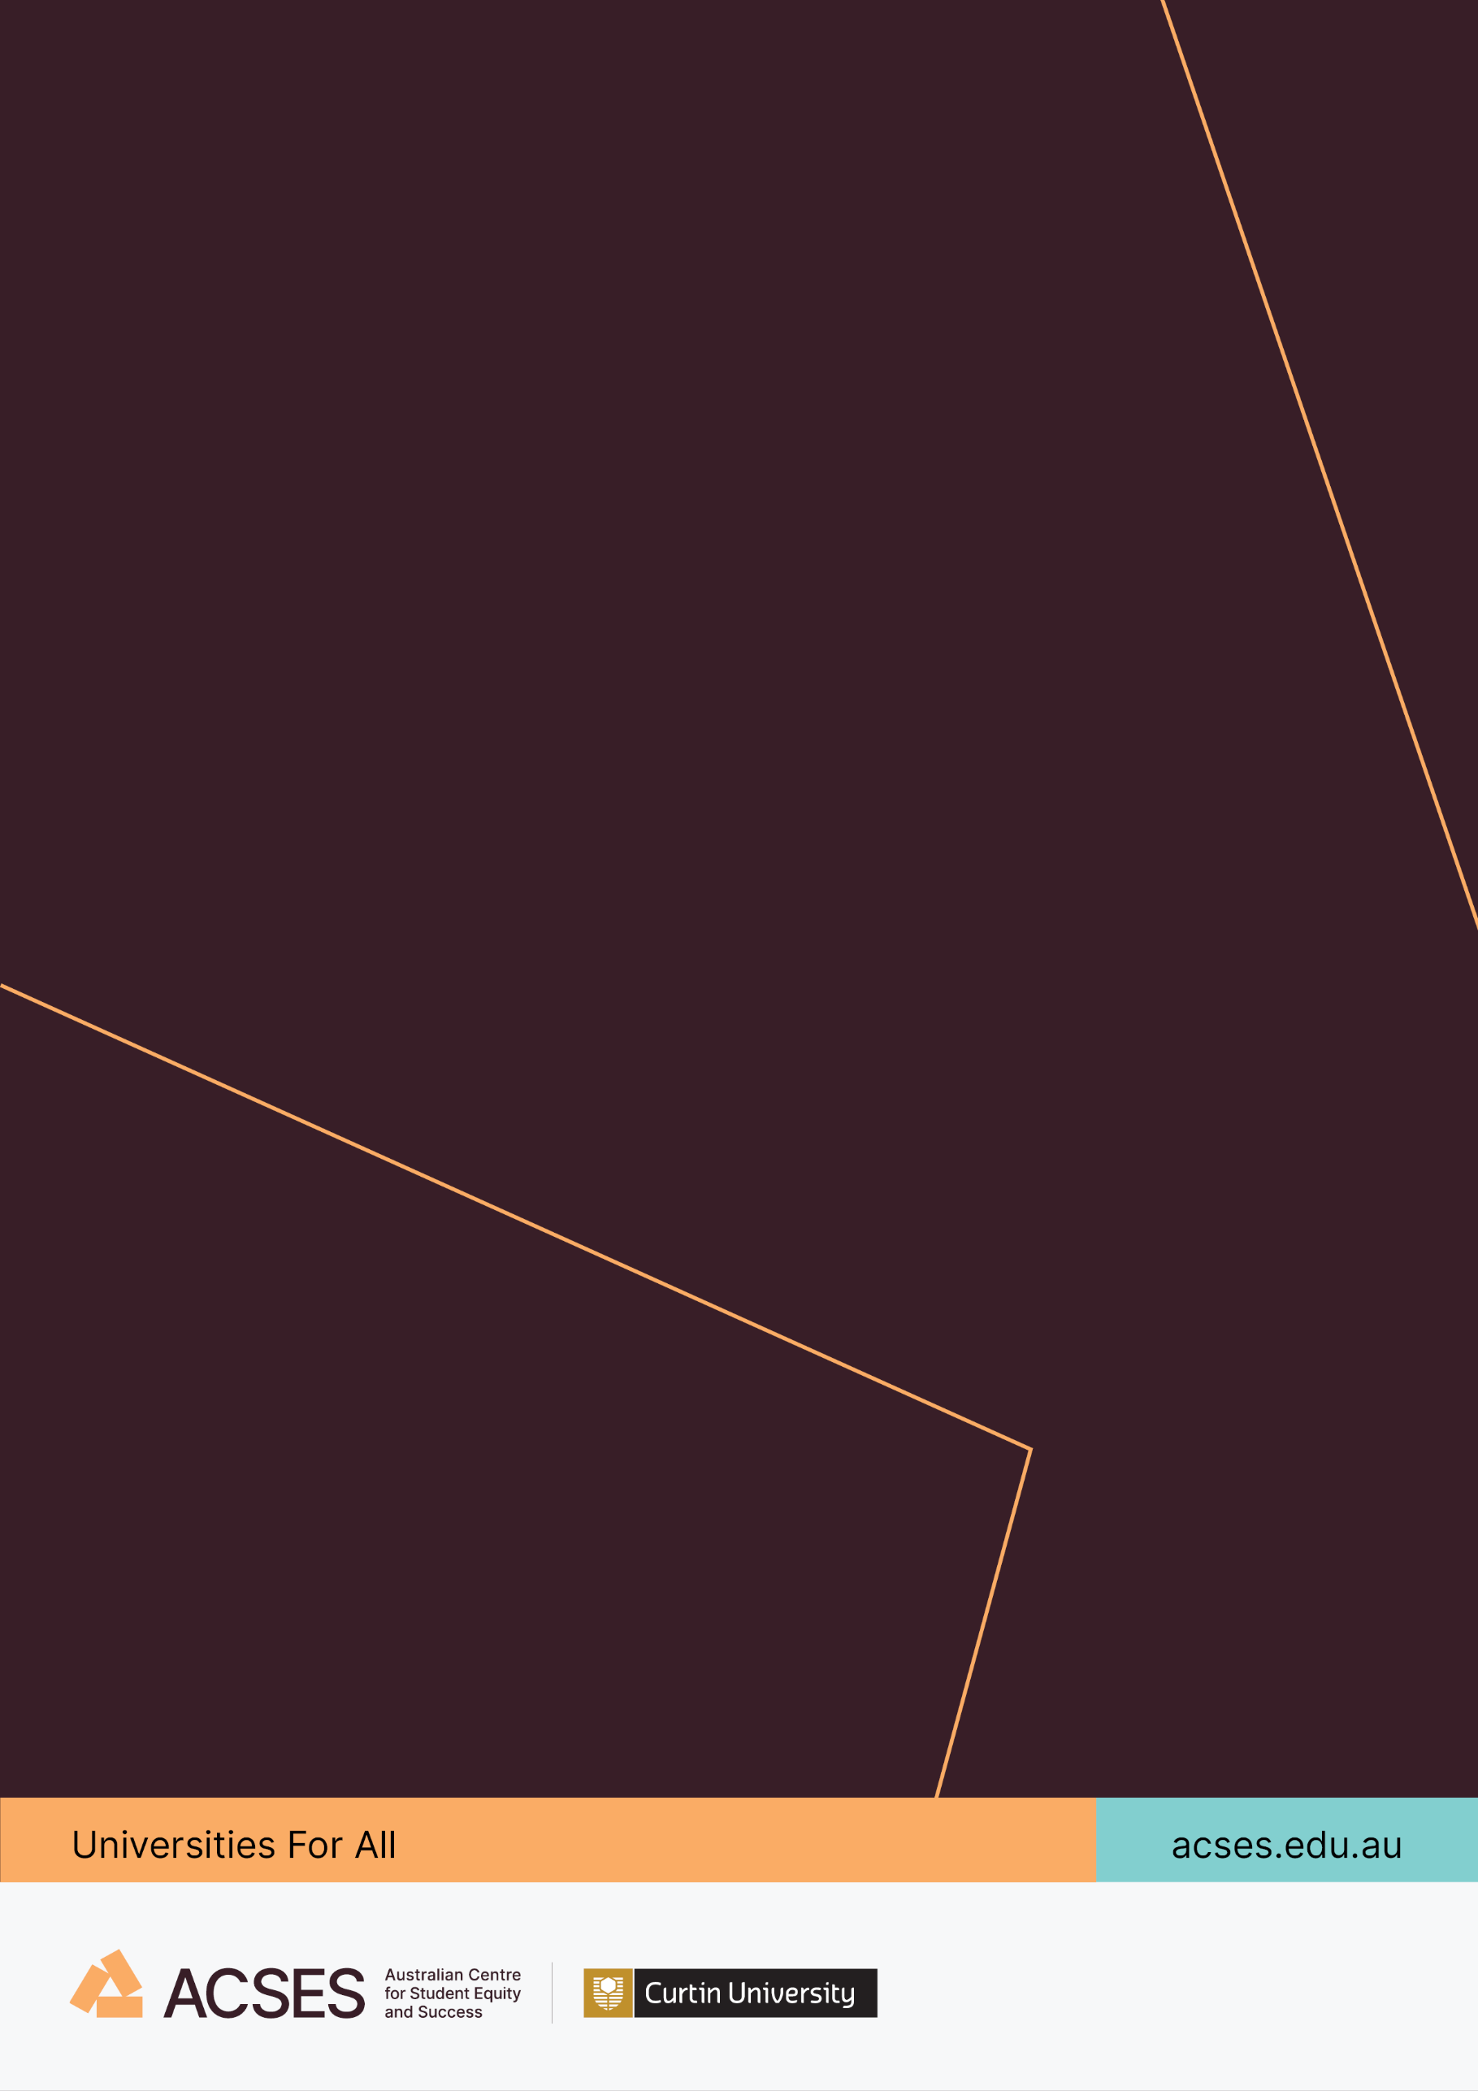
ACSES Awards for Innovation and Excellence in Impact on Higher Education Policy and Practice 2026
  - Application Pack

Acknowledgement of Country
The Australian Centre for Student Equity and Success (ACSES) acknowledges Indigenous peoples across Australia as the Traditional Owners of the lands on which the nation’s campuses are situated. With a history spanning more than 60,000 years as the original educators, Indigenous peoples hold a unique place in our nation. We recognise the importance of their knowledge and culture, and reflect the principles of participation, equity, and cultural respect in our work. We pay our respects to Elders past, present, and future, and consider it an honour to learn from our Indigenous colleagues, partners, and friends.

The 2026 ACSES Awards

Introduction
The ACSES Awards for Innovation and Excellence in Impact on Higher Education Policy and Practice 2026 will recognise teams or individuals who have made significant contributions in shaping policy and/or transforming practices in ways that drive positive outcomes in student equity in Australian higher education.
This year’s awards will honour up to five recipients, each excelling in different aspects of the award criteria. This approach acknowledges the wide-ranging and impactful work being undertaken across the sector, whether through innovation, advocacy, collaboration, or evidence-based practice.
This Awards celebrate those teams or individuals whose work has not only influenced decision-makers but has also led to tangible improvements in higher education outcomes for students from equity backgrounds. This work may span any stage of the student lifecycle, from pre-access and participation to university completion and post-graduation pathways.
Award recipients (or a nominated team member for team awards) will be supported by ACSES for their attendance at the 2026 Australian Student Equity Symposium in Brisbane, where they will be formally recognised for their contributions and presented with their awards.

Eligibility
Nominations are open to teams or individuals employed at a Table A or Table B provider or a University Study Hub.
Both self-nominations and third-party nominations are welcome.

Key Dates
Milestone | Date
Request for Proposals | Friday, 13 February 2026
Closing date for Proposals | Tuesday, 30 June 2026 – 4pm (AWST)
Assessment by ACSES Awards Judging Panel | July to August 2026
Awards Presentation: The 2026 Australian Student Equity Symposium (Brisbane) | September 2026

The Selection Process

Selection Criteria
Up to five recipients will be recognised for demonstrating excellence in one of the following criteria:
- Innovation and Originality
- The extent to which the nominee has introduced new ideas or approaches in their work on Australian higher education student equity and outcomes
- Creativity in addressing complex issues in Australian higher education student equity and in identifying unique solutions
- Impact and Effectiveness
- Demonstrated positive and measurable outcomes resulting from the nominee’s work on Australian higher education equity policy or practice
- Clear evidence of the lasting and sustainable impact on students from equity backgrounds
- Collaboration and Stakeholder Engagement
- Evidence of effective collaboration with key stakeholders, including institutional leaders, policymakers, practitioners, students, and communities
- Demonstration of the ability to build partnerships and foster support for policy change or practice transformation
- Advocacy and Leadership
- Strong leadership or advocacy for change in influencing decision-makers in policy or practice
- Evidence and Research-Based Approach
- Use of sound evidence, research, or data to inform decisions, policies, or practices
- Commitment to applying rigorous methods in assessing impact and outcomes
As evidence for both design and impact, applicants are requested to address at least three of these criteria in their applications.

Judging panel
The winners of the 2026 Awards will be determined by a judging panel consisting of:
- A senior higher education leader (Chair)
- A senior equity and/or First Nations higher education leader
- A representative from Equity Practitioners in Higher Education Australasia (EPHEA)
- An expert in higher education equity research and/or trials and evaluation
- The ACSES Executive Director

Applications
Applications should be completed using the template provided in Appendix A.
The main application should be between three (3) to five (5) A4 pages only, with up to four (4) A4 pages of supporting documentation, following the format outlined below, and in the specified order. Applications from teams can include one A4 page outlining the contributions of team members. Video presentations and related evidence should only be included in applications via links to publicly available platforms.
Applications should not exceed ten (10) A4 pages in total.
To assist applicants, redacted versions of applications to the 2025 ACSES Awards are available upon request to ACSES at the email address below.

Application format
Applications should follow the format outlined in the template, including:
- A synopsis of the nominee’s work, approach(es), methods and outcomes in Australian higher education student equity. The synopsis should be no more than 200 words. ACSES will draw on the synopsis in publicising the work of award winners.
- A statement addressing award criteria, including evidence supporting the claims being made. Nominees are encouraged to draw on quotes from students, colleagues and other stakeholders, as well as measurable and tangible outcomes. Please address award criterion in the order specified.
- A statement of team nomination (for team nominations only) outlining the contribution of each team member to the work described in the application. No more than one additional A4 page.
- Other supporting documentation of up to four (4) additional A4 pages. This can include commendation and impact statements in relation to outcomes from the activities undertaken. It is recommended that supporting documents be referenced to in the statement addressing award criteria.
- A reference list in APA 7 format. The reference list is not included in the page limit, but nominees should be judicious in their use of references.
All documents produced by the applicant must meet accessibility guidelines.
Teams are encouraged to include a link to a video presentation outlining the activities and impact of their initiative. The video should be hosted in a way that allows anyone with the link to view it (for example, an unlisted YouTube video). Please include the link in the written application and ensure it is easily accessible to the judging panel.

Submission
Submission Date: Tuesday, 30 June 2026 (4pm AWST)
Email: acses@curtin.edu.au (Subject: 2026 ACSES Awards)

Appendix A: Application Form

ACSES Awards for Innovation and Excellence in Impact on Policy and Practice 2026 – Application Form

Applications must follow the format presented below and be between three (3)-5 A4 pages, with an additional one (1) A4 page team statement (where applicable) which can be appended to the application. In addition, up to four (4) A4 pages of supporting documentation. A reference list can also be included, as required.
Applications should not exceed 10 A4 pages in total.
Applicant Details
Program Title
Lead Title (e.g., Prof, A/Prof, Dr, Mr, Mrs, Ms, etc)
Name
Position/Role
Organisational Unit
Institution
Email Address
Telephone Number
Nominator Details | Self-Nomination (Details as above) ☐  Low SES Background ☐
Third Party Nomination (Details below) ☐
Name:
Position/Role:
Institution:
Relationship to Applicant:
Email:
Phone:

(All responses must be in Arial 11)
- Synopsis
The synopsis should outline the applicant’s (nominee’s) work, approaches, methods, and outcomes in shaping student equity in Australian higher education. A final form of this will be used in publicising the work of award winners (Maximum 200 words)

- Statement of claim against at least three of the award criteria
Statements of claim are encouraged to cite evidence from the supporting documentation and include any links to video presentations in identifying measurable and tangible outcomes. Please address at least three award criteria (Maximum 2 to 3 pages)

- Statement of team nomination (teams only)
Statements of team nomination should outline the contribution of each member to the work specified in the application. (Maximum 1 page)

Team Member | Contribution

(Please add rows as required)

- Supporting documentation
Up to four (4) additional pages of supporting documentation can be included in the application. This can include commendation and impact statements. This material should be referenced in the Statement of Claim. (Maximum 4 pages)

- Reference list
The reference list should be APA 7 formant. It is not included in the page limit, but nominees should be judicious in their use of references. (Not included in the page limit)

