
  - EQUITY FELLOWSHIP REPORT

Is the problem us? Helping part-time students succeed in a full-time world

  - Kelly Linden, Charles Sturt University
2025 ACSES Equity Fellow
2026

Is the problem us? Helping part-time students succeed
in a full-time world

5 August 2026

Associate Professor Kelly Linden, Charles Sturt University

Suggested citation: Linden, K. (2026). Is the problem us? Helping part-time students succeed in a full-time world (Research Fellowship final report). Australian Centre for Student Equity and Success, Curtin University.

Australian Centre for Student Equity and Success
Tel: +61 8 9266 1573
Email: acses@curtin.edu.au
Web: www.acses.edu.au
Building 100
Curtin University
Kent St, Bentley, WA, 6102 | GPO Box U1987, Perth, WA, 6845

DISCLAIMER
Information in this publication is correct at the time of release but may be subject to change. This material does not purport to constitute legal or professional advice.
Curtin accepts no responsibility for and makes no representations, whether express or implied, as to the accuracy or reliability in any respect of any material in this publication. Except to the extent mandated otherwise by legislation, Curtin University does not accept responsibility for the consequences of any reliance which may be placed on this material by any person. Curtin will not be liable to you or to any other person for any loss or damage (including direct, consequential or economic loss or damage) however caused and whether by negligence or otherwise which may result directly or indirectly from the use of this publication.

COPYRIGHT
© Curtin University 2026
Except as permitted by the Copyright Act 1968, and unless otherwise stated, this material may not be reproduced, stored or transmitted without the permission of the copyright owner. All enquiries must be directed to Curtin University.
CRICOS Provider Code 00301J
ISBN 978-1-7648267-1-6

Acknowledgement of Country
The Australian Centre for Student Equity and Success acknowledges Indigenous peoples across Australia as the Traditional Owners of the lands on which the nation’s campuses are situated. With a history spanning more than 60,000 years as the original educators, Indigenous peoples hold a unique place in our nation. We recognise the importance of their knowledge and culture, and reflect the principles of participation, equity, and cultural respect in our work. We pay our respects to Elders past, present, and future, and consider it an honour to learn from our Indigenous colleagues, partners, and friends.

Acknowledgements
It has been an absolute privilege to be given an opportunity to fully immerse myself in a full-time 12-month Equity Fellowship, and for that I cannot thank ACSES enough. I have held academic roles at Charles Sturt University for over 18 years and with a high proportion of students studying part-time there, the plight of part-time students is something very close to my heart. It was wonderful over the past 12 months to meet so many people who care so deeply for student success and who were so supportive of the project. Specifically, I would like to thank Professor Ian Li for his support and enthusiasm; it has been a pleasure to work with you. I would also like to thank the ACSES Grants and Fellowships Committee for selecting my project and to express an enormous thank you to the chair, Professor Sally Kift, for her unwavering support and for enabling me to share regular updates through her Needed Now newsletter. Thank you also to Associate Professor Gemma Cadby for her many informative discussions on equity data. Not only did I learn an enormous amount about the nuances of different datasets but we also shared a lot of laughs (data should always be fun!).
I would also like to thank my “fellow Fellow”, Darlene McLennan. It was a stroke of luck that we have such complementary skills and the same sense of humour. Thank you for your friendship, for your kindness, and for helping me share my part-time survey far beyond the reach of what I could have dreamed. It was also a delight to meet the ACSES First Nations Fellows, Lauren Tynan and John Doolah—all the best with your Fellowships.
I was incredibly fortunate to have two mentors through my Fellowship, Distinguished Professor Sarah O’Shea and Dr Cathy Stone. Thank you both for sharing your wisdom and advice and for helping guide my Fellowship. I would also like to thank the members of the Expert Panel for helping guide the project and for the wonderful, thoughtful discussions.
I would like to thank the four Australian universities who shared de-identified student data that added a layer of richness to the analysis. I would also like to thank every staff member who shared my survey and the students who completed the survey or attended an interview. I was overwhelmed by your enthusiasm and generosity to share your stories. I have listened and will continue to advocate for you.
Finally, this research would not have been possible without the collaboration and friendship from colleagues at Charles Sturt University. There are too many people to list; however, if I spoke to you in 2025 about part-time students, you helped me in some way—thank you. I would like to specifically thank Dr Sarah Teakel for her enthusiastic collaboration throughout the project, particularly with interviews, thematic analysis, and the literature review. It would have been impossible to do it all on my own, and the project has benefited immensely for being able to bounce ideas off you and debate the merits of one theme over another! I would also like to thank Associate Professor Rachel Whitsed, the data guru. It was so great to have someone to bounce data ideas off with such a unique and amazing dataset and who had the experience to take the lead in the regression modelling. We have so many ideas now for future analysis! Finally, I would like to thank Mr Neil Van der Ploeg and Dr Noelia Roman. We have written many internal reports together and your insightful feedback on my draft Fellowship report was incredibly helpful—thank you. I have not in any way used artificial intelligence in the ideation, design, or write-up of this research.

Table of contents
Acknowledgement of Country iii
Acknowledgements iv
Table of contents v
List of tables vi
List of figures vii
Abbreviations ix
1. Executive summary 1
2. Recommendations 2
3. Introduction 3
3.1 Structure of this report 4
4. Background 5
4.1 Part-time study 5
4.2 Widening participation 5
4.2.1 Scholarships 8
4.2.2 Universal Design for Learning 9
4.2.3 Special consideration and assessment extensions 10
5. Methods 12
5.1 Project aims 12
5.1.1 Expert reference group 12
5.2 Ethics 12
5.3 Data characteristics 13
5.3.1 Calculating student study load 13
5.3.2 Student success 13
5.3.3 Student retention and attrition 13
5.3.4 Sociodemographic characteristics 13
5.3.5 Sector data 14
5.3.6 Institutional data 14
5.4 Survey and interview participants 16
5.5 Data analysis 17
6. Findings 18
6.1 Overview of sector data and institutional data 18
6.1.1 Summary 18
6.1.2 Participation 18
6.1.3 Load 22
6.1.4 Success 22
6.1.5 Retention 24
6.1.6 Completions 25
6.1.7 Generalised linear models 25
6.1.8 Learning management system access 32
6.2 Overview of survey and interview findings 32
6.2.1 Summary 32
6.2.2 Participants 33
6.2.3 Study mode 34
6.2.4 Why do students study part-time? 36
6.2.5 Challenges 37
6.2.6 Commitments 38
6.2.7 Success 40
6.2.8 Unit design considerations 41
6.2.9 Compulsory classes 43
6.3 Case Study 1: Simple extensions 49
6.4 Case Study 2: Scholarships 53
6.5 Case Study 3: Consequences of failing 58
6.6 Case Study 4: Enrolment patterns 64
7. Discussion 68
8. Conclusion 73
9. References 74

List of tables
Table 1: Three regression models and the total student/semester enrolments in 2022 and 2024 from each university 16
Table 2: Australian universities with the highest proportion of students studying part-time in 2024 19
Table 3: Proportion of part-time students enrolled in 2022 and 2023 at each of the four universities 20
Table 4: Model 1: Unadjusted and adjusted passing and relative retention rates (expressed as a %) and differences between priority groups and the reference variable (bold) for undergraduate internal students from the four universities 27
Table 5: Model 2: Unadjusted and adjusted passing and relative retention rates (expressed as a %) and differences between priority groups and the reference variable (bold) for undergraduate online students from the four universities 29
Table 6: Model 3: Unadjusted and adjusted passing and relative retention rates (expressed as a %) and differences between priority groups and the reference variable (bold) for postgraduate students from the four universities 31
Table 7: Self-reported demographics of survey participants and the 2024 sector average 34
Table 8: Relative retention and success of undergraduate students from one Australian university in 2024, with and without a scholarship 56
Table 9: Percentage point increase in relative retention and success for undergraduate students with a scholarship from one Australian university 57

List of figures
Figure 1: Proportion of part-time domestic students studying at Australian universities in 2024 by student group 21
Figure 2: Proportion of part-time domestic students studying at Australian universities in 2024 by equity group count 21
Figure 3: Domestic commencing undergraduate students in 2024 by (A) ATAR range and (B) basis of admission 22
Figure 4: Success rate of part-time versus full-time domestic students by student group: (A) sector data in 2024; (B) one of the four institutions in 2022 and 2023 23
Figure 5: (A) Equity count participation and (B) success for domestic students enrolled in the four Australian institutions in 2022 and 2023 24
Figure 6: Commencing undergraduate students enrolled in the four Australian universities in 2022 and 2023 showing the proportion of (A) participation, (B) success by ATAR range, (C) participation, and (D) success by basis of admission to university 24
Figure 7: (A) First-year retention rate of domestic students studying at Australian universities in 2023 (retained in 2024) by student group and (B) relative retention rate of domestic students enrolled in the four Australian institutions in 2022 and 2023 25
Figure 8: (A) Average number times that full-time and part-time students enrolled in University 2 accessed the LMS; (B) percentage of part-time students who accessed the LMS in each week of semester, by semester result 32
Figure 9: Responses to the survey question “Do you attend classes or activities on campus?” (A) 72% of participants were studying mostly online and (B) 28% of participants were studying mostly on campus 35
Figure 10: Responses to the survey question, “What influenced your decision to study part-time?” 36
Figure 11: Responses to the survey question, “What are the main challenges in studying part-time?” 38
Figure 12: Responses to the survey question, “During semester, what is the average number of hours of work that you undertake in a week?” 39
Figure 13: Survey responses to the question, “Do you have personal caring responsibilities?” 40
Figure 14: Responses to the survey question, “How important are each of the following in the design of your units?” using a 5-point Likert scale 42
Figure 15: Survey responses to the questions (A) “Regarding your work-integrated learning placements, which of the following were available” and (B) “Were there any barriers that prevented you from attending a WIL placement?” 44
Figure 16: Survey responses to (A) “Regarding your compulsory on-campus classes or intensive schools, which of the following were available” and (B) “Were there any barriers that prevented you from attending compulsory on-campus classes or experiences?” 45
Figure 17: Survey responses to (A) “Regarding your compulsory online classes or exams, which of the following were available” and (B) “Were there any barriers that prevented you from attending compulsory online classes or exams?” 47
Figure 18: Survey responses from one Australian university to (A) “What are the reasons that you took an automatic seven-day extension?” and (B) “Overall, how satisfied are you with the automatic seven-day extension?” 52
Figure 19: Student use of the no-questions-asked, seven-day extension from one Australian university in 2023 and 2024: (A) number of days before the due date extensions were submitted and (B) value of assessment item 52
Figure 20: Survey responses to the question, “Have you applied for a scholarship to support your study?” 54
Figure 21: (A) Survey responses to the question, “What were the circumstances around your failing grades?”; (B) Selected adjectives responding to the question, “How did receiving failing grades make you feel?” 60
Figure 22: Survey responses to the question, “To what extent were these circumstances within your control?” 60
Figure 23: Sanky diagram tracing the flow of results of commencing students across the first year 61
Figure 24: All domestic students from three Australian universities with one or more failing grades in any trimester. “Some fails” indicates that students received at least one but not all failing grades in a semester 62
Figure 25: Proportion of failing grades in each submission category from one Australian university 63
Figure 26: Semester unit load, success rate, and the proportion of students enrolled in the four Australian institutions in 2022 and 2023: (A) enrolled in Semester 1 and (B) enrolled in the summer term 66
Figure 27: Toxic unit combinations: (A) two-unit “toxic” combinations and success rate for all combinations of Unit 1 and all combinations of Unit 2, and (B) average success rate of toxic unit combinations and average success rate of all possible enrolment combinations of Unit 1 and Unit 2 67

Abbreviations
ADCET Australian Disability Clearinghouse on Education and Training
ARIA+ Accessibility and remoteness index of Australia
ATAR Australian Tertiary Admission Rank
EAP Education access plan
EFTSL Equivalent full-time student load
HDR Higher Degree by Research (research Masters or research Doctorate)
LMS Learning management system
PhD Doctor of Philosophy
QILT Quality Indicators for Learning and Teaching
RRR Rural, regional, and remote
RUN Regional University Network
SA1 Statistical Area 1
SES Socio-economic status
TCSI Tertiary Collection of Student Information
UA Universities Australia
UDL Universal Design for Learning
VET Vocational education and training
WIL Work-integrated learning, also known as pracs or clinical placements

Executive summary
This Fellowship report highlights the extent to which part-time students, who make up 35% of all domestic Australian university students, are juggling competing responsibilities, such as caring and work commitments. This report includes analysis of 2024 sector data, detailed student-level data from domestic students enrolled in 2022 and 2023 at four Australian universities, interview responses from 965 part-time students from 35 Australian universities, and 80 follow-up semi-structured interviews. This report highlights that part-time students on average have lower rates of success and retention, and are more likely to belong to an equity group than full-time students. The students who participated in the research demonstrated that although they were incredibly dedicated to their studies, university cannot always be their number one priority. In many instances, students require flexibility and support to succeed:
“They don’t care what you have had to juggle just to turn up to class, and that’s the tricky thing with part-time study … We are treated like we are less committed, when it’s the opposite, we are on average a lot more committed.”
Australian universities are designed for students who no longer make up the majority. The Australian Universities Accord set the ambitious target of tertiary attainment of 80% of the working age population by 2050. To meet this need, the Accord acknowledged that the higher education system needs to be more equitable, and this report provides evidence-based recommendations that should be adopted to achieve this.
Universities should review workload policies to ensure that academics have adequate time for quality learning and teaching. Special consideration policies should be reviewed to meet the needs of modern students, with work and caring commitments listed as acceptable reasons, and all students should have access to no-questions-asked extensions. Maximum-time-to-complete policies should allow sufficient time for a part-time student to complete their degree at the lowest rate the university allows students to enrol (for example, one unit per semester). Student load policies should be simplified so that any student studying 0.75 equivalent full-time study load (EFTSL) across a calendar year has the benefits of a full-time student. In addition, more clarity should be provided at admission regarding compulsory activities and timetabling.
State governments should provide discounted public transport for all students studying on campus. States provide free public transport to the football; yet, part-time, on-campus students pay full fare to travel to university, and this is inequitable.
The federal government should provide access to Youth Allowance, Austudy and Tertiary Access Payments to part-time students, and scholarships and PhD stipends should be tax exempt. This aligns with Recommendations 15 and 26 of the Universities Accord.
It is time to start designing our universities for the new normal.

Recommendations
University workload policies should provide adequate time and resourcing for:
Recommendation 1: Quality learning and teaching, including academic workload for:
- academics to connect, engage, and empathise with students
- high-quality units with consistent layout and clear expectations
- learning content to be released early
- all classes to be recorded
- opportunity to connect with peers.
Universities leaders should ensure that policies and procedures address:
Recommendation 2: Student load policy. Any student studying 0.75 EFTSL or higher across a calendar year should have access to the benefits of a full-time student.
Recommendation 3: Equity in work-integrated learning (WIL) placements. Part-time students should be able to complete part-time placements, and students with industry experience should receive fair recognition of prior learning.
Recommendation 4: Minimising compulsory activities. Information on compulsory classes and timetabling should also be more transparent at enrolment.
Recommendation 5: Access to no-questions-asked extensions. Special consideration policies should also be revised to allow work and caring responsibilities as reasons to apply, and disability access plans should provide access to automatic extensions.
Recommendation 6: Equitable access to scholarships. Many part-time students are under considerable financial constraints and should have access to university scholarships.
Recommendation 7: Promotion of success. Resubmissions should be allowed for near-miss fails, and failing students should be the last resort.
Recommendation 8: Part-time study patterns. Students require clear advice around study patterns, and maximum-time-to-complete policies should be reviewed to ensure that they are equitable for part-time students.
Recommendation 9: Shared campus facilities. Having a reciprocal study space agreement between universities could benefit many students.
State governments should legislate changes to allow:
Recommendation 10: Public transport discounts. These should be based on mode, not load. States provide free public transport to the football; yet, part-time, on-campus students pay full fare to travel to university, and this is inequitable.
Federal government should legislate changes to allow:
Recommendation 11: Access to government financial support. Part-time students should qualify for Youth Allowance, Austudy, and Tertiary Access Payments.
Recommendation 12: Tax-free scholarships. Part-time students pay tax on scholarships and PhD stipends, whereas full-time students do not. This is not equitable.

Introduction
In response to the Australian Universities Accord (the Accord), a comprehensive 12-month review of Australia’s higher education system, the Australian Government adopted an ambitious target to significantly increase participation in tertiary education. Along with a number of other targets, this includes lifting the tertiary attainment rate of the working age population from 60% to 80% by 2050 (O’Kane et al., 2024). The Accord acknowledges that to meet this target, the higher education system needs to be more equitable. Thus, it recommends that by 2025 university enrolments for several currently underrepresented groups reach population parity, and interim targets by 2035. These priority equity groups include First Nations Australians, people from low socio-economic status (SES) backgrounds, people with disability, and people from rural, regional, and remote (RRR) communities. Currently, participation, success, retention, and completions for students from these groups is below the rates of their more advantaged peers. To address this, a new model of needs-based funding has been proposed to provide funding to universities to support low SES and First Nations Australian students to succeed (O’Kane et al., 2024). While many of the details of needs-based funding are not yet available, one important element that has been clarified is funding for commencing students will be based on headcount, ensuring funding for part-time enrolments (Norton, 2026). This report provides evidence that one way to support the ambitious targets of the Accord is for universities and the government to prioritise a growing cohort that intersects with all the priority groups: students who study part-time.
Traditionally, university students have studied full-time and, therefore, university processes, support, and government funding are skewed towards supporting full-time students. It is therefore not surprising that studying part-time is one of the leading predictors of failure and attrition, and is one of the longest-running and consistently vexing challenges in higher education. Part-time study is defined as less than 0.75 EFTSL, and the most common study load is four units a year (Norton et al., 2018). From 2019 to 2022, part-time students were more than twice as likely to drop out of university than full-time students (O’Kane et al., 2024). A comprehensive report found that part-time study is the single biggest risk for non-completing across Australian universities, largely because most part-time students have other major responsibilities at home and at work (Norton et al., 2018). More recently, analysis on all Australian university students enrolled between 2011 and 2018 indicates that after adjusting for other factors, studying part-time is the biggest risk factor for taking leave (Harvey et al., 2025). Data from the 2022 Quality Indicators for Learning and Teaching (QILT) survey suggest that part-time student enrolment is primarily to accommodate other life circumstances, and students who consider dropping out do so because of paid work and family responsibilities (O’Kane et al., 2024). It is important that universities adapt to better support part-time students because the proportion of Australian students studying part-time is increasing. In 2022, 34 of Australia’s 38 publicly funded universities reported a reduction in EFTSL per student. Part-time students are also more likely to be from an equity group, and part-time study intersects with multiple underrepresented groups (O’Kane et al., 2024). Currently, university processes, support, and government funding is skewed towards supporting full-time students. There are, however, changes that could have a significant impact on the success and completions of part-time students.
As it stands, most government financial support is limited to full-time students, and part-time students generally have very limited financial assistance available. Youth Allowance (under 25 years) and Austudy (25 years and over) are restricted to full-time students and are valued at approximately $48 per day for students living away from home without children. The Tertiary Access Payment, a one-off payment of between $3,000 and $5,000, is available for full-time students aged under 22 years who are moving away from a regional or rural area to study full-time. However, ABSTUDY is available to both part-time and full-time Aboriginal and Torres Strait Islander students (Services Australia, 2026a). Part-time students who enrol to study on campus are not eligible for public transport discounts. The Accord recommended that the government extend pro-rata support to all students who study part-time with an EFTSL of 0.5 to 0.74, which is equivalent to studying four or five units a year (Recommendation 15; O’Kane et al., 2024). This has the potential to have a meaningful impact on part-time students.
Looking beyond finances, the requirements of part-time students in some courses are prohibitive. For example, a student may have a WIL placement, compulsory on-campus intensive schools, and exams (requiring availability for the entire exam period) in one year. This compulsory attendance can quickly drain annual leave allowances. There are certain criteria for special consideration, such as being in the military; however, no specific consideration is given to students who are enrolled part-time and are busy juggling other commitments. These challenges drive part-time students to unenroll from units, which increases the chance of taking leave from study (Harvey et al., 2025), dropping out of university, and reaching the maximum course duration (Cherastidtham et al., 2018; Norton et al., 2018). The current maximum time for course completion used widely across the sector is the formula, twice the full-time standard degree length plus one or two years (Norton et al., 2018). This formula has no consideration of study load. For a student enrolled part-time in a one-year masters course, they must pass a minimum of two units per year with no leave of absence to complete in time, assuming that the student is passing. We need to rethink our policies and design our universities for students who are enrolling in university today.

Structure of this report
This report provides background literature, followed by evidence-based recommendations on how universities and the government can better support part-time students. The report then details the mixed method approach used, including analysis of sector data; detailed de-identified enrolment, demographic, success, and engagement information of students enrolled in four Australian universities; a national survey completed by 965 part-time students from 35 Australian universities; and 80 follow-up semi-structured interviews. The findings upon which 12 recommendations are based are then presented and discussed, some as short case studies, followed by a conclusion.

Background

Part-time study
It is widely understood that traditional university education was developed for young school leavers enrolled to study full-time. There is an expectation that university will be their top priority, and they will be available for on-campus activities. Most institutions are designed to support these students from the ground up, from recruitment to the availability of the support offered by student services, and to policies and procedures. However, there is a worldwide trend in which university students are diversifying. Many university students are studying part-time, are older, are employed, and have significant caring responsibilities, and they now serve as the “new majority” (Malm & Weber, 2017; Younger et al., 2019). Despite the increase in the number of students studying part-time, there has been surprisingly little research into how universities can support part-time students. An analysis of all university students enrolled in the United States in 1997 found that the number of hours of weekly paid employment did not affect the grades of part-time students, indicating that there are other factors at play (Darolia, 2014). Students highlight the challenge of balancing part-time study with other responsibilities, the difficulty of accessing university support, and a lack of belonging (Gardner & Gopaul, 2012; Kember, 1999). One Australian study reported that although part-time research students have been acknowledged as “invisible”, over a five-year period, part-time PhD students completed their degrees faster than full-time students in equivalent terms, highlighting the need for universities to be more welcoming to part-time higher degree by research (HDR) students (Neumann & Rodwell, 2009). Students who study part-time are more likely to be from an equity group, and part-time study intersects with multiple underrepresented groups (O’Kane et al., 2024). If Australia is to meet the ambitious target of 80% university attainment by 2050, and reach population parity across equity students, it is urgent that universities better support part-time students.

Widening participation
More recently, much of the research on the “new majority” of students has focused on those studying online. Online learning has been critical to widening participation for students from non-traditional backgrounds. This is particularly the case for students who are older and have other responsibilities, such as work and family, that would have otherwise prevented them from enrolling in university (Stone, 2017). Many students choose to study online because of the flexibility that is offered, allowing students to combine their studies with other responsibilities, and many online students enrol to study part-time. This can be particularly important for RRR students who do not live near campus (Stone, 2019). Both retention and completion rates for students studying online are considerably lower than those for students enrolled on campus (Stone, 2017). One explanation for this is that the subculture of university expectations and rules may not always be clear to online students and, therefore, needs to be built into learning, teaching, and support strategies (Moore & Greenland, 2017). Other reasons for the disparity in levels of success are a lack of time because of competing commitments (Ilgaz & Gülbahar, 2015), poor-quality course materials and delivery (Devlin & McKay, 2016), and a lack of access and responsiveness of online teachers (Vincenzes & Drew, 2018).
Of the four government priority groups, Australian First Nations people, people from low SES backgrounds, and people in RRR areas constitute a lower proportion of students in higher education than in the Australian population. Students from these groups are also more likely to study part-time (O’Kane et al., 2024). A recent report identified that the low proportion of Indigenous secondary school teachers must be addressed to reach educational population parity. The report found that there is a critical need to attract Aboriginal and Torres Strait Islander peoples to study teacher education at university. They will then be role models to share stories of their success with Indigenous students (Woodroffe, 2025).
There is much evidence worldwide to show that socio-economic characteristics affect university participation and attainment. In the United Kingdom, the average success rate is 20% lower for university students from low-income backgrounds (Baines et al., 2024). Low-income students in the United States are less likely to enrol and less likely to graduate than their high-income peers (Ruiz Alvarado et al., 2020). In Australia, the evidence is less clear because there are many issues related to how students are assigned as “low SES”, such as the fact that low SES status is derived from an aggregation of an area then applied to an individual. The calculation does not directly measure family income and applies if an address is in an area in the lowest quartile of the Socio-economic Indexes for Areas—Index of Employment and Occupation. The indicators used in the calculation include average measures of employment, occupation, and education across a geographical area. In contrast to the definitions used in the United States and United Kingdom, there are no direct indicators related to wealth (Australian Bureau of Statistics, 2021; Department of Education, 2026). A government-funded review of Australian equity groups reported the need to incorporate a student-level socio-economic disadvantage measure based on factors that are strongly associated with disadvantage in higher education (Tomaszewski et al., 2018). To date, this has not occurred.
Students who are the First-in-Family to study at university are also often included as a non-traditional, or equity adjacent, group. It is thought that much of the educational disadvantage comes from being “first” (Patfield et al., 2022). A recent report highlighted that participation of First-in-Family students is 23 percentage points lower when adjusted for other factors than those with university-educated parents (Zając et al., 2025). Students who are First-in-Family can have a sense of bewilderment when navigating complicated university systems at the beginning of a course (O’Shea et al., 2024). They may also be less prepared to enter higher education because of a lack of social and family capital; therefore, there are calls for this group to be integrated into an expanded equity framework (O’Kane et al., 2024; Patfield et al., 2022). In Australia, there is a large overlap between students who are low SES and those who are First-in-Family (Patfield et al., 2022; Zając et al., 2025). In this report, wherever possible, analysis to investigate part-time First-in-Family student success was conducted.
Because of issues with data collection and reporting, it is difficult to estimate whether parity of participation in higher education has been achieved for students with disability. However, it is known that students with disability are at higher risk of attrition and have lower rates of success and completion (O’Kane et al., 2024), largely because of unexpected interruptions to study associated with disability. Students with disability can also face additional academic challenges related to executive skills, concentration, and time management (Grimes et al., 2021; Hakala et al., 2026). Universities generally adopt a medical model, which requires students with disability to register and provide medical evidence. Students are then eligible for a disability access plan, a formal agreement to ensure that agreed-upon reasonable adjustments can be communicated to academic staff. Reasonable adjustments are personalised and generally support assessments. Depending on the institution, disability access plans may be submitted as the evidence required for formal extensions or to provide students with access to automatic extensions or altered exam conditions (Pitman et al., 2022). When students are provided with reasonable adjustments, they report a positive impact on academic performance (Baker et al., 2022). However, for students with disability who do not receive reasonable adjustments, either because they do not wish to disclose their disability, or cannot because of a lack of medical documentation, there is limited access to disability support (Dollinger et al., 2024). Students have reported negative attitudes among academic staff, including opinions that some disabilities are not “real” (Hamilton et al., 2023). The process can be stressful, particularly for students with a condition of a personal nature, and there can be a stigma associated with disability (Edwards et al., 2022). When students disclose a disability and share their disability access plan, they are not guaranteed support, despite this contravening federal anti-discrimination laws. Academic staff who lack resources or willingness to implement those adjustments create additional barriers for students to overcome (Harpur et al., 2025).
The Accord has highlighted priority groups for participation and success; however, we know that barriers to education are generally not single or isolated. Intersectionality theory conceptualises compounding disadvantage because of membership of multiple groups. This was first reported by Kimberlé Crenshaw, who proposed that inequality cannot be fully understood by treating class, gender, and race as discrete social categories (Crenshaw, 1989). An extensive 2019 report found that intersectionality theory can also apply to an educational setting when counting the number of equity groups of which a student is a member (Tomaszewski et al., 2020). The report found that students who were members of two or more equity groups comprised approximately 10% of Australian university students, and that cumulative disadvantage was associated with poorer educational outcomes throughout the student lifecycle (Tomaszewski et al., 2020). When considering access to university, 68% of secondary school students with no equity factors reported that they expected to complete university, compared with only 21% of students with three equity factors. Similarly, 72% of undergraduate student with no equity factors graduated university within eight years, compared with only 48% of undergraduate students with three equity factors (Tomaszewski et al., 2020). In addition to the simple addition of equity factors, the report identified three categories of disadvantage that stood out as requiring targeted interventions and improved support from universities because of low completion rates. They were students who are low SES and RRR (with no other equity factors), Australian First Nations students with another equity factor, and students with a disability and one other equity factor but who are not an Australian First Nations student (Tomaszewski et al., 2020). While the report identified 10% of all university students across the sector as being a member of two or more equity groups, this can be much higher at individual universities. At a regional Australian university in 2022, 50% of commencing undergraduate students were members of two or more equity groups. Disengaged students were identified in the first four weeks of semester because of non-submission of assessment items or inactivity in the learning management system (LMS). Those students with two or more equity factors were more likely to accept a phone call and discuss support options with the student outreach team, which resulted in higher retention rates than for students with one or no equity factors (Linden et al., 2023). At the same university, approximately 50% of commencing undergraduate students were provided with access to a discipline-specific tutor for one-on-one assessment support in the two weeks leading up to the due date. The success rate of students with no equity factors who chose not to meet with a tutor was 73%, increasing by 22% for those who met with a tutor. This changed dramatically for students with three equity factors, whose average success rate without a tutor was 68%; however, if the student met with a tutor, the success rate increased by 26% to be on par with students with no equity factors (Teakel, Linden, van der Ploeg & Roman, 2024). These interventions provide evidence that support targeted to non-demographic factors, such as assessment non-submission, and booking a tutor appointment can preferentially support equity students.
We know that part-time students have major responsibilities at home and that students who consider dropping out do so because of paid work and family responsibilities (Norton et al., 2018; O’Kane et al., 2024). The remainder of this section focuses on how universities could adapt to better support part-time student success.

Scholarships
Financial pressures increasingly impact university students, negatively affecting students’ mental health and academic success (Russell et al., 2025). Rising living costs have intensified the financial stress, although the burden is not evenly distributed. Students from low socio-economic backgrounds are particularly vulnerable, because financial stress and the need to work substantial hours can hinder both access to and success within higher education. Concerns about accruing student debt further discourage university participation. Scholarships are frequently presented as an approach to reduce inequality and improve student retention (Naim, 2025). However, barriers—such as limited awareness, restrictive eligibility criteria, and the requirement to evidence financial hardship—limit access for many students who are also experiencing financial stress (Harris et al., 2026). Evidence suggests that scholarships can alleviate financial stress and support retention, particularly for students from non‑traditional backgrounds (Zacharias & Ryan, 2021). Recent comparative studies indicate that scholarship recipients show higher rates of university access and academic success (Berlanga et al., 2022; Reed & Hurd, 2016). However, disparities exist for non‑recipients, highlighting limitations within current funding systems. Scholarships are generally oriented towards full-time students. A detailed search reveals that many universities in Australia have almost no scholarships available for part-time students, and when part-time students do receive scholarships, they are taxed. The Accord emphasises expanding equity scholarships and improving methods for identifying students with the greatest need, recognising that financial aid alone cannot address broader non‑financial barriers to participation (O’Kane et al., 2024). A recommendation of the Acord is to make part-time PhD scholarships tax-free (Recommendation 26; O’Kane et al., 2024). Increasing scholarship availability will have a meaningful impact on some part-time students, whereas for others, it is more important that structural barriers to learning are removed.

Universal Design for Learning
It has been suggested that universities should become more inclusive to support the success of all students. Almost 20 years ago, Sally Kift’s transition pedagogy framework was developed to ensure that as students transition into university, the first-year experience brings together a seamless experience across the entire institution (Kift & Nelson, 2005). Kift proposed that to see meaningful improvements in student retention, initiatives should be curriculum-centred, promote diversity, and include a whole-of-institution approach (Kift & Nelson, 2005). There are several synergistic frameworks that align with transition pedagogy principles that were not part of Kift’s first articulation, for example, employing principles of Universal Design for Learning (UDL), an educational framework developed to encourage a more inclusive teaching environment (Rogers-Shaw et al., 2018). Many barriers that students encounter at university stem not from their personal circumstances but from institutional structures that create unnecessary complexity. The hidden curriculum, encompassing unclear processes and communication, can particularly disadvantage students with diverse life situations, including part‑time learners (Orón Semper & Blasco, 2018). UDL promotes flexible, inclusive learning environments through diverse representation, multiple means of expression, and varied opportunities for engagement (CAST, 2024). Its growing adoption in higher education reflects a sector‑wide shift towards embedding inclusivity into routine teaching practices (Timuș et al., 2024). Studies indicate that relatively simple unit‑level adjustments, such as providing early access to materials (Accardo et al., 2019) and offering lecture recordings (Anderson et al., 2020), can meaningfully support students. In addition, a pedagogy of kindness can further enhance inclusivity (Teakel, Linden & Clatworthy, 2024). Kindness considers students feelings, experiences, and situations and demonstrates acceptance, as well as including more traditional acts of kindness. Student-centred learning should “meet students where they are” while showing empathy, care, and compassion (Teakel, Linden & Clatworthy, 2024).
We have previously shown that by introducing consistent unit guidelines based on the principles of UDL, promoting flexibility, clarity, and consistency to seven large first-year units, the average success rate of the units increased by 27% (Linden et al., 2025). The number of zero-fail grades was halved, and the number of high distinction grades almost doubled. Importantly, students with two equity factors benefited more than those with none or one (Linden et al., 2025). UDL has been shown to benefit students with disability, who reported that having multiple formats for demonstrating learning reduces anxiety and enhances motivation (Edwards et al., 2022). Although there is no research specific to UDL and part‑time students, experiences of being time poor and balancing competing responsibilities align with those of students with disability. This overlap suggests that UDL may reduce cognitive and administrative burdens, increase flexibility, and enhance clarity for all students. Despite its benefits, UDL implementation remains inconsistent, because adoption in higher education is largely voluntary. Challenges include limited time, resources, and staff awareness, and institutional barriers frequently hinder uptake (Duncan et al., 2025). The literature has emphasised growing demand for professional development on UDL and equity policy, and evidence shows that staff training can reduce stigma and improve inclusive teaching (Waisman et al., 2023). One simple yet practical and high-impact approach to increase flexibility is to provide simple assessment extensions.

Special consideration and assessment extensions
It has been suggested that the outcomes of equity students may improve with increased flexibility to support their circumstances (Ajjawi et al., 2025). One important way that universities could approach this is through assessment flexibility. Success in assessment not only is critical to progress through a degree but also provides a student with confidence about their capability for university study (Dargusch et al., 2026; Nieminen, 2024; Vanderburg et al., 2023). Passing assessments is also critical for passing units, which is important for retention into the following year of study (Ajjawi et al., 2020; Li & Carroll, 2020; van der Ploeg et al., 2024). Assessment success requires having resources available to be successful, including access to instructions and learning resources. However, one important resource that is inequitably distributed among students and is not always considered is time (Burke et al., 2017; Dargusch et al., 2026).
Students who conform to traditional university time, such as by meeting assessment deadlines and class attendance, are generally considered to have the ability and commitment required for success at university, whereas those who have difficulty conforming are misrecognised as lacking capability, being disorganised, or being uncommitted (Bennett & Burke, 2018; Lucey & Grydaki, 2023). Solutions offered by universities commonly involve resources or short courses on time-management skills (Dargusch et al., 2026). These entrenched perceptions around commitment do not consider circumstances outside of a student’s control. We know that many part-time students juggle competing responsibilities, such as employment and caring, and do not have the same time to dedicate to study as their full-time peers (Norton et al., 2018; O’Kane et al., 2024). A recent report on assessment practices in Australian universities found that instead of the onus being on the student to find time to meet assessment requirements, universities should take responsibility and develop more inclusive approaches to support diverse student groups (Dargusch et al., 2026).
Most assessment policies currently have formal special consideration provisions to request extensions. They generally require documented evidence that can be difficult to obtain and are not always accommodating to paid employment or caring responsibilities (Dargusch et al., 2026). The need for documented evidence has been shown to disproportionately affect equity students, for whom accessing documentation can be challenging. These obstacles include limited healthcare access in regional or remote areas and the cost of obtaining evidence (Fossey et al., 2017; Gurung et al., 2025; Norris & Wood, 2023). An extreme example of requiring evidence is Palestinian students being required to submit official death certificates for extension requests to be considered (Australian Human Rights Commission, 2026). However, it is becoming more common for universities to offer simple extensions to assessment deadlines. A range of approaches have been reported, and by removing barriers to extensions, there are a wide range of benefits to students. Some of these benefits include the ability to manage family and work demands, reduced stress and anxiety, reduced likelihood of failing, reduced academic bias when granting extensions, and improved academic performance (Boswell, 2023; Edwards et al., 2022; Ruesch & Sarvary, 2024; Taylor-Partridge et al., 2024). Currently, 17 Australian public universities have introduced some form of a simple extension policy, which vary in length from two to seven days. They vary greatly and can be an online, automatically approved application, an email to a unit coordinator that requires a reason, or a short grace period for which no penalty will be applied. One study has provided preliminary evidence that part-time undergraduate students who used a no-questions-asked automatic seven-day extension in 2024 at an Australian university had a significant increase in success rate and were less likely to drop out. Students were strongly in favour of the extension policy; however, academic staff expressed mixed views, and many were concerned about students’ time management and accountability (Linden et al., 2026). There is still much to learn about the ideal length and process for simple extensions; however, they provide evidence of an elegant solution to meet the needs of modern students.

Methods

Project aims
The major aim of this Fellowship was to understand the barriers that contribute to the disparity between part-time and full-time study and to capture the factors that enable part-time students to succeed. The aims of this Fellowship were to:
- provide an overview of the current state of part-time student success, retention, and completions
- identify the barriers that contribute to the disparity between part-time and full-time study success, retention, and completions
- identify existing policies that contribute to the disparity between part-time and full-time students
- capture the factors that enable part-time students to persist and succeed
- identify key recommendations that policymakers and universities can implement to help meet the anticipated increase in university enrolments from underrepresented groups.

Expert reference group
An expert reference group was established and met regularly to discuss the project aims, methodology, and findings. Membership included:
- Professor Sarah O’Shea (Dean of Graduate Studies, Charles Sturt University)
- Dr Bret Stephenson (Principal Adviser, Data and Ethics, La Trobe University)
- Professor Karen Nelson (Interim Vice Chancellor, University of Southern Queensland)
- Associate Professor Julie Fleming (Head of Course, Central Queensland University)
- Dr Kathy Egea (First and Further Year Experience Program Coordinator, University of Technology Sydney)

Ethics
Ethics approval was received from the Charles Sturt University Human Research Ethics committee for the data component of this study (H25104), as well as for the surveys and interviews with part-time students across Australia (H25099). Additional ethics approval was received to survey students on a no-questions-asked seven-day extension from one university (H24290) and for analysis of assessment submission patterns from one university (H21170). The data component of this study includes semi-aggregated sector data, available through the Universities Australia (UA) data-sharing agreement, as well as de-identified student-level data that was provided from four participating Australian universities (referred to as institutional data).

Data characteristics

Calculating student study load
An EFTSL of 1.0 indicates that a student is enrolled full-time across that year. Each unit is assigned an EFTSL. The most common unit load is an EFTSL of 0.125, which equates to a full-time load of eight units across the year. According to the Tertiary Collection of Student Information (TCSI), a part-time load is when the student load, aggregated across all courses, is less than 0.75 EFTSL (less than six units) and a full-time load is 0.75 (six or more units) or more across a calendar year (Department of Education, 2026).
In some instances, study load is calculated for Semester 1 and Semester 2. For example, Australian Government financial support (Austudy or Youth Allowance) traditionally requires a student to have an EFTSL of 0.375 (three units) or higher in each semester; however, this can be negotiated by the university (Services Australia, 2026b).
To complicate matters, some universities have an enrolment policy that calculates study load in Semesters 1 and 2 only and others calculate study load across all study sessions in a calendar year.

Student success
EFTSL is expressed in two ways: the completed EFTSL, which accounts for all completed units, and the successful EFTSL, for which only the EFTSL of units passed is calculated. The success rate, also known as the passing or progress rate, was calculated as EFTSL passed/(EFTSL passed + EFTSL withdraw + EFTSL failed) and expressed as a percentage.

Student retention and attrition
Student retention was calculated in two ways.
The sector data provided under the UA data-sharing agreement calculates first-year retention as the proportion of students who commenced a course in 2023, did not complete it, and continued in 2024, divided by the total number of students enrolled who did not complete at any institution in that period. Conversely, first-year attrition is the proportion of students who did not complete and did not continue.
A relative retention rate was calculated using the institutional data, as the proportion of all students who were enrolled at one of the four institutions in 2022 or 2023, divided by the total number of students enrolled or who graduated from the same institution the following year. The relative attrition rate was the proportion of students who were not enrolled and who did not graduate the following year.

Sociodemographic characteristics
Student sociodemographic characteristics were collected with the sector data and the institutional data. The characteristics collected include Australian Tertiary Admission Rank (ATAR), age, and gender, as well as those related to the four government priority equity groups: Australian First Nations people, students with disability, students from a low SES background, and RRR students.
Australian First Nations people, students with a disability, age, and gender were defined by self-reports at enrolment.
SES was defined by the area characteristic of the first-known address provided by a student at enrolment in two ways. The Department of Education calculates SES included in the sector data using Statistical Area 1 (SA1). Students with a low SES were defined as living in an SA1 with a Socio-economic Indices of Areas— Index of Employment and Occupation for the working age population score in the bottom 25% of the population aged 15 to 64. The Index of Employment and Occupation is part of the Australian Bureau of Statistics’ suite of Socioeconomic Indexes for Areas (Australian Bureau of Statistics, 2021; Department of Education, 2026) Secondly, the institutional data for SES was defined using the same formula; however, it used the postcode, not the SA1. To assign a student to an SA1, the address needs to be geocoded using geospatial software. Some universities do not have student’s address linked to geospatial software and therefore calculate low SES by postcodes (which are collected at admission) rather than by SA1. Australia has 61,844 SA1s and only 2,644 postcodes. Each postcode contains between one and 283 SA1s (median 11).
RRR status was taken from the postcode provided in the student’s first-known address, based on the Australian Bureau of Statistics’ Accessibility and Remoteness Index of Australia (ARIA+), under the Australian Geography Standard (Australian Bureau of Statistics, 2026).
Two additional demographics were captured in the institutional data. First-in-Family status was self-reported at enrolment as the highest educational attainment of each parent or guardian when neither parent or guardian had a bachelor level or higher degree, and the distance from nearest campus was calculated by the number of kilometres from the centre of the radius of the last-known postcode to nearest campus of that university.
Cumulative equity group count was calculated by the addition of each reported sociodemographic characteristic. The sector data included the four priority groups of the Australian Government. For the institutional data, First-in Family status was included because there is extensive literature to suggest that these students have lower rates of participation, success, and retention (Zając et al., 2025).

Sector data
Semi-aggregated sector data for Australian domestic students enrolled in Table A universities in 2023 and 2024 was provided by the Department of Education under the UA data-sharing agreement. Given the semi-aggregated nature of the data, statistical analysis was not possible, and data are presented as the mean of each group.

Institutional data
De-identified data were provided from four Australian universities, of which two are regional universities and two are metropolitan universities. The data were presented at a student by semester level, with enrolment information (commencing/not commencing), study mode (online, internal), and grades for all students with an active enrolment in 2022 and 2023 (179,324 unique students). In addition, Universities 1, 2, and 3 provided weekly LMS access, which indicated whether a student accessed the LMS for any enrolled unit for that week of semester. University 2 also provided more detailed data, which indicated how many times each week a student accessed the LMS.
During the study period, all four universities had a trimester model. Most students were enrolled in the two main semesters, and only 12% of enrolments were in the summer term. Across all four universities, 87% of students studied in the summer term part-time, despite many students maintaining a full-time enrolment. Other study sessions, such as micro sessions, were excluded from the analysis. Each student was provided with a unique scrambled ID so performance and enrolment could be anonymously tracked across semesters and years.
The EFTSL of the vast majority of units at all four universities was 0.125. A full-time study load (EFTSL = 1) was eight units.
Institutional part-time study load was calculated in three ways:
- Across the year, using the universities policy definition of part-time. This was used for analysis unless otherwise stated.
- Across the year, using the government definition of EFTSL across the year. An EFTSL of less than 0.75 was considered part-time (equivalent to less than six units) if the student was enrolled in two or more semesters. An EFTSL of less than 0.375 was considered part-time if the student was enrolled in one semester
- By semester, an EFTSL of less than 0.375 (equivalent to less than three units) was considered part-time.
To investigate whether some unit combinations presented a higher risk of failing than others, the average success rates of students enrolled in two units in a semester was calculated. Unit combinations with a success rate at or below 60% and 30 or more total enrolments were labelled as “toxic” combinations.
A generalised linear model with binomial link function, converted to odds ratios, was used to evaluate the impact of various factors on student success and retention. For each cohort, two models were run with binary response variables: (a) passing/failing and (b) relative retention/relative attrition. For each combination of cohort and response, a model was created with each predictor variable individually to calculate unadjusted odds. The best model (based on Akaike Information Criterion) was then selected to calculate adjusted odds. Models were run for different cohorts separately: Model 1 for undergraduate on campus (n = 251,555), Model 2 for undergraduate online (n = 114,978), and Model 3 for postgraduate coursework (n = 83,885; see Table 1). The use of regression models allows for the isolation of the effect size of the various sociodemographic variables while controlling for the impact of all other variables in the model. These variables included course commencing status, calculated session load, Australian First Nations, SES, RRR, disability, First-in-Family, age, gender, and distance to nearest campus of the enrolled university. Model 3 also included course attendance mode (online, internal). ATAR was not included as a variable because only 9.5% of students in the dataset had an ATAR. Students without an ATAR tend not to be school leavers.
Table 1: Three regression models and the total student/semester enrolments in 2022 and 2024 from each university
Cohort | University 1 | University 2 | University 3 | University 4 | Total
Model 1  Undergraduate internal | 23,648 | 101,170 | 16,239 | 110,498 | 251,555
Model 2  Undergraduate online | 47,751 | 31,917 | 35,310 | 0 | 114,978
Model 3  Postgraduate | 27,783 | 32,507 | 10,777 | 12,818 | 83,885

To investigate how students were failing, detailed data on assessment-submission patterns at one university were collected. Analysis was conducted on almost 500,000 assessment submissions from 676 units with a high proportion of commencing students between 2020 and 2023. Assessment submissions and grades from the LMS were manually checked to the unit outline assessment due dates so that assessment submission patterns could be mapped to each week of semester.

Survey and interview participants
An online survey was developed in Survey Monkey and made available from May to August 2025. The online survey was shared via links on student portals, student newsletters, and social media across many Australian universities inviting part-time students to participate in the study. A public post was also shared on LinkedIn, and the Australian Disability Clearinghouse on Education and Training (ADCET) shared an email through their network to disability and inclusion teams, which, in some instances, was passed on to students registered with disability. Any student who was currently or had in the past three years studied part-time at an Australian university was eligible to participate. A total of 1,095 students reached the first page of the online survey and provided informed consent to participate in the study. However, 130 participants were excluded because of incomplete responses (less than 20% of the survey).
A total of 965 part-time students from 35 Australian universities completed over 55% of the survey and were included in the study. Students had the option at the end of the survey to provide an email address if they wanted to (A) be contacted regarding participation in an interview or (B) be placed in a draw to win one of 20 $50 vouchers. Contact details were removed from the survey data prior to analysis. After the survey was closed, 20 students were selected at random to receive a voucher as recognition of the value of their time.
A total of 326 respondents agreed to be contacted regarding an interview; however, because of the time constraints of the project, 272 respondents were contacted via email with details of the proposed interview, a consent form, a participant information statement, and a link to an online calendar to book a convenient time. Times were available from early morning until late in the evening and on weekends to accommodate the busy lives of part-time students. Interviews were booked by 94 participants, and 80 participants attended: 34 undergraduate students, 38 postgraduate students, and eight HDR/PhD students. Interviews were conducted using a videoconferencing platform between May and October 2025, and the duration ranged from 15 minutes to 62 minutes (average duration 35 minutes). Following the interview, participants were sent a copy of the interview transcript and were provided with an opportunity to provide tracked changes. All de-identified transcripts were the final edited versions that were approved or modified by participants. Interview participants were advised that they could withdraw from the study at any time up until two weeks after the interview transcript was finalised; however, no participants elected to withdraw from the study. Following the conclusion of the interviews, 20 students were selected at random to receive a $50 voucher as recognition of the value of their time.
To investigate the impact of a recently introduced no-questions-asked, automatic seven-day extension, an additional short survey was emailed to 2,000 current students who had used the extension in Semester 2, 2025 at one university. A total of 332 students completed the survey. Results from the 207 part-time students are shared in this report.

Data analysis
Statistical analysis was completed in GraphPad Prism (Version 11.0). Z-score tests for two population proportions were conducted to determine the difference between part-time and full-time student success and retention by various demographics, and between different failing categories. A two-way analysis of variance determined the statistical significance of the average number of times a student accessed the LMS each week according to study load (part-time, full-time). Linear regression modelling was conducted in R using the stats and questionr packages. Statistical significance was set at p < 0.05. A single asterisk, *, indicates p < 0.05, a double asterisk, **, indicates p < 0.01, and a triple asterisk, ***, indicates p < 0.001.
Quantitative responses from the survey were analysed using descriptive statistics. Open text survey responses and interview transcripts were imported into NVivo 15 for qualitative analysis. Initial codes were identified individually by two researchers after a sample of responses had been analysed. The researchers then discussed the themes to develop a richer and more nuanced reading of the data. Detailed coding in NVivo 15 was then conducted using a process of reflexive thematic analysis (Braun & Clarke, 2019).

Findings

Overview of sector data and institutional data

Summary
- In 2024, 35% of domestic, Australian, Table A university students were enrolled part-time.
- University study load policies should be calculated across a calendar year. This would mean that students studying 0.75 EFTSL or higher across a calendar year should have the benefits of a full-time student.
- Students from equity cohorts study part-time at a higher rate than the average.
- It is common for students to switch between part-time and full-time study.
- Rates of success and retention are lower for part-time students than for full-time students.
- After adjusting for other factors, studying part-time is the biggest risk factor for passing for undergraduate internal students and is the biggest risk factor for retention for postgraduate students.
- Part-time students access the LMS fewer times per week than full-time students.

Participation
Sector data from the UA data-sharing agreement provided an overview of part-time study in Australian Table A public universities. In 2024, 360,125 Australian domestic university students were enrolled part-time, which equates to 35% of domestic university student enrolments. Of these part-time students, 53% were undergraduate, 37% were enrolled in postgraduate coursework, and the remaining 10% were enrolled in other course levels, such as enabling, micro credentials, or HDR. Table 2 provides an overview of the 20 universities with the highest headcount of part-time students, and a breakdown by course level.
Table 2: Australian universities with the highest proportion of students studying part-time in 2024
University | Part-time students |  | Of all part-time students
University | Number | % | UG | PG coursework | Otherª
Charles Sturt University | 18,714 | 56 | 55% | 35% | 10%
Deakin University | 17,116 | 39 | 54% | 41% | 5%
University of Tasmania | 17,032 | 60 | 48% | 45% | 7%
University of New South Wales | 16,033 | 35 | 27% | 65% | 8%
Curtin University | 15,650 | 38 | 70% | 22% | 9%
Queensland University of Technology | 14,371 | 33 | 53% | 41% | 6%
Monash University | 13,980 | 27 | 35% | 56% | 9%
Swinburne University of Technology | 13,845 | 46 | 82% | 16% | 2%
Griffith University | 12,826 | 35 | 58% | 35% | 8%
The University of Melbourne | 12,741 | 29 | 25% | 68% | 7%
The University of New England | 12,442 | 64 | 66% | 29% | 5%
University of South Australia | 11,729 | 41 | 68% | 24% | 8%
Western Sydney University | 11,224 | 30 | 68% | 26% | 6%
The University of Sydney | 10,558 | 27 | 38% | 48% | 15%
University of Southern Queensland | 9,927 | 52 | 55% | 19% | 25%
Macquarie University | 9,878 | 28 | 74% | 20% | 5%
University of Technology Sydney | 9,692 | 25 | 47% | 47% | 6%
The University of Newcastle | 9,490 | 31 | 39% | 36% | 25%
RMIT University | 9,385 | 24 | 49% | 45% | 6%
La Trobe University | 9,257 | 32 | 48% | 40% | 11%
National total | 360,125 | 35 | 53% | 37% | 10%
ª Other includes HDR, enabling, and unaccredited courses, such as micro credentials.
To allow for a more detailed analysis, student-level data were provided from four Australian universities for all students enrolled in 2022 and 2023. Part-time study load was calculated in two ways: first, using the government definition of having an EFTSL of less than 0.75, in accordance with the sector data reported above (left column, Table 3) and, second, using the definition based on university policies (middle column, Table 3). In this study, Universities 1 and 2 used the two main teaching sessions to calculate load and the summer term was not counted, despite a December census date. This has a meaningful impact on many students from these universities. Over the two-year period, 1,698 and 3,328 students, respectively, from Universities 1 and 2 were enrolled with an EFTSL over 0.75 (when including all three semesters); however, they were not eligible for benefits such as Youth Allowance, tax-free scholarships, and public transport discounts. In contrast, Universities 3 and 4 had policies that counted all enrolled units in a calendar year to calculate student load. For the remaining analysis, students’ part-time status was derived from their respective university policies. The average proportion of students who were studying part-time at the four universities (47%; Table 3) was higher than the national average of 35%.
Table 3: Proportion of part-time students enrolled in 2022 and 2023 at each of the four universities
University | % of part-time students (EFTSL) | % of part-time students (university policy) | Number of students who were full-time EFTSL and part-time policy
University 1 | 67 | 70 | 1,698
University 2 | 40 | 43 | 3,328
University 3 | 56 | 56 | 0
University 4 | 25 | 25 | 0
Average | 45 | 47 | 5026 (Total)

Recommendation 2: Student load policy. Any student studying 0.75 EFTSL or higher across a calendar year should have access to the benefits of a full-time student.

Best Practice: Student load policy
A number of universities, including The University of Southern Queensland, have a simplified student load policy: “Enrolment in less than 0.75 EFTSL in any year shall be deemed to be part-time study”.

Nationally, 35% of all students were studying part-time in 2024 (Figure 1, left bar and dashed line), and 25% of all undergraduate students were studying part-time. Other groups shown in Figure 1 that studied at a rate higher than the average of 35% include postgraduate coursework (65%), online (69%), and students over 25 years old (62%). Part-time participation was also higher among students from the four government priority groups: students with disability (38%), Australian First Nations students (42%), and students from low SES backgrounds (39%) and RRR areas (42%). Of the students enrolled in the four Australian universities, 23% of part-time students and 6% of full-time students lived over 150 km from the closest campus of their enrolled university.
Figure 1: Proportion of part-time domestic students studying at Australian universities in 2024 by student group
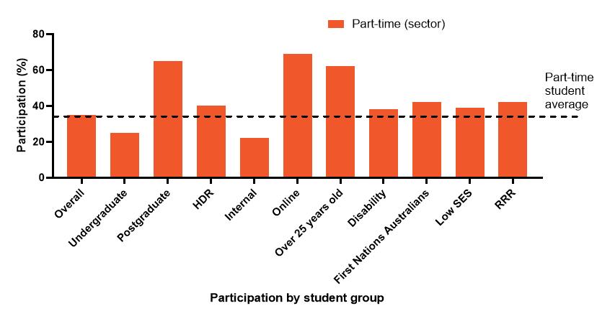
Students with no equity factors were less likely than the part-time average of 35% to study part-time. As the cumulative equity group count increases, the proportion of students studying part-time in that group also increases, with 49% of students with four equity factors enrolling part-time (see Figure 2).
Figure 2: Proportion of part-time domestic students studying at Australian universities in 2024 by equity group count
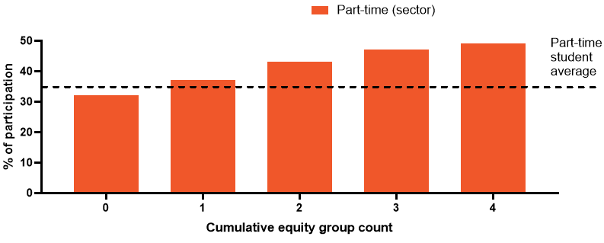
A total of 17% of commencing undergraduate students were studying part-time across the sector in 2024 (Figure 3A left, dashed line), and part-time students represented only a small proportion of all ATAR ranges. Only 4% of students with an ATAR over 90 studied part-time (Figure 3A), and most part-time students enrolled with an unknown ATAR (79%; data not shown). These students tended to not be recent school leavers. Similarly, when looking at the basis of admission for commencing undergraduate students, only 5% of students who enrolled from secondary education (high school) were studying part-time, whereas 32% of students coming from vocational education training (VET) studied part-time (Figure 3B). The two most common bases of admission for part-time undergraduate students were higher education and VET (47% and 19% of all part-time students, respectively; data not shown).
Figure 3: Domestic commencing undergraduate students in 2024 by (A) ATAR range and (B) basis of admission
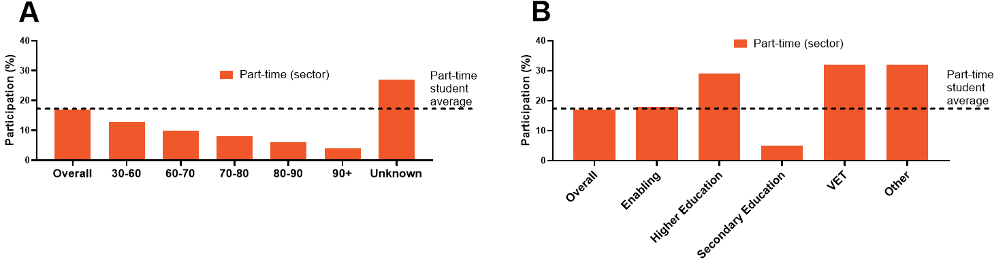

Load
The average EFTSL across the sector for part-time students was 0.33, which equates to between two (0.25 EFTSL) and three (0.375 EFTSL) units studied per year, assuming an eight-unit full-time load. The full-time average was just over six units per year (0.79 EFTSL).
When looking at the institutional data, the average EFTSL for part-time students was 0.30, compared with the full-time average of 0.71, which are slightly lower than the national average. Across 2022 and 2023, 34% of full-time students studied part-time in Semester 1 or 2 at least once, providing evidence that it is common for students to move between full-time and part-time study.

Success
Overall, the success rate of part-time students across the sector was seven percentage points lower than for full-time students (84% vs. 91%; Figure 4A). Students enrolled part-time in a postgraduate or HDR course who were studying online or were aged 25 years or older had a success rate higher than the part-time student average. Groups with a success rate lower than the part-time student average include undergraduates (79%) and students from any of the four priority groups: students with disability (77%), Australian First Nations students (71%), and students from low SES backgrounds (79%) and RRR areas (82%; Figure 4A). Similarly, the success rate was seven percentage points lower between part-time and full-time students studying at the four institutions, which was found to be statistically significant (Z = −140.02, p < 0.001; Figure 4B). The success rate of part-time students from each student group examined was significantly lower than that for full-time students, except for students studying online (see Figure 4B). Interestingly, averaged across the sector, the success rate for part-time online students was four percentage points lower than that for full-time students (see Figure 4A).
Figure 4: Success rate of part-time versus full-time domestic students by student group: (A) sector data in 2024; (B) from the four Australian institutions in 2022 and 2023
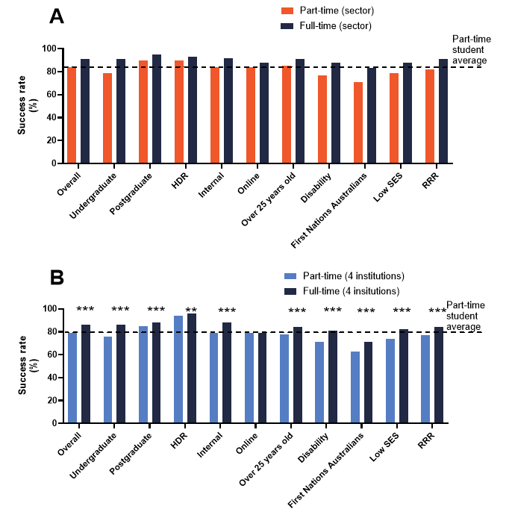
** p < 0.01; *** p < 0.001, compared with part-time students
As with the sector data, when looking at the institutional data, as the cumulative equity group count increases, the participation rate of part-time students increases (see Figure 5A). Overall, the success rate of part-time students was seven percentage points lower than for full-time students (79%; Figure 5B dashed line, vs. 86%). As the cumulative equity group count increases the success rate of part-time students decreases; the success rate of part-time students from four or five equity groups was 65%, 14 percentage points below the part-time average. The average part-time success rate was significantly lower than the full-time success rate for each equity group count (p < 0.001; Figure 5B).
Figure 5: (A) Equity count participation and (B) success for domestic students enrolled in the four Australian institutions in 2022 and 2023
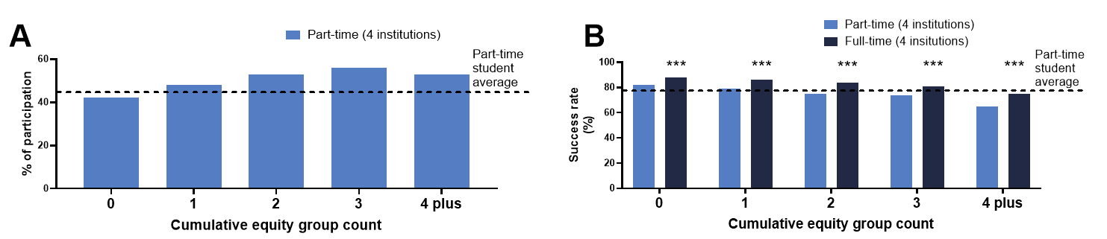
*** p < 0.001, compared with part-time students
There was a similar pattern between the institutional participation rates by ATAR range and data on basis of admission to the sector, with part-time students making up a small proportion of all ATAR groups (see Figures 6A and 6C). As with the sector data, most part-time commencing undergraduate students had an unknown ATAR (65% vs. 75% sector), and the average success rate was 77% (Figure 6B). The success rate of commencing part-time students was highest for those coming from secondary or higher education (both 81%). Part-time success was significantly lower than full-time success for all ATAR ranges and basis of admissions categories (p < 0.001; Figure 6B and D).
Figure 6: Commencing undergraduate students enrolled in the four Australian universities in 2022 and 2023 showing the proportion of (A) participation, (B) success by ATAR range, (C) participation, and (D) success by basis of admission to university
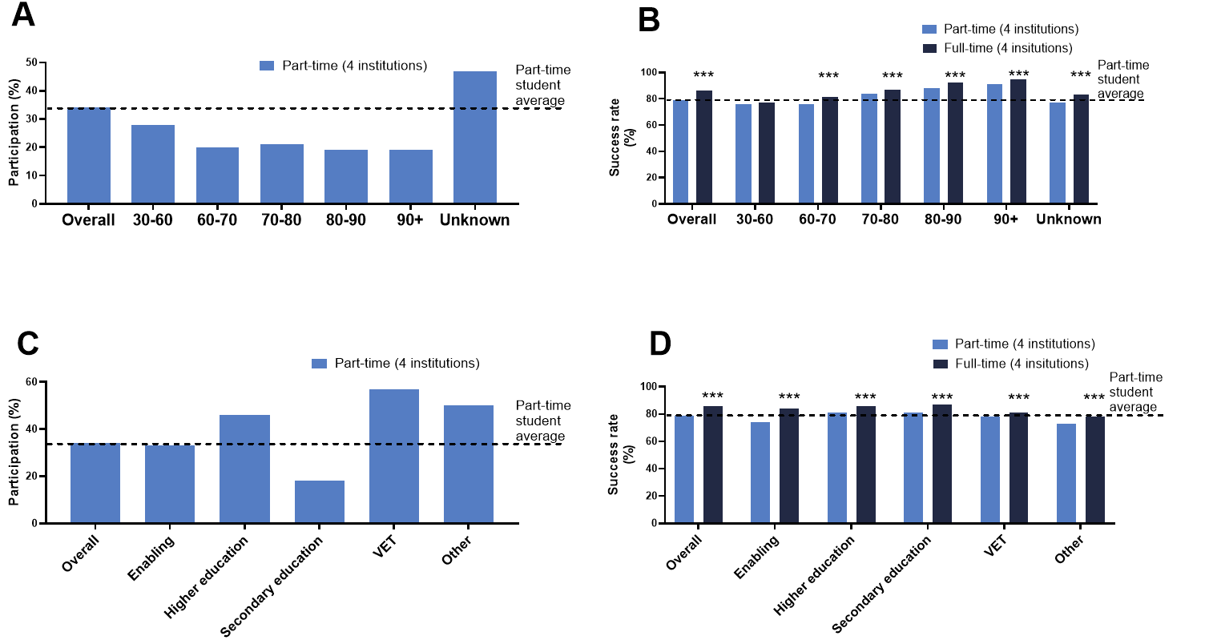
*** p < 0.001, compared with part-time students

Retention
The first-year retention rate (sector data) of part-time students was 15 percentage points lower than that for full-time students (dashed line, 77% vs. 92%; Figure 7A), whereas the relative retention rate of domestic students enrolled in the four institutions was 9 percentage points lower for part-time students (dashed line, 79% vs. 89%; Figure 7B). The relative retention was significantly lower than the full-time relative retention for each group examined (p < 0.001; Figure 7B).
Figure 7: (A) First-year retention rate of domestic students studying at Australian universities in 2023 (retained in 2024) by student group and (B) relative retention rate of domestic students enrolled in the four Australian institutions in 2022 and 2023
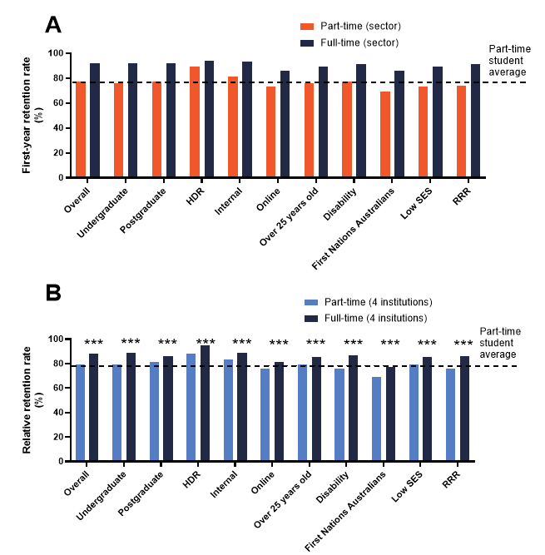
*** p < 0.001, compared with part-time students

Completions
It is not surprising that part-time students take longer to complete their degrees across the sector. Part-time students took on average an additional two years to complete HDR and 1.3 years to complete an undergraduate degree. However, it should be noted that from the institutional analysis, a substantial number of students likely alternated between part-time and full-time enrolment.

Generalised linear models
Initially, all predictor variables were considered for a single model using institutional data, and the Phi coefficient (j) was calculated to test for correlation between each pair of predictor variables (Cohen, 1988). Because there was a moderate correlation between attendance mode (internal and online) and load (part-time and full-time; j = 0.44) and between attendance mode and course level (undergraduate, postgraduate; j = 0.38), three separate models were developed to avoid multicollinearity of predictor variables.
Studying part-time was the strongest indicator of failing in undergraduate internal students after adjusting for other variables, and part-time students were less than half as likely to pass (adjusted odds of 49%, p < 0.001) as full-time students. Part-time enrolment was the second strongest indicator, after commencing status (0.43, p < 0.001), of relative attrition. After adjusting for other variables, part-time students were only 0.59 times as likely to be retained as full-time students (p < 0.001; Table 4).

Table 4: Model 1: Unadjusted and adjusted passing and relative retention rates (expressed as a %) and differences between priority groups and the reference variable (bold) for undergraduate internal students from the four universities
Variable | Category | Odds of passing |  | Odds of relative retention
Variable | Category | Unadjusted odds ratio | Adjusted odds ratio | Unadjusted odds ratio | Adjusted odds ratio
Load | Full-time  Part-time | –  49%*** | –  49%*** | –  63%*** | –  59%***
Commencing status | Not commencing  Commencing | –  79%*** | –  70%*** | –  43%*** | –  43%***
Age | 20–24  16–19  25+ | –  92%***  61%*** | –  96%  74%*** | –  55%***  52%*** | –  77%***  62%***
Gender | Female  Male | –  79%*** | –  74%*** | –  92%*** | –  86%***
Distance to campus | <150 km  150 to 300 km  >300 km | –  109%*  91% | –  121%***  104% | –  104%  72%*** | –  122%***  85%**
Disability status | No disability  Disability | –  60%*** | –  61%*** | –  79%*** | –  80%***
First Nations status | Not First Nations  First Nations | –  51%*** | –  60%*** | –  84%*** | –  70%***
SES | Not low SES  Low SES | –  77%*** | –  76%*** | –  76%*** | –  82%***
RRR status | Urban  RRR | –  95%** | –  100% | –  82%*** | –  86%***
First-in-Family status | Not First-in-Family  First-in-Family | –  82%*** | –  84%*** | –  84%*** | –  87%***
* p < 0.05; ** p < 0.01; *** p < 0.001

Part-time undergraduate online students were only 0.77 (p < 0.001) times as likely to pass as full-time students, making part-time study the third largest risk factor for passing for undergraduate online study, behind being an Australian First Nations student (0.57, p < 0.001) and a student with disability (0.59, p < 0.001). Similarly, part-time undergraduate online students were only 0.67 (p < 0.001) times as likely to be retained, the second biggest risk factor behind commencing status (adjusted odds 53%, p < 0.001; Table 5).

Table 5: Model 2: Unadjusted and adjusted passing and relative retention rates (expressed as a %) and differences between priority groups and the reference variable (bold) for undergraduate online students from the four universities
Variable | Category | Odds of passing |  | Odds of relative retention
Variable | Category | Unadjusted odds ratio | Adjusted odds ratio | Unadjusted odds ratio | Adjusted odds ratio
Load | Full-time  Part-time | –  82%*** | –  77%*** | –  73%*** | –  67%***
Commencing status | Not commencing  Commencing | –  83%*** | –  82%*** | –  53%*** | –  53%***
Age | 20–24  16–19  25+ | –  94%  110%*** | –  104%  110%*** | –  61%***  102% | –  78%***  104%
Gender | Female  Male | –  97% | –  93%*** | –  90%*** | –  91%***
Distance to campus | <150 km  150 to 300 km  >300 km | –  119%***  109%*** | –  122%***  115%*** | –  140%***  113%*** | –  146%***  120%***
Disability status | No disability  Disability | –  60%*** | –  59%*** | –  80%*** | –  78%***
First Nations status | Not First Nations  First Nations | –  52%*** | –  57%*** | –  71%*** | –  74%***
SES | Not low SES  Low SES | –  84%*** | –  87%*** | –  90%*** | –  89%***
RRR status | Urban  RRR | –  96%** | –  106%** | –  99% | –  107%***
First-in-Family status | Not First-in-Family  First-in-Family | –  96% | –  96%* | –  105%** | –  104%*
* p < 0.05; ** p < 0.01; *** p < 0.001

For postgraduate students, studying part-time was the strongest risk factor for relative attrition, and part-time students were just over half as likely to be retained as postgraduate full-time students (adjusted odds 53%, p < 0.001; Table 6). After adjusting for other variables, part-time postgraduate students were only 70% (p < 0.001) as likely to pass as postgraduate full-time students, making part-time study the fourth biggest risk factor behind studying online (61%, p < 0.001), being a student with disability (51%, p,0.001), and being an Australian First Nations student (50%, p,0.001; Table 6) for postgraduate students.

Table 6: Model 3: Unadjusted and adjusted passing and relative retention rates (expressed as a %) and differences between priority groups and the reference variable (bold) for postgraduate students from the four universities
Variable | Category | Odds of passing |  | Odds of relative retention
Variable | Category | Unadjusted odds ratio | Adjusted odds ratio | Unadjusted odds ratio | Adjusted odds ratio
Load | Full-time  Part-time | –  64%*** | –  70%*** | –  52%*** | –  53%***
Commencing status | Not commencing  Commencing | –  91%*** | –  89%*** | –  65%*** | –  62%***
Mode | Internal  Online | –  55%*** | –  61%*** | –  52%*** | –  60%***
Age | 20–24  25+ | –  56%*** | –  74%*** | –  59%*** | –  77%***
Gender | Female  Male | –  93%** | –  86%*** | –  102% | –  100%
Distance to campus | <150 km  150 to 300 km  >300 km | –  98%  87%*** | –  114%***  110%** | –  111%**  85%*** | –  134%***  108%*
Disability status | No disability  Disability | –  52%*** | –  51%*** | –  79%*** | –  76%***
First Nations status | Not First Nations  First Nations | –  39%*** | –  50%*** | –  58%*** | –  73%***
SES | Not low SES  Low SES | –  72%*** | –  78%*** | –  78%*** | –  86%***
RRR status | Urban  RRR | –  84%*** | –  100% | –  84%*** | –  100%
First-in-Family status | Not First-in-Family  First-in-family | –  87%*** | –  91%** | –  94%** | –  99%
* p < 0.05; ** p < 0.01; *** p < 0.001

Learning management system access
Universities 1, 2, and 3 provided data for weekly LMS access for each student, and University 2 also provided the number of times each student accessed the LMS each week. Full-time students accessed the LMS on average eight times per week across the semester, which was significantly more than part-time students, who accessed the LMS an average of three times per week (p < 0.001; Figure 8A). A total of 88% of part-time students who passed 50% or more of their units in a semester accessed the LMS site in Week 1 (passing, green; Figure 8B). Only 76% of students who failed (nutmeg) and 52% who received all zero-fail grades (orange) accessed the LMS in Week 1. This dropped dramatically across the semester to 38% and 16%, respectively, in Week 14 (orange; Figure 8B).
Figure 8: (A) Average weekly LMS access for full-time and part-time students; (B) percentage of part-time students who accessed the LMS in each week of semester, by semester result
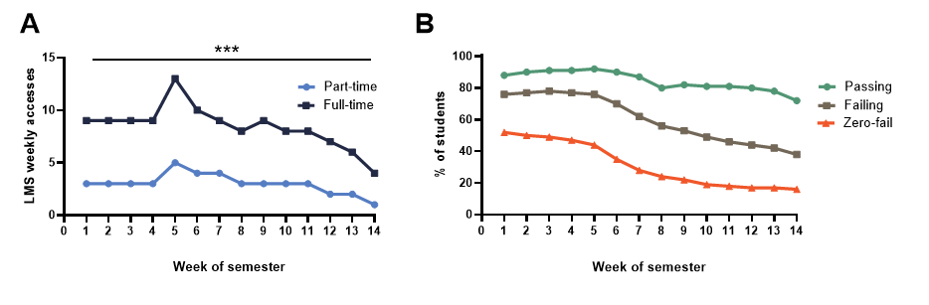
Note: Passing, passed 50% or more of units; Failing, failed more than 50% of units; Zero-fail, did not submit any assessment items for any enrolled units
*** p < 0.001, compared with part-time students

Overview of survey and interview findings
“We often don’t drop to part-time because we want to, it’s because we have to.” (Participant 85)

Summary
- A total of 965 part-time students consented to a survey and 80 participated in a follow-up interview. Participants were enrolled across Australia and had varied tertiary experience.
- A total of 90% of part-time students studying on campus attended campus one or more days a week.
- The main reasons student studied part-time was to manage work and caring responsibilities.
- The main challenges to part-time study were work, finding time to study, and the timing of classes.
- A total of 39% of participants worked full-time, and 47% had caring commitments.
- The most important factor in successful part-time study was quality learning and teaching, which includes access to engaging and understanding lecturers.
- The top three unit design considerations for part-time students were having well-spaced-out assessments, a consistent LMS site layout, and learning content made available early.
- It was important for part-time students that all classes are recorded.
- Part-time students found it difficult to attend compulsory classes because of work and caring commitments. In-person attendance adds a financial constraint. Providing flexibility, early notice, and scholarships for WIL and intensive schools reduces the burden.

Participants
“Just stop treating us like ‘less than’, like we’re not serious about our studies because we can’t dedicate all of our lives to it.” (Participant 277)
A total of 965 part-time students from 35 Australian universities completed an online survey; 67% were enrolled in an undergraduate course, 29% were studying postgraduate, and 4% were enrolled in HDR (see Table 7). Participants had a range of experience; 28% had been enrolled in their course for less than one year, 28% for one to two years, 42% for three or more years, and 2% had completed in the past three years. Participants were enrolled in a broad range of courses from 21 of the 25 disciplines used in the Quality Indicators for Learning and Teaching survey program. The only disciplines not represented were tourism, hospitality, personal services, and sport and recreation. The majority of participants were studying online (72%), and the remaining 28% were studying on campus.
The average age of survey participants was 36 years old, exceeding the part-time sector average of 32 by four years. Participants were more likely to be studying online and more likely to belong to one or more equity group than the sector average (see Table 7). The high proportion of students with disability (44% in total) who participated in the study can be explained in part by ADCET successfully promoting the survey through disability teams at Australian universities. We acknowledge that the survey data are not a true representation of the average part-time student in Australia; however, this is the representation of the students who completed the survey, and a strength of the study is the high proportion of students with disability who participated and provided feedback. If higher education is made more inclusive and accessible for students with disability, all students will benefit. The 2024 sector average is included for comparison (Table 7, right column).
Table 7: Self-reported demographics of survey participants and the 2024 sector average
Survey participants | Undergraduate | Postgraduate | HDR | 2024 sector average
All participants | 647 (67%) | 279 (29%) | 35 (4%) | –
Average age | 34 years | 39 years | 40 years | 32 years
On campus | 33% | 20% | 14% | 47%
Online | 67% | 80% | 86% | 53%
Disability | 42% | 32% | 51% | 14%
First Nations Australians | 2% | 2% | 6% | 3%
Low SES | 24% | 22% | 17% | 17%
RRR | 41% | 41% | 31% | 21%
First-in-Family | 51% | 42% | 60% | 30%ª
ª First-in-Family sector average data are not provided in the UA data-sharing agreement, so these were taken from the ACSES Interactive Tool for 2024 domestic undergraduate students.
Semistructured interviews were conducted with 80 interview participants who were enrolled across 28 Australian universities: 34 undergraduates, 38 postgraduate coursework, and eight HDR students. Interview participants had varied experience: 28% were at the beginning of their course, 28% were midway through, 34% were near the end, and 9% had recently graduated. Overall, 77% of all participants had previous tertiary experience. Most students were studying mostly online with some compulsory on-campus attendance, such as intensive schools (83%), and 17% of interview participants were mostly studying on campus.

Study mode
“Still being able to have a concession opal card despite studying part-time, as I attend on campus part-time due to a disability.” (Participant 125)
The mode of study affected the frequency at which students attended campus, with 70% of online students rarely or never attending campus (see Figure 9A). Meanwhile, 90% of students studying on campus reported attending one or more days a week (see Figure 9B). In 2024, nationally, 47% of part-time students were enrolled to study internally (see Table 7). Part-time internal students highlighted the high cost of public transport, because they did not qualify for a concession:
Even simple things like, I can’t get a travel concession because I’m below the threshold of university hours. Despite the fact I spend, my God, I spend more than a full-time job’s worth of time either travelling, attending classes, or studying. Well and truly more than a full-time job’s worth, but I still have to pay full public transport costs. It’s so frustrating, like I said, particularly in Sydney. People go, oh, well, it’s not that expensive? Yeah, right? You don’t live here. It’s 12 bucks like for me to get to and from uni just on the public transport like forget the time or anything. (UG Interview 26)
Unfortunately, I don’t get bus concession. I have to spend $300 per month to go to university. And when we talk about the full-time students, they get concession for the bus. (PhD Interview 1)
Figure 9: Responses to the survey question “Do you attend classes or activities on campus?” for (A) students studying mostly online and (B) students studying mostly on campus
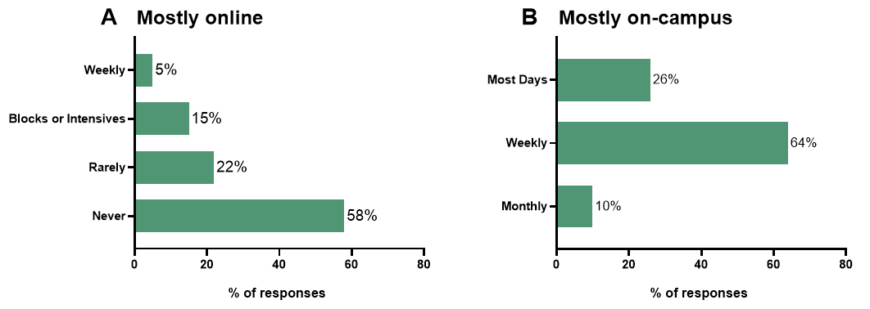
Note: N = 958 participants responded
A number of students who studied online and never attended campus highlighted the difficulty in finding somewhere to study. Those who lived close to a Regional University Study Hub highlighted many benefits, including connection, academic support, and support for navigating university systems, including scholarships. However, towns and suburbs with a university campus are less likely to have a Regional or Suburban University Study Hub. If a student is not enrolled at their local campus, they will not have the same access to the university library as enrolled students:
The [local university] library is open for certain hours to the public. And then, if you want to stay there past like 7 or 8, which are the hours that I would study, they come around and check … it depends on who’s working whether or not they kick me out. (PG Interview 36)
One student suggested that there should be “a partnership with other universities and TAFEs in all states and territories of Australia, so that students can go and study in a dedicated place for study, even if their course is run out of another state” (Participant 298).

Recommendation 9: Shared campus facilities. Having a reciprocal study space agreement between universities could benefit many students
Recommendation 10: Public transport discounts should be based on mode, not load. States provide free public transport to the football, yet part-time, on-campus students pay full fare to travel to university, and this is inequitable.

Why do students study part-time?
“Having the option to do part-time online study is the only way I could possibly attend university.” (Participant 619)
Students were asked “What influenced your decision to study part-time?”. The main response was the need to work (73%), followed by having caring responsibilities (35%) and financial reasons (29%; Figure 10). In addition, 97 students provided an open text response, indicating that there was a range of reasons other than full-time work that influenced their decision to study part-time. For example, one student said: “My disability makes it difficult to take on a full load and work enough to support myself, about 8 to 12 hours a week” (Participant 293).
Figure 10: Responses to the survey question, “What influenced your decision to study part-time?”
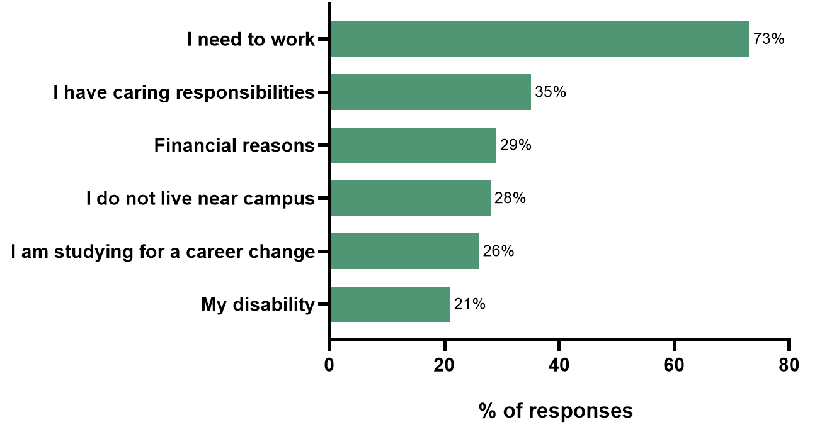
ª Percentages add up to more than 100% because participants were able to select more than one response.
Note: N = 959 participants responded
Some students explained that reducing their study load improved their wellbeing and success. Students also highlighted in interviews that work was a non‑negotiable necessity for many students, making full‑time study financially impossible:
The big one would be acknowledge the fact that people have to work. It’s not a choice. You’ve got to work. You’ve got to work to live. And if you don’t have a job and you’re not earning money, you can’t study, it’s end of story. The pressure to do courses full-time, I watch some of my classmates, and they’re absolutely cracking under the pressure. They’re not coping at all. Their mental health is being affected, and I’ve actually said to a few of them, drop a subject … But they feel like they’re going to be left behind, like, sort of fear of missing out, not graduating with the same class … I think the universities could do a lot to encourage people to actually study part-time as well, but work being a legitimate reason to need an extension. (UG Interview 26)
I just knew I wouldn’t have the capacity to do it … part of that reason being, I do need to work as well. (UG Interview 34)

Challenges
“Sometimes I feel ‘less of a student’.” (Participant 198)
Survey participants were asked, “What are the main challenges in studying part-time?”. Of the nine options provided, work commitments (67%) and allocating time to study (66%) were the most common responses (see Figure 11). A total of 113 participants provided an optional open text response, which were thematically analysed. Here, 23 participants commented on poor-quality learning and teaching and a lack of understanding from lecturers. For example:
I have a full-time job and other commitments. If a subject is presented poorly, it makes it much more difficult. Studying online is hard, poor study material makes it harder. (Participant 894)
Perhaps it’s because I am a professional secondary school teacher, but I feel that there needs to be a master/bachelor of teaching (tertiary) created for academic staff to complete prior to being allowed to teach. Expertise in one’s academic field isn’t enough. (Participant 102)
Some students commented that a lack of clarity required additional support from teaching staff:
Students would ask less simple questions if teachers provided more clear information more often without too much assumed knowledge. When I make time to study, I need it to be productive, not time wasted trying to get answers to simple questions. Some teachers seem to not help with simple things with anticipated or timely help because they think post-grad students should struggle to avoid making it too easy. (Participant 343)
The importance of understanding lectures was also highlighted:
Also, an understanding from the teaching staff that most of the students in the course are part-time, as in my case, and not assuming everyone is full-time. When this assumption is made, it can be demeaning to part-time students, for example, the assumption that you’re part-time because you don’t care enough about your study. (Participant 626)
Figure 11: Responses to the survey question, “What are the main challenges in studying part-time?”
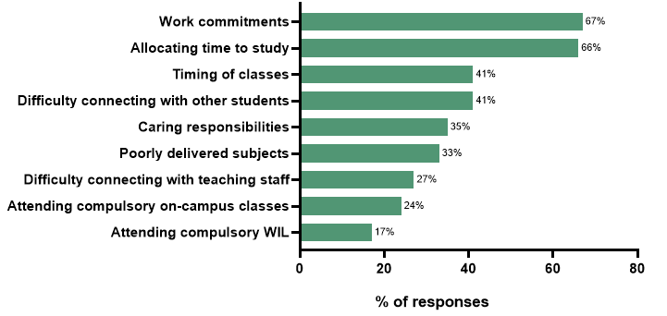
ª Percentages add up to more than 100% because participants were able to select more than one response
Note: N = 960 participants responded
Sixteen participants commented on the difficulty of balancing study with life. Their comments included:
Allocating energy to study, even when the time is available” (Participant 430)
Complete absence of consideration of anyone over the age of 25 and is juggling other commitments. Lots of young people are busy too and need to study part-time, but uni structures are weighted towards young people and don’t cater for people with more life/work experience, more complex life outside uni (Participant 59).
Students (n = 11) also commented on support issues: “Lack of class support beyond discussion board, i.e., available tutor and study groups among classmates” (Participant 120). Another theme was the lack of unit availability (n = 9), which is further explored in Section 6.5. Eight students commented on challenges associated with their disability, for example: “How my disability is affecting me day to day, as my symptoms fluctuate” (Participant 252).
Students highlighted in interviews that challenges were motivation, a lack of connection to fellow students, and balancing study with other competing responsibilities: “The main challenge being just balancing it with other areas of life work, family responsibilities, and trying to have a social life as well. It makes it more difficult to give attention to other areas of your life” (UG Interview 34) and “Generally motivation to study. You know, you’re sitting down. It’s a very lonely sort of thing, studying, part-time or online. Just motivating yourself” (UG Interview 15).

Commitments
“Every student’s personal commitments are different. Some have commitments as important if not more than study.” (Participant 287)
Survey participants reported working an average of 24 hours per week: 53% of respondents worked part-time hours of 30 hours a week or less (navy; Figure 12) and 39% of participants work 31 hours or more a week (green; Figure 12).
Figure 12: Responses to the survey question, “During semester, what is the average number of hours of work that you undertake in a week?”
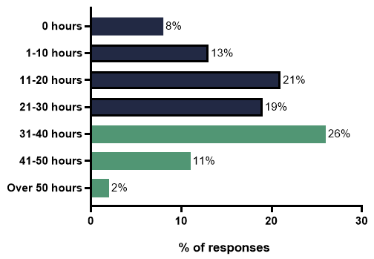
Note: N = 900 participants responded
Interview participants described competing responsibilities, such as caring and work commitments, during a cost-of-living crisis. Financial pressures significantly affected their capacity for studying at university:
In an ideal world, if I didn’t have to work then I would love to study in person, but I’ve got a young person to pay bills for and I work and my life situation is different to when I was at uni the first time when I was 19. (UG Interview 5)
Several students reduced their study load while working full-time to reduce stress. One student said:
I very foolishly made the decision to do my first semester full-time. That nearly killed me, so I dropped part-time immediately after that, because I have to work as well because I have a professional day job as an engineer. And so, once I dropped to part-time, my marks went up, which was very nice, and the stress levels went down. So just as a learning experience it was, it was certainly a lot better to do part-time. (UG Interview 26)
Almost half of the survey participants (48%) indicated that they had caring responsibilities, with the most common being school-aged children (26%; Figure 13). A number of students listed other caring responsibilities, such as pets and a farm: “Farm, two children at uni and living at home and a husband—please don’t discredit the fact that they too require support/care as well” (Participant 763).
Figure 13: Survey responses to the question, “Do you have personal caring responsibilities?”
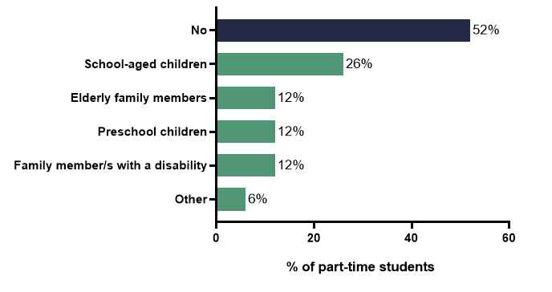
ª Percentages add up to more than 100% because participants were able to select more than one response
Note: N = 884 participants responded
Interview participants demonstrated that despite a strong commitment to study, they had to work around caring responsibilities and work obligations that sometimes needed to take priority:
I still have life and responsibilities, and I’m responsible for sort of fitting that in and managing it accordingly, and, unfortunately, I’d love to make university the priority. But it has to come behind, you know, caring requirements, work requirements, and the things that provide for life. (UG Interview 20)
They don’t care what you have had to juggle just to turn up to class, and that’s the tricky thing with part-time study. It’s not being part-time, it’s what comes with it. It’s why you’re part-time … We are treated like we are less committed, when it’s the opposite. We are on average a lot more committed. (PG Interview 12)

Success
“Give it to me early. I needed to see what hill I am climbing. I need to know how to pace myself because I’ve got other responsibilities. How am I going to pace myself?” (PG Interview 38)
A total of 810 survey participants provided an open text response to the question, “What factors or resources have been the most helpful?”. The most common theme (n = 192) referenced “teachers that are engaging, helpful, and deliver content in a manageable way” (Participant 749). Students took the opportunity to comment on the characteristics of their educators they valued the most, such as understanding and engaging lecturers: “Excellent lecturers who are experts in their subjects—who inspire me to keep going and keep me interested and challenged” (Participant 122) and “When lecturers are understanding and show an awareness of the monumental juggling act that is postgraduate study with small children, it can completely change your mindset and your ability to engage with your course. Knowing that you have someone in your corner is invaluable” (Participant 271). Students also acknowledged the associated workload of quality teaching:
There are no useful resources provided by the university as an institution. All genuine help I have received has come from individual professors trying their hardest to ameliorate an irreparably broken system. (Participant 823)
The next four most common responses were thematically coded to flexible approaches to learning and teaching and included an LMS that is easy to navigate (n = 148), recorded lectures (n = 140), content available early (n = 70), and access to simple or no-questions-asked extensions (n = 70). An additional 35 participants directly referenced UDL. These are some of the examples of their comments:
Clearly presented, well-organised content and well-explained assessment tasks. Subject that have all three are really manageable, even if content is challenging. (Participant 169)
Really clear and easy-to-use online systems. Reminders through these systems are invaluable, and it makes the learning experience clear. (Participant 626)
Having all of the weekly modules, assignments etc available from the first week of each semester rather than slowly releasing it piece by piece. (Participant 764)
Extension support probably is the most important and helpful. (Participant 704)
Survey participants identified student support from the disability team (n = 44) and the library, particularly access to after-hours appointments (n = 18), resources (n = 25), and free access to textbooks (n = 19) as supporting their studies:
The Inclusion and Disability Unit has been life-changing for me. The officer who attended to me, she immediately understood my situation without me sharing too much details. She did not doubt me or question me, because she could read the medical reports, doctor’s discernments, and me. We need intelligent people like her.” (Participant 825)
I have found the library resources the most helpful, being able to loan a book and pick it up any time has been great, and the abundance of online resources available there.” (Participant 427)

Unit design considerations
“A clear understanding of the expectations required by lecturers and of assessments without complex words or complicated expectations.” (Participant 811)
Survey participants were asked to rate the importance of 11 unit design considerations using a 5-point Likert scale (Very important, Somewhat important, Neutral, Low importance, Not important at all). The 11 options were based on the principles of UDL (Rogers-Shaw et al., 2018) and transition pedagogy (Kift & Nelson, 2005). The aggregate of very important and somewhat important responses is displayed in Figure 14. The top three responses were having well-spaced-out assessments (93% agree), a consistent unit site layout (90%), and learning content available early (88%). One student stated that “it would be amazing to see each course offer all (not just some) of these excellent features” (Participant 343).
Figure 14: Responses to the survey question, “How important are each of the following in the design of your units?” using a 5-point Likert scale
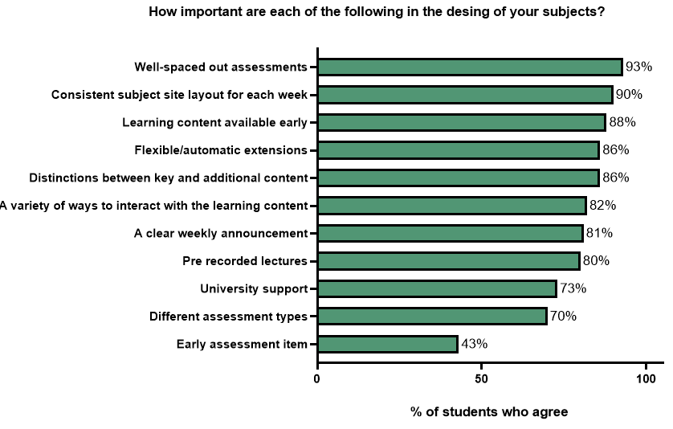
Note: N = 963 participants responded. The aggregate of very important and somewhat important responses is displayed as a percentage of all responses.
In total, 153 students responded to the open text question, “Please discuss factors that are important in subject/unit/course design”. Many students (n = 35) repeated the options shown in Figure 14 and provided additional details, such as: “Study materials for the entire course should be accessible at the start of the course, so that students can self-pace, and go ahead in the material at times if they need to in order to avoid falling behind at other times” (Participant 436). An additional theme (n = 32) referenced recordings (as opposed to pre-recordings) of synchronous lectures and tutorials: “Not necessarily pre-recorded lectures, but recorded lectures so can watch or rewatch at any time” (Participant 356). Students highlighted that all classes should be recorded and “recordings uploaded promptly on a predictable schedule” (Participant 582). Some students requested a more specific timeframe, such as “available within 24 hours online” (Participant 198). Importantly, “tutorial content should not be gated behind attendance” (Participant 814). Students also commented on the importance of a quality microphone and transcripts of the recording.
Students consistently emphasised in interviews the importance of clear, organised materials and early access to content and unit outlines (n = 8):
Careful structuring of the course material, but also of the assessments, so that you know upfront exactly what you’re doing, and when it’s due, and what is expected. Because having a job and being part-time, I need to be able to plan. And I do. I plan it down to the day. I know exactly how long I need to do stuff, and the earlier I get that information the better … short timelines just doesn’t work … So clear information, well organised, as much information upfront as possible. (UG Interview 26)
In contrast, students who were enrolled in units in which content was released late found managing their time difficult: “Lectures were released late for various reasons, whether it’s technological or them being sick. And then you’d have even less time to be able to do things and schedule it in. It was just very difficult” (UG Interview 20).
Students appreciated units that offered varied formats (n = 7):
They do a fantastic job because they deliver the content in different ways. So, there’ll be visual content, the lectures, and maybe attach to YouTube segments and things like that … There’s the reading. There’s forums. There’s opportunities to join groups. So, depending on your learning style, you can take one of those methods, whether it’s the lectures or the readings and drill down on them, even if you cover everything, your learning style will tap into one of those things specifically that you can use just to pass very well. (UG Interview 16)
Consistency was appreciated, particularly regarding the layout of the online LMS (n = 4):
The main thing that really needs to be important is a really easily intuitive learning platform, because we’re going to do a lot of it online … The learning platform and the, really, flexibility that [the university] has been offering, at least for this semester, has made it much easier. (UG Interview 18)
Finally, when a unit is not designed with part-time in mind, it can be incredibly frustrating:
It’s variable. Some of the subjects and the lecturers really get it and make sure that there’s appropriate learning materials available. And others just don’t. They seem to really only cater towards the full-time on-campus students. It can be quite frustrating, because you really do feel as though you’re paying the same price for something, except that you’re getting worse material. (UG Interview 20)

Recommendation 1: Quality learning and teaching.
University workload policies should provide adequate time and resourcing for:
- academics to connect, engage, and empathise with students
- high-quality units with consistent layout and clear expectations
- learning content to be released early
- all classes to be recorded
- opportunities to connect with peers.

Compulsory classes
Survey participants were asked about their experience with compulsory activities. In total, 32% of participants had completed WIL placements, 52% had attended compulsory on-campus classes or intensive schools, and 67% had attended compulsory online activities including classes and exams.

Work-integrated learning
“They need to be financially supported, or the hours reduced. There also needs to be a more mutually respectful relationship between the student and the university about the timing, location of placement. There is an attitude of ‘go where and when we tell you’ or leave. For courses specifically aimed at students with so many outside commitments, it is a very poor approach.” (Participant 804)
Only 15% of students reported receiving financial assistance to support their WIL placements, and a large number of students reported taking paid (45%) or unpaid (59%) leave from work (see Figure 15A). The main barrier that students reported for missing a WIL placement were work commitments (37%) and financial constraints (34%; Figure 15B).
Figure 15: Survey responses to the questions (A) “Regarding your work-integrated learning placements, which of the following were available” and (B) “Were there any barriers that prevented you from attending a WIL placement?”
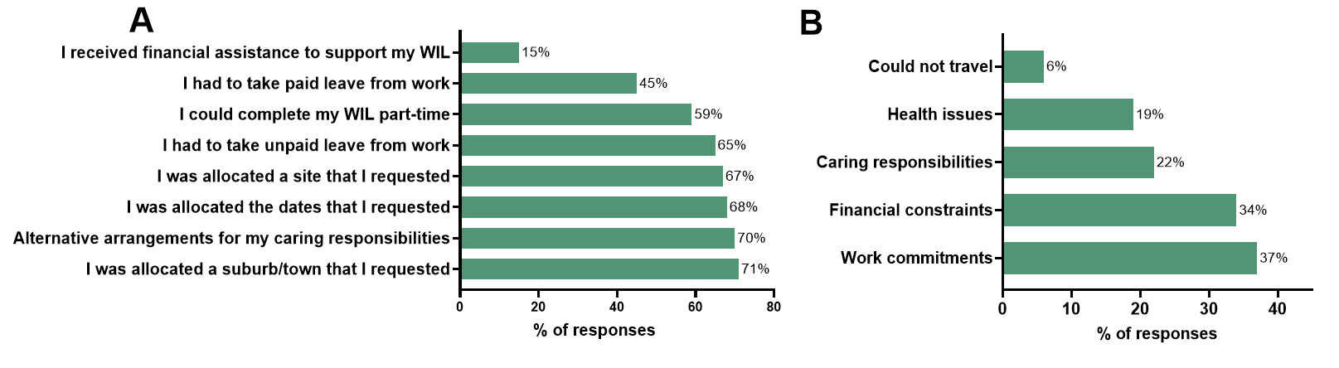
ª Percentages add up to more than 100% because participants were able to select more than one response.
Note: (A) N = 305 participants responded; (B) N = 219 responded
When asked how WIL could be improved, nine students responded that they were happy with their WIL experience and 206 students provided constructive feedback. The most common theme was the cost of WIL and a lack of available financial support or scholarships (n = 64):
Payment!!! I had to delay my studies for three years as I was unable to afford taking time off for my placements, meaning I could only take theory classes until I qualified for Youth Allowance. (Participant 314)
While no students who completed the survey reported receiving the new government Commonwealth Prac Payment, students indicated that there was a need across other disciplines and to support future students: “Financial support—fortunately this has been implemented for future nursing students” (Participant 466).
The next most common themes, as discussed by 46 students, were the need for flexibility of dates, times, and locations. Students commented that large blocks of time were difficult to manage, especially when they were a long distance from home: “I have three weeks coming up, over two hours from where I live” (Participant 734).
Fifteen students identified that part-time placements would be beneficial: “Option to do part-time placements. Understand and acknowledge that not every student is capable of or would like to work full-time” (Participant 558).
A further 10 students reflected on their experience in the industry and the need for better recognition of prior learning: “Signed off completely in my current workplace, not just half of it. I work in case management with social workers in a OPS role. It’s exactly the same thing, hence my high grades” (Participant 555).
One student who had over 20 years of industry experience was required to take three months long service leave to complete their WIL, even though their regular job would count as WIL for any of their classmates. Those experienced students reported very little supervision while on WIL.

Recommendation 3: Equity in WIL placements. Part-time students should be able to complete part-time placements, and students with industry experience should receive fair recognition of prior learning.

Compulsory on-campus classes or intensive schools
“Lots of time, notice. Early on, flagged in the semester. Not assumed that everyone will just be free.” (Participant 924)
Given the different nature of compulsory on-campus classes for students studying on campus versus for intensive and residential schools, or blocks for students studying online, the survey responses were examined separately. Only 15% of online students received financial assistance to travel to compulsory classes, and a high proportion (70%) needed to make alternative arrangements for caring responsibilities. Work was an issue for many students who needed to take unpaid (54%) or paid (61%) leave (green; Figure 16A). Work commitments were the biggest barrier that prevented all students from attending compulsory on-campus classes (Figure 16B), and health issues were a barrier for 38% of students studying mostly on-campus.
Figure 16: Survey responses to (A) “Regarding your compulsory on-campus classes or intensive schools, which of the following were available” and (B) “Were there any barriers that prevented you from attending compulsory on-campus classes or experiences?”
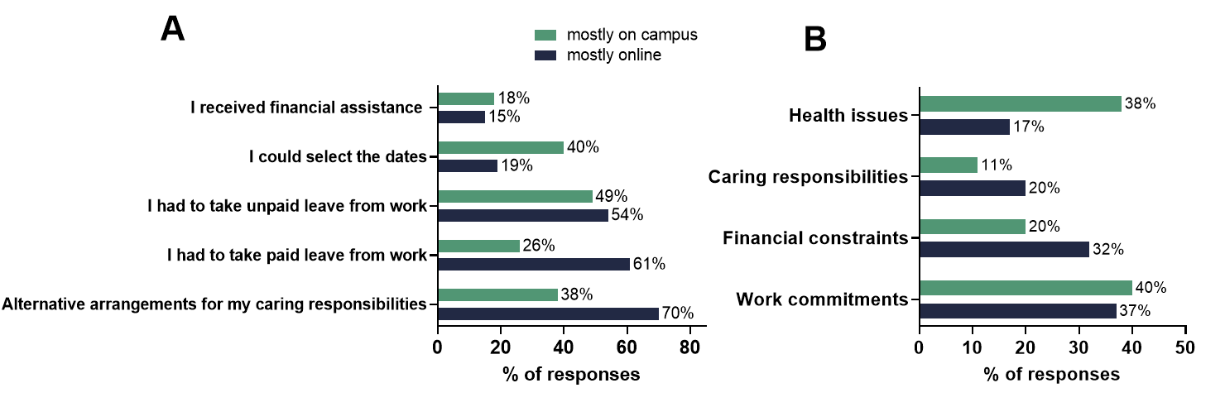
ª Percentages add up to more than 100% because participants were able to select more than one response
Note: (A) N = 489 participants responded; (B) N = 355 responded
In response to the open text question, “How could compulsory on-campus experience be improved?”, 177 online students and 140 on-campus students responded. The most common theme across both groups was flexibility of time (n = 110); however, there was no consensus. Some students preferred classes to be held through the week: “I would love if it wasn’t on the weekends” (Participant 480). Others preferred classes on the weekend: “Evening and weekend classes to be offered for all courses” (Participant 410).
Some students were only available during the day:
Although I’m an online student, being able to study during the day supports me being able to attend online classes live. However, many times I have had to attend classes of an evening, usually when I am trying to organise dinner and my family. There needs to be more options for both daytime classes and evening classes for online students, to enable people to work around personal commitments. (Participant 698)
Meanwhile, for some students, attendance was more convenient in the evening: “Make it available outside of work time. Most part-timers work because we have financial commitments. No job, no survive, especially if you’re a mature-aged student with dependents” (Participant 631).
One interview participant summarised the issue :
There’s obviously a big intersection between people who are studying part-time and people who are working. But then there’s also an intersection with people who are managing disability, or have got caring responsibilities, or whatever, and often the availability for those two cohorts is actually just diametrically opposed. If you’re working 9 to 5, you can’t really attend classes 9 to 5. But if you have caring responsibilities, you’re picking kids up, you can’t really attend after work times. And for me, like, the closer I get to 5 pm, the less effective my brain is. And so, those out-of-hours timeslots are just shocking. (PG Interview 10)
Of the students studying online, 27 participants commented on the classes being as engaging as possible and ensuring that the on-campus experiences “are not just an in-person version of what would’ve been online anyway. Sometimes it doesn’t seem as worthwhile when it’s already very tiring to make it work” (Participant 414). Advanced notice was identified by 14 students, such as: “As long as the dates are known well in advance to give appropriate time to arrange childcare and work cover” (Participant 355).
Students also reported that costs were prohibitive (n = 45), and a number of students suggested that the university should provide free on-campus accommodation because “travel is already expensive enough for most online students” (Participant 628):
By somehow reducing the out-of-pocket costs associated. Paying almost $500 for a week of on-campus accommodation, plus anywhere from $600 to $800 in flights to get there, and then even $150 or so in taxi/uber costs to get to and from the airport all adds up, and having this every session makes me consider whether I will be able to complete them all and actually make it to the end of my degree. (Participant 746)
For students studying mostly on campus, many (n = 20) questioned the need for classes to be compulsory, for example, attendance at 10 out of 12 weeks or an automatic fail: “Making it easier for people with disability to bypass the 90% attendance requirement without having to get a doctor’s note every time as that is too expensive” (Participant 104).
One option provided by students was more flexibility to attend another session. Students would like an online option when hands-on activities are not required (n = 18) and for sessions to be recorded (n = 15):
By making them only compulsory when they are actually needed. I understand coming to a lab to do a biochemistry experiment, but coming for a workshop where we are writing answers on paper and then following the academic sharing their screen on Zoom is a bit silly. Again, I understand trying to get students to work together, but I think making that a compulsory element is uncalled for. If it can be done online, do it online, and give people the choice. I’ve had to miss one of these because of a sick child having been sent home from daycare, and having to apply for special consideration through a central unit to then get that sent to the subject coordinator to then approve. All so I could miss a workshop is overkill. (Participant 277)

Compulsory online classes and exams
“Most people do online for the convenience otherwise they would just attend face to face.” (Participant 697)
Survey participants were less likely to report taking leave from work or organising alternative caring arrangements to attend compulsory online classes and exams (see Figure 17A) than for compulsory on-campus activities. Work commitments presented the biggest barrier to attending compulsory online classes and exams (see Figure 17B).
Figure 17: Survey responses to (A) “Regarding your compulsory online classes or exams, which of the following were available” and (B) “Were there any barriers that prevented you from attending compulsory online classes or exams?”
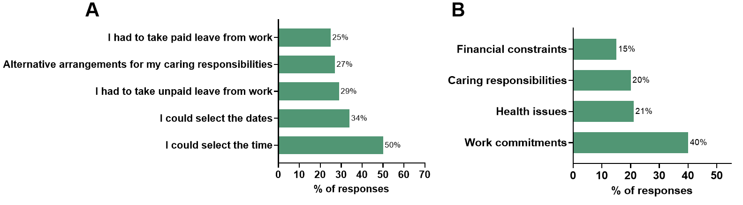
ª Percentages add up to more than 100% because participants were able to select more than one response
Note: (A) N = 630 participants responded; (B) N = 602 responded
A total of 327 participants provided feedback to the open text question, “How could compulsory online classes and exams be improved?”. The most common theme, with 118 responses, was to provide flexibility in the date and time of compulsory online classes (n = 118). Students would like universities to “offer multiple times, dates and understand if a student cannot attendant when studying fully online” (Participant 557). In addition to managing competing commitments, such as work and caring, students highlighted that this helps avoid clashes because online classes are often not timetabled:
Last semester, I had some classes with subjects being on the same evening, which made it hard. Watching a recording after isn’t the same as being there live and being able to ask questions as a part of the uni community, students and lecturer. In this instance I had to alternate the subjects. (Participant 699)
Students indicated that they appreciated “lecturers providing a range of options in a survey at the beginning of the semester … so that everyone has their say in order to schedule the most appropriate time that everyone can make” (Participant 840).
Students appreciated the flexibility of having recorded classes (n = 41), especially if they missed a class because of work or illness: “Ensuring there are recordings if you are sick and can’t attend” (Participant 939). A further 18 participants highlighted that online classes should not be compulsory and “as long as you can show you watched a recording, it should suffice as an attendance if the time of a compulsory online clashed with work” (Participant 725).
Regarding exams, many students needed a larger window to select a suitable time (n = 28) so that “there is ability to do exams over a couple of days and you have ample time to organise your work commitments to complete online tests and exams” (Participant 603). One week is an ideal time because some students are only available to study on the weekend: “I sat an online exam that was open for a period of one week. This was helpful to me as I work full-time so I opted to complete the exam on a weekend day. Please offer more of these” (Participant 745). It is also important that students are provided with plenty of notice: “We had one with a weeks’ notice of the time and date, so several of us couldn’t take leave. Unfair when it’s a hurdle exam too. It felt like the teacher wanted us to fail. Her rants in the pre-exam lecture all made us feel that way” (Participant 416).
Many students highlighted a dislike of exams:
Don’t do exams. The time limit is ridiculous. People learn at different paces. I need to think before I answer the questions, but I didn’t have enough time. The subject with the exam, I got a credit. I usually get HD or D. (Participant 572)
Another theme was the importance of online classes being engaging and interactive and the lecturer being confident with the technology (n = 47): “Make it interactive” (Participant 896). Participants highlighted that there should be “training for those delivering content. Most lecturers struggled with the technology and how to present online effectively” (Participant 826).
Students expanded on these themes, including the need for flexibility in delivery (n = 7). In particular, students believed that they should not be disadvantaged or penalised for not attending. One online student studying a Bachelor of Social Work reported that tutorials were not recorded and were scheduled during the day yet had an 80% online attendance pass requirement:
Well set out is not rigid class structure. You have the option to watch it later recorded, and you don’t get penalised for not being online while the lecture’s live. That’s the whole point of having part-time online university … you don’t have to be online when the lecturer is, so there is more freedom to go at your own pace. (UG Interview 22)
The importance of releasing clear assessment instructions early was highlighted by one student:
In one memorable occasion, my compulsory online class, two weeks before an assignment was due, contained so much information about the final assignment that it rendered all of my previous work worthless, and I had to start over. Online classes could be improved if they did not pull this kind of switcheroo on the subject outline and rubric. (Participant 831)
Recommendation 4: Minimising compulsory activities. Information on compulsory classes and timetabling should also be more transparent at enrolment.

Case Study 1: Simple extensions
- Universities should have a simple, no-questions-asked extension policy, which provides part-time students with flexibility to plan ahead around competing commitments, such as work and family.
- Many formal special consideration policies restrict students from applying for extensions for common reasons, such as paid employment, and the reasons that part-time students require extensions are difficult to evidence, such as caring commitments.
- Disability support plans should provide students with access to an automatic extension of an appropriate length.
“I will say that I don’t appreciate the comments work and family commitments are not an acceptable reason for applying for an extension. Although they do get approved in the end, those comments make students feel like they can’t request an extension and are being set up for failure through fear tactics. Higher ed is an adult learning environment, adults have a range of responsibilities outside of study that can significantly affect their time, and they are generally all very valid reasons. Students are paying money and putting in the best effort they can. They are not wasting their time and money to intentionally fail or waste the facilitators time. Flexibility it important.” (Participant 233)
Extensions at university have traditionally been offered as informal and privately negotiated arrangements with a unit coordinator; as a formal application process requiring documented evidence; or as part of a disability support plan (Bosch, 2020). Traditional special consideration processes require documented evidence and the meeting of strict criteria (Dargusch et al., 2026). These include medical reasons, family and personal reasons (such as death or severe medical or personal problems), and employment-related reasons (such as substantial change to routine employment arrangements or status). Many formal policies also list the reasons a student cannot apply, and they often include routine demands of employment, difficulties in adjusting to university life, and stress or anxiety associated with assessment (Dargusch et al., 2026). Recently, flexible extensions were proposed (Boswell, 2023; Ruesch & Sarvary, 2024). In Australia, 17 of the 39 public universities have introduced some form of institution-wide, automatic, no-questions-asked—or simple—extension policy that does not require documented evidence. These extensions vary in length from two to seven days. They vary greatly in how they are implemented: an online, no-questions-asked, automatically approved application; an email to a unit coordinator requiring a reason; or a grace period where no penalty is applied (Linden et al., 2026).
A total of 892 survey participants responded to the open text question, “How would you describe your experience in applying for assessment extensions?”. Of all respondents, 379 students commented on the ease of use of their institution’s simple extension policy. Benefits included the reduced cost and time burden of seeking documented evidence and not needing to provide evidence: “When it is automatic and it is late at night and something’s gone wrong, it is a godsend. Never been able to apply for documentation. Necessary extensions, as my ADHD is undiagnosed (cost), so I just end up failing those subjects” (Participant 517). Students also identified caring responsibilities that can be difficult to evidence: “There are a lot of parents in my cohort as well. So, you know, your kid gets sick, you’re in the hospital with your kid all night. You can’t do your assignment, or you’ve got three kids with runny noses, hanging off you. You just can’t do it. So their policy was very fair” (UG Interview 19). A number of students identified issues when the simple extension was less than seven days:
The process isn’t hard. But also, once you hit that three days, they want proof and sometimes you don’t always have that proof, you know. If you can’t get in to see a doctor, what do you do? You know if it’s a life event, that’s a problem. How do you prove that? Now, that’s everyone, that’s not just me. And you need to work to survive. So, you know, even the younger ones, you know, get an extra shift, they’re in trouble. (UG Interview 22)
A total of 83 students identified having a disability. Those with access to automatically approved extensions included in their disability support plan noted the ease of use: “I am on the disability scheme at my university so I get an automatic one-week extension. It was difficult to obtain but after I got it, it was smooth sailing” (Participant 450). Those students with disability without access to automatic extensions referred to the process of negotiating a formal extension with each unit coordinator as “gruelling” (Participant 831) and said that academics did not always follow disability legislation: “One staff member has said that he only provides limited extensions, which causes a lot of extra anxiety, and which may not be legal with disability reasonable adjustments” (Participants 180). The lack of clarity created additional workload for students:
I have an Education Access Plan [EAP] and have had extensions denied or have been asked for a medical certificate anyway (even if following all the rules around applying before the due date, through canvas, or emailing the convener, etc.). I have submitted (successful) formal complaints in the past because of this, but that process is taxing and stressful. The AccessAbility unit wasn’t able to provide clarification around how many days extension an EAP entitles students to, and it seems to be up to teaching staff to decide. (Participant 35)
A total of 141 students identified that they did not have access to a university-wide flexible extension policy and instead relied on formal extension policies that require documented evidence. These students provided negative commentary on the process, identifying that it was unnecessarily complicated: “I once applied for an extension before the one-week automatic was introduced, and it was such a laborious process I ended up pulling out of the subject. Horrible experience” (Participant 514). Students commented that a formal extension was difficult to evidence (n = 34): “The evidence is challenging to obtain for time-poor students who work full-time. Evidence needs to be more flexible, with emphasis on the quality of the assessment” (Participant 504). Students also said that the process was stressful:
Applying for special considerations is stressful. The person assessing my application does not know me or my circumstances. I have to go over all my extenuating, difficult, and sometimes traumatic circumstances to be considered for extensions. Facing the special cons system often makes me want to give up and accept a failure. (Participant 221)
Other students commented on the process being “confusing and inconsistent. As an example, I have moved house six times during my studies, and sometimes that qualifies for an extension, sometimes it doesn’t. Sometimes I am given leniency for work conflicts, other times I am not” (Participant 824). A further 21 students reported not feeling comfortable providing a reason, and 11 students reported failing or withdrawing from a unit when extensions were not approved with comments such as:
It was actually frustrating and discouraging. I failed my one subject due to not being able to reschedule the online exam. I had to travel interstate for work. The teacher is not helpful as he didn’t have control over the scheduling and just told me to apply for an extension. Also mentioned it may not be approve because my reason is not that important. Well, it’s my livelihood that we are talking about. (Participant 123)
A further 130 students reported that they had never applied for an extension.
Case study of a no-questions-asked seven-day extension at a single university
A total of 207 part-time students from an Australian university completed a survey in October 2025 regarding their experience of a no-questions-asked, automatic, seven-day extension that was introduced at the beginning of 2023. Students were permitted to take one extension per unit semester, and the extension needed to be submitted before the assessment due date. A number of assessments did not qualify, such as those due at the end of semester and assessments that were difficult to reschedule, for example, exams and practical assessments. The top three reasons provided by students for taking the extension are managing stress (57%), managing full-time work demands (54%), and spacing out assessments (48%; Figure 18A). These three reasons were clearly stated in the special consideration policy as reasons that students could not apply for a formal extension, highlighting the disparity between some academic policies and the needs of “modern” students. When part-time students were asked to rate their satisfaction with the no-questions-asked extension out of 10, the average score was 9.2, very satisfied (see Figure 18B).
Figure 18: Survey responses from one Australian university to (A) “What are the reasons that you took an automatic seven-day extension?” and (B) “Overall, how satisfied are you with the automatic seven-day extension?”
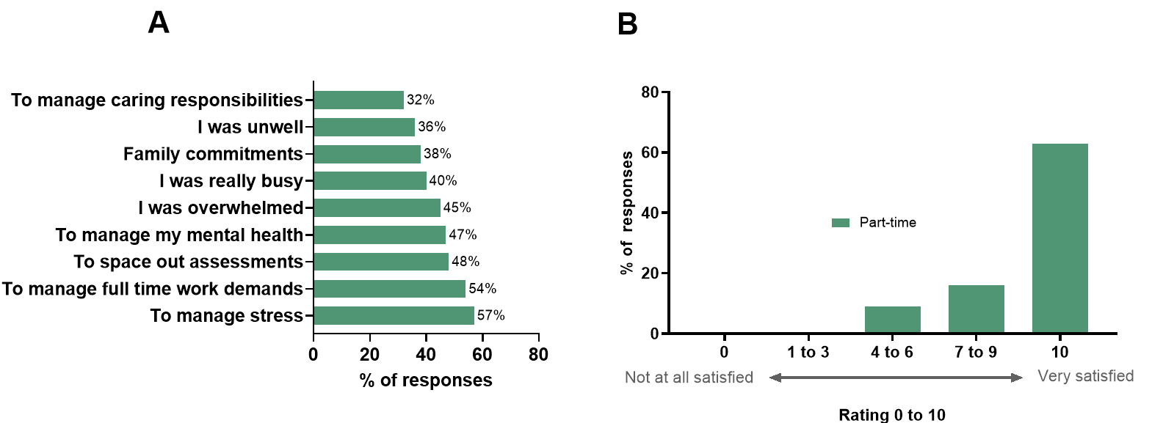
ª Percentages add up to more than 100% because participants were able to select more than one response for A
Note: N = 207 participants responded
At the same university in 2023 and 2024, 63% of all part-time students submitted at least one no-questions-asked extension request. A total of 20% of extensions requested by part-time students were made one week or more before the original due date, indicating that these students planned ahead (see Figure 19A). Unfortunately, 16% of extensions requested by part-time students, and 23% by full-time students, were made on the due date, which was not permissible under the policy. The average value of an assessment with an extension was 40%. Further, 32% of part-time students used the extension on assessments valued between 31–40%, and only 2% of students used the extension for an assessment valued at 10% or less (see Figure 19B).
Figure 19: Student use of the no-questions-asked, seven-day extension from one Australian university in 2023 and 2024: (A) number of days before the due date extensions were submitted and (B) value of assessment item
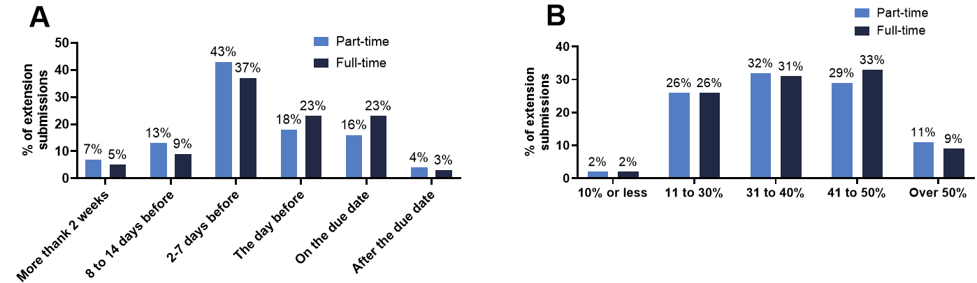
Access to simple, no-questions-asked extensions reduces stress, and the vast majority of students are very satisfied. Formal special consideration policies should be updated to reflect the “modern” student, and caring and work (without a substantial change in role) commitments should be allowable reasons to request special consideration. However, introducing a no-questions-asked policy has many additional benefits, including meeting the flexible needs of students; and removing the cost, time, stress, and anxiety of obtaining documented evidence. This also helps students avoid late penalties and, in some instances, avoid failing grades. Given the high number of students requesting a flexible extension on the due date, policies should consider extensions being taken on the due date.

Recommendation 5: Access to no-questions-asked extensions. Special consideration policies should also be revised to allow work and caring responsibilities as reasons to apply, and disability access plans should provide access to automatic extensions.

Case Study 2: Scholarships
- Only 15% of surveyed students had received scholarship funds.
- Analysis from one university showed that when part-time students received scholarships, success was 12 percentage points higher and relative retention was 10 percentage points higher than for part-time students without scholarships.
- Universities should ensure that part-time students have access to a broad range of scholarships.
- Universities should avoid halving the value of part-time scholarships, especially if it is for a specific purpose, such as to purchase a laptop.
- Part-time scholarships should not be taxed.
“I sort of gave up on scholarships. I wasn’t eligible … To have some government part-time student assistance would be amazing.” (UG Interview 15)
Many students experience financial stress while studying at university, negatively affecting their mental health and academic performance (Russell et al., 2025). However, some students are more financially vulnerable than others. For some students, particularly those from low socio-economic backgrounds, financial pressures and work commitments pose significant barriers to access and success in higher education. In addition, concerns regarding student debt can be a deterrent to attending university for these students (Furuta, 2024). One comparative study of three universities found that scholarships can help alleviate financial pressures and positively affect the retention of students from non-traditional backgrounds (Zacharias & Ryan, 2021). However, scholarship models vary considerably across countries and are often designed with the “traditional” student in mind, that is, one who studies full-time and on campus, and is academically high achieving. This can inadvertently and disproportionately affect part-time students and students from non-traditional backgrounds.
Almost one-third of students (30%) who completed the survey indicated that they were not aware of what scholarships were available or were not interested in applying (see Figure 20, navy). This sentiment is supported by the open text comments: “No, I might qualify but I am supported financially in my study by my employer so I feel that scholarships should be left for those who need it more than I do” (Participant 121).
The remaining 70% of students indicated that scholarships were of interest to them, however, reported little success in obtaining them, and 45% of students indicated that they did not qualify for any scholarships. Of the 25% of students who applied for scholarships, 15% were successful (see Figure 20, green). Students also highlighted barriers that existed through the application process in open text responses:
I attempted to but did not qualify for most due to not studying full-time and then struggled to find time to apply to the scant few I qualified for due to studying and not having support to complete parts I didn’t know how to. For example, some asked for a resume, but as someone who has never been able to work due to disability, I neither have one nor know how to write one. As such, I was stumped, and with no support or spare time, I missed the deadlines. (Participant 531)
Figure 20: Survey responses to the question, “Have you applied for a scholarship to support your study?”
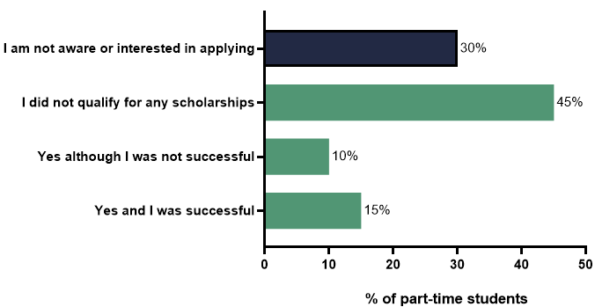
Note: N = 957 participants responded
A recurring theme highlighted in interviews was the systemic or structural exclusion of part-time students from scholarship eligibility (n = 7): “I’m regularly checking the scholarships page. And they’re always like, basically, all full-time, on-campus … it’s quite frustrating. There was one that I could apply for … they had a lot of applicants” (UG Interview 3). Many students described encountering rigid criteria that reflected full-time, on-campus students, effectively disqualifying them from most scholarship opportunities. This exclusion extended to students who, despite working full-time, faced significant financial stress because of caregiving responsibilities or placement costs:
That would be awesome, that would relieve so much pressure. I coincidentally just went through all the scholarships to see if I was eligible for anything, and there’s really not many for people in my situation … I might be working full-time, but I’m a single parent and to do my workplace learning, this session, just gone cost me over $1,500 because I had to pay for accommodation … more financial support would be great. (UG Interview 21)
Even when scholarships were awarded, students often found the financial support insufficient to meet the real costs of study. Taxation of scholarship funds further eroded the value of some scholarships:
I don’t get anything back at tax time from that, either, because it becomes part of my salary, and I lose half of it, over half of it. You lose that. So that doesn’t even pay for a year’s worth of tuition, or everything that you have to buy for courses. There’s no incentive, really. I know so many people that have pulled out. I don’t think it has been a good experience. I want more than anything to be in a classroom with my own class teaching. I really, really do. (UG Interview 4)
A number of students reported that of the few scholarships available to part-time students, their university halved the value of scholarships for part-time students, even for equity scholarships to purchase a laptop.
Despite these challenges, many students expressed gratitude for the support they did receive, often framing it as a critical enabler of their continued study (n = 6): “Massively … it’s allowed me to not focus on trying to get as many hours at work as I possibly can, so that I can focus both on study as well as sort of everything else” (UG Interview 23). Students highlighted benefits such as “would relieve so much pressure” (UG Interview 21) and “would change things completely for me. If I was able to do that, I would jump on that in a second” (UG Interview 24).
One student highlighted the complexity of the scholarship system and the importance of timing and awareness in accessing support: “I had to pay for accommodation. I could have applied for funding for that, but I didn’t get in in time. I wasn’t aware of it. So I know there is some support out there as long as you’re onto it, and you’re on time” (UG Interview 21).
Students disclosed feeling discouraged or helpless when applying for financial support. These feelings were associated with navigating a system perceived as exclusionary or overly complex. A number of students described equity-based scholarships, which were inclusive of part-time learners, particularly those from marginalised backgrounds: “Yeah, more with the equity, being a single parent, and coming from a low socioeconomic area. And I have experience of domestic violence. So, a lot of those scholarships, it doesn’t matter whether you’re full-time or part-time” (UG Interview 33). This exclusion was also an issue for HDR students, and some universities did not award PhD stipends to part-time students: “[University] has a policy that if you go part-time you don’t get a scholarship. They’re very black and white in their approach to PhDs and to students” (PhD Interview 8). When universities do offer part-time PhD stipends, they are usually half the value and are taxed.
Case study of scholarship distribution at one university
Student-level scholarship information was provided by one Australian university for all undergraduate students enrolled there in 2024. The analysis only included undergraduate students because almost all scholarships were targeted at these students. Part-time students comprised 57% of undergraduate students, yet they only received 25% of the scholarships (see Table 8). The average value of a part-time scholarship was 47% of the value of a full-time scholarships (data not shown). When a part-time student received a scholarship, the relative retention rate increased by 10 percentage points, compared with 3 percentage points for full-time students. Similarly, the part-time student success rate increased by 12 percentage points, whereas this only increased by 6 percentage points for full-time students (see Table 8).

Table 8: Relative retention and success of undergraduate students from one Australian university in 2024, with and without a scholarship
 | Part-time | Full-time
% of students | 57 | 43
% of scholarships | 25 | 75
Relative retention, no scholarship | 81% | 91%
Relative retention, all scholarships | 91% | 94%
Success, no scholarship | 76% | 85%
Success, all scholarships | 88% | 92%

The proportion of students in various demographics that received scholarships was further explored (see Table 9). Part-time online students were the least likely to receive a scholarship; only 4% of students from this group successfully obtained any scholarship in 2024, despite making up the largest cohort of students at this university. Interestingly, when successful, this group had a 13 percentage point increase in relative retention and success. Similarly, only 5% of part-time students who were First-in-Family received a scholarship, and these students had a 13 percentage point increase in relative retention and a 15 percentage point increase in success.
Table 9: Percentage point increase in relative retention and success for undergraduate students with a scholarship from one Australian university
 | Part-time |  |  | Full-time
Demographic group | Increase in relative retention | Increase in success | % with scholarship | Increase in relative retention | Increase in success | % with scholarship
First Nations | 18% | 23% | 10 | 7% | 8% | 55
Low SES | 18% | 21% | 6 | 3% | 10% | 33
RRR | 9% | 16% | 7 | 4% | 8% | 30
Disability | 4% | 15% | 10 | 4% | 11% | 31
First-in-Family | 13% | 15% | 5 | 12% | 0% | 26
Zero equity groups | 15% | 20% | 5 | 4% | 9% | 13
One equity group | 3% | 7% | 5 | 19% | 18% | 21
Two equity groups | 10% | 16% | 6 | 4% | 7% | 31
Three equity groups | 9% | 13% | 8 | 4% | 12% | 31
Four or more equity groupsª | 20%ª | 61%ª | 7ª | 14% | 11% | 54
Online | 13% | 13% | 4 | 4% | 7% | 13
Internal | 6% | 13% | 21 | 3% | 5% | 37
ª Four or more equity groups part-time with a scholarship had fewer than 40 students
It is clear that scholarships are not being evenly distributed and that part-time students benefit immensely from scholarship support. As shown throughout this report, there are many reasons that students study part-time, and many part-time students are under considerable financial constraints. Universities should provide more equitable access to scholarships, by adjusting the criteria to encourage part-time students to apply. The Accord panel recommended making part-time PhD scholarships tax-free (Recommendation 26). A finding of this report is that all scholarships awarded to part-time students should not be taxed.
Recommendation 6: Equitable access to scholarships. Many part-time students are under considerable financial constraints and should have access to university scholarships.
Recommendation 11: Access to government financial support. Part-time students should qualify for Youth Allowance, Austudy, and Tertiary Access payments.
Recommendation 12: Tax-free scholarships. Part-time students pay tax on scholarships and PhD stipends, whereas full-time students do not. This is not equitable.

Case Study 3: Consequences of failing
- When a part-time student fails more than 50% of enrolled units in the commencing semester of study, there is only a 24% chance they will be retained in second year.
- Part-time students are 63% more likely to receive a zero-fail grade than a full-time student.
- Failing made students feel less confident and affected their motivation to study.
- At one Australian university, 66% of part-time commencing students failed because of non-submission of assessment items.
“It simply did not reflect me as a student. It reflected my life at the time.” (Participant 612)
Students who failed units at one university were found to be four times less likely to return to study the following year (Ajjawi et al., 2020). However, failing can affect more than academic progression through a course. After failing a unit, students reported feelings of disappointment and devastation, as well as a lack of concern from the university (Ajjawi et al., 2020). We know that part-time students have a higher rate of failing and attrition than their full-time peers (Cherastidtham et al., 2018; Norton et al., 2018; O’Kane et al., 2024) and that part-time students are more likely to enrol in a unit and not submit any assessment items, receiving a zero-fail grade (Stephenson et al., 2021). However, it is not clear what the impact of failing is on part-time students.
A total of 73 survey participants reported receiving one or more failing grades. Student reflections on failing grades reveal a complex interplay of preparedness, institutional support, emotional resilience, and structural barriers. When asked about the circumstances around failing grades, the main responses were feeling overwhelmed (67%), prioritising paid work (53%), and illness (37%; see Figure 21A). For many students, failing a unit triggered an emotional response, including shame, self-doubt, and existential questioning of their academic path. When asked how the failing grades made them feel, 64 participants provided a response, of which 59 included emotional adjectives such as “useless and stupid” or “disappointed and uncomfortable” (see Figure 21B). In addition, five students indicated that the assessment was harder than they expected: “It made me feel like all my hard work was for nothing. The failing grade was on an in-person quiz, and I was underprepared for the difficulty of the exam, and it made me feel inadequate and like I was not ‘smart’ enough for my degree” (Participant 117).
Another theme was the negative impact of not having the required assumed prior knowledge:
Pretty shit, I let myself down but I also think the assessments themselves were very hard, the learning material wasn’t great (for online students), and it was presumed you already knew most of the things that was taught, which put me behind massively, on top of my full-time work commitments. (Participant 959)
Survey participants also cited long hours at work, making it difficult to find time to study: “Hopeless, like I’m not cut out for ag and that I can’t manage my time well enough. Note, when I failed subjects I was working full-time, long hours on farm and was so tired each night and up so early in mornings. It was very hard to find time for effective study” (Participant 350).
Students described reasons for failing that could have been avoided with support, such as poor referencing and misinterpreting the assessment instructions. There was also a lack of support from the university and an inability to resubmit assessments: “I felt dejected as there was no support afterwards, or opportunity to explain why I failed or opportunity to retake assignment or exam” (Participant 553).
Students expanded on these themes, including the emotional impact of failing, during the interviews:
Oh, it’s always deflating. It was awful, you know. You get upset, you feel like, is this path for me? And you know that’s probably a universal feeling, and it would be easier to give up. I spend this time on top of everything else I’m doing to then get told, basically, I’m not good enough. But I’m basically doing that job. (UG Interview 22)

Figure 21: (A) Survey responses to the question, “What were the circumstances around your failing grades?”; (B) Selected adjectives responding to the question, “How did receiving failing grades make you feel?”
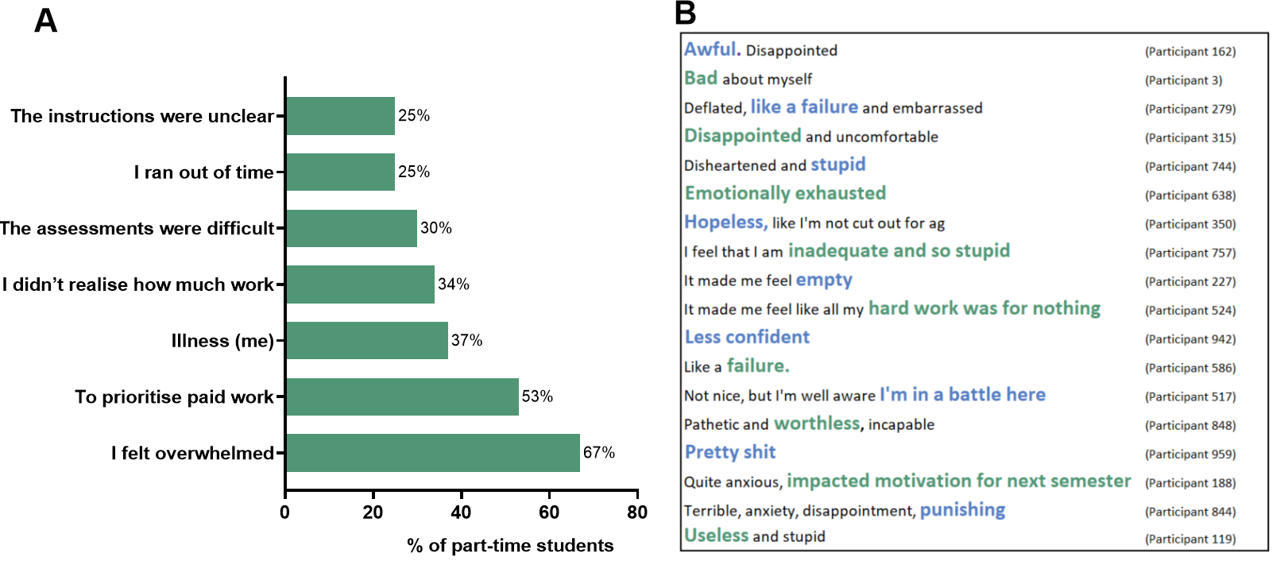
ª Percentages add up to more than 100% because participants were able to select more than one response
Note: (A) N = 73 participants responded; B) N = 64
When asked whether the failing grades were within a student’s control, participants varied in their responses: 34% indicated that they were somewhat or mostly outside of their control (Figure 22, rating of 7 to 10).
Figure 22: Survey responses to the question, “To what extent were these circumstances within your control?”
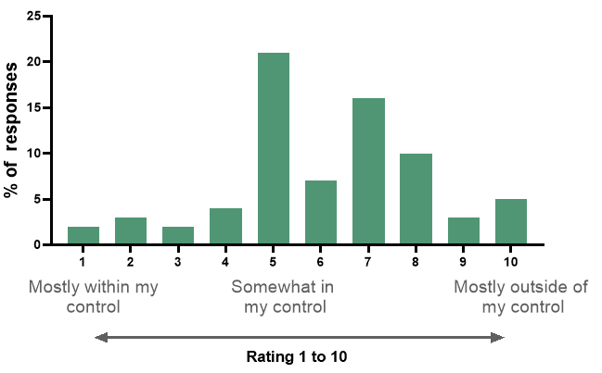
Note: N = 74 participants responded
Commencing student grades from all students enrolled in the four universities were used to trace the flow of results across the first year of study, from Semester 1 (see Figure 23, left) to Semester 2 (centre), and then into second year (right). Passing (green) indicates that a student passed 50% or more of their units in the semester, whereas failing (orange) indicates that they failed more than 50% of all enrolled units. When a part-time student was failing in Semester 1 of their commencing year of study, most withdrew and did not attempt any units in Semester 2. There was only a 24% chance they would be retained the following year (vs. 32% retention for full-time students who failed).
Figure 23: Sanky diagram tracing the flow of results of commencing students enrolled in four Australian universities across the first year
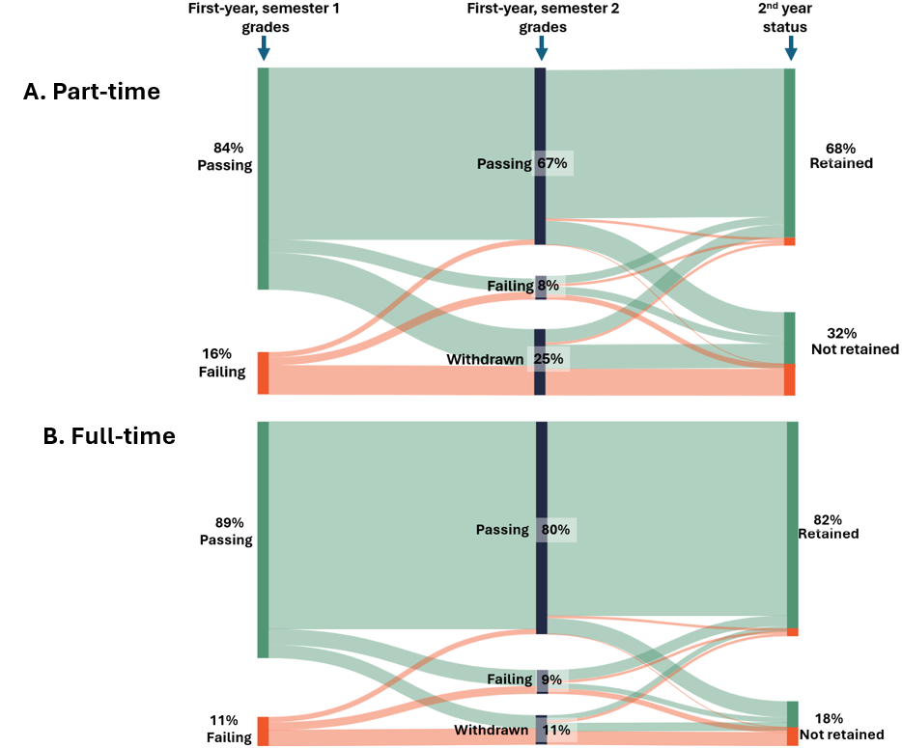
Note: Passing, passed 50% or more of units; Failing, failed more than 50% of units
Universities 1, 2, and 3 had a zero-fail unit grade, which was used when a student remains enrolled past census and does not submit any assessment items in the unit. Part-time students were 63% more likely to receive a zero-fail grade than full-time students (Z = 40.59, p < 0.001; 2.9% part-time compared with 1.8% full-time, data not shown).To investigate the semester results of students who received one or more failing grades, analysis was conducted on all domestic students enrolled in Universities 1, 2, and 3 in 2022 and 2024 across all trimesters. Because it did not have a zero-fail grade, University 4 was excluded from the analysis. Part-time students were more likely than full-time students to receive a zero-fail grade for all of their units (Z = 50.40, p < 0.001; see Figure 24), which results in an average relative retention rate of 35% (Figure 24, left). Part-time students were also more likely than full-time students to fail all units (Z = 98.49, p < 0.001), producing a relative retention rate of 48%. Part-time students were less likely than full-time students to be classified as “failing”, which involves passing at least one unit, but failing 50% or more in the semester. The relative retention rate for this group was 75% (Figure 24).
Figure 24: All domestic students from three Australian universities with one or more failing grades in any trimester
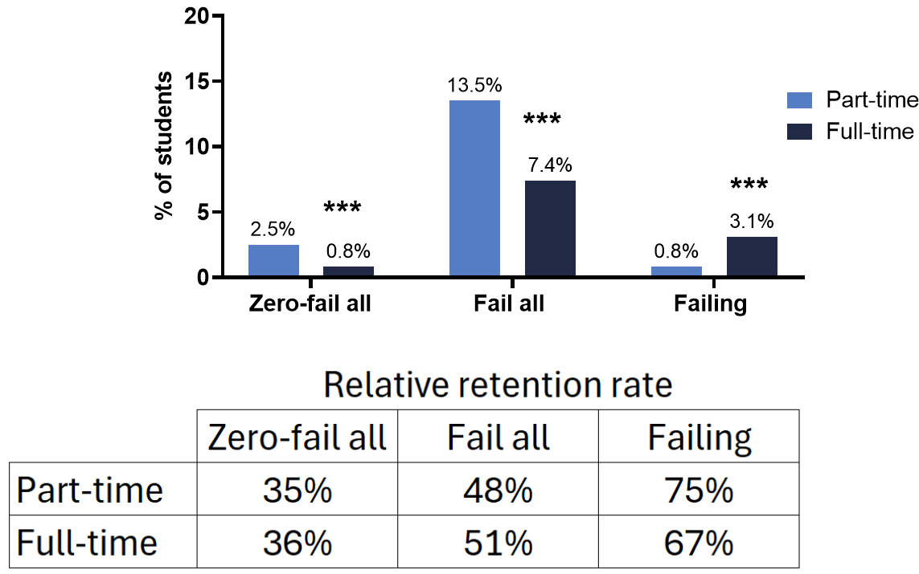
Note: Failing, failed more than 50% of units and passed at least one; Zero-fail, did not submit any assessment items for any enrolled units. p < 0.001, compared with part-time
Case study of failing submission patterns at one university
To investigate how students were failing a unit, detailed data on assessment-submission patterns were collected from one Australian university. Analysis was conducted on almost 500,000 assessment submissions from 676 units with a high proportion of commencing students between 2020 and 2023. Failing grades were divided into four categories according to the submission pattern of assessment: zero-fail, where no assessment was submitted; submit then stop, where at least the first assessment item was submitted before the student stopped submitting assessments; submitted all; and other, where one or more assessments were missed, without following the submit then stop pattern. Part-time students were 12 percentage points more likely to “submit then stop” than full-time students. Part-time students were also eight percentage points less likely to submit all assessments (and fail) than full-time students, indicating that failing patterns differ between full-time and part-time students (see Figure 25). In the submit then stop group, the median week during which students submitted their last assessment was Week 6 of a 14-week semester, and the median week during which students missed an assessment-submission was Week 10. Importantly, less than 15% of part-time students were failing when they stopped submitting (data not shown).
Figure 25: Proportion of failing grades in each submission category from one Australian university
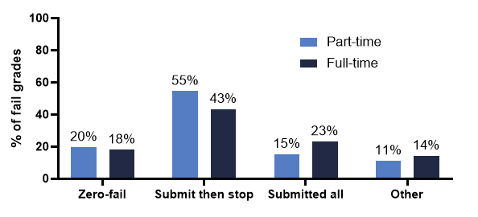
Part-time students juggle many commitments, and 12 weeks is a long time for nothing to go wrong. It is not surprising that when a semester is shortened to a 4 or 6 week “block” that fail rates reduce (Wilson et al., 2025). Many student-retention initiatives focus on pre-census support for commencing students (Cox & Naylor, 2018; Kift, 2015; Linden et al., 2025). Universities with a standard 12–14-week semester should consider monitoring student engagement, particularly for missed assessment items, across the whole semester. Students reported that once they failed, there was no support from the university. Universities should ensure that academic progress policies monitor and support part-time students who receive failing grades. At many universities, students must fail a certain number of units (up to eight) before they trigger the academic progress policy, and a part-time student may fail all units for a year or two before this is triggered. Receiving failing grades has a greater impact than simply slowing academic progression; it affects students’ motivation to continue study and their self-worth. Universities should consider revising policies to allow re-submission if, for example, a student has submitted all assessment items and failed, because failing students should be the last resort.

Recommendation 7: Promotion of success. Resubmissions should be allowed for near-miss fails, and failing students should be the last resort.

Case Study 4: Enrolment patterns
- Approximately half of the part-time students at the four institutions enrolled in one unit per semester and had a similar success rate to those enrolled in two units per semester.
- Universities should review their maximum-time-to-complete policies to consider the time it takes to complete a degree studying very part-time.
- Universities should provide guidance on part-time enrolment patterns and avoid students enrolling in “toxic unit combinations”, which are combinations of units that have a very low chance of success.
“Indicate what courses are best to study together.” (Participant 589)
As highlighted throughout this report, there has been limited research into how to support part-time student success. It is clear that many part-time students are juggling competing responsibilities and that there is an expectation that an average unit in a standard semester requires approximately 10 hours of study a week. It has been shown that students taking one or two units a year are much less likely to graduate in eight years than those taking five or six (Norton et al., 2018). It is also known that students who study a very light load can risk reaching the university’s maximum time to complete a degree (Norton et al., 2018). However, it is not clear how important enrolment patterns are on success rates.
A theme that was raised in response to various survey and interview questions was the lack of guidance on unit selection and enrolment patterns. When asked about the challenges of studying part-time, 11 students commented on the difficulty of selecting units: “Researching which units to study in which order to ensure there are no semesters where I cannot study due to units not being offered in second or first semester that also need prerequisites” (Participant 485). Students also identified the problem of when “subjects are not available more frequently, so it takes much longer for me to finish the course than necessary” (Participant 529). Another issue was “subjects having informal prerequisites building off a subject I haven’t done” (Participant 934), generally because lecturers are assuming students are enrolled in a normal full-time pattern. In some instances, students had enrolled online; however, there was a “lack of available electives online or evening” (Participant 620).
When asked, “What changes could be made to better support part-time students?”, six students commented on the need for help with enrolment patterns: “More clarity around which units should be completed before other units (I did two of mine in the wrong order)” (Participant 798).
One student expanded on this point:
Enrolment plans have all been designed for a full-time study load. As a part-time student who has chosen this pathway due to still having full-time work, it would be helpful if there were part-time enrolment plans provided. It takes quite a level of understanding to properly plan an enrolment pattern, taking into account prerequisites, compulsory on-campus classes, etc. I don’t see why there couldn’t be an interactive software-based enrolment plan generator. (Participant 762)
A further seven students commented on the need to increase the number of enrolments in the summer term, for example: “Offering a wider range of subjects for summer school so the course can be completed quicker” (Participant 283). Students also commented on the difficulty of managing two units a semester, which accounts for approximately 20 hours of study per week: “I did first have two subjects on the go, and I just realised I wasn’t going to be able to manage that, so I did just drop back to one subject by the census date” (UG Interview 30). Students reported that a reduced load of one unit was better for balancing competing commitments: “I’m just doing one unit at a time, because working and kids and it’s just too much” (UG Interview 6) and “Two subjects are too many. One subject is enough for beginners” (Participant 913).
However, students also commented on the consequences of not completing their degree within the strict timeframe of their universities’ maximum-time-to-complete policy: “Remove the very restricting timeline to complete teacher librarian masters part-time in under four years. One subject at a time is big enough and leaves no room for other life events, like babies!” (Participant 507).
The consequences of strict maximum time to complete policies were highlighted:
I birthed two children and worked both full and part-time while studying, so only completed subjects when my work and caring responsibilities allowed, which delayed the completion of the certification. When applying for a leave of absence, I was told that if I did not complete my final subject within four years, my entire certification I had completed to date would be null and void. This equated to nearly $12,000 and hundreds of hours of study. The only reason I was provided regarding why this deadline exists was due to the government not wanting people to go into the workforce with outdated information. This seems very irrelevant given the course could only be entered if you already had a degree or were actively working in the field, of which I have been doing for nearly 15 years. So, to finish the certification I had to therefore complete my final subject with a two-month-old baby, or lose the whole certification. I chose to complete it, so not only have I had to find time between post-partum recovery, three-hourly feeds, and no sleep to study but I have also had to miss out on some aspects of the first couple of months of my baby’s life because I had my focus on computer screens instead of my baby, and I can’t get that time back. Seems like this rule should either be extended or have some flexibility so to not put a person in such a difficult position. (Participant 356)
In a follow up interview, it was revealed that the course included outdated teaching material. This highlighted the misalignment between the expectations of the currency of teaching resources and the time limit imposed on the currency of knowledge for graduating students. “One of the lecture slides in a previous subject, I'm fairly certain, had a 2015 date on the bottom of it. And it's like, so you're reusing slides from that long ago. And yet I'm not allowed to take a session off.” (PG Interview 17).
Unit enrolment and success
Enrolments from the four universities were examined to investigate the proportion of students studying part-time (two units per semester), versus very part-time (one unit per semester). When looking across the year, approximately half of part-time students studied one unit and approximately half studied two units. In Semester 1, both enrolment options had an average success rate of 81% for students studying online, which increased to 84% for online students enrolled in four units (see Figure 26A). This is consistent with other findings and may be due to full-time students having fewer commitments. Student enrolment and success followed a similar pattern in Semester 2 (data not shown). The summer term was markedly different: 60% of all students studied one unit and had an average success rate of 88% for students enrolled internally and 85% for online students. There was a decline in the rate of success with any additional unit enrolment (see Figure 26B). The results could be interpreted to suggest that over summer, all students, including those studying full-time through the year, are juggling competing commitments and benefit from a reduced study load.
Figure 26: Semester unit load, success rate, and the proportion of students enrolled in the four Australian institutions in 2022 and 2023: (A) enrolled in Semester 1 and (B) enrolled in the summer term
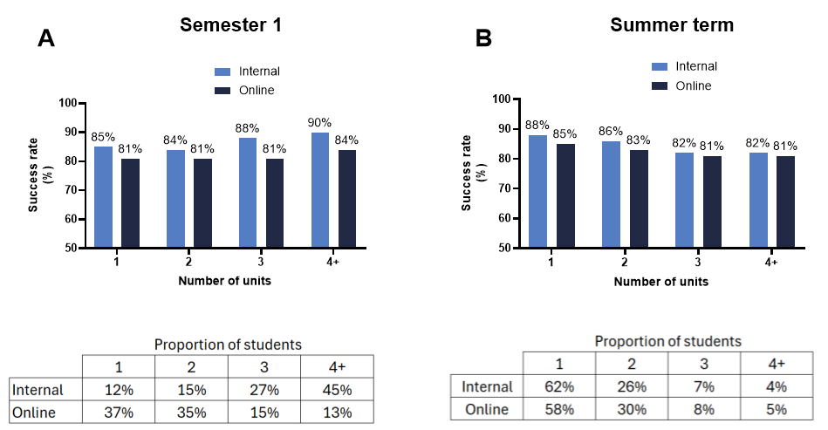
Part-time unit combinations
Analysis was completed on enrolment data from the four Australian universities to investigate whether certain part-time unit combinations had a lower-than-average success rate, making them “toxic”. The average success rate of each two-unit combination taken in a semester was calculated. To ensure anonymity, each university was re-named as A, B, C, or D. When looking at unit combinations with an average success rate of 60% or less, and 30 or more students, 15 “toxic” part-time unit combinations were identified. All coursework unit combinations were assessed; however, the 15 most “toxic” combinations were all undergraduate Level 1 (first year) units, indicating the importance of selecting appropriate enrolment patterns in the commencing year. The average number of students enrolled in the toxic unit combination was 46 students, and the average success rate was 53%. This was approximately 20 percentage points below the average success rate of any other combination of those units and below the part-time average success rate of 79% (see Figures 27A and 27B). University D had no toxic combinations in the list of 15 shown in Figure 27, and another set of criteria needs to be used for that university.
Figure 27: Toxic unit combinations: (A) two-unit “toxic” combinations and success rate for all combinations of Unit 1 and all combinations of Unit 2, and (B) average success rate of toxic unit combinations and average success rate of all possible enrolment combinations of Unit 1 and Unit 2
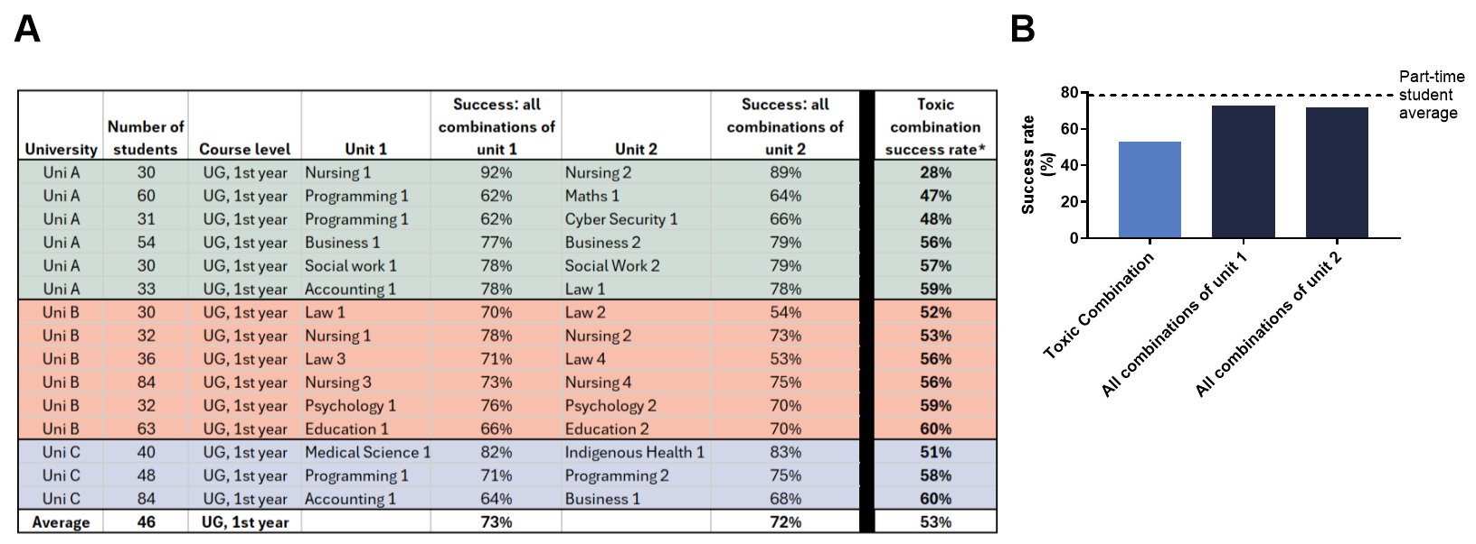
ª Toxic combination success rate is the average success rate for any student that takes the two toxic units together in one semester
Universities should ensure that students have access to part-time enrolment patterns for students enrolled in one or two units a semester. More consideration should be given to ensure that units are offered enough to allow part-time progression through a course, and students should be prevented from enrolling in toxic unit combinations. Many students need to study one unit per semester, which is approximately 10 hours of weekly study on top of other commitments. To accommodate this, universities should consider reviewing their maximum-time-to-complete policy and ensure that it supports part-time students to complete their degrees without the added stress of facing exclusion, while still ensuring that enrolled students graduate with currency of knowledge where required. One simple solution is to replace a complicated formula based on full-time enrolments and provide students with a maximum of 10 years to complete, which will be overridden by specific course accreditation requirements.

Best Practice: Maximum time to complete
Charles Sturt University recently changed its maximum-time-to-complete policy: “To ensure currency of graduates’ knowledge and skills, the maximum allowed period for coursework components of an award course is 10 years”.

Recommendation 8: Part-time study patterns. Students require clear advice around study patterns, and maximum-time-to-complete policies should be reviewed to ensure that they are equitable for part-time students.

Discussion
In 2024, 35% of domestic Australian university students enrolled to study part-time, and students from equity cohorts studied part-time at a higher-than-average rate. At the same time, across the sector, student success was seven percentage points lower, and first-year retention was 15 percentage points lower for those studying part-time. Others have previously reported poorer outcomes for part-time students (Cherastidtham et al., 2018; Harvey et al., 2025; Norton et al., 2018; O’Kane et al., 2024); however, this is the first study to provide a comprehensive analysis of part-time study in Australia.
Part-time study is important for widening participation, and all non-traditional groups examined in this report studied part-time at a higher rate than the average of 35%. This included those studying online (61% studied part-time), those over 25 years old (62%), students with disability (38%), First Nations Australian students (42%), and students from low SES backgrounds (39%) and RRR areas (42%). This was also the case for students from multiple equity groups, with 49% of students who were members of all four government priority groups studying part-time. However, when looking at the results from the four Australian universities that provided detailed student data for this study, as the cumulative equity group count rose, the average student success rate of part-time students decreased to 65% for students with four or five equity factors. When adjusting for all other factors, analysis of data from the four Australian universities revealed that part-time study was one of the biggest risk factors for success and retention. Part-time study was the single biggest risk factor for passing for undergraduate on-campus students and for retention for postgraduate students. If the Australian Government is to reach the ambitious target of 80% tertiary attainment for the working age population by 2025 (O’Kane et al., 2024), it is critical that changes are made to better support part-time student success, retention, and completions.
A major finding of this study is the single most important factor that students highlighted to support their success: good-quality learning and teaching. They highlighted the need for lecturers who were understanding of the “monumental juggling act” that is part-time study and who inspire and engage students in the content. Students feed off their lecturers’ passion. Students also acknowledged the associated workload of “individual professors trying their hardest to ameliorate an irreparably broken system”. A number of specific elements were highlighted as being critical to support successful study. First, an LMS that is consistent and easy to navigate. This makes a unit manageable, even if the content is challenging. Students suggested having recorded lectures, ideally available within 24 hours of the synchronous class, and, even better, having pre-recordings that are available from the start of semester. The third most important element was having content available early and, wherever possible, from the beginning of the semester because students need “to see what hill I am climbing” and how to pace themselves through the semester. These elements align with the principles of UDL (Rogers-Shaw et al., 2018), transition pedagogy (Kift & Nelson, 2005), and a pedagogy of kindness (Teakel, Linden & Clatworthy, 2024). There is a sector-wide shift towards embedding inclusive practice into routine learning and teaching; however, the adoption in higher education remains inconsistent (Timuș et al., 2024). University leadership should ensure that workload policies provide lecturers with the time and resourcing to connect and empathise with students and provide quality, inclusive resources.
The main reason for studying part-time, as reported by students who completed the survey, was to manage work and caring responsibilities. The average age of part-time students across the sector is 32 years old, and it is therefore not surprising that many part-time students are juggling multiple responsibilities. Students reported working an average of 24 hours per week, with 53% of survey respondents working 30 hours a week or less and 39% working over 31 hours a week. Students reported the need for work because of financial pressures; however, work significantly affected their capacity to study. Similarly, 48% of survey participants reported caring responsibilities, 12% with preschool children and 26% with school-aged children. Universities have been designed with a full-time, school leaver in mind, and they generally lack leniency for students with outside commitments (Malm & Weber, 2017; Younger et al., 2019). This is particularly clear when looking at special consideration policies for assessment extensions and missing compulsory classes (Dargusch et al., 2026). These policies generally have tight requirements around documented evidence and, for many, work and caring commitments are not a valid reason to apply. Students reported that “fear tactics” were used when they were told that work and family commitments were not acceptable reasons to apply for an extension.
Students who conform to traditional university time, such as meeting assessment deadlines, are generally considered to have the commitment required for success (Bennett & Burke, 2018; Burke et al., 2017); however, these perceptions do not consider circumstances outside of a student’s control (Dargusch et al., 2026). Simple extensions have been proposed as a solution to provide flexibility for “modern” students (Boswell, 2023; Ruesch & Sarvary, 2024), and, in recent years, 17 Australian universities have introduced some form of a simple extension policy that vary in length from two to seven days (Linden et al., 2026). In line with this, 42% of survey respondents commented on the ease of use of their institution’s simple extension policy. Students highlighted many benefits, including providing reduced costs and time burdens to seek documented evidence and flexibility around undiagnosed disabilities. The 141 students who identified that they did not have access to a university-wide flexible extension policy provided negative commentary on the formal special consideration process. They reported that it was unnecessarily complicated and inconsistent, and it was unfair to be denied because a work commitment was “not that important”. One student reflected that “facing the special cons system often makes me want to give up and accept a failure”. While simple extensions provide many benefits for assessment extensions, exemptions from other academic activities, such as compulsory class attendance, still require the formal consideration pathway, a policy which should be reviewed to allow work and caring commitments.
Part-time students who participated in the study highlighted challenges with attendance at compulsory academic activities including WIL placements, compulsory on-campus classes, and intensive schools and exams, with work commitments proving the biggest barrier. Many students were unable to complete their WIL part-time, and a number of students with extensive industry experience described a lack of recognition of prior learning. This aligns with findings from a recent report into placement inequality, which found that universities and professional bodies should critically examine current WIL models (Bell, 2025). The most common theme raised with WIL was a lack of financial support. Only 15% of part-time students reported receiving financial assistance to support their WIL, which is the same proportion of students who reported receiving any scholarship funds to support their study. Scholarships have been shown to alleviate financial stress and support retention (Zacharias & Ryan, 2021). The single university case study presented in this report provided evidence that part-time undergraduate students, who made up 57% of students, only received 25% of scholarships, with only 4% of part-time online students receiving a scholarship. However, for those who were successful, the average rates of success and relative retention increased by 10 and 12 percentage points, respectively. This aligns with the literature that shows scholarship recipients have higher rates of university success (Berlanga et al., 2022). It is important that universities review scholarship allocation and increase access to part-time students. When looking specifically at HDR students, scholarships were awarded at a higher rate (37%). Students were generally understanding that because they would take twice as long to complete, it was somewhat fair they were receiving half of the full-time stipend. However, what was not fair was the need to declare the scholarship or stipend on their tax return, further reducing its value. Recommendation 26 of the Australian Universities Accord is to make part-time scholarships tax-free for HDR students (O’Kane et al., 2024); however, results from this study provide evidence that scholarships should be tax-free for all part-time students. HDR students raised issues with not being allowed to enrol part-time. Others have shown that part-time PhD students complete their degree faster than full-time students in equivalent terms (Neumann & Rodwell, 2009). Universities should be more accepting of part-time HDR students.
Other financial concerns raised by part-time students were a lack of access to student discounts for public transport and government financial assistance. Many students studying on campus have compulsory attendance requirements, and students reported timetables with compulsory classes spread across three or four days. Public transport in Sydney and Perth was costing students up to $200 to $300 a month, which would have been half price for full-time students in Sydney and free in Perth. It is common for states to provide free public transport to the football, and state governments should consider legislative changes to provide public transport discounts based on mode of study (students studying on campus) instead of study load. Many students raised the lack of access to government payments such as Youth Allowance and Austudy. Considering that many part-time students have caring commitments or are managing disability and are unable to manage a full-time study load, it would be equitable for financial assistance to be extended to this group of students. It was acknowledged in the Accord that because of the increased risk of non-completions this group face that income support payments should be expanded to support students studying a part-time load of 0.5 to 0.74 EFTSL (Recommendation 15; O’Kane et al., 2024). This would have a meaningful impact on many part-time students. While legislative changes would be required to make the aforementioned changes, there is a simple policy change that could provide immediate access to financial assistance to some part-time students. Two of the four universities that provided detailed data for this study had an enrolment policy that only counted a student load in Semester 1 and 2. The minimum full-time load to qualify for financial assistance was three units in each of the two semesters (EFTSL 0.75). The other two universities counted load across the year; therefore, a student could study two units in each of the trimesters (EFTSL 0.75) and qualify for all the benefits of a full-time student. If universities adopted a unified definition of part-time enrolment, such as “enrolment in less than 0.75 EFTSL in any year shall be deemed to be part-time study”, this could have a meaningful impact on students who are able to enrol in six units across a calendar year.
There was no consensus when it came to what time was most suitable for compulsory classes: some students were available during weekdays, some weeknights, and some on weekends. Part-time students agreed, however, that not recording classes or making them compulsory put students at a disadvantage. A similar issue was raised about exams. Students highlighted difficulties in obtaining documented evidence for work and caring commitments when they were unavailable for these compulsory activities, especially when limited notice was provided. Students with disability were usually able to use their disability access plan to provide flexibility; however, it is widely known that up to 20% of students with disability have not disclosed it to their university for reasons such as privacy or a lack of medical documentation (Dollinger et al., 2024; Linden et al., 2026; Pitman et al., 2022). The scheduling of online exams will likely become more important in the coming years with an increased focus on supervised assessment in response to the challenges of generative artificial intelligence. It is important that universities and unit coordinators consider that many part-time students are juggling competing responsibilities when scheduling online exams. Universities cannot rely on the current special consideration systems and disability access plans to provide flexibility. One recent study provided evidence that the current system of disability accommodations in exams is not meeting students’ needs (Harris et al., 2026). Part-time students need advanced notice and understanding that sometimes other commitments cannot be moved.
The main challenge to success reported by part-time students who completed the survey were work commitments and allocating time to study. It is therefore unsurprising that a theme that was raised in response to various survey and interview questions was a need for guidance on unit selection and enrolment patterns. Previous research has indicated that there is an increased risk of dropping out with a reduction in load, and students studying one or two units a year are at the highest risk (Cherastidtham et al., 2018; Norton et al., 2018). However, for some students who participated in this study, studying two units a semester was too much, and they reported improved grades when they dropped to one unit, which is still a time commitment of approximately 10 hours per week. Around half of the part-time students enrolled in the four institutions enrolled in one unit per semester, with a similar success rate to those enrolled in two units per semester. If universities are to support widening participation, it is important that they provide guidance on part-time study patterns and ensure that students have time to complete their degree at the lowest enrolment rate allowed (such as one unit a semester). A maximum-time-to-complete policy of 10 years would still ensure currency of knowledge and provide equitable access to part-time students. This would be overridden by course accreditation requirements, such as a maximum of seven years to complete a law degree.
To learn more about how to support part-time students to succeed, it is important to learn how students are failing. Failing is important for retention the following year (Ajjawi et al., 2020; Li & Carroll, 2020; van der Ploeg et al., 2024), and students who fail have been shown to feel disappointed and experience a lack of sympathy from the university (Ajjawi et al., 2020). When students enrolled in the four universities failed 50% or more of their enrolled units in their commencing semester, there was only a 24% chance of them being retained into a second year. Part-time students were more likely to receive all zero-fails or to fail all units in a semester than full-time students. Analysis of failing grades for students enrolled in first-year units at one university indicates that the most common way that part-time students fail a unit is by non-submission of assessment items. The median week during which students submitted their final assessment was in Week 6 of a 14-week semester. The median week of the first missed assessment was Week 10. More than 85% of students were on track to pass before missing an assessment. This is unlikely to be a phenomenon specific to that one university. When looking at the weekly LMS access of students enrolled at three of the four Australian universities, there was a decline in weekly access from Week 5 for students who ended up failing 50% or more of their units. The survey participants who had received one or more failing grades reported that the main circumstances were feeling overwhelmed and prioritising paid work and illness. These reasons could be overcome with timely, targeted support. Students felt anxious, worthless, and incapable, and lost motivation for the next semester after failing. Students described failing a unit because of issues with referencing or misinterpreting assessment instructions, which could have been avoided with clear instructions or embedded academic skills support. There has been a focus across the sector on monitoring early assessment item submission to identify and support students at risk of failing (Cox & Naylor, 2018; Linden et al., 2023; Nelson et al., 2006); however, findings from this report suggest that universities should monitor assessment submissions and provide targeted support following non-submission after the census date. It is clear that failing is bad for the student, bad for the university, and bad for the government. Assessment policies should be reviewed to avoid failing students who have submitted all assessment items and to allow them to resubmit.

Conclusion
This report presents a comprehensive summary of part-time study in Australia. Findings from this report led to nine recommendations for university leadership, one that requires state legislative changes and two that require federal legislative changes, that align with recommendations from the Australian Universities Accord.
Several recommendations require changes to university policies and can be cost-effective to implement, such as changes to how scholarships are allocated. However, Recommendation 1, that university workload policies provide adequate time and resourcing for quality learning and teaching, requires funding of academic time, which can be associated with considerable cost. Recently, the federal government announced a new needs-based funding model for students from three priority groups: students from low SES backgrounds, Australian First Nations students, and students from RRR areas. Funding for the low SES and First Nations component will be based on headcount for commencing students and EFTSL for continuing students, ensuring that there is funding for each part-time commencing student. It has been argued that this needs-based funding should fund more reliable and broader changes to pedagogy or student services rather than niche targeted programs that are not always evidence based or evaluated (Norton, 2026). This is particularly the case for the low SES component of the funding. A major finding from this report is that according to part-time students, the most important element for success is quality learning and teaching. We know that current government funding is challenging traditional workload models. At the same time, it is essential that universities support academic time to connect and empathise with students, whether that be via consultation, preparation, reflection, or professional development. Findings from this report support the argument that needs-based funding should be spent on initiatives to support quality learning and teaching for the benefit of all students yet benefit non-traditional students the most (Norton, 2026).
In this report, after adjusting for other factors, studying part-time was the biggest risk factor for passing for undergraduate internal students, and was the biggest risk factor for relative retention for postgraduate students for students enrolled in the four Australian universities analysed. Studying part-time intersects with all equity groups. To meet the ambitious target of 80% tertiary attainment by the working age population by 2025 (O’Kane et al., 2024), it is critical that changes are made to better support part-time student success, retention, and completions. What better way to approach increased attainment and success than by funding initiatives that support quality learning and teaching.

References
Accardo, A. L., Kuder, S. J., & Woodruff, J. (2019). Accommodations and support services preferred by college students with autism spectrum disorder. Autism, 23(3), 574–583. https://doi.org/10.1177/1362361318760490
Ajjawi, R., Crawford, N., Bearman, M., Brett, M., Dollinger, M., & Tai, J. (2025). The house of cards: Equity-group students’ experiences of structural inequity in higher education. Higher Education Research & Development, 44(4), 793–807. https://doi.org/10.1080/07294360.2025.2456819
Ajjawi, R., Dracup, M., Zacharias, N., Bennett, S., & Boud, D. (2020). Persisting students’ explanations of and emotional responses to academic failure. Higher Education Research & Development, 39(2), 185–199. https://doi.org/10.1080/07294360.2019.1664999
Anderson, A. H., Stephenson, J., & Carter, M. (2020). Perspectives of former students with ASD from Australia and New Zealand on their university experience. Journal of Autism and Developmental Disorders, 50(8), 2886–2901. https://doi.org/10.1007/s10803-020-04386-7
Australian Bureau of Statistics. (2021). Socioeconomic indexes for areas (SEIFA): Technical paper. https://www.abs.gov.au/statistics/detailed-methodology-information/concepts-sources-methods/socioeconomic-indexes-areas-seifa-technical-paper/2021
Australian Bureau of Statistics. (2026). Remoteness areas (ASGS Edition 3). https://www.abs.gov.au/statistics/standards/australian-statistical-geography-standard-asgs-edition-3/jul2021-jun2026/remoteness-structure/remoteness-areas
Australian Human Rights Commission. (2026). Respect at uni: Study into antisemitism, Islamophobia, racism and the experience of First Nations people. https://humanrights.gov.au/resource-hub/by-resource-type/reports/race/respect-at-uni-study-into-antisemitism,-islamophobia,-racism-and-the-experience-of-first-nations-people
Baines, L., Gooch, D., & Ng-Knight, T. (2024). Do widening participation interventions change university attitudes in UK school children? A systematic review of the efficacy of UK programmes, and quality of evaluation evidence. Educational Review, 76(3), 628–647. https://doi.org/10.1080/00131911.2022.2077703
Baker, C., Ellis, J., & Peddle, M. (2022). Experiences of undergraduate nursing students with a learning access plan. Teaching and Learning in Nursing, 17(1), 61–67. https://doi.org/https://doi.org/10.1016/j.teln.2021.09.002
Bell, A. (2025). Addressing placement inequities via participatory action research (Equity Fellowship final report). Australian Centre for Student Equity and Success, Curtin University. https://www.acses.edu.au/publication/addressing-placement-inequities/
Bennett, A., & Burke, P. J. (2018). Re/conceptualising time and temporality: An exploration of time in higher education. Discourse: Studies in the Cultural Politics of Education, 39(6), 913–925. https://doi.org/10.1080/01596306.2017.1312285
Berlanga, V., Corti, F., & Perea, E. (2022). The effect of scholarships on university persistence: A case study. Revista de Cercetare si Interventie Sociala, 76, 69–83. https://doi.org/10.33788/rcis.76.5
Bosch, B. (2020). Adjusting the late policy: Using smaller intervals for grading deductions. College Teaching, 68(2), 103–104. https://doi.org/10.1080/87567555.2020.1753644
Boswell, S. S. (2023). Students’ use and perceptions of a due date extension policy. Journal of Effective Teaching in Higher Education, 6(2), 1–16.
Braun, V., & Clarke, V. (2019). Reflecting on reflexive thematic analysis. Qualitative Research in Sport, Exercise and Health, 11(4), 589–597. https://doi.org/10.1080/2159676X.2019.1628806
Burke, P. J., Bennett, A., Bunn, M., Stevenson, J., & Clegg, S. (2017). It’s about time: Working towards more equitable understandings of the impact of time for students in higher education. National Centre for Student Equity in Higher Education, Curtin University. https://www.acses.edu.au/publication/its-about-time-working-towards-more-equitable-understandings-of-the-impact-of-time-for-students-in-higher-education/
CAST. (2024). CAST universal design for learning guidelines Version 3.0. CAST. https://udlguidelines.cast.org
Cherastidtham, I., Norton, A., & Mackey, W. (2018). University attrition: What helps and what hinders university completion (0648230783). Grattan Institute. https://apo.org.au/sites/default/files/resource-files/2018-04/apo-nid142971.pdf
Cohen, J. (1988). Set correlation and contingency tables. Applied Psychological Measurement, 12(4), 425–434.
Cox, S., & Naylor, R. (2018). Intra-university partnerships improve student success in a first-year success and retention outreach initiative. Student Success, 9(3), 51–65. https://doi.org/10.5204/ssj.v9i3.467
Crenshaw, K. (1989). Demarginalizing the intersection of race and sex: A black feminist critique of antidiscrimination doctrine, feminist theory and antiracist politics. University of Chicago Legal Forum, 139–168.
Dargusch, J., Harris, L., Willis, J., Kettle, M., Arnold, J., Rogers, N., Gallagher, J., & Chi, D. N. (2026). Time for a rethink: Assessment policy to enable equity (Small Grants Research Program final report). Australian Centre for Student Equity and Success, Curtin University. https://www.acses.edu.au/publication/time-for-a-rethink-assessment-policy-to-enable-equity/
Darolia, R. (2014). Working (and studying) day and night: Heterogeneous effects of working on the academic performance of full-time and part-time students. Economics of Education Review, 38, 38–50. https://doi.org/https://doi.org/10.1016/j.econedurev.2013.10.004
Department of Education. (2026). Tertiary collection of student information: Type of attendance. Commonwealth of Australia. https://www.tcsisupport.gov.au/node/8033
Devlin, M., & McKay, J. (2016). Teaching students using technology: Facilitating success for students from low socioeconomic status backgrounds in Australian universities. Australasian Journal of Educational Technology, 32(1) 92–106. https://doi.org/10.14742/ajet.2053
Dollinger, M., Ajjawi, R., Finneran, R., & O’Shea, S. (2024). Conceptualising responsibility and hostility within work-integrated learning placements for students with disabilities. Disability & Society, 39(9), 2217–2235. https://doi.org/10.1080/09687599.2023.2209276
Duncan, J., Butler, K., Leonard, C., Foggett, J., Page, A., & Roche, L. (2025). Uncovering challenges in universal design for learning in higher education. Australasian Journal of Special and Inclusive Education, 49(2), 94–110. https://doi.org/10.1017/jsi.2025.10003
Edwards, M., Poed, S., Al-Nawab, H., & Penna, O. (2022). Academic accommodations for university students living with disability and the potential of universal design to address their needs. Higher Education, 84(4), 779–799. https://doi.org/10.1007/s10734-021-00800-w
Fossey, E., Chaffey, L., Venville, A., Ennals, P., Douglas, J., & Bigby, C. (2017). Navigating the complexity of disability support in tertiary education: Perspectives of students and disability service staff. International Journal of Inclusive Education, 21(8), 822–832. https://doi.org/10.1080/13603116.2017.1278798
Furuta, K. (2024). The burden of student loan debt: Differences in socioeconomic background and attitudes towards higher education. British Journal of Sociology of Education, 45(1), 41–59. https://doi.org/10.1080/01425692.2023.2267771
Gardner, S. K., & Gopaul, B. (2012). The part-time doctoral student experience [Report]. International Journal of Doctoral Studies, 7, 63+. https://link.gale.com/apps/doc/A302402988/AONE?u=anon~e34fcdd9&amp;sid=googleScholar&amp;xid=806d1b23
Grimes, S., Southgate, E., Scevak, J., & Buchanan, R. (2021). Learning impacts reported by students living with learning challenges/disability. Studies in Higher Education, 46(6), 1146–1158. https://doi.org/10.1080/03075079.2019.1661986
Gurung, R. A. R., Kiefer, C., & White, H. (2025). Cushions don’t hurt: Assignment buffers, extensions, and learning. Scholarship of Teaching and Learning in Psychology, 1(4), 697–706. https://doi.org/10.1037/stl0000442
Hakala, H. L., Virtanen, V., Toom, A., & Pyhältö, K. (2026). Enhancing study engagement and inclusion of students with disabilities in higher education through self-determination. International Journal of Inclusive Education, 30(2), 341–358. https://doi.org/10.1080/13603116.2025.2449831
Hamilton, P. R., Hulme, J. A., & Harrison, E. D. (2023). Experiences of higher education for students with chronic illnesses. Disability & Society, 38(1), 21–46. https://doi.org/10.1080/09687599.2021.1907549
Harpur, P., Stafford, L., & Ellis, K. (2025). A disability-led disability inclusion strategy for the higher education sector. Journal of Higher Education Policy and Management, 47(3), 368–385. https://doi.org/10.1080/1360080X.2025.2478537
Harris, L. R., Tai, J., Mahoney, P., Dargusch, J., Bearman, M., & Ajjawi, R. (2026). An intersectional analysis of students with disabilities’ exam experiences. Teaching in Higher Education, 31(2), 304–322. https://doi.org/10.1080/13562517.2025.2573703
Harvey, A., Tomaszewski, W., & Kubler, M. (2025). Student leave-taking and attrition in Australian higher education: Lessons for equity policy. Journal of Higher Education Policy and Management, 1–17. https://doi.org/10.1080/1360080X.2025.2595236
Ilgaz, H., & Gülbahar, Y. (2015). A snapshot of online learners: e-Readiness, e-Satisfaction and expectations. International Review of Research in Open and Distributed Learning, 16(2), 171–187. https://doi.org/https://doi.org/10.19173/irrodl.v16i2.2117
Kember, D. (1999). Integrating part-time study with family, work and social obligations. Studies in Higher Education, 24(1), 109–124. https://doi.org/10.1080/03075079912331380178
Kift, S. (2015). A decade of transition pedagogy: A quantum leap in conceptualising the first year experience. HERDSA Review of Higher Education, 2(1), 51–86. https://doi.org/https://altf.org/wp-content/uploads/2019/03/HERDSARHE2015v02p51-1-1.pdf
Kift, S., & Nelson, K. (2005, July 3–6). Beyond curriculum reform: Embedding the transition experience. Proceedings of the twenty-eighth HERDSA annual conference, Sydney, NSW, Australia. https://herdsa.org.au/publications/conference-proceedings/research-and-development-higher-education-higher-education-75
Li, I. W., & Carroll, D. R. (2020). Factors influencing dropout and academic performance: An Australian higher education equity perspective. Journal of Higher Education Policy and Management, 42(1), 14–30. https://doi.org/10.1080/1360080X.2019.1649993
Linden, K., Teakel, S., & Tinkler, J. (2026). ‘An intelligent response to the modern student’: Enhancing flexibility with an institution-wide, no-questions-asked extension policy. Journal of University Teaching and Learning Practice, 23(2). https://doi.org/10.53761/qbgfht60
Linden, K., Teakel, S., & van der Ploeg, N. (2025). Seen and supported: Implementing a university-wide transition framework to improve first-year success. Student Success, 16(3), 67–78. https://doi.org/10.63608/ssj.3761
Linden, K., van der Ploeg, N., & Roman, N. (2023). Explainable learning analytics to identify disengaged students early in semester: An intervention supporting widening participation. Journal of Higher Education Policy and Management, 45(6), 626–640. https://doi.org/10.1080/1360080X.2023.2212418
Lucey, S., & Grydaki, M. (2023). University attendance and academic performance: Encouraging student engagement. Scottish Journal of Political Economy, 70(2), 180–199. https://doi.org/https://doi.org/10.1111/sjpe.12334
Malm, E., & Weber, M. E. (2017). Academic transformation: A design approach for the new majority. Rowman & Littlefield.
Moore, C., & Greenland, S. (2017). Employment-driven online student attrition and the assessment policy divide: An Australian open-access higher education perspective. Journal of Open, Flexible, and Distance Learning, 21(1), 52–62. https://doi.org/10.61468/jofdl.v21i1.286
Naim, A. (2025). Equity across the educational spectrum: Innovations in educational access crosswise all levels. Frontiers in Education (Lausanne), 9: 1499642. https://doi.org/10.3389/feduc.2024.1499642
Nelson, K., Kift, S., Humphreys, J., & Harper, W. (2006). A blueprint for enhanced transition: Taking an holistic approach to managing student transition into a large university. In K. Dopson (Ed.), Ninth Pacific Rim in higher education (FYHE): 2006 conference proceedings (pp. 1–11). Queensland University of Technology. https://eprints.qut.edu.au/4557/
Neumann, R., & Rodwell, J. (2009). The ‘invisible’ part‐time research students: A case study of satisfaction and completion. Studies in Higher Education, 34(1), 55–68. https://doi.org/10.1080/03075070802601960
Nieminen, J. H. (2024). Assessment for inclusion: Rethinking inclusive assessment in higher education. Teaching in Higher Education, 29(4), 841–859. https://doi.org/10.1080/13562517.2021.2021395
Norris, M. E., & Wood, V. M. (2023). A case study on flexible design: Eliminating documentation requirements for academic adjustments on a test (Practice Brief). Journal of Postsecondary Education and Disability (Print), 35(4), Article 355.
Norton, A. (2026). Needs based funding – the low SES and Indigenous component. Andrew Norton: Higher education commentary from Carlton. https://andrewnorton.id.au/2026/02/19/needs-based-funding-the-low-ses-and-indigenous-component/
Norton, A., Cherastidtham, I., & Mackey, W. (2018). Dropping out: The benefits and costs of trying university (0648230775). Grattan Institute, Melbourne, Vic, Australia. http://hdl.voced.edu.au/10707/454571
O’Kane, M., Behrendt, L., Glover, B., Macklin, J., Nash, F., Rimmer, B., & Wikramanayake, S. (2024). Australian Universities Accord: final report. Department of Education. https://www.education.gov.au/australian-universities-accord/resources/final-report
Orón Semper, J. V., & Blasco, M. (2018). Revealing the hidden curriculum in higher education. Studies in Philosophy and Education, 37(5), 481–498. https://doi.org/10.1007/s11217-018-9608-5
O’Shea, S., May, J., Stone, C., & Delahunty, J. (2024). First-in-family students, university experience and family life: Motivations, transitions and participation. Springer Nature.
Patfield, S., Gore, J., & Weaver, N. (2022). On ‘being first’: The case for first-generation status in Australian higher education equity policy. The Australian Educational Researcher, 49(1), 23–41. https://doi.org/10.1007/s13384-020-00428-2
Pitman, T., Ellis, K., Brett, M., Knight, E., & McLennan, D. (2022). Calculating the costs of supporting people with disability in Australian higher education. National Centre for Student Equity in Higher Education, Curtin University. https://www.acses.edu.au/research-policies/calculating-the-costs-of-supporting-people-with-disability-in-australian-higher-education-2/
Reed, R. J., & Hurd, B. (2016). A value beyond money? Assessing the impact of equity scholarships: From access to success. Studies in Higher Education, 41(7), 1236–1250. https://doi.org/10.1080/03075079.2014.968541
Rogers-Shaw, C., Carr-Chellman, D. J., & Choi, J. (2018). Universal design for learning: Guidelines for accessible online instruction. Adult Learning (Washington, D.C.), 29(1), 20–31. https://doi.org/10.1177/1045159517735530
Ruesch, J. M., & Sarvary, M. A. (2024). Structure and flexibility: Systemic and explicit assignment extensions foster an inclusive learning environment. Frontiers in Education (Lausanne), 9: 1324506. https://doi.org/10.3389/feduc.2024.1324506
Ruiz Alvarado, A., Stewart-Ambo, T., & Hurtado, S. (2020). High school and college choice factors associated with high-achieving low-income students’ college degree completion. Education Sciences, 10(6), Article 153. https://www.mdpi.com/2227-7102/10/6/153
Russell, J., Austin, K., Charlton, K. E., Igwe, E. O., Kent, K., Lambert, K., O’Flynn, G., Probst, Y., Walton, K., & McMahon, A. T. (2025). Exploring financial challenges and university support systems for student financial well-being: A scoping review. International Journal of Environmental Research and Public Health, 22(3), Article 356. https://doi.org/10.3390/ijerph22030356
Services Australia. (2026a). Payments you can get. https://www.servicesaustralia.gov.au/payments-you-can-get-for-higher-education?context=60078
Services Australia. (2026b). Study loads for Austudy and Youth Allowance. https://www.servicesaustralia.gov.au/study-loads-for-austudy-and-youth-allowance?context=22441#fulltimestudy
Stephenson, B., Cakitaki, M. B., & Luckman, M. M. (2021). ‘Ghost student’ failure among equity cohorts: Towards understanding non-participating enrolments (NPE). National Centre for Student Equity in Higher Education, Curtin University. https://www.acses.edu.au/app/uploads/2021/03/Stephenson_LaTrobe_GhostStudentFailure_2021_FINAL.pdf
Stone, C. (2017). Opportunity through online learning: Improving student access, participation and success in higher education. National Centre for Student Equity in Higher Education, Curtin University. https://www.acses.edu.au/app/uploads/2022/06/CathyStone_EQUITY-FELLOWSHIP-FINAL-REPORT-1.pdf
Stone, C. (2019). Online learning in Australian higher education: Opportunities, challenges and transformations. Student Success, 10(2), Article 1. https://doi.org/10.5204/ssj.v10i2.1299
Taylor-Partridge, T., Boswell, S. S., & Lockhart, L. K. (2024). The life happens pass: Use of a flexible and fair assignment extension policy. College Teaching 74(3), 235–237. https://doi.org/10.1080/87567555.2024.2377554
Teakel, S., Linden, K., & Clatworthy, D. (2024). Embedded tutors: Enhancing student success and academic integrity with a pedagogy of kindness in first-year university. Journal of Applied Learning & Teaching, 7(S1), 39–50. https://doi.org/https://doi.org/10.37074/jalt.2024.7.S1.4
Teakel, S., Linden, K., van der Ploeg, N., & Roman, N. (2024). Embedding equity: Online tutor support to provide effective feedforward on assessments. Assessment & Evaluation in Higher Education, 49(3), 320–333. https://doi.org/10.1080/02602938.2023.2232955
Timuș, N., Bartlett, M. E., Bartlett, J. E., Ehrlich, S., & Babutsidze, Z. (2024). Fostering inclusive higher education through universal design for learning and inclusive pedagogy: EU and US faculty perceptions. Higher Education Research & Development, 43(2), 473–487. https://doi.org/10.1080/07294360.2023.2234314
Tomaszewski, W., Kubler, M., Perales, F., Clague, D., Xiang, N., & Johnstone, M. (2020). Investigating the effects of cumulative factors of disadvantage. University of Queensland. https://espace.library.uq.edu.au/view/UQ:2a76ba9
Tomaszewski, W., Kubler, M., Perales, F., Western, M., Rampino, T., & Xiang, N. (2018). Review of identified equity groups. University of Queensland. https://espace.library.uq.edu.au/view/UQ:bd8a044
Vanderburg, R., Harris, L., Dargusch, J., & Richardson, S. (2023). Low socioeconomic status students transitioning from Vocational Education and Training (VET) to university: Examining definitions of success. Higher Education Research & Development, 42(3), 742–756. https://doi.org/10.1080/07294360.2022.2089098
van der Ploeg, N., Linden, K., Hicks, B., & Roman, N. (2024). Understanding university failure: Zero-fails, COVID-19 and commencing student outcomes at an Australian university. Higher Education Research & Development, 43(6), 1416–1430. https://doi.org/10.1080/07294360.2024.2315041
Vincenzes, K. A., & Drew, M. (2018). Facilitating interactive relationships with students online: Recommendations from counselor educators. Distance Learning, 14(4), 13–22. https://doi.org/10.1108/DL-05-2018-0002
Waisman, T., Williams, Z. J., Cage, E., Santhanam, S. P., Magiati, I., Dwyer, P., Stockwell, K. M., Kofner, B., Brown, H., Davidson, D., Herrell, J., Shore, S. M., Caudel, D., Gurbuz, E., & Gillespie-Lynch, K. (2023). Learning from the experts: Evaluating a participatory autism and universal design training for university educators. Autism, 27(2), 356–370. https://doi.org/10.1177/13623613221097207
Wilson, E., Roche, T., & Goode, E. (2025). Enhancing student success for the ‘new majority’ in higher education through immersive block model learning. Innovations in education and teaching international, 1-14. https://doi.org/10.1080/14703297.2025.2532055
Woodroffe, T. (2025). Increasing the number of Aboriginal teachers in the Northern Territory: Planning for the future final report (Research Fellowship final report). Australian Centre for Student Equity and Success, Curtin University. https://www.acses.edu.au/publication/increasing-the-number-of-aboriginal-teachers-in-the-northern-territory/
Younger, K., Gascoine, L., Menzies, V., & Torgerson, C. (2019). A systematic review of evidence on the effectiveness of interventions and strategies for widening participation in higher education. Journal of Further and Higher Education, 43(6), 742–773. https://doi.org/10.1080/0309877X.2017.1404558
Zacharias, N., & Ryan, J. (2021). Moving beyond ‘acts of faith’: Effective scholarships for equity students. Journal of Higher Education Policy and Management, 43(2), 147–165. https://doi.org/10.1080/1360080X.2020.1777499
Zając, T., Stahl, G., Tomaszewski, W., & Xiang, N. (2025). Investigating the relationships between first-in-family status, equity groups, and university access (Small Grants Research Program Final Report). Australian Centre for Student Equity and Success, Curtin University. https://www.acses.edu.au/publication/fif-status-equity-groups-and-university-access/

