
LARGE GRANTS RESEARCH PROGRAM REPORT

Equitable learning for students with invisible disabilities in higher education:
Voice, systems, and institutional change

Ellen Dungavell, Caitlin Mollica,
Pok Yin Stephenson Chow, Fiona McGaughey, Amy Maguire, and Chloe Walton

2026

Equitable learning for students with invisible disabilities in higher education:
Voice, systems, and institutional change

29 October 2026

Ellen Dungavell, The University of Newcastle
Caitlin Mollica, The University of Newcastle
Pok Yin Stephenson Chow, Western Sydney University
Fiona McGaughey, The University of Western Australia
Amy Maguire, The University of Newcastle
Chloe Walton, The University of Newcastle

Suggested citation: Dungavell, E., Mollica, C., Chow, P.Y.S., McGaughey, F., Maguire, A., & Walton, C. (2026). Equitable learning for students with invisible disabilities in higher education: Voice, systems, and institutional change (Large Grants Research Program final report). Australian Centre for Student Equity and Success, Curtin University.

Australian Centre for Student Equity and Success
Tel: +61 8 9266 1573
Email: acses@curtin.edu.au
Web: www.acses.edu.au
Building 100
Curtin University
Kent St, Bentley WA 6102 | GPO Box U1987, Perth WA 6845

DISCLAIMER
Information in this publication is correct at the time of release but may be subject to change. This material does not purport to constitute legal or professional advice.
Curtin accepts no responsibility for and makes no representations, whether express or implied, as to the accuracy or reliability in any respect of any material in this publication. Except to the extent mandated otherwise by legislation, Curtin University does not accept responsibility for the consequences of any reliance which may be placed on this material by any person. Curtin will not be liable to you or to any other person for any loss or damage (including direct, consequential or economic loss or damage) however caused and whether by negligence or otherwise which may result directly or indirectly from the use of this publication.
COPYRIGHT
© Curtin University 2026
Except as permitted by the Copyright Act 1968, and unless otherwise stated, this material may not be reproduced, stored or transmitted without the permission of the copyright owner. All enquiries must be directed to Curtin University.
CRICOS Provider Code 00301J
ISBN 978-1-7648267-3-0

Acknowledgement of Country
The Australian Centre for Student Equity and Success acknowledges Indigenous peoples across Australia as the Traditional Owners of the lands on which the nation’s campuses are situated. With a history spanning more than 60,000 years as the original educators, Indigenous peoples hold a unique place in our nation. We recognise the importance of their knowledge and culture, and reflect the principles of participation, equity, and cultural respect in our work. We pay our respects to Elders past, present, and future, and consider it an honour to learn from our Indigenous colleagues, partners, and friends.

Acknowledgements
This project was made possible by the Australian Centre for Student Equity and Success (ACSES). The authors thank ACSES for their continued support, flexibility, and feedback.
We are grateful to the students and staff members who contributed their time and perspectives to research. Our peer researchers, Chloe Walton and Ellen Dungavell, showed thoughtfulness and care and created a safe space for our student participants to speak with honesty.
We are particularly thankful to students with lived experiences of invisible disabilities who generously shared their experiences, insights, and challenges of navigating higher education. Your willingness to share honest reflections and thoughtful discussions has been invaluable and ensured this report and recommendations are both meaningful and reflect the realities of higher education systems.
Finally, we thank Darlene McLennan and the Australian Disability Clearinghouse on Education and Training (ADCET) for their advice, and Rhys Burke for their research assistance in the earlier stages of this project.

Table of contents
Acknowledgement of Country ii
Acknowledgements iii
Table of contents iv
List of tables vi
List of figures vi
Abbreviations viii
Glossary ix
1. Executive summary 1
2. Recommendations 3
2.1 Recommendations for more inclusive disclosure practices 5
2.2 Recommendations for incremental shifts towards more inclusive institutional practices and learning processes 5
2.3 Recommendations for more responsive accessibility plans (reasonable adjustments) 6
2.4 Recommendations for implementation and oversight of accessibility provisions 7
2.5 Recommendations on post-disclosure support 7
3. Introduction 9
4. Background 11
4.1 Project aims and rationale 11
4.2 Invisible disabilities: Scope and salience 12
4.3 Legal policy framework informing the findings 14
5. Methods 17
5.1 Phase 1: Assessment of university commitments against reported student and staff experiences 17
5.1.1 Analysis of university disability action plans 17
5.1.2 Large-N online surveys conducted across all 42 Australian universities (n = 449) 18
5.1.3 Response rate and recruitment 19
5.2 Phase 2: Revealing the stories of invisible disabilities in higher education 22
5.3 Phase 3: Closing the feedback loop and co-designing recommendations 23
5.3.1 Approach and positionality 23
5.4 Ethics 24
6. Findings 25
6.1 University disability action plans 25
6.1.1 Theme 1: Institutional recognition and conceptualisation of invisible disability 25
6.1.2 Theme 2: Institutional pathways for support systems and adjustment processes 26
6.1.3 Theme 3: Inclusive learning environments 27
6.1.4 Theme 4: Digital and technological accessibility for cognitive and sensory diversity 27
6.1.5 Theme 5: Belonging, campus participation, and the social experience of invisibility 28
6.1.6 Theme 6: Structural, policy, and governance frameworks supporting invisible disability inclusion ……………………………………………………………………………………………………………..29
6.2 Nationwide surveys 30
6.2.1 Student survey macro trends and thematic findings 30
6.2.2 Staff survey macro trends and thematic findings 37
6.2.3 Thematic trends across student and staff surveys 47
6.3 Student focus group findings 50
6.3.1 Disclosure and stereotypes 50
6.3.2 Challenges in accessing reasonable adjustments 53
6.3.3 Privacy violations and dignity breaches in implementation 55
6.3.4 Tension in how flexibility is understood 56
6.3.5 Additional barriers 57
6.3.6 Inflexible practical learning and placement barriers 59
6.3.7 Extensions as best practice 60
6.4 Staff interview findings 61
6.4.1 The changing face of the student cohort 61
6.4.2 Access plans: What works, what fails, and why it matters 62
6.4.3 Training: A gap with consequences 65
6.4.4 Institutional culture and the structural conditions for inclusion 66
6.4.5 Universal Design for Learning: Widely valued, unevenly implemented 68
6.4.6 Trust, disclosure, and the hidden costs of an opt-in system 69
6.4.7 Redefining professionalism and the placement problem 71
6.4.8 Towards a more inclusive system: Opportunities for reform 73
7. Discussion 76
7.1 A system built around the false assumptions 76
7.2 The burden falls on the wrong people 77
7.3 Legitimacy, trust, and the hidden cost of invisibility 78
7.4 Fragmentation, flexibility, and the COVID proof of concept 79
7.5 Co-design, accountability, and the path forward 80
8. Conclusion 83
9. References 84
10. Appendix 1: List of university disability action plans 91
11. Appendix 2: Additional survey graphics 95
11.1 Student survey data 95
11.2 Staff survey graphics 99
12. Appendix 3: Student survey 101
13. Appendix 4: Staff survey 108

List of tables
Table 1: Diagnosis-based descriptors used by student survey respondents 31
Table 2: Adjustments or supports student survey respondents received from their university 32
Table 3: Staff survey responses: Encountered barriers to the learning environment 41
Table 4: Staff survey responses: “How can institutions better support staff to address the challenges experienced by students with invisible disabilities?” 43
Table 5: List of university disability action plans 91
Table 6: Student survey responses: “How would you rate the following learning supports?” 97
Table 7: Student survey responses: “How accessible do you find these aspects of university?” 97

List of figures
Figure 1: Top five universities represented in student responses 20
Figure 2: Degrees represented in the student survey 21
Figure 3: Word cloud showing student survey respondents’ descriptors of their disability 31
Figure 4: Student survey responses: “How accessible do you find university services”? 33
Figure 5: Word cloud illustrating initiatives or changes that would improve inclusion, according to student survey responses 34
Figure 6: Student survey responses: “How inclusive is your university community for students with invisible disabilities?” 35
Figure 7: Student survey responses: “Do you feel your peers understand how invisible disabilities impact your learning experience?” 36
Figure 8: Student survey responses: “Do you feel university staff are adequately trained to support students with invisible disabilities?” 37
Figure 9: Staff survey responses: “How long have you been working in higher education?” 39
Figure 10: Staff survey responses: “As part of your employment responsibilities, have you interacted with students with invisible disabilities?” 39
Figure 11: Staff survey responses: “How comfortable do you feel communicating with students about their needs related to their invisible disability?” 40
Figure 12: Staff survey responses: “Have you received formal training?” 41
Figure 13: Word cloud illustrating how universities could better support staff to meet the learning needs of students with invisible disabilities, according to staff survey responses 42
Figure 14: Word cloud illustrating challenges staff face implementing reasonable adjustments for students with invisible disabilities, according to staff survey responses 44
Figure 15: Effectiveness of institutional policies, according to staff survey responses 45
Figure 16: Factors that influence staff members’ personal views on reasonable adjustments 46
Figure 17: Student disclosure rates, according to student survey results 95
Figure 18: Accessibility of communication with lecturers and tutors, according to student survey results 96
Figure 19: Accessibility of disability supports and adjustments, according to student survey results 96
Figure 20: Student survey responses: “Do you feel empowered to advocate for your needs?” 98
Figure 21: Student survey responses: “Do you feel the university has provided sufficient information about your rights and their legal obligations?” 98
Figure 22: Student survey responses: “How well do you think the current curriculum is designed to support all students, without needing further adjustments?” 99
Figure 23: Staff survey responses: “What is your primary role at the university?” 99
Figure 24: Age demographics for staff survey participants 100
Figure 25: Staff survey responses: “I believe it is my professional responsibility to implement reasonable adjustments for students with invisible disabilities” 100

Abbreviations
ADCET Australian Disability Clearinghouse on Education and Training
AHRC Australian Human Rights Commission
AIHW Australian Institute of Health and Welfare
ADHD Attention deficit hyperactivity disorder
CRPD Convention on the Rights of Persons with Disabilities
DAP Disability action plan
DDA Disability Discrimination Act 1992 (Cth)
DSE Disability Standards for Education 2005 (Cth)
HESF Higher Education Standards Framework (Threshold Standards) 2021
LMS Learning management system
SES Socio-economic status
UDL Universal Design for Learning
WCAG Web Content Accessibility Guidelines

Glossary
Access plan
(also known as a “learning access plan” [LAP], “reasonable adjustment plan” [RAP], “academic reasonable adjustment plan” [ARAP], or “integration plan”, depending on the institution)
A document developed in consultation with a student that records the reasonable adjustments, supports, and services required to enable the student to participate in learning and assessment on the same basis as other students.

Ableism
Attitudes, practices, or institutional structures that privilege non‑disabled ways of being and learning, and that marginalise or disadvantage people with disability. Ableism may be explicit or embedded within policies, procedures, assessment practices, and cultural norms.

Co‑design
A collaborative process in which people with lived experience of disability are actively involved in the design, implementation, and evaluation of policies, practices, services, or research that affect them. Co‑design recognises students with disability as experts in their own experiences and is central to inclusive and effective practice.

Disclosure
The voluntary act of informing an institution about a disability or health condition which may impact on the learning experience (ADCET, n.d). Disclosure may occur at any stage of study and may be informal (in verbal or non-verbal conversation with higher education professionals) or formal process (through accessibility systems). Disclosure is often motivated by the need to access support, academic adjustments, or accommodations to make learning more accessible. Students are not legally required to disclose, and information disclosed must be treated confidentially.

This report acknowledges that the language of “disclosure” is not unproblematic. Critical scholarship highlights that the term can carry connotations of revealing something hidden, sensitive, or potentially risky, reflecting the genuine concerns many individuals hold about stigma, bias, or adverse consequences when sharing disability‑related information (Seelman, 2017; Lid, 2026; Scorgie and Scorgie, 2017). Nevertheless, this report retains the term “disclosure” because it remains the dominant and widely understood terminology within Australian higher education policy and practice. Its continued use also reflects the current operational reality that access to individualised adjustments under the Disability Standards for Education 2005 (Cth) (DSE) typically requires some level of communication about disability‑related needs. Consistent with contemporary inclusive practice, however, this report adopts a functional and rights‑based interpretation of disclosure, emphasising it as a voluntary, context‑specific process focused on enabling access and participation.

Disability action plan (DAP)
A strategic, action‑oriented document developed by organisations under the Disability Discrimination Act 1992 (Cth) (DDA) that identifies barriers to access and participation and outlines actions to prevent discrimination and promote inclusion of people with disability. In higher education, DAPs commonly address governance, teaching and learning, student services, physical and digital environments, and accountability mechanisms.

Functional impact
The practical effect of a disability or health condition on a student’s learning, participation, or assessment (for example, impacts on concentration, memory, fatigue, sensory processing, executive functioning, or communication).

Functional needs model
(also known as a “functional impact model”)
A functional needs model prioritises identification of specifical individual support requirements. Under this model, institutions and practices adapt their environments and teaching strategies to meet students’ needs (Department of Education, Skills and Employment, 2020). By centring the student experience, this socially aligned approach to disability adjustment ensures students can access, participate, and succeed on an equal basis with their peers.

Inherent requirements
The essential components of a course or program that must be met to achieve learning outcomes and, where relevant, professional accreditation. Inherent requirements must be clearly articulated, applied in a non‑discriminatory manner, and considered alongside reasonable adjustments to ensure students with disability are not excluded unnecessarily.

Invisible disability
(also referred to as “non‑visible” or “hidden disability”)
A disability or health condition that is not immediately apparent to others. Invisible disabilities may include neurodivergence, mental health conditions, chronic illness, learning disabilities, and fluctuating or episodic conditions. Students with disability may have non‑visible conditions, and barriers to accessing support often arise from systems that rely on visibility or disclosure to trigger assistance.

Neuro‑affirming
An approach that recognises neurological differences (such as autism and ADHD) as natural forms of human diversity rather than deficits. Neuro‑affirming practice focuses on strengths, respects different ways of thinking and learning, and seeks to reduce environmental and institutional barriers.

Neurodivergence
Refers to an individual neurological profile that differs from socially defined neurotypical norms.

Neurodiversity
A concept recognising that variation in neurological functioning is a normal and valuable aspect of human diversity.

Reasonable adjustment
A measure or group of measures implemented by an education provider to assist a student with disability to apply, enrol, participate in, and demonstrate learning on the same basis as a student without disability. “Reasonable adjustment” and “reasonable accommodation” are often used interchangeably.

Same basis
A legal standard under the DDA and DSE requiring that students with disability can participate in education in ways that are comparable in substance, quality, and dignity to those of students without disability. Treating students “the same” does not necessarily mean treating them “identically”.

Social model of disability
A framework that understands disability as arising from barriers within environments, systems, attitudes, and practices, rather than from an individual’s impairment. This model underpins ADCET’s emphasis on inclusive design, reasonable adjustments, and Universal Design for Learning (UDL).

Student-led initiatives
Activities, programs, campaigns, or forms of governance that are conceived, designed, driven, and/or implemented by students, rather than by institutional staff or administrators.

Universal Design for Learning (UDL)
A framework for designing learning environments, curricula, and assessments that are accessible, inclusive, and challenging for all learners from the outset. UDL focuses on changing the design of the environment rather than locating difficulty within the learner and is based on providing multiple means of engagement, representation, and action and expression.

Unjustifiable hardship
A legal threshold under the DDA whereby an education provider may refuse an adjustment if it would impose an excessive or unreasonable burden, having regard to factors such as cost, impact on others, and institutional resources. The threshold is high and must be assessed on a case‑by‑case basis

Executive summary
Australian universities have articulated sustained commitments to equity, diversity, and inclusion. Yet for students with invisible disabilities, including neurodivergence, mental health conditions, chronic illness, and specific learning disabilities, equitable participation in higher education remains uneven and uncertain. Despite the presence of a clear legal framework for inclusion, which is provided for by both the Disability Discrimination Act 1992 (Cth) (DDA) and the Disability Standards for Education 2005 (Cth) (DSE), many students continue to face structural, cultural, and environmental barriers to learning. These barriers impose disproportionate emotional, cognitive, and administrative burdens on students with invisible disabilities which impact their access to and engagement with higher education.
This report presents findings from the first large‑scale, mixed‑methods national study to examine the lived experiences of students with invisible disabilities, the understandings and capacities of academic and professional staff relevant to those students’ experiences, and the institutional systems through which reasonable adjustments and accessibility measures are delivered in Australian universities. The research responds to a significant empirical gap in the sector at a time when universities are enrolling increasing numbers of students with invisible and intersecting disabilities, while contending with intensified workload pressures and regulatory scrutiny.
Study design and scope
The research was conducted in three phases. Phase 1 involved a systematic mapping and thematic analysis of publicly available university disability action plans (DAPs) and two large‑N national surveys, one of students with invisible disabilities, and one of academic and professional staff across Australian universities.
Phase 2 aimed to contextualise the survey findings and capture the stories of those individuals with invisible disabilities who interact with the higher education sector. Peer-led focus groups were conducted to make visible the voices of students. To complement this, semi-structured interviews were held with staff who interact daily with students, through education, governance, or accessibility services. A neuro‑affirming, inclusive research methodology was adopted throughout, prioritising accessibility, participant choice, and lived‑experience expertise.
Phase 3 sought to validate the findings of phases 1 and 2, through participatory workshops with both staff and students. Through interactive discussions of the findings, the workshops aimed to close the feedback loop and implement a co-design approach for the development of the recommendations included in the report. By applying a co-design approach at this phase of the research, the project aimed to ensure that the findings and recommended actions are meaningful for those with lived experience and responsive to the needs and experiences of our participants as critical stakeholders.
Key findings
- Invisible disability is widespread but unevenly recognised in university DAPs. Students with invisible disabilities are an important cohort, and at some universities, the majority of students who engage with university accessibility services. Despite this, explicit institutional recognition and visibility remain fragmented.
- Disclosure and access to support remain costly and uneven. Requirements for medical documentation, time‑limited plans, and repeated disclosure impose cumulative burdens and discourage engagement.
- Reasonable adjustments are available, but often generic and reactive. Adjustments are predominantly time‑based and frequently fail to address core pedagogical barriers.
- Where staff commitment is high, institutional support is insufficient. Confidence is often dependent on personal initiative rather than structured systems.
- Universal Design for Learning (UDL) is widely valued, but inconsistently embedded. Where implemented, UDL reduces reliance on individual adjustments and benefits all students.
- Trust, relationships, and implementation matter. Inconsistent application of access plans and privacy breaches undermine confidence.
Significance and sector impact
This research provides the first comprehensive national evidence base linking student experience, staff capacity, and institutional governance in relation to invisible disability. It demonstrates that improving outcomes for students with invisible disabilities is fundamental to educational quality, workforce sustainability, and regulatory integrity in Australian higher education.
Critically, this research equips Australian universities with the evidence needed to move from fragmented, individualised responses towards more coherent, proactive, and equitable systems of support for students with invisible disabilities. By making visible the points at which students disengage, self‑ration support, or exit entirely, and by identifying where staff confidence and institutional processes falter, the findings equip universities with the evidence base needed to redesign policies, teaching practices, and governance arrangements in ways that reduce reliance on crisis‑driven adjustments and continuous self‑advocacy. In practical terms, the research supports universities to design learning environments that anticipate diverse access needs, implement reasonable adjustments more consistently and transparently, align staff capability with legal and pedagogical expectations, and embed accountability for inclusion across institutional structures rather than locating it within individual services or actors. In doing so, this research provides universities with a pathway to improve student success, strengthen trust between students and staff, and ensure that students with invisible disabilities can participate in higher education equitably and with dignity.

Recommendations
Data collection revealed five areas of concern for students with invisible disabilities and the higher education professionals working closely to support their learning needs:
- Disclosure: Reduce the burden of disclosure through simplified processes and practices that normalise flexibility, and responsiveness to functional needs.
- Institutional processes and Universal Design for Learning: Prioritise reform of teaching and learning practices to support the uptake of Universal Design for Learning (UDL). Streamline, communicate, and coordinate accessibility processes to reduce administrative friction.
- Accessibility plans (reasonable adjustments): Ground adjustments in functional impact rather than diagnosis and amend processes to prioritise flexibility.
- Meaningful consultation, implementation, and oversight: Review and revise governance and accountability practices in consultation with students. Central to ensuring meaningful collaboration is the use of, where appropriate, co‑design mechanisms to capture the voices and expertise of students with lived experience.
- Post‑disclosure support: Provide ongoing pastoral and relational support. Prioritise the establishment of an enabling environment both in the classroom and while accessing university spaces.
Cutting across all areas is an acknowledgement that UDL should be widely adopted as a foundational framework at all Australian universities. UDL provides a proactive scaffold for teaching and learning that guides pedagogy and informs the creation of learning environments, curricula, and assessment that are accessible for all students, not just those who identify as having a disability (Duncan et al., 2025). As such, UDL offers a student-centred approach to learning that aims to address barriers before students encounter them, reducing the need for individual, retroactive accommodations.
In addition to the importance of UDL, across the data collected there was broad consensus that the lived experiences of students with invisible disabilities meant that they were uniquely positioned to contribute substantively to decisions about their learning and university experience. Central to our findings was the recognition that individuals with disabilities are active knowledge leaders, not just passive subjects in their education. Broadly, the agency and capacity of traditionally marginalised individuals to take ownership of their experiences when advocating for their needs and interests is widely acknowledged across the social sciences literature (Pearson & Boskovich, 2019), particularly in the context of discussions about their decision-making capacities. Previous empirical research has highlighted the importance of co-design for inclusion (Bjørnerås et al., 2024). It notes explicitly the need to develop strategies and practices with, rather than for, individuals most impacted by policy decisions and structural marginalisation to ensure that reforms are sustainable, meaningful, and targeted.
The research team recommends two overarching strategies to address the concerns and challenges faced by students with invisible disabilities:
- Strengthen system-wide adoption of Universal Design for Learning.
The higher education sector should work towards the adoption of a more purposive and system-wide commitment to UDL. This would significantly enhance the inclusiveness and effectiveness of teaching and learning. Approaches such as offering multiple ways for students to access key ideas, building flexible options for how they demonstrate attainment of learning, and designing learning routines that support different levels of content scaffolding can assist with anticipating learner variability without dictating specific classroom practices. UDL in these contexts is operationalised as a guide, rather than a prescriptive set of requirements, providing educators with the flexibility to adapt principles to their own context, subject matter, and professional judgement.
- Advance procedures that enable the co-design of policies and practices with students with invisible disabilities.
The higher education sector, working with university leadership, should undertake a tertiary accessibility alignment process to establish clear and consistent guidelines for embedding a paid student advisory panel within the governance structures of universities. This advisory panel should consist of broad representation for students with disabilities, to ensure that the cohort and their experiences are not homogenised. This paid student panel, with a final structure to be determined by each individual university, would be responsible for offering recommendations and “frank and fearless” policy advice (Bromell, 2017) on all university initiatives and matters that impact students with invisible disabilities. This body should also be empowered to meaningfully consult with the full student cohort, provide feedback on communication strategies, and suggest proactive improvements to ensure policies and practices remain responsive to the needs of students with invisible disabilities. To secure continual progress and accountability in the establishment of the student advisory body, the alignment process should provide benchmarks for universities to monitor and evaluate their commitment and planning, as well as to report on the adoption, rejection, referral, or decline of their advice and recommendations.
In addition to the above two overarching strategies, the research team makes the following targeted recommendations as a way to respond to the five areas of concern (sections 2.1–2.5). It is important that the two overarching strategies of UDL and co-design are embedded in the processes employed for the implementation of these recommendations.
The following recommendations reflect the complex and detailed input of student participants and have been designed to reflect the co-design strategy. They are intended to articulate what good practice ought to look like across the sector, acknowledging that institutions will operationalise these principles differently depending on their resources and structures. These recommendations are designed to support institutions in tailoring their approaches while still working towards comparable student experiences, and a universal framework for accessibility provision.
As a companion to this report, the research team will publish an action plan matrix to support higher education providers to engage with and implement these recommendations.

2.1 Recommendations for more inclusive disclosure practices
- Accessibility services in Australian universities should revise evidentiary policies for accessibility plans to ensure minimal burdens are placed on students.
- Student accessibility services should accept interim or alternative evidence and provide transitional, needs-based adjustments for a defined period (for example, one semester) without requiring formal diagnosis. Students looking to access these transition plans should be empowered to self-report and provide documentation of diagnosis planning (for example, screening assessments, appointment wait time confirmation, general practitioner referral to a specialist, or statutory declaration).
- Student accessibility services, working in cooperation with academic units, should deliver outreach at targeted, highly visible points in the university life cycle. This would enhance the visibility of information among all students, including those with invisible disabilities, with the aim to demystify the supports available and the associated step-by-step processes. Targeted outreach would involve providing information to all students about the services available during critical times of stress during the semester. These could include exam week and times of high student engagement, such as orientation week and week one of each learning period. A targeted approach would also prioritise forums where students from intersectional backgrounds frequently engage, for example, First Nations services, education support services, student services, and wellbeing services and activities. By providing information to all students, this recommendation operationalises the principles which underpin UDL. Specifically, it provides information for all students on the resources available to them and thus creates opportunities for ownership surrounding a student’s decision to act based on this information or not.
- Student support and accessibility services should operate a formal referral pathway to accessibility and support services.
- Student services should create, maintain, and publicise anonymous inquiry channels with guaranteed response timeframes.

2.2 Recommendations for incremental shifts towards more inclusive institutional practices and learning processes
- Student services and accessibility services should develop a centralised, student-facing accessibility information hub.
- Policy and governance departments should ensure accessibility policies and processes are publicly available, written in plain language, and easily navigable through disability information hubs.
- Universities should standardise disclosure and adjustment request processes with defined timelines and named responsibilities.
- Universities should embed mandatory training on privacy requirements and invisible disabilities accessibility into staff onboarding and ongoing professional development.
- Universities should require automatic lecture recording and capturing, clear assessment rubrics, and the implementation of minimum standards for accessible document design.
- Schools should set minimum timeframes for the release of assignment instructions and require the timely release of lecture materials before class delivery.

2.3 Recommendations for more responsive accessibility plans (reasonable adjustments)
- Accessibility services should adopt a functional needs framework for determining reasonable adjustments.
- Accessibility services should conduct a systematic review (utilising feedback from course evaluation surveys, and information collected from students who have previously interacted with accessibility services or have current accessibility plans) of all offered accessibility provisions. This evaluation should aim to identify and evaluate how students are using these services to provide insights on gaps in the current reasonable adjustments profile and consider additions that expand the scope of available provisions.
- Accessibility services should work towards the development of a formal online pathway for students to request new or unlisted reasonable adjustments. In creating this mechanism, universities should consider implementing a process for students to submit their request in writing. This mechanism should also incorporate an accountability mechanism via written response for any denied requests to provide students with a justification for the unsuccessful outcome.
- Accessibility services should enable students to seek adjustment requests and updates at any point during the semester.
- Accessibility services should embed trauma-informed practices into adjustment, support processes, and communication policies.
- Accessibility services should empower students to set personal learning and capacity building goals within their accessibility plans.
- Accessibility services should connect students to training, education, or development opportunities to support skill building over time.
- Accessibility services should develop a tiered adjustment pathway that supports gradual transitions where appropriate. Academic staff should be trained to implement these adjustments in ways that support learning and reduce stigma.
- Schools and faculties should provide low-stakes, nongraded opportunities to assess progress where appropriate in alignment with tiered adjustment pathways.

2.4 Recommendations for implementation and oversight of accessibility provisions
- Universities should establish minimum accessibility standards for course design based on Universal Design for Learning (UDL).
- Schools should implement course-level accessibility feedback mechanisms for students with invisible disabilities.
- Universities should embed disability-specific questions into institutional student surveys.
- University facilities units should undertake annual accessibility audits of physical spaces and campus navigation tools.
- Schools, in consultation with IT and digital learning teams, should conduct annual audits of the learning management system (LMS) and digital learning tools to ensure accessibility.
- Universities should provide monitored silent study areas and clearly designated low-sensory spaces on each campus.
- Facilities units should develop and maintain an accessible, interactive campus map highlighting low-sensory routes and spaces.
- Faculty/college and university teaching and learning committees should require a digital accessibility and Universal Design for Learning review for all new and redeveloped courses.
- Universities should establish and/or review grievance reporting processes to ensure they are student-centred (focused on students’ wellbeing, needs, and interests). If not already occurring, processes should be implemented to ensure direct contact is minimised between students and staff who are the subject of complaints.
- Universities should create disability action plans (DAPs) that include enforceable goals, transparency procedures, and measurable success metrics for accountability. Students should consult on plans where practical.

2.5 Recommendations on post-disclosure support
- Universities should increase availability of counselling sessions and expand trauma-informed, neuro-affirming counselling services.
- Student services should mandate trauma-informed and disability-focused training for accessibility and support staff.
- Student services should be co-located where practicable to increase visibility and reduce access barriers.
- Accessibility services should assign a consistent liaison or case officer to students and expand peer mentoring programs.
- Clubs and student organisations should be required to meet minimum accessibility standards for events. This should be subject to practical constraints and responsive to the nature of events.
- Universities should provide targeted funding to support enhanced accessibility and disability awareness initiatives.

Introduction
Inclusive higher education is central to a democratic society that values diversity and inclusion. Australian universities have articulated strong equity commitments, yet students with invisible (or “hidden”) disabilities—that is, disabilities that are not immediately apparent to others and may not involve visible physical indicators, including ADHD, Autism, mental health conditions, specific learning disabilities, and chronic illnesses—continue to face distinct barriers to equitable learning. These barriers are often rooted in misunderstanding of needs, inconsistent provision of reasonable adjustments, and non‑disclosure due to stigma, despite a clear legal framework in Australia that establishes duties to provide equitable access, as laid out in the Disability Discrimination Act 1992 (Cth) (DDA) and the Disability Standards for Education 2005 (Cth) (DSE). Meanwhile, staff capability, resource constraints, attitudinal barriers, and inconsistent institutional processes can impede the effective delivery of reasonable adjustments, creating risks of non-compliance and undermining equity goals. Sector‑wide, there remains a lack of robust, large‑scale empirical evidence mapping lived experiences across Australian institutions, particularly for invisible disabilities. This evidence gap makes it difficult to target support, embed consistent good practice, and assure compliance with legal duties.
This project was designed to respond to that gap by building an empirical foundation for understanding how reasonable adjustments are requested, implemented, and experienced by students with invisible disabilities. To develop a holistic picture of the higher education landscape experienced by these students, we also engaged higher education staff to reveal how they understand their obligations and their capacity to provide such adjustments. The study adopted an inclusive, neuro-affirming approach, emphasising accessibility, co-design, and participant choice. This approach was underpinned by a commitment to empower people with invisible disabilities to meaningfully participate in all research stages, including design and dissemination. By grounding our work in this inclusive design, we aimed to contribute to the growing body of scholarship adopting alternative approaches to traditional research methods (Thom-Jones & Lowe, 2024).
This comprehensive study revealing the experiences of students with invisible disabilities across the higher education sector in Australia utilised three complementary phases. Phase 1 involved two large‑N national surveys (one of students and one of academic and professional staff), as well as a desk review of institutional policies and grey literature to map the formal settings in which adjustments are made. Phase 2 expanded these findings through focus groups and interviews to deepen understanding of the opportunities and barriers that inform the student experience. Phase 3 consisted of co-design feedback workshops, with students and staff who participated in Phase 2, to ensure that recommendations were reflective of the needs and experiences of students with invisible disabilities.
This report situates the project’s findings within the relevant legal and policy context to support institutional leaders, practitioners, and policymakers with efforts to align operational practices with legal obligations and inclusive pedagogies. By making visible the experiences of students with invisible disabilities and the constraints faced by staff, the report aims to assist universities to better meet their statutory obligations while advancing broader student equity and success objectives.
This report meets three aims:
- It analyses student and staff surveys and maps the institutional and policy landscape to provide a comprehensive overview of current experiences and practices relating to invisible disabilities in higher education.
- It identifies gaps between policy intent and lived experience, including where processes, knowledge, or resourcing limit equitable participation.
- It makes recommendations for good practice to guide improvement across the sector.
The structure of remaining sections of this report:
- Part 4, Background, outlines the conceptual, legal, and policy context for reasonable adjustments in Australian higher education and reviews relevant literature on invisible disabilities.
- Part 5, Methods, summarises the mixed‑methods design.
- Part 6, Findings, presents results from a thematic analysis of 34 disability action plans (DAPs), the student and staff surveys, the interviews and focus groups, as well as the feedback from the co-design workshops.
- Part 7, Discussion, brings these findings together and situates them within scholarship and practice.
- Part 8, Conclusion, summarises the contribution of this research and proposes next steps.

Background

4.1 Project aims and rationale
This project sought to develop a robust, sector‑relevant evidence base on the experiences of students with invisible disabilities in Australian higher education, and the capacities and understandings of academic and professional staff to provide reasonable adjustments and other accessibility measures. While Australian institutions have strong equity commitments (Department of Education, 2024), the day‑to‑day delivery of adjustments remains uneven, with students reporting variable access, uncertain processes, and stigma that complicates disclosure and accessing adjustments (Fossey et al., 2017; Hickey, 2023). This research therefore combined large‑N surveys (students and staff) with desk‑based policy mapping to illuminate how formal frameworks, organisational processes, and practical constraints interact to shape lived experiences across the sector.
The rationale is threefold. First, despite growth in the numbers of students informing universities of their disability (Australian Institute of Health and Welfare [AIHW], 2024), Australia lacks broad, cross‑institutional empirical data that captures both student experience and staff capability at scale, particularly for invisible disabilities (Tai et al., 2022; Hickey, 2023). Existing studies are valuable but often small-scale or context‑specific (frequently focused on examinations), limiting the capacity to identify patterns and target system‑level improvements (Tai et al., 2022). Second, the literature repeatedly points to a translation gap between legal and policy commitments and operational realities—a gap driven by attitudinal barriers, workload and resource pressures, fragmented responsibilities, and uncertainty about pedagogically appropriate alternatives (Fossey et al., 2017; Cumming et al., 2013). Third, national policy and human rights frameworks now emphasise inclusive systems rather than reactive adjustments alone; without stronger empirical grounding, universities risk defaulting to compliance‑minimal practices that meet the letter of the law but fall short of equitable learning (United Nations, 2016; Pitman & Brett, 2022).
The AIHW reports that an estimated 18% of Australians live with disability, around one in 10 university students identify as having a disability, impairment, or long‑term condition, and people with disabilities continue to experience lower educational attainment, social inclusion, and employment outcomes (AIHW, 2024). Students with disabilities are more likely to report dissatisfaction with aspects of their higher education experience and to consider early dropout, signalling systemic barriers that remain insufficiently addressed (AIHW, 2024; Kilpatrick et al., 2017). These statistics align with qualitative accounts of not informing universities of disability needs, inconsistent provisions of reasonable adjustments, and questioning of needs—patterns that are especially salient for invisible disabilities (Mullins & Preyde, 2013; Moriña, 2024; Santuzzi et al., 2014).
At the level of institutional governance, significant variability remains in policy design and accountability. University action plans and disability policies vary in approach and specificity, with notable inconsistencies in commitments to measurable actions, most notably around targets, lead agents, and reporting expectations. There is also substantial diversity across the sector’s reporting with respect to the provision of clear guidance for the translation of accessibility aspiration into tangible action (Harpur & Stein, 2018; Harpur et al., 2025; Mellifont, 2020). Weaknesses in policy transparency and role clarity can diffuse responsibility across disability services, academic units, and central administration, creating duplication and implementation gaps (Dunn, 2017; Fairclough, 2013).
This project addresses a key silence within the sector around our understanding of the experiences of students with invisible disabilities. It looks specifically at the tensions between the stated commitments of Australia’s universities to disability inclusion for these students and the implementation of practices that fulfil these commitments. Across the three phases (outlined in detail above), we used thematic analysis to map the rhetorical commitments as described in the DAPs to create an expectations baseline, against which students’ experiences were examined. Next, drawing on interviews, surveys, and focus groups data, we revealed the lived realities of higher education students with invisible disabilities, illustrating explicitly the barriers to accessible learning and the pedagogical, cultural, and structural conditions that shape access to adjustments. Finally, co-design workshops with staff and students who participated in Phase 2 were conducted to close the feedback loop and create an action plan to address the challenges faced by students with invisible disabilities. The recommendations resulting from this research reflect a diverse set of practices and opportunities to systematise good practice across the sector.
The co-design approach which underpins the research identifies and aims to address key points of alignment and tension between policy, institutional processes, and everyday practice. Together, these phases systematically connect policy intent with lived experience, generating an empirically grounded understanding of how inclusion is negotiated in higher education and where meaningful institutional change is needed.

4.2 Invisible disabilities: Scope and salience
A defining feature of invisible disabilities is that they are not externally apparent. As such, access to support typically depends on a student’s self‑disclosure and the provision of documentation rather than obvious visible cues (Mullins & Preyde, 2013; Osborne, 2019). The literature emphasises that invisibility introduces credibility tests—students may be asked (explicitly or implicitly) to prove their disability and the reasonableness of requested adjustments, a dynamic that can intensify shame, self‑doubt, and non‑disclosure (Ysasi et al., 2018). These psychosocial burdens are not merely incidental; they intersect with institutional procedures (medical certificates, time‑limited plans, staff approvals) to shape whether students pursue and ultimately obtain the supports they require in time (Lightner et al., 2012; Moriña, 2024).
The disclosure dilemma is thus central to understanding the lived experiences of students with invisible disabilities. On the one hand, disclosure may allow access to exam arrangements, attendance flexibility, and assistive technologies. On the other, it can expose students to stigma (including perceptions that they are being “afforded special treatment”) and repeated retellings of sensitive histories (Santuzzi et al., 2014; Hickey, 2023). Students often describe disclosure as iterative rather than one‑off, re‑enacted across courses, assessment points, clinical placements, and for different staff each term (Lightner et al., 2012; Hickey, 2023). The provision of an access plan outlining agreed reasonable adjustments is common for students with disabilities at universities, but even with an access plan in place, implementation may be contested in the classroom or challenged by the broader assessment design and marking processes, particularly where staff are concerned about the impacts on academic standards or perceived fairness to the cohort (Riddell & Weedon, 2006; Cumming et al., 2013). As a result of these factors, a pattern of partial or delayed uptake of supports and, in some cases, attrition emerges (Ruβmann et al., 2024). Existing literature therefore suggests that disclosure is costly and uncertain, and students are more likely to disclose when the support context feels safe and immediately useful (Moriña, 2024; Osborne, 2019).
Empirical evidence specific to Australia remains limited. Tai et al. (2022), for instance, examined assessment adjustments in examinations among a small cohort, finding that flexible assessment practices can enhance inclusion, but that universities preference timed, invigilated exam formats that disadvantage students with executive function, processing speed, or handwriting impairments. Hickey’s (2023) qualitative study showed the value of flexibility (attendance and assessment) for academic success, alongside staff accounts of feeling under‑resourced and underprepared to support students with disabilities in classrooms. These findings echo broader international literature on staff concerns about validity, competency standards or inherent requirements, and workload, as well as limited practical guidance on redesigning complex assessments (Cumming et al., 2013; Cameron et al., 2019; Sandoval et al., 2021).

The interface between pedagogy and procedure is also where many tensions surface. Cumming et al. (2013) characterised reasonable adjustments in assessment as occurring at “the interface of three theoretical and practice frameworks; legal compliance requirements and case law in discrimination and educational assessment; best education practice for students with disability; and effective educational assessment practice”. Staff are often asked to reconcile these frameworks under tight timeframes, with variable institutional support. Cumming et al. (2013) further noted that what constitutes reasonableness is often dictated by the balance of interests between the benefits and detriment to the parties involved—university, staff, and student—rather than being driven entirely by students’ needs. Some literature notes that where guidance focuses on procedural compliance (for example, extra time or separate rooms), staff and universities may meet the letter of the law without addressing barrier‑removal or universal design principles that would make assessments accessible by default (Cumming et al., 2013; Bunbury, 2020). Labelled by scholars of disability pedagogy as the “prosthetic approach”, this highlights how adding individual fixes to otherwise unchanged inaccessible curricula and assessments can keep structural barriers intact and perpetuate inequities for students with invisible disabilities who most need flexibility in format, timing, or method of demonstrating learning (Williams, 2016; Pitman & Brett, 2022).
A final salient point concerns intersectionality. Students rarely embody a single equity category; disability may intersect with low socio-economic status (SES), regionality, non-English speaking background, Indigeneity, gender, and caring responsibilities (Lama, 2025; Pearson & Boskovich, 2019). Many students also experience the co-occurrence of multiple physical, cognitive, or mental-health conditions which can be seen to complicate both learning experiences and administrative engagement. Governance analyses of university disability policies find variable treatment of intersectionality—from explicit commitments to implicit or absent references—and frequent lack of measurable actions tied to intersectional aims (Harpur et al., 2025). Yet co-occurrence receives even less systematic attention: despite its prevalence, it is typically subsumed under generic disability categories, leaving universities ill-equipped to design supports that accommodate fluctuating or interacting disabilities. For students with invisible disabilities, these compounded disadvantages—whether arising from intersecting identities or co-occurring conditions—can intensify non‑disclosure, administrative friction, and financial barriers to obtaining medical documentation: dynamics under‑examined in prior Australian studies and directly relevant to interpreting survey responses in this project.

4.3 Legal policy framework informing the findings
Australian higher education providers have legal obligations to deliver non‑discriminatory, inclusive education. The Disability Discrimination Act 1992 (Cth) (DDA) prohibits discrimination and recognises reasonable adjustments as mechanisms to ensure equal participation. Section 22 of the DDA makes disability discrimination unlawful in education and, since 2009, expressly embeds a duty to make reasonable adjustments; its breach can constitute discrimination (Sections 5-6, DDA). The reasonableness inquiry is bounded by the statutory defence of “unjustifiable hardship” which weighs costs, the impact on the student, and the institution’s circumstances.
The Disability Standards for Education 2005 (Cth) (DSE), as subordinate legislation under the DDA, clarifies providers’ obligations and students’ rights “on the same basis” as their peers across key domains: enrolment, participation, curriculum development, accreditation and delivery, student support services, and protection from harassment and victimisation. The DSE articulates three operational pillars for implementing reasonable adjustments:
- Consultation with the student (Section 3.5), requiring providers to consider the student’s individual circumstances and views (Section 3.4).
- Making reasonable adjustments (Sections 3.6–3.7), which must be provided within reasonable time (Section 3.7), supported by procedures for ongoing review and modification (Section 3.6).
- Maintaining academic integrity and competence standards (Section 3.4).
Under Section 3.4 of the DSE, an adjustment is “reasonable in relation to a student with disability if it balances the interests of all parties affected”.
While the DDA and DSE set the anti‑discrimination baseline and affirm the entitlement of students to access education on the same basis as others, the Higher Education Standards Framework (Threshold Standards) 2021 (HESF), made under Section 58(1) of the Tertiary Education Quality and Standards Agency Act 2011, functions as a sector‑wide quality assurance and regulatory framework. Through requirements embedded in domains such as Student Participation and Attainment (HESF, A1), Learning Environment (HESF, A2), Teaching (HESF, A3), and Governance and Accountability (HESF, A6), the Threshold Standards require providers to maintain robust systems that:
- ensure the availability of appropriate student support mechanisms (HESF, 3.3.4)
- identify and remove barriers to equitable participation (HESF, 3.3.3)
- design teaching and learning environments that accommodate student diversity (HESF, 2.2)
- monitor and evaluate institutional performance to ensure ongoing compliance with legal and regulatory obligations (HESF, 5.3).
Unlike the DDA and the DSE, which operate primarily at the level of individual rights and compliance, the Threshold Standards impose institution‑wide governance, quality, and accountability obligations on all registered higher education providers. These obligations extend to all students (HESF, 2.2), and in specific provisions expressly encompassing students with disability (for example, HESF, 2.3.3). In doing so, the Threshold Standards integrate equity—including disability inclusion—into the core architecture of institutional governance and course design. They thereby ensure that the sector’s regulatory framework supports not only compliance with anti‑discrimination law, but also the proactive embedding of inclusive practices across all aspects of higher education provision.
Australia is a party to the United Nations (UN) Convention on the Rights of Persons with Disabilities (CRPD). The UN Committee on the Rights of Persons with Disabilities issued its General Comment No. 4 to articulate a systems‑level approach to inclusive education—rather than an individualised, deficit‑based model—that requires institutions to identify and remove barriers through both universal design and reasonable accommodation, while expressly prohibiting the use of medical diagnosis as a precondition for support. This guidance makes clear that granting individual adjustments is not sufficient. Institutions must also operationalise their adjustment duties in ways that align with the CRPD, including how students are required to evidence disability, engage with administrative processes, and navigate procedural complexity, as well as how universities reconcile pedagogical aims, assessment integrity, and resource constraints within this legal framework.
Yet, operation is where inconsistency becomes most apparent. Much of this inconsistency stems from compliance-driven managerialism: studies of Australian higher education describe disability support as embedded within bureaucratised workflows oriented towards risk management, resource rationing, and the preservation of standardised curricula and assessments (Nguyen & Nguyen, 2025). Within such systems, adjustments tend to be narrowly construed and reactive—contingent on student disclosure and medical documentation—rather than proactively integrated into teaching. The result is that accommodations are often minimal, with limited space for co-design of discipline-specific alternatives and little attention to universal design at the course or program level (Duncan et al., 2025; Edwards et al., 2022).
The literature reviewed in this section indicates that the challenges experienced by students with invisible disabilities are not the consequence of individual deficits, but arise at the intersection of structural, pedagogical, and legal and regulatory factors. Invisible disabilities become disabling within systems that rely on procedural disclosure, rigid assessment formats, and variable institutional interpretations of legal duties. At the same time, many academic and professional staff work within constraints—including workload and time pressures, resource limitations, ambiguous role delineations, and uncertainty about how to reconcile discipline-specific assessment norms with legal obligations—which can impede consistent implementation of adjustments even where commitment exists (Kenny & Fluck, 2019). This is within the broader context of widespread psychosocial risks among university staff in Australia due to constant restructuring, heavier workloads, digital stress, and long-term sector instability (Dollard et al., 2026). Understanding these challenges is essential to generate recommendations that are practically feasible in institutional contexts. These considerations underscore the need for a rigorous, mixed-methods approach capable of capturing both the breadth of sector-wide patterns and the depth of lived experience.
The following section outlines the neuro-affirming methodological framework used in this project—detailing the design, recruitment strategies, methodological concerns, and ethical considerations that enable the study to interrogate these structural questions systematically and to generate findings that are empirically grounded, theoretically informed, and responsive to the legal and policy contexts of Australian higher education.

Methods

5.1 Phase 1: Assessment of university commitments against reported student and staff experiences

5.1.1 Analysis of university disability action plans
Phase 1 analyses the commitments universities make in their formal documentation, both individually and collectively across the sector, and assesses their alignment with the reported experiences of students and staff. We conducted a systematic review of publicly available disability action plans (DAPs) (or “disability access and inclusion plans”)—action-oriented documents prepared under the Disability Discrimination Act 1992 (Cth) (DDA) which operate as planning and accountability tools for institutions to remove barriers, identify discriminatory practices, and improve accessibility (see DDA, Section 61 on plan content). DAPs are voluntary under the DDA but mandatory for public universities in Western Australia (Disability Services Act 1993, Section 28), New South Wales (Disability Inclusion Act 2014, Section 12), and Victoria (Disability Act 2006, Section 38). The DDA also provides for lodging DAPs publicly with the Australian Human Rights Commission (AHRC), which functions as a mechanism of public accountability by making plans visible to stakeholders and enabling scrutiny of commitments and progress.
We adopted a qualitative thematic content analysis approach to examine university DAPs. Content analysis involves a structured method for examining written documents to identify patterns and meanings within the material (Yanovitzky & Weber, 2018; Bowen, 2009; Caulley, 1983). The study was conducted from November 2024 to July 2025. During this period, 34 of the 42 universities’ DAPs were publicly available and were located. Of these, nine were outdated (end‑dated 2023). Through the AHRC and comprehensive searches of university websites, we confirmed the latest available plan for each institution and noted where earlier DAPs had been replaced or superseded. Several universities explicitly reported achievements from prior DAPs within their current DAPs, while others provided cumulative reporting or continuity statements indicating that current plans build on earlier work. The list at Appendix 1 presents an overview of plan availability, update status, and iteration.
We identified a set of first‑level themes through an inductive review of the DAPs. These themes capture discrete conceptual units that recur across documents, such as approaches to Universal Design for Learning (UDL), mechanisms for reasonable adjustment, digital accessibility practices, staff development, and institutional culture. Each first‑level theme represents a specific policy concern, operational process, or normative commitment that universities articulate within their DAP. They include (but are not limited to): express acknowledgement of invisible or hidden disability; reasonable adjustments in learning and assessment; clear communication of staff responsibility for implementing adjustments documented in access plans; digital interface usability; recognition and celebration of invisible disability; grievance and escalation pathways; monitoring systems and audit processes; and measurable targets and indicators.
Building on this initial coding, we then grouped the first‑level themes into six broader second‑level themes. These second‑level themes function as higher‑order analytical categories that organise related first‑level codes around substantive areas of institutional practice and responsibility. The second-level themes are:
- Theme 1: Institutional recognition and conceptualisation of invisible disability
- Theme 2: Institutional pathways for support systems and adjustment processes
- Theme 3: Inclusive learning environments
- Theme 4: Digital and technological accessibility for cognitive and sensory diversity
- Theme 5: Belonging, campus participation, and the social experience of invisibility
- Theme 6: Structural, policy, and governance frameworks supporting invisible disability inclusion
The DAP analysis is then analytically compared and integrated with qualitative data collected through focus groups and interviews, using participants’ stories to situate policy commitments within lived experience and to examine the relationship between institutional intentions and everyday practice of inclusion.

5.1.2 Large-N online surveys conducted across all 42 Australian universities (n = 449)
Survey questions and accessibility provisions (both for the survey and the focus groups in Phase 2) to facilitate more inclusive participation were co-designed with peer researchers Ellen Dungavell and Chloe Walton and refined with feedback from the ADCET. The surveys, one for higher education professionals and one for students, captured the experiences of students and educators with respect to accessibility provisions and inclusive learning approaches.
Student-focused questions: Captured how students with invisible disabilities experience, engage with, and perceive the support they receive during their studies, focused on (but not limited to) reasonable adjustment plans.
Questions for higher education professionals: Explored the perceptions and capacities of educators and professional staff when supporting students with invisible disabilities.
Both surveys used a series of 5-point Likert scales (“strongly disagree” to “strongly agree”) to explore the attitudes of staff and students with respect to their interactions with learning support processes. By providing a series of statements about current institutional learning support practices and resources, Likert scales offered opportunities for the chief investigators to assess respondents' feelings towards these, and to gain initial insights about the relationship between these practices and students’ study experience, performance, and attrition (Croasmun & Ostrom, 2011). This form of survey design allowed us to capture broad trends, such as demographic and service provision behaviours, and laid the foundation for a deeper understanding of our respondents’ ideas and preferences, which were further investigated and contextualised in Phase 2 (Dawes, 2008). Likert scales were an appropriate means of data collection for the project due to their capacity to measure opinions and behaviours (Tanujaya et al., 2022; Croasmun & Ostrom, 2011). The Likert scale data was analysed as descriptive data (Croasmun & Ostrom, 2011; Dawes, 2008). The responses also enabled CIs to develop initial questions for the Phase 2 focus groups and interviews. As the first of its kind large-scale, empirical survey on the experiences of students with invisible disabilities, this phase of the data collection contributes to understanding and recommending good practice for higher education.
While the first to focus specifically on students with invisible disabilities, previous research (Pitman, 2022) has employed a similar mixed-methods approach to capture both breadth and depth of experiences within the higher education sector. The study by Pitman examined the support services available for persons with disabilities, with a specific focus on understanding whether differences in university location (regional or metropolitan) create varied levels of resourcing and engagement, and thus impact student success. Pitman’s empirical work, which included a national survey that received 1,700 responses (including 500 from regional students), echoes many of the findings of this report. Specifically, Pitman illustrates that structural and social barriers, such as under-resourcing, quality of and access to services, community perceptions, and inconsistent communication standards, create significant challenges for persons with disabilities at regional and remote higher education institutions. Despite this, Pitman’s report also reveals comparable satisfaction ratings between those undertaking higher education at metropolitan universities and regional institutions. To that end, Pitman’s report reinforces both the recommendations and findings of this report, most notably concerning the importance of sector-wide standards for accessible learning resources, and the creation of inclusive and enabling environments through the adoption of UDL and mandatory training for all higher education staff.
Taken together, these data collection processes provided a holistic, empirical mapping of the higher education disabilities landscape in Australia.

5.1.3 Response rate and recruitment
During the first five months of the project, we received 449 responses (across the two participant pools).
For the student survey, a total of 320 responses were received, with 161 participants completing all questions (50.31% completion rate). Among the student cohort, 19 distinct universities were represented across every state and territory. As illustrated in Figure 1, the survey responses were heavily concentrated across three universities: The University of Newcastle, The University of Sydney, and Flinders University. Students from these three universities accounted for most of all completed responses. This represents a potential limitation, as the survey findings may disproportionately reflect the experiences, perspectives, and institutional contexts of students from these universities. As such, in isolation they may not be representative of the broader Australian higher education sector. However, several respondents either declined to name their institution or provided unclear or non-institutional responses. Thus, the true distribution of universities represented in the sample may be broader than the data suggests, further complicating claims about sectoral representativeness. To that end, the survey findings should be read and understood alongside the findings from the focus groups and DAP analysis. Taken together, these three data sources reveal common themes, highlighting the importance of data triangulation for the validation of results and accuracy of analysis.
Figure 1: Top five universities represented in student responses
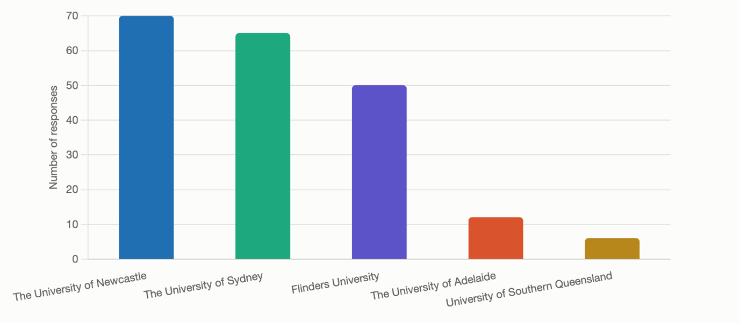
With respect to the representativeness of the student survey, responses came from a broad cross section of degrees and disciplines (Figure 2). Medical science was the single largest cohort, driven largely by the Flinders University cohort. Criminology and law were the second-largest cohort, heavily represented by University of Newcastle students. The high rate of response from these fields at these institutions can be in part attributed to the recruitment efforts of our peer researchers Ellen Dungavell and Chloe Walton. As students in these disciplines, peer researchers were able to leverage their relationships with their colleagues to drive survey recruitment. The concentration of responses, however, reinforces the earlier discussion about the potential institutional skew, as discipline representation in this survey is partly an artefact of recruitment. It is also important to note that because respondents were asked to enter their degree as an open-ended question, some categorisations reflect individual judgement, by both the students and the researchers. In Figure 2, combined degrees (for example, Arts/Law and Science/Psychology) were assigned to the discipline that appears most prominent or was listed first. In addition, there were a small number of responses that were vague or unclear, resulting in the need for an “other/unclear” classification. As with the above discussion of university representativeness, a significant number of survey respondents elected not to name their degree.

Figure 2: Degrees represented in the student survey
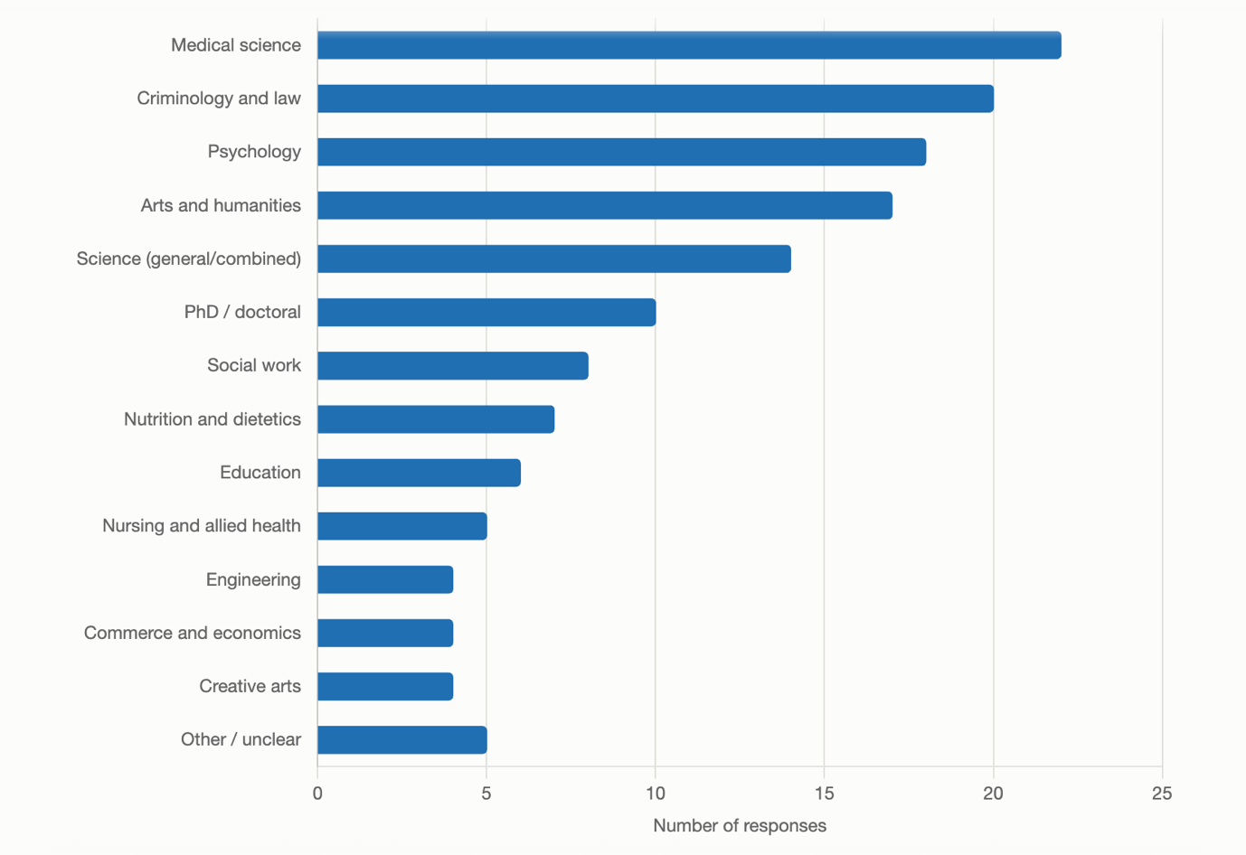
For the survey of higher education professionals, we received a total of 129 responses, with 49 participants completing all questions (37.98% completion rate). For Large-N surveys, a completion rate of 50% provides an optimal dataset for understanding core trends and capturing participant sentiment. While the 38% response rate is less desirable, the partially completed surveys provided significant insights and served as validation points for Phase 2 qualitative interviews with higher education professionals. The low completion rate for university staff is likely attributable to the survey length (53 questions). As was echoed in the findings of this research, at times of heightened workload pressure, substantive tasks, such as a long survey, place extra burdens on staff and result in high levels of opt-out behaviour for volunteer, time-intensive opportunities.
Demographic data including age, gender, faculty, and university role were captured as part of the survey. However, after consultation with colleagues across the university sector, the decision was made not to collect data on the location or university of survey participants. Feedback received on the draft survey was that academic and professional staff would be less likely to participate if they were asked to identify their workplace. This concern is well supported in survey methodology literature, which indicates that perceived anonymity is a significant predictor of participation rates and response honesty. This is particularly evident when the subject matter relates to workplace practices or institutional culture (Tourangeau & Yan, 2007). By removing institutional identifiers, the survey aimed to maximise psychological safety for respondents and to encourage more candid and representative responses across the sector.
Despite this, the team acknowledges that this decision may represent a limitation of the study. Without institutional or geographic data, it is not possible to disaggregate findings by university type, size, or location, which may mask meaningful variation in the experiences of providing reasonable adjustments for students with invisible disabilities across different institutional contexts. It is worth noting, however, that despite the absence of geographic and institutional data in Phase 2 (interviews), participants were drawn from across Australian states and territories, providing a degree of geographic breadth to the broader study. Furthermore, the primary focus of the research is on the lived experiences of students; as such, the professional and academic staff survey responses serve as an important but complementary dataset rather than a central analytical focus. Future research may benefit from employing opt-in institutional identification or aggregate-level location data as a compromise between participant comfort and analytical depth.
Several avenues for recruitment were used. First, CIs drew on existing networks across the Australian university sector (including teaching, research, and professional staff, as well as management) to distribute and promote the survey and its potential benefits. Second, the survey was shared by CIs and the funding body (ACSES) on LinkedIn to capture professional networks. Finally, the survey information and links were shared via the ADCET newsletter.

5.2 Phase 2: Revealing the stories of invisible disabilities in higher education
Phase 2 employed a qualitative grounded theory approach (Charmaz, 2014) to better understand the learning experiences of students with invisible disabilities. This approach centred the voices and experiences of individuals traditionally silenced in investigative research (Fairclough, 2013). While the findings below are organised thematically, our focus was not to identify generalisable trends, but rather to reveal the lived experiences of the student participants in the research and those who work closely with them. We sought explicitly to create thematic links, using participants’ narrations, and to highlight what reasonable adjustments can and should be, as well as the barriers and opportunities that inform their experiences.
Phase 2 involved a combination of focus groups (90 minutes in duration) and online semi-structured interviews (one hour). Focus groups were selected as the initial approach, as scholarship suggests peer-to-peer exchange presents greater opportunity for candidness (Berents et al., 2024) and has successfully been used before with students with disabilities in higher education (Biggeri et al., 2020). Thirteen focus groups and four individual interviews were conducted, engaging 44 students with invisible disabilities. To ensure inclusive research practice (De Cesarei & Baldaro, 2015), students who opted to participate in a focus group had the opportunity to do so with their cameras off, by typing responses into the chat rather than engaging verbally, and closed captions were available. These options were noted in the invitation, and students with disabilities could request other adjustments with the researcher upon their acceptance of participation (Olsen, 2019). Focus groups were led by peer researchers Ellen Dungavell and Chloe Walton, supported by Chief Investigator Caitlin Mollica. During focus groups, the peer researchers coordinated their engagement with students, with one monitoring the chat, while the other facilitated the verbal discussion. This helped to ensure that all students, regardless of how they chose to participate, felt supported, engaged, heard and seen in the conversation.
As the experiences of students with invisible disabilities are often informed by their interpersonal engagement with university staff, it was important to hear the perspectives of these individuals. The chief investigators and peer researchers utilised an opt-in function in the survey, and snowball sampling to conduct 19 semi-structured interviews with higher education professionals. These interviews took place online between August and December 2025.

5.3 Phase 3: Closing the feedback loop and co-designing recommendations

To validate the data and to continue our co-design approach, student and staff participants from Phase 2 were invited to an optional online workshop or to provide written feedback in March 2026. A one-hour staff workshop was held with two higher education professionals—one academic and one professional staff member—from different institutions. A 90-minute workshop was held with two students from different institutions. Additionally, written feedback was provided by one staff member and one student. Low participation can likely be attributed to timing and workload pressures for both staff and students. Interviews were conducted during working hours, and at a busy time in the university calendar (within the first weeks of semester for many). The available sample for this third phase was also informed by the exclusion criteria, as only previous focus group and interview participants were invited to attend. Despite the small number of participants, these workshops were invaluable for the research and its outcomes due to the highly engaged nature of participating staff and students.
Recommendations were initially constructed by the research team, led by the peer researchers. They respond directly to the core challenges identified during the data collection. Following this initial development phase, recommendations were workshopped with both higher education professionals and students who had participated in Phase 2 of the project. Participants unable to attend the workshops were invited to provide written feedback to ensure their voices were still captured in the final phase of the project. To implement a co-design approach, individuals were presented with the core findings of the research and the draft recommendations (written documentation was sent to participants prior to the workshops to enable preparation). During the workshops, participants were asked to provide feedback on the appropriateness of the recommendations, and to make any suggestions for changes and additions. This process, including the workshopping of the recommendations, has produced a series of targeted, tangible, and responsive actions that the research team is confident reflect the needs and experiences of the key stakeholders most impacted by accessibility processes in the higher education sector.
This process aimed to ensure that any implementation of policy changes or amendments to practice that result from these recommendations will be informed by the individuals most impacted by these processes and their subsequent outcomes.

5.3.1 Approach and positionality
In the project design, in data collection, and in the analysis of the data, we adopted a neuro-affirming, inclusive approach to the research, recognising that research has often been done on, rather than by or with, disabled people (Ollerton, 2012). Our research design incorporated choice as a key participatory mechanism, ensuring that respondents had ownership over how they participated. By providing participation options, the chief investigators were able to account for the accessibility needs of participants (Biggeri et al. 2020) and conducted the research by, with, and for people with disabilities (Biggeri & Ferrannini, 2014; De Cesarei & Baldaro, 2015). In terms of positionality, the team includes both researchers and peer researchers with invisible disabilities and researchers who are carers for people with invisible and physical disabilities.

5.4 Ethics
Ethics approval was granted by the University of Newcastle Low Risk Ethics Committee (Ethics Approval Number H-2024-0277). All data is de-identified except for the last section of the survey, which allowed participants to opt in for further research engagement. Participants were free to withdraw at any time and supported to participate in a way that suited them.

Findings
This section presents the findings from Phase 1, the analysis of the 34 publicly available disability action plans (DAPs) (Section 6.1) and the staff and student survey (Section 6.2); and the findings from Phase 2, student focus groups (Section 6.3) and staff interviews (Section 6.4).

6.1 University disability action plans
The thematic analysis of DAPs identified six key themes as outlined below:

6.1.1 Theme 1: Institutional recognition and conceptualisation of invisible disability
We reviewed university DAPs to assess whether they expressly acknowledged invisible disability, including its (invisible) nature, prevalence, and characteristics. While all 34 plans addressed disability in general terms, only nine (approximately 26%) explicitly recognised “invisible,” “hidden,” or “non-visible” conditions. Recognition often remained implicit, appearing under terms such as “neurodivergence” (24%), “chronic health-related experiences” (18%), or “fluctuating conditions” (18%). Other plans recognised aspects of invisible disability indirectly through measures such as the provision of sensory spaces (15%), wellbeing initiatives (47%), or strategies targeting cognitive load (26%) and variable participation (32%).
DAPs that acknowledge the prevalence of invisible disability remain rare. Only two (6%) of the reviewed plans—those of Charles Darwin University and Federation University Australia—expressly noted the proportion of registered students with disability who had invisible disabilities (87% and 83%, respectively).
Disability is not static and may be temporary, short‑term, or fluctuating in its impact, which is particularly relevant for students with invisible disability. Eleven (32%) of the reviewed plans explicitly acknowledged this. In addition, four plans (12%) noted that students with the same diagnosis may require different support measures, and five plans (15%) acknowledged that students may have more than one disability or complex needs involving multiple conditions. Six plans (18%) explicitly recognised that students have the right to choose whether to disclose their condition or elect to disclose only aspects of it.
Twelve plans (35%) addressed intersectionality, expressly adopting it as a core part of their strategy (for example, Monash University and The University of Queensland), while 27 plans (79%) linked the disability plan to other equity and diversity frameworks. Some plans specifically acknowledged First Nations peoples with disabilities (32%).
Overall, students with invisible disability were unevenly represented across university DAPs. Our review of DAPs indicates a general shift towards the social model of disability, although this often coexists with medical-model language, perhaps due to the requirements of the Disability Discrimination Act 1992 (Cth) (DDA). While some DAPs explicitly adopt the social model of disability as a guiding framework, others continue to rely on express medical-model formulations. Federation University Australia’s DAP illustrates this tension. Although the plan includes action items aimed at removing barriers, it frames restrictions on participation primarily in terms focused on individual challenges, rather than institutional and societal barriers:
Disability can impair a person’s functionality, limit their activities and/or restrict their participation in life situations, including their involvement in some or all facets of university life. (Federation University Australia)
More broadly, many DAPs combine strong commitments to barrier removal and lived experience but with continued reliance on diagnosis, documentation, and categorical eligibility as gateways to support, rather than implementing universal design approaches and a less medical-based analysis of disability. Given these mixed framings, it is difficult to determine how many universities expressly adopt a social model as opposed to a medical model in practice.

6.1.2 Theme 2: Institutional pathways for support systems and adjustment processes
All DAPs reviewed set out formal pathways for accessing disability support, including referral processes, determination of adjustments, and their implementation and oversight. Common measures included early signposting at recruitment and enrolment (included in approximately 41% of DAPs), confidential consultations (15%), and formal procedures for documenting and implementing reasonable adjustments (100%). Some plans emphasised coordinated processes (24%), including communication with teaching staff and compliance monitoring, while others prioritised responsiveness and accessible channels for discussing adjustments (26%). Several universities also sought to improve navigability through plain‑language guidance and “how‑to” materials (32%), alongside commitments to consistency, timeliness, and feedback‑driven improvement (44%).
Substantively, all DAPs committed to reasonable adjustments in learning and assessment, with some extending these commitments to professional placements, work‑integrated learning, and practicums (41%). Twenty-seven (79%) of the plans committed to clear communication of responsibilities to teaching staff to ensure that adjustments documented in access plans are implemented. Twelve (35%) of the plans sought to ensure faculty- or university‑wide consistency expectations.
More than half of DAPs (53%) included formal commitments to develop, publish, or review “inherent requirement” statements, outlining fundamental tasks and core expectations of a program—including those mandated by professional accrediting bodies—which must be met with or without reasonable adjustments. Only one plan (Charles Darwin University) explicitly emphasised that such requirements must not be designed or applied in exclusionary ways.
Most DAPs distinguished between individual adjustments and proactive, embedded accessibility measures (76%)—including to “actively remove barriers wherever possible” (Western Sydney University)—intended to “reduce the need for individual or remedial services” (James Cook University). In a small number of cases (21%), plans articulated a longer‑term shift towards universal design and structural change. These plans contained similar end goals as reflected in the following statement:
Over time, the need for Access Plan documents should diminish as inclusive teaching practice is adopted and embedded in course design and options for flexible assessments become more commonplace. (Victoria University)

6.1.3 Theme 3: Inclusive learning environments
All DAPs reviewed included substantive commitments to inclusive learning environments, translating high-level aspirations into pedagogical goals.
Twenty-seven out of 34 plans (approximately 79%) specified staff development in inclusive teaching, typically through disability awareness training or Universal Design for Learning (UDL) workshops. Among these, 15 mandated that these resources and training be provided to both academic and professional staff. Some DAPs provided case studies for each disability type to allow better understanding of students’ needs and to ensure inclusive pedagogy is both mandated and supported (for example, Victoria University and La Trobe University).
The majority of universities (62%) acknowledged that UDL promotes flexible curriculum design to reduce barriers for diverse learners. Eight plans (24%) moved beyond curriculum design to extend UDL principles to wider institutional practices, including assessment, building accessibility, and technology development. Ten plans (29%) set explicit expectations for standardised LMS design to reduce cognitive load and ensure equitable navigation. Nine plans (26%) prescribed strict timelines for reading lists and alternate formats. For learning that occurs beyond lecture theatres, half of the plans (50%) called for inclusive approaches to placements, fieldwork, and laboratories to ensure students could meet learning outcomes through accessible methods.
While all universities incorporated student input on the learning environment (ranging from surveys and consultation to other forms of feedback mechanisms), 26% of plans identified co-designing institutional solutions with students with disabilities and 38% championed student-led initiatives, including student-led committees or other positions (for example, senate representation of students with disabilities).

6.1.4 Theme 4: Digital and technological accessibility for cognitive and sensory diversity
All DAPs reviewed referred to digital and technological accessibility as an important component of institutional support and legal compliance. Nine plans (approximately 26%) noted that digital environments need to accommodate varied sensory and cognitive processing styles, often linking this to neurodivergence (for example, Monash University and La Trobe University). Nine DAPs committed to accessible interface design (for example, clear navigation structures and predictable layouts) and reducing cognitive load through consistent digital layouts (for example, Macquarie University, Charles Darwin University, and Victoria University). Twenty DAPs (approximately 59%) included specific commitments to provide captioned and transcribed multimedia (for example, Curtin University, Queensland University of Technology, and University of New South Wales). Twenty-five DAPs (74%) connected digital accessibility to formal accessibility audits, Web Content Accessibility Guidelines (WCAG)‑aligned development, the creation of digital‑accessibility guidelines, and ongoing quality‑assurance processes intended to maintain inclusive digital practice. Twenty-three DAPs (68%) outlined the use of multimodal learning materials and specific assistive or adaptive technologies to support students who require flexible formats (for example, Murdoch University, The University of Melbourne, The University of Newcastle, and The University of the Sunshine Coast).
Further, six DAPs (18%) committed to measures being implemented to ensure that IT software and applications are tested for reliability and responsiveness. Macquarie University reported embedding a procedure to ensure all student-facing systems “include user testing with people who have lived experience of disability before being launched”. Seventeen plans (50%) mandated compliance with accessibility requirements during the procurement process.

6.1.5 Theme 5: Belonging, campus participation, and the social experience of invisibility
Belonging and participation refer to the extent to which students with invisible disabilities can fully engage in university social and cultural life without stigma or the need for their disabilities to be visible. Nine DAPs (approximately 26%) explicitly identified fostering a sense of belonging as a guiding principle for inclusive education (for example, Monash University, Deakin University, and Flinders University). For instance, the University of Tasmania has committed to creating “educational experiences and environments to which people with disability feel a sense of belonging and connection”, while 14 others (41%) link sense of belonging to the general wellbeing of students with disabilities.
Nineteen universities (56%) supported this aim by requiring campus events and communications to follow accessibility checklists (32%) and/or inclusive language guidelines (53%), (for example, Australian National University, Curtin University, and The University of Sydney). In addition, twelve DAPs (35%) addressed attitudinal barriers through staff training on respectful communication and awareness of invisible disability.
Fourteen DAPs (41%) further institutionalised inclusion by directing marketing and communications staff to use positive language and inclusive imagery to ensure that disabled identities are represented respectfully in the campus narrative (for example, Swinburne University of Technology, University of Wollongong, and Charles Darwin University). Plans also recognised and celebrated the achievements of students with disability (47%)—through awards (18%), profile stories (24%), or participation in International Day of People with Disabilities activities (32%)—so that disability becomes part of the community’s shared story.
Nineteen DAPs highlighted that inclusiveness and accessibility are essential preconditions for equitable participation, academic success, and a culture in which all members of the university community are valued. As The University of Sydney’s DAP emphasised, this means: “…developing a university culture where each person is valued for their individual contribution”.
In building an inclusive culture, 12 plans (35%) reported on institutional monitoring of cultural change (for example, The University of Sydney, Australian National University, Monash University, Western Sydney University, and The University of Western Australia).

6.1.6 Theme 6: Structural, policy, and governance frameworks supporting invisible disability inclusion
Across the DAPs reviewed, universities embedded progressive improvement cycles—such as scheduled reviews and reporting (100%)—and defined measurable targets or indicators that allowed monitoring of implementation quality and outcomes (approximately 91%). Thirty-one DAPs (91%) provided express timeframes or implementation deadlines for key actions. These functions were commonly overseen by formal governance bodies operating within regular review cycles (100%).
All DAPs specified accountability structures by assigning clear role accountabilities, naming officers, committees, or senior administrators responsible for specific actions (for example, Pro Vice‑Chancellors, Directors of student support, and access and inclusion teams). Accountability was distributed across academic and administrative leadership (for example, human resources and culture, IT, facilities and estates, and marketing and communications) rather than siloed within disability services (100%). All universities utilised cross-functional committees (for example, Flinders University’s Disability and Accessibility Committee and the University of New South Wales’ Disability Inclusion Action Plan Implementation Group) that reported directly to the Vice-Chancellor or university executive.
Policy coherence was reinforced through alignment with legislation (100%), including the DDA, the Disability Standards for Education 2005 (Cth) (DSE), and state legislation (for example, the Western Australian Disability Services Act 1993). However, reference to the DDA may sometimes lead to mixed messages about the appropriate social or medical model framing as noted above. Ten DAPs (29%) referenced international standards and frameworks including the UN CRPD, the UN Sustainable Development Goals, the WCAG, and the European Union Universal Design for Learning – Best Practice Guidelines. Twenty-seven DAPs (79%) integrated disability considerations into broader institutional strategies and core plans.
Twenty-five DAPs (74%) specified grievance and escalation pathways, enabling students to raise concerns when institutional practices do not meet policy commitments (for example, University of Southern Queensland and Bond University). Uniquely, only the University of South Australia incorporated positive recognition (as opposed to complaints) into its reporting mechanism. All universities (100%) committed to community-wide dissemination of the DAP to ensure visibility and shared responsibility across the university.
The extent to which stated commitments in DAPs matched the experiences of students and staff is explored in the findings from the nationwide surveys (section 6.2), the student focus groups (section 6.3), and the staff interviews (section 6.4).

6.2 Nationwide surveys
Survey findings were analysed using a mixed-methods approach. Data was cleaned to remove invalid responses (that is, participants from countries other than Australia). Following this, calculations were run for descriptive statistics (averages and percentages) to reveal top-level trends within and between the two surveys. Finally, open-ended questions were thematically analysed in both the student survey (section 6.2.1) and the staff survey (section 6.2.2). Due to length requirements, further quantitative analysis including regression analysis have not been included in this report. Instead, the survey findings have been utilised to illustrate the macro trends emerging within the higher education sector with respect to the experiences of students with invisible disabilities and higher education professionals. These trends assist in providing a thematic foundation for the findings and analysis of Phase 2 (sections 6.3 and 6.4). Further analysis of the survey data is planned for future publications.

6.2.1 Student survey macro trends and thematic findings
The student survey instrument reached 1,262 views and was completed by 161 participants (50.32% completion rate); however, as noted previously, there was a total of 320 responses. To ensure student autonomy, the survey settings allowed for participants to skip questions. Accordingly, response rates are reported alongside averages and percentages to support data transparency.
A substantial majority of respondents answered “yes” (n = 252/281) to the question of whether they self-identified as having an invisible disability (89.68%). The approximately 10% of students who responded “no” have been excluded from the analysis and findings. Among those who answered the diagnostic question, 94.12% reported a clinical diagnosis (n = 208/221). Women constituted 71.85% of the sample (n = 171/238), with 11.34% identifying as non-binary (n = 27/238), 14.29% identifying as male (n = 34/238), and 2.52% preferring not to disclose their gender or self-describing (n = 6/238). The majority of participants were undergraduates 76.37% (n = 181/237), and 72.2% (n = 177/244) were studying full-time.

Figure 3: Word cloud showing student survey respondents’ descriptors of their disability
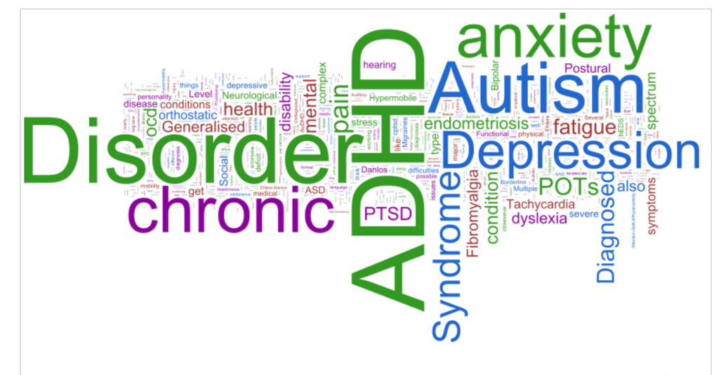
When asked to describe their invisible disability, students used a wide range of language beyond the medical terminology. However, some common diagnosis-based phrases did emerge as prominent in how people understood their invisible disabilities (Table 1).
Table 1: Diagnosis-based descriptors used by student survey respondents
Word | Count
ADHD | 72
Disorder | 65
Autism | 51
Chronic | 46
Anxiety | 44

6.2.1.1 Disclosure and support needs
In total, 80% of respondents (n = 193/239) disclosed their disability to their university (for full disclosure statistics, see Appendix 2). Yet many described the process as administratively heavy and emotionally taxing. As one student explained: “Even applying for academic plans every semester for permanent disabilities is exhausting and unnecessary”. Another noted: “The process of accessing [support pathways] seems difficult, long wait times to be seen caused me to just give up”. Students repeatedly asked for plain English guidance and streamlined steps, with one respondent suggesting: “Clear guidelines and easy-to-follow steps would help students feel more confident in accessing the support they need”. Among students who chose not to disclose their disability, the responses revealed that bureaucratic processes (for example, an absence of formal diagnosis, long wait times, and extensive paperwork), negative perceptions about what help is available, and fear of stigma and reprisal were key demotivators. Student responses also revealed several prominent reasonable adjustments across the higher education sector.
These prioritised environmental or structural adjustments to assessments. Respondents indicated that they believed an administrative preference exists for the provision of accommodations that are time-based (for example, extra time in exams, assignment extensions, and rest breaks), or environmental (for example, smaller exam rooms, permission to leave class, and access to assistive technologies such as text-to-speech). Students acknowledged some supports, but many experienced them as generic rather than tailored, and often not functionally relevant. As one student explained: “Everyone gets the same basic plan—more time for assignments and exams”. Among the noted adjustments that students found helpful, recorded lectures and the advance release of materials were singled out as impactful. This was reflected in the student responses, one of which noted: “I LOVE … that all lectures are recorded”. Others valued one-on-one or alternative assessment formats, including one student who shared: “My lecturer allowed me to do an in-class presentation one-on-one”.
ILLUSTRATIVE RESPONSES ABOUT NON-DISCLOSURE
“Who would I even inform? I’m not sure. Some of my lecturers know.”
“I know it’s a long wait list for the support. I should (disclose), but I haven’t.”
“The supports they have are not things that would help me. Extended time for assignments is not something I need.”
“The process of declaring it seemed too complicated, and its easer to just get doctor notes as needed for ‘mental health’.”

Table 2: Adjustments or supports student survey respondents received from their university
Accessibility provision | Count
Additional time for every hour in exams | 117
Smaller exam rooms | 95
Extra assistance through assistive technologies (talk to text) | 92
Other assignment adjustments (unspecified) | 56
Assignment extensions | 54
While students indicated that time-based supports were “somewhat” useful, they expressed a preference in the open-ended responses for pedagogical adjustments. Specifically, they highlighted the importance of clearer instructions, standardised LMS pages, scaffolded tasks, and multiple ways to demonstrate learning. One wrote: “Assignments are slightly inaccessible because I need more clarification on layout and content”. Another wrote: “I would love it if all CANVAS [LMS] pages were standardised”. Where group work and presentations were concerned, students indicted that adjustments, such as recorded presentations or private or reduced audience options, were often essential to enabling their learning.
These sentiments were also reflected in students’ responses to diverse aspects of their university experience. For example, cumulatively, 19.69% (n = 37/188) recorded different degrees of inaccessibility in communication with lecturers and tutors; and 23.29% (n = 43/184) noted a degree of inaccessibility when accessing disability related supports and adjustments (see Appendix 2 for further graphs). Student sentiment in the quantitative data suggested a high degree of neutrality with respect to their university experience (Figure 4). When asked to elaborate in open-ended questions about these experiences, sentiment was less neutral, suggesting a complexity exists in how students with invisible disabilities reflect on the nature of their experiences. This was evident in the following illustrative qualitative response: “The accessibility of content, online learning platforms, and assignments is really variable by each topic and coordinator”. Another student noted: “I think it can vary between subjects and tutors. Some teachers made my uni [experience] more accessible than others”.
Figure 4: Student survey responses: “How accessible do you find university services”?
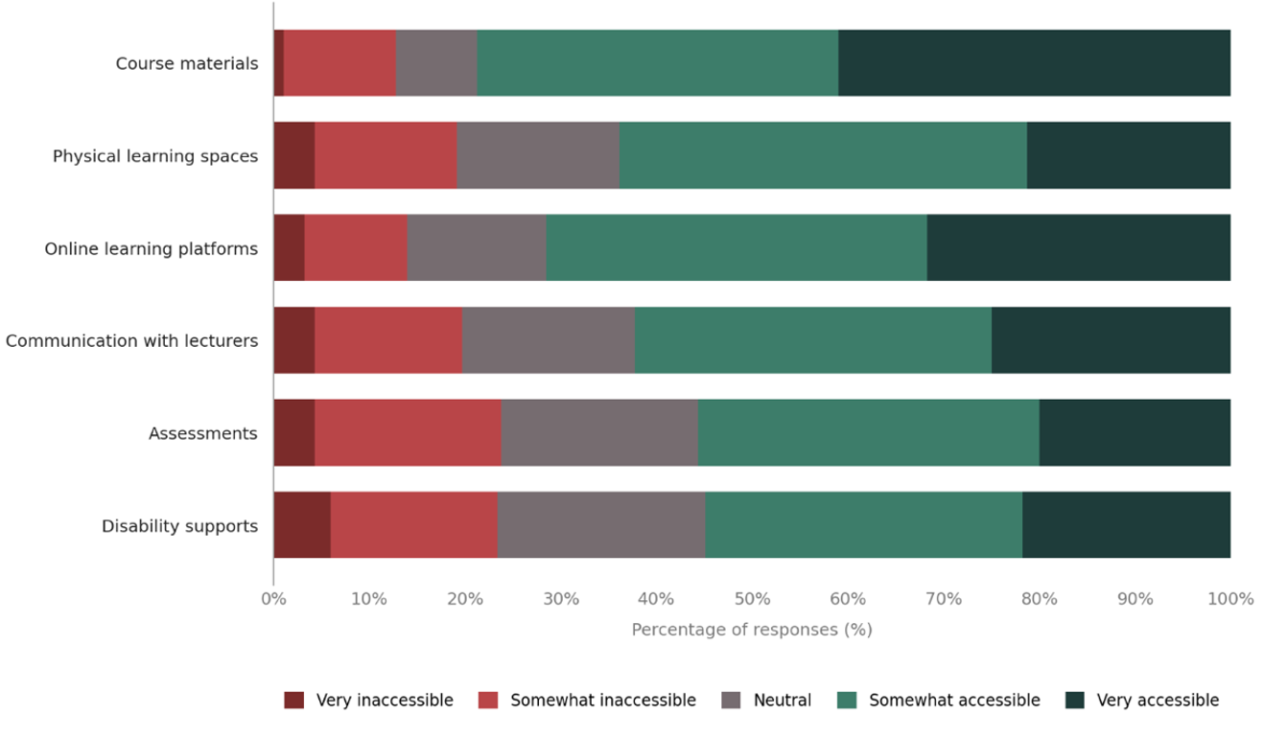
The neutrality in student responses continued when they were asked to reflect on their access to information. Qualitative responses suggested that sentiments around accessibility provisions were less neutral than quantitative metrics can capture. Open-ended questions within the survey provided important insights regarding what accessibility provisions students would find most useful. For example, many students highlighted the importance of neuro-affirming, person-centred language in policy and communication. This trend was reflected in the response of one participant who suggested that all references of and about disability in university communications, particularly to students, should prioritise inclusive language that highlights the traits and characteristics of the disability experience, as opposed to emphasising symptoms and preferencing deficit medical language. They noted specifically that deficit-focused language can erode trust between the student and the institution. Throughout the survey responses, students also expressed a desire for plain English policy guides to reduce the hidden curriculum of self-advocacy.

Figure 5: Word cloud illustrating initiatives or changes that would improve inclusion, according to student survey responses
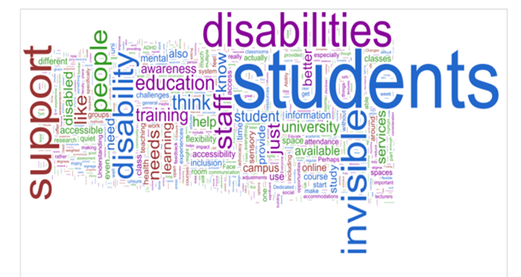
Where students reported genuinely positive experiences, and when asked what changes would improve their access to education, the strongest positive testimony clustered around positive interpersonal relationships with university staff, informed needs-based choice, education for students and teachers, and purposive design choices that reduce cognitive load and social risk, such as:
- predictability and clarity: standardised LMS, step-by-step briefs, early release of materials
- meaningful choice: alternative formats (for example, oral versus written), private presentations, flexible attendance
- low-friction supports: automatic short extensions, proactive check-ins
- visible allyship: staff who signal understanding (including lived experience).
Illustrative quotes included: “I have been granted numerous no-questions-asked extensions”, and “She [the lecturer] made me feel extremely supported and has forever left a positive mark on my university journey”.
Beyond classroom pedagogy, students identified barriers in the campus ecology including long distances between classes, lighting and sensory factors, and timetable clustering. When asked what adjustments could be made to create a more enabling environment for their learnings, suggestions included more low-sensory spaces and hybrid or online options to accommodate fluctuating capacity, fatigue, or pain. These environmental and scheduling adjustments were framed by survey respondents as crucial for the feasibility of their learning, including their active participation in class.

6.2.1.2 The burden of help-seeking
Access to inclusive education for students with invisible disabilities is often contingent on the student’s capacity to consistently and repeatedly advocate for their needs, as demonstrated in the survey responses. Many participants described supportive staff and disability teams; however, trust was often conditional and uneven.
When asked how inclusive they felt the university community was for students with invisible disabilities, 67% (n = 108/160) responded negatively or with neutrality. This suggests that survey respondents felt isolated in their learning experience by interpersonal and environment factors (Figure 6). This sentiment was also reflected in the open-ended questions, where students reported a reluctance to disclose their disability unless staff first signalled safety. One student noted: “I avoid telling people because … I am treated differently.”
Figure 6: Student survey responses: “How inclusive is your university community for students with invisible disabilities?”
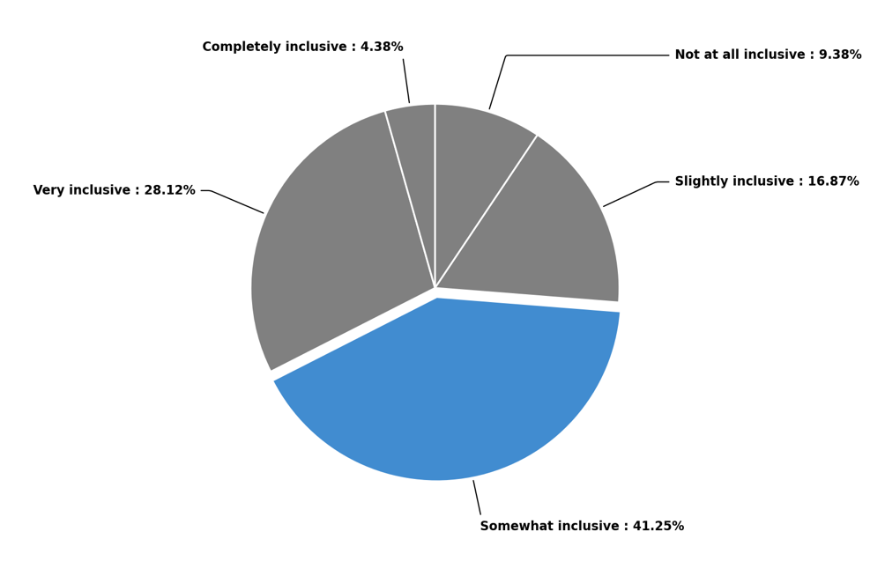In addition, where disclosure had occurred there was often a significant emotional cost, as one student explained: “Every time I have to decide whether to disclose my disability … I feel embarrassed, ‘less than’, [and I] worry others will think I am not capable and a burden”. This emotional labour is often exacerbated when peer stigma occurs, with respondents reporting that they had received comments from peers about their adjustments being “unfair”. The value of peer understanding was further revealed in the survey data (Figure 7), with many participants expressing the belief that their peers do not have a good understanding of how invisible disabilities impact on learning experiences. This form of stigma further discourages visibility and help-seeking among students with invisible disabilities.
Figure 7: Student survey responses: “Do you feel your peers understand how invisible disabilities impact your learning experience?”
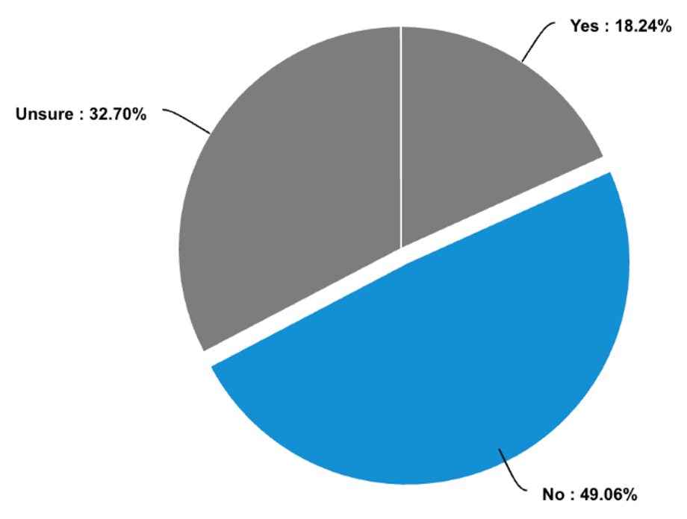
Within the survey data, the burden of help-seeking was reflected in students’ responses regarding advocacy and information. When asked if they felt empowered to advocate for their needs, 43.64% (n = 72/165) indicated that they were “somewhat” empowered, with only 7.2% (n = 12/165) feeling “completely” empowered. At the same time, when asked if they felt the university provided sufficient information about their rights and legal obligations, 45.78% (n= 76/166) responded that they were “unsure”, indicating that not only do students experience challenges advocating for their needs, they also likely do not have the information to ensure that advocacy would be successful (see Appendix 2 for survey data graphs). Among the responses collected via open-ended questions, there was a reoccurring and prominent sentiment that documentation burden was a significant barrier to access and inclusion. The feeling of having to “prove” disability repeatedly highlighted the negative impacts of help-seeking, as one student explained: “The sheer amount of medical evidence you need … is exhausting”. Students reported delays, opaque webpages, and duplicative steps (for example, reapplying every term). For some, formal proof was financially and logistically hard to obtain, especially for neurodivergence or complex chronic illness. As one student noted: “I have ADHD declared, but also migraines, POTS (Postural Orthostatic Tachycardia Syndrome), and now perimenopause (not declared as obtaining extra supporting documentation was too much)”. These responses reveal that the creation of a more inclusive higher education sector for students with invisible disabilities requires reforms to the processes that are pathways to access. Furthermore, they suggest that there is a significant need to streamline how students interact with these practices and systems, to build trust among students that they are operationalised in their best interests.
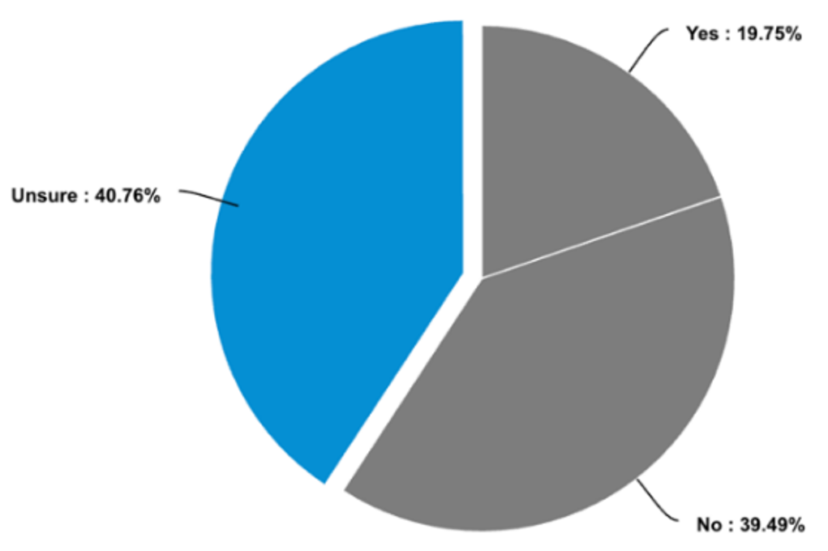
Figure 8: Student survey responses: “Do you feel university staff are adequately trained to support students with invisible disabilities?”

6.2.1.3 Concluding insights
Throughout the survey data, the general sentiment was not that adjustments do not exist, but that access to the right adjustments, early enough, with minimal friction, remains inconsistent.
Among the respondents, there was uncertainty about the capacity of staff to support students with invisible disabilities (40.76%) (n = 64/157), and cumulative belief that current curriculum is not designed to be proactively supportive of students’ needs (see Appendix 2). In response, students reflected a desire for implemented strategies that would enable universities to design for difference up-front (UDL), to simplify and humanise administrative pathways (for example, once-only verification for permanent conditions, and plain English steps), and to normalise flexibility so it is not seen as exceptional. Where teaching teams and services did this, students described real inclusion. They noted that within these enabling environments, they did not bear the cumulative cognitive, emotional, and financial costs of navigating a system not built for fluctuating capacity.

6.2.2 Staff survey macro trends and thematic findings
The staff survey received a total of 129 responses, with 49 participants completing the survey (37.98% completion rate). As with the student survey, to ensure autonomy and flexibility, the survey settings allowed for participants to skip questions. To that end, when averages and percentages are included here, we have provided the response rate for the specific question to ensure data transparency. Among survey respondents, there was an even split between academic and professional staff (see Appendix 2). Within the data, the research team sought to capture responses from university staff who occupied roles most directly connected to students’ academic experience and the implementation of accessibility plans. Thus, the decision was made to disaggregate between different types of academic staff (for example, course coordinators, tutors, and research assistants), but not to capture the role of professional staff members (for example, disability support officers and student support staff). Despite this decision, open-ended questions throughout the survey did provide opportunities for professional staff members to highlight their specific role at the university. By including the roles of tutor and research assistant as distinct categories, we were able to capture data that highlighted how individuals in these roles interact with and inform students’ day-to-day academic experience. Tutors frequently serve as primary points of contact for students around assessment and coursework, and as such are often central to the negotiation, communication, and enactment of accessibility plans, alongside the course coordinator. Their unique perspectives were therefore considered particularly important to capture within the study design.

In contrast, the category of “professional staff” was not intended to represent the full diversity of professional staff roles within the university sector. While staff working in areas such as disability support, student services, and academic learning and skills play a valuable role in the broader student experience, the survey was designed to centre the perspectives of those staff most directly engaged in a day-to-day academic relationship with students, particularly with respect to the implementation of accessibility plans. Professional staff responses are captured within the dataset as an important complementary source of insight. However, the granular breakdown of professional staff functions was considered outside the scope of a study which primarily aims to analytically engage with the lived experiences of students with invisible disabilities and their experiences with the implementation of accessibility adjustments.
Of the 84 participants who answered the question “How long have you been working in higher education?”, 50% had been in the sector more than 10 years (Figure 9). In addition, 70% of staff identified as female (n = 56/80), 20% as male (n = 16/80), 5% as non-binary (n = 4/80), and 5% chose not to declare their gender (n = 4/8). A wide age range was also represented in the survey (see Appendix 2).

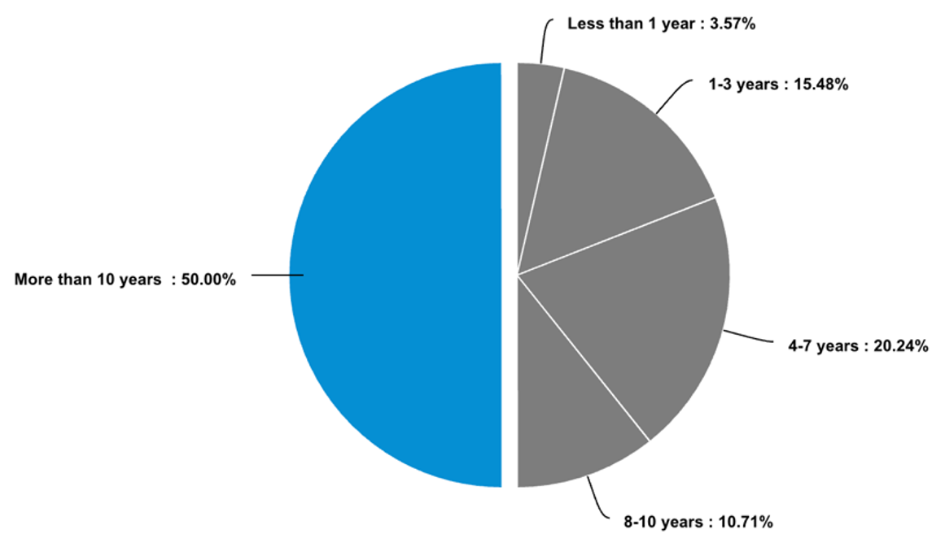
Figure 9: Staff survey responses: “How long have you been working in higher education?”
A broad range of schools, professional departments, and disciplines are represented in our survey responses. However, there are also some noticeable absences including education and traditional science, technology, engineering, and mathematics (STEM) subjects (although medicine and public health is well represented). Across the disciplines, 89.29% (n = 75/84) of staff reported interactions (both direct and indirect) with students who identify as having an invisible disability (Figure 10), indicating a high degree of familiarity with these students.
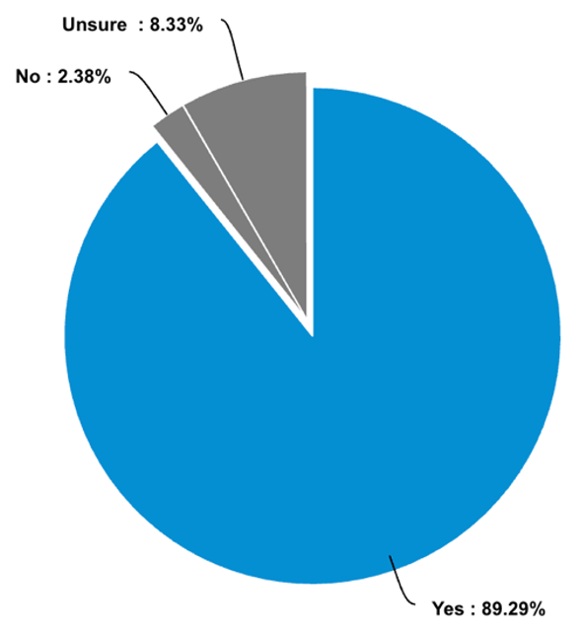
Figure 10: Staff survey responses: “As part of your employment responsibilities, have you interacted with students with invisible disabilities?”
Generally, staff reported a high level of commitment to ensuring inclusive education but acknowledged that their capacity was constrained by structural and environmental conditions. This dedication was reflected in the high proportion of staff who reported feeling either “very” or “completely” comfortable communicating with students about their needs (Figure 11). It was also evident in the higher percentage of respondents who indicated that a professional responsibility exists with respect to the implementation of reasonable adjustment for students with invisible disabilities. Indeed, 89.86% (n = 62/69) agreed or strongly agreed that it was their professional responsibility to implement adjustments (see Appendix 2 for further data). Despite this dedication, only 42.03% (n = 29/69) felt institutionally supported to fulfil this commitment.
Figure 11: Staff survey responses: “How comfortable do you feel communicating with students about their needs related to their invisible disability?”
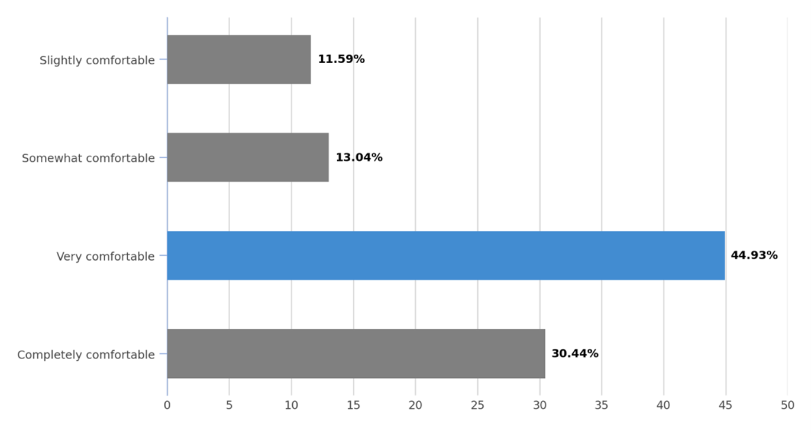A reduced sentiment about institutional support did not, however, extend to training, with over half of respondents indicating that they had received some form of formal training on disability inclusion and accessibility (Figure 12). In addition, there was a diverse range of sentiments among survey respondents with respect to confidence in their capacity to implement reasonable adjustments, with 33.3% (n = 23/69) indicating a high level of confidence, 31.9% (n = 22/69) agreeing they felt confident, 23.2% (n = 16/68) expressing neutral feelings, and 11.6% (n = 8/69) noting some degree of uncertainty with respect to implementation capacity.
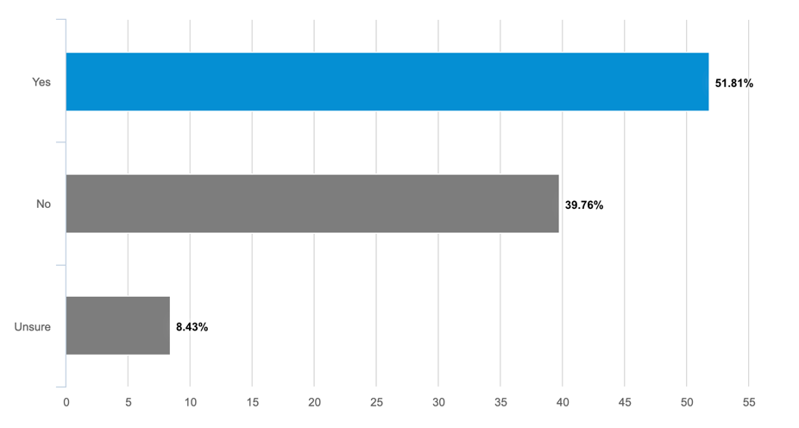
Figure 12: Staff survey responses: “Have you received formal training?”
For 57.82% (n = 37/64) of staff surveyed, UDL has become a central component of their teaching pedagogy. Indeed, 53% (n = 34/64) indicated that they designed their teaching or support services in ways accessible for all students. Despite this, many indicated that they often or always experienced barriers, such as rigid policies and inaccessible technological tools, which they believed impacted upon the learning experiences of students with invisible disabilities.
Table 3: Staff survey responses: Encountered barriers to the learning environment
How often do you encounter barriers when seeking to support students in their learning environment? | Response (%)
Always | 8.47% (5)
Often | 38.98% (23)
Sometimes | 40.68% (24)
Rarely | 8.47% (5)
Never | 3.40 % (2)

Responsibility emerged as a prominent trend in the staff responses to open-ended questions. As previously indicated, staff overwhelmingly agreed that implementing reasonable adjustments was part of their professional responsibility, not simply a compliance obligation. One respondent summarised the sentiment when they explained that: “Accommodating students with invisible disabilities ought not be seen as a burden but rather as an indication that our society is progressing”.
Many also described their practice in normative terms, with one respondent highlighting that: “Trust is earned. Try to learn and understand without judgement or condescension”. Among staff surveyed, perceptions about trust also highlighted a belief in their individual capacity to support students with invisible disabilities. More than half (53.63%) (n = 37/69) of respondents believed that students with invisible disabilities had a high level of trust in their ability to understand and support their needs. These findings highlight the importance of the staff-student relationship when creating enabling environments for students with invisible disabilities, particularly in contexts where structural or procedural barriers may impact negatively on inclusive practices for these students.
When asked how institutions could better enable staff to support the learning needs of students with invisible disabilities, staff overwhelmingly responded with requests for mandatory practical training, clearer policies, and time and resources (Figure 13). For example, one staff member explained that supporting staff with resources and knowledge was essential for reducing the barriers students experienced. Specifically, they noted that meaningful staff support required incorporating training about invisible disabilities into learning professional development as well as creating “a space for staff themselves to be open and honest without fear of judgement”. Similarly, many staff highlighted the importance of “more time and space” to enable them to be “truly student-centred”. These measures were important, staff noted, as often “pre-emptive UDL is better than receiving complaints”, and “pastoral care … is … necessary to work outside of the official systems”.
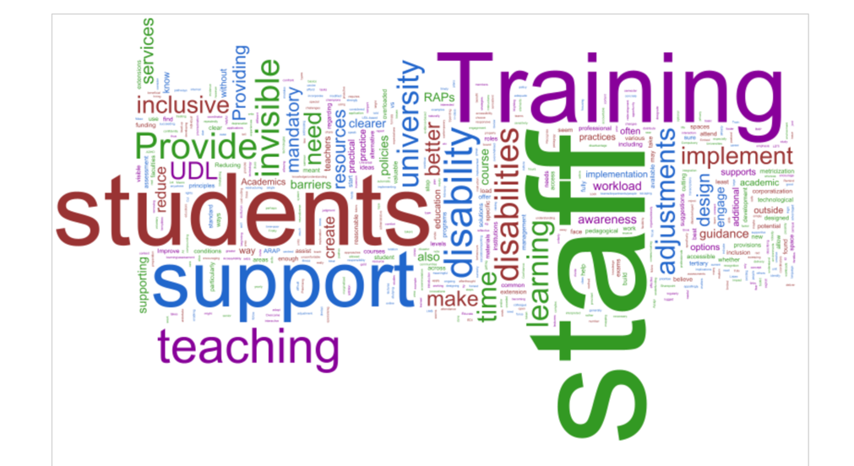
Figure 13: Word cloud illustrating how universities could better support staff to meet the learning needs of students with invisible disabilities, according to staff survey responses

6.2.2.1 Barriers
As noted in section 6.2.2, a tension emerged between personal intent and institutional capacity across the staff survey data. Despite this tension, staff demonstrated a high degree of knowledge regarding the systems needed to mitigate the barriers faced by students with invisible disabilities. Among staff, institutional support and leadership received the highest importance rating (mean ≈ 4.69/5), with improved communication and trust with students closely behind (mean ≈ 4.58/5). The survey of staff sentiment thus reveals that visible leadership, resourcing, and policy clarity are essential mechanisms for scaling inclusion beyond the dedication of individual staff.
Table 4: Staff survey responses: “How can institutions better support staff to address the challenges experienced by students with invisible disabilities?”
Statement | Not  important | Slightly important | Somewhat important | Very  important | Extremely important | Overall
Proactive course design and accessibility strategies | 0  (0%) | 3  (5.09%) | 4  (6.78%) | 13  (22.03%) | 39  (66.10%) | 59  (100%)
Institutional support and leadership | 0  (0%) | 0  (0%) | 2  (3.39%) | 14  (23.73%) | 43  (72.88%) | 59  (100%)
Ongoing professional development and training | 0  (0%) | 0  (0%) | 6  (10.17%) | 24  (40.68%) | 29  (49.15%) | 59  (100%)
Improved communication and trust with students | 0  (0%) | 0  (0%) | 3  (5.09%) | 19  (32.20%) | 37  (62.71%) | 59  (100%)
Technology-enabled teaching and learning spaces | 0  (0%) | 1  (1.70%) | 9  (15.25%) | 23  (38.98%) | 26  (44.07%) | 59  (100%)

Across the open-ended responses, staff highlighted a diverse range of barriers, particularly with respect to the implementation of inclusive practices and reasonable adjustments. Overwhelmingly, the most common challenges for staff, irrespective of academic position or experience, were excessive workloads and time pressures. Many highlighted the importance of providing time and guidance for staff to implement and engage with accessibility plans and engage with student learning needs. Furthermore, respondents shared that a desire to undertake inclusive redesign of their courses often competed with heavy teaching, research, and administration loads, especially when teaching responsibilities were assigned close to teaching start dates.

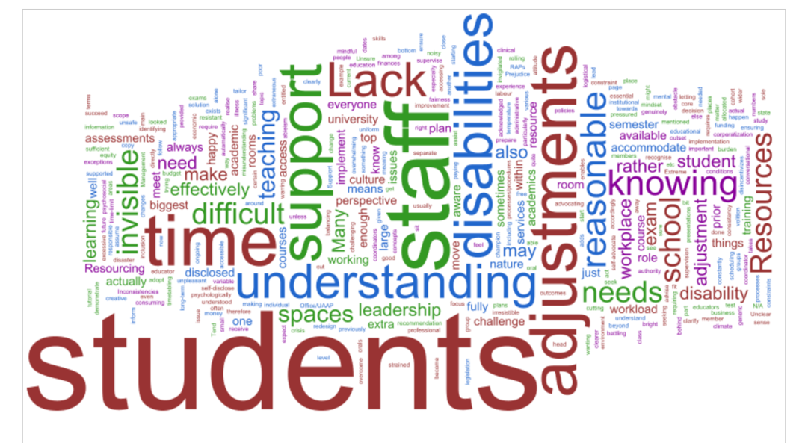
Figure 14: Word cloud illustrating challenges staff face implementing reasonable adjustments for students with invisible disabilities, according to staff survey responses

Policy ambiguity and fragmentation also featured prominently among staff surveyed when asked to reflect on barriers to more inclusive education. In the quantitative data, staff overwhelmingly indicated that institutional policies were only “somewhat effective” (52%) (n = 26/50) in facilitating the implementation of reasonable adjustments. This was echoed in the responses to open-ended questions, where staff highlighted the importance of “clearer guidance on the interpretation of access plans”, a tension between access plans and other institutional policies, particularly surrounding attendance, and a lack of guidance about how best to manage “flexibility” without disadvantaging others. Among staff surveyed, the general sentiment was summed up by one respondent who stated that: “The university could much better explain how we are meant to implement [reasonable adjustments] … when there is no funding nor support available.”

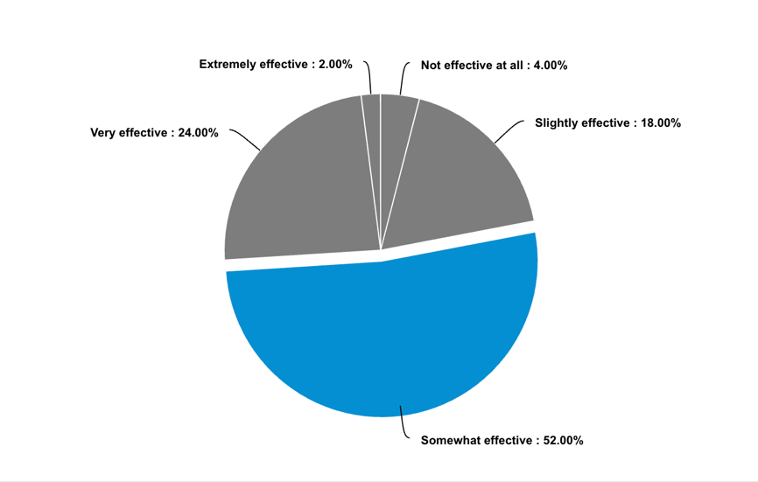
Figure 15: Effectiveness of institutional policies, according to staff survey responses

Aligning with the findings from the student survey (section 6.2.1), staff reported bearing the burden of complex, repetitive processes, particularly surrounding the implementation of time-based adjustments. This has significant implications for the types of actions staff implement to ensure more inclusive education. As one staff member explained: “I often spend more time troubleshooting pathways rather than teaching”, so it is essential that universities “cut through red tape [to] deliver solutions”. Less common in the findings, but important in the context of understanding trust sentiments among the student cohort surveyed, was the emergence of ableism and stringent performance metrics as considerations for how staff approach reasonable adjustments. One staff member expressed that there was “extreme ableism among our teaching staff”. Similarly, another lamented that: “The corporatisation … throttles the conditions for effective and responsive pastoral care”.

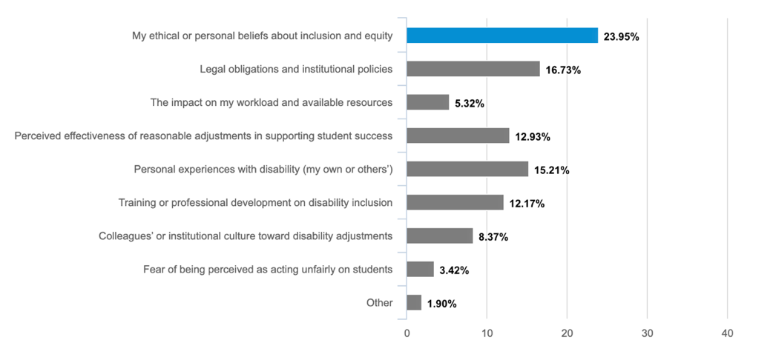
Figure 16: Factors that influence staff members’ personal views on reasonable adjustments

Collectively, these barriers suggest that across the higher education sector, goodwill and individual advocacy exist, however, the structures and systems make consistent inclusion piecemeal, inconsistent, and labour intensive.

6.2.2.2 Self-identified “good practice”
Despite these constraints, staff described a wide range of effective practices in design and delivery. Staff highlighted their commitment to implementing captioning and transcription, releasing materials early, amalgamating instructions, offering multiple content formats, and adopting Hyflex approaches. One educator described converting ambiguous assessment instructions into scaffolded frameworks to reduce task paralysis and offering explicit choices in how students demonstrate learning. Others referred to flexible assessment and participation strategies. These included strategies such as oral discussion in place of high-stakes timed writing, reduced-audience presentations, and permission to move or take breaks during class or examinations. One staff member explained how, after transitioning to an “oral exam format”, “the students performed significantly higher”. Among the discussions of good practice, many staff highlighted the importance of creating enabling environments, particularly during assessment. As one respondent explained:

I provided a safe and judgement-free space when a student was near total breakdown during a presentation due to their disability. With my guidance and care, they were able to regain their composure and complete their presentation. The student was proud of themselves, as they should have been.
The significance of enabling environments was echoed by another staff member who explained: “I have adapted my office to be a low-sensory space with options for adapting the environment. I include a variety of sensory aides and regulatory tools. I also offer to hold appointments in other spaces”. These good practice examples illustrate the importance of understanding the student experience through a holistic, functional needs lens.
In addition, many staff identified proactive relationship-building as critical for supporting the learning needs of students with invisible disabilities. The most popular strategies for building rapport among survey participants were open invitations to disclose needs, early meetings with students who have access plans, and frequent check-ins. As one participant explained: “I acknowledge my wishes to support students within the introductory course welcome [and] meet with all students who are willing with RAPs [reasonable adjustment plans] at the start of semester”. Many staff also reported advocating within the institution or with placement partners to secure fit-for-purpose adjustments, such as part-time placement schedules or scholarship rule changes to accommodate part-time study. These practices align with student responses with respect to good-practice supports. Common among these strategies is an emphasis on predictability, clarity, meaningful choice, and low-friction access. Taken together, this suggests that staff participants possess the knowledge to support students on a one-to-one basis, but scaling this support requires institutional investment.

6.2.3 Thematic trends across student and staff surveys
The staff and student surveys provide a holistic picture of how invisible disability is experienced, supported, and understood in university settings. Taken together, they reveal strong alignment in values, especially around the importance of inclusion, equity, and flexibility. However, also evident across the two surveys is a significant tension in how those values are enacted and encountered. The following synthesis brings together the thematic contrasts and provides a comparative discussion of the findings and their implications.
Students and staff expressed a shared commitment to inclusion and accessibility, though this was articulated in different ways. While both groups agreed supporting invisible disability is integral to an equitable university experience, staff framed this support in terms of professional duty and ethical practice, whereas students emphasised concrete actions. This importance was reflected in the responses of one staff member who noted that “accommodating students with invisible disabilities ought not be seen as a burden”. Ethical practice and duty were, as previously discussed, also evident in the prominence of staff interactions with students, and the consensus that implementation of adjustments is central to their teaching responsibilities (see Section 6.2). Where students were concerned, inclusion was assessed through the staff and institutional demonstrations of consistency and timeliness of support, as well as the emotional weight required to access appropriate and meaningful support. While 82% of students surveyed reported notifying their university of an invisible disability, many described the process for help-seeking to be exhausting and overly bureaucratic. This was reflected in one student’s explanation that having to “apply for academic plans every semester for permanent disabilities is exhausting and unnecessary”. In addition, student responses also revealed deeply embedded institutional frustration at overlapping but ineffectual systems and structures. This frustration manifested in negative descriptors and in blame being attributed to the individuals perceived as being responsible for the operation of these processes. As one student explained: “Hardly anyone calls themselves disabled for fun, and disabled students shouldn't be punished for the actions of others”.
With respect to the barriers to inclusive education, both staff and students observed that these exist and create exclusionary systems and structures; however, the nature of these barriers was often described differently. Staff, for example, described heavy workload, time scarcity, unclear policy interpretation, and limited institutional scaffolding. Among the responses to the staff survey, many noted that meaningful support for students with invisible disabilities often occurred “outside of the official systems” due to the “inability of the system to recognise diverse lived experiences and fluctuations” in capacities. While staff emphasised the tension between their personal desire to provide support and external pressures, students characterised the barriers as largely bureaucratic, pointing explicitly to long wait times, opaque processes, heavy documentation demands, and at an interpersonal level, unpredictable and highly varied staff responses. For students, the burden is not only administrative but emotional, with respondents describing disclosure as a practice which requires a continuous risk calculation. Student responses also highlighted key bureaucratic challenges, including inconsistent implementation of access plans, a lack of knowledge about their rights, and a fear of being perceived as seeking unfair advantage.
In the context of reasonable adjustments and inclusive teaching, staff highlighted the importance of implementing proactive, design-led inclusion, such as UDL-aligned strategies, multiformat content (for example, text, video, and transcripts), scaffolded instructions, Hyflex and online options, and explicit classroom expectations. Where students were concerned, however, these strategies were yet to be widely received or acknowledged by respondents. Students instead focused on the impacts of assessment-based and tangible adjustments. The most common adjustments discussed in survey responses were:
- generic accommodations and their often unresponsiveness to lived experience (for example, extensions and exam adjustments such as extra time, smaller rooms, and rest breaks)
- the importance of clear instructions and standardised LMS layouts to create predictability in learning environments
- the importance of alternative assessment modes, as one student explained: “Assignments are slightly inaccessible … I need more clarification on layout and content”
- accessibility of materials, including access to recorded lectures and the early release of materials
- inclusive, enabling institutional spaces, including quiet and/or sensory-friendly spaces.
Students reported particular difficulty with group tasks, as well as high-value and timed tasks where the format is complex, particularly when time is restricted. There was broad consensus that early warnings and explicit details about the nature of interactive activities would create a more inclusive learning environment. Students also were in agreement that learning options and assessable tasks that prevent social or sensory overload should be considered good practice and be widely implemented across the higher education sector. Staff validated in their survey responses that alternative formats (for example, oral exams and staged feedback) can fairly assess competence and provide a viable option to enable students to demonstrate assurance of learning outcomes. Similarly, both staff and students recognised the need for flexibility, including in placements and professional pathways. Students requested flexible placement arrangements (timing, location, and mode) and policy clarity around class participation to acknowledge fluctuating capacity. Staff described advocating with external partners and co-designing reasonable changes to maintain the learning outcomes embedded in placements and class workshop activities. The enabling environment, beyond the classroom, was also a key area of concern for both staff and students. Across both surveys, campus distances, lighting, noise, and timetable clustering were identified as barriers. Both cohorts also highlighted the opportunities presented by the creation of more low-sensory spaces.
When it comes to the relationship between staff and students, students described conditional trust and many reported disclosing their disability only when staff had already signalled safety or when disclosure felt unavoidable. Experiences ranged from deeply supportive, to invalidating or shaming. Students also cited peer attitudes (for example, “unfair advantage” comments) as barriers to belonging and inclusion. Staff emphasised approachability and neuro-affirming discourses as critical for creating a positive and accessible environment for students. They also highlighted the significance of listening without judgement, clarifying expectations, and normalising disability (including transparent self-disclosure). As one staff member explained: “Trust is earned. Try to learn and understand without judgement or condescension”.
Staff and students used slightly different language and framing when discussing the experiences of students with invisible disabilities. Staff commonly employed policy-rights framing and cited duty of care, legal, and ethical obligations to describe their engagement with students in the learning environment. However, for many students this form of language felt clinical and isolating, with respondents’ emphasising the value of person-centred, strengths-based language. The central consensus in the student survey was that students would prefer that communications avoid medicalised or deficit framing, and instead “use traits/characteristics, not symptoms, [as] negative deficit medical language is not disability-centric”. They also want plain English guidance on rights and processes. Similarly, staff want clarity and coherence around access plans and policies, including guidance, exemplars, and school-level supports to make local practices consistent. This emphasis on resources and consistency across schools would benefit the students who also indicated a preference for fewer procedural hurdles, faster responses to help-seeking, and less repetition in documentation requests. These duplications in bureaucratic processes caused some students to abandon support pathways, particularly when the process exacerbated their condition. Many also highlighted the importance of automatic short extensions (which become prevalent across the higher education sector during COVID) and once-only verification for permanent conditions.
Where knowledge is concerned, staff emphasised the importance of mandatory, targeted, practice-oriented training and development. Across survey responses, staff highlighted the desire for “compulsory … disability training for new staff” and annual refreshers. There was also a general consensus among staff surveyed that for UDL to be successfully and consistently embedded in student learning, it will require greater resources, and “champions”. Students expressed the need for greater transparency and visibility with respect to the inclusive learning strategies used by staff to facilitate accessible learning. Student responses indicated a perception that a high level of variability exists across their classes concerning staff understanding and the desire and capacity of staff to implement adjustments. In response, they indicated a strong preference for consistent expectations to be applied within schools across units, clear signposting of support, and visible procedures that normalise flexibility rather than make it exceptional.
Across both staff and student datasets, several principles were noted to produce better outcomes and experiences for students. These included:
- predictability and clarity (for example, standardised LMS layouts)
- meaningful choice (for example, alternatives for participation and assessment, sensory spaces, and breaks)
- low-friction supports such as “no-questions-asked” short extensions, clear contacts, and proactive check-ins
- visible allyship and modelling, and staff who signal understanding (including their own disability) and explain how adjustments will be enacted.

6.3 Student focus group findings
Peer-led focus groups with students, held between August and September 2025, provided important insights into the experiences of students with invisible disabilities. While the focus groups revealed a diverse range of highly embedded interpersonal, structural, and environmental issues, common among all the focus groups was a sincere enthusiasm for learning. In addition, there was a consensus about the importance of empowering students with information and resources which enable greater autonomy and agency over their learning. Ultimately, the student focus groups provided a highly generative discussion, where students spoke with candour about their experiences. The richness of this discussion was due, in large part, to the leadership of our peer researchers, who through shared experiences and empathy created a safe and constructive environment for frank and fearless dialogue. Focus group transcripts were analysed thematically using NVivo software, drawing on codes identified in Phase 1 of the project and through the literature review. The following themes emerged from the analysis.

6.3.1 Disclosure and stereotypes
Disclosure emerged not as a straightforward decision but as an ongoing, context-dependent risk calculation. Students described constantly assessing the safety of disclosure based on the specific individual, institutional context, and potential consequences. This strategic approach to disclosure reveals the absence of psychologically safe learning environments where students can be forthcoming about their needs without fear of professional or academic repercussions.
Healthcare students articulated particularly acute dilemmas around disclosure. A nursing student explained the impossible bind they faced:
Technically, there's a physical or mental condition that someone thinks could preclude you from providing healthcare. Someone could report you. In an ideal world that wouldn't be the case, but I'm just very hesitant about disclosing things like autism or ADHD, and even my chronic pain condition. It's very selective about which teachers I feel comfortable discussing that with.
This statement reveals how fitness-to-practice frameworks can position disability as inherently suspect, requiring students to strategically conceal aspects of their identity to protect their professional futures. Another nursing student elaborated on the values assessment required before disclosure:
I feel like being autistic and having ADHD makes me a better nursing student/future RN [Registered Nurse], but then I've had some interactions with people where it's very clear our values are quite different around disability and neurodivergence.
This statement reflects students' sophisticated understanding that disclosure is not just about sharing information but also assessing whether the recipient holds ableist beliefs that could harm the student's standing or opportunities.
The language students used also varied strategically, depending on context and audience. Many adopted umbrella terms like “neurodivergent” or “chronically ill” to avoid the specificity that detailed diagnostic disclosure requires. One student captured this adaptive approach:
The language I use depends on who I'm talking to, how acceptable it is, how little or much detail. It really comes down to context and how safe I feel to disclose, really. Is it going to be used against me? Or is it going to be used to help me? At times, it's hard to know.
The uncertainty embedded in this statement (“at times, it's hard to know”) speaks to the unpredictability of responses to disclosure and the emotional labour required to constantly gauge safety.
Some students also encountered pervasive misunderstanding of their conditions, often rooted in media stereotypes. This was reported by student participants to be particularly acute for autism, where television representations dominated public understanding, and chronic fatigue syndrome, where the name led to simplistic assumptions about symptoms. An autistic student explained:
I think that the stereotypes are not helpful and that they're gross mis-characteristics [mischaracterisations] of the truth. Autism doesn't give you superpowers. I'm sure there's a lot of TV shows out there that give people the wrong messages about autism.
The reference to “superpowers” speaks to media representations that represent autism as conferring special abilities rather than representing it as neurological difference. Another student elaborated:
The shows on TV […] they're not accurate. The only other place most people have recognised autism is in primary school when you get the really […] stereotypical kids. So, they only know the extremes.
Students perceived such narratives as reducing scope to understand the diversity of autistic experience.
Students with other conditions such as ADHD, post-traumatic stress disorder, bipolar, dyslexia, and chronic fatigue syndrome faced different but equally problematic simplifications. For example: “A lot of people just say, ‘oh, you have chronic fatigue’, and just think about it as the fatigue side and not the whole range of symptoms”. The focus on fatigue alone obscures the complex constellation of symptoms including pain, cognitive dysfunction, post-exertional malaise, and autonomic dysfunction that characterise chronic fatigue syndrome (Hamilton et al., 2023). This misunderstanding led to inadequate accommodations that addressed only one symptom while ignoring others.
While disclosure carried substantial risks, some students engaged in strategic disclosure as a means of deliberate community-building and consciousness-raising, recognising that individual privacy might be worth sacrificing to reduce stigma collectively and create safer environments for other students with disabilities. This approach to disclosure as activism represented resistance to cultures of shame and concealment around disability. One student explained their activist approach to disclosure:
I think it's really important for stigma […] so it's very rare that I actually don't disclose […] If I'm talking about it, then someone who's hiding it might feel more comfortable to talk about it. Then we talk about it together, and then the more people talk about it, the more normal it is, the less scary it is.
The student consciously used their own disclosure to create permission and safety for others, recognising that visibility and normalisation required some students to take risks in speaking openly.
Another student described becoming more open about disclosure as a result of exhaustion from masking and concealment:
I did initially change how I disclose things to different people; I am now just at the point where I will tell everyone. If they don't like me after that, or they don't want to work with me, then that's their problem. I'm not going to hide and mask [my disability] all the time, because I'm so tired.
The decision to disclose universally followed from two realisations: first, that maintaining strategic concealment was unsustainable; and second, that opportunities lost due to others' ableism represented incompatible environments anyway.

6.3.2 Challenges in accessing reasonable adjustments
A consistent barrier across institutions was that students simply did not know what adjustments were possible or available. At some universities, this knowledge gap was compounded by systems where doctors—who possessed no knowledge of university systems, pedagogical options, or available supports—were tasked with “prescribing” academic accommodations. Several students reported that this created absurd situations where medical professionals determined educational interventions that they were unqualified to assess, and meant students had to pay for additional appointments if they wanted new reasonable adjustments. One student explained the information vacuum:
You don't actually know what is possible, so you don't really know what to ask for. Sometimes there could be something that might work really well, but they just don't think about it when they get your plan together, or the doctor doesn't know either.
Neither student nor doctor possessed the institutional knowledge needed to identify potentially helpful accommodations, creating a situation where supports existed but remained inaccessible due to lack of information. Another student described the doctor-driven system at their university:
The form had a bit on the bottom […] “what does this student need?” My doctor went “oh, here, I'll give you a little bit of extra time on your assignments” […] I just didn't know what they offered and I still actually don't know what they offer.
The doctor's prescription of generic extra time reflected their lack of knowledge about university-specific options, available technologies, or pedagogical alternatives that might better support the student's particular needs and learning style. In contrast, one student had a transformative experience with an informed Disability Advisor:
We just had a conversation. “So, what does your day-to-day look like?” […] It was just a conversation about me, my activities, how I do things, and from that, as she was taking notes, she drew up possible ways that could help […] “Would you like to split up that assessment between a couple of days?” […] “What I'll do is, I'll always make sure there's at least a day in between your exams, so that you have time to recover”. It was something she drew out of our conversation rather than me specifically asking.
This collaborative, conversation-based approach with a knowledgeable Disability Advisor produced creative, individualised adjustments that neither student nor doctor would have identified alone.
Students' willingness to disclose disability, and ability to access meaningful support, varied dramatically by discipline, institutional size, and peer culture. These environmental factors proved as consequential as individual characteristics in shaping experiences, revealing that disability is not solely an individual attribute but emerges in interaction with specific contexts that either enable or constrain participation. A student who transferred between disciplines described stark differences:
When I was […] studying law, there was like a set standard and that competition […] I definitely didn't disclose. When I was studying nursing, a lot of the students I was studying with, my peers, also had disabilities […] and it was just something we talked about very openly, and no-one treated you any differently or felt that you were less capable.
The student reported that the competitive culture of the law faculty actively discouraged disclosure through implicit messages that disability signalled weakness or an inability to meet standards. In contrast, they reported that the nursing faculty's culture of care and the prevalence of disabled peers created safety for disclosure. Another student in visual arts noted:
It's interesting [that] in my course of visual arts, there are a lot of people with invisible disabilities, especially ADHD and autism, so often people will say to me first, “oh, I've got autism”, or whatever, and so that makes me feel more comfortable about saying, “well, I've got chronic fatigue syndrome”.
The normalisation of neurodivergence within arts communities created peer-led disclosure where students' openness facilitated others' comfort, creating positive feedback loops of acceptance.
Institution size emerged as another critical variable. A student at a small campus explained:
Smaller university, 200 students max on campus, really one-on-one relationship with the teachers, and that kind of allowed them to see me as me first. Then, when I was able to disclose […] I didn't feel like I was giving excuses. They knew where I was capable.
The relational knowing that small institutions enable creates different conditions for disclosure than large universities, where students are more likely to become anonymous numbers and educators know them only through assessment performance.
Another challenge reported by students was being systematically bounced between disability services and academic faculties, with each claiming responsibility lay elsewhere. This “ping-ponging” left urgent accommodation needs unmet while students navigated bureaucratic blame-shifting, often with high academic workloads. This fragmentation indicates that universities’ diffused responsibility serves to avoid institutional liability, rather than meet students’ support needs. One student captured this dynamic vividly:
They separate everything. It's like the disability services is one thing, you put your paperwork in with them and then you get ping-ponged between your faculty and disability services. If you've got a question, they're like, “oh, refer it to your faculty”, [so] you go to the faculty, and they're like, “oh, refer it to disability services”. They're like, “oh, refer to your faculty”. That's just like, this is such bullshit. Meanwhile this is your assignment or exam that's looming.
The circular referrals create administrative purgatory where students expend enormous energy trying to get a straight answer or concrete help while the actual assessment deadline approaches relentlessly.
Another student encountered even more explicit refusal to help from disability services: “When I went to that office, they initially went to help me and then literally came back and went, ‘oh, unless we're actually breaching discrimination legislation, we don't have to help you. It's not in our remit’”. This statement starkly reveals how some university disability services position themselves as legal compliance offices rather than support services. In these cases, help is provided only when legally mandated, not based on student need or institutional values of inclusion and equity.
Another barrier often addressed by students was that poorly designed or implemented adjustments removed the benefits that reasonable adjustments provided by placing students in a more precarious position. For example, many students highlighted that group projects impacted their ability to receive reasonable adjustments, such as extensions or adjustments for class presentations. Similarly, students who were offered extra time for timed assessments commonly said that the adjustment was insufficient. Extra time adjustments usually ranged from 1–15 extra minutes per hour, which was described as inadequate (while students who received between 20–30 extra minutes per hour described the adjustment as adequate, though this extra time amount was rare). Extra time adjustments were usually the only provision provided for timed assessments, and students expressed that these adjustments were not “worth” the labour they had engaged in, or would have to engage in, to receive the reasonable adjustments. As one student explained: “I know other people who've got reasonable adjustment plans just had to do the exam with everyone else [anyway], so it's like … ‘is it worth it, going through [the] trouble? … Do I do it or not?’”. Ultimately, students perceived reasonable adjustments as reciprocal in nature. Without adequate adjustments that support their needs, students will not engage with reasonable adjustment systems, further isolating themselves from support.

6.3.3 Privacy violations and dignity breaches in implementation
Even when students successfully obtained formal accommodation plans, implementation often involved devastating privacy violations that publicly exposed their disabilities and fundamentally undermined their dignity. These breaches were not isolated incidents but reflected systematic failures in staff training, institutional procedures, and cultural understanding of disability as private medical information requiring confidentiality. One nursing student described a particularly egregious breach:
I've had instances where I'm in the classroom with people and the teacher said, “oh, one of you has disabilities, who is it? It's this person. You need to go to this room”. I was just like, “that's really humiliating and also disclosing my private medical information. You've just outed me to everybody”. Yes, in a perfect world it shouldn't be a big deal, but that's such a big fuck-up and you're an upper education nursing teacher.
The public “outing” was compounded by the stress of having to navigate to a different room during an examination, precisely when the student needed to focus and minimise anxiety. When the student raised this violation with the educator, the response was deeply problematic:
She was just like, “oh, I'm sorry you felt distressed”. I was like, “that's not a real apology” […] When people say it's like “you felt distressed”, it's not actually “I'm sorry, we should do better”, it's literally “you're the problem”.
This non-apology epitomises how institutions deflect responsibility by reframing legitimate complaints as the complainant's oversensitivity. Rather than acknowledging the breach and committing to changed practices, the instructor positioned the student's distress as the problem, not the privacy violation itself.

6.3.4 Tension in how flexibility is understood
A critical insight emerging across focus groups was that basic flexibility practices that would benefit all students were treated as special accommodations for students with disabilities, rather than good pedagogical design. Many students noted how simple changes would remove barriers universally while reducing stigma around requesting individual accommodations. As one student explained:
Basically, I've been telling myself, “if you think you require all these accommodations and have all these needs and are struggling in these ways because university is not made to be accessible to you, then maybe you just shouldn't be here”.
The positioning of flexibility as a luxury or privilege, rather than a human right, reveals resistance to accessibility rooted in tradition and control rather than genuine pedagogical necessity. One student articulated this clearly:
For me, reasonable adjustments, extra supportive classes, that shouldn't be the norm […] A textbook that's easier to understand isn't only going to help students who require it, but it's going to help everyone. So, it should just be from the get-go, from the very start, setting up these structures. The technology is there; the resources are available that it is able to be done.
This observation highlights how UDL principles—inclusion by design, rather than inclusion as an afterthought—create better learning environments for all students while simultaneously reducing the need for individual accommodations that may carry stigma.
Another student discussed automatic recording systems as an example of technology that enables flexibility with minimal burden:
[At] our university […] as soon as the hour ticks over, it automatically starts recording and the whole process is automated to automatically upload it […] I don't understand why every uni doesn't do that […] It helps everybody.
The automation means no additional work for instructors, no need for students to request recordings and disclose a disability, ease of access for students whose first language is not English, and universal benefit for students who need to review material, miss class for any reason, or prefer asynchronous learning.

6.3.5 Additional barriers
Students with intersecting marginalised identities reported facing compounded barriers that could not be understood through a single-axis analysis. International students, students from non-English speaking backgrounds, students from low SES backgrounds, and students of colour navigated disability alongside other systems of oppression, creating unique challenges that standard adjustment frameworks failed to address. A student from a culturally and linguistically diverse background explained how multiple forms of discrimination intersected:
There's discrimination about your race, your background, your accent, and many [other things] like that, not just about disability. In my own case, I just tend to find a way out […] You might speak out, [but then] you might get discriminated and […] you might not get the right support.
This intersectionality where racism and ableism intersect created situations where disclosure felt even more risky. Barriers for low SES students emerged explicitly around diagnosis requirements. Multiple students described the financial gatekeeping inherent in requiring formal diagnosis:
It really bothers me that we have to have a formal diagnosis to get the support […] [because] it's a privilege in itself being able to pay for all of that and the wait lists and everything. Personally, we had to borrow money from my grandma in order to pay for the psychologist's appointment, because they're really bloody expensive.
The lack of availability in the public system and the cost of assessment in the private system—often thousands of dollars, not covered by insurance, with months-long wait lists—creates a class-based barrier where only students with financial resources can access formal diagnosis and therefore institutional support.
Perhaps the most pervasive finding and complex barrier was how deeply students had internalised ableist beliefs about their own worth, capacity, and legitimacy. This internalised ableism functioned as an invisible barrier that prevented students from accessing support even when available, from valuing their achievements, and from believing they deserved adjustments. Students described constant internal questioning of whether they were truly “disabled enough”, working hard enough, or deserving enough to request help. One student captured the self-sabotage of internalised ableism:
I remember I got an extension for a particular assessment, did really well in it, and basically discredited myself where I was like, “oh, well, it's not really worth that because I had extra time compared to everyone else”, which is so not the way to think about it.
Another student described the constant self-monitoring and justification:
The biggest barrier for me is the self-discrimination. The […] feelings that I have to always monitor my behaviour because of how it might be viewed [in] the structure of everything […] I always need to [explain my experiences] and showcase [for people why I do things or need things] so they allow me [provisions and understand] “oh, this is why”, so that the judgment isn't there. When in reality, it shouldn't matter.
The student recognised intellectually that justification should not be necessary but felt compelled to constantly explain and prove disability to pre-empt anticipated judgment, both external and internal. The perfectionism trap emerged repeatedly:
It's almost like if I don't perform to a specific level, which is unachievable at times, I feel like I don't have an excuse […] I'm like, “no, I need to do it up here, so that all of that is kind of worth it” […] We [students with invisible disabilities] always push ourselves. I've had teachers and people tell us, “we actually find that sometimes these are the best students” […] It's because we are pushing ourselves to a level because we feel like we have something to prove.
The student articulated the impossible bind: needing to prove through exceptional performance that disability does not impair capability, while that very performance requires unsustainable effort that exacerbates disability and burnout.
A significant revelation was students’ internalisation of hierarchies of disability legitimacy, strategically emphasising diagnoses they perceived as more credible while downplaying conditions they feared would be dismissed or stigmatised. This hierarchy reflects broader societal attitudes that validate only certain disabilities as “real” or “serious”, forcing students to navigate which aspects of their experience to foreground when seeking support. A student with both multiple sclerosis (MS) and neurodivergence provided insight:
I almost feel like the only [reason] I'm able to [seek accessibility provisions] is because I have the MS. It's where even within my invisible disabilities, I almost put the priority [on], or I use, my MS to guide my need for adjustments. [But when I do this I feel like] I'm almost […] invalidating myself [because I also have] […] depression, anxiety, and ADHD, [but] I feel less confident to ask and talk about these […] If I'm actually applying for an extension, I tend to emphasise more on the effects of my multiple sclerosis than my other [disabilities] […] It may be the ADHD that’s [causing me more functional difficulties], but I still tend to use [MS].
This student's candid reflection reveals the challenge often associated with social and educational perceptions, which produce disability hierarchies that impact how response accessibility planning can be for a student. As demonstrated in the quote above, it is evident that MS, a physical neurological condition, may carry more weight and legitimacy than mental health or neurodevelopmental conditions, even when ADHD may be causing more functional difficulty in the specific context. The student went on to question whether the increased acceptance they experienced was about having MS rather than a genuine shift in institutional culture: “Are they more accepting and understanding because of the MS, when they weren't previously with just my neurodivergence and ADHD?”. These responses reveal an awareness that the hierarchy is real and consequential, not merely perceived.
Alongside perceptions of disability, across the focus groups many noted the significance of structural barriers, including inflexible attendance requirements, rigid deadlines, and unavailability of resources in a timely manner. This discussion was often accompanied by a belief that these barriers are produced and exacerbated by rigid institutional decision-making, rather than educational necessity or a reflection of pedagogical “good practice”. This tension was revealed, many suggested, during the COVID-19 pandemic. The consensus among students participating in the focus groups was that the COVID-19 pandemic functioned as an unintended natural experiment in universal accessibility. Indeed, there was broad agreement that COVID-19 learning contingency plans provided legitimacy for practices which enhanced flexibility, including remote options and increased deployment of recorded content. Students in the focus groups concluded that flexibility provisions were technically possible, but universities simply chose not to provide them until an external crisis forced their hand. The rapid implementation of accessible practices during lockdowns, followed by their equally rapid rollback post-pandemic, revealed that institutional resistance to accessibility stems from choice and tradition rather than genuine constraints. One student reflected on how pandemic-era flexibility enabled their success:
I did some study […] during COVID times […] There was a lot of flexibility with COVID, and that helped me […] But then, [in] 2021, once COVID had kind of gone and we were shifting back to normal, then I really struggled. I decided to drop out because […] I just couldn't find that support.
The flexibility that made participation possible was positioned as a temporary emergency measure rather than a permanent improvement, and its removal forced the student to leave their program. A visual arts student, on the other hand, described unexpected benefits:
When I started, it was during COVID and lockdown; that was actually quite helpful for me because the staff had to change everything to suit. People were doing things from home […] Obviously, on one level, it wasn't as good in that we didn't have access to all this equipment, but on the other level, for me it was really good because I did learn how to do all these things at home first.
The forced adaptation to remote delivery created opportunities and skills that the student carried forward, demonstrating how accessibility innovations can benefit learning even beyond their immediate purpose.

6.3.6 Inflexible practical learning and placement barriers
Students in professional programs with mandatory placements, practicums, or field components faced particularly rigid barriers where missing even brief periods resulted in catastrophic consequences, including adding entire years to degrees. The students saw this inflexibility as revealing how “inherent requirements” often served as convenient justification for institutional rigidity rather than genuine professional necessities. A nursing student who experienced a medical emergency described the cascading consequences:
I was in a car accident. I passed out behind the wheel because of [disability], and I missed one week of placement, which then meant I had to do two weeks the following semester. But it meant that I couldn't do […] the next subject, which meant I had to add an entire year to my degree […] Everyone was just like, “oh, it's okay if you just had to add another year; you're young, you have time”. I'm like, “that shouldn't be some compromise I have to accept. I should be able to graduate with my peers”.
The medical emergency was completely unavoidable and directly caused by the student's disability, yet the institutional response was to add an entire year to the degree rather than find flexible solutions. The student challenged the inherent requirements justification:
When you really look into it […] there's nothing technically in your inherent requirements that requires you to have to complete it consecutively for two weeks. All it really needs is just resources, and that's something that the university can't do or work around.
The student’s response revealed that the requirement for consecutive completion was administrative convenience, not professional necessity. The university could have made reasonable adjustments such as arranged make-up placement time during breaks, or split placements, but did not do so.

6.3.7 Extensions as best practice
Several universities offered automatic, universal short extensions (typically three to five days) without requiring justification, medical documentation, or formal disability status. Students repeatedly highlighted in focus groups that this accommodation was helpful as it allowed them to receive an extension without needing to discuss or disclose their invisible disability with staff. This “simple extensions” model emerged as best practice that reduced barriers for all students while particularly benefiting those with disabilities, representing a UDL-informed approach that eliminated the need for individual adjustments in many cases. One student explained the benefit of no-questions-asked extensions:
They just have a default; anyone can apply for a three-day extension […] You don't have to say why, you just apply and you get it. I think that would be really good because, for my case, I'm only doing the one unit there, so to go through the whole process of getting a learning plan just for that would be a bit much. But because they have that, I don't have to worry about it as much.
The simple extension eliminated the burden of formal accommodation processes for students taking individual units, students with temporary difficulties, or students not yet diagnosed but experiencing challenges. Another student at a university with automatic extensions described their value as a bridge to formal support:
We have simple extensions […] We have five-day extensions that you apply for online, but you do have to have justification, but often, it's just a letter explaining it. So, I used that constantly until I got my disability action plan, and I still use it pretty much constantly.
The simple extension system served students waiting for formal accommodation plans, students with fluctuating conditions who needed occasional flexibility beyond their base accommodations, and students whose needs were met through this universal system without requiring formal disability disclosure.

6.4 Staff interview findings
Individual interviews conducted online with 19 staff members (both academic and professional) from several universities between August 2025 and January 2026 provided important insights into the experiences of staff teaching and supporting students with invisible disabilities. Staff spoke of their experiences, both positive and negative, including where systems and the sector could be better, and they provided examples of successful outcomes for students. Interview transcripts were analysed thematically using NVivo software, drawing on codes identified in Phase 1 of the project and through the literature review. The following themes emerged from the analysis.

6.4.1 The changing face of the student cohort
Every staff participant, regardless of role or institution, remarked on the significant increase in students presenting with invisible disabilities—and particularly, the dramatic growth in neurodivergent students seeking support. While participants in disability advisory roles were best placed to observe this trend, it was also visible to teaching academics who described receiving far more access plans and adjustment requests than they had in previous years. It was also evident to enabling program educators who described their cohorts as disproportionately comprising equity students with high and complex needs.
The growth was not simply a matter of more students having these conditions. It was also, several participants suggested, a matter of increasing willingness to name them. They pointed to changing societal attitudes towards mental health and neurodivergence, which, together with greater public awareness of conditions like ADHD and autism in women—a historically under-diagnosed population—appeared to be driving more students to seek formal recognition of difficulties they might previously have struggled through alone. We also note research that suggests the National Disability Insurance Scheme has also driven diagnoses of autism in particular (Ranjan & Bruenig, 2026).
One disability advisor, reflecting on decades in the field, described now being able to identify autism in students with considerable accuracy before any formal assessment. They noted that academic colleagues in disciplines like occupational therapy and allied health were developing similar pattern recognition:
Most of the students we work with have invisible disabilities. More and more academics are getting it [due to increased prevalence among students, and their decades of experience interacting with theses student]. Because [of this], I have a few students [where] I've just imputed autism. It's obvious. Talking to the academics, as confidential as you can be, they're more and more [saying], “yes, autism”.
Several participants described students who had arrived at university with anxiety disorders that they traced directly to the experience of navigating a school system that had been unable, or unwilling, to accommodate neurodivergent ways of learning. The participant quoted above reflected at length on students who came through high school being repeatedly told to sit down, focus, and stop talking. They highlighted how this punitive response often compromised students’ self-confidence and entrenched anxiety that was then misread by university staff as attitudinal, and exacerbated by historical legacies of ableist environments.
The transition from secondary school to university was identified as a particularly precarious moment for some students. Several participants described what they perceived to be a structural problem: secondary schools had, with good intentions, provided highly managed support for students with disabilities, protecting them from consequences they were not yet equipped to handle but also preventing them from building the skills, tolerance for frustration, and self-advocacy capacity that university would demand. Students arrived expecting the same scaffolding and found instead an environment that valorised independence, expected students to navigate complex bureaucratic processes alone, and provided intensive support only to those who actively sought it. For students with executive function difficulties associated with their disability, this expectation was particularly cruel. Participants typically identified this structural problem as relating more to the school environment, rather than recognising that similar types of supports may in fact be required for success at university too. As one Disability Advisor explained:
The way that students describe their learning experience [at university] is vastly different from their learning experience at school. They're finding that executive function was very much externalised in the school setting, and now they're just left to their own devices and they're feeling misunderstood. The common feedback we're getting from students is [that] it's a fairly poor experience at university, because they don't feel understood and supported without engaging with our service.
Participants also noted increasing complexity in presentations. Students were not arriving with single conditions but with co-occurring disabilities, for example, ADHD and anxiety, autism and depression, and chronic physical illness and the mental health consequences of years of mismanagement of their illness. This complexity challenged systems designed to produce and implement standardised access plans, and it strained the capacity of under-resourced disability advisory services.
Mental health conditions were described by multiple participants as constituting the single largest category of invisible disability in their institutions. One described the situation as “a bigger pandemic than COVID”, with General Practitioners being asked to fill the gaps left by wait lists for psychologists, and students in crisis receiving mental health care plans from practitioners who had seen them once by telehealth.

6.4.2 Access plans: What works, what fails, and why it matters
Access plans, referred to across institutions as either reasonable adjustment plans, equity plans, learning access plans, or accommodation plans, were reported in interviews to be the primary formal mechanism through which universities respond to students with invisible disabilities. All participants engaged with access plans in some capacity, though their relationship to them varied enormously. Across the interviews we spoke with staff responsible for creating them in prolonged one-to-one consultations with students; staff who received these plans and were expected to implement them, often without guidance; those who helped other staff navigate the systems through which they were communicated; and those who had observed the plans' effects on students.
There was genuine appreciation by staff for what access plans can accomplish. At their best, they translate a student's particular circumstances into concrete, actionable adjustments that protect the student from the application of standard procedures that would disadvantage them, provide staff with clear guidance that removes some of the burden of individual decision-making, and create a documented record that gives both parties a degree of procedural protection. Participants in disability advisory roles described the careful consultative work that good plan creation involves—an hour-long conversation in which a student is invited to describe not their diagnosis but the functional impact of their condition on their learning, and in which adjustments are tailored to that specific presentation rather than to a diagnostic category. As one Disability Advisor explained:
I always try to make [the access plan and the meeting to establish these provisions] as student-led and student-specific as possible, because yes, someone might have the same health condition, but it can be a completely different presentation of what that student needs. It really is just […] a discussion with the person on their specific needs and their functioning and what is helpful for them.
Against this, however, staff participants raised sustained and substantive criticisms. The most frequent was that plans tend towards generic adjustments—extra time in exams, extensions for assessments, or flexibility around attendance—that some staff believe do not always address the specific learning needs of individual students and may, in some cases, actively work against their interests. One Associate Professor described at length the example of students with mental health difficulties who received access plans entitling them to apply for extensions, and argued that in many cases the extension itself was part of the problem as it prolonged the period of anticipatory stress, pushed assessments to overlap with later work, and created a cascading pattern that prevented the student from resetting. In some cases, staff participants’ approaches were paternalistic, risked undermining student agency, and could undermine centring the student voice.
Ultimately, this perception reflects a misalignment with student sentiment, where the importance of flexibility was emphasised as a core enabling factor for inclusive education. Students with invisible disabilities consistently highlighted the often-fluctuating nature of their capacity or health, which has significant and often unpredictable impacts on their ability to engage with their learning. The misalignment between staff and student responses to the efficacy of certain assessment tasks highlights the need for co-creation and knowledge sharing within the higher education sector. By centring students’ voices in a way that creates opportunities for frank and fearless advice around the policies and practices that most impact them, universities will be better able to balance assurances of learning with the needs of the growing cohort of students with invisible disabilities.
A related and important criticism concerned the mismatch between the language of access plans and the realities of specific disciplinary contexts. Law schools featured prominently in this discussion, partly because of their attendance requirements and professional accreditation obligations, and partly because academic lawyers—trained to interrogate the precision and implications of language—were particularly sensitive to the non-committal wording that characterised many plans. When a plan stated that a student “may not always be able to attend class” or that they should be given “flexibility” around submission deadlines, it also created interpretive difficulties for course coordinators trying to apply these provisions consistently while also meeting their obligations under attendance policies and accreditation standards. As one senior leader at a law school explained:
Where lawyers look for [and have] rules and principles [to guide their interactions], we don't get that it's very much within your discretion. I've tried to explain to course coordinators that these things are within your discretion, but you have to think about what is being said in the access plan for this particular student [and use that to guide your decision-making]. It becomes a judgement call a lot of the time.
The problem of inconsistency in implementation was raised across institutions and disciplines. Where discretion is high and guidance is low, the experience of a student with an access plan varies significantly depending on which staff member receives and responds to it. One participant described students who, having received a generous interpretation of their plan from one course coordinator, then complained to another that their plan was not being properly implemented—not because either coordinator was acting incorrectly, but because there was no shared standard for what proper implementation looked like. This inconsistency created not only practical frustration but also interpersonal conflict, complaints, and in some cases formal grievances that consumed significant institutional time and energy.
The administrative burden of access plans on academic staff was also a recurring theme, particularly in large-cohort teaching contexts. One academic described receiving access plans for 100 or more students in a single unit of 1,000, with no dedicated administrative support for managing them, no automated system for implementing adjustments, and no allocated time for the work. Paradoxically, the same participant observed that students with formal plans were not actually the primary source of administrative burden—it was students without plans who required the most individuated, time-consuming decision-making, because there was no formal framework for those interactions.
A core concern for staff interviewed as part of this project was the role that intersecting identities occupied in the compounding of challenges for students with invisible disabilities. A general consensus emerged which highlighted concerns about the impact of unresponsive accessibility plans and burdensome bureaucratic processes on students who experience cumulative marginalisation due to intersectional identities. Several participants raised questions about how current access plans achieve their intended purpose, particularly for students with invisible disabilities from low SES backgrounds, as they noted that these intersectional identities may exacerbate exclusion. They suggested that current accessibility plan systems and structures benefit students who have already secured a diagnosis, who have the social awareness and cultural capital to navigate a formal institutional process, and who feel safe to disclose a condition and advocate for support. Students who lack any of these, who have undiagnosed conditions, who distrust authority, or who have reasons to fear the consequences of disclosure, may be structurally excluded from a system that is presented as universal.

6.4.3 Training: A gap with consequences
The inadequacy of formal training for staff working with students with invisible disabilities was one of the most consistent findings across all 19 interviews. The basic pattern was striking in its uniformity: most staff had received little or no mandatory training in disability awareness. What training existed was self-selected, driven by personal interest or a specific student encounter rather than by institutional expectation. Even staff members in designated disability support roles expressed that their training was insufficient to properly support students with invisible disabilities. This was true both of teaching academics, and of professional staff in disability support-related roles where disability was more central but formal professional preparation was still limited. As one Accessibility Services Advisor explained:
The training I've received has been positive, but with the caveat that it's always been training that I have actively sought, rather than something that's been mandated in my roles. I was very surprised—I came into tertiary education from government, and there was no training to become a disability advisor, or no active professional development around it.
The consequence of this gap was not merely that some staff lacked awareness of conditions—though that was a real problem. The deeper consequence was that key decisions about student welfare and academic progression were being made by people without the knowledge to make them well. When a law academic had to decide whether a student's access plan entitled them to a particular arrangement, when a physiology coordinator was asked to support a neurodivergent student through a clinical placement, when a course coordinator was confronted by a student in acute psychological distress—in all of these situations, the quality of the outcome depended on whether the staff member happened to have sought out relevant training on their own initiative. A Health Sciences Lecturer provided further insight:
I think there needs to be a stronger focus in the training on personal interactions with students with invisible disabilities; being able to recognise characteristics and traits. A lot of academics are starting to struggle with what other options and alternatives they can turn to, to offer students, so that they can still complete their courses. Some are feeling a bit trapped within what they can and can't offer because they don't necessarily know what else to do.
Several participants described the challenge of training staff to understand conditions whose manifestations are context-dependent, dynamic, and non-linear. A student with severe social anxiety may appear entirely comfortable in informal social situations while being unable to participate in a formal oral assessment. A student with ADHD may manage routine tasks adequately but struggle with the initiation demands of a long-form assignment. These context-specific difficulties are precisely those most likely to be misread by untrained observers as inconsistency, lack of effort, or dishonesty—and several participants described instances where this had occurred, sometimes with serious consequences for students.
On the question of training format, there was notable consensus across participants: face-to-face, interactive training was strongly preferred over online modules, which were widely described as being clicked through without genuine engagement. The value of in-person training was understood to lie not only in the quality of attention it received, but in the relationships it built between disability services staff and academics, and between the service and the broader institution. One participant described how delivering face-to-face disability awareness training had fundamentally changed the relationship between the disability advisory team and the academic community, with academics who had now met the team in person being willing to reach out with questions they would not previously have raised.
Across the interviews with staff, important insights were provided on what should be included in training. Several participants pointed to a gap between awareness-raising content, which was necessary but insufficient, and practical, actionable guidance on what to do in specific situations. One participant described wanting a flowchart: “If this happens, I contact this person, I send the student to this service”. The most effective training was described as both building genuine understanding of how conditions manifested, while also providing concrete strategies and clear referral pathways. As one educator whose responsibilities include the implementation of an enabling program at their institution explained: “… there are still staff who either don't believe it [invisible disability] exists or don't believe that it needs to be accommodated”.
They also noted that staff need practical training. Mandatory training that focuses on practical strategies, as reflected in the above quote, was advocated for by several participants. Staff also noted that the invisibility of these disabilities, and the absence of knowledge about how they impact learning, was, in part, what created the necessity for widespread, compliance-driven training. Staff explained that when a student has a visible, physical disability, staff seek out guidance; but the invisibility of conditions like autism, ADHD, and anxiety means that many staff can be unaware and may not realise the need for training that would, in practice, affect every cohort they teach.

6.4.4 Institutional culture and the structural conditions for inclusion
Below the surface of the practical challenges described by participants—such as inconsistent implementation, inadequate training, and generic adjustments—lay a set of deeper structural tensions about the culture and incentive architecture of contemporary Australian universities. These tensions shaped what was possible for well-meaning staff and what pressures even the most committed practitioners operated under. They appeared in different forms across different interviews, but their common thread was the gap between what universities say they value and reward.
The research–teaching divide was the most prominent structural theme. Participants at multiple institutions described a career environment in which research output—publications, citations, and grant income—was the primary determinant of academic success, and teaching was valued principally insofar as it did not create problems. Academic promotions were understood to be decided mainly on research metrics. Teaching quality was measured, where it was measured at all, through student satisfaction surveys that staff perceived to incentivise grade inflation, accessibility of content, and avoidance of academic rigour rather than genuine educational engagement. In this context, the additional time and attentiveness that effective support for students with invisible disabilities requires was not rewarded—and to the extent that it detracted from research productivity, it was implicitly penalised. A Senior Lecturer provided further insight:
The institution wants you to turn up to class and to teach. As an academic, you're not taught how to teach, you're not taught how to do it better, you're not necessarily taught how to be inclusive. I don't think that's necessarily a university or institutional priority. They just assume it's done. If you haven't done enough research, you get more teaching, and if you get more teaching, you're never going to have time to do your research. You get stuck in your career. So, you can care, but only to a certain degree.
A connected concern was the increasing commercialisation of the university environment and its effects on the integrity of academic standards and support systems. Several participants described institutions that had adopted customer service models in their responses to student requests, granting extensions and accommodations not because they had assessed them as appropriate but because the path of least resistance was to say yes. This superficially appeared to support students, but several participants argued it undermined them by removing the structure and scaffolding that many students with executive function difficulties needed, and by creating inconsistent expectations that left students confused about the rules. Whether this was the student experience of the adjustment did not seem to be a central consideration in this framing.
The post-COVID period emerged as a specific inflection point. Several participants described how the pandemic had, by necessity, shifted pastoral care to a reactive, opt-in model: staff could no longer see students in corridors, could not read non-verbal cues, and had no means of proactively checking in on students who seemed to be struggling. Instead, students who reached out received intensive attention; those who did not were left alone. The concern voiced by participants was that this model had persisted well beyond the circumstances that created it. Institutions had grown accustomed to lower levels of proactive pastoral engagement, and the financial savings associated with reduced face-to-face teaching and support staff had proved too attractive to reverse. An Associate Professor shared their experience:
Post-COVID, that's just never come back. We've just said, “oh well, this is what we do now”. It's all a little bit more hands-off and if students really need help, they can come to us. But I won't be reaching out to them proactively. Without the resources to do that, we simply can't. I would call it the new normal. It's really hard to make a case for student care—even when we do talk about it, we talk about it in terms of student experience and that's good for recruitment. But that's pretty disingenuous. It's a really superficial way of thinking about pastoral care.
The emotional burden on individual staff who took their responsibility to students with invisible disabilities seriously was articulated with considerable candour by several participants. Academics described personally escorting students to campus health clinics. One participant described a colleague who had received photographs of self-harm. The personal costs of this work—the emotional labour of sustained engagement with students in significant distress, with no formal preparation, no supervision, and no recognition—were substantial, and the institutional framework within which it occurred was described as wholly inadequate to the demands being placed on it. In this context, staff risk experiencing vicarious trauma and psychosocial harm (Ramluggun et al., 2022).
Participants also identified an important issue around the legal and linguistic framing of invisible disabilities. One participant noted that the language used in institutional communications—for example, “neurodiversity”, “ADHD”, and “mental wellbeing”—while informative, could paradoxically obscure the legal dimension of what was at stake. When conditions are described in clinical or descriptive terms rather than as disabilities, the clear obligations that arise under the DDA and the DSE can be overlooked. The term “disability” carries legal weight and clarity of obligation that other language does not. As one Lecturer explained:
Neurodiversity [neurodivergence] does not necessarily sound the same as invisible disability. There is a significant difference there. If you bring back the word “disability”, I do think there's a heightened sense of obligation. The language you use, it does change people's perception.

6.4.5 Universal Design for Learning: Widely valued, unevenly implemented
Universal Design for Learning (UDL)—the approach of designing educational environments, content, and assessments to be accessible to as wide a range of learners as possible from the outset, rather than modifying them after the fact for individual students—was viewed positively by almost every participant and identified by several as the most important structural response to the growth of students with invisible disabilities. Its appeal lay in its potential to reduce the dependency of inclusive practice on individual access plans and individual acts of goodwill, and to embed accessibility into the educational environment as a baseline rather than an exception.
Participants described a range of UDL-informed practices they had either adopted themselves or observed others implement effectively. These included adding closed captions to all recordings as a default rather than only when a student with hearing impairment was enrolled; redesigning rubrics for screen-reader accessibility; providing lecture content in multiple formats; making course structures, assessment criteria, and key dates transparent and consistent from the beginning of semester so students could plan around them; using discussion forums that allowed introverted or anxious students to participate in seminar discussion without the pressure of real-time contribution; and redesigning assessments to allow multiple modes of demonstration rather than a single high-stakes format. As one Enabling Program Educator explained:
There is, on campus, a Neurodiversity Community of Practice. We've been talking a lot about getting a resource embedded, more for staff, so that it becomes standard practice about how they deliver in curriculum and teaching and learning—instead of, like, a “nice-to-have” or an add-on—[so] that it's the default. Because then it automatically meets everyone's needs, regardless of whether they get an access plan or not. I've been trying to get that message across quite a bit. When we nut it out, there are a lot of really easy wins that aren't too onerous for staff. They just have to be willing to think differently.
One participant who taught a large first-year unit of 1,000 students described deliberate practices around group composition in workshops—distributing students with accessibility needs across groups rather than concentrating them, and balancing gender representation based on evidence about participation dynamics—as an example of how UDL thinking could inform the logistics of teaching. Another participant described implementing a “contribution cap” in seminars—asking students to limit themselves to three contributions per session—as a strategy that benefited neurodivergent students prone to dominating discussions, while also creating space for anxious students who would otherwise be crowded out.
Perhaps the most important insight from participants about UDL was the observation that well-designed, accessible practice benefits all students, not just those with disabilities. One teaching-focused academic described how redesigning workshops to be more interactive and collaborative had not only created a more supportive environment for students with social anxiety or autism, but had also dramatically improved engagement and social connection across the whole cohort. Students were forming friendships, attending voluntarily, and reporting in course evaluations that the environment had helped them find a place in a large university.
However, participants were also candid about the difficulties of achieving meaningful buy-in for UDL at the institutional level. The gap between those who had engaged with UDL principles and those who had not was described as wide and resistant to closure. Several participants described attempts to share practices with colleagues that had been met with indifference or resistance. The pattern identified was that UDL adoption tended to be driven by individual champions—people with personal investment in the question, often through lived experience of disability in themselves or family members—and that there was no institutional mechanism for translating the insights of those champions into systemic practice. As one Educator explained:
A real willingness to think differently is needed. The tricky thing is that universities are always going to have that tension between being a decent human being and a good quality teacher, against the fact that the recruiting imperative means you need to be a researcher and have publication output.
Several participants identified the relationship between disability services and learning design teams as an important, and currently underdeveloped, structural resource. If the people responsible for designing accessible educational content worked in close collaboration with the people who understood the specific access needs of student cohorts, the result could be curricula that were meaningfully more inclusive from the ground up. In practice, participants described these teams as operating largely in isolation from one another, with disability services responding to individual student needs and learning designers focused on platform and content management rather than accessibility by design.

6.4.6 Trust, disclosure, and the hidden costs of an opt-in system
A theme that ran through the majority of the interviews was the importance of trust, and how best to build and maintain this across the various institutional relationships that students encounter throughout their degrees. Unsurprisingly, the most common interactions that were discussed were between students and staff, between staff and accessibility services and learning and teaching leadership, and between higher education institutions and the students they serve. Trust shaped whether students disclosed, whether disclosures were taken seriously, whether support was sought and received in time, and whether the experience of seeking accommodation left students feeling dignified or diminished. Its centrality to the functioning of the access plan system was evident: a system that depends on self-disclosure and individual advocacy can only work equitably if students trust that disclosure is safe and that advocacy will be received with care.
Participants identified numerous reasons why students with invisible disabilities might not disclose. Some feared the practical consequences: that disclosure would be recorded somewhere that could damage their academic or professional prospects, that it would change how staff perceived and assessed their work, or that it would trigger scrutiny they did not want. Some lacked confidence in their own self-knowledge, particularly where their diagnosis was recent or where they had spent years being told by authority figures that their difficulties were not real or not serious. Some had had previous bad experiences—dismissal, minimisation, or bureaucratic obstruction—that had taught them the system was not worth engaging with. One Accessibility Services Advisor described the predicament:
We still [see] a fear around disclosure, because students don't know whether it goes on their transcript, [and] they don't know if they're then going to be disadvantaged in their classrooms. Just having systems in place that show students that people [particularly staff] are here, are happy to have a chat, and that accessibility discussions don’t necessarily have to be formalised, goes a long way towards building the deep relationships necessary for students to be vulnerable about their needs and experiences.
A Lecturer echoed a similar sentiment:
I have ADHD myself, [and] I'm very open with the students about that, and still they don't want to come and approach me and talk to me about it. I don't have the answer, but I think there needs to be something figured out between academics and students as to what would make both parties feel comfortable and feel like they can have that open space.
Several participants identified a structural dimension to this problem that went beyond individual psychology. The access plan system—by requiring students to have secured a formal diagnosis, to navigate an appointment process with disability services, and to actively share their plan with each new course coordinator each semester—selects for students who already possess significant social confidence and institutional familiarity. Students from professional-class families, who have grown up learning how to deal with institutions and authority figures, are better placed to manage these demands than students from backgrounds without this cultural preparation. The system is formally universal but functionally stratified. As one Associate Professor explained:

You create this group of students who feel emotionally secure enough to engage in the whole process and also confident enough. It tends to benefit students whose parents work in laptop jobs, who kind of feel confident dealing with managers. Even I took three years to apply for a reasonable adjustment plan, and I've had a diagnosis since I was 10 […] And then you realise the battle doesn't stop once you get a reasonable adjustment plan—then you have to advocate continuously to a bunch of different people.
Trust between staff and students was described as built through consistency, availability, patience, and the willingness to treat students as experts on their own experience. Several participants described proactive outreach strategies—for example, emailing students with access plans at the start of semester to invite a conversation about their needs; reaching out to students known to be struggling with low-pressure, open-ended messages; and making themselves visible at student support events. These practices were individual rather than institutional, sustained by personal commitment rather than by job design, and described as having a meaningful impact on the students who received them.
A further dimension of trust concerned the relationship between staff and their institutions. Several participants described working in environments where attempting to go above and beyond for a student with complex needs was unsupported, and where the fear of making a decision that would be questioned by management or challenged by a student complaint created incentives for rigid rule-following rather than creative problem-solving. One participant, an Accessibility Services Advisor, described the paradox in which an academic might feel more comfortable implementing a substandard adjustment that was formally approved than a genuinely appropriate adjustment that lay outside the standard framework:
Academics would prefer us to put it in an access plan so that then they have something to fall back on if something goes wrong. Well, I'm more comfortable if it's on a plan, because then if anything happens, if my head of school questions it or the student complains […] it's been formalised and therefore they've done the right thing.

6.4.7 Redefining professionalism and the placement problem
One of the most distinctive and practically significant themes to emerge from the interviews—raised most forcefully by participants in health sciences but with implications across disciplines—was the question of how existing standards of professional behaviour interact with the characteristics of students with invisible disabilities. Placements, clinical practicums, and work-integrated learning settings presented particular difficulties because they occurred in environments over which universities had limited control (or were perceived to have limited control), where the expectations of supervisors and employers might not reflect the inclusive values of the educational institution, and where the stakes for students were high.
Several participants described a pattern in which neurodivergent students were being removed from placements for behaviour described as unprofessional, including talking too much about personal experiences, arriving late, appearing disorganised, or failing to read social cues. Staff noted these behaviours were often later found to be consistent with the known characteristics of the students’ disabilities, and not reflective of their potential to perform competently in professional roles. In response to these instances, staff interviewed noted that the university's response was often punitive, prioritising a focus on professionalism training for students, rather than dialogue and engagement with the hosts to create an enabling environment. This neurotypical response ignores the diverse communication styles of neurodivergent students. Where questions of accessibility are concerned, responses that are deficit-centred create significant barriers for students with disabilities, and may not meet the university’s obligations under the DDA and DSE. In addition, these deficit-based responses ignore future employers’ obligations under the DDA, and their obligations to ensure reasonable adjustments. The impact and persistence of these perceptions was best explained by a Lecturer:
What if these students think they're being professional? Or there's things that are just a part of who they are, and it's not actually unprofessional, it's neurodivergent professionalism? There was one student a few years ago who just continuously got pulled up for talking too much about her own life and her own experiences. I was like, “that's such a neurodivergent thing to do”. We might still be applying 1950s-1960s professionalism standards to today.
This insight is critical for understanding the complexities of these accessibility systems and their potential long-term impact on graduate success. Indeed, while some universities have made significant progress in supporting students with invisible disabilities in the classroom and across their own educational environment, there remains a significant gap in their capacity to offer post-graduation support as students seek to transition into the workforce. As such, it highlights both the importance of university placements for students to gain real world experience, and their inability to manage implementation inertia. The tension between the pedagogical importance and the realities for students with invisible disabilities is most acute in circumstances where workplace norms and dynamics do not have inclusive practices, and may not incorporate accessibility provisions for individual students. This raises important questions about what meaningful preparation for placement in future employment looks like for students; there is a need to prepare students to navigate workplace norms and expectations while also fostering awareness of inclusive practices in the placement environment, and supporting students to self-advocate for their rights under the DDA. As a result, there is a strong need for student support throughout placement, for further inclusive workplace practices to be implemented, and for further advocacy for reasonable adjustments in employment. Universities should also engage directly with placement providers to foster inclusive practice and communicate specific reasonable adjustments for individual students. As such, across the university sector it is critical, particularly in the context of placements, that processes be established that work to redefine notions of what constitutes professionalism, and the establishment of an enabling environment.
One participant had developed a training workshop for clinical placement supervisors, built on both research and direct input from students who had experienced problematic placements, that aimed to help supervisors distinguish between genuinely unprofessional behaviour and characteristics associated with invisible disabilities. The response from supervisors was described as enthusiastic—there was genuine appetite for this kind of guidance—and the model was being expanded, with plans to co-design further materials with students and to extend the initiative to other disciplines.

6.4.8 Towards a more inclusive system: Opportunities for reform
In their closing reflections, participants were invited to describe what they would change in their institution, or in the sector. The responses were diverse in their specificity, reflecting institutional processes and practices, however the underlying values informing these suggestions reflected significant convergence in belief and ideas. What emerged was less a policy checklist than a set of animating principles to guide how staff and processes interact with students who identify as having an invisible disability. Among the most important consideration for universities was that practices should reflect a trust-based model, where evidence of disability is managed from a needs-based assessment perspective, rather than as a requirement for students to prove their disability and learning adjustment needs. Second, there was a broad consensus that any reforms to the accessibility models of universities prioritise proactive rather than reactive provisions. Finally, higher education professionals across institutions emphasised the importance of frameworks that build inclusion and ownership into their mandate, noting specifically that those best placed to design better accessibility systems are those with lived experience of navigating inadequate ones.
The most fundamental reform suggested by participants was a shift from a system in which students with invisible disabilities must advocate continuously for themselves within a framework designed around other assumptions, towards a system in which the educational environment is designed from the outset to accommodate the full range of human neurological and psychological diversity. This is the core aspiration of UDL, and its appeal to participants lay precisely in its potential to reduce the burden on individual students and on the patchwork of individual staff members who currently hold the system together through personal commitment. As one Accessibility Services Advisor explained:
I would love to see a university environment where a student can have a conversation with their academic about what they need, and that can be worked out without them having to jump through formal hoops. An environment where people are accessing meaningful training before they are then having to deliver to a class. But also, the student doesn't necessarily have to come through us to get an access plan to make it all happen.
Another participant, an Associate Professor, provided further recommendations:
Just trust students. Not require as much paperwork and evidence and bureaucracy and signed forms from medical professionals—to trust that the person who's telling you the thing is the expert on their own lived experience and engagement with the world and their learning.
Several participants identified more specific structural reforms. A number called for better integration between disability services and academic schools: the development of embedded advisory relationships in which disability services staff developed enough familiarity with specific disciplines to create adjustments that worked within their accreditation requirements, assessment structures, and threshold standards, rather than applying generic frameworks that created friction and resistance. One Disability Advisor described this as one of the most important, untapped opportunities in the current system.
The necessity for reform of how teaching quality is measured was raised by participants as both one of the most difficult and one of the most consequential changes needed. The current dominance of student satisfaction metrics was understood to incentivise exactly the wrong things: grade inflation, reduced academic rigour, and superficial accommodation of student requests rather than the kind of genuine educational engagement that benefits students in the long term. Meaningful metrics for teaching quality would need to capture something about the depth of learning that occurs and the quality of the educational environment created, not just whether students reported feeling satisfied.
Mandatory and meaningfully designed training was another consistently raised reform priority. The argument was not simply that training would improve individual outcomes—though participants believed it would—but that making training mandatory would send a signal about institutional values, closing the gap between universities' stated commitment to inclusion and the training framework that prepared staff to deliver on it.
Several participants pointed to co-design with students as both a reform priority and a guiding principle. Specifically, they noted the significance of processes that include students with lived experience of invisible disabilities as genuine partners in the design of the support systems they need to navigate. One participant cited the research project underpinning this report, and its inclusion of student peer researchers, as a model of this approach. They further noted that there was something “quietly significant” about a student peer researcher being the one to conduct the interview. Another participant, a Lecturer, explained:
I think it would be cool to have more co-designed processes. The experience is better when students are involved in controlling the outcome. Making sure that students who have invisible disabilities do have a seat at the table. I don't know if that's a policy; that's more just an approach to pedagogy and teaching and learning design, but I think that would be something that would really help.
A consistent theme that emerged during discussions with higher education professionals was the ethical imperative of meaningful and substantive inclusion. In particular, participants highlighted the importance of implementing learning reforms underpinned by the value of inclusion. Participants further explained that it was important to engage in a process of continual improvement in learning design from the belief that inclusion is not simply a compliance exercise or a reputational asset but a moral commitment that has implications for how universities are designed, staffed, funded, and led. The importance of values-driven, meaningful reform is exemplified in the passionate response of one participant, an Associate Professor, who described their university’s approach to accessibility and support for students with invisible disabilities as “really gross” due to its emphasis on performative virtue signalling when interacting with these students, while also failing to acknowledge the mountains of paperwork and bureaucratic obstruction these students had climbed. Specifically, she explained:

Students with invisible disabilities don't look as good in the marketing material either, so they don't tend to be seen because they just look like a person. Then you have to also overcome [this invisibility] to be believed that you really do have a disability, and it really is an issue, and the university really should help you. Then when you finally win that fight, they're like—ta-da—“look, we helped”. Just do the thing. You don't need a pat on the back as an institution for it. Doing the thing is the thing.

Discussion
The data collected on experiences of reasonable adjustments for students with invisible disabilities in the higher education sector provides important insights regarding the needs of this growing cohort. Discussions with students and responses to the survey revealed a wide range of complex and intersectional invisible disabilities are present in the higher education sector. ADHD, autism, chronic fatigue, anxiety, and depression were the most prevalent descriptors used by students when asked to describe their experience with invisible disability. However, during focus groups a common theme associated with the power of disability “hierarchies” emerged, with many students explaining that they often mediated how they described their disabilities across contexts to avoid misunderstandings or stigma. While students were uncomfortable with diagnosis medical descriptors, there was a consensus that drawing on these commonly known descriptors was necessary to ensure support was received. In addition, discussions about perceived disability hierarchies revealed that persistent power asymmetries exist within the accessibility frameworks, where some forms of experiences are seen as “easier” to manage institutionally. Where staff perceptions of invisible disabilities are concerned, responses revealed that mental health constituted the most recognisable category.
Overall, the findings illustrate that there is a significant misalignment between an institutional commitment to inclusion, most visibly articulated through university disability action plans (DAPs), and the lived realities of students with invisible disabilities, where barriers to accessibility remain persistent and systemic. What is both notable and significant is how closely the accounts of staff and students aligned. Both groups identified the same failures, felt the weight of the same structural inadequacies, and articulated the same vision of what a better system would look like. This convergence is not coincidental. It reveals that often the barriers students encounter are not the result of individual attitudes or isolated failures, but of institutional architecture that consistently prioritises protection over support, compliance over care, and tradition over equity. The Australian Universities Accord provides a blueprint for the next decade to help build a better and fairer education system, primarily focused on growing the higher education sector, including increasing participation (Department of Education, 2024). This policy direction as well as existing legal protections in the Disability Discrimination Act 1992 (Cth) (DDA) and Disability Standards for Education 2005 (Cth) (DSE) provide a clear impetus for inclusive and accessible education. This study highlights key gaps and recommendations to support this policy direction.

7.1 A system built around the false assumptions
Perhaps the most consequential finding to emerge from both the staff and student data, as well as the DAP analysis, is that the current model of disability support in Australian higher education is built on false assumptions: that students with invisible disabilities are readily identifiable, resourced to seek formal help, and capable of self-advocating at the very moments when their conditions make this most difficult. The access plan system, with its requirements for formal diagnosis, appointments with disability services, and semester-by-semester activation of adjustments, was designed with a particular student in mind, one who has already received an official diagnosis, who possesses the social capital and institutional literacy to navigate bureaucratic processes, and who feels sufficiently safe disclosing personal medical information to institutional strangers. For many students with invisible disabilities, these conditions do not reflect their lived realities (Couzens et al., 2015).
Students described disclosure not as a straightforward administrative step but an ongoing risk calculation: a continuous assessment of whether the potential benefit of support outweighs the potential cost of being disbelieved, stigmatised, or professionally disadvantaged (Goode, 2007; Riddell et al., 2005).
This aligns closely with what the DAP analysis revealed as an illusion of compliance. While universities increasingly adopt the language of the social model of disability, operational practices remain shared by medicalised and risk management approaches that place the burden of access on individual students with little to no institutional actions to reduce barriers.
Staff responses echoed this, as participants observed students who struggled without support, recognised the barriers to disclosure that their institutions created, and described working within a system that has no mechanism for proactively reaching students who have not yet asked for help (Fossey et al., 2017; Nieminen et al., 2024). The result is what one participant described as a “vicious cycle”: those who most need accommodation often feel least able to request it. The recommendations for provisional, needs-based adjustments without requiring formal diagnosis, alongside referral programs, anonymous inquiry channels, and targeted outreach embedded at key points in the student lifecycle, directly address this structural mismatch by reorienting the system to ensure that students with disabilities are not disadvantaged, in line with legal obligations.

7.2 The burden falls on the wrong people
One of the most consistent themes across all datasets is the concentration of burden on students, not on the institutions. Students must secure expensive diagnoses, navigate fragmented and often uncoordinated support services, repeatedly re-disclose to new staff each semester, and advocate continuously for adjustments (Fossey et al., 2017; Nieminen et al., 2024) that should, in many cases, simply be the default. This burden does not fall equally. Low SES students who cannot afford diagnosis (including private psychological assessments), rural students who do not have access to the relevant services for diagnosis, international students navigating unfamiliar systems and whose first language is not English, and students from communities where disability carries stigma, all face compounded barriers that standard accommodation frameworks do not acknowledge or address (Lindsay et al., 2018). The intersecting nature of these disadvantages means that the students most likely to benefit from support are also the most likely to be excluded from it (only 35% of DAPs analysed addressed intersectionality as a core part of their strategy).
Staff, too, carry a burden that institutions do not formally acknowledge. Academics described personally escorting students to health clinics, managing acute disclosures of self-harm, and navigating disability support decisions without training, guidance, or allocated time. Their commitment was genuine and often remarkable, but also fragile, unsupported by institutional structures that were not designed to make it sustainable (Duncan et al., 2025). It relied on individual goodwill rather than institutional design. The toll of sustained engagement with students in significant distress, with no formal preparation, no supervision, and no recognition, was substantial, and the institutional framework within which it occurred was described as wholly inadequate to the demands being placed on it (Margrove et al., 2014). In this context, there are real risks of vicarious trauma and psychosocial harm (Ramluggun et al., 2022).
This institutional silence is reflected in the analysis of university DAPs, which revealed a notable absence of any mention of staff workload regarding the implementation of accessibility measures. While 100% of DAPs assign formal responsibility for implementing adjustments to staff, they largely fail to articulate how these tasks are resourced or protected within existing employment frameworks.
The research-teaching incentive framework that shapes academic careers effectively penalises the time and relational energy that genuine inclusion requires, creating a structural disincentive that sits alongside the expressed commitment to student success and wellbeing. The recommendations that most directly address this imbalance include mandatory, practically-oriented training for all staff; formal recognition of accessibility and Universal Design for Learning (UDL) work within workload models; and the streamlining of institutional processes so that individual staff are not left to construct supports from scratch each time a student needs help. The goal is to shift the system from one that asks individuals, students, and staff alike to carry the weight of responsibility, towards one in which the institution itself bears more of the obligation for inclusion.

7.3 Legitimacy, trust, and the hidden cost of invisibility
The data reveals an embedded problem of legitimacy: the persistent institutional and cultural tendency to position invisible disabilities as less real, less serious, and less deserving of accommodation than conditions that are visible and recognisable (Sachs & Schreuer, 2011). Students described internalising these hierarchies, strategically foregrounding diagnoses they perceived as more credible (such as multiple sclerosis), while downplaying conditions they feared would be dismissed (such as ADHD or anxiety), even when it was the latter causing greater functional difficulty (Pennington, 2010; Hernandez et al., 2000). Staff observed the same dynamic: they described colleagues who questioned whether conditions like ADHD or anxiety truly warranted adjustments, and institutional systems whose evidentiary requirements implicitly validated only certain kinds of disability (Grimes et al., 2020).
This institutional vacuum where it comes to invisible disabilities is mirrored in the DAP analysis, which found that only 26% of universities explicitly acknowledge “invisible”, “hidden”, or “non-visible” conditions. Only two of the 34 universities’ DAPs openly acknowledge the high prevalence of these conditions, despite registration data at some institutions showing that students with invisible disabilities comprise over 80% of the population of students with disabilities. Only 32% of DAPs acknowledge that disability can be episodic and fluctuating, which is particularly relevant to students with invisible disability. This lack of formal policy recognition is problematic because it institutionalises the invisibility of these students. In the absence of clear policy recognition or anticipatory design, universities default to individualised assessment as the primary mechanism for determining legitimacy and entitlement. This in turn positions formal medical documentation as the principal—if not sole—means through which invisible disability is rendered institutionally legible, which reinforces the need for medicalised gatekeeping, requires students to undergo a “credibility test”, and potentially signals support as a discretionary “special treatment” rather than a proactive institutional obligation under the HESF.
The consequences of this legitimacy problem are both practical and psychological. As noted in the literature, and supported by the findings of our focus groups, students who do not believe their experiences will receive a meaningful response are less likely to disclose, less likely to activate their access plans, and more likely to exhaust themselves managing conditions without support (Kerschbaum et al., 2017). Psychologically, they internalise ableist beliefs about their own worth, discrediting achievements made with accommodation, pushing themselves to extreme limits to prove they do not need help, and experiencing the very act of requesting support as admission of inadequacy (Reeve, 2014; Bessant, 2012). Staff accounts confirm that this pattern is visible and troubling to those paying attention, yet there is no institutional mechanism for addressing it. The shift to a functional needs framework, in which adjustments are determined by a student’s account of how their condition affects their learning, rather than by diagnostic labels or external credibility assessments, is one of the most important structural responses to this problem, alongside the widespread implementation of UDL. Equally important is the investment in staff training that goes beyond legal compliance (Dunn, 2019; Dolmage, 2017) to build genuine understanding of how invisible disabilities manifest, challenge stereotypes, and centre lived experience as the primary source of knowledge about a student’s needs.

7.4 Fragmentation, flexibility, and the COVID proof of concept
Across both datasets, the fragmentation of institutional support systems emerges as a significant and consistent barrier. Students described being bounced between disability services and academic faculties, with each claiming the other holds responsibility, what one student described as the “ping-pong effect”. This lived reality is somewhat reflected in the formal policy landscape: while 100% of university DAPs formally establish procedures for documenting and implementing reasonable adjustments, only 24% of these plans explicitly emphasise the need for coordinated response, and only 26% address responsiveness.
Staff similarly described disability services and learning design teams operating in isolation of one another, with no structural mechanism for collaboration. The result is a system in which each student must repeatedly navigate the same institutional maze, re-disclosing and re-advocating at every turn (Brewer, et al., 2025), while staff make decisions without access to relevant expertise or shared guidance. The recommendations for standardised disclosure and adjustment processes with defined timeframes and named responsibilities, a centralised accessibility information hub, and formal referral pathways between support units, are all attempts to replace this fragmentation with something coherent. Structural mechanisms for collaboration across departments are also required. The systemic lack of cross-unit support is reflected in the DAP analysis, which reveals that only 35% of university plans seek to ensure faculty- or university-wide consistency in the implementation of accessibility expectations.
The COVID-19 pandemic provides perhaps the most telling evidence of all. Both staff and students observed that pandemic conditions forced universities to implement, almost overnight, practices that had previously been positioned as impossible: recorded lectures, flexible deadlines, remote attendance options, and extended assessment windows (Bones & Ellison, 2022). The rapid rollback of these practices once crisis pressure lifted, described by staff and students with equal frustration, confirmed that institutional resistance to accessibility is not primarily a practical limitation but a cultural one. This institutional inertia is also reflected in the analysis of university DAPs: while 76% of university plans intend to embed accessibility measures to remove barriers wherever possible, only 21% commit to long-term structural shifts—such as UDL—that would perhaps embed pandemic-era flexibility as a permanent baseline.
Despite students indicating during focus groups that flexible learning practice produced broad benefits, many universities returned to pre‑pandemic modes of rigidity. Focus group responses also indicated that the withdrawal of flexible measures produced a destabilising effect for students with invisible disabilities, as they had, for the first time, experienced forms of accessible participation. Previous research examining the impact of COVID-19 on students with disabilities produced mixed results that seemingly challenge the findings of our research. Multiple studies have reported adverse effects on mental health (Mullins & Mitchell, 2022), inconsistencies in accessibility pandemic arrangements (Kishira & Sasaki, 2024), and the long-term consequences of digital inaccessibility (Matsieli & Mutula, 2024), suggesting the need for further targeted research on how COVID-19 has changed the higher education sector for students with disabilities. Furthermore, the complexity and diversity evident in these research findings underscores the need for deliberate, well‑designed approaches to inclusion that extend beyond reactionary strategies. Accordingly, the recommendations in this report invite institutions to reflect critically on the lessons of the pandemic period: to treat accessibility gains not as emergency compromises but as evidence that better practice is possible, and to embed them permanently in course design, policy, and culture.

7.5 Co-design, accountability, and the path forward
The most hopeful finding is that staff who have sought out training are more effective at supporting students or connecting them with support services. In addition, among the staff who participated in this project, across the multiple datasets there was a high degree of motivation to engage in proactive strategies that improve access to education for students with invisible disabilities. Interpersonal connections and trust were two core principles revealed in our interactions with staff, yet often their contributions and innovations towards student support and wellbeing were under-recognised and unsupported. As a result, they were unsustainable and reliant on individual engagement rather than systemic change and consistency. Institutions with well-resourced disability services, functional needs approaches, and cultures of genuine inclusion produce markedly better experiences for students compared to institutions that have maintained more rigid and traditional approaches. Simple, low-cost innovations, automatic short extensions available to all students, default lecture recording where compliance at the school level is enforced, and collaborative conversations with informed disability advisors, make substantial differences to the learning experiences of this cohort. The prevalence of these strategies across the higher education sector is evidence that good practice exists but is often not mandated, nor consistently applied and resourced.
Addressing this requires accountability, will, proper resourcing, and the motivation to engage with students from the ground up. The recommendation for a paid student advisory panel, comprising students with lived experience of invisible disabilities, is perhaps the most essential recommendation to emerge from the student focus group research. This recommendation is critical for ensuring that higher education responds proactively to this growing cohort of students. By engaging students with lived experience in co-designing policies, processes, and communication, universities can ensure that their practices for assessment and education meet the needs of students with invisible disabilities. Alongside the importance of remuneration, a co-design approach also prioritises a centring of students’ voices, knowledge, and expertise, as well as their ownership in decision-making processes. Co-design necessitates that students be empowered to advise on changes to policy and process, through meaningful and substantive engagement with institutional leadership (Berents et al., 2024). Closing the accountability loop in these co-designed contexts also requires transparent responses to student proposals. This recommendation, for a paid student advisory panel, directly addresses a critical deficit identified in the DAP analysis. Specifically, the DAP mapping revealed that only 26% of universities explicitly commit to co-designing institutional solutions with students with disabilities, and only 38% champion student-led initiatives. This recommendation recognises the expertise that comes from navigating inaccessible systems and creates an accountable, transparent governance mechanism through which the gap between stated commitments and lived experience can be made visible and addressed. Annual audits, mandatory consultation before policy reform, disability-specific institutional surveys, and formal escalation pathways complete this accountability architecture. While 100% of DAPs assign formal role accountabilities to senior leaders, the analysis underscores that without measurable targets, transparent reporting, and enforceable goals, these strategic “blueprints” often remain aspirational rather than operational (78% of DAPs commit to escalation pathways; 91% define measurable targets or indicators). What both staff and students are asking for is not a more complex and technocratic version of the current system. They are asking for a fundamental shift in whose experience the system is designed around, and who is responsible for inclusion.
To that end, an overarching recommendation of the report is the implementation of a more strategic and sector-wide commitment to UDL. By engaging across the sector with this proactive approach to education, universities could more consistently and transparently engage with the diverse needs of their cohorts. This would significantly enhance the inclusiveness and effectiveness of teaching and learning. Practices such as offering varied ways for students to access key ideas and content, building flexible options for how they demonstrate understanding, and designing learning routines that support different levels of content scaffolding, can assist with anticipating leaner variability without dictating specific classroom practices. UDL in these contexts is operationalised as a guide, rather than a prescriptive set of requirements, providing educators with flexibility to adapt principles to their own context, subject matter, and professional judgement (Duncan et al., 2025).
While many educators who participated in this research utilised UDL-aligned principles, adoption remains uneven due largely to structural factors such as workload pressures and under-resourcing. Embedding UDL more consistently across the sector, in institutional policies, through professional development, leadership endorsement and targeted, comprehensive resourcing, as well as integrated curriculum planning, would ensure that inclusive design becomes a foundational expectation rather than an optional enhancement. This shift would not only reduce the need for individual adjustments but create learning environments that better support diverse student cohorts. A more consistent, sector-level emphasis on UDL, supported through inter- and intra-institutional collaboration and dialogue, would contribute to more equitable learning experiences for all students and significantly impact those with invisible disabilities positively. This would enable improved student participation, and greater teacher confidence in fulfilling their responsibilities for students with diverse needs.
Alongside the recommendation for a strategic and sector-wide approach to UDL is the acknowledgement of the importance of including people with disabilities in decision-making around strategies and practices that impact them. In response, this report recommends a sector harmonisation approach that enables the embedding of co-design into its consultation for the policies and practices that may impact students with invisible disabilities. As demonstrated throughout our discussions with students and higher education professionals, a consensus exists around the belief that students with invisible disabilities possess forms of lived experience that uniquely position them to substantively contribution to decisions about their learning. Findings throughout this report highlight that their insights extend beyond personal preferences, reflecting instead deep, situated knowledge of how policies, pedagogical routines, and institutional structures shape their participation. Expanding opportunities for co-design, through the embedding of a paid student advisory panel, would allow university systems to draw on this expertise while still enabling flexibility around how engagement occurs.
Central to our findings is the recognition that people with invisible disabilities are active knowledge leaders, not passive recipients of education provision. This aligns with a substantial body of literature in the education and social sciences that highlights the capacity of traditionally marginalised individuals to exercise agency, articulate their needs, and advocate for their interests, particularly in contexts where their decision-making capacities have been historically silenced or underestimated (Kreider et al., 2015). Under these circumstances, co-design is not merely rhetorical; it functions as an ethical and epistemic commitment to valuing the knowledge that emerges from lived experience. Previous empirical research underscores the importance of co-design for inclusion (Bjørnerås et al., 2024). It highlights the need to develop strategies and practices with those most affected by policy decisions and structural exclusion, rather than for them. Embedding co-design more systematically—through transparent feedback loops, shared decision-making structures, and mechanisms that ensure student perspectives inform both policy development and implementation—would shift institutional cultures towards more participatory and equitable forms of decision-making. This recommended approach would not only enhance the relevance and effectiveness of policy; it would affirm the legitimacy of students’ perspectives as central to inclusive education.

Conclusion
The Disability Discrimination Act 1992 (Cth) (DDA) and the Disability Standards for Education 2005 (Cth) (DSE) provide for students with disabilities to receive reasonable adjustments. However, to date, little was known about the application of this in practice in Australia’s higher education sector. To address this gap, this report has outlined the experiences of students with invisible disabilities—including neurodivergence, mental health conditions, chronic illness, and specific learning disabilities—in higher education in Australia. It has presented findings from an analysis of 34 university disability action plans and two Large-N national surveys—one of students with invisible disabilities, and one of academic and professional staff across Australian universities. These insights were explored further and validated via a thematic analysis of data generated using semi-structured interviews with staff and peer-led focus groups with students. To ensure the responsiveness of the recommendations, co-design workshops with both students and staff were conducted. Overall, we engaged with 204 students and 68 staff to understand their experiences.
This research shows that invisible disability is widespread but unevenly recognised and that disclosure and access to support remain costly and uneven. Students with invisible disabilities are eager to engage with institutions to enact change, but feel frustrated that they are often overlooked, problematised, and not supported by both teaching staff and the larger institution. Students demonstrated both balanced and practical perspectives on reform, positioning them as capable decision-makers. Staff expressed a commitment to support students’ wellbeing, reasonable adjustments, and the implementation of Universal Design for Learning (UDL), but often lacked the necessary support and resourcing. Leadership, commitment, and trust are essential for success. There are glimmers of hope—examples of good practice and positive experiences that students have defined as transformational. Future research could further explore intersectional experiences, including those of Indigenous students with invisible disabilities. This report has set out detailed recommendations for the sector, including ways of simplifying and streamlining processes around reasonable adjustments. When students with invisible disabilities feel meaningfully supported, they thrive. As one student, remarking on a particularly impactful lecturer, explained: “She made me feel extremely supported and has forever left a positive mark on my university journey”. By building relationships and trust and centring student voices, it is possible to strengthen governance and accountability within the higher education sector.

References
Australian Disability Clearinghouse on Education and Training. (N.d.). Disclosure. https://www.adcet.edu.au/students-with-disability/disclosure
Australian Institute of Health and Welfare. (2024). People with disability in Australia 2024: Summary fact sheet 6: Education and skills. https://www.aihw.gov.au/getmedia/d55bd482-bf1e-479b-a0c5-1e5ff0f0579e/aihw-dis-72-2024_fact-sheet-06_education-and-skills.pdf
Berents, H., Mollica, C., Odgers-Jewell, C., Payne, H., & Spalding, S. (2024). Conducting Care-full Research: Collaborative Research amidst Corona, a Coup, and Other Crises. International Studies Perspectives, 26(1), 88–109. https://doi.org/10.1093/isp/ekae005
Bessant, J. (2012). ‘Measuring Up’? Assessment and students with disabilities in the modern university. International Journal of Inclusive Education, 16(3), 265–281. https://doi.org/10.1080/13603116.2010.489119
Biggeri, M., & Ferrannini, A. (2014). Sustainable Human Development: A New Territorial and People-Centred Perspective. Springer.
Biggeri, M., Di Masi, D., & Bellacicco, R. (2020). Disability and higher education: assessing students’ capabilities in two Italian universities using structured focus group discussions. Studies in Higher Education, 45(4), 909–924. https://doi.org/10.1080/03075079.2019.1654448
Bjørnerås, A. B., Langørgen, E., Witsø, A. E., Kvam, L., Leithaug, A. E., & Horghagen, S. (2024). Aiming for inclusion: processes taking place in co-creation involving students with disabilities in higher education. International Journal of Inclusive Education, 28(14), 3437–3453. https://doi.org/10.1080/13603116.2023.2230198
Bones, P. D. C., & Ellison, V. (2022). The “new normal” for disabled students: Access, inclusion, and COVID-19. Sociation, 21(1), 21–40. https://hdl.handle.net/11274/16968
Bowen, G.A. (2009). Document Analysis as a Qualitative Research Method. Qualitative Research Journal, 9(2), 27–40. https://doi.org/10.3316/QRJ0902027
Brewer, G., Urwin, E., & Witham, B. (2025). Disabled student experiences of Higher Education. Disability & Society, 40(1), 108–127. https://doi.org/10.1080/09687599.2023.2263633
Bromell, D. (2017). The Art and Craft of Policy Advising. Dordrecht: Springer, 10, 978–3.
Bunbury, S. (2020). Disability in higher education – do reasonable adjustments contribute to an inclusive curriculum? International Journal of Inclusive Education, 24(9), 964–979. https://doi.org/10.1080/13603116.2018.1503347
Butler, K. (2023). Key achievements of New South Wales local government Disability Inclusion Action Plans in the era of inclusion policy and planning: A policy content analysis. Australian Journal of Social Issues, 58(2), 398–411. https://doi.org/10.1002/ajs4.259
Cameron, H., Coleman, B., Hervey, T., Rahman, S., & Rostant, P. (2019). Equality law obligations in higher education: reasonable adjustments under the Equality Act 2010 in assessment of students with unseen disabilities. Legal Studies, 39(2), 204–229. https://doi.org/10.1017/lst.2018.31
Caulley, D.N. (1983). Document analysis in program evaluation. Evaluation and Program Planning, 6(1), 19–29. https://doi.org/10.1016/0149-7189(83)90041-1
Charmaz, K. (2014). Constructing Grounded Theory: A Practical Guide through Qualitative Analysis (2nd ed.). Sage Publications.
Couzens, D., Poed, S., Kataoka, M., Brandon, A., Hartley, J., & Keen, D. (2015). Support for Students with Hidden Disabilities in Universities: A Case Study. International Journal of Disability, Development and Education, 62(1), 24–41. https://doi.org/10.1080/1034912X.2014.984592
Croasmun, J.T., & Ostrom, L. (2011). Using Likert-Type Scales in the Social Sciences. Journal of Adult Education, 40(1), 19–22.
https://www.proquest.com/scholarly-journals/using-likert-type-scales-social-sciences/docview/1018567864/se-2
Cumming, J., Dickson, E., & Webster, A. (2013). Reasonable Adjustments in Assessment: Putting Law and Policy into Practice in Australia. International Journal of Disability, Development and Education, 60(4), 295–311. https://doi.org/10.1080/1034912X.2013.846467
Dawes, J. (2008). Do Data Characteristics Change According to the Number of Scale Points Used? An Experiment Using 5-Point, 7-Point and 10-Point Scales. International Journal of Market Research, 50(1), 61–104. https://doi.org/10.1177/147078530805000106
De Cesarei, A., & Baldaro, B. (2015). Doing online research involving university students with disabilities: Methodological issues. Computers in Human Behavior, 53, 374–380. https://doi.org/10.1016/j.chb.2015.07.028
Department of Education, Skills and Employment. (2020). Research report – Best practice adjustments for Students with Disability. https://www.education.gov.au/swd/resources/research-report-best-practice-adjustments-students-disability
Department of Education. (2024). Australian Universities Accord Final Report. https://www.education.gov.au/australian-universities-accord/resources/final-report
Dollard, M.F., Neser, D., Lushington, K., Zadow, A. (2026). Australian University Sector Report: Findings from the Australian University Census on Staff Wellbeing, Technical Report. Adelaide University. https://stresscafe.net/census/
Dolmage, J.T. (2017). Academic Ableism: Disability and Higher Education. University of Michigan Press. https://doi.org/10.3998/mpub.9708722
Duncan, J., Butler, K., Leonard, C., Foggett, J., Page, A., & Roche, L. (2025). Uncovering Challenges in Universal Design for Learning in Higher Education. Australasian Journal of Special and Inclusive Education, 49(2), 94–110. https://doi.org/10.1017/jsi.2025.10003
Dunn, P. A. (2019). Disability in Higher Education: How Ableism Affects Disclosure, Accommodation, and Inclusion [Review of Academic Ableism: Disability and Higher Education; Authoring Autism: On Rhetoric and Neurological Queerness; Negotiating Disability: Disclosure and Higher Education, by J. T. Dolmage, M. Yergeau, S. L. Kerschbaum, L. T. Eisenman, & J. M. Jones]. College English, 82(2), 226–242. https://www.jstor.org/stable/26870405
Dunn, W.N. (2017). Public Policy Analysis: An Integrated Approach (6th ed.). Routledge. https://doi.org/10.4324/9781315181226
Edwards, M., Poed, S., Al-Nawab, H., & Penna, O. (2022). Academic accommodations for university students living with disability and the potential of universal design to address their needs. Higher Education, 84, 779–799.
https://doi.org/10.1007/s10734-021-00800-w
Fairclough, N. (2013). Critical discourse analysis and critical policy studies. Critical Policy Studies, 7(2), 177–197. https://doi.org/10.1080/19460171.2013.798239
Fossey, E., Chaffey, L., Venville, A., Ennals, P., Douglas, J., & Bigby, C. (2017). Navigating the complexity of disability support in tertiary education: perspectives of students and disability service staff. International Journal of Inclusive Education, 21(8), 822–832. https://doi.org/10.1080/13603116.2017.1278798
Goode, J. (2007). ‘Managing’ disability: early experiences of university students with disabilities. Disability & Society, 22(1), 35–48. https://doi.org/10.1080/09687590601056204
Grimes, S., Southgate, E., Scevak, J., & Buchanan, R. (2020). University Student Experiences of Disability and the Influence of Stigma on Institutional Non-Disclosure and Learning. Journal of Postsecondary Education and Disability, 33(1), 23–37. https://eric.ed.gov/?id=EJ1273678
Hamilton, P. R., Hulme, J. A., & Harrison, E. D. (2023). Experiences of higher education for students with chronic illnesses. Disability & Society, 38(1), 21–46. https://doi.org/10.1080/09687599.2021.1907549
Harpur, P., & Stein, M.A. (2018). Universities as disability rights change agents. Northeastern University Law Review, 10(2), 542–582.
Harpur, P., Stafford, L., & Ellis, K. (2025). A disability-led disability inclusion strategy for the higher education sector. Journal of Higher Education Policy and Management, 47(3), 368–385. https://doi.org/10.1080/1360080X.2025.2478537
Hernandez, B., Keys, C., & Balcazar, F. (2000). Employer attitudes toward workers with disabilities and their ADA employment rights: A literature review. Journal of Rehabilitation, 66(4), 5–16. https://www.researchgate.net/publication/279655194_Employer_attitudes_toward_workers_with_disabilities_and_their_ADA_employment_rights_A_literature_review
Hibbs, T., & Pothier, D. (2006). Post-Secondary Education and Disabled Students: Mining a Level Playing Field or Playing in a Minefield? In D. Pothier & R. Devlin (Eds.), Critical Disability Theory: Essays in Philosophy, Politics, Policy, and Law (pp. 195–219). University of British Columbia Press.
Hickey, J. M. (2023). “Am I included?” - An Australian case study exploring the experiences of university students with ‘hidden disability’. PhD thesis, Victoria University. https://vuir.vu.edu.au/id/eprint/45673
Kenny, J., & Fluck, A. (2019). Academic administration and service workloads in Australian universities. Australian Universities’ Review, 61(2), 21–30. https://eric.ed.gov/?q=Annual+Work&id=EJ1228011
Kerschbaum, S. L., Eisenman, L. T., & Jones, J. M. (Eds.). (2017). Negotiating Disability: Disclosure and Higher Education. University of Michigan Press. https://doi.org/10.3998/mpub.9426902
Kilpatrick, S., Johns, S., Barnes, R., Fischer, S., McLennan, D., & Magnussen, K. (2017). Exploring the retention and success of students with disability in Australian higher education. International Journal of Inclusive Education, 21(7), 747–762. https://doi.org/10.1080/13603116.2016.1251980
Kishira, H., & Sasaki, G. (2024). Information and communication technology use by students with disabilities in higher education during the COVID-19 pandemic. Universal Access in the Information Society, 23, 1723–1737.
https://doi.org/10.1007/s10209-023-00997-w
Kreider, C. M., Bendixen, R. M., & Lutz, B. J. (2015). Holistic Needs of University Students with Invisible Disabilities: A Qualitative Study. Physical & Occupational Therapy In Pediatrics, 35(4), 426–441. https://doi.org/10.3109/01942638.2015.1020407
Lama, D. (2025). The Complexities of Disability in Higher Education: Understanding the Impact of Intersectionality on Disability Accommodation Requests and Academic Success. University of Texas at Austin. https://doi.org/10.26153/tsw/61722
Lawson, A. (2008). Disability and Equality Law in Britain: The Role of Reasonable Adjustment. Hart Publishing.
Lid, I.M. (2026). Recognising Disability in Higher Education: A Human Rights Perspective (1st ed.). Routledge. https://doi.org/10.4324/9781003671077
Lightner, K.L., Kipps-Vaughan, D., Schulte, T., & Trice, A.D. (2012). Reasons University Students with a Learning Disability Wait to Seek Disability Services. Journal of Postsecondary Education and Disability, 25(2), 145–159. https://eric.ed.gov/?id=EJ994283
Lindsay, S., Cagliostro, E., & Carafa, G. (2018). A Systematic Review of Barriers and Facilitators of Disability Disclosure and Accommodations for Youth in Post-Secondary Education. International Journal of Disability, Development and Education, 65(5), 526–556. https://doi.org/10.1080/1034912X.2018.1430352
Margrove, K. L., Gustowska, M., & Grove, L. S. (2014). Provision of support for psychological distress by university staff, and receptiveness to mental health training. Journal of Further and Higher Education, 38(1), 90–106. https://doi.org/10.1080/0309877X.2012.699518
Matsieli, M., & Mutula, S. (2024). COVID-19 and Digital Transformation in Higher Education Institutions: Towards Inclusive and Equitable Access to Quality Education. Education Sciences, 14(8), 819. https://doi.org/10.3390/educsci14080819
McGrath, R. (2008). What Do They Say They Are Doing? Thematic analysis of local government Disability Action Plans. Annals of Leisure Research, 11(1–2), 168–186. https://doi.org/10.1080/11745398.2008.9686791
Mellifont, D. (2020). A critical exploration of university policy supporting the employment and career development of people with disability in the Australian academy. Australian Journal of Career Development, 29(2), 117–126. https://doi.org/10.1177/1038416220919799
Moriña, A. (2024). When what is unseen does not exist: disclosure, barriers and supports for students with invisible disabilities in higher education. Disability & Society, 39(4), 914–932. https://doi.org/10.1080/09687599.2022.2113038
Mullins, L., & Preyde, M. (2013). The lived experience of students with an invisible disability at a Canadian university. Disability & Society, 28(2), 147–160. https://doi.org/10.1080/09687599.2012.752127
Mullins, L. E., & Mitchell, J. (2022). The Transition Online: A Mixed-Methods Study of the Impact of COVID-19 on Students with Disabilities in Higher Education. International Journal of Higher Education, 11(2), 13–29. https://eric.ed.gov/?id=EJ1341189
Nguyen, C. K., & Nguyen, A. (2025). Disability support in higher education in Australia: a metasynthesis. International Journal of Inclusive Education, 22(12), 1–22. https://doi.org/10.1080/13603116.2025.2567427
Nieminen, J.H., Moriña, A., & Biagiotti, G. (2024). Assessment as a matter of inclusion: A meta-ethnographic review of the assessment experience of students with disabilities in higher education. Educational Research Review, 42, 100582.
https://doi.org/10.1016/j.edurev.2023.100582
Ollerton, J. (2012). IPAR, an inclusive disability research methodology with accessible analytical tools. International Practice Development Journal, 2(2). https://www.proquest.com/scholarly-journals/ipar-inclusive-disability-research-methodology/docview/1550838175/se-2
Olsen, J. (2019). The Nominal Gorup Technique (NGT) as a Tool for Facilitating Pan-Disability Focus Groups and as a New Method for Quantifying Changes in Qualitative Data. International Journal of Qualitative Methods, 18. https://doi.org/10.1177/1609406919866049
Osborne, T. (2019). Not lazy, not faking: teaching and learning experiences of university students with disabilities. Disability & Society, 34(2), 228–252. https://doi.org/10.1080/09687599.2018.1515724
Pearson, H., & Boskovich, L. (2019). Problematizing Disability Disclosure in Higher Education: Shifting Towards a Liberating Humanizing Intersectional Framework. Disability Studies Quarterly, 39(1). https://doi.org/10.18061/dsq.v39i1.6001
Pennington, A. (2010). Disability Disclosure: A literature review. Journal of Occupational Psychology, Employment and Disability, 12(2), 52–59.
https://www.valeofglamorgan.gov.uk/Documents/Living/Social%20Care/Disability/Adult-Autism-Advice-Employment/Additional-Materials---Session-5---Disclosure/Article-on-Disability-Disclosure.pdf
Pitman, T., & Brett, M. (2022). Disability and Australian higher education: The case for an Accessible model of disability support. Australian Journal of Education, 66(3), 314–325. https://doi.org/10.1177/00049441221120713
Pitman, T. (2022). Supporting persons with disabilities to succeed in higher education: Final report (Research Fellowship final report). National Centre for Student Equity in Higher Education, Curtin University.
https://www.acses.edu.au/publication/supporting-persons-with-disabilities-to-succeed-in-higher-education/
Ramluggun, P., Kozlowska, O., Mansbridge, S., Rioga, M., & Anjoyeb, M. (2022). Mental health in higher education: faculty staff survey on supporting students with mental health needs. Health Education, 122(6), 601–616.
https://doi.org/10.1108/HE-02-2022-0011
Ranjan, M., & Breunig, R. (2026). Individualized disability support schemes and their impact on autism diagnoses. Journal of Health Economics, 105, 103100. https://doi.org/10.1016/j.jhealeco.2025.103100
Reeve, D. (2014). Part of the problem or part of the solution? How far do ‘reasonable adjustments’ guarantee ‘inclusive access for disabled customers?’ In K. Soldatic, H. Mogan, & A. Roulstone (Eds.), Disability, Spaces and Places of Policy Exclusion (pp. 130–147). Routledge.
Riddell, S., Tinklin, T., & Wilson, A. (2005). Disabled students in higher education: Perspectives on widening access and changing policy. Routledge.
Riddell, S., & Weedon, E. (2006). What counts as a reasonable adjustment? Dyslexic students and the concept of fair assessment. International Studies in Sociology of Education, 16(1), 57–73. https://doi.org/10.1080/19620210600804301
Ruβmann, M., Netz, N., & Lörz, M. (2024). Dropout intent of students with disabilities. Higher Education, 88, 183–208. https://doi.org/10.1007/s10734-023-01111-y
Sachs, D., & Schreuer, N. (2011). Inclusion of Students with Disabilities in Higher Education: Performance and participation in students' experiences. Disability Studies Quarterly, 31(2), 1–19. https://doi.org/10.18061/dsq.v31i2.1593
Sandoval, M., Morgado, B., & Doménech, A. (2021). University students with disabilities in Spain: faculty beliefs, practices and support in providing reasonable adjustments. Disability & Society, 36(5), 730–749. https://doi.org/10.1080/09687599.2020.1751078
Santuzzi, A.M., Waltz, P.R., Finkelstein, L.M., & Rupp, D.E. (2014). Invisible Disabilities: Unique Challenges for Employees and Organizations. Industrial and Organizational Psychology, 7(2), 204–219. https://doi.org/10.1111/iops.12134
Scorgie, K., & Scorgie, S. (2017). The disclosure dilemma: Disability, identity and self-determination. In L. Nota & S. Soresi (Eds.), Counseling and Coaching in Times of Crisis and Transition: From Research to Practice (pp. 218–229). Routledge.
Seelman, K. D. (2017). Students with Disabilities in Higher Education: Welfare, Stigma Management, and Disclosure. In S. L. Kerschbaum, L. T. Eisenman, & J. M. Jones (Eds.), Negotiating Disability: Disclosure and Higher Education (pp. 135–148). University of Michigan Press.
Tai, J., Ajjawi, R., Bearman, M., Dargusch, J., Dracup, M., Harris, L., & Mahoney, P. (2022). Re-imagining exams: How do assessment adjustments impact on inclusion? National Centre for Student Equity in Higher Education, Curtin University.
https://www.acses.edu.au/publication/re-imagining-exams-how-do-assessment-adjustments-impact-on-inclusion/
Tanujaya, B., Prahmana, R. C. I., & Mumu, J. (2022). “Likert Scale in Social Sciences Research: Problems and Difficulties.” FWU Journal of Social Sciences, 16(4), 89–101. https://doi.org/10.51709/19951272/Winter2022/7
Thom-Jones, S., & Lowe, J. (2024). Innovative and Neuro-affirming Autistic Approaches to Autism Research. In H. Bertilsdotter Rosqvist & D. Jackson-Perry (Eds.), The Palgrave Handbook of Research Methods and Ethics in Neurodiversity Studies (pp. 161–182). Palgrave Macmillan.
Tourangeau, R., & Yan, T. (2007). Sensitive questions in surveys. Psychological Bulletin, 133(5), 859–883. https://doi.org/10.1037/0033-2909.133.5.859
United Nations Committee on the Rights of Persons with Disabilities. (2016). General comment no. 4 on article 24 - the right to inclusive education. OHCHR, United Nations.
https://www.ohchr.org/en/documents/general-comments-and-recommendations/general-comment-no-4-article-24-right-inclusive
Williams, A. R. (2016). Disability support in Australian higher education 1990–2009 [PhD Thesis]. The University of Melbourne. http://hdl.handle.net/11343/162203
Yanovitzky, I. & Weber, M. (2018). Analysing use of evidence in public policymaking processes: a theory-grounded content analysis methodology. Evidence & Policy, 6(1), 65–82. https://doi.org/10.1332/174426418X15378680726175
Ysasi, N.A., Becton, A.B., & Chen, R.K. (2018). Stigmatizing Effects of Visible Versus Invisible Disabilities. Journal of Disability Studies, 4(1), 22–29. https://scholarworks.utrgv.edu/rhc_fac/54/

Appendix 1: List of university disability action plans
Table 5: List of university disability action plans
 | University name | Disability action plan (DAP) title | Status | Current cycle / relations with wider university policies
1 | Australian Catholic University | A publicly available DAP cannot be located
2 | Australian National University | Disability Action Plan 2020–2024 | Current | Based on a preceding plan; integrated with ANU’s Inclusion, Diversity, Equity and Access Framework
3 | Avondale University | A publicly available DAP cannot be located
4 | Bond University | University Disability Action Plan for Students 2009 | Outdated | Serves as a framework to support university policies including the Disability Access Policy and Assessment Policy
5 | Charles Darwin University | Accessibility Action Plan 2023–2026 | Current | Treated as a “working document” subject to on-going feedback and reviewed biannually; integrated with broader governance framework including CDU’s Strategic Plan and Equity, Diversity & Inclusion Enabling Plan 2022–24
6 | Charles Sturt University | Accessibility and Inclusion Plan 2024–2025 | Current | Situated within CSU’s University Strategy 2030
7 | CQUniversity | A publicly available DAP cannot be located
8 | Curtin University | Disability Access and Inclusion Plan 2022–2030 | Current | Informed by review of the 2017–2021 DAP
9 | Deakin University | Disability Access and Inclusion Plan 2021–2025 | Current | Registered DAPs since 2000; replaces Disability Action Plan 2018–2020; aligned with Deakin’s Diversity & Inclusion Strategy 2020–2025
10 | Edith Cowan University | Disability Access and Inclusion Plan (DAIP) 2016–2021 | Outdated | ECU’s third DAIP, dating back to DAP 2004–2008
11 | Federation University | Accessibility Action Plan 2024–2026 | Current | Alignment with Federation’s Strategic Plan 2021–2025
12 | Flinders University | Disability Action Plan 2024–2027 | Current | Successor of Disability Plan 2014–2016; Disability Action Plan 2023–2026 (draft/transitional)
13 | Griffith University | Disability Access and Inclusion Action Plan 2024–2025 | Current | Serves as Griffith’s fifth iteration; alignment with Strategic Plan 2020–2025
14 | James Cook University | Disability Action Plan 2011–2013 | Outdated | Alignment with the James Cook University Action Plan
15 | La Trobe University | Universal Design and Inclusion Action Plan 2023–2030 | Current | Alignment with 2020–2030 Strategic Plan
16 | Macquarie University | Student Accessibility Action Plan 2025–2028 | Current | Aligned with Diversity, Inclusion and Belonging Framework 2024–2028
17 | Monash University | Disability and Accessibility Action Plan 2024–2030 | Current | Fifth iteration since first in 1998; alignment with Equity, Diversity and Inclusion Framework 2022–2030
18 | Murdoch University | Disability Access and Inclusion Plan 2022–2025 | Current | Developed first DAP in 2006
19 | Queensland University of Technology | Disability Inclusion Action Plan 2022–2025 | Current | Replaces Disability Action Plan 2011–2013; alignment with Connections – the QUT Strategy 2023 to 2027
20 | RMIT University | Disability Action Plan 2009–2015 | Outdated | Based on the Disability Action Plan 2005–2008; alignment with RMIT 2010: Designing the Future
21 | Southern Cross University | A publicly available DAP cannot be located
22 | Swinburne University | AccessAbility Action Plan 2015–2020 | Outdated | Developed through a representative advisory group of Swinburne staff and students
23 | Torrens University Australia | A publicly available DAP cannot be located
24 | University of Adelaide | Disability Inclusion Action Plan 2020–2024 | Current | Developed following a formal review of the Disability Action Plan 2014–2019; operates in conjunction with the university’s Equal Opportunity Policy
25 | University of Canberra | A publicly available DAP cannot be located
26 | University of Divinity | A publicly available DAP cannot be located
27 | University of Melbourne | Disability Inclusion Action Plan (DIAP) 2023–2026 | Current | First consolidated DIAP; alignment with Diversity and Inclusion Strategy 2030
28 | University of New England | Accessibility Action Plan 2020–2021 | Outdated | Based on the 2014–2017 Disability Action Plan; alignment with the University Strategic Priorities 2016–2020
29 | University of New South Wales | Disability Inclusion Action Plan 2022–2025 | Current | Follows first DIAP from 2018–2020; supports broader UNSW 2025 Strategy
30 | University of Newcastle | Disability Inclusion Action Plan 2024–2025 | Current | Alignment with Looking Ahead Strategic Plan (2020–2025) and Equity, Diversity and Inclusion Strategy (2023–2025)
31 | University of Notre Dame | A publicly available DAP cannot be located
32 | University of Queensland | Disability Action Plan 2023–2025 | Current | UQ's eighth iteration (first plan lodged 1999); alignment with UQ Strategic Plan
33 | University of South Australia | Disability Action Plan 2014–2018 | Outdated | Builds on previous DAPs; alignment with Strategic Action Plan 2013–2018
34 | University of Southern Queensland | Disability Action Plan 2017–2020 | Outdated | Review and redrafting undertaken in 2020 for implementation in 2021–2024 (not publicly available); alignment with Strategic Plan 2016–2020
35 | University of Sydney | Disability Inclusion Action Plan 2019–2024 | Current | University’s fourth iteration (first plan lodged 1999); alignment with Inclusion and Diversity Framework
36 | University of Tasmania | Disability Inclusion Action Plan 2022–2024 | Current | Builds on previous equity and diversity plans; alignment with UT’s Strategic Plan
37 | University of Technology Sydney | Access and Inclusion Plan 2020–2024 | Current | University’s fifth iteration (initiated disability action planning 1997); alignment with UTS 2027 Strategy
38 | University of the Sunshine Coast | Disability Access and Inclusion Plan 2021–2024 | Current | First DAP developed 1999; alignment with UniSC Strategic Plan 2021–2024
39 | The University of Western Australia | Disability Access and Inclusion Plan 2020–2025 | Current | UWA’s fourth iteration; alignment with UWA2030 Strategic Vision
40 | University of Wollongong | Disability Inclusion Action Plan 2024–2026 | Current | Alignment with UoW’s Strategic Plan 2020–2025
41 | Victoria University | Student Accessibility Action Plan 2021–2023 | Outdated | VU’s fifth iteration; alignment with Strategic Plan 2016–2021
42 | Western Sydney University | Accessibility Action Plan 2018–2020 | Outdated | Third consecutive plan registered with AHRC; alignment with Securing Success Strategic Plan 2015–2020
Note: The universities listed accord with the list available on the Australian Government website. DAPs are classified as outdated where the stated end date is 2023.

Appendix 2: Additional survey graphics

11.1 Student survey data
Figure 17: Student disclosure rates, according to student survey results
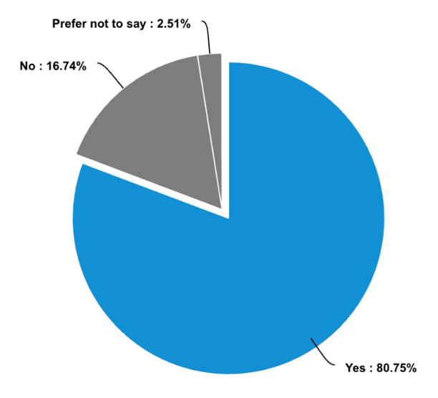

Figure 18: Accessibility of communication with lecturers and tutors, according to student survey results
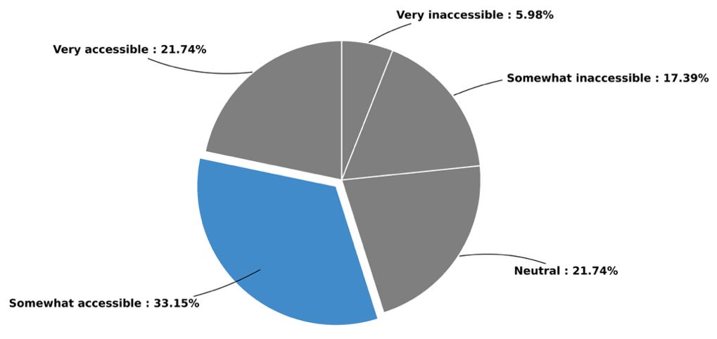

Figure 19: Accessibility of disability supports and adjustments, according to student survey results
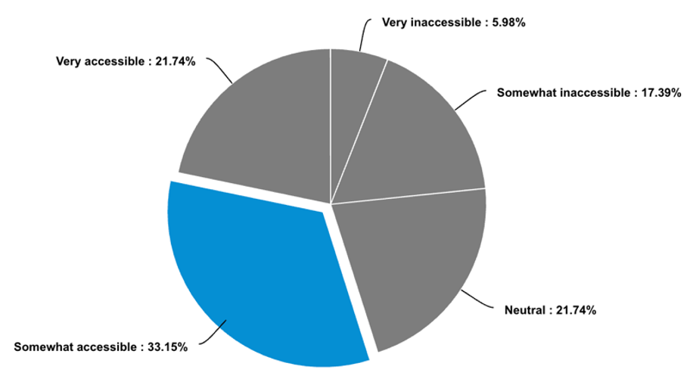

Table 6: Student survey responses: “How would you rate the following learning supports?”
Statement | I have not used this service | Very poor | Poor | Neutral | Good | Excellent | Overall
Ease of accessing support | 42 (25.15%) | 9 (5.39%) | 15 (8.98%) | 32  (19.16) | 48 (28.74%) | 21 (12.57%) | 167  (100%)
Timeliness of adjustments provided | 39 (23.49%) | 2  (1.2%) | 11 (6.63%) | 22 (13.25%) | 58 (34.94%) | 34 (20.48%) | 166  (100%)
Effectiveness of adjustments in addressing your needs | 40 (24.1%) | 10 (6.02%) | 12 (7.23%) | 28 (16.87%) | 58 (34.94%) | 18 (10.84%) | 166  (100%)
Staff attitudes and understanding of invisible disabilities | 35 (21.08%) | 13 (7.83%) | 11 (6.63%) | 32 (19.28%) | 45 (27.11%) | 30 (18.07%) | 166  (100%)

Table 7: Student survey responses: “How accessible do you find these aspects of university?”
Statement | Very inaccessible | Somewhat inaccessible | Neutral | Somewhat accessible | Very accessible | Overall
Course materials (e.g., lecture slides, reading lists) | 2  (1.06%) | 22  (11.7%) | 16 (8.51%) | 71 (37.77%) | 77 (40.96%) | 188  (100%)
Physical learning spaces (e.g., lecture halls, libraries) | 8  (4.26%) | 28  (14.98%) | 32 (17.02%) | 80 (42.55%) | 40 (21.28%) | 188  (100%)
Online learning platforms (e.g., learning management systems) | 6  (3.23%) | 20  (10.75%) | 27 (14.52%) | 74 (39.78%) | 59 (31.72%) | 186  (100%)
Communication with lecturers and tutors | 8  (4.26%) | 29  (15.43%) | 34 (18.09%) | 70 (37.23%) | 47  (25%) | 188  (100%)
Assessments (e.g., exams, submitted assessments, and group projects) | 8  (4.32%) | 36  (19.46%) | 38 (20.54%) | 66 (35.68%) | 37  (20%) | 185  (100%)
Disability related supports and adjustments | 11  (5.98%) | 32  (17.39%) | 40 (21.74%) | 61 (33.15%) | 40 (21.47%) | 184  (100%)
Figure 20: Student survey responses: “Do you feel empowered to advocate for your needs?”
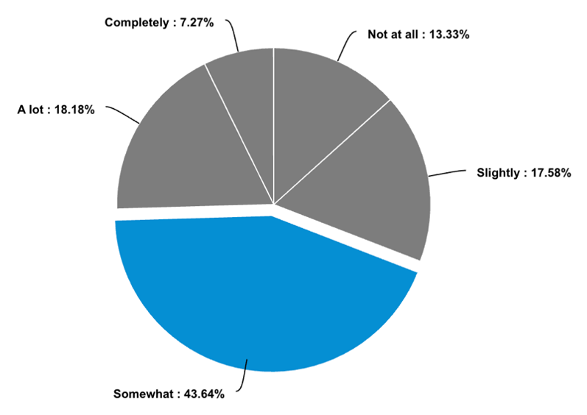

Figure 21: Student survey responses: “Do you feel the university has provided sufficient information about your rights and their legal obligations?”
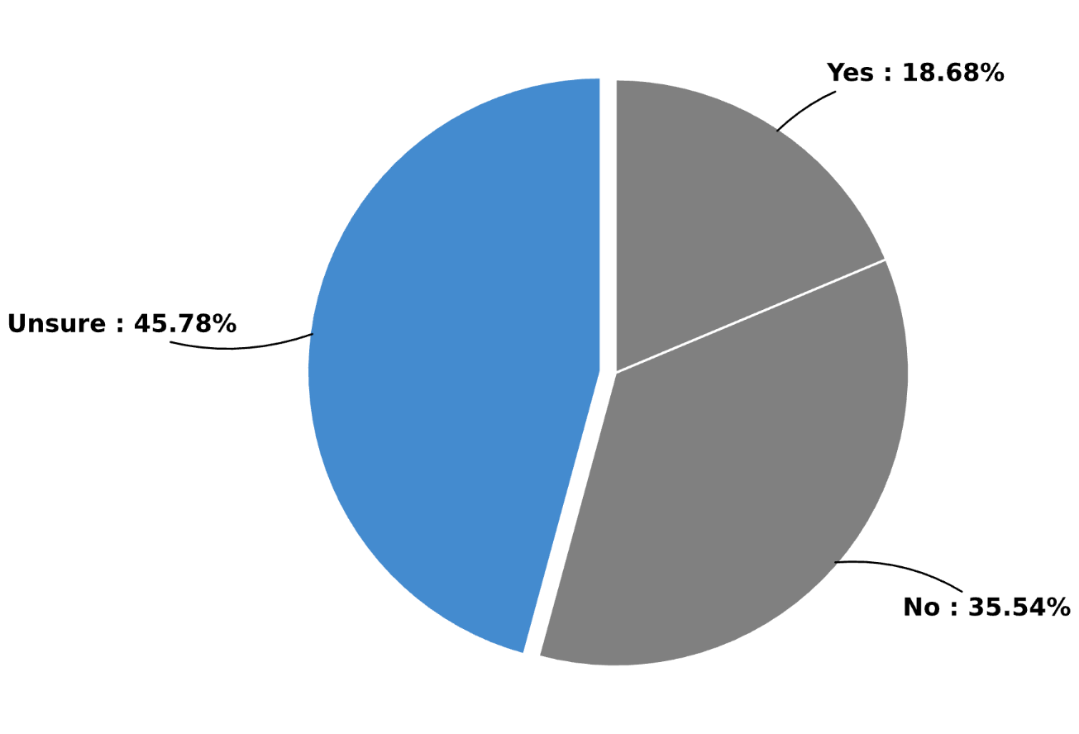

Figure 22: Student survey responses: “How well do you think the current curriculum is designed to support all students, without needing further adjustments?”
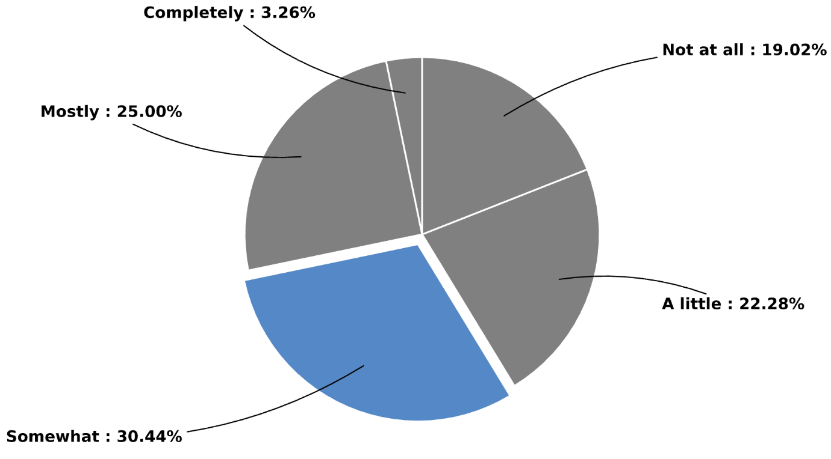

11.2 Staff survey graphics
Figure 23: Staff survey responses: “What is your primary role at the university?”
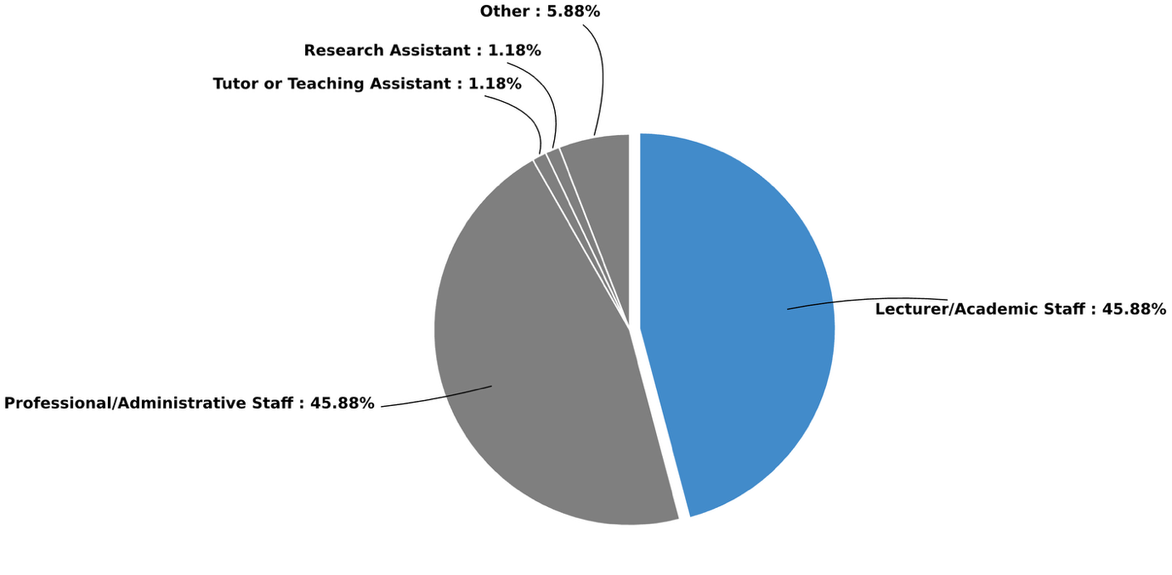

Figure 24: Age demographics for staff survey participants
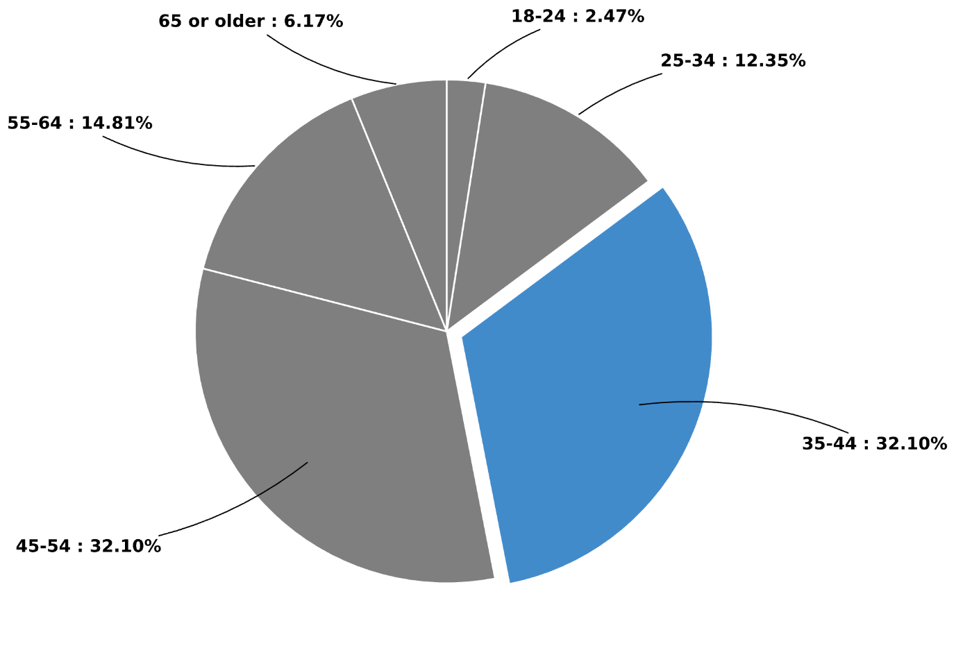

Figure 25: Staff survey responses: “I believe it is my professional responsibility to implement reasonable adjustments for students with invisible disabilities”
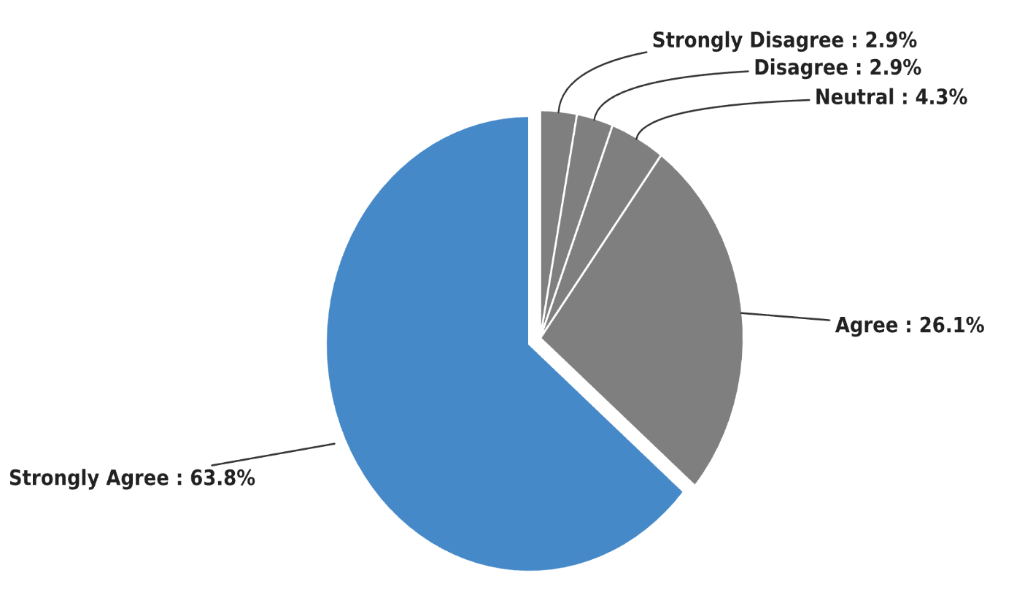

Appendix 3: Student survey
ABOUT: This survey is for all students currently enrolled in Higher Education. It can be taken by students who self-identify as having an invisible disability, as well as their peers and colleagues who do not. This survey is the first phase in a project which aims to understand how students who identify as having an invisible disability experience the learning environment of universities. Invisible disabilities, also known as hidden or non-visible disabilities, are defined as health conditions, impairments or chronic illnesses that are not immediately visible to others. They include, but are not limited to physical, mental, and neurological conditions (Invisible Disabilities Australia, N.D). Reasonable adjustments are "any form of assistance or adjustment that is necessary, possible and reasonable to reduce or eliminate barriers" to your learning (Australian Government, N.D). They are personalised to your individual needs and can be temporary or long-term. We would like to understand students’ experiences with the supports provided at their university. You will be asked to answer a series of questions about your experiences of and/or with invisible disabilities while attending university as a student. Questions ask students to reflect on the adjustments recommended by the university to your lecturer aimed at reducing the impact of invisible disabilities on your studies. Questions also aim to understand what other support services are available beyond these reasonable adjustments. For students who don’t identify as having an invisible disability we would still like to hear from you. Your insights are important for understanding how you view the experiences of your peers with an invisible disability, as well as social perceptions of invisible disabilities.

LANGUAGE DISCLAIMER: This survey uses person-first language (e.g., 'student with disability'), but we recognise that many individuals prefer identity-first language (e.g., 'disabled student'). We acknowledge that language preferences around disability are deeply personal, and terminology varies across communities and individuals. The terms used within this survey may not reflect your preferred language, and we respect each person's right to self-identify in their own way.

DURATION AND CONTENT: The online survey can be conducted at a time that is convenient to you and will take between 15-25 minutes. If at any time you need to leave the survey but would like to come back and finish it later, you can click the "save and continue later" button at the bottom of the page. Beginning the survey implies that you consent for your responses to be used anonymously to inform the outcomes of the research. You can close the survey at any time without completing it, and your responses up to that point will be captured. The survey is being conducted via the University supported software question-pro. Information about the platform including its privacy and security policy is available here: https://www.questionpro.com/help/privacy-policy.html#:~:text=We%20will%20never%20use%20any,your%20activity%20on%20the%20Internet
ASSISTANCE: While completing the survey it is possible that the questions may trigger an emotional response, and you may like to take a break, stop the survey, or contact a support service such as: Lifeline: 13 11 14 Beyond Blue: 1300 224 636 Reach Out: au.reachout.com Disability Gateway: 1800 643 787 Disability Australia Hub: https://www.disabilityaustraliahub.com.au/organisations/

FINDINGS AND FURTHER INFORMATION: At the end of the survey a separate link will be available. You can use this link to provide your contact details should you wish to receive a summary of the findings or any publications from the research. This link will also provide you with an opportunity to “opt-in” to participating in Phase two (interview or focus group) and Phase three (interactive workshop) of this research. If you choose to participate in this further research, you will be contacted by a member of the research team, and you can change your mind at any time. Please note: There is no obligation to participate in the next phases of the research. You can choose to provide your information to receive a copy of the report while also opting out of any further participation in the research. This survey has received approval via the University of Newcastle ethics process: Protocol Number: N-2024-0277

BEFORE YOU START SOME FINAL INFORMATION AND REASSURANCE: This survey can be completed by any student currently enrolled in higher education. The experiences of non-disabled individuals are also important for understanding the wider cultural values that students in higher education are exposed to. Some questions won't be relevant, please leave them blank. If you self-identify as having an invisible disability but feel a question is not relevant to your experience or you don't have an answer, please leave it blank. You can skip questions at any time. This survey will save your progress; there is no need to complete the survey in one sitting. Just click "save and continue" and you can come back at another time. If a survey isn't your thing, you can opt to participate in an interview or focus group: Please contact the University of Newcastle's Chief Investigator Dr. Caitlin Mollica at caitlin.mollica@newcastle.edu.au to discuss your participation. We would love to hear from you. There are 7 sections in this survey, depending on your reading and writing speed it may take you between 25-45 minutes to complete.

SECTION 1: Demographic Information and Disability Contexts

Do you identify as having an invisible disability/disability? (You can still participate in the survey if you select no - we want to hear from you)
- Yes
- No

Have you received a clinical diagnosis for your individual disability/disabilities? (You can still participate if you select no for this question)
- Yes
- No

How would you describe your invisible disability? You could provide the name of your disability/condition or list symptoms if you are unable to label your disability. You do not have to have an official diagnosis. (For more information on how the government classifies disability: https://www.tcsisupport.gov.au/element/615)

What is your Gender?
- Male
- Female
- Non-Binary
- I’d rather not say
- Other

What is your age range?
- 17-21
- 22-26
- 27-31
- 32-35
- 36-40
- 41-45
- 46-50
- 51+

What program/course/degree are you enrolled in?

What university do you attend?

What is your level of study?
- Undergraduate
- Postgraduate
- Graduate Certificate (TAFE course or a private institution)

Are you studying full time or part time?
- Full time
- Part time

Why did you choose to study part time?
How long have you been enrolled in university?
- Less than 1 year
- 1-2 years
- 3-4 years
- More than 4 years

Have you informed the university about your invisible disability/disabilities?
- Yes
- No
- Prefer not to say

What adjustments or support do you receive from your university to adjust for your learning needs?

Why have you chosen not to inform the university about your invisible disability?

Thanks for providing us with this demographic information. Please proceed to the next section about Learning Experiences.

Section 2: Learning Experiences

How accessible do you find the following aspects of university?

 | Very inaccessible | Somewhat inaccessible | Neutral | Somewhat accessible | Very accessible
Course materials (e.g., lecture slides, reading lists) | ❏ | ❏ | ❏ | ❏ | ❏
Physical learning spaces (e.g., lecture halls, libraries) | ❏ | ❏ | ❏ | ❏ | ❏
Online learning platforms (e.g., learning management systems) | ❏ | ❏ | ❏ | ❏ | ❏
Communication with lecturers and tutors | ❏ | ❏ | ❏ | ❏ | ❏
Assessments including (exams, submitted assessments, and group projects) | ❏ | ❏ | ❏ | ❏ | ❏
Disability related supports and adjustments | ❏ | ❏ | ❏ | ❏ | ❏

Is there anything you would like to tell us about why you have given any of the above aspects of the university experience a particular ranking?

Please answer the following:

 | Not at all | A little | Somewhat | Mostly | Completely
How well do you think the current curriculum is designed to support all students, without the need for further adjustments? | ❏ | ❏ | ❏ | ❏ | ❏

What are the most significant barriers you face in accessing your education or in achieving success in your education?

Please answer the following:

 | Not at all | Slightly | Somewhat | A lot | Completely
Do you feel societal attitudes about invisible disability influence your experience at university? | ❏ | ❏ | ❏ | ❏ | ❏

Thanks for completing the second section! This helps us understand more about the accessibility of different aspects of university.

Section 3: Perceptions of Learning Support Services In the following section, questions are designed to capture how beliefs, interactions and access impact how students with invisible disabilities experience university.

Have you tried to access information about services to support students with invisible disabilities?
- Yes
- No

If you answered yes, to attempting to access information about services to support students with invisible disabilities:

 | Not at all | A little | Somewhat | Mostly | Very Easy
How easy was this information to find? | ❏ | ❏ | ❏ | ❏ | ❏
How accessible was this information in terms of your ability to understand the services and support available? | ❏ | ❏ | ❏ | ❏ | ❏

Why have you chosen not to access information about services and support for students with invisible disabilities?

Please answer the following about university support and staffing:

 | Not at all | A little | Somewhat | Mostly | Well known
In general, how well do you think your university supports the learning needs of students with invisible disabilities? | ❏ | ❏ | ❏ | ❏ | ❏
In general, how willing do you think staff at your university are to support learning adjustments for students with invisible disabilities? | ❏ | ❏ | ❏ | ❏ | ❏
In general, how widespread is knowledge amongst the student cohort about their right to request reasonable adjustments to support their learning if they have an invisible disability? | ❏ | ❏ | ❏ | ❏ | ❏

Consider the following: “My friends and I know how to access learning support for invisible disabilities?”
- True
- False

Thanks for your insights! Section 4 coming up next

Section 4: Interactions with Learning Support Processes

Please answer the following:

 | Not at all | A little | Somewhat | Mostly | Completely
How comfortable are you discussing your needs with your lecturers and tutors? | ❏ | ❏ | ❏ | ❏ | ❏

Please consider the following statement:

 | Never | Rarely | Sometimes | Often | Always | I have never asked for reasonable adjustments
“In my interactions with lecturers and tutors, I have found the response to my request for reasonable adjustments to be consistently positive” | ❏ | ❏ | ❏ | ❏ | ❏ | ❏

Can you provide an example of a time when you had a positive interaction with your lecturers and/or tutors regarding your invisible disability?

Can you provide an example of a time when you have a negative interaction with a lecturer or tutor regarding your invisible disability?

Please answer the following:

 | I didn’t know that these services were available at my university | Not at all | Somewhat | Mostly | Completely | These services do not apply to me
How comfortable are you discussing your needs with the disability/accessibility team within your university? | ❏ | ❏ | ❏ | ❏ | ❏ | ❏

If you have used learning support services, how would you rate the following?

 | I have not used this service | Very Poor | Poor | Neutral | Good | Excellent
Ease of accessing support | ❏ | ❏ | ❏ | ❏ | ❏ | ❏
Timeliness of adjustments provided | ❏ | ❏ | ❏ | ❏ | ❏ | ❏
Effectiveness of adjustments in addressing your needs | ❏ | ❏ | ❏ | ❏ | ❏ | ❏
Staff attitudes and understanding of invisible disabilities | ❏ | ❏ | ❏ | ❏ | ❏ | ❏

What challenges, if any, have you faced in accessing learning support services?

Do you feel that the university’s learning support services are adequately equipped to address the needs of students with invisible disabilities? Why or why not?

Thanks for telling us about your interactions with university staff and accessibility support. You are over halfway!

Section 5: Empowerment and Awareness of Rights

The Disability Discrimination Act 1992 (Cth) prohibits discrimination in Education. Under the Act discrimination occurs when the failure to make reasonable adjustments results in a person with a disability being treated less favourably than a person without a disability in circumstances that are not significantly different. It also determines that indirect discrimination occurs when an absence of reasonable adjustments prevents a person with a disability from meeting their obligations. After reading the above statement were you:
- Fully aware of the details outlined in the above protections
- Assumed that there was this legal protection
- Completely unaware of this legal protection

Please answer the following:
 | Not at all | Slightly | Somewhat | A lot | Completely
Do you feel empowered to advocate for your needs at university? | ❏ | ❏ | ❏ | ❏ | ❏

Has the university provided you with sufficient information about your rights and their legal obligations?
- Yes
- No
- Unsure

What additional resources or support would help you feel empowered to navigate your disability rights at university regarding reasonable adjustments?

Thanks for your answers about disability rights and empowerment!

Section 6: Perceptions of Inclusion and Accessibility Accessibility occurs when a person with a disability is given the opportunity to receive the same information, participate in the same interactions, and enjoy the same services as a person without a disability in an equally effective and integrated way (Australian Human Rights Commission: N.D). The following questions ask you to reflect on your experiences and perceptions of accessibility

Please answer the following:

 | Not at all inclusive | Slightly inclusive | Somewhat inclusive | Very inclusive | Completely inclusive
How inclusive do you feel your university community is for students with invisible disabilities? | ❏ | ❏ | ❏ | ❏ | ❏

Please list or describe any specific aspects of the university experience that make you feel included?

Please list or describe any specific aspects of the university experience that make you feel excluded?

What initiatives or changes would improve inclusion, accessibility and learning outcomes for students with invisible disabilities at your university?

Do you feel that staff at the university are adequately trained to support students with invisible disabilities?
- Yes
- No
- Unsure

Do you feel that your peers understand what invisible disabilities are and how they can impact the learning experience?
- Yes
- No
- Unsure

Can you share a positive experience where you (or your peers) felt that the needs of students with invisible disability were effectively supported? (In your response please do not list any specific names, course names or codes this will ensure that confidentiality is maintained)

Thanks for letting us know your insights about inclusion. Only one more section left!

Section 7: Closing Reflections

What advice would you give to the university to better support students with invisible disabilities?

Is there anything else you would like to share about your experiences as a student with an invisible disability?

Thank you for sharing your insights. If you would like to participate in the next stage of this research (a focus group, interview, or interactive workshop) please select yes below and you will be taken to a new survey to provide your details. Please also select yes below if you would like to be contacted to receive information about participating in the next phase of this research, or you would like to receive a copy of any reports or publications that draw on the findings from this survey. Focus groups and interviews are optional and aim to expand the research teams understanding of the experiences of students with invisible disabilities. Once you have provided your details you will then be contacted by a member of the research team to discuss. PLEASE NOTE: You can change your mind at any time.
- Yes
- No

Appendix 4: Staff survey
ABOUT SURVEY: This survey is the first phase in a project which aims to understand how higher education workers interact with and support students who identify as having an invisible disability. Invisible disabilities, also known as hidden or non-visible disabilities, are defined as health conditions, impairments or chronic illnesses that are not immediately visible to others. They include, but are not limited to physical, mental, and neurological conditions (Invisible Disabilities Australia, N.D). You will be asked to answer a series of questions about your experiences working to support students with invisible disabilities. Questions ask staff to reflect on the reasonable adjustments, and other support services available to students who self-identify as having an invisible disability. You will also be asked to reflect on the legal and ethical obligations associated with supporting students with invisible disabilities. Reasonable adjustments are "any form of assistance or adjustment that is necessary, possible and reasonable to reduce or eliminate barriers" to learning (Australian Government, N.D). They are personalised to the student's individual needs and can be temporary or long-term.

LANGUAGE DISCLAIMER: This survey uses person-first language (e.g., 'student with disability'), but we recognise that many individuals prefer identity-first language (e.g., 'disabled student'). We acknowledge that language preferences around disability are deeply personal, and terminology varies across communities and individuals. The terms used within this survey may not reflect your preferred language, and we respect each person's right to self-identify in their own way.
DURATION & CONTENT: The online survey can be conducted at a time that is convenient to you and can take approximately 15-25 minutes if completing in one sitting. Alternatively, you can work through the responses in your own time by saving the survey at any point by selecting the "Save and continue later" button at the bottom of the screen. There are 7 sections with ~44 questions total (27 MCQ and 17 text-based). Beginning the survey implies that you consent for your responses to be used anonymously to inform the outcomes of the research.

ASSISTANCE: This survey is being conducted via the University supported software question-pro. Information about the platform including its privacy and security policy is available: https://www.questionpro.com/help/privacy-policy.html#:~:text=We%20will%20never%20use%20any,your%20activity%20on%20the%20Internet While completing the survey it is possible that the questions may trigger an emotional response, and you may like to take a break, stop the survey, or contact a support service such as: Lifeline: 13 11 14Beyond Blue: 1300 224 636Reach Out: au.reachout.comDisability Gateway: 1800 643 787Disability Australia Hub: https://www.disabilityaustraliahub.com.au/organisations/
FINDINGS & FURTHER INVOLVEMENT: At the end of the survey there will be an opportunity for you to provide your details should you wish to be involved in phase two of this research or should you wish to receive a copy of the findings. If you choose to provide your details this information will be stored separately from your responses and will remain confidential. If you choose to participate in this research, you will be contacted by a member of the research team, and you can change your mind at any time.

*Please note: There is no obligation to participate in the next phases of the research. You can choose to provide your information to receive a copy of the report while also opting out of any further participation in the research.This research project is approved through university ethics protocol number: H-2024-0277

Section 1: Demographic Information

Q1 of 10. What is your primary role at the university?
- Lecturer/Academic Staff
- Professional/Administrative Staff
- Tutor or Teaching Assistant
- Research Assistant
- Other __________

Q2 of 10. How long have you been working in higher education?
- Less than 1 year
- 1-3 years
- 4-7 years
- 8-10 years
- More than 10 years

Q3 of 10. Which faculty, school, or department do you primarily work in?

Q4 of 10. As part of your employment responsibilities, have you interacted (directly or indirectly) with students with invisible disabilities?
- Yes
- No
- Unsure

Q5 of 10. Have you received any formal training on disability inclusion or accessibility in higher education?
- Yes
- No
- Unsure

Q6 of 10. Are you involved in designing, delivering, or supporting courses or programs for students?
- Yes
- No

Q7 of 10. Do you identify as having a disability (invisible or visible) or chronic condition yourself?
- Yes
- No
- Prefer not to say

Q7a of 10. How would you describe your disability?

Q8 of 10. What is your age group?
- Under 18
- 18-24
- 25-34
- 35-44
- 45-54
- 55-64
- 65 or older

Q9 of 10. What is your gender?
- Female
- Male
- Non-binary
- I’d rather not say
- Other __________

Q10 of 10. What is the highest level of education you have completed?
- Bachelor’s degree
- Master’s degree
- Doctorate/PhD
- Other (please specify)

Section 2: Interactions with Students with Invisible Disabilities

Q1 of 9. How comfortable do you feel communicating with students about their invisible disability-related needs?
- Not at all comfortable
- Slightly comfortable
- Somewhat comfortable
- Very comfortable
- Completely comfortable

Q2 of 9. Do you feel that students with invisible disabilities trust you to understand and support their needs?
- Not at all
- Slightly
- Somewhat
- A lot
- Completely

Q3 of 9.&#34;I believe it is my professional responsibility to implement reasonable adjustments for university students with invisible disabilities.&#34;
- Strongly Disagree
- Disagree
- Neutral
- Agree
- Strongly Agree

Q4 of 9.“I feel confident implementing reasonable adjustments for university students with invisible disabilities.”
- Strongly Disagree
- Disagree
- Neutral
- Agree
- Strongly Agree

Q5 of 9. Which of the following factors most influence your personal views on implementing reasonable adjustments for university students with invisible disabilities? (Select all that apply)
- My ethical or personal beliefs about inclusion and equity
- Legal obligations and institutional policies
- The impact on my workload and available resources
- Perceived effectiveness of reasonable adjustments in supporting student success
- Personal experiences with disability (my own or others’)
- Training or professional development on disability inclusion
- Colleagues’ or institutional culture toward disability adjustments
- Fear of being perceived as acting unfairly on students
- Other

Q6 of 9. Can you briefly describe a positive experience where you felt your actions significantly improved the learning experience or outcomes for a student with an invisible disability? (please make sure that you refrain from naming the student, the course name and code, or any other identifying features)

Q7 of 9. Do you feel supported by your institution to engage meaningfully with students requiring reasonable adjustments for invisible disabilities?
- Yes
- No
- Unsure

Q7a of 9. If no, what changes would help you better support these students?

Q8 of 9. How often do you design your teaching or support services in a way that helps all students learn, including those with disabilities, without needing extra changes later?
- Never
- Rarely
- Sometimes
- Often
- Always

Q9 of 9.“Universal Design for Learning (UDL) is a central component of my teaching pedagogy”
- Strongly Disagree
- Disagree
- Neutral
- Agree
- Strongly Agree

Section 3: Addressing Societal Barriers and Inaccessible Environments

Q1 of 7. How often do you encounter barriers in the learning environment that impact students with invisible disabilities (e.g., inaccessible technological tools and platforms, rigid policies)?
- Never
- Rarely
- Sometimes
- Often
- Always

Q2 of 7. What are the most common requests for adjustments received from students with invisible disabilities?

Q3 of 7. Describe some of the steps you have taken to reduce barriers for students with invisible disabilities?

Q4 of 7. Rate the following factors based on their importance in mitigating barriers for students with invisible disabilities:
 | Not important | Slightly important | Somewhat important | Very important | Extremely important
Proactive course design and accessibility strategies | ❏ | ❏ | ❏ | ❏ | ❏
Institutional support and leadership | ❏ | ❏ | ❏ | ❏ | ❏
Ongoing professional development and training | ❏ | ❏ | ❏ | ❏ | ❏
Improved communication and trust with students | ❏ | ❏ | ❏ | ❏ | ❏
Technology enabled teaching and learning spaces | ❏ | ❏ | ❏ | ❏ | ❏

Q5 of 7. What could your university could do better to support staff in reducing barriers for students with invisible disabilities?

Q6 of 7. Please provide some examples of practices that your university has implemented, which positively support staff’s capacity to understand the barriers experienced by students with invisible disabilities?

Q7 of 7. Please provide some examples of practices that your university has implemented, which have had a negative impact on staff's capacity to understand the barriers experienced by students with invisible disabilities?

Section 4: Empowerment and Capacity Building

Q1 of 4. Do you feel empowered to support students with invisible disabilities effectively?
- Not at all
- Slightly
- Somewhat
- A lot
- Completely

Q2 of 4. What additional training or resources would help you feel more confident in supporting students with invisible disabilities?

Q3 of 4. How might the university better foster a culture of empowerment for students with invisible disabilities?

Q4 of 4. What actions do you take to encourage students with invisible disabilities to advocate for their own needs?

Section 5: Implementation Obligations

Q1 of 5. How effective are the reasonable adjustment provisions used by your university to support students with invisible disabilities?
- Not effective at all
- Slightly effective
- Somewhat effective
- Very effective
- Extremely effective

Q2 of 5. How often do you pre-emptively incorporate accessibility considerations into your teaching or professional practices (e.g., when designing assessments or planning learning materials)?
- Never
- Rarely
- Sometimes
- Often
- Always

Q3 of 5. What specific action have you taken to ensure your teaching or support work meets the needs of students with invisible disabilities?

Q4 of 5. Rate the effectiveness of the following in supporting your implementation of reasonable adjustments:

 | Not effective at all | Slightly effective | Somewhat effective | Very effective | Extremely effective
Institutional policies | ❏ | ❏ | ❏ | ❏ | ❏
Support from the disability services team | ❏ | ❏ | ❏ | ❏ | ❏
Direct communication with students about their needs | ❏ | ❏ | ❏ | ❏ | ❏
Technology and tools provided by the university | ❏ | ❏ | ❏ | ❏ | ❏
Support from your school/department's teaching and learning leadership team. | ❏ | ❏ | ❏ | ❏ | ❏

Q5 of 5. What challenges, if any, do you face implementing reasonable adjustments for students with invisible disabilities?

Section 6: Understanding Legal and Ethical Obligations

Q1 of 4. How familiar are you with your legal obligations regarding students with invisible disabilities?
- Not at all familiar
- Slightly familiar
- Somewhat familiar
- Very familiar
- Completely familiar

Q2 of 4. How confident are you in your understanding of the concept of “reasonable adjustments” for students with invisible disabilities?
- Not at all confident
- Slightly confident
- Somewhat confident
- Very confident
- Completely confident

Q3 of 4. Have you received any formal training on working with students with disabilities, including individuals with invisible disabilities?
- Yes
- No

Q3a of 4. If yes, how effective was the training in preparing you to fulfill your legal and ethical obligations?
- Not effective at all
- Slightly effective
- Somewhat effective
- Very effective
- Extremely effective

Q4 of 4. Please describe your primary ethical and legal responsibilities when working with students with invisible disabilities?

Section 7: Final Reflections

Q1 of 2. What advice would you give to a new staff members about working with students with invisible disabilities?

Q2 of 2. Is there anything else you would like to share about your experiences or insights regarding supporting students with invisible disabilities?

Thank you for participating, we appreciate you taking the time to share your experiences. If you would like to participate in an anonymised online interview (or receive more information about participating) or if you would like to receive a copy of the outputs that result from this survey please select &#34;yes&#34; and you will be taken to another short survey to provide your details.Interviews are optional and aim to deepen the research teams understanding of your experiences working with students with invisible disabilities.
- Yes
- No

Hyflex includes aspects of hybrid teaching and is a flexible approach that gives students the option of attending face-to-face, online, or both.
Within the data and in the focus group discussions, there was substantial deviation in beliefs about the suitability of oral exams for students with invisible disabilities. As discussed below, many students highlighted that presentations felt inaccessible.

