
ACSES CAPACITY BUILDING GRANTS PROGRAM
Evaluation for practitioners: Developing capacity, confidence, and passion for evaluation and monitoring to improve student outcomes by measuring impact

  - Charles Darwin University

2026

Evaluation for practitioners: Developing capacity, confidence, and passion for evaluation and monitoring to improve student outcomes by measuring impact

February 2026

Charles Darwin University

Suggested citation: Charles Darwin University (2026). Evaluation for practitioners: Developing capacity, confidence, and passion for evaluation and monitoring to improve student outcomes by measuring impact (Small Grants Research Program final report). Australian Centre for Student Equity and Success, Curtin University.

Australian Centre for Student Equity and Success
Tel: +61 8 9266 1573
Email: acses@curtin.edu.au
Web: www.acses.edu.au
Building 100
Curtin University
Kent St, Bentley WA 6102 | GPO Box U1987, Perth WA 6845

DISCLAIMER
Information in this publication is correct at the time of release but may be subject to change. This material does not purport to constitute legal or professional advice.
Curtin accepts no responsibility for and makes no representations, whether express or implied, as to the accuracy or reliability in any respect of any material in this publication. Except to the extent mandated otherwise by legislation, Curtin University does not accept responsibility for the consequences of any reliance which may be placed on this material by any person. Curtin will not be liable to you or to any other person for any loss or damage (including direct, consequential or economic loss or damage) however caused and whether by negligence or otherwise which may result directly or indirectly from the use of this publication.

COPYRIGHT
© Curtin University 2026
Except as permitted by the Copyright Act 1968, and unless otherwise stated, this material may not be reproduced, stored or transmitted without the permission of the copyright owner. All enquiries must be directed to Curtin University.
CRICOS Provider Code 00301J
ISBN 978-1-7644511-6-1

Acknowledgement of Country
The Australian Centre for Student Equity and Success acknowledges Indigenous peoples across Australia as the Traditional Owners of the lands on which the nation’s campuses are situated. With a history spanning more than 60,000 years as the original educators, Indigenous peoples hold a unique place in our nation. We recognise the importance of their knowledge and culture, and reflect the principles of participation, equity, and cultural respect in our work. We pay our respects to Elders past, present, and future, and consider it an honour to learn from our Indigenous colleagues, partners, and friends.

Approach
Charles Darwin University (CDU) is a small institution with limited resourcing to support specialist monitoring and evaluation (M&E) capability within equity and student support programs. Unlike larger universities, CDU does not have dedicated equity research teams; instead, practitioners responsible for designing and delivering programs are also expected to evaluate their effectiveness. Many have limited formal training or confidence in assessing outcomes and impact.
To address this gap, we engaged an external expert consultant to design and deliver a targeted training and support program for equity practitioners at CDU. The program focused on strengthening foundational M&E knowledge, practical application of tools and frameworks, and confidence in evaluating equity initiatives, with particular emphasis on the Student Equity in Higher Education Evaluation Framework (SEHEEF).
A second, complementary component involved developing practical tools and templates to support consistent application of M&E concepts across programs.
The initiative sought to:
- Build staff capability and confidence to strengthen the impact of equity programs.
- Enhance CDU’s institutional evaluative capability to meet increasing accountability and reporting requirements, including needs-based funding and the support for students policy.
- Improve the design, delivery, and evaluation of student support programs to enhance access, participation, and success for equity cohorts.
Originally planned for delivery between April and November, the workshop series was rescheduled to the second half of the year to minimise disruption to service delivery. The two-day face-to-face intensive was held during the mid-semester break in August. A blended delivery model (online and face-to-face) maximised participation and supported applied learning.

Table 1: Schedule and descriptions of workshops
Dates | Mode | Workshop | Focus
22 August | Online | Introduction to  Monitoring & Evaluation | Core M&E concepts; SEHEEF; monitoring vs evaluation vs impact
28 August | Face-to-face | Understanding Outputs | Defining outputs; developing output statements
28 August | Face-to-face | Introduction to Outcomes | Outcome concepts; outcome statements
29 August | Face-to-face | Developing Outcome  Indicators | SMART indicators and measures
29 August | Face-to-face | Integrating Outputs and Outcomes | Developing a simple M&E framework
25 September | Online | One-on-One Support | Refining outputs, outcomes, indicators
26 September | Online | One-on-One Support | Data collection tools and alignment
24 November | Online | Tools and Templates | Introduction to shared templates and dashboards

A total of 25 staff participated, representing a broad cross-section of student support and equity functions:
- First Year Student Success
- First Nations Student Support
- Language and Learning
- Access and Inclusion
- Library Services
- Student Advocacy
- Campus Activation and Student Life
- Peer Advisor Program
- Counselling and Wellbeing
- Tertiary Enabling Program
- Careers Centre
- International Student Support

One of the challenges we faced was the variety of experience levels of the participants. The concepts, models, and frameworks discussed were completely new to some participants, whilst others had some experience of basic evaluation practices in other sectors (for example, not-for-profit). There was also a wide variety of programs that participants were working on. To overcome this, the consultant was briefed on the nature of the programs, allowing the activities at each session to be tailored accordingly. There was also the opportunity to pair up more and less experienced participants to share knowledge and build confidence. We also introduced one-on-one coaching in the second half of the program, enabling participants to spend focused time with the consultant after applying the concepts to their own programs.

Outputs

Introduction of key concepts and the purpose of M&E (workshop 1)
The program aimed to introduce monitoring and evaluation concepts and to build understanding of the benefits of implementing a monitoring and evaluation framework across equity and student support programs. This workshop introduced core concepts such as inputs, activities, outputs, outcomes, and impact and how this fit within a program logic model. It highlighted the importance of planning activities, and that a clear program logic is the foundation for useful M&E. The participants also learnt the difference between program monitoring, program evaluation of impact evaluation, and when and how to apply the methods.
The use of case studies and interactive small group work enabled participants to work through examples of applying the concepts to understand how they connect.

Understanding outputs and outcomes (workshops 2 and 3)
These two workshops built a coherent understanding of the differences between outputs and outcomes and how they work together within the monitoring and evaluation cycle. Participants learnt the importance of having outputs and outcomes that are realistic and aligned to institutional goals and funding requirements, which is important as many of the programs are HEPPP funded. There was a focus on understanding the importance of having clearly stated outputs, well framed outcomes, tested assumptions and clear evidence to demonstrate program effectiveness.
The use of a meaningful case study, using Carer Support Services as an example, helped clarify the concepts of output and outcomes. Participants then worked through their own activity of developing outputs and outcomes for a chosen activity.

Indicators and measures (workshop 4)
This workshop focused on how to translate outcomes into measurable evidence of change in programs. Participants learnt how to distinguish outcomes (the change sought) from indicators (the signs that change has occurred) and measures (the specific data collected), and how these elements work together within program logic.
Participants worked in pairs to develop indicators and measures using the outcomes drafted in the previous workshop.

Developing a simple M&E framework (workshop 5)
This workshop consolidated what was learnt in the previous sessions by showing how to integrate outputs, outcomes, indicators, measures, data sources, and assumptions into a simple, practical M&E framework. The workshop emphasised using the framework both for accountability (tracking what was delivered) and learning (understanding whether and how change occurred), setting realistic performance targets, and identifying gaps in data before implementation.
Key takeaways from the workshop series include:
- M&E is not just about data collection—it’s about making sense of data to improve programs and demonstrate value.
- Outputs are what you deliver; outcomes are what changes as a result.
- Indicators provide evidence of whether outcomes are achieved.
- M&E framework implementation provides data for planning different types of evaluation, continuous learning, and improvement of program activities.
Building on the outputs of the previous workshop, participants used a basic template to map a ‘mini M&E framework’ to develop an understanding of the integration of key concepts. The remainder of the program focused on one-on-one coaching with the final session used as an introduction to the second component of the program, the practical tools and templates for consistent application across all programs and activities. This included a standardised M&E framework tool, outcomes dashboard, and standardised survey questions (see Appendix for examples).

Figure 1: Face-to-face workshops held at CDU Danala Campus, Darwin.
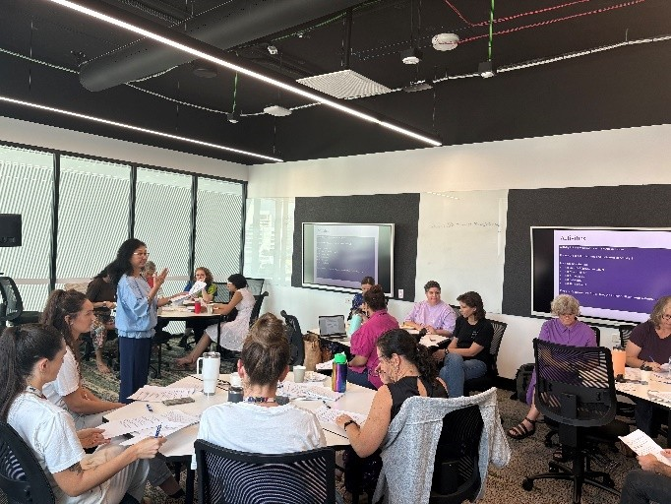

Impact
The program has generated a clear shift in understanding, confidence, and engagement with evidence-informed evaluation across participating teams. Prior to the project, evaluation activity was largely limited to tracking outputs, with limited access to structured training or consistent frameworks.
The program addressed this gap by:
- Building participants’ foundational understanding of M&E concepts, terminology, and methods.
- Equipping staff with practical skills to define and measure outputs, outcomes, and indicators using the SEHEEF framework.
- Providing coaching to support the application of learning within active HEPPP-funded projects.
Participants reported increased confidence in developing program logic models, aligning data collection with evaluation objectives, and articulating evidence of impact. While many outcomes will continue to emerge as frameworks are embedded, CDU expects to see stronger evaluation practice and improved program design from 2026 onwards.
To sustain momentum, there are plans to establish an ongoing community of practice to support continued learning and application.
At the completion of the program, participants completed a survey surrounding their agreement with statements and about the program’s impact. (1 = strongly disagree, 5 = strongly agree):
Figure 2: Results of survey of workshop participants
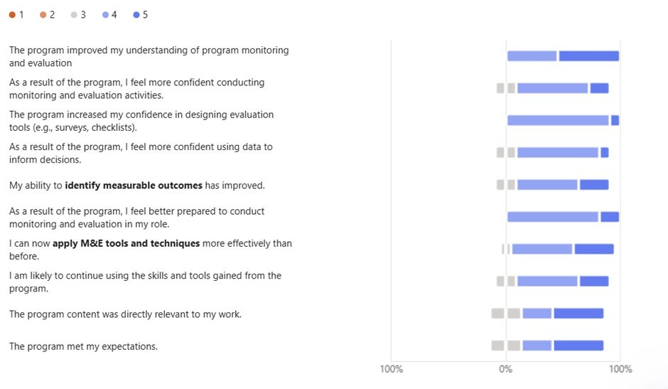

The results indicate that for most of the statements, participants agreed or strongly agreed. This demonstrates that the program has built the capacity within CDU to evaluate equity initiatives.
An open-ended question asked for any further comments or feedback on the program. The following examples demonstrate how the program has built confidence and understanding about monitoring and evaluation. As indicated earlier in the report, the level of expertise at the beginning of the program reflects the increased confidence levels at the conclusion of the program.
The Measurement and Evaluation workshop series significantly increased my knowledge and confidence in using evidence to guide decision-making. The sessions provided clear, practical strategies for collecting, interpreting, and applying data, which has already made it easier for me to write stronger, more persuasive business cases supported by appropriate evidence. The real challenge now is embedding these practices consistently in our day-to-day work. While I feel more capable, ongoing support and opportunities to apply the frameworks in real contexts will help ensure the skills become part of our regular approach. (Participant 1)
It was so helpful and well structured. Lien is brilliant at breaking things down so we could understand the process better. Whilst challenging, it really helped to clarify some of our activities and the way we word our surveys to get useful feedback. Thank you. (Participant 2)
Thanks for providing this opportunity. I don’t yet feel fully confident in my monitoring and evaluation skills, but it was a good start and helped me wrap my head around it. (Participant 3)

