
ACSES CAPACITY BUILDING GRANTS PROGRAM

Chartering change: Building developmental evaluation capacity for equity initiatives

  - University of South Australia

2026

Chartering change: Building developmental evaluation capacity for equity initiatives

February 2026

University of South Australia

Suggested citation: University of South Australia (2026). Chartering change: Building developmental evaluation capacity for equity initiatives (Small Grants Research Program final report). Australian Centre for Student Equity and Success, Curtin University.

Australian Centre for Student Equity and Success
Tel: +61 8 9266 1573
Email: acses@curtin.edu.au
Web: www.acses.edu.au
Building 100
Curtin University
Kent St, Bentley WA 6102 | GPO Box U1987, Perth WA 6845

DISCLAIMER
Information in this publication is correct at the time of release but may be subject to change. This material does not purport to constitute legal or professional advice.
Curtin accepts no responsibility for and makes no representations, whether express or implied, as to the accuracy or reliability in any respect of any material in this publication. Except to the extent mandated otherwise by legislation, Curtin University does not accept responsibility for the consequences of any reliance which may be placed on this material by any person. Curtin will not be liable to you or to any other person for any loss or damage (including direct, consequential or economic loss or damage) however caused and whether by negligence or otherwise which may result directly or indirectly from the use of this publication.

COPYRIGHT
© Curtin University 2026
Except as permitted by the Copyright Act 1968, and unless otherwise stated, this material may not be reproduced, stored or transmitted without the permission of the copyright owner. All enquiries must be directed to Curtin University.
CRICOS Provider Code 00301J
ISBN 978-1-7645328-3-9

Acknowledgement of Country
The Australian Centre for Student Equity and Success acknowledges Indigenous peoples across Australia as the Traditional Owners of the lands on which the nation’s campuses are situated. With a history spanning more than 60,000 years as the original educators, Indigenous peoples hold a unique place in our nation. We recognise the importance of their knowledge and culture, and reflect the principles of participation, equity, and cultural respect in our work. We pay our respects to Elders past, present, and future, and consider it an honour to learn from our Indigenous colleagues, partners, and friends.

Approach
The University of South Australia (UniSA) and the University of Adelaide will, in 2026, become Adelaide University (AU). As a part of this transition, the new institution intends to develop a whole-of-university framework for widening participation which includes a Theory of Change (ToC) and impact framework to guide the design of pre-access and access initiatives. While this work will provide a unified structure for monitoring targets and participation metrics, there is also a clear aspiration to move towards approaches that generate actionable insights for program design and improvement.
The Chartering Change project has contributed to this shift by establishing a foundational ToC for three UniSA programs in which each engage distinct student groups—that is, primary school students (pre-access stage), secondary students in alternative school settings (pre-access stage), and students participating in an enabling program within UniSA College (participation stage). The project has also acted as a catalyst to identify the types of locally meaningful data that can inform ongoing program refinement and strengthen the evidence-base ahead of the formation of AU.
UniSA’s outreach programs and activities are currently managed by assorted internal teams, two of which include UniSA College and the Education Futures Academy (EFA). Prior to the Chartering Change project, there had been no formal evaluation of the EFA or UniSA College outreach activities and so the project sought to:
- Create an in-house evaluation team comprised of staff from UniSA’s EFA and UniSA College capable of working alongside Program Officers (POs).
- Build capacity of three early career researchers (Smith, Devis, and Weiler) in the higher education (HE) equity evaluation space.
- Develop the project team’s capacity to both conduct and utilise evaluation to improve the design and delivery of programs enhancing student equity by providing a structure in which we can bring together in-house experts in educational evaluation.
- Increase POs’ awareness of and skills in working with the Student Equity in Higher Education Evaluation Framework (SEHEEF);
- Develop a clearer understanding of how the equity “pipeline” is intended to work, and how it is actually working, ahead of the new AU in 2026.
- Promote cross-collaboration between units and academic and professional staff.
- Enable opportunities for early career researchers to sustainably apply their newly acquired skills in evaluation to future outreach initiatives by sharing insights, methodologies, and good practice.
The evaluation team selected three outreach programs (as identified in our original grant submission) for Theory-Based Impact Evaluation (TBIE). We refer to these programs—that is, STEM Showdown, Starting Strong, and University Makes a Difference Outreach Program (UMaDOP)—more accurately as “connect” programs as they go beyond an equity perspective that focuses narrowly on increasing student recruitment and retention. Their intent is more expansive and altruistic by design as they emphasise relationship-building, community contribution, and forms of impact that are not reducible to participation metrics. It follows that each program’s design has generally been guided by one or more of Gale et al.’s (2010) three equity perspectives:
- Unsettling deficit views: challenges narrow assumptions about disadvantaged students and their communities by promoting a strengths-based approach to engagement. Rather than working on communities, this perspective advocates working with them. These programs prioritise the cultivation of meaningful learning opportunities for all students with a deliberate focus on those most disengaged from educational pathways.
- Researching “local knowledge” and negotiating local interventions: the importance of context in shaping educational inequalities. Interventions aligned with this orientation avoid a “one-size fits all” approach. Instead, they are developed through processes of listening, learning, and negotiation with schools and/or communities.
- Building capacity in communities, schools, and universities: moves beyond short-term engagement to focus on systemic, long-term investment in the conditions that support equitable participation and success. Importantly, this perspective also brings universities into sharper focus with a call to reflect on how HE practices, cultures, and structures either enable or constrain student success. Programs, including HE enabling programs, aligned with this orientation not only build capacities to aspire—that is, “the ability to both imagine the future in detailed ways and to transfer these imaginaries into desired outcomes” (Smith, 2011, p. 167)—but actively equip students with the knowledge, skills, and dispositions (including confidence) necessary to navigate HE environments.

Outline
Our original plan was to develop and deliver a short micro-credentialled module consisting of a sequence of six short interactive workshops focused on systems mapping—that is, using a systematic approach to understand “human activities and interactions in real-world complex environments” (Yamagata-Lynch, 2010, p. 2). This was intended to support each of the three connect programs to identify the subject (individuals or groups involved as the primary actor/s in the activity), tools (the resources used in an activity), rules (social norms and behaviours that affect how an activity takes place), community (social group involved in the activity), and division of labour (how tasks are shared in an activity), and to then map the tensions and enablers within these systems as a means for authentic measurement and change. However, in our initial meetings with each program lead, it became clear that the connect programs did not have an explicit or logically sequenced ToC—a necessary precursor for TBIE—as tied to HE equity research and literature. Without a coherent ToC informed by current equity literature, we deemed that it was not possible to progress to the TBIE as originally planned.
While the leads of Starting Strong and UMaDOP—both academic staff with expertise and publication histories in HE equity—were able to articulate the equity impetus underpinning their program design and identify their intended outcomes, all three programs required the evaluation team’s particular expertise in developing a research-informed, logical, and testable ToC. This was a critical early finding for the team. Given the complexity and myriad influencing factors on students’ access, participation, and persistence in HE, best practice cannot be fully prescribed. Instead, we determined that evaluation efforts must be contextualised in order to identify “what works, in what situations, for whom, and why” (Johnstone et al., 2021, p. 26), and to use these findings to inform decisions about future activity. Hence, a clearly articulated ToC provides the necessary foundation and precursor for this contextualised approach to evaluation.
In recognition of this gap, we shifted focus from the proposed combined delivery microcredential workshop model and instead redesigned the workshops as a four-hour standalone intensive ToC-focused session delivered separately to each connect program team. This allowed us to work with each group in sufficient depth to elicit the program’s Object of Change—this object relates to the specific aspect that is being intentionally changed by an activity or program—clarify assumptions and articulate immediate-, intermediate-, and long-term outcomes.
Each re-designed workshop included:
- An introduction to the SEHEEF and TBIE.
- Purpose of the initial evaluation activity.
- PO led program overview and design—that is, program “architecture”—with the opportunity for the evaluation team to elucidate further details as required.
- PO identification of the equity impetus.
- Explanation of ToC concepts with modelled examples.
- Interactively mapped explanation—involving both POs and the evaluation team—of each program’s emerging ToC, including making explicit the POs’ supporting assumptions and follow-up questioning by the evaluation team to trace how these assumptions were informed.
Across the three programs, we observed considerable variation in evaluative readiness. For instance, Starting Strong and UMaDOP—designed by academic program leads with significant knowledge and expertise in HE and equity—had drawn on a strong literature base to inform their original program design, particularly around concepts such as cultural capital, social capital, and hot knowledge and the capabilities required for low socioeconomic (L-SES) students to access and progress through university. In contrast, the STEM Showdown facilitators demonstrated strong pedagogical knowledge for program delivery but required pedagogical reasoning and conceptual grounding in order to propose or articulate a coherent ToC. Furthermore, the program impetus remained mired in the historically persistent assumption that early STEM engagement leads to later STEM degree enrolment, an assumption that is not generally supported by contemporary research.
In the absence of empirical program data, we adopted a more developmental evaluation approach. As a team, we undertook extensive review of the literature—prioritising Australian evidence where available so as to remain contextually relevant and comparable to the programs they were informing—post-workshop in order to support the refinement of each program’s ToC. The ToCs generated during the workshops were later strengthened through this alignment with literature to produce research-informed, logically sequenced, and defensible models tailored to each program’s context and equity impetus. Consequentially, each program report focuses on the ToC with discussion elaborating on relevant literature and its connections to the program, assumptions made, its Object of Change and outcomes (see Figures 1 to 3).

Figure 1: Theory of Change for Starting Strong (MacGillivray et al., 2025)
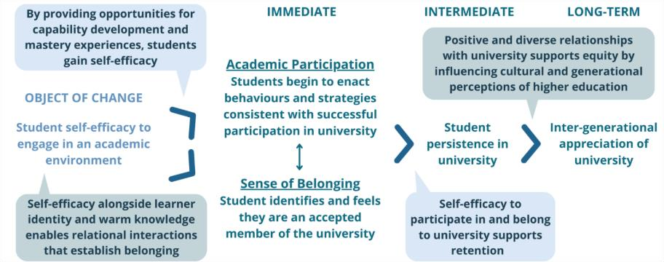

Figure 2: Theory of Change for University Makes a Difference Outreach Program (UMaDOP) (Smith et al., 2025)
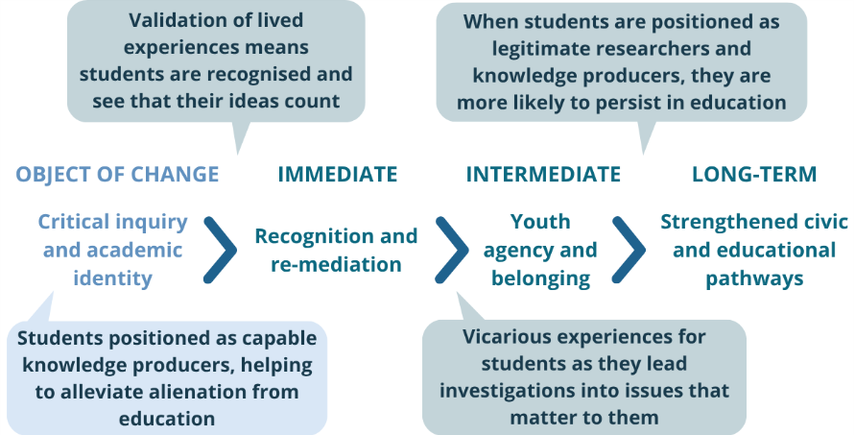

Figure 3: Theory of Change for STEM Showdown (Devis et al., 2025)
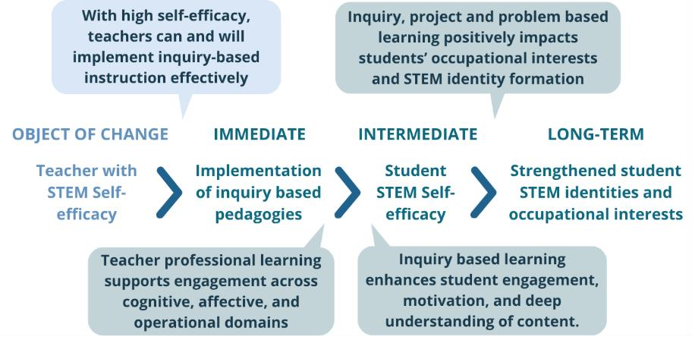

Concurrently, we used workshop discussion and the literature to clarify the equity impetus underpinning each program by identifying who the program is likely to work for, in what context, and toward what interpretation of equity. For example, STEM Showdown was ultimately conceptualised as being grounded in curricular justice as it aims to provide primary school students with access to high-quality STEM learning experiences as a means for broadening future pathway opportunities.

Overview
The Chartering Change project team was comprised of:
- Dr Lisa Smith (Research Fellow)
- Dr Debbie Devis (Research Fellow)
- Dr Tanya Weiler (Senior Lecturer)
- Professor Simon Leonard (Professor of the Learning Sciences)
- Maesie MacGillivray (Research Assistant).
Smith and Devis developed and delivered the workshops in June 2025 with MacGillivray recording extensive notes from the workshop discussions. As a facilitator of both UMaDOP and Starting Strong, Weiler prepared and presented the program overviews for the workshops and contributed to program-specific reporting.
The interactive mapping and refinement of each program’s ToC was undertaken by Smith, Devis, and MacGillivray who drew on their collective experience in contribution analysis and ToC methodology. This process combined whiteboard-based collaborative mapping alongside engagement in the academic literature which resulted in the diagrams presented in Figures 1 to 3. Initial ToCs were provided to POs for verification and discussion and were subsequently refined through literature-informed review. This refinement phase occurred over August to October 2025 through a series of inhouse team discussions and iterative visualisation of each ToC in a shared Canva space.
The evaluation work culminated in three reports of approximately 10,000 words each—one for each outreach program—which were developed in parallel with the iterative refinement of the ToCs—occurring across August to October. The reports were produced through a cyclic construction process in which synthesis of the literature both informed, and was shaped by, ongoing validation and adjustment of each connect program’s ToC. The specific responsibilities of project team members in relation to the writing of the reports were as follows:
- Smith: led the development of each report’s equity impetus, evaluation overview, and methodology; authored the ToC discussion sections for UMaDOP and STEM Showdown; authored the summary and opportunities sections; identified potential quantitative instruments suitable for future TBIE and included them as appendices.
- Devis: authored the recommendations for each report; refined the logic underpinning the Starting Strong ToC discussion; provided advisory input and critical review of the ToC logic across all programs.
- Weiler: prepared the initial ToC discussion for Starting Strong and developed the program overviews for Starting Strong and UMaDOP.
- MacGillivray: led the analysis and writing of each program’s tensions and enablers and generated the ToC diagrams.
- Leonard: reviewed the final drafts of all reports and provided feedback to guide necessary revisions.
These reports have provided all POs with an accessible synthesis of existing knowledge.

Challenges
Several challenges were encountered during this project. Firstly, Smith, Devis, and MacGillivray—all of whom are on research-only contracts—are co-located at UniSA’s Mawson Lakes campus in a shared office suite which enabled regular, and at times spontaneous, discussion that supported the development and refinement of each program’s ToC and the drafting of the associated reports. In contrast, Weiler—who is a senior lecturer and has a teaching load—is based at UniSA College at the City West campus which required whole team discussions to be formally scheduled. This arrangement inevitably reduced opportunities for informal engagement and limited inclusion in the iterative ToC refinement process.
A further challenge related to the strong sense of ownership demonstrated by some POs. While reflective of their commitment to their programs, this ownership at times constrained the depth of critical reflection regarding program design and outcomes. These dynamics were also intensified by the broader institutional context surrounding the creation of AU, particularly in relation to the uncertainty of which connect programs will remain in the intermediate future. Within this environment, some POs tended to emphasise the need for affirming data to demonstrate program value. This climate and tendency indicate difficulties for PO-led evaluation, especially at this point in time. Our preference and recommendation would be to continue to develop our team’s capacity for evaluation work so that we might work somewhat independently of these pressures.
Finally, even highly experienced POs with research expertise found it challenging to fully articulate their program’s ToC. They worked from a significant degree of tacit knowledge together with a strong critical research basis of the barriers and enablers faced by differing equity groups in accessing and participating in HE. However, they still relied on the expertise of Smith, Devis, and MacGillivray to translate this knowledge into and identify the causal pathways between different components of the ToC. As a result of this challenge, we recommend that sustained and structured evaluative support is integral for the initial generation of a measurable ToC.

Outputs

Key learnings, results, and findings
The project demonstrated the value of a research-informed ToC as a means for mitigating potential unintended outcomes that could adversely affect the student equity groups each program seeks to support. The collaborative ToC mapping processes—including POs—enabled implicit assumptions to be surfaced, interrogated, and later translated into clearer, evidence-informed program logics for STEM Showdown, Starting Strong, and UMaDOP.
For Starting Strong, the process of generating the ToC revealed that the program’s change pathway was not in fact linear in nature as initially assumed, but instead diverged at the point of the immediate outcome before reconverging at the intermediate outcome (see Figure 1). Identification of this divergence is significant as it demonstrates that two complementary causal links—academic participation and students’ sense of belonging—operate in parallel and jointly contribute to student persistence in HE. This insight will strengthen the next phase of evaluation of the program by ensuring that indicators are identified and evidence is interpreted with reference to both pathways. Additionally, the divergent nature of Starting Strong’s program logic indicates a shift from the more linear representation as documented in the SEHEEF (Johnstone et al., 2021, p. 7). Recognising this complexity is important because it enables a more accurate understanding of how change occurs within and as a result of the program and supports. Likewise, this divergence presents a possible volatility in student life beyond the program, necessitating multiple design components and objects of change to better support the student through the transition. This is particularly important because it challenges linear design decisions, which program design is vulnerable to falling back on. Making the ToC itself complex anchors the program, and any future iterations, in designing for complexity.
While some of the outcomes identified across the three connect programs demonstrate consistency with the SEHEEF’s supporting outcomes, the primary outcomes largely differ. SEHEEF’s primary outcomes focus on progression, acceptance, participation, retention, and attainment metrics (p. 7). However, these indicators alone do not fully capture the broader impact these programs seek to generate. In particular, they do not encompass longer-term or community-level outcomes—such as intergenerational appreciation of HE—that are essential for enabling more sustainable change in disadvantaged communities.

Impact

Capacity-building impact
The project has contributed substantially to building evaluation capacity within UniSA ahead of the formation of AU. A key outcome was the development of the team’s practical experience in generating research-informed ToCs. Smith, Devis, and MacGillivray led the ToC mapping using their prior experience and knowledge of contribution analysis and ToC methodology, whilst also extending this expertise through immersion in academic literature and iterative collaborative mapping. Their co-location enabled ongoing peer learning and joint problem-solving.
Other team members also developed evaluative capability through their participation. For example, Weiler—and more indirectly, POs—engaged in unpacking outcomes as relevant to the program logic, articulating their assumptions (as informed via experience and/or a research basis) and identifying some of the initial tensions and enablers which highlight the key relationships, activities and mediating factors that influence how their program operates in practice.
Capacity building has also extended beyond individual team members. Through the production of logical, well-articulated ToCs and accompanying developmental evaluation reports, the project has created institutional artefacts that will support a sustained program of developmental/formative evaluation and research in the pre-access, equity, and widening participation areas of AU. These reports have been distributed to relevant engagement and equity teams across UniSA and the University of Adelaide where it is anticipated that this work will continue through the establishment of a dedicated working group in early 2026.

Capacity development
Smith is an early career researcher with a background in equitable schooling and HE and has experience in university-school partnered research. This is her first opportunity to lead as a Chief Investigator on a grant-funded project. Prior to this project she had limited expertise in program evaluation and generating ToCs. The co-delivery of the workshops, including the interactive mapping and observations of Devis as she guided discussions around each program’s ToC, allowed Smith to learn vicariously and develop mastery for translating these insights into high quality initial program evaluation reports.
Leonard’s role as a project mentor supported Smith to situate the project within a broader institutional context, including its potential value for Adelaide University. He also facilitated connections with colleagues working in equity and evaluation across the current universities (UniSA and the University of Adelaide) which has extended Smith’s professional networks in these areas.
Devis is a midcareer researcher with a background in knowledge brokerage, educational design, and systems thinking. Devis was deeply involved in the development of frameworks for the system’s theoretical design used in this evaluation. Prior to this project, she had limited experience as a Chief Investigator, and this was her first experience in applying the methodology for evaluative purposes. Working closely with Smith and MacGillivray as a collaborative team, with mentoring from Leonard, allowed Devis to establish frameworks for leading projects and developing other evaluators/early career researchers. While beyond the scope of this project, the latter frameworks are instrumental to Devis’s research interests in knowledge brokerage.
MacGillivray is an early career researcher with a background in Activity Systems analysis, and an interest in teacher-student relationships and interdisciplinary collaboration. MacGillivray also has the positionality of an undergraduate student studying English and Psychology—a lens that influenced her contributions in the development of the ToCs. This evaluation developed MacGillivray’s ability to generate ToCs, as well as to engage with activities’ tensions and enablers, in a deeply collaborative context while drawing on and learning from the expertise of Smith and Devis. She also found that she was challenged in her thinking and has come to greater appreciate the extensive and varied knowledge bases that the POs offer.
Collectively, Smith, Devis, and MacGillivray—through the co-facilitation of these workshops together with immediate evaluation team-based debrief and follow-up ToC focused discussions—have developed mastery experiences for generating the first iteration of program evaluation. For instance, by listening to POs articulate program intentions, reflect on implementation challenges, and undertake sensemaking as they explored causal assumptions, our team developed an ability to collectively translate practitioner knowledge into explicit and measurable ToCs. This work provides a template—what we currently refer to as a “compass” due to its navigational capacity rather than a prescriptive approach—for undertaking future connect program evaluation in the new Adelaide University.
POs’ evaluation capacity was developed through a facilitated workshop focused on introducing the concept and purpose of a ToC together with a demonstration of how a ToC is constructed and used in evaluation. In this sense, POs were guided by the evaluation team through steps one to three of Mayne’s (2008) approach to exploring cause and effect:
- Step 1: Set out the attribution problem to be addressed
- Step 2: Develop a theory of change and risks to it
- Step 3: Gather the existing evidence on the theory of change (p. 1)
Rather than undertaking the analytic steps themselves, these workshops were deliberately structured as collaborative learning spaces (as opposed to didactic training sessions) for POs to contribute their knowledge and practice-based expertise to support the evaluation team in the collaborative generation of each ToC.
By working collectively, each program’s team of POs were able to expand on one another’s ideas, make explicit their assumptions and surface different perspectives as linked to each person’s distinct role within the facilitation of the program.

References
Devis, D., Smith, L., MacGillivray, M., & Leonard, S. N. (2025). A developmental evaluation of the University of South Australia's STEM Showdown program: Report no. 1. University of South Australia. https://doi.org/10.25954/s5bp-3n38
Gale, T., Hattam, R., Comber, B., Tranter, D., Bills, D., Sellar, S., & Parker, S. (2010). Interventions early in school as a means to improve higher education outcomes for disadvantaged students.
Department of Education, Employment and Workplace Relations.
Johnstone, M., Robinson, M., Salom, C., Tomaszewski, W., Kubler, M., Clague, D., Zajac, T., & Povey, J. (2021). Student Equity in Higher Education Framework (SEHEEF): Guidance manual. The Institute for Social Science Research; The University of Queensland. https://www.education.gov.au/heppp/resources/student-equity-higher-educationevaluationframework-seheef-guidance-manual
MacGillivray, M., Smith, L., Weiler, T., Devis, D., & Leonard, S. N. (2025). A developmental evaluation of the University of South Australia's Starting Strong program: Report no. 1. University of South Australia. https://doi.org/10.25954/h6hk-4d31
Mayne, J. (2008). Contribution analysis: An approach to exploring cause and effect.
Smith, L. (2011). Experiential “hot” knowledge and its influence on low-SES students’ capacities to aspire to higher education. Critical Studies in Education, 52(2), 165-177.
Smith, L., Devis, D., MacGillivray, M., Weiler, T., & Leonard, S. N. (2025). A developmental evaluation of the University of South Australia's University Makes a Difference Outreach Program: Report no. 1. University of South Australia. https://doi.org/10.25954/mtx0-7353
Yamagata-Lynch, L. C. (2010). Activity Systems Analysis Methods: Understanding Complex Learning Environments (1. Aufl. ed.). Springer Science + Business Media. https://doi.org/10.1007/9781-4419-6321-5

