
ACSES CAPACITY BUILDING GRANTS PROGRAM

Building evaluative capacity to improve equity student retention and experience at the University of Wollongong

  - University of Wollongong

2026

Building evaluative capacity to improve equity student retention and experience at the University of Wollongong

February 2026

University of Wollongong

Suggested citation: University of Wollongong (2026). Building evaluative capacity to improve equity student retention and experience at the University of Wollongong (Capacity Building Grant final report). Australian Centre for Student Equity and Success, Curtin University.

Australian Centre for Student Equity and Success
Tel: +61 8 9266 1573
Email: acses@curtin.edu.au
Web: www.acses.edu.au
Building 100
Curtin University
Kent St, Bentley WA 6102 | GPO Box U1987, Perth WA 6845

DISCLAIMER
Information in this publication is correct at the time of release but may be subject to change. This material does not purport to constitute legal or professional advice.
Curtin accepts no responsibility for and makes no representations, whether express or implied, as to the accuracy or reliability in any respect of any material in this publication. Except to the extent mandated otherwise by legislation, Curtin University does not accept responsibility for the consequences of any reliance which may be placed on this material by any person. Curtin will not be liable to you or to any other person for any loss or damage (including direct, consequential or economic loss or damage) however caused and whether by negligence or otherwise which may result directly or indirectly from the use of this publication.

COPYRIGHT
© Curtin University 2026
Except as permitted by the Copyright Act 1968, and unless otherwise stated, this material may not be reproduced, stored or transmitted without the permission of the copyright owner. All enquiries must be directed to Curtin University.
CRICOS Provider Code 00301J
ISBN 978-1-7645328-4-6

Acknowledgement of Country
The Australian Centre for Student Equity and Success acknowledges Indigenous peoples across Australia as the Traditional Owners of the lands on which the nation’s campuses are situated. With a history spanning more than 60,000 years as the original educators, Indigenous peoples hold a unique place in our nation. We recognise the importance of their knowledge and culture, and reflect the principles of participation, equity, and cultural respect in our work. We pay our respects to Elders past, present, and future, and consider it an honour to learn from our Indigenous colleagues, partners, and friends.

Approach
This project’s aim was to build evaluative capacity amongst teams that run equity-promoting initiatives at the University of Wollongong (UOW) with a particular focus on the Student Retention team. The premise was adapted from an approach developed by the Social Policy Evaluation and Research Unit (Superu) evaluation capacity building (ECB) project (2016).
Evaluation capacity building is often understood as a development of the knowledge and technical skills needed to undertake an evaluation. However, initiatives such as developing resources, tools, and templates and guidance on how to use them are just one component of being able to enact good evaluations and good evaluators in an organisation. It is also important to work on the organisational culture and behavioural changes to embed evaluative thinking (ET), which is a reflective practice (Baker, 2011) “applied in the context of evaluation, motivated by an attitude of inquisitiveness and a belief in the value of evidence” (Buckley et al., 2015).
Developing evaluative inquiry also requires building transparency and trust, and creating an environment where innovative ideas can thrive, or just as importantly, are allowed to fail. As such, ECB is more about organisational development as opposed to individual professional development (Taylor-Powell & Boyd, 2008). When embedded, such a culture can ensure learnings from the monitoring and evaluations of programs can drive organisational program development and be applied to strategic planning, rather than sit in isolation.
Linking theory to practice and communicating and applying research results is an intrinsic process to academics at universities (Taylor-Powell & Boyd, 2008). While experts in their fields, equity professionals are less likely to have a research background and may require support and coaching to conduct evaluations for social programs. The rationale for this project was to build evaluation capacity by assessing and addressing capability, providing motivation through engaging workshops, and providing opportunity via means of practice and application, using the COM-B framework to influence behaviour (Mitchie et al., 2011).
Central to the project was the development of an Evaluation Capacity Needs Assessment Tool (the Tool). This tool served a dual purpose. Firstly, it sought to identify the gaps in evaluation capacity at the team level and to highlight the variation of capacity across equity programs at UOW. This enabled us to understand what unique support they may need to successfully evaluate their programs. Secondly, the tool acted as a self-reflection exercise and helped embed ET and the cyclical nature of evaluative or continuous quality improvement work through practice and application.
By inviting senior managers and equity program owners to a series of workshops, we wanted to secure buy-in for the importance of evaluation, moving away from seeing the Student Equity in Higher Education Evaluation Framework (SEHEEF) as a tick-box exercise for meeting funding conditions and instead moving towards understanding what the results of measuring real impact mean for improved student outcomes and enhanced organisational program delivery.

Timeline
During the project we undertook six activities:
- The development of an Evaluation Capacity Needs Assessment Tool for use by equity practitioners across UOW.
- The organisation of a workshop (Evaluation Essentials for Equity Practitioners), that introduced the tool and provided equity program team members with a good baseline understanding of what healthy evaluative practice looks like.
- Four teams used the tool to assess their own project capability and identify gaps, barriers, and enablers to conducting impact evaluations at UOW through a guided workshop approach as opposed to using the tool in isolation as outlined in the initial proposal.
- One team, the Student Retention team, undertook a series of four workshops to design an evaluation plan for an Impact Evaluation of the Student Retention program.
- Support was provided for other equity program teams to resolve impact evaluation challenges of their choosing at an Evaluation Symposium (NB: this changed from the initial proposal of providing individual coaching to teams to a collective approach in the symposium).
- Finally, we introduced an evaluation Community of Practice (CoP) for UOW equity programs.
All teams working in equity programs at UOW and funded by the Higher Education Participation and Partnership Program (HEPPP) in 2025 were invited to the Evaluation Essentials for Equity Practitioners workshop and the final symposium. Programs sit across several divisions at UOW including the Division of Student Life, Woolyungah Indigenous Centre, Student Administration Services Division, and the Outreach and Future Students Division. The programs operate across the SEHEEF student lifecycle including pre-access, access, participation, and attainment and transition out.
The project ran from August 2025 to December 2025 and was led by Cassy King in collaboration with Lucy Snowball, Duncan Rintoul, and George Argyros from evaluation consultancy Rooftop Social.

Challenges
One of the unique challenges faced in this project was that it coincided with a UOW transformation project. This meant timelines and outputs needed to shift to align with availability of staff and their capacity to engage with the project, while navigating potential redundancies.
Delays in contract execution were also significant due to availability and capacity of staff at UOW, meaning the project started four months later than anticipated in the original proposal. As a result, while the Evaluation Community of Practice was introduced during the project symposium, the work to organise and plan activities for the CoP will be carried out in 2026.

Outputs

Evaluation Capacity Needs Assessment Tool
In collaboration with Rooftop Social, an evaluation consultancy, we designed a self-assessment tool (see Appendices 1 and 2) to measure evaluation capacity. The Tool is comprised of six domains (questions) each with five response options and an option to indicate “not known”. The domains were designed to help teams identify gaps in knowledge as well as barriers and enablers to influence a change in evaluative thinking among equity practitioners at UOW, promote a change in behaviours for good evaluative practice, and to improve capacity in conducting impact evaluations of equity programs.
The domains were:
- evaluative culture
- evaluative policies and procedures
- evaluative planning and practice
- evaluation and research capability building
- data and IT systems to support research/evaluation
- use of research and evaluation for program design
During the development of the Tool, it was piloted with the Retention team to test if the questions were appropriate for use and understood by equity practitioners. One of the learnings from the pilot was that teams did not know how they could answer questions that were “outside their sphere of influence”. A second was that it was difficult knowing whether they should answer for the current or future (post transformation) state UOW, where, for example, there may be changes in IT systems or the make-up of teams.
We decided that the teams would answer as best as they saw fit and for the current state of UOW. Additional notes were provided for clarity in the guidance and it was advised that when an issue came up outside of their immediate control, this is when it would be escalated in the university’s appropriate routes of risk planning and mitigation to ensure visibility of these blockages at a senior management level in the organisation.

Evaluation Capacity Building workshop
To support the implementation of the Tool by the University’s equity teams, we delivered an Evaluation Capacity Building workshop entitled “Evaluation Essentials for Equity Programs”, open to all equity team members. The workshop explained how to assess their capacity via the Tool and how to use the findings.
Held in October 2025, the workshop was an intensive, interactive, and motivating event for equity practitioners. A total of 23 participated, working in outreach; transition and retention; access and inclusion; equity scholarships for low socio-economic status (SES) students; and programs for Aboriginal and Torres Strait Islander students. The workshop highlighted what good practice looked like in impact evaluation and delivered guidance on how to complete the Tool (Figure 1, 2, and 3).

Figure 1: Evaluation sparking joy. Dr Cassy King (project lead) launching the Evaluation Essentials for Equity Programs workshop.
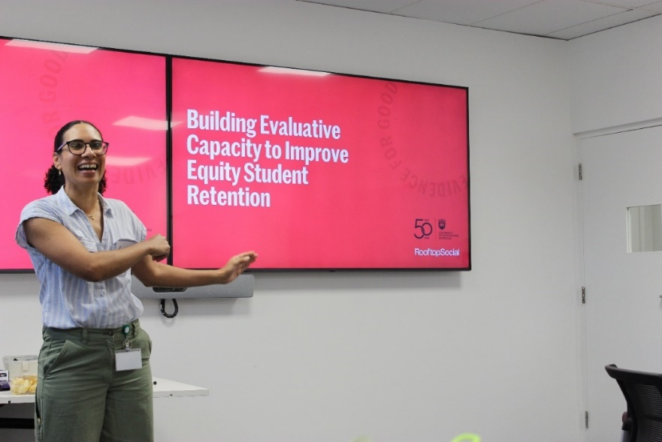
Figure 2: Setting expectations of the workshop.
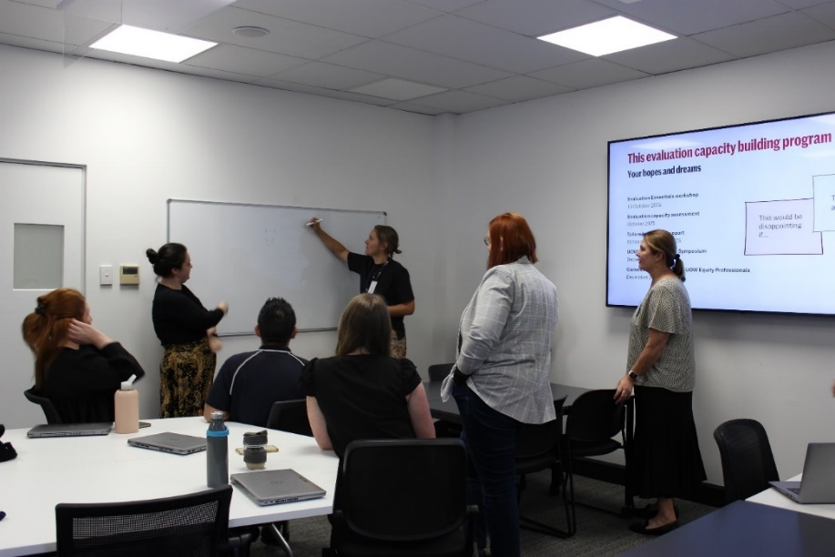
Figure 3: Gallery walk to familiarise participants with the six domains of the ECB Tool.
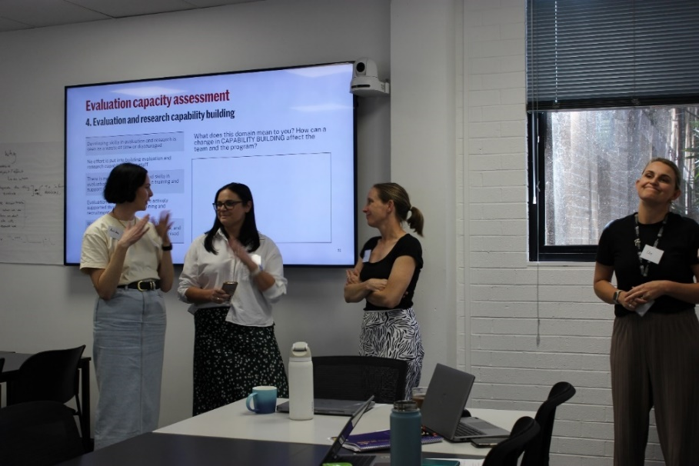

Evaluation Needs Assessment
After the tool was introduced at the Evaluation Essentials for Equity Programs workshop, the tool was used by four teams of equity practitioners across UOW to map their current state of capacity for undertaking evaluation and measuring impact. Using the Tool, program teams were supported to assess their own evaluation capacity needs and to ready the teams in terms of evaluative thinking, professional development, and what steps were required to influence the culture of evaluation at UOW.
Whilst the original plan was to let the teams complete the Tool in their own time, providing a link for completion, Dr Cassy King (project lead) identified that the team worked well to a guided approach when the tool was first used by the Student Retention team in a workshop format. This was therefore the approach adopted for other equity teams.
In the workshops, the teams went around the room to give their individual response to each of the questions and, if they were all in agreement, that was used as the collective response. If individual team members had differing views, a conversation was held to come to a shared response. This approach helped with transparency around the issues each of the domains provided in the context of UOW. Taking this revised approach, following the workshop Dr Cassy King held individual sessions with program teams to complete the tool and identify barriers and gaps in evaluation capacity and capability for their specific program.
The Tool uses a system of four progressive stages of capability: 1) opposed, 2) absent, 3) emerging, 4) embedded, and 5) leading, across each of the six domains (see above). Results across the four participating UOW equity teams (Figure 4) found:
- One domain was seen as “absent” by three out of four teams: Data and IT Systems to Support Research/Evaluation.
- All other domains were seen to be “emerging”.
- No domains were reported as “opposed” for any team.
- No domains were reported as “embedded” or “leading” for any team.
All teams had similar findings mostly identifying as “emerging” with some teams stronger in Data and IT systems then others, identifying a shared learning opportunity between equity teams at UOW (Figure 4, middle/bottom). Importantly the results highlighted that UOW equity teams were more developed than they thought, providing motivation.
Full results and recommendations from the Tool can be found in Appendix 3.

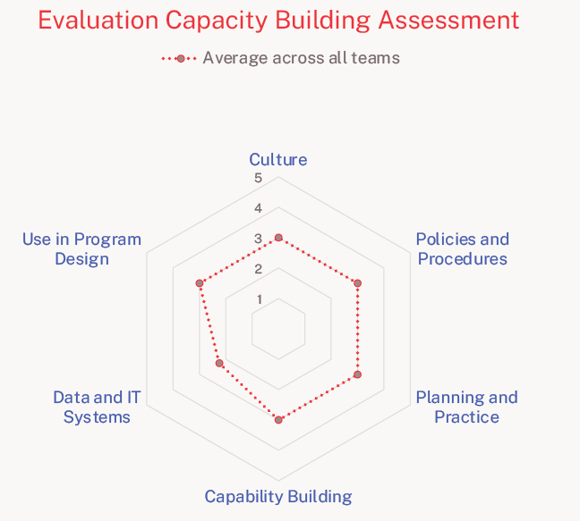
Figure 4: Top: results across all four equity teams that participated in the Tool. Middle: results from the Retention Team and Equity Scholarships team. Bottom: results from Future Students and International Engagement and Student Academic Success teams. (1 = opposed, 2 = absent, 3 = emerging, 4 = embedded, and 5 = leading)

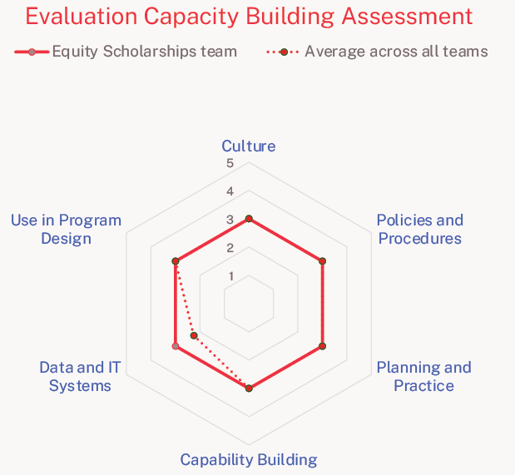
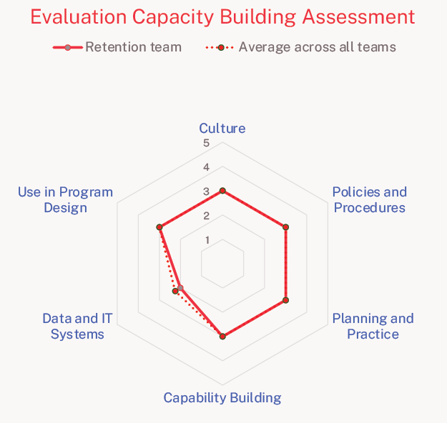
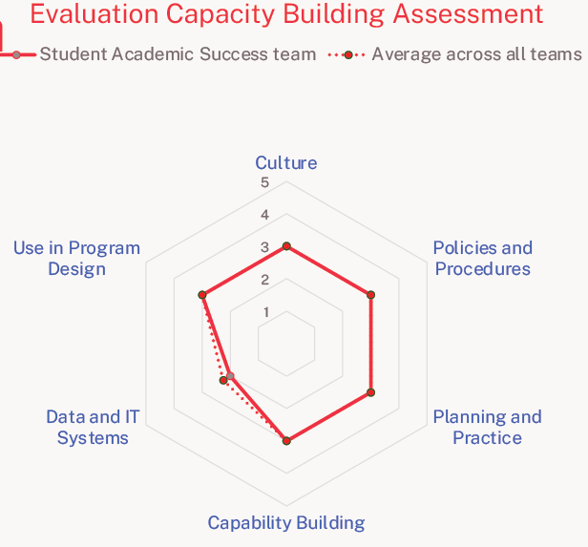
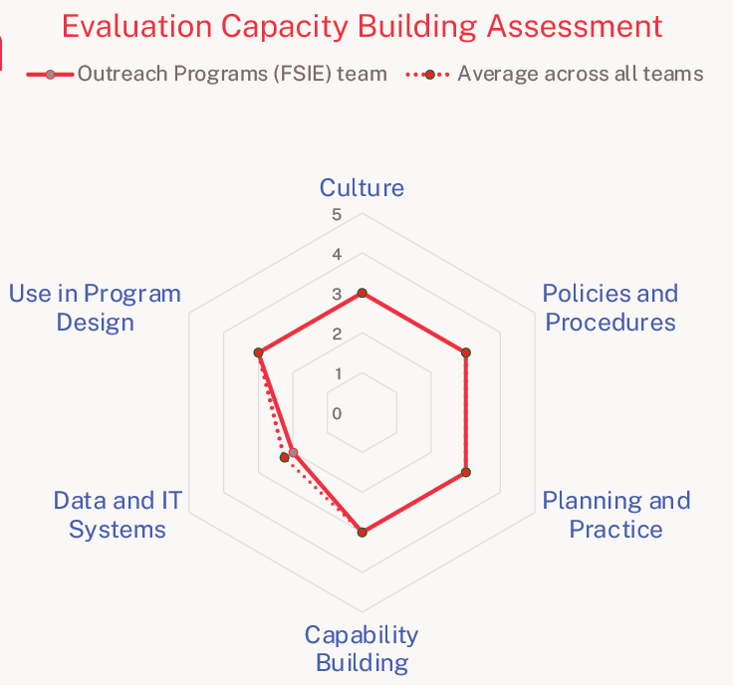

Designing an Impact Evaluation for The Retention Program
The Retention Program at UOW provides proactive and supportive outreach to students whose behavioural data suggests are disengaging from their studies or are at-risk of not completing their studies. This outreach is undertaken by Student Retention Coordinators and can take the form of:
- A text message: to nudge behaviour change or engagement.
- Email: As a mechanism to provide further information or step-by-step instructions.
- Phone call: To engage with students who have opted in for more tailored support and promote their engagement with their studies through a Student Success Plan.
- Face-to-face or phone meeting: Student Success Plans developed collaboratively with students outlining the steps and support required to promote engagement with their studies and increase the likelihood of completion. The Success Plan is a strength and needs based assessment undertaken in consultation with a Student Success Coordinator. By exploring past success and current challenges, the student develops a plan with suggested actions and support referrals to help them succeed.
The Retention Program is planning (outside the scope of this project) to undertake a Quantitative Impact Evaluation (QIE) on the impact providing the tailored level of outreach to students belonging to equity cohorts (low socio-economic status; Aboriginal and Torres Strait Islander; and regional, rural, and remote [RRR}) provides, and validate the mechanism to identify at risk and disengaged equity students through behavioural flags.
Parallel to determining and building evaluation capacity, we drafted a flexible QIE design and project plan, with the outcome being the combination of ECB across the team and the QIE plan to set up the Retention team for success in measuring impact for the program through QIE in 2026.
To design the plan, four workshops were held with the team with the following focus for each workshop:
- Review and revise the Retention Program Program Logic Model (PLM).
- Identify the Key Evaluation Questions (KEQs).
- Define data quality, availability, and outcome measures.
- Review of evaluation plan and design.
Figure 5: Program Logic Model design with the Retention team.
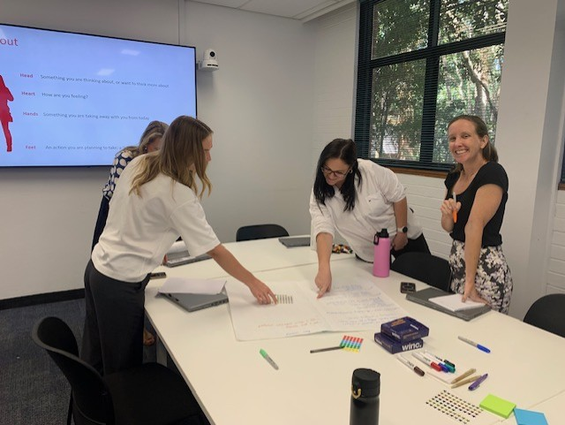

The Retention Team already had a program logic model which was developed in 2023 and revised in 2024. Using this process as an opportunity to reassess the program’s logic, the team provided feedback on the old model (Appendix 4) and changes were made to isolate the “enablers” from the intervention itself, as well as a simplification of what the final impact would be. During the workshop, assumptions were tested as well as any leaps of faith in the logic. Importantly, the team identified a set of values for the evaluation which acted as principles in its design (Figure 6). The workshop also included identification of what’s working and what needs improvement (Appendix 5), which was included in the final PLM to highlight revisions and quick lessons learned in future (Figure 7).

Figure 5: Identified design principles of the Retention Program evaluation.
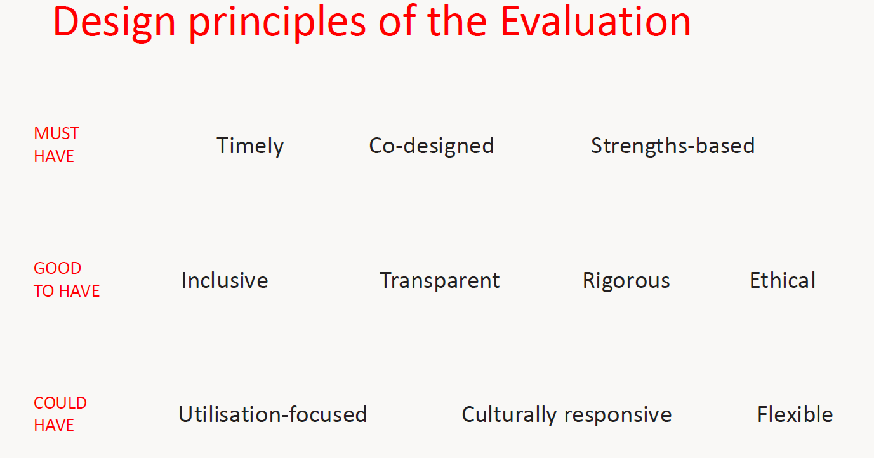

Figure 6: The UOW Retention Program Logic Model (2026).
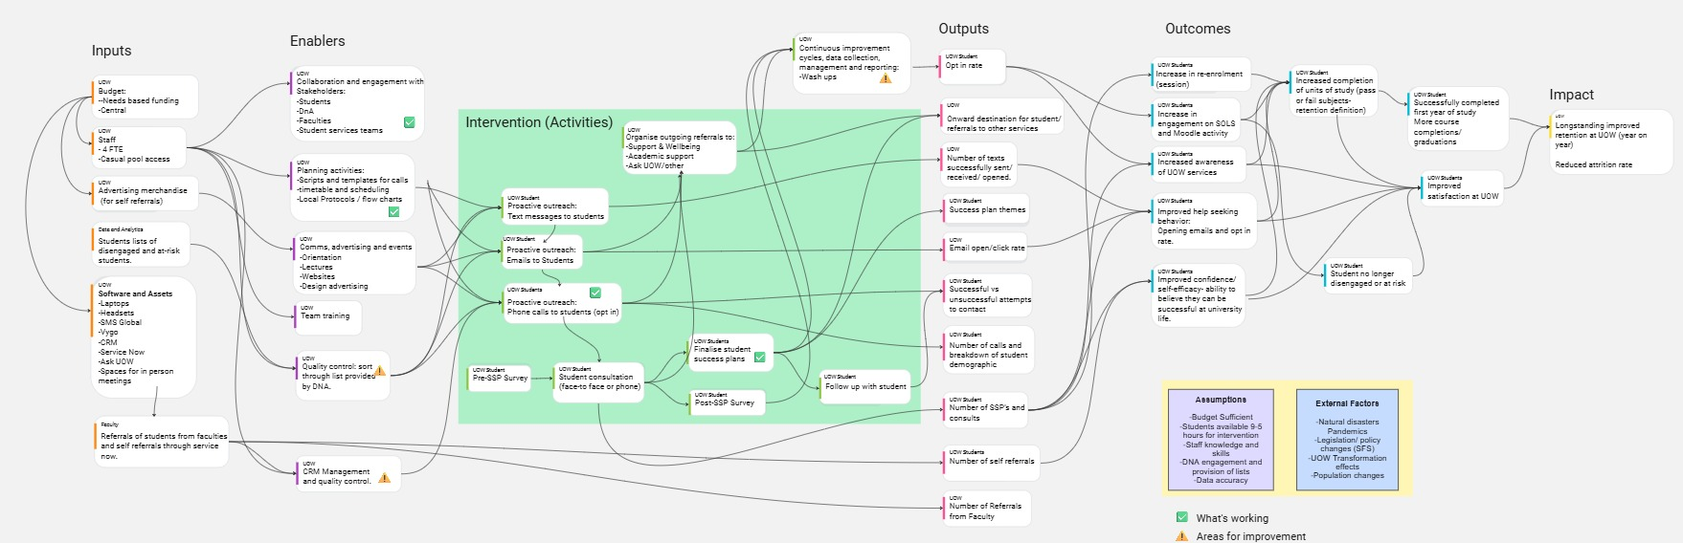

After the Evaluation Essentials for Equity Programs workshop, the next steps were to provide direct support and coaching to equity program teams to use the Tool’s assessment and insights to improve their impact evaluation practice as well as address specific challenges through targeted action. Originally, we had thought this would be in the form of individual coaching sessions, with an aim of presenting the ideas in the planned symposium at the end of the project.
However, we found that participants had limited time and capacity to dedicate to coaching sessions and developing the ideas in advance. We decided to change the outcome of the Evaluation Symposium to a “hackathon”, allowing participants to receive the coaching collectively and to develop their ideas for impact measurement whilst providing a tangible real-world output to use beyond the proposal. This also directly addressed some of the feedback over the duration of the project that teams often did not have the time to set aside to plan for evaluation activities.

Evaluation Symposium and evaluation Community of Practice for UOW equity staff
At the conclusion of the project, we held an Evaluation Symposium. This provided an opportunity to showcase the Student Retention team’s personal development and their experience planning an impact evaluation to other equity practitioners at UOW. It was also a place to introduce the first Community of Practice (CoP) for Equity Evaluation at UOW.
The retention team participated in a panel (Figure 8) and discussed their journey on the program including giving advice to teams on what they found useful and sharing what they had learned on the journey.
Figure 7: Panel Chaired by Lucy Snowball and Cassy King with two members of the Retention team.
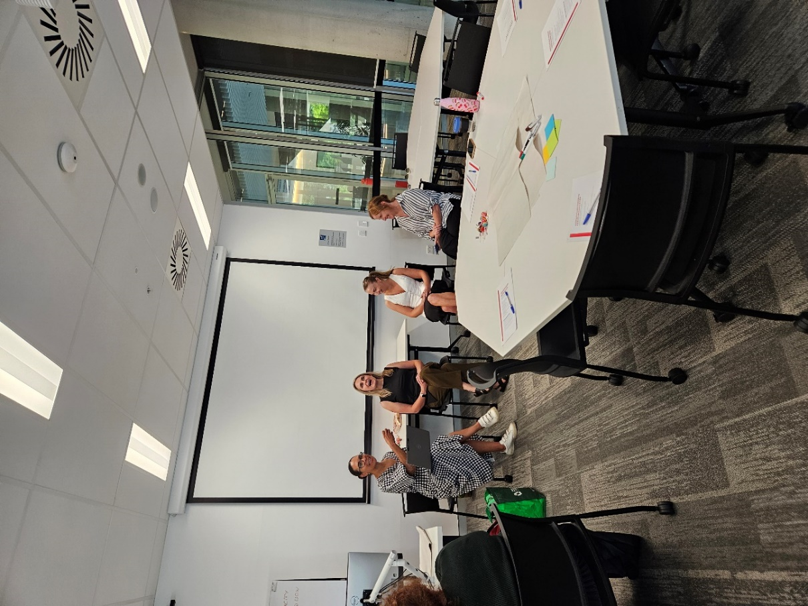

The workshop then held a “hackathon” of four 20-minute sprints to build an evaluation plan, followed by a showcase of what the teams had designed. The sprints were to:
- Clarify evaluation purpose and scope.
- Draft Key Evaluation Questions.
- Identify their indicators.
- Map their data sources.
Three additional sprints were used as homework for the teams to complete following the meeting:
- Choose their analysis methods.
- Set their timeline.
- Document any risks or assumptions.
The showcase asked teams to provide an elevator pitch of their plan and the other teams provided feedback on what they liked and would consider providing community guidance akin to a Community of Practice.

Figure 8: Two teams presenting during the elevator pitch of their evaluation plans developed during the “hackathon”.
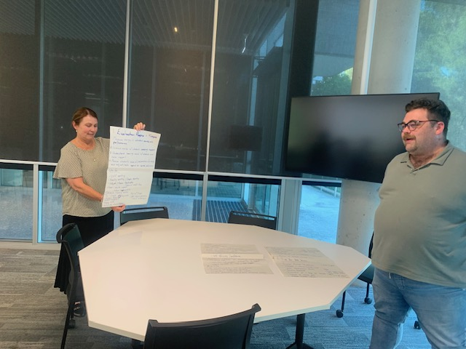
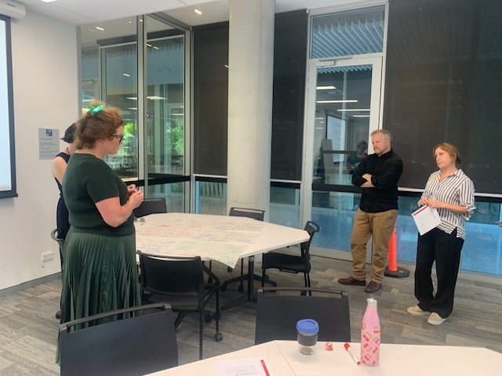

The establishment of the first Community of Practice (CoP) for Equity Evaluation at UOW was an important outcome of this project. It provides the opportunity for UOW equity colleagues to meet regularly and share evaluation and impact measurement learnings, identify further opportunities to co-design, collaborate, and improve our practice.
Due to significant changes in staff at UOW, the CoP was introduced at the symposium outlining examples of an agenda to include skills in understanding data, surveys, and student experience, and outcome measures (for example, a sense of belonging). Detailed plans of activities will be developed in 2026.

Impact
Creating an intentional learning environment (the workshops and symposium) for evaluation and evaluative thinking (ET); and learning to apply ET through practice (self-assessment tool, symposium) helped embed the learning into equity practitioners. Due to various factors at UOW, challenging program assumptions—a key facet in evaluative inquiry—is often met with caution. The workshops keep this in mind, scaffolding (Buckley et al., 2015) the evaluative learning already built in our teams through the SEHEEF and Logic Model workshops already undertaken.
Quotes from participants at the workshop included:
I really resonated with the idea of falling in love with the problem, not the solution to it. Framing your work as about the problem, so you are not too attached to the solution and can't unbiasedly evaluate it. (Participant 1)
It was engaging and interesting. The content was presented in ways that encouraged interaction and reflection, encouraging us to really process the information and apply it to our own contexts. (Participant 2)
The Retention Program team received additional support and coaching in evaluation, and the tangible output of a QIE design, providing long-lasting impact. The combination of evaluation capacity building and a fully drafted flexible QIE design/plan provides an uplift in skills and capability. The flexibility of the plan gives three stackable options for design, enabling future decision-makers to be fully presented with the options including the resources required, the type of evaluation (such as mixed methods or quasi-experimental), and what outputs could be expected from each. The modular nature also means work can be built on and chosen depending on the demands the team may later be facing.
Finally, the Tool provides a baseline measurement for evaluative capacity at UOW. The Tool can also be used periodically by teams and results compared year on year to indicate changes, whether improvements or declines.
It was identified with the Tool that UOW could grow from “emerging” to “embedded” taking the following steps:
- Celebrate successes, use early adopters to build awareness/interest.
- Begin process of ensuring consistency.
- Encourage reflection and action.
It was identified with the Tool that UOW could grow from “absent” to “emerging” by taking the following steps:
- Raise awareness and articulate the case for change.
- Introduce practice into role descriptions.
- Provide worked examples and training.
These findings and steps of action will ultimately inform and guide senior leadership on how they can influence professional development and improve evaluative culture at UOW.
The Tool provides a sustainable resource available to equity practitioners to re-assess at any time point, which is important for future iterations of programs which may change when new funding models such as the Needs-Based Funding model are introduced. Its design will help engender a culture of evaluation and evidence-based decision making that avoid the traps of conformation bias (Buckley et al., 2015) due to the six domains addressing key areas in evaluative capacity building and thinking. Using a facilitated workshop to complete the tool also helped open discussion about evaluation culture at UOW, which in turn helps build a culture of transparency.
It highlighted some key insights about the evaluation culture including:
Implementation is key, how can we implement a culture of evaluation? (Participant 3)
Feel we “reflect” rather than evaluate. Although we do have evaluation plans in place. (Participant 4)
We need a supportive role of an evaluator/specialist to get to the next step. (Participant 5)
While culture change takes time beyond the lifecycle of this project, the workshop and symposium were opportunities for equity practitioners at UOW to gather and introduced the idea of a community of practice for equity program evaluation at UOW. For longer term benefits “Evaluation Champions” could be created including those in positions of influence (Volkov & King, 2007, Buckley et al., 2015) recognising not all need to be an expert evaluator in an organisation but will champion evaluation and ET locally (Taylor-Powell & Boyd, 2008).

References
Baker, A. (2011). Evaluative thinking in philanthropy pilot. Report submitted to the Bruner Foundation, Effectiveness Initiatives. Lambertville, NJ: Author. Retrieved from http://www.evaluativethinking.org/docs/eTip.FINAL_REPORT.V8.pdf
Baker, A., & Bruner, B. (2012). Integrating evaluative capacity into organizational practice. Cambridge, MA: The Bruner Foundation. Retrieved from http://www.evaluativethinking.org/docs/Integ_Eval_Capacity_Final.pdf
Buckley, J., Archibald, T., Hargraves, M., & Trochim, W. (2015). Defining and Teaching Evaluative Thinking: Insights From Research on Critical Thinking. American Journal of Evaluation, 36.
McKegg, K et al. (2016) The Evaluation Capacity Building Project; developing an evaluation capacity assessment tool and process for New Zealand NGOs. Social Policy Evaluation and Research Unit (Superu). Retrieved from https://library.nzfvc.org.nz/cgi-bin/koha/opac-detail.pl?biblionumber=5565
Michie, S., van Stralen, M.M. & West, R. (2011). The behaviour change wheel: A new method for characterising and designing behaviour change interventions. Implementation Science, 6, 42.
Rintoul, D. (2019) Evaluation capacity building in the NSW Department of Education: The story so far. Australian Educational Leader, 41(1).
Stewart, J. (2014). Developing a culture of evaluation and research. Australian Institute of Family Studies [CFCA Paper No. 28]. Retrieved from https://aifs.gov.au/resources/practice-guides/developing-culture-evaluation-and-research
Taylor-Powell, E., & Boyd, H. H. (2008). Evaluation capacity building in complex organizations. New Directions for Evaluation, 120, 55–69.
Volkov, B. & King, J. (2007) Evaluation Capacity Building (ECB) Checklist, Retrieved from https://www.wmich.edu/sites/default/files/attachments/u350/2014/organiziationevalcapacity.pdf

Appendix
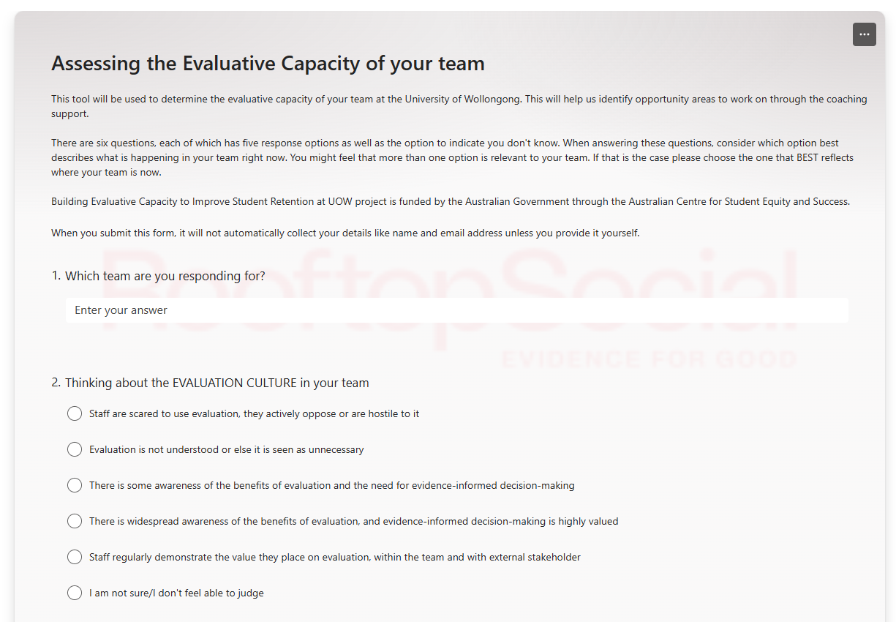
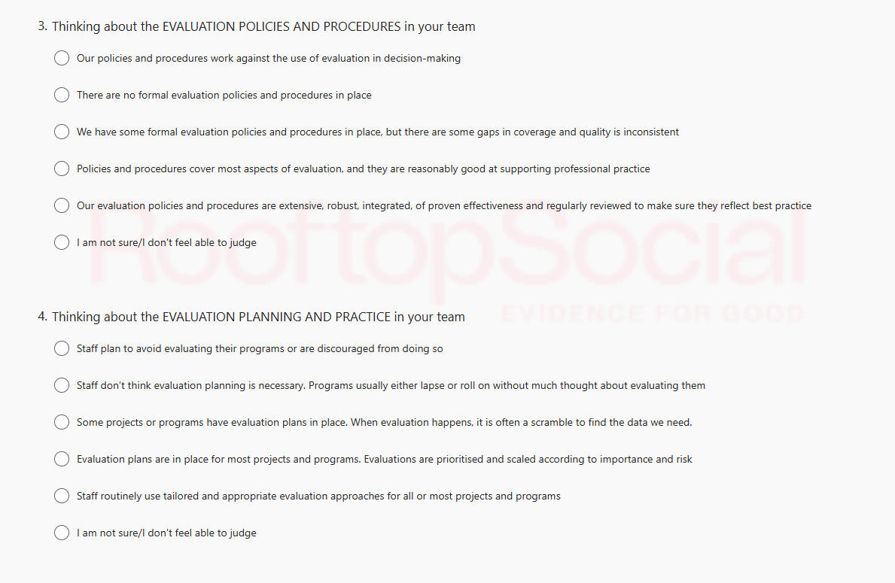
Appendix 1: The Evaluation Capacity Needs Assessment Tool (“The Tool”). Used to measure team evaluation capacity. Questions 1–3, covering the domains of evaluative culture, evaluation policies and procedures, and evaluation planning and practice.
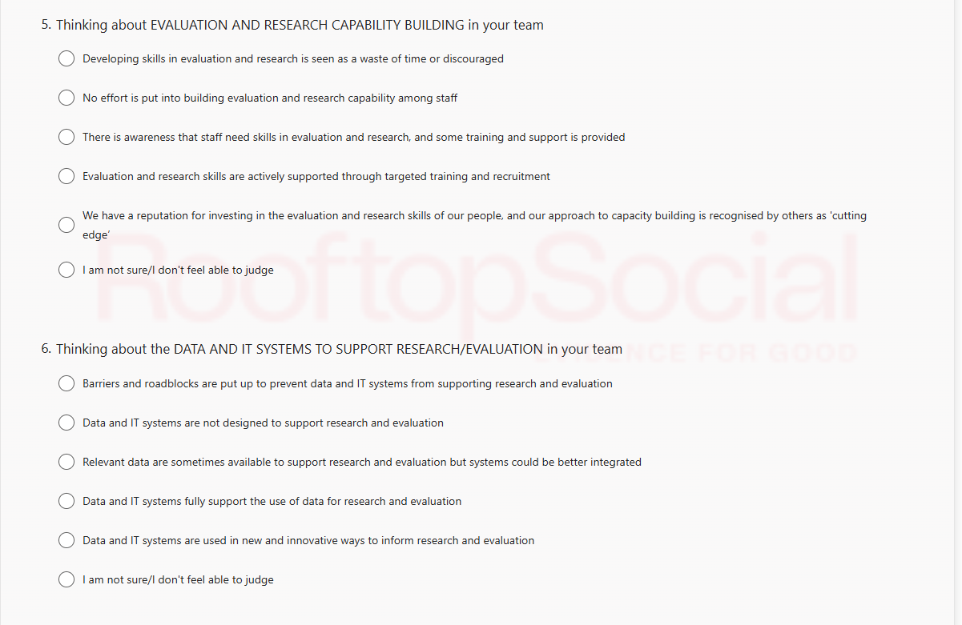
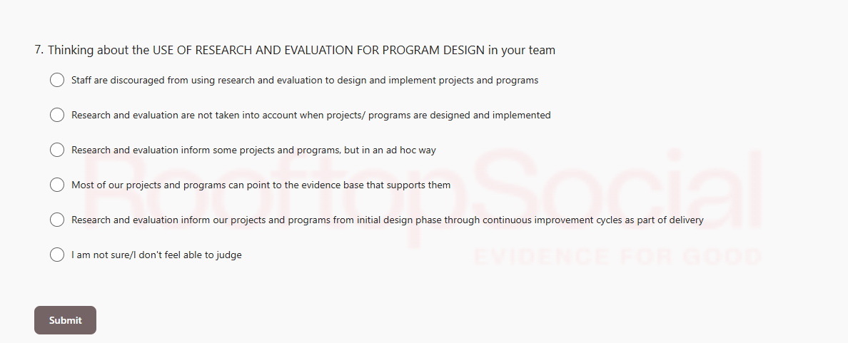
Appendix 2: The Evaluation Capacity Needs Assessment Tool (“The Tool”) used to measure team evaluation capacity. Questions 4–6, covering the domains of evaluation and research capability, data and IT systems, and evaluation for program design.

Appendix 3: Evaluation Capability Assessment Tool results.
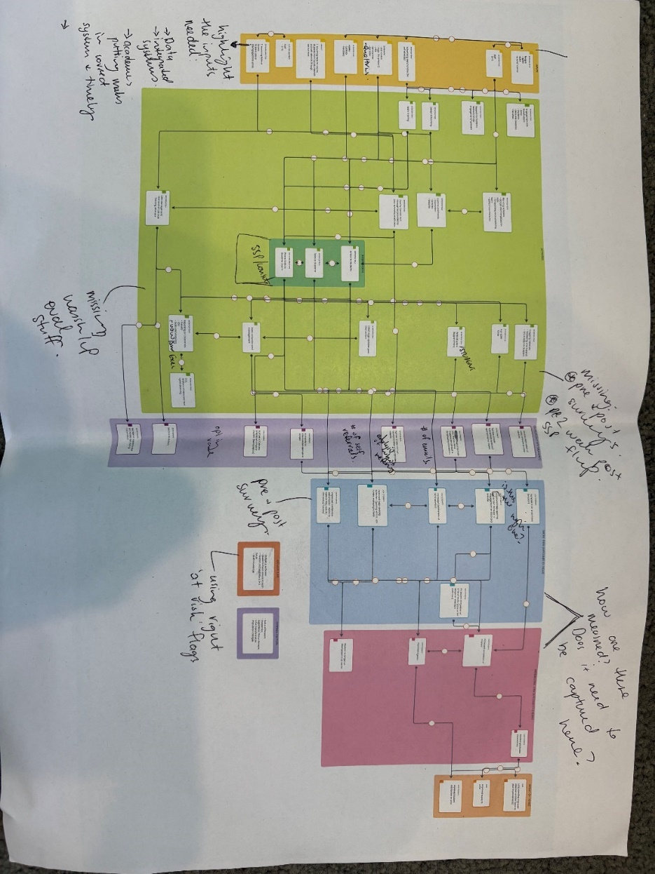
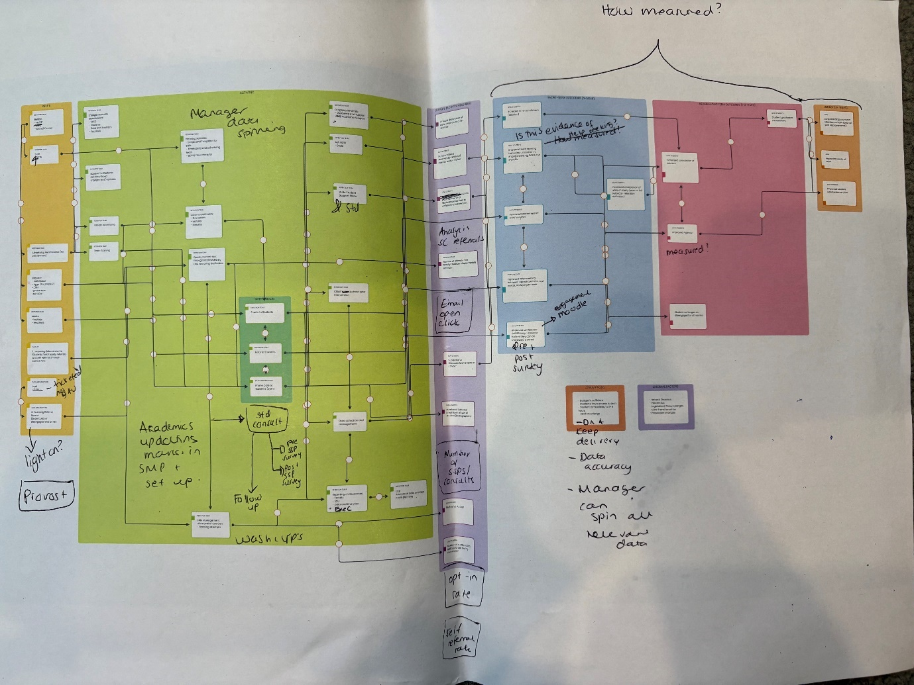
Appendix 4: Annotations to the 2025 Retention Program Logic Model.

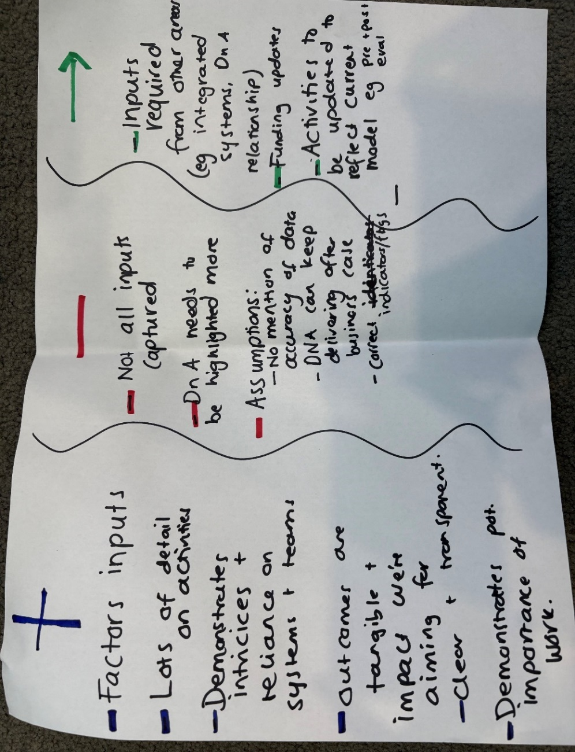
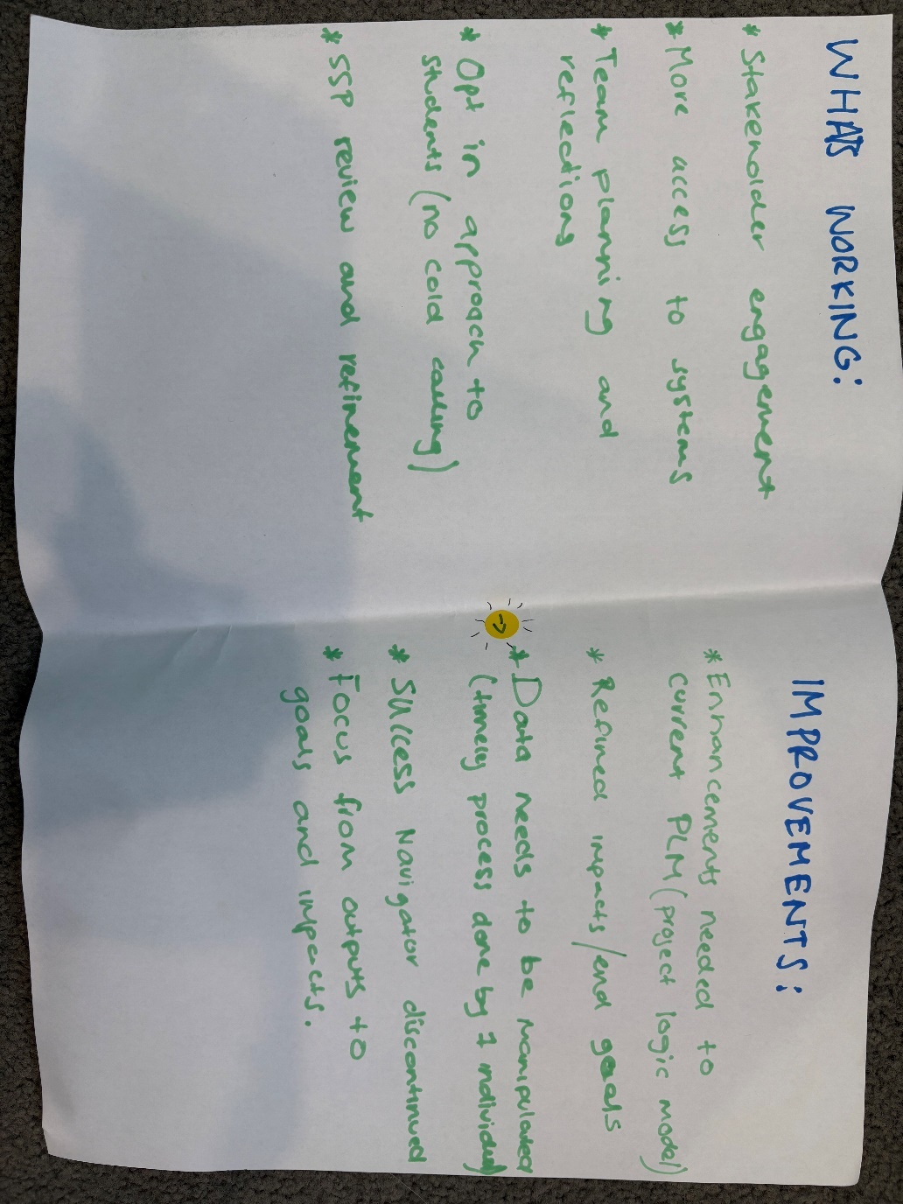
Appendix 5: Workshop notes on what’s working and what needs improvement (top) and highlighting positives and negatives (bottom).
Appendix 6: Final Evaluation Plan for the Retention Program.

