
ACSES CAPACITY BUILDING GRANTS PROGRAM

Towards impact evaluations of student equity programs across the Innovative Research Universities (IRU) group

  - Griffith University and Equity by Design

2026

Towards impact evaluations of student equity programs across the Innovative Research Universities (IRU) group

January 2026

Griffith University (Ruth Kamrowski & Rehana Lakhani)
Equity by Design (Mel Henry and Nadine Zacharias)

Suggested citation: Henry, M., Zacharias, N., Kamrowski, R., Lakhani, R. & Bentley, P (2026). Towards impact evaluations of student equity programs across the Innovative Research Universities (IRU) group (Capacity-Building Grants Program final report). Australian Centre for Student Equity and Success, Curtin University.

Australian Centre for Student Equity and Success
Tel: +61 8 9266 1573
Email: acses@curtin.edu.au
Web: www.acses.edu.au
Building 100
Curtin University
Kent St, Bentley WA 6102 | GPO Box U1987, Perth WA 6845

DISCLAIMER
Information in this publication is correct at the time of release but may be subject to change. This material does not purport to constitute legal or professional advice.
Curtin accepts no responsibility for and makes no representations, whether express or implied, as to the accuracy or reliability in any respect of any material in this publication. Except to the extent mandated otherwise by legislation, Curtin University does not accept responsibility for the consequences of any reliance which may be placed on this material by any person. Curtin will not be liable to you or to any other person for any loss or damage (including direct, consequential or economic loss or damage) however caused and whether by negligence or otherwise which may result directly or indirectly from the use of this publication.

COPYRIGHT
© Curtin University 2026
Except as permitted by the Copyright Act 1968, and unless otherwise stated, this material may not be reproduced, stored or transmitted without the permission of the copyright owner. All enquiries must be directed to Curtin University.
CRICOS Provider Code 00301J
ISBN 978-1-7645328-0-8

Acknowledgement of Country
The Australian Centre for Student Equity and Success acknowledges Indigenous peoples across Australia as the Traditional Owners of the lands on which the nation’s campuses are situated. With a history spanning more than 60,000 years as the original educators, Indigenous peoples hold a unique place in our nation. We recognise the importance of their knowledge and culture, and reflect the principles of participation, equity, and cultural respect in our work. We pay our respects to Elders past, present, and future, and consider it an honour to learn from our Indigenous colleagues, partners, and friends.

Approach
The project brought together the member institutions of the Innovative Research Universities (IRU) to develop evaluative capacity through peer learning and expert support. It leveraged the IRU Strategic Plan 2022–2027 commitment for a joint project (in partnership with the Australian Centre for Student Equity and Success [ACSES]) to improve evaluation of equity, student support, and/or student success programs, as well as the existing collaborative and productive working relationship between IRU.
This capability building initiative aimed to:
- Engage in cross-institutional collaboration to share knowledge/best practices and identify opportunities for scalability.
- Provide professional development and training activities for key staff to enable impact evaluation of student equity programs across the Innovative Research Universities.
The approach involved a series of four workshops, two face-to-face and two virtual. The workshops were supplemented by expert guidance and support from the specialist consultants engaged for this project (Dr Nadine Zacharias from Equity by Design and Dr Mel Henry) to assist with the preparation of institutional case studies for the virtual workshops. Initially, six member institutions opted into the project, namely Murdoch University, La Trobe University, Flinders University, University of Canberra, Griffith University, and James Cook University. Western Sydney University opted out of participating in the project due to capacity constraints, but some staff attended the virtual workshops as observers. A full list of participating representatives is provided in Appendix A.

Workshop 1
Workshop 1 was held in Brisbane, at Griffith University, on 12 June 2025 and was attended by 17 representatives from the IRU and the six participating universities. The objectives of this workshop were to compare evaluation approaches, findings, and learnings from existing student equity program evaluations at each participating institution, and to identify common student equity evaluation(s) for case study. One institution, Murdoch University, subsequently chose to withdraw their participation from the project citing internal capacity constraints.

Workshops 2 and 3
The second and third workshops were held online, via Microsoft Teams, on 5 August and 19 August, attended by 25 and 36 participants respectively. Each of these sessions involved three case study presentations of a priority initiative from three institutions, in which they shared:
- an overview of the applicable situation and program objectives
- a completed Program Logic Model
- details of the program’s reach and participants
- key outcomes from the program in 2024
- insights and learnings from delivering and evaluating the program to date
- future plans for the program or evaluation
- relevant advice for other institutions.
Expert guidance was provided to presenters in preparing for these sessions, including the development of their Program Logic Models, determining relevant information and compiling informative presentations. Representatives from University of Canberra, James Cook University, and Griffith University presented on their Work Integrated Learning (WIL) Bursary programs at Workshop 2, and Griffith University, Flinders University, and La Trobe University presented on their Academic Advisory programs at Workshop 3. These workshops were recorded and open to other staff from participating institutions to attend to extend their reach.

Workshop 4
The final workshop was held in Sydney, at the University of Technology Sydney (UTS), on 11 September 2025. 14 individuals attended, representing all participating institutions and the IRU, along with three guest speakers from ACSES and two ACSES-supported impact evaluation projects (at UTS and Curtin). Workshop 4 aimed to:
- Discuss learnings from existing evaluation practices based on the case studies.​
- Identify a suitable program(s) to undergo Impact Evaluation in 2026.​
- Discuss an appropriate design for a collaborative Impact Evaluation of the selected program(s).​
- Develop an action plan to develop the proposal and secure funding to support the proposed Impact Evaluation.
The workshop included a presentation and guest panel discussion on impact evaluation design, facilitated by Jesse Parmar from ACSES, along with focused reflection and discussion. The group undertook an action planning session on how to continue the collaboration after the grant period ceases.

Challenges
As noted above, capacity constraints to support comprehensive capability building activities were the most prominent challenges in the implementation of the project. Logistical challenges of organising travel across six institutions and with three external parties, as well as coordinating event spaces in two different cities also arose as challenges but were overcome with dedicated and effective resourcing by Griffith University.

Outputs

Case Studies
Over the course of the project, each institution developed a case study of an agreed priority program and its evaluation, paving the way for comparative case study evaluation of common student equity initiatives. The group shared designs of selected student equity programs (WIL Bursaries and/or Academic Advising) at each institution, including a Program Logic Model (as per Figure 1), as well as insights from existing continuous quality improvement (CQI) data collection and evaluations (as per Figure 2). Through this process, participants were able to identify valuable opportunities to enhance their own program design and evaluation practices, informed by focused exploration of program outcomes to date, and learnings from other institutions.
As a result of preparing and/or listening to these case study presentations, participants identified common program designs, impacts, and challenges and identified opportunities to further strengthen their own programs and evaluation capability, as summarised in
Table 1 (see page 5). Participants also shared common challenges in relation to evaluation data more broadly, including having access to the right data; data quality, completeness, and consistency; disconnected systems; and establishing baselines for complex programs incorporating disparate activities, diverse ownership, and siloed evolution.
Copies of all workshop slides and facilitator notes, as well as recordings of all case study presentations are provided in Appendix B and C. These offer further opportunity to extend the evaluation capability of other equity practitioners and evaluators.
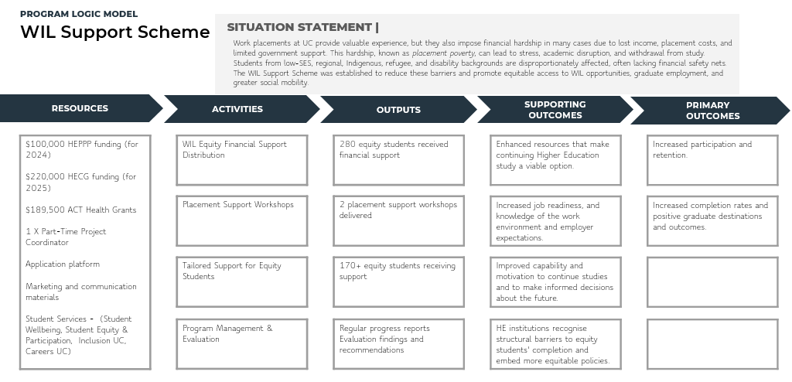
Figure 1: Example Program Logic Model, prepared by University of Canberra representatives for their case study on WIL Bursaries.

Figure 2: Insights, learnings and opportunities shared by representatives from Griffith University, as part of their case study presentation on WIL Bursaries.
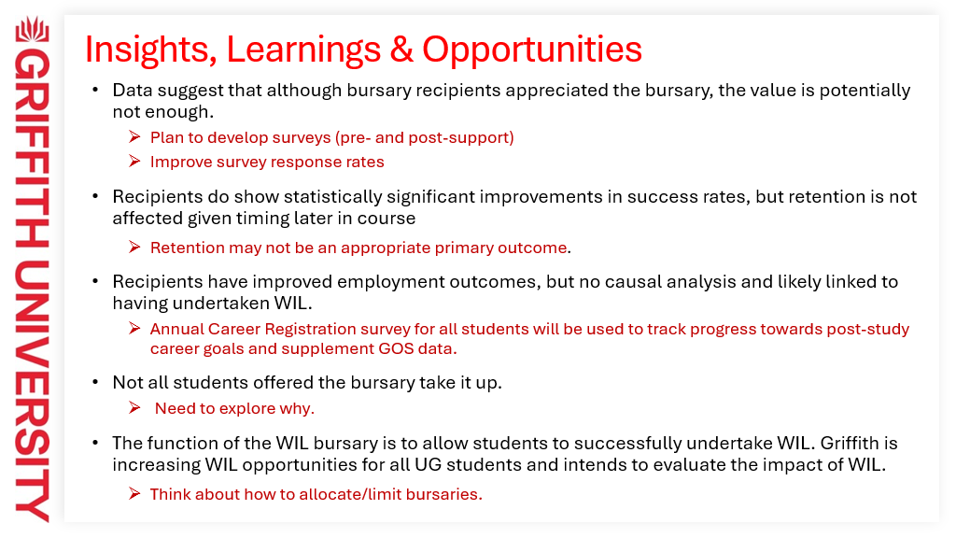

2026 Impact Evaluation Plan
At the final workshop, participants identified the opportunity to conduct an impact evaluation on individualised learning support as a common academic advisory activity across all institutions. A pilot Randomised Encouragement Trial was selected as a suitable approach, involving commencing students (teaching period 1/2026) from low socio-economic status (LSES) background with lower ATAR (<80) or an alternative pathway as their basis of admission, with the possibility of a second pilot in teaching period 2/2026. A focused evaluation question was proposed with guidance from the ACSES representative:
To what extent does individualised learning support impact subject/unit pass rates of LSES first year students?
Griffith University’s Dr Ruth Kamrowski agreed to lead the next phase of work. A collaborative working group has been established, involving Prof Michelle Picard (Flinders), Dr Nick Emtage (JCU), Jay Glasier (La Trobe), and Dr Lara Drew (UC), with the first meeting scheduled for 7 November, and preliminary advice regarding experimental design already sought from ACSES. The opportunity to be involved will also be extended to remaining IRU members.

Table 1: Key Insights from Case Study Exploration
 | WIL Bursaries | Academic advising
  Design Commonalities | - WIL Bursaries address heightened risk of placement poverty for LSES students and its impact on their wellbeing, retention and success by reducing financial burden and systemic barriers to participation in WIL. | - Most programs involve similar types of activities (resources, assignment review, workshops, consultations, drop-in sessions).  - All showcased programs are contextualised to the curriculum, which is understood to be a key success factor.
Consistent Impacts | - All showcased programs were associated with strong retention, academic success, and completion rates. | - All showcased programs are associated with an uplift in pass rates, academic success, and retention, though causal links are unclear.  - Qualitative feedback suggests students appreciate and find academic advice valuable.  - Students often access multiple learning advice services/tools, and benefits appear to increase for repeat users.
  Shared Challenges | - Evaluating outcomes is hampered by difficulties quantifying the eligible population—students from equity cohorts who also engage in WIL activities as part of their studies.  - There is potential for selection/sampling bias in terms of awareness of available support and eligibility, academic success or enrolment conditions, willingness and capacity to pay up front without certainty of reimbursement, course-specific WIL requirements, assertiveness, and self-efficacy.  - Institutional location (LSES & regional, rural, and remote (RRR) areas in catchment) and difference between first and current home address, impacts eligibility. | - Academic advising is resource-intensive, especially in relation to 1-1 consultations.
  Ideas to Explore Further | - Introduction of placement payments and needs-based funding may require redesign/rethink of which students are eligible/selected going forward.  - Expansion of WIL may increase potential eligibility and/or need. | - Is there an accumulative impact of accessing academic advisory services/ tools?  - What is the relative uptake & outcomes of different academic advisory services/tools and why do students choose one over another?

Impact
The workshop series built upon existing practice, supporting institutions to develop their evaluative capacity, systems, and toolbox—especially Program Logic Models and data collection systems and processes—that will enable meaningful evaluations into the future. The systematic sharing helped identify best practices across member institutions and opportunities to work toward an impact evaluation of a common student equity activity across the IRU in 2026–27. It has also empowered participants to apply learnings in their context and enhance the design of student equity programs to improve student outcomes and the student experience.
At the conclusion of the project, participants were invited to reflect on the impact of engaging in the evaluation capacity building program and their shared goals discussed at the program’s commencement. Detailed reflections from Program participants can be found in Appendix D.

Evaluation capability and capacity uplift
Thought through our programs and activities more deeply. Thought through data more deeply. Clear thinking around evaluation of our activities and evaluating impact. Great sticky-beaking into other IRUs fantastic programs and evaluation methods. (Workshop 4 participant)
The group unanimously agreed that the primary objectives of the project had been achieved, namely, to engage in cross-institutional collaboration to share knowledge/best practices and identify opportunities for scalability; and to provide professional development and training activities for key staff to enable impact evaluation of student equity programs across the IRU.
Aligned to these outcomes, participants also reflected on how well they felt their own goals discussed in Workshop 1 had been addressed (illustrated in Figure 3). Participants consistently reported that these goals had been achieved to the extent they were within the group’s control.

Figure 3: Participant-defined goals for the program, unanimously accepted as achieved.
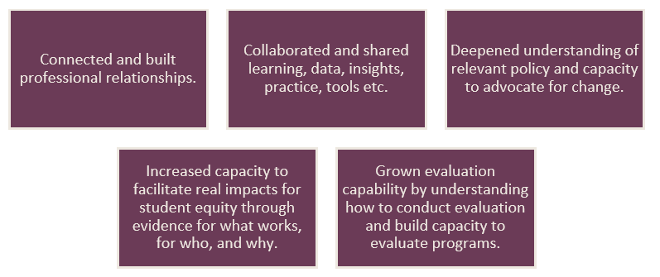

Additional benefits
What have I gotten out of this? My biggest takeaways have been the time and space to immerse myself in the evaluation process from beginning to end. It’s been wonderful to have the opportunity to problem solve with colleagues from across institutions and to think about what might/might not work and why. I’ve gained the confidence to navigate the SEHEEF (Student Equity in Higher Education Evaluation Framework) and apply it to a range of programs. (Workshop 4 participant)
Participants also shared that they had gained additional benefits through their engagement in the capability development program beyond these high-level objectives summarised in Figure 4.
Figure 4: Additional benefits of program engagement highlighted by participants.

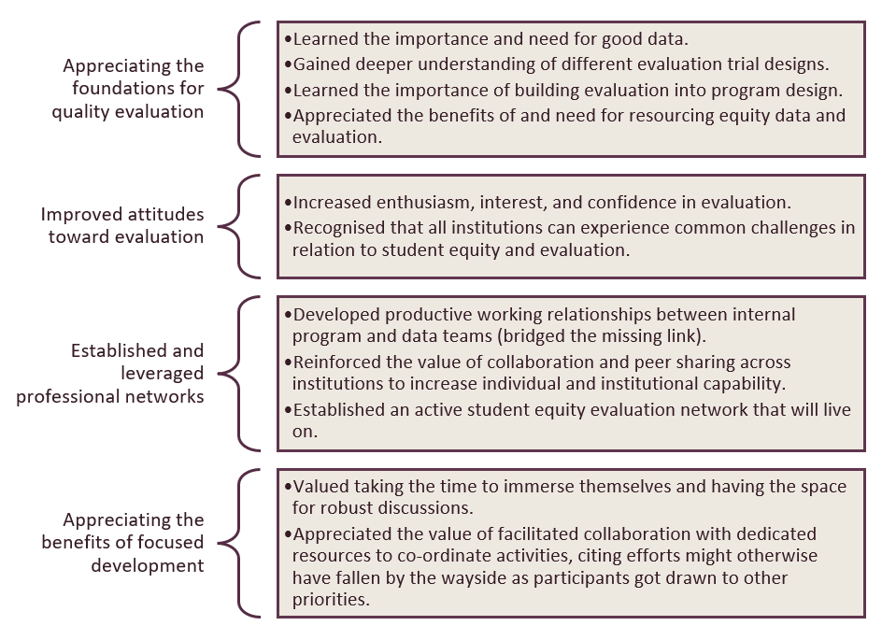

Appendices

Appendix A: List of participating institutional representatives
Flinders University
- Michelle Picard
- Chris Brebner
- Genevieve Haskett
- Kung-Keat Teoh (Teoh)

Griffith University
- Rehana Lakhani
- Ruth Kamrowski
- Vivian Wu
- Clancy Birrell

James Cook University
- Nick Emtage
- Colleen Kaesehagen
La Trobe University
- Jay Glaisyer
- Sarah Midford
- Eva Sarr
Murdoch University (Workshop 1 only)
- Rebecca Bennett
- Kohilavani (Vani) Lambourne

University of Canberra
- Mara Eversons
- Lara Drew
- Laurie Poretti

Appendix B: Members of the 2026 Impact Evaluation Working Group
Dr Ruth Kamrowski (Griffith, Lead), Prof Michelle Picard (Flinders), Dr Nick Emtage (JCU), Jay Glasier (La Trobe), Dr Lara Drew (UC)

Appendix C: Consolidated reflections from program participants
What have you got out of this capability building project?
- Enthusiasm for and interest in evaluation.
- Importance and need for good data.
- Importance of building evaluation into program design.
- Gained much broader and deeper understanding of impact evaluation methodology and different evaluation trial designs (for example, RED).
- Resourcing equity data/evaluation and collaboration between program and data teams (bridged the missing link).
- Opportunity to think through programs and activities more deeply, consider how numerous activities add up to a greater whole for the students, identify priorities for improvement.
- Value of peer sharing across institutions: skills, knowledge, network, sense of belonging.
- Supportive and affirming network that will live on.
- Value of taking time to immerse ourselves and having the space for robust discussions, it’s been wonderful to have the opportunity to problem-solve with colleagues from across institutions.
- Peer engagement has proven an effective tool for building evaluation capability and taking practice to the next level.

