Aspire UC Small Schools Program
Quasi Experimental Design Evaluation Plan
TABLE OF CONTENTS
1. PROGRAM CONTEXT 1
1.1 Aspire UC background 1
1.2 Rationale for the 2027 evaluation 1
1.1 Evaluation purpose and audience 1
2. EVALUATION FRAMEWORK 3
2.1 Evaluation objectives and questions 3
2.2 Evaluation design 3
2.2.1 Overview of the Quasi-Experimental design 4
3. METHODS 4
3.1 Evaluation methods 4
3.2 Data collection methods 4
3.3 Evaluation design 5
3.3 Sample and recruitment 7
3.4 Participant information and consent 7
3.5 Ethics considerations 7
4. DATA COLLECTION AND ANALYSIS 8
4.1 The data collection tools 8
4.2 Quantitative analysis 9
4.3 Qualitative analysis 10
4.4 Integration and interpretation 10
4.5 Communication plan 10
5. IMPLEMENTATION PLANNING 11
5.1 Timeline 11
5.2 Constraints, limitations and risks 12

- Program Context
  - Aspire UC Background
The Aspire UC program is funded by the Higher Education Participation and Partnerships Program (HEPPP). The key objective of the HEPPP is to promote equality of opportunity in higher education by improving:

- outreach to widen aspiration and promote higher education to persons from a low SES background, persons from regional areas and remote areas, and Indigenous persons; and

- the extent to which persons from a low SES background, persons from regional areas and remote areas, and Indigenous persons access, participate, remain and succeed in higher education, and obtain higher education awards.

In alignment with the Student Equity and Higher Education (SEHEEF) outcomes, and HEPPP, Aspire UC school outreach programs aim to increase university participation by cultivating aspirations and awareness of post-secondary options and careers. These outcomes include fostering aspirations and enhancing the perception that higher education is a viable and attainable option, increasing knowledge in relevant areas such as occupations and pathways, improving both soft and hard skills, and fostering an increased sense of belonging.

The Aspire UC ‘Small Schools’ program commenced in 2020 with three participating schools and has since expanded to nine schools. The program supports regional NSW primary schools (K–6) with fewer than 50 students, located within a three-hour drive of the University of Canberra (UC) Bruce campus. Aspire UC delivers one in-school session each term, complemented by an annual on-campus visit.

In 2025, the program also broadened its reach through additional community engagement activities involving schools and their local communities. Across the nine participating schools, the program engaged approximately 250 students.

  - Rationale for the 2027 evaluation
Previous process and outcome evaluations have examined early implementation and short-term changes associated with the Aspire UC Small Schools program. However, these evaluations have not tested impact at a level that allows for attribution or causal inference. A quasi-experimental (QE) design is therefore required to more rigorously assess whether observed changes can be linked to program participation rather than external factors.
  - Evaluation purpose and audience
The purpose of the realistic evaluation of the Aspire UC program is to assess the effectiveness and impact of the Aspire UC program in enhancing primary school students understanding of higher education pathways and in raising their aspirations toward higher education and the associated career opportunities. This evaluation aims to derive high quality evidence on how the program influences:
- students’ knowledge and awareness of Higher Education;
- their future educational aspirations;
- the normalisation of Higher Education within their communities.
The audience: The audience of the evaluation is UC and external parties. The evaluation will also be used to demonstrate the impact of the Aspire UC program to UC community and to external parties (for example, the Department of Education).

- Evaluation Framework

  - Evaluation objectives and evaluation questions
The realist evaluation is guided by six research objectives aligned with the Aspire UC Theory of Change. These objectives examine whether participation contributes to measurable developmental shifts in awareness, aspiration, and community perceptions of higher education.
The realistic evaluation is driven by six research objectives.
- Increased awareness and understanding of higher education (including familiarity with university environments and study pathways).
- Expanded knowledge of career options and their connection to post-school education.
- Strengthened aspirations and future orientation towards higher education.
- Enhanced perceived accessibility of higher education (i.e., “university is for people like me”).
- Increased visibility of higher education opportunities within participating schools and communities.
- Reduced stereotypes and greater normalisation of higher education within local communities (including among students, parents, and school principals/teachers).
The realistic evaluation is driven by the following evaluation question:

How does participation in Aspire UC program shape regional (and rural) primary school students’ understanding of higher education and related career opportunities, their aspirations to pursue higher education, and the normalisation of higher education within their local communities?

  - Evaluation design
- Quasi-experimental trial (stage 2), stage 1 is currently being conducted in 2025.
- Using Aspire UC schools (n = 9) and control schools (n = 9), aiming for a total of approximately 250 students in control group (to match the number of students involved within Aspire UC intervention schools) – The key point to consider here is that between control and intervention groups they must be comparable (i.e. either at the student level or at the school level).
Timeline | Sample | Task
Start of academic year | Controls + Aspire UC schools | Baseline data collection (pre-intervention)
Feb – Nov | Aspire UC schools | Receive usual intervention:  • Site visit 1/term
Feb | Controls | Incentive ($/books/etc) for involvement
Nov | Controls | Receive intervention (1 day)  • Conduct post-intervention (survey and interviews) data collection with students and teachers.  (Note: prior to any campus exposure)
Nov | Aspire UC schools | Receive usual intervention:  - Final on campus visit  - Conduct post-intervention (survey and interviews) data collection with students, staff/teachers and parents  (Note: post-program data collection back at school within 1-2 weeks of the visit)

    - Overview of the Quasi-Experimental Design
To conduct a quasi-experimental evaluation in 2026, recruitment of participants and the sample would include the following:
- Intervention group = current UC Aspire schools (n = 9); n = 250 students.
- Control group = more schools / students would need to be recruited.
(using the same methods that were used for recruiting the current 2025 Aspire UC schools).
Note: The control group and the intervention group should be comparable at either the individual level OR the school/cluster level.

At the Individual level, the students could be matched in the intervention and control groups based on key characteristics such as age (5 years old, 6 years old, etc), year level (i.e. year 1, year 2, etc), gender (i.e. female, male, non-binary), and any other individual level demographic characteristics (i.e. identify as First Nations, disability, or non-English speaking background, single parent family, or other).

For example, if matching were to be based upon the individual / student level for:
#of students – recruitment should aim for equal number of students in Aspire UC group (n = 250) compared to the control group (n = 250).

At the school / cluster level to be comparable, the intervention and control groups could be matched based on school level characteristics such as ICSEA score, school size, student attendance rates, proportion of students from priority populations (identified equity groups), NAPLAN performance, geographic location, etc.

For example, if matching were to be based upon the school / cluster level for:
ICSEA score – recruitment should aim for equal ICSEA score in Aspire UC group compared to control group.

By matching control group and intervention group in this manner this helps to ensure that the intervention group and the control group are comparable, this reduces bias and strengthens the validity of the evaluation findings.

- Methods

  - Evaluation methods
This evaluation will adopt a quasi-experimental mixed-methods design to assess the effectiveness and impact of the Aspire UC Small Schools program. The design combines quantitative and qualitative approaches to capture both measurable changes and contextual insights.
Quantitative Component
- Pre–post comparison: Changes in students’ aspirations, university awareness, and related constructs will be assessed using a child-centred pre–post survey administered before and after program participation.
- Program reach and engagement metrics: Counts of participating students, schools, workshops, and other engagement indicators will be collected to measure program reach.
Qualitative Component
- Pre–post comparison using arts-based methods and student interviews: A structured pre–post storyboard (draw and write) activity will be used to capture changes in students’ aspirations, agency, and pathway understanding. Follow up interviews at the end of the year will invite students to reflect on their storyboards, enabling deeper exploration of how and why their perspectives may have changed.
- Interviews with teachers and parents: Interviews will be conducted to explore perceptions of program impact on students’ aspirations, confidence, and engagement, as well as broader attitudes toward higher education within the school and community.

This mixed-methods approach will enable triangulation of findings, combining quantitative evidence of change with qualitative insights into mechanisms and contextual factors influencing outcomes.

  - Data collection methods
Data collection methods are summarised in the table below.

Respondent | Group  (control or intervention) | Type of data collection | When
Student | Intervention | Pre-intervention survey instrument | Each site visit
Student | Intervention | Pre-intervention storyboard (draw and write) instrument | Each site visit
Student | Intervention | Qualitative component – Storyboard elicitation interviews: Semi-structured interviews will be conducted using students’ pre–post storyboards as the primary elicitation tool. Students will be invited to explain the meaning of their drawings and written responses, reflecting on what has changed and why. The interview format will prioritise open-ended prompts, allowing students to articulate their thinking in their own words without leading or interruption. The aim is to centre and authentically capture the student voice. | 4–5 students at each site visit (end of the year once the post program storyboard is complete)
Student | Control | Pre-intervention survey and storyboard (draw and write) instrument | Prior to incentive
Student | Control | Post-intervention survey | End of the year  prior to any campus exposure
Student | Control | Qualitative component – Storyboard elicitation interviews: Semi-structured interviews will be conducted using students’ pre–post storyboards as the primary elicitation tool. Students will be invited to explain the meaning of their drawings and written responses, reflecting on what has changed and why. The interview format will prioritise open-ended prompts, allowing students to articulate their thinking in their own words without leading or interruption. The aim is to centre and authentically capture the student voice. | 4–5 students at each site visit (end of the year once the post program storyboard is complete)
Teachers /Principals | Intervention | Interviews | End of the year (after campus visit)
Teachers/ Principals | Control | Interviews | N/A
Parents/ carers/ family | Intervention | Interviews | End of the year (after campus visit)
Parents/ carers/ family | Control | Interviews | N/A

  - Sample and recruitment
This section outlines how many people data is intended to be collected from and the characteristics of the sample, and it describes how the sample will be recruited.

There are currently 9 Aspire UC schools. The stakeholder analysis for 2025 includes:
- Students (n=266)
- Schools (n=9)
- Teachers (n=32)
- Parents (n= 300)
- Community members
- Department of Education

Note: in 2026 the stakeholder analysis may differ, due to the new funding model for HEPPP programs.
  - Participant information and consent
Participant information sheet and participant consent form to be sent home with students for parents/caregivers to provide informed consent for their child/ren’s involvement in the program evaluation. In addition, parents and teachers/principals that are wishing to be involved in the qualitative data collection will also need to be provided with a participant information sheet to obtain their informed consent prior to any involvement with the program evaluation.
The participant information sheet will include:
- A description of the research project
- Benefits of the research project
- Risks of the research project.

In addition, the participant information sheet will contain the following details:
Participation in the research is completely voluntary, and participants may, without any penalty, decline to take part or withdraw at any time without providing an explanation or refuse to answer a question. Only the researcher/s will have access to the individual information provided by participants. Privacy and confidentiality will be always assured. The research outcomes may be presented at conferences and developed for publication. However, in all publications, the privacy and confidentiality of individuals will be protected. All reports and publications of the research will contain no information that can identify any individual, and all information will be kept in the strictest confidence. The information collected will be stored securely on a password protected computer throughout the project and then stored at the University of Canberra for the required five-year period after which it will be destroyed according to university protocols.

The participant information sheet and consent form will include University of Canberra Human Research Ethics Committee approval number and provide contact details for the researchers shall there be any queries or questions regarding the research.
  - Ethical considerations
This section outlines the ethical considerations for the project, including how informed consent will be obtained from the participants.
Key ethical considerations include:
- Informed consent and assent – Written parent/guardian consent and school consent will be obtained, alongside developmentally appropriate child assent. Participation will be voluntary and clearly explained in age-appropriate language.
- Equity and fairness in design – As control schools will not receive the full intervention during the initial study period, the design will ensure that participation is fair, transparent, and justified, with appropriate consideration given to delayed or alternative access later where feasible.
- Minimising disruption – Data collection will align with school calendars and classroom schedules to avoid undue burden on students and staff.
- Role separation and bias mitigation – Where possible, program delivery and evaluation functions will be separated to reduce bias and strengthen the validity of findings.
- Data collection and analysis
Student demographic data and self-reported Aspire UC program measures will be collected for participating Aspire UC students through the existing pre–post storyboard, the pre–post survey, and administrative data. For the control group, equivalent demographic and self-report data will be collected.
  - The data collection tools
The current evaluation framework already captures the core constructs outlined below. For the purposes of the QE evaluation, minor refinements are proposed to strengthen alignment and ensure comprehensive coverage.
Type of data | Indicators | Data collection tool
Student demographic data | Student name  Student age  Student class (K-6)  Name of school | In pre-post Storyboard + questionnaire
School data | Name and location of school  Size of school  ICSEA, proportion of low SES and first in family students  Length of student involvement in Aspire UC  Number of staff exposed to Aspire UC at the school | Administrative data (school) Administrative data (school)  Administrative data (school)  Administrative data (from workshops)  Administrative data (from workshops)
Aspire UC data (self-reported) | Have you been involved with any programs similar to Aspire UC?  If so, how many? | Questionnaire (new additions)
Aspire UC (administrative data) | School (number of, locations of)  # of students (total)  # of workshops (total)  Student attendance:  For each workshop  Type of workshop  Campus visit  Workshop:  Type of workshop (e.g. career in caring)  Type of career (e.g. nurse)  Type of activity (e.g. dress up, drawing, etc) | Administrative data (workshops) Administrative data (workshops)  Administrative data (workshops)  Administrative data (workshops)  Administrative data (workshops)  Administrative data (site visit)  Administrative data (workshops)  Administrative data (workshops)  Administrative data (workshops)
 | How many Aspire UC workshops has each student attended in total? (i.e. if attended all four every year for X # of years) | Administrative data (workshops)
Aspire UC data | Knowledge of HE related career types  Understanding of pathways to a chosen career (e.g., what needs to be learned or done to reach that job)  Aspiration towards pursuing HE  Sense of belonging (Aspire and HE) Favourite career and why  Benefits of Aspire UC (post) | In pre-post storyboard + questionnaire and end of year interviews.

The evaluation will use both quantitative and qualitative analysis techniques to address the research questions and triangulate findings.
  - Quantitative Analysis
- Pre–post student data: Responses from the survey will be analysed using descriptive statistics (means, frequencies) and inferential tests (i.e., paired t-tests or non-parametric equivalents) to assess changes in knowledge and aspirations before and after program participation.
- Reach and engagement metrics: Counts of participating students, schools, and workshops will be summarised using descriptive statistics to evaluate program coverage and implementation fidelity.

  - Qualitative Analysis
- Pre–post storyboard (draw-and-write) and interviews: Students’ narrative explanations of their storyboard responses will be analysed using thematic analysis to identify patterns and shifts in aspirations, agency, higher education visibility, and career pathway understanding over time.
- Interviews: Transcripts from parents and teachers will be coded inductively and deductively to explore perceptions of program impact and contextual factors influencing outcomes.
  - Integration and Interpretation
Findings from the quantitative and qualitative strands will be integrated using a convergent mixed-methods approach. Quantitative results will identify measurable patterns of change, while qualitative findings will provide contextual explanation and insight into how and why these changes occurred. Interpretation will focus on:
- The extent and nature of change in student aspirations, agency, and pathway understanding.
- The mechanisms through which Aspire UC activities influence higher education visibility, belonging, and future orientation.
- Factors that facilitated or hindered program impact.
o Uncertainty surrounding sustainable program funding - e.g.
  - Higher Education Continuity Funding (HECG)
  - Needs-based funding
  - Outreach fund
  - Communication plan
The Aspire UC evaluation communication plan is designed to ensure clear, timely, and accountable engagement with key audiences, including:
- the Department of Education – Higher Education Participation and Partnerships Program (HEPPP) through mandatory reporting requirements
- internal and external stakeholders
The plan ensures that all communication efforts are aligned with expectations and contribute to strengthened engagement, transparency, and impact across all levels of the program.
For the Department of Education, communication will centre on fulfilling HEPPP mandatory reporting obligations. This includes the submission of annual reports, progress updates, and detailed data reporting aligned with government templates and timelines. These reports will provide evidence of student participation, program outcomes, and any continuous improvement strategies implemented throughout the program cycle.
For program stakeholders, including participating schools, teachers, and community partners, the communication approach will emphasise regular updates and opportunities for feedback. Tailored messaging will be delivered through newsletters and existing school communication channels to ensure stakeholders remain informed and engaged with the program’s progress and outcomes.
For funders, the communication plan will prioritise accountability and transparency in resource use. This will involve providing annual reports, financial reconciliations, and acquittals, as well as responding to any ad hoc requests for briefings or reports. These communications will demonstrate the responsible management of funds and the effectiveness of the Aspire UC program in achieving its objectives.
Finally, for internal UC teams, interim findings and final reports will be shared with leadership and program teams to inform strategic decisions and continuous improvement. Internal meetings and dashboards will be used to provide timely updates and maintain alignment with institutional priorities.
This multi-layered communication strategy ensures that all audiences receive relevant, accurate, and timely information, fostering trust and reinforcing the impact of the Aspire UC program.
- Implementation Planning

  - Timeline
A summary of the draft evaluation timeline for the Aspire UC program evaluation inclusive of a ‘responsibility and completion checklist’ is provided in the table below.
Table 1- Summary of draft QE evaluation timeline for the Aspire UC program
What are the milestones in the evaluation? | Sample | Who is responsible? | Date | Completed?  (Y/N)
Baseline survey + Storyboard (draw and write) | + Aspire UC  group  + Control group |  | Start of academic year
Receive usual intervention:  Site visit 1/term | Aspire UC group |  | Feb – Nov
Incentive  ($/books/etc) for involvement | Control group |  | Feb
Receive intervention: 1-day UC Campus visit) | Control group |  | Nov
Receive usual intervention: 1 day UC campus visit | Aspire UC group |  | Nov
Post intervention  Post storyboard (draw and write) + survey + interviews  2 weeks after campus visit | + Aspire UC  group |  | Nov / Dec
Post intervention  Post storyboard + survey + interviews  2 weeks after campus visit | +Control group |  | Nov / Dec

  - Constraints, limitations and risks

The 2026 evaluation plan for the Aspire UC program is shaped by several constraints, limitations, and potential risks that may affect implementation and outcomes.
Budget and Resourcing:
Limited funding may restrict the depth of data collection, reduce opportunities for site visits, and limit access to external evaluation expertise for QE design requirements.
Timeline:
Conducting the full recruitment, data collection, analysis, and reporting process within a single calendar year places considerable pressure on project timelines, potentially reducing the depth and robustness of findings.
Staffing Capacity:
Existing personnel may be supporting multiple projects which could affect the consistency and quality of evaluation activities.
Recruitment Challenges:
Securing an appropriate control group (schools or clusters) may prove difficult and could delay implementation or compromise comparability between intervention and control groups.
Stakeholder Engagement:
Variability in school and community engagement may influence program delivery, data completeness, representativeness, and the external validity of results.

The table below provides a summary of risks and planned mitigation strategies.
Table 2- Summary of risks and planned mitigation strategies
Risk Area | Identified Risk | Mitigation Strategy
Budget  Constraints | Limited funding may restrict data collection and travel. | Prioritise essential evaluation activities; seek in-kind support or partnerships; use cost-effective tools.
Timeline (1  Calendar Year) | Compressed schedule may affect recruitment, data analysis, and reporting. | Develop a detailed project timeline with milestones; begin recruitment early; streamline reporting tools.
Staffing and Resources | Limited personnel availability may delay evaluation tasks. | Allocate dedicated staff for evaluation; cross-train team members; consider temporary or contract support for QE design elements.
Recruitment Challenges | Difficulty in recruiting comparable control group schools/students. | Use proven recruitment methods from 2025 Aspire UC schools; offer incentives; engage school networks early.
Data Access and Quality | Inconsistent or incomplete data from participating schools. | Provide clear data collection guidelines; offer support to schools; conduct regular data quality checks.
Stakeholder Engagement | Low participation or feedback may limit representativeness. | Maintain regular communication; use multiple engagement channels; schedule feedback sessions with flexibility.

Program Evaluation ‘How To’ Guide:
UC Student Equity and Participation
Table of Contents
PART 1 – FOUNDATIONS OF EVALUATION 15
1. About this guide 15
2. What is evaluation 15
3. Types of evaluation 16
4. Why do we evaluate 16
5. What outputs are included in program evaluation 17
PART 2 – DEVELOPING AN EVALUATION PLAN 17
6. What is included in an evaluation plan 17
7. Core components of an evaluation plan 18
7.1 Evaluation questions 18
7.2 Program logic model and theory of change 19
7.3 Avoiding evaluation failure – The ‘If-Then Test’ 21
7.1 Indicators, measures and data sources 22
7.2 Aligning with the Student Equity in Higher Education Evaluation Framework 23
7.3 Selecting measures: a quick alignment framework 23
7.3 Feasibility and development appropriateness 23
PART 3 - DESIGNING THE EVALUATION 24
8. Methods and Tools 24
8.1 Selecting data collection methods 24
8.2 Developmentally appropriate methods for children 24
8.3 Selecting appropriate instruments 25
8.4 Additional instruments and frameworks 26
9. Evaluation Designs 26
10. Evaluation Approaches 27
PART 4 – PROGRAM EVALUATION INVOLVING CHILDREN 27
11. Evaluating Programs with Children 27
11.1 Foundational principles 27
11.2 Age-Appropriate methods 28
11.3 Child-Centred methods in Aspire UC 28
11.4 Practical considerations 29
11.5 Further guidance 29

PART 1 – Foundations of Evaluation
- About this guide
This resource manual is designed to support UC staff, particularly those new to evaluation, in developing clear, practical, and contextually appropriate evaluation plans for equity-focused and widening participation initiatives.
The guide is informed by the Aspire UC Small Schools program, which works with primary-aged students (K-6) at an earlier stage than most higher education outreach initiatives, which typically focus on secondary school students. Evaluating programs at this early developmental stage requires tailored, age-appropriate approaches. This manual therefore provides practical guidance for evaluating early-stage outreach programs within a student equity context.
While grounded in the Aspire UC context, the principles and tools provided can be adapted to other equity programs at UC.
The guide is structured to be read from front to back; however, evaluation planning is rarely linear. In practice, you may need to move between sections as you refine your approach. The manual is therefore designed to be both a step-by-step guide and a flexible reference that you can return to when seeking information on specific evaluation topics.
- What is evaluation
Evaluation is the systematic assessment of a program’s design, implementation and outcomes. Evaluations can be categorised in different ways depending on their purpose and focus.
- Types of evaluation

BY PURPOSE

- Formative – conducted during development or early implementation to improve program design.
- Summative – conducted after implementation to assess overall effectiveness.

BY FOCUS
- Process evaluation
Examines how the program was delivered and implemented. It focuses on aspects such as fidelity (was it delivered as intended?), dose (how much was delivered?), reach (who participated?), and accessibility. Process evaluation helps determine whether implementation aligns with the program design.
- Outcome evaluation
Assesses whether short- or medium-term changes have occurred among participants (e.g., increased awareness, strengthened aspirations, improved belonging).
- Impact evaluation
Examines whether observed changes can be attributed to the program and assesses longer-term or causal effects. Impact evaluation typically requires stronger design structures (e.g., comparison groups) and may explore effectiveness, value, and unintended outcomes.

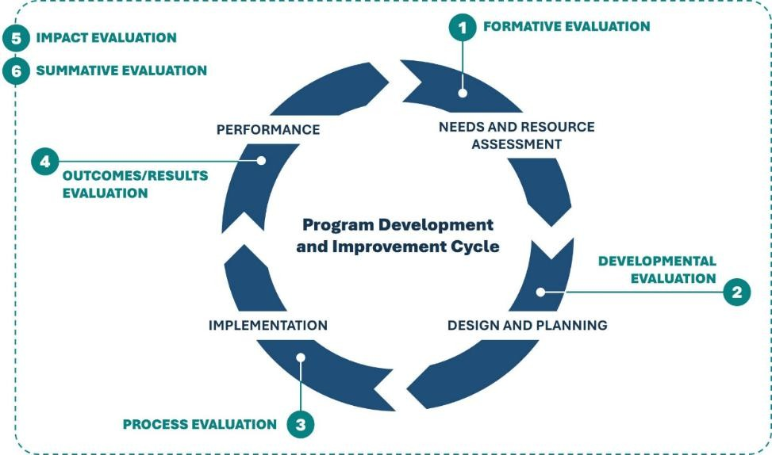

Figure 1. Visual representation of the program evaluation cycle (Source: PAN, 2025).

When talking to others about evaluation, there are two key points to consider:
- Designing programs with evaluation in mind from the beginning is essential. Early alignment between program objectives, activities, and intended outcomes strengthens both implementation and measurement.
- Evaluation is a team effort. High-quality evaluation requires complementary expertise in program design, qualitative and quantitative methods, data analysis, and statistical input from a statistician.
- Why do we evaluate
Programs are evaluated to:
- Improve program quality and effectiveness
- Generate credible evidence of impact
- Inform strategic decision-making
- Ensure accountability to stakeholders and funding bodies

In the context of student equity, evaluation also supports alignment with institutional and sector priorities. Evaluation of equity programs according to ACSES seeks to answer three questions:

- Are our programs consistent with strategic objectives in relation to equity and social inclusion?
- Are our programs achieving the desired outcomes?
- What aspects of our programs require refinement or improvement?

For more information on why we evaluate equity programs in higher education in Australia, see Understanding evaluation for equity programs: A guide to effective program evaluation

- What outputs are included in program evaluation
A well-designed program evaluation produces several key outputs. These documents and tools work together to ensure coherence, rigour, and clarity across the evaluation lifecycle.
A typical evaluation will include:
- An Evaluation Plan
Outlining the design, evaluation questions, methods, timeline, governance arrangements, and intended use of findings.
- A Theory of Change
Articulating the causal assumptions and pathways through which program activities are expected to lead to short-, intermediate-, and long-term outcomes.
- A Program Logic Model (PLM)
Visually mapping inputs, activities, outputs, and outcomes to demonstrate how the program is intended to operate.
- An Indicators and Measurement Framework
Specifying what will be measured, how change will be demonstrated, and how this aligns with relevant frameworks (e.g., SEHEEF).
- Data Collection Tools
Including survey instruments, interview guides, observation protocols, or administrative data extraction plans.
- An Analysis Plan
Outlining quantitative and qualitative analytic strategies, including how data strands will be integrated (where relevant).
- Reporting Outputs
Detailing how findings and recommendations will be communicated to stakeholders (e.g., internal reports, executive summaries, presentations, school feedback).

Part 2 – Developing an Evaluation Plan

- What is included in an evaluation plan
An evaluation plan outlines how you will systematically assess your program. It clarifies the purpose of the evaluation, the key questions to be answered, the data required, and how findings will be analysed and used.
Developing an evaluation plan requires making several foundational decisions, outlined below.

Planning Area | Key Decisions | Practical Considerations (Aspire UC Context)
Purpose & Audience | Why are we evaluating? Who is the evaluation for? | Improve outreach; demonstrate early-stage impact; inform leadership and school partners. Focus on developmental shifts (awareness, belonging, aspiration) rather than enrolment outcomes.
Evaluation Questions | What are we trying to understand? | Align with program objectives. In K–6 context, prioritise awareness, belonging, aspiration, and pathway understanding. Frame questions in developmentally meaningful ways.
What Will Be Measured | What outcomes or processes will be assessed? Which indicators demonstrate change? What tools will be used? | Student aspirations, HE awareness, pathway understanding, engagement. Indicators aligned to SEHEEF domains. Tools: surveys, storyboard activities, interviews. Must be age-appropriate and visually supported where needed.
Who & When | Who will provide data? When will it be collected? | Students (pre–post); teachers and parents (interviews). Align with school calendar and HE academic year. Minimise burden and consider attention span.
Analysis & Interpretation | Who will analyse the data? How will it be interpreted? | Mixed-methods (quantitative + qualitative). Interpret findings in light of developmental stage and school context.
Use of Findings | How will findings be used? | Program refinement; equity reporting; strategic planning; feedback to schools in age-appropriate ways.
Data Governance | Where and how will data be stored and managed? | Secure storage; ethical handling; parental consent and child assent processes.
Program Context | What contextual factors influence design? | Program maturity (new or established), target population (primary-aged, rural/regional), existing administrative data, and appropriate evaluation approach (e.g., formative, realist, outcome-focused).

The purpose (“why”) and audience (“who”) should be clarified first, as these decisions shape the type of evaluation undertaken, the level of evidence required, and the data that must be collected. Establishing these foundations early strengthens the coherence and feasibility of the entire evaluation plan.
- Core components of the evaluation plan
A comprehensive evaluation plan brings together several interrelated components. Each plays a distinct role in ensuring clarity, coherence, and rigour.
  - Evaluation questions

Evaluation questions are high level questions that should be determined in the initial planning stages. They articulate what you are trying to understand and the overarching purpose of the evaluation.
Here is an example of the overarching question for the Aspire UC Small Schools Program:
“How does participation in Aspire UC program shape regional and rural primary school students’ understanding of higher education and related career opportunities, their aspirations to pursue higher education, and the normalisation of higher education within their local communities?”
This question is primarily outcome-focused, as it seeks to understand changes in students’ knowledge, aspirations, and perceptions attributable to program participation.
Your evaluation questions can be either process /implementation questions or outcome questions.
Evaluation questions may be:
- Process questions, which examine how the program was delivered (e.g., reach, fidelity, engagement),
- Outcome questions, which assess changes in participants’ knowledge, attitudes, behaviours, or experiences.
When identifying and polishing your evaluation questions remember to ensure your evaluation questions are clear, that the answers to your evaluation questions are, what you really want to know, and avoid using jargon.
It is also important to ensure that you have the right number of evaluation questions (2–3 evaluation questions, with max 5–7 for large scale evaluations). Keep in mind that collaboration and brainstorming potential evaluation questions with your team is really useful, as this helps to determine what you are really wanting to know and find out.
  - Program logic model and theory of change
Program logic models and theory of change are used to describe and demonstrate how and why a specific change is expected to happen as a result of your program.
Although the terms theory of change and program logic model are often used interchangeably, they serve distinct purposes.
A theory of change provides a detailed explanation (either visually or in writing) of the strategies, conditions, and resources that drive change, and importantly, it clarifies why certain actions are expected to lead to specific outcomes. Here is a one example:
  - Theory of Change, Aspire UC Example.

Limited exposure to higher education in rural/regional low SES communities
↓
Age-appropriate outreach activities
(play-based activities, storytelling, classroom workshops, campus visits, reflective activities)
↓
Increased visibility with university environments and different types of jobs
↓
Emerging awareness of future possibilities and early future thinking
↓
Growing sense that higher education and diverse careers are “for people like me”
↓
Greater perceived openness of pathways beyond school
↓
Long-term normalisation of higher education within local communities

A program logic model (PLM) is a visual representation that maps how a program is expected to work. It links resources and activities to outputs and intended outcomes in a structured, typically linear format.
Unlike a theory of change, which explains the underlying assumptions and causal reasoning behind why change is expected to occur, a program logic model focuses on clearly outlining what the program does and what it aims to produce.
In practice, a narrative theory of change may be used to articulate the reasoning that underpins the logic model.
A typical PLM includes the following component:
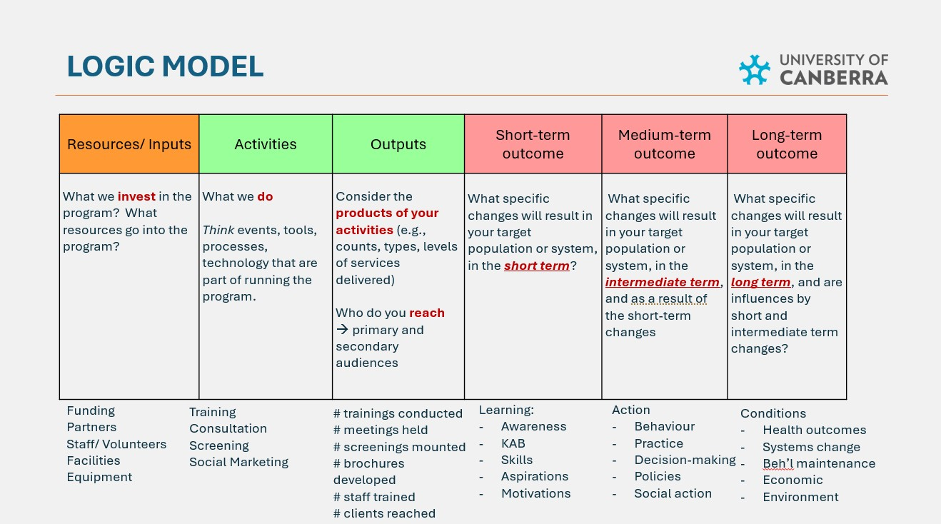
Figure 2. Program Logic Model: Visual explanation of components.

Below is an example Program Logic Model illustrating the structure and components using the Aspire UC Small Schools Program.

  - Program Logic Model, Aspire UC Example

Component | Aspire UC Example
Situation Statement | Students from low socio-economic, regional and remote, and Aboriginal and Torres Strait Islander backgrounds remain significantly under-represented in higher education. Contributing factors include structural barriers such as financial constraints, geographic distance, and limited early exposure to university environments and diverse career pathways.  Evidence indicates that aspiration development and pathway awareness begin well before secondary school. Early-stage outreach is therefore critical to widening participation, as it builds familiarity, future orientation, and a sense that higher education is accessible and relevant.  The Aspire UC Small Schools program works with selected regional and low SES communities (ICSEA <1000) to provide age-appropriate outreach experiences that strengthen awareness, belonging, and early pathway thinking among primary-aged students.
Inputs | Outreach staff and Aspire Agents; partnerships with rural primary schools; curriculum-aligned workshop materials; transport for campus visits; program funding.
Activities | Full-day classroom workshops; monthly school engagement; university campus visits; aspiration-building and reflective activities.
Outputs | Number of participating schools; number of workshops delivered; number of students engaged; number of campus visits conducted.
Short-Term Outcomes | Increased familiarity with university environments; improved understanding of different career types; emerging awareness of future possibilities; ability to articulate a personal aspiration.
Intermediate Outcomes | Strengthened future orientation; early pathway thinking; growing sense that higher education and diverse careers are “for people like me”; increased sense of belonging to Aspire UC and connection to university.
Long-Term Outcomes | Greater perceived accessibility of higher education; gradual normalisation of higher education within participating school communities.
Assumptions | Students attend consistently; schools prioritise engagement; staff are trained and retained; partnerships remain stable.
External Factors | School staffing changes; curriculum pressures; regional disruptions; broader higher education policy shifts.

More resources on Program Logic Models: See NSW Health: Developing and using program logic- A guide , the Australian Institute of Family Studies (AIFS): How to develop a program logic for planning and evaluation, and the Treasury: Commonwealth Evaluation Toolkit.

  - Avoiding evaluation failure – The ‘If–Then Test’
When developing a Program Logic Model, it is easy to become overly detailed or overly ambitious. A useful strategy for strengthening clarity and avoiding evaluation failure is to apply the “if–then” test.
This involves checking whether the logic of your program makes sense:
- If we deliver these activities,
- Then this output should occur.
- If this output occurs,
- Then this short-term outcome should follow.
- If this outcome occurs,
- Then this longer-term change becomes more plausible.
If the “then” does not logically follow the “if,” this signals a gap in the model. That gap may reflect:
- Unrealistic assumptions
- Missing intermediate outcomes
- Activities that do not directly support the intended change
- Overstated claims about impact
Figure 3 provides a simple illustrative example to demonstrate how small breaks in logic can undermine a program’s intended outcomes when evaluation thinking is not embedded from the outset.

Figure 3. Evaluation Failure: 'If and Then' considerations
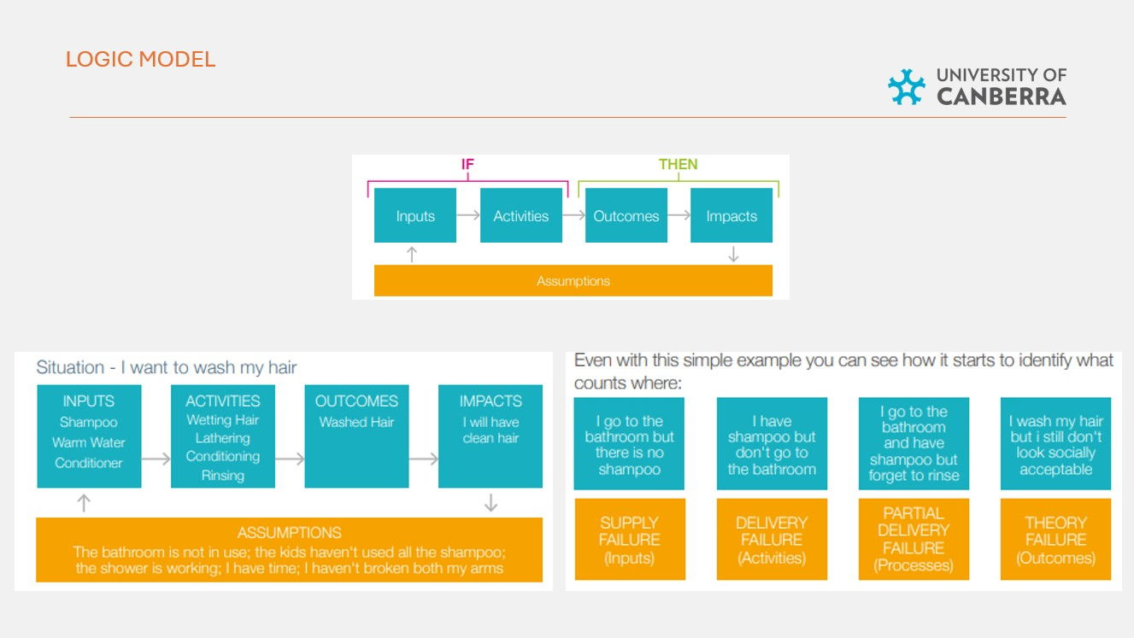

  - Indicators, Measures and Data Sources
Indicators and measures define how change will be demonstrated and assessed in your evaluation.
Indicators describe what change looks like.
Measures describe how that change will be assessed.
Data sources describe where the information will come from.
Together, these form the evidence base of your evaluation.

Indicator (What change looks like) | Measure (How it is assessed)
PROCESS INDICATORS (Implementation & Reach)

Number of school engagement visits delivered per term | Program tracking sheet
Number of participating small schools engaged across the academic year | Administrative records
Number of Aspire UC sessions delivered (workshops, campus visits) | Program tracking sheet
Number of students participating in Aspire UC activities | Attendance records
OUTCOME INDICATORS (Participant Change)
Increased awareness of higher education | Pre–post survey items assessing knowledge of university
Improved understanding of different career types | Storyboard reflections + short survey items
Improved pathway understanding | Pre–post survey items + visual storyboard explanations
Strengthened aspirations and future orientation | Survey items on future plans + student interviews
Increased sense that university is “for people like me” | Belonging scale items + interviews
Increased perceived accessibility of higher education | Survey items assessing perceived openness of pathways
Enhanced ability to articulate a future aspiration | Pre–post storyboard (draw and write) analysis

Tip: Indicators should be SMART — specific, measurable, achievable, relevant, and time-bound.

  - Aligning with the Student Equity in Higher Education Framework (SEHEEF)
When determining measures and indicators for program evaluation, it is important to ensure alignment with the Student Equity in Higher Education Evaluation Framework (SEHEEF). Page 7 of the SEHEEF guidance manual presents the overarching Program Logic Model, including the primary and supporting outcomes associated with the pre-access stage of the student lifecycle.
While SEHEEF’s pre-access domain has traditionally focused on secondary school students and transition to higher education, its underlying principles are adaptable to earlier stages of the student lifecycle. For primary school–focused outreach, alignment does not require measuring immediate enrolment outcomes. Instead, it involves identifying developmentally appropriate indicators that reflect early shifts in awareness, belonging, future orientation, and pathway understanding.
In this context, measures should maintain conceptual alignment with SEHEEF’s intended outcomes while being tailored to the cognitive and developmental stage of participating students.
  - Selecting Measures: A Quick Alignment Framework
When selecting measures, ensure they are aligned across three interconnected dimensions:
where the program is in its evaluation cycle,
where change is expected to occur, and
when that change is likely to be visible.
For example, a formative measure may assess planning readiness before implementation begins (e.g., teacher feedback on program relevance or pilot testing of survey tools); a process measure may track delivery at the school level during the program (e.g., number of workshops delivered, attendance rates, school participation); and an outcome measure may assess short-term changes in student awareness or longer-term shifts in aspiration and community-level normalisation (e.g., pre–post changes in higher education familiarity, emerging pathway thinking, or sense of belonging).
Thinking across stage, level, and timeframe simultaneously helps ensure your measures are coherent, realistic, and appropriately targeted.
  - Feasibility and Developmental Appropriateness
When selecting indicators and measures, consider both feasibility and developmental suitability.
Ask:
✔ Can this realistically be implemented within available time and resources?
✔ Is it ethically appropriate within a school-based context?
✔ Is it developmentally appropriate for primary-aged students?
✔ Will it generate valid and reliable data?
For early-stage outreach programs, indicators must be measurable in ways that are meaningful and accessible to children. This may require selecting or adapting measures to ensure age-appropriate language, reduced cognitive load, and alignment with classroom contexts.
More detailed guidance on child-centred methods and tool selection is provided in the Methods sections.
Part 3 – Designing the Evaluation
- Methods and Tools
Once you have identified your indicators and selected appropriate measures, the next step is to determine how the data will be collected. Methods refer to the strategies used to gather evidence (e.g., surveys, interviews, observations, administrative data), while tools are the specific instruments used to implement those methods (e.g., questionnaires, storyboard templates, interview guides).
Together, methods and tools operationalise your evaluation design and ensure that the evidence generated is credible, rigorous, and aligned with your program’s intended outcomes.

  - Selecting data collection methods

When working with primary-aged students, selecting appropriate methods is particularly critical. Tools must not only capture valid data, they must also be developmentally suitable, engaging, and inclusive.

For example:
- Abstract Likert-scale survey items may be difficult for younger students to interpret reliably.
- Long questionnaires may exceed attention spans.
- Conceptually complex terms (e.g., “aspiration,” “pathways,” “belonging”) may require simplified language or concrete framing.
In these contexts, structured visual and interactive approaches are often more effective.

  - Developmentally appropriate methods for children
Best practice evaluation involving children prioritises:
- Clear, simple language
- Concrete and observable prompts
- Visual or creative expression
- Short, focused engagement periods
- Opportunities for children to explain meaning in their own words
Examples of methods suited to primary-aged outreach include:

Structured child-friendly surveys
Short, clearly worded items with visual supports where needed (e.g., smiley scales, examples embedded in questions).

Draw-and-write or storyboard activities
Students illustrate and describe their future aspirations, career ideas, or perceptions of university before and after program participation. These can capture shifts in awareness, agency, and pathway understanding.

Photo-elicitation or visual prompts
Images used to prompt discussion about university environments, careers, or learning experiences.
Short semi-structured interviews
Brief conversations that allow children to explain the meaning of their drawings or survey responses without leading them.

Teacher and parent interviews or focus groups
Used to contextualise student-level findings and explore broader school or community shifts.
In all cases, methods should minimise power imbalances, avoid leading language, and allow children’s voices to be authentically represented.

Further detail available in Part 4 – Program Evaluation Involving Children.

  - Selecting appropriate instruments

When choosing tools, consider:
- Whether a standardised instrument exists
- Whether it has been validated for the target age group
- Whether adaptation is required
- Whether the tool remains reliable after adaptation

Figure 4 (Australian Institute of Family Studies Instrument Decision Tree) outlines key considerations when selecting appropriate data collection methods and instruments. As noted in Figure 3, measures and indicators may require adaptation to suit your program, participants, and evaluation audience. However, where possible, it is preferable to use standardised, valid, and reliable instruments to ensure rigour and comparability.

Where no appropriate standardised measure exists, as is often the case in early-stage widening participation outreach, carefully designed, theory-informed, child-centred tools may be more suitable.

Figure 4. Instrument Decision Tree.

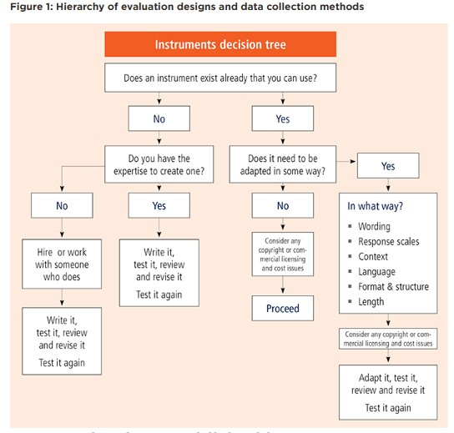

8.2 Additional instruments and frameworks
There are currently few standardised measures specifically designed to evaluate impact in early-stage, primary-aged outreach contexts that precede the conventional secondary-focused pre-access stage described in SEHEEF. As a result, programs such as Aspire UC often need to balance the use of validated instruments with careful adaptation to ensure developmental appropriateness.
If the scope of the Aspire UC evaluation were to expand in future, additional instruments related to student belonging and wellbeing may be considered.

For example, Tell Them From Me (TTFM)—used widely in NSW public schools—includes student, parent, and teacher surveys that capture student engagement and wellbeing. While not designed specifically for outreach evaluation, selected components may offer contextual insight where appropriate.
Similarly, the Simple School Belonging Scale (SSBS), originally developed for older students, may offer relevant constructs for upper primary cohorts with thoughtful adaptation.

The ARACY Nest framework, which provides a validated wellbeing framework for children and young people aged 0–24 years, includes domains such as participation, identity and culture, and learning that may align with early-stage outreach objectives.
Additional validated measures can be explored through the Australian Institute of Family Studies (AIFS) Outcomes Measurement Matrix. Where instruments are adapted for primary-aged contexts, they should remain psychometrically sound while incorporating child-centred and developmentally appropriate approaches.

- Evaluation Designs
An evaluation design refers to the overall strategy used to determine whether and how a program contributes to change.
The most appropriate design depends on:
- The purpose of the evaluation
- The evaluation questions
- Ethical considerations (e.g., is it appropriate to withhold the program?)
- Available data
- Timeframes and resources
In early-stage outreach contexts, additional considerations include developmental appropriateness, school timetables, and feasibility within small rural settings. There are a number of different evaluation designs. Some examples of evaluation designs include experimental, quasi-experimental and non-experimental.
The table below provides some examples for each and provides a brief description of when it is best to use each of the design types.
Design type | Example | Best for | Advantages | Limitations
Experimental | RCTs, cluster RCT’s | Isolating program impact | High rigour, causal impact | Often not ethical or practical, expensive
Quasi-experimental | Matched comparison,  time series | When a RCT is not feasible | Practical, adaptable | May have bias, less control
Non-experimental | Case studies, interviews | Exploring context,  voices, stories | Rich insights | No casual inference, less generalisability

- Evaluation approaches
In addition to selecting an evaluation design, it is important to consider the broader approach guiding the evaluation. An evaluation approach reflects the underlying philosophy, purpose, and orientation of the work.
Common approaches include:
- Utilisation-focused evaluation, which prioritises producing findings that are practical and useful for decision-makers.
- Participatory evaluation, which involves stakeholders—such as program staff, schools, or participants—in shaping the evaluation process.
- Developmental evaluation, which supports innovation and adaptation in evolving programs.
- Culturally responsive evaluation, which centres cultural context, equity, and community perspectives in design and interpretation.
For early-stage primary outreach programs such as Aspire UC, a combination of utilisation-focused, participatory, and developmental approaches is often appropriate.

PART 4 – Program Evaluation Involving Children

- Evaluating programs with children
Evaluating programs that involve children requires additional ethical, developmental, and methodological care. Children are not simply “small adults.” Their cognitive, linguistic, emotional, and social development shapes how they understand questions, express ideas, and engage in evaluation activities.
High-quality evaluation involving children is therefore not only about selecting appropriate tools, but about creating conditions that enable meaningful, safe, and authentic participation.
  - Foundational principles
When designing evaluations involving children, consider the following core dimensions:
DEVELOPMENTALLY APPROPRIATE ENGAGEMENT
Evaluation methods must align with the children’s age, attention span, vocabulary, and abstract reasoning capacity. Younger children may struggle with abstract survey items or hypothetical questions, whereas concrete prompts, visual tools, and structured creative tasks often yield more reliable results.
MANAGING POWER IMBALANCES
Children may attempt to “please” adults or provide answers they believe are expected. Evaluators should:
- Use neutral language
- Avoid leading questions
- Emphasise that there are no right or wrong answers
- Create a psychologically safe environment

LANGUAGE AND CLARITY
Vocabulary must be simple, concrete, and inclusive. Terms such as “aspiration,” “pathway,” or “belonging” require reframing into observable or relatable language (e.g., “What would you like to be when you grow up?” or “Do you feel like you could go to university one day?”).

CULTURAL RESPONSIVENESS
Evaluation approaches must align with culturally safe and inclusive practice. This is particularly important when working with Aboriginal and Torres Strait Islander students and rural or regional communities. Evaluators should ensure that methods are respectful, strengths-based, and aligned with relevant cultural frameworks.

ETHICAL CONSENT
Evaluations involving children require:
- Parental or caregiver consent
- Child assent (developmentally appropriate explanation of participation)
- Consideration of literacy levels and capacity to consent
- Clear explanation of how data will be used

Participation should always be voluntary and transparent.
  - Age-Appropriate methods

As a general guide:

Children aged 8 years and above may be able to respond reliably to short, clearly worded surveys, provided language is simplified and attention demands are reasonable.

For younger children (particularly under 8), more interactive and visual approaches are often more appropriate, including:
- Short informal interviews
- Guided conversations
- Drawing or storyboard activities
- Visual prompts or photo-elicitation
- Diaries (written, audio or visual formats)
- Puppet or character-assisted conversations, where a neutral character (e.g., a puppet or illustrated figure) is used to prompt a discussion in a low-pressure and developmentally accessible way

These methods reduce cognitive load and allow children to express meaning in ways that suit their developmental stage.
  - Child-Centred methods in Aspire UC
In the context of the Aspire UC Small Schools program, arts-based elicitation approaches are particularly well suited.
For example, the current use of structured pre–post storyboard activities allow children to:
- Draw and describe their future aspirations
- Explain how they see university or careers
- Articulate what they think they would need to learn
Follow-up semi-structured interviews enable evaluators to ask children to explain the meaning behind their drawings, rather than imposing adult interpretations. This strengthens validity and preserves the child’s voice.
  - Practical considerations
When evaluating programs involving children, it is also important to consider:
- Alignment with school calendars
- Classroom time constraints
- Staff capacity
- Resource availability
- Whether children’s participation will meaningfully inform program decisions
Children should understand why they are being asked to participate and how their input will contribute to change. Research increasingly recognises children as experts in their own lived experiences; meaningful evaluation honours this principle.
  - Further guidance
For more information and best practice guidance on program evaluation involving children:
Involving Children in Evaluation from the Australian Institute of Family Studies is an excellent practice guide resource. It expands on additional data collection methods, while looking at the strengths and limitations, combined with additional information.
Involving children and young people the Centre for Community Child Health Voice Health- Voice of the Child Toolkit provides a suite of best practice and evidence based resources for involving children and young people.
For inclusive language guidance material that is specific to child/ren the Telethon Kids Institute Inclusive Language Guide is a great place to start. The Faculty of Education at The University of Melbourne Inclusive Language Guide is for use within education settings.
Consent procedures and involving First Nations children in your program evaluations: visit AITSIS Code of Ethics and Australian Evaluation Society (AES) First Nations Cultural Safety Framework

