
ACSES CAPACITY BUILDING GRANTS PROGRAM

Development of a Program Evaluation Community of Practice to support a whole-of-university approach to SEHEEF

  - Edith Cowan University

2026

Development of a Program Evaluation Community of Practice to support a whole-of-university approach to SEHEEF

February 2026

Edith Cowan University
Elle Beaumont-Bilsby, Liam Downing

Suggested citation: Beaumont-Bilsby, E., Downing, L. (2026). Development of a Program Evaluation Community of Practice to support a whole-of-university approach to SEHEEF (Capacity Building Grants final report). Australian Centre for Student Equity and Success, Curtin University.

Australian Centre for Student Equity and Success
Tel: +61 8 9266 1573
Email: acses@curtin.edu.au
Web: www.acses.edu.au
Building 100
Curtin University
Kent St, Bentley WA 6102 | GPO Box U1987, Perth WA 6845

DISCLAIMER
Information in this publication is correct at the time of release but may be subject to change. This material does not purport to constitute legal or professional advice.
Curtin accepts no responsibility for and makes no representations, whether express or implied, as to the accuracy or reliability in any respect of any material in this publication. Except to the extent mandated otherwise by legislation, Curtin University does not accept responsibility for the consequences of any reliance which may be placed on this material by any person. Curtin will not be liable to you or to any other person for any loss or damage (including direct, consequential or economic loss or damage) however caused and whether by negligence or otherwise which may result directly or indirectly from the use of this publication.

COPYRIGHT
© Curtin University 2026
Except as permitted by the Copyright Act 1968, and unless otherwise stated, this material may not be reproduced, stored or transmitted without the permission of the copyright owner. All enquiries must be directed to Curtin University.
CRICOS Provider Code 00301J
ISBN 978-1-7644511-9-2

Acknowledgement of Country
The Australian Centre for Student Equity and Success acknowledges Indigenous peoples across Australia as the Traditional Owners of the lands on which the nation’s campuses are situated. With a history spanning more than 60,000 years as the original educators, Indigenous peoples hold a unique place in our nation. We recognise the importance of their knowledge and culture, and reflect the principles of participation, equity, and cultural respect in our work. We pay our respects to Elders past, present, and future, and consider it an honour to learn from our Indigenous colleagues, partners, and friends.

Approach

Situation prior to project
Edith Cowan University’s (ECU) current maturity level in impact evaluation is developing, and as a result equity projects may be proposed that struggle to attract support—in the form of internal funding or prioritisation of staff time—as their strategic and operational impacts are unclear at the planning phase. Of projects that are supported, many will struggle to evidence measurable impacts of the work being undertaken (or provide very simple measures of output), and as a result it can be unclear which initiatives ECU should scale up or scale down.

Rationale for project
The focus of the project was to develop an evidence-based, reflective approach to project proposals, development, and outcomes assessment. This approach will be based on evaluation and evaluative thinking, incorporating Theory-Based Impact Evaluation (TBIE) approaches such as realist evaluation.
The project was led through a collaborative approach between a range of support and service teams across the university. Operational areas that receive Higher Education Participation and Partnership Program (HEPPP) funding to increase participation and support for equity cohorts in higher education were active participants in the Project Reference Group.
A key goal of this cross-disciplinary, collaborative approach was to develop a formalised, robust framework that can be applied across different contexts when designing, developing, and evaluating student-facing programs and services at the university. This will develop the capacity of ECU organisational areas to apply a person-centred lens within a mutually agreed framework, with demonstrated benefits for equity, diversity, and inclusion. The implementation of this framework, supported through a Program Evaluation Community of Practice (CoP), will enable the development of more inclusive and impactful student engagement and learning experiences. Activities shared with the CoP will be used as exemplars with transferrable components, forming the foundation of scalable, whole-of-university student equity programs in the future.

Project outline and activities completed
Table 1: Project outline and activities completed with comments and variations noted.
Project stage | Activity | Milestone
Initiation | Identify Project Leads and members of the Project Reference Group from key service areas. | May 2025
Scoping | Consultation with external facilitator on Program Logics and evaluation. External facilitator interviews selected members of the Project Reference Group to benchmark evaluation requirements and current capacity for operational teams. | May 2025
Capacity development | Full-day workshop with Project Reference Group—Evaluation Essentials, Program Logic models and TBIE.  Feedback survey on workshop.  VARIATION: Interviews with Service Teams to discuss specific contexts and business area needs for evaluation.  VARIATION: Launch CoP including workshop resources via MS Teams and SharePoint. | July 2025 – August 2025
Development of prototypes | Build exemplars of the Program Logics process framework as a guide for implementation across Project Reference Group.  Available in PDF and Lucid digital collaboration platform.  COMMENT: Service Team availability to develop prototypes limited due to other operational commitments. | August 2025
Embed and operationalise | VARIATION: ‘Ask Liam’ channel created in CoP to create “available any time” feedback channel about evaluation in practice.  COMMENT: Service Team engagement with CoP limited due to other operational commitments. | September 2025
Project review | VARIATION: ‘Ask Liam’ webinar to create a real-time Q&A session with operational teams about evaluation in practice.  VARIATION: Pivot from CoP to tailored evaluation resources based on operational team feedback and limited availability due to other operational commitments. | September 2025 – October 2025
Development of  ECU Equity  Evaluation  Resource Hub | VARIATION: Adaptation of resources that were originally in project scope to suit different user experiences tailored to different operational team (and individual team member) requirements:  - existing evaluation capacity  - availability in the context of other operational demands  - organisational awareness  - project progress (before, during, or after).  VARIATION: ECU Equity Evaluation Resource Hub is available to all ECU staff via ECU SharePoint. | November 2025 – December 2025
Project reporting | A summarised record of key activities throughout the project will be paired with feedback from the Project Reference Group. | December 2025
Please note: The table ‘Project Outline and Activities Completed’ includes variations to the planned project activities (listed as ‘VARIATION’ or ‘COMMENT’).

Key changes to the original project plan
A key gap identified through interviews with participants after the July full-day workshop was the current lack of alignment between evaluation reporting requirements and the knowledge conveyed in the workshop. In any capacity building strategy, opportunity to apply knowledge is key, and Evaluation Capacity Building (ECB) efforts are most effective when integrated into existing structures and reforms. For example, in NSW Education, ECB support and resources are integrated within the School Excellence Framework and school reporting requirements which are mandatory for school leaders and staff; thus, evaluation is accepted practice (Rintoul, 2019).
In the ECU context, the most pressing need identified was support in creating evaluation reports that are both meaningful to program teams and compliant with university and external requirements. This includes tools, templates, and exemplars for evaluative reporting that meet internal (ECU) and external (for example, HEPPP, SEHEEF) standards. Additionally, a need was identified for qualitative data gathering tools and templates for capturing data through formal means (for example, interviews and focus groups) and in incidental moments (such as Harvard minute papers and back pocket questions), observation guides, and continuous quality improvement (CQI) focused evaluative practice resources.
To meet these needs and support the practical application of evaluation tools and methods adapted to the ECU context, a suite of resources was developed, building on the existing engagement with participants in the Evaluation Essentials for Student Experience and Equity (EESEE) Community of Practice. These resources would be available via an online staff intranet site—the ECU Equity Evaluation Resource Hub.
The ECU Equity Evaluation Resource Hub includes existing resources provided in an easily accessible format, with the addition of dedicated templates and resources to align with ECU and Department of Education standards. The ECU Equity Evaluation Resource Hub was launched to ECU staff on 12th December 2025.

Outputs
Table 2: Key outputs developed for the project
Project stage | Resources developed to support Evaluation Capacity Building
Capacity development | Evaluation Essentials for Student Experience and Equity (EESEE)  Workshop  One-day EESEE Workshop delivered to 42 ECU staff by Evaluation  SME, Liam Downing (29th July 2025):  - workbook (hardcopy and PDF)  - workshop presentation  - workshop activities (Logic Model and Realist Evaluation)  - supporting documentation (PDF)  - EESEE Community of Practice SharePoint site and MS Teams Space.  13 workshop follow-up sessions between operational teams and  Evaluation SME, Liam Downing (30th and 31st July 2025).
Development of prototypes  Embed and operationalise | Ongoing discussions about evaluation in the EESEE Community of Practice (August – September 2025).  ‘Ask Liam’ webinar to focus on key questions about evaluation in practice (24th September 2025).
Project review | Progress review on post-workshop participant feedback, EESEE community engagement, and exploration of emergent needs (October – November 2025).
ECU Equity Evaluation  Resource Hub | Development of tools and templates for evaluative planning and reporting. All resources available online as accessible MS Word documents:  - initiative establishment evaluation checklist  - guide to ethical evaluation  - evaluation planning template  - criteria and standards for evaluation template  - evaluation utilisation planning checklist  - internal evaluation reporting template  - external evaluation reporting template  - CQI reflection template  - ECU equity minute paper  - qualitative interviewing  - focus groups  - incidental interviews— “back pocket qualitative questions”  - observation methods  - document analysis  - ‘Fresh Eyes’ resource.

Figure 1. Evaluation Essentials for Student Experience and Equity (EESEE) workshop delivered to 42 ECU staff by Liam Downing (Evaluation Consultant for the Project), 29th July 2025.
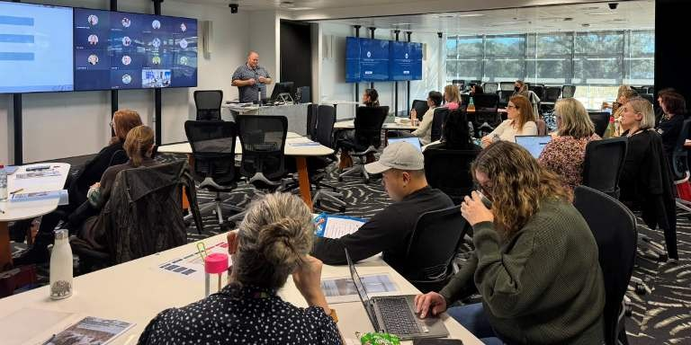
Figure 2. ECU staff from different equity-focused operational areas completing Logic Model activity in EESEE workshop.
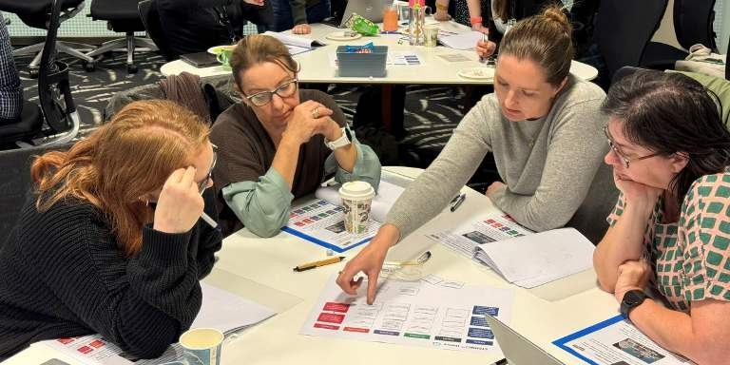
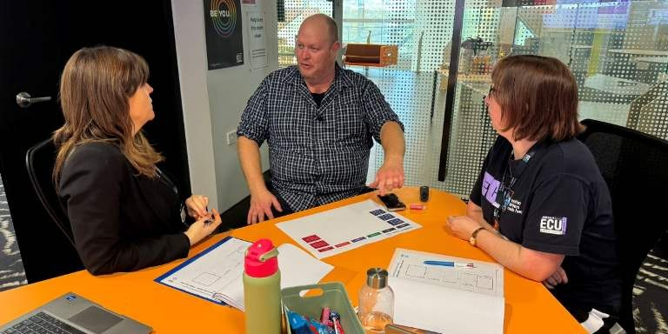
Figure 3. Liam Downing and ECU staff discussing the Logic Model activity in EESEE workshop.

Key insights from the project

Setting the scene: context is everything
The ACSES Capacity Building Grant project for Edith Cowan University—"Development of a Program Evaluation Community of Practice to support a whole-of-university approach to SEHEEF”—was firmly grounded in addressing the needs of equity practitioners to understand and apply evaluation tools and methods across their day-to-day activities. This practical focus required the following key elements to be considered throughout the design, development, and review of the project:
WHO IS INVOLVED?
Project Reference Group: key stakeholders of an equity evaluation Community of Practice:
- Operational teams involved in planning and delivering equity-targeted services.
- Leaders of teams that deliver equity-targeted services.
- University reporting and governance teams members.
- Subject-matter expert in equity evaluation—Liam Downing.
- The Project team (comprised of members from each of the stakeholder groups).
WHAT IS THE CURRENT CONTEXT?
- What existing knowledge do stakeholders have about equity evaluation?
- What requirements and expectations do stakeholders currently have for evaluation and reporting?
- How applicable is equity evaluation for the day-to-day work that services teams do?
WHEN?
- When do stakeholders engage with equity evaluation currently?
- When do we want stakeholders to ideally engage with equity evaluation?
GAP IDENTIFICATION
Regarding equity evaluation practices:
- Where are stakeholders now?
- Where do we want them to be?
- How might we bridge gaps between the current state and the desired future state?
Key insight: Evaluation Capacity Building is highly context dependent, is emergent over time, influenced by organisational changes, service workloads, and project lifecycle stages.

The project outline and activities as stated in Section 1.3 of this report followed a standard project process; exploring the problem space by engaging with stakeholders to understand current conditions before framing opportunities to instigate changes that may drive desired outcomes. The Evaluation Essentials for Student Experience and Equity (EESEE) workshop and initial set of support resources were developed through this process. The post-workshop evaluation survey with participants was overwhelmingly positive (see Section 3).
As the project moved into the “Development of prototypes” and “Embed and operationalise” stages, the project team continued to engage with stakeholders to support the desired outcomes. Engagement with evaluation resources and the EESEE Community of Practice varied between different operational teams. A key challenge identified by EESEE community members was not having the time to apply the learnings from the EESEE workshop to their day-to-day work. In most cases, teams had very specific practical requests about how and when to apply a certain evaluation method or tool to inform service improvement.
Throughout the project the context for the scope of works was influenced by large-scale University changes, new projects that intersected with equity student service delivery, team restructures, and the addition of new operational staff and EESEE Community members.
The highly contextually dependent nature of the operational environment to which evaluation can be applied highlighted a key challenge to formal capacity building workshops and resources; it is not possible to support a linear progression for capacity development when operational teams are often working on multiple concurrent projects, are resource constrained, and, as a result, may find it extremely difficult to formally plan and implement step-by-step evaluation to their work.
In addition, some evaluation methods may have the appearance of a linear step-by-step process, but to a new practitioner who is unfamiliar with the method any reflexive, iterative stages may seem extremely confusing.
The project team sought to address these challenges through developing a way of presenting resources that could “meet people where they are at.”

“Meeting people where they’re at”—a Persona-based approach
Following on from the insight that understanding and applying evaluation practices is highly contextually dependent, the project team flipped the concept of capacity building from a linear step-by-step educational process to a needs-based toolkit with diverse entry points and applications that can meet high-level ‘”jobs-to-be-done” (Jobs-To-Be-Done Framework, n.d.). Through articulating different use cases that university staff can readily identify and match to their own situations, they may more readily seek out and implement an evaluation approach, resource, or method. In User Experience (UX) practices, different types of users of a service or product that have similar attributes, needs, or behaviours are often clustered into groups known as ‘Personas’ (Dykes, 2025).
Based on the in-depth conversations with EESEE Community members from different operational teams throughout the project about their evaluation requirements, the following Personas were developed. These Personas were tested with stakeholders prior to being employed in the content design and structure for the Equity Evaluation Resource Hub.

Table 3: Personas used to group evaluation resources on the ECU Equity Evaluation Resource Hub.
Persona | Need | Job-to-be-done
The Doer | “Time is precious as I’m deeply focused on supporting students and  suddenly the end of the year is here!” | “I want to reflect on the past year of an initiative.”
The Reporter | “My leaders need a HEPPP / ACSES /senior leadership compatible evaluation report, and they need it very soon!” | “I want to write a formal internal end-of-year evaluation report for an initiative.”
The Planner | “I am designing an initiative from the  ground up and I recognise that:  a) I will need to report on the  initiative’s impact, and  b) evaluation is useful for refining  my project as I implement it.” | “I want to establish or propose a new initiative.”
The Researcher | “I need guidance on data collection methods so I can start gathering meaningful, reliable data to inform my CQI or full evaluation.” | “I want to begin collecting meaningful, reliable data on my initiative.”
The Fresh Eyes | “I started at ECU recently and need to understand all that jargon.” | “I need guidance on equity in higher education and evaluation as it relates to my work.”

The ECU Equity Evaluation Resource Hub presented each Persona’s “need” and “job-to-be-done” as a distinct option that a web site user can click on to view a tailored subset of relevant evaluation resources that can help them meet their desired goal.
Each evaluation resource is an accessible MS Word document that provides a clear step-by-step guide, checklist, or template to scaffold the implementation of a particular facet of evaluation practice. The resources were tailored to align with ECU’s organisational reporting requirements, where relevant, so users of the ECU Equity Evaluation Resource Hub can see tools that are directly relevant to their operational context.
Key insight: Resource mapping to the needs of different personas can provide multiple entry points to the same content based on different requirements. This can increase the accessibility and perceived usefulness of resources to a broader range of stakeholders.

Figure 4. ECU Equity Evaluation Resource Hub home page. Showing different Persona statements that act as specific calls to action for different stakeholders.
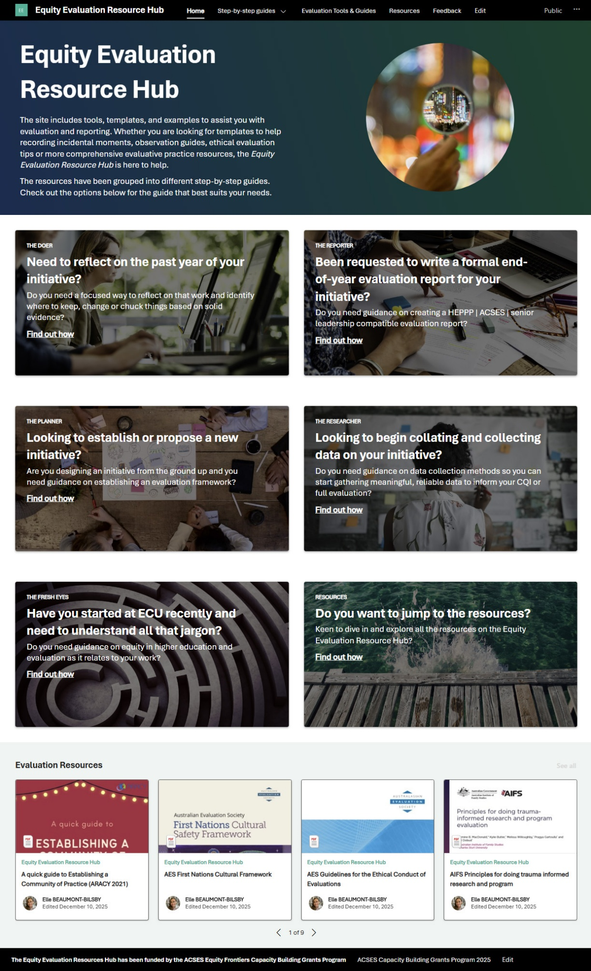

Equity Evaluation Hub Resources matched to different Personas
Each ECU Equity Evaluation Hub Resource was matched to different Personas so that users can quickly see tools that are directly relevant to their operational context and need.

Table 4: List of evaluation resources with associated categories and related personas.
Evaluation resource | Category | Related personas
CQI reflection template | Guides and templates | The Doer  The Researcher  The Fresh Eyes
Evaluation planning template | Guides and templates | The Doer  The Reporter  The Planner
Evaluation utilisation planning checklist | Guides and templates | The Doer  The Reporter  The Planner
Guide to ethical evaluation | Guides and templates | The Researcher
Internal evaluation reporting template | Guides and templates | The Doer  The Reporter  The Researcher
Initiative establishment evaluation checklist | Guides and templates | The Planner
Criteria and standards for evaluation | Guides and templates | The Planner
External evaluation reporting template | Guides and templates | The Reporter
Document analysis | Tools | The Researcher
Focus groups | Tools | The Researcher
Guide to qualitative analysis | Tools | The Researcher
Incidental interviews | Tools | The Researcher
Observation methods | Tools | The Researcher
Qualitative interviewing | Tools | The Researcher
Survey methods | Tools | The Researcher
Problem Tree worksheet | Tools | The Planner
MoSCoW Prioritisation worksheet | Tools | The Planner
Logic Model worksheet | Tools | The Planner
Realist Evaluation worksheet | Tools | The Planner
Fresh eyes resource | Tools | The Fresh Eyes
ECU equity minute paper | Tools | The Researcher

Impact
The proposed impact of this work was to:
- Develop a formalised, robust framework that can be applied across different university contexts when designing, developing, and evaluating student-facing programs and services.
- Increase understanding of contribution and attribution of HEPPP via adoption of SEHEEF.
The Phase 1 Interim Report findings indicated that the EESEE workshop took some initial steps toward this desired impact. Average likelihood to recommend in the post-workshop survey was 8.9 on a 0–10 scale, and participants reported a shift in confidence in conducting impact evaluation (3.3 pre [n = 12] to 4.2 post [n = 20] on a 1–5 scale. Qualitative data also suggested that participants were actively learning and considering how to apply theory-based impact evaluation in their own contexts.
While I am familiar with evaluation I learnt a new approach from you today and you provoked some new thinking for me that is highly relevant to my work. (Participant 1)
Thank you, Liam—I think today provided excellent grounding to get everyone using the same language and start thinking about application to their own areas. (Participant 2)
This was a fantastic workshop, Liam. Extremely informative, engaging, and enjoyable. Stella and STEMWin were great tools to help me understand and apply. Thank you. (Participant 3)
Liam is an engaging facilitator. As someone who is novice in the world of evaluation, I really appreciate the explicit approach he took to making a challenging subject understandable. (Participant 4)
That said, participants clearly expressed that there would be barriers to taking evaluation into their practice, with the challenges of ‘business-as-usual’ serving as a barrier.
I think we will still struggle to find the me and resources to put this into practice, but I will be looking for opportunities to evaluate alongside everyday activities within our workflow. (Participant 5)
I’m conscious of me available to apply what I have learned moving forward. Hence the “a little” response for question 3 [How much do you plan to use your learning today in your practice moving forward?]. If I could evaluate everything our team does in support of students and then adjust what we do, following our evaluation, I would. (Participant 6)
This was borne out by the emergent challenges, outlined in Section 2, in establishing the Community of Practice. While there were significant external factors at play, the key insight that “Evaluation Capacity Building is highly context dependent, is emergent over time, influenced by organisational changes, service workloads, and project lifecycle stages” reinforced that a more context-sensitive approach to supporting usage of evaluation would be more effective than a CoP (which, per ARACY’s “A quick guide to establishing a Community of Practice” (Goodhue, 2021) is most effective when working on shared problems. ECU elected to develop the ECU Equity Evaluation Resource Hub with the added feature of the personas-based approach.
Given the ECU Equity Evaluation Resource Hub was completed and launched in December 2025, it is too early to establish impact as of January 2026. This is evidenced by 19 unique users (beyond the project team) having accessed the hub so far. It is likely that impact of the combination of the workshop, additional support, and the resource hub can begin to be assessed as HEPPP practitioners move into reporting on their 2025 impact and planning activities and evaluation for 2026. To continue learning and understanding the impact of this work, ECU will work with Liam Downing to monitor capacity building outcomes throughout 2026 with the aim of publication or presentation of impact in either conference (for example. Australian Evaluation Society) or journal channels (for example, Evaluation Journal of Australasia), and/or directly with ACSES.

Key insight: Change takes time, and meaningful and sustained utilisation of learning leading to impact takes good timing. While there was clear engagement and enthusiasm driven by the EESEE workshop and subsequent individual support, participants were largely not at a point in their work where they immediately apply Theory-Based Impact Evaluation to their work.

Appendix

Project Reference Group—Stakeholder map
Portfolio | Directorate | HEPPP Activities Student Life Cycle
Portfolio | Directorate | Pre-Access | Access | Participation | Transition  Out
DVC (Students, Equity, and  Indigenous) | Student Life  Student Success  Business Improvement  Student Transitions  Student Hub  Psychological Counselling Support |  |  | X | X
DVC (Students, Equity, and  Indigenous) | Access and Equity  Equity Projects  Academic Pathways  Access and Inclusion |  | X | X | X
DVC (Students, Equity, and  Indigenous) | Kurongkurl Katitjin | X | X | X | X
DVC (Education) | Employability |  |  | X | X
DVC (Education) | Centre for Learning and Teaching |  |  | X | X
DVC (Education) | Library  Learning Support |  |  | X | X
VP (Engagement) | Growth, Engagement and Marketing | X | X | X
DVC (Regional  Futures) | Office of DVC (Regional Futures)  Strategic Initiatives | X | X | X | X

Resources developed throughout the project

Evaluation Resource |  | Purpose
EESEE Community SharePoint and MS Teams Space |  |  | A shared space for ECU staff from the EESEE Community (Project Reference Group) to access evaluation resources, share information and ask questions about evaluation in practice.  See Figure 5. EESEE Community SharePoint site.
ECU Workshop 20250729 deck |  |  | Workshop presentation delivered by Liam  Downing via PowerPoint and MS Teams to the EESEE Community (in-person and online). Available as a PDF from the EESEE Community SharePoint after the workshop.
ECU Workshop 20250729 workbook |  |  | Printed workbook that accompanied the Workshop. Available as a PDF from the EESEE Community SharePoint after the workshop.
 | Ask Liam—Q&A 24/09/2025 Webinar notes |  |  | MS Teams Webinar with Liam Downing to answer specific questions from the EESEE Community about evaluation in practice. Webinar video recording, transcript, and summary document available from the EESEE Community SharePoint after the webinar. See Figure 6. EESEE Community MS Teams update post on the ‘Ask Liam’ webinar.
 | Equity Evaluation Resource Hub |  |  | SharePoint web site accessible to any ECU staff. See Figure 4. ECU Equity Evaluation Resource Hub home page.  Resource Hub content contains 21 documents tailored to the EESEE Community requirements gathered throughout the Project.  See Figure 7. ECU Equity Evaluation Resource Hub—The Doer web page.

Figure 5. EESEE Community SharePoint site. The site provides an accessible web interface for the EESEE Community MS Teams Space.
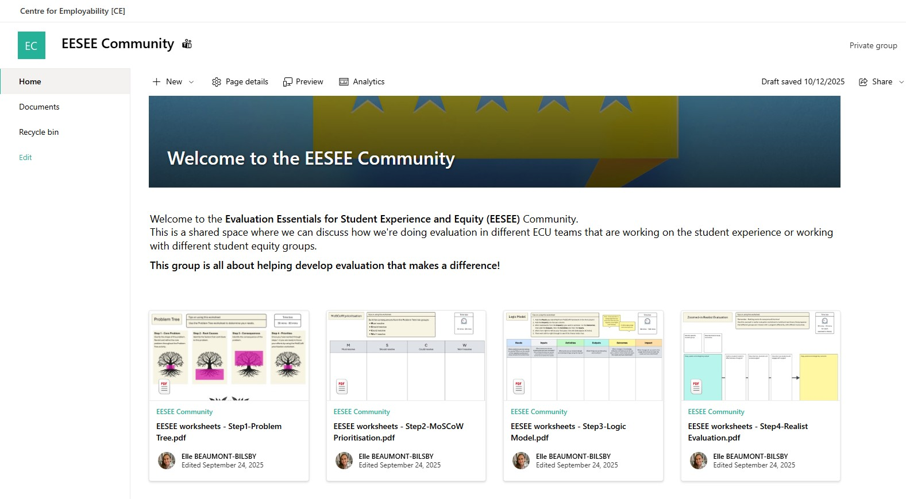

Figure 6. EESEE Community MS Teams update post on the ‘Ask Liam’ webinar. The MS Teams space enabled evaluation resources to be collected and shared with the EESEE Community. This post includes the following content:
- Text content: TLDR (‘too long didn’t read) version of the ‘Ask Liam’ webinar summary.
- ‘Ask Liam’ webinar summary available as an accessible MS Word document.
- ‘Ask Liam’ webinar recording available via MS Stream.
- Ask Liam’ webinar transcript available as an accessible MS Word document.
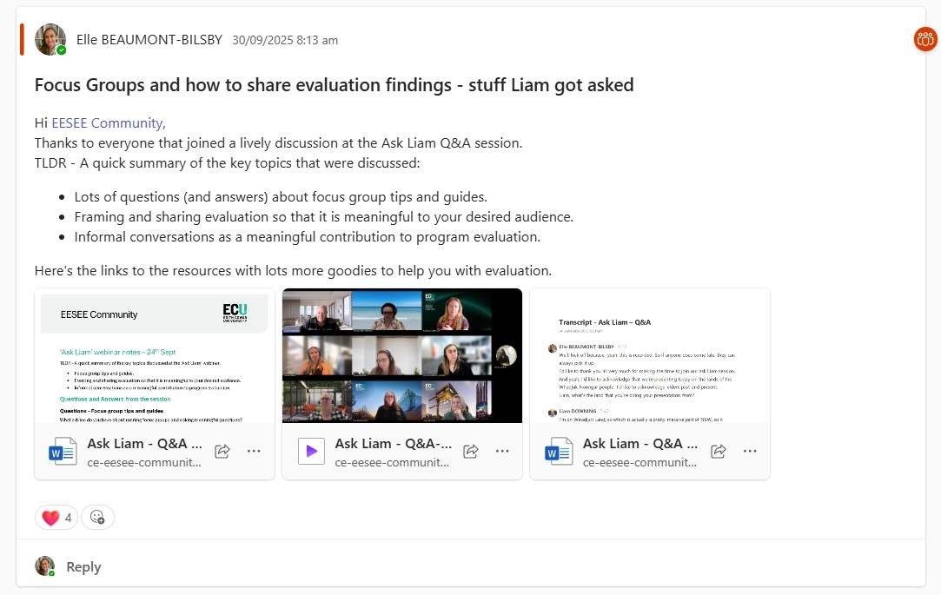

Figure 7. ECU Equity Evaluation Resource Hub—The Doer web page.
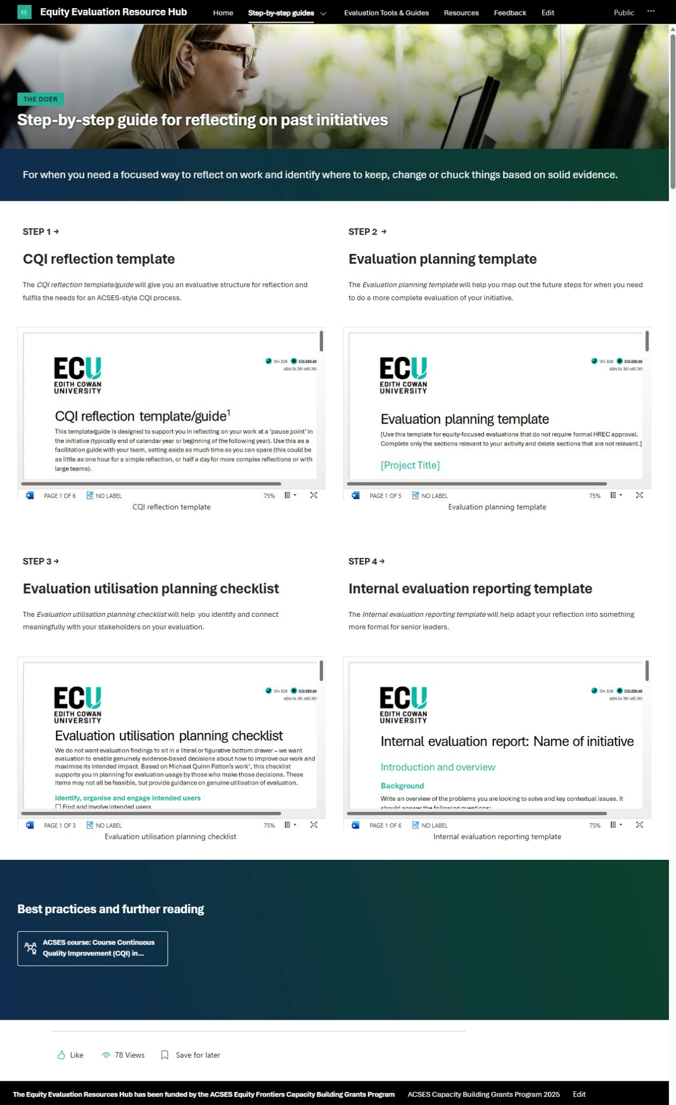

References
Dykes, T. (2025, October 3). Personas Make Users Memorable. Retrieved from NN/Group: https://www.nngroup.com/articles/persona/
Goodhue, R. &. (2021). A quick guide to establishing a Community of Practice. Retrieved from www.aracy.org.au: https://www.aracy.org.au/wp-content/uploads/2024/09/A_quick_guide_to_Establishing_a_Community_of_Practice_ARACY_2021_-_FINAL.pdf
Jobs-To-Be-Done Framework. (n.d.). Retrieved from ProductPlan: https://www.productplan.com/glossary/jobs-to-be-done-framework/
Rintoul, D. (2019). Evaluation capacity building in the NSW Department of Education: The story so far. Australian Educational Leader, 41(1), 36–39. Retrieved from https://search.informit.org/doi/10.3316/informit.513232265152447

