
ACSES CAPACITY BUILDING GRANTS PROGRAM

Building capacity for impact evaluation through uplift of equity data practice
  - Final report

  - University of the Sunshine Coast

2026
Building capacity for impact evaluation through uplift of equity data practice

April 2026

University of the Sunshine Coast

Suggested citation: University of the Sunshine Coast (2026). Building capacity for impact evaluation through uplift of equity data practice (Capacity Building Grants final report). Australian Centre for Student Equity and Success, Curtin University.

Australian Centre for Student Equity and Success
Tel: +61 8 9266 1573
Email: acses@curtin.edu.au
Web: www.acses.edu.au
Building 100
Curtin University
Kent St, Bentley WA 6102 | GPO Box U1987, Perth WA 6845

DISCLAIMER
Information in this publication is correct at the time of release but may be subject to change. This material does not purport to constitute legal or professional advice.
Curtin accepts no responsibility for and makes no representations, whether express or implied, as to the accuracy or reliability in any respect of any material in this publication. Except to the extent mandated otherwise by legislation, Curtin University does not accept responsibility for the consequences of any reliance which may be placed on this material by any person. Curtin will not be liable to you or to any other person for any loss or damage (including direct, consequential or economic loss or damage) however caused and whether by negligence or otherwise which may result directly or indirectly from the use of this publication.

COPYRIGHT
© Curtin University 2026
Except as permitted by the Copyright Act 1968, and unless otherwise stated, this material may not be reproduced, stored or transmitted without the permission of the copyright owner. All enquiries must be directed to Curtin University.
CRICOS Provider Code 00301J
ISBN 978-1-7645328-5-3

Acknowledgement of Country
The Australian Centre for Student Equity and Success acknowledges Indigenous peoples across Australia as the Traditional Owners of the lands on which the nation’s campuses are situated. With a history spanning more than 60,000 years as the original educators, Indigenous peoples hold a unique place in our nation. We recognise the importance of their knowledge and culture, and reflect the principles of participation, equity, and cultural respect in our work. We pay our respects to Elders past, present, and future, and consider it an honour to learn from our Indigenous colleagues, partners, and friends.

Table of contents
Acknowledgement of Country ii
Table of contents iii
1. Approach 1
1.1 Project team 2
1.2 Project timeline 2
1.3 Challenges 4
2. Outputs 5
2.1 Development of equity project data report 5
2.1.1 Report development 5
2.2 Revision of funding request and evaluation forms 8
2.3 Current to future state transition support 9
2.3.1 Theory of change 9
2.3.2 Data practice transition workshops 9
2.3.3 Outcome measure bank 10
2.3.4 Future improvement planning 10
3. Impact 12
4. References 13
5. Appendix 15
5.1 Appendix 1: Equity project engagement report 15
5.2 Appendix 2: Data needs workshop survey 20
5.3 Appendix 3: Form input summary 25
5.4 Appendix 4: HEPPP theory of change statement 29
5.5 Appendix 5: Supporting outcome measure bank 32

Approach
The higher education sector has been the subject of extensive scrutiny in recent years. The Universities Accord Final Report (O’Kane et al., 2024) has prompted real reform to how universities design, deliver, and evaluate equity initiatives, as well as changes to the funding model that typically enables this work. With the Higher Education Participation and Partnerships Program (HEPPP) now replaced by outreach and needs-based funding (NBF), and the introduction of the Student Equity in Higher Education Evaluation Framework (SEHEEF) (Robinson et al., 2021), the University of the Sunshine Coast (UniSC) has an opportunity to strengthen its internal capacity to conduct data-driven, theory-informed project evaluation. This will support more effective demonstration of impact and more evidence-based decision-making across equity initiatives (Burke et al., 2023; Zacharias et al., 2024).
Approximately 40% of UniSC students identify with at least one HEPPP equity group, with many experiencing intersectional inequity across multiple cohorts, including first-in-family, mature-aged students, and students with disability. HEPPP funding at UniSC is overseen by a HEPPP coordination and evaluation team and HEPPP Steering Committee, with initiatives delivered via a distributed model. The University has sought to foster evaluative thinking within the project teams responsible for the delivery of equity initiatives, with all project teams having developed a program logic model (PLM) and performing routine continuous quality improvement. Despite this, some inconsistencies remain in the maturity of institutional reporting across workstreams, largely due to the limits imposed by the current data architecture. The University will address this to best understand “what works” for equity groups.
This project aimed to enhance UniSC’s HEPPP reporting and evaluation resources and data architecture to strengthen the capacity of staff to evaluate and report on HEPPP-funded projects in line with the SEHEEF. A high-quality data architecture is essential to support scalable evaluation and informed decision-making in continuous quality improvement and resource prioritisation (Wood et al., 2017; Williamson, 2018; Robinson et al., 2025; Zacharias et al., 2025). While the project focused on HEPPP-funded initiatives, the deliverable is intended to be iterative and, through future refinement, become the foundation of an internal data architecture enabling evidence-based impact evaluation and decision-making for other student equity initiatives at UniSC.
This project aligns with the objectives of the ACSES Equity Frontiers Capacity Building Grants Program by strengthening UniSC’s capacity for equity project evaluation, supporting a pan-university culture of evaluation, and improving student outcomes for equity cohorts. The project ran from August 2025 to March 2026 led by Hiedi Wilkinson, Equity Impact Evaluation Analyst at UniSC. This report presents the project’s outcomes to inform discussion and replication across the sector.
Work on this project commenced prior to the cessation of HEPPP and the introduction of outreach and NBF. For clarity, while this report includes numerous references to HEPPP projects and processes, these projects and processes are not expected to differ substantially under the new funding model. Thus, all references to HEPPP are relevant in the post-HEPPP environment (as of the date of report submission).

Project team
The project team brought together varied evaluation, stakeholder engagement, and equity practitioner expertise essential for successful completion of the deliverable. All members of the project team made significant contributions to this report and were invaluable to the creation of the end deliverable.
Hiedi Wilkinson (Project Lead) is the Equity Impact Evaluation Analyst at UniSC, with responsibility for student equity analytics, contributions to statutory reporting and evaluation across Student Services. As Project Lead, Hiedi led the design and development of the equity data architecture and Power BI reporting solution, and supported consultation, data needs analysis, and transition planning with HEPPP project teams.
Joshua Dale is the Coordinator of Student Access and Equity at UniSC, providing evaluation and admin support to HEPPP project teams and coordinating institutional HEPPP reporting. Joshua is also the co-convenor of the Equity Practitioners in Higher Education Association (EPHEA) QLD Chapter, as well as a regular contributor to the student equity literature. Joshua led creation of the project PLM, consulted with HEPPP project teams on their current state and data needs, and led development of transition plans to align internal practice with the project deliverable.
Dr Sarah Glencross is former Manager of the Access and Diversity Unit at UniSC, with responsibility for equity, outreach, and widening participation initiatives, a former member of the EPHEA Executive Committee, and lead author of several peer-reviewed publications in student equity. She co-facilitated consultations with equity project leads, contributed to the development of revised measures, and led the development of the project’s theory of change.
Jarna Baudinette is an expert in communications, stakeholder engagement, and project management, and supports teams across UniSC to deliver key initiatives and manage organisational change. As part of the project team, Jarna contributed knowledge in systems and data management to help define data needs, and to support the development of a clear, fit‑for‑purpose system solution brief.
The project team consulted widely across the university throughout the project. We extend our thanks to HEPPP project teams, Financial Services, the Insights and Analytics Unit, Information Technology, and Student Systems. We further thank ACSES for their advice and support throughout the project.

Project timeline
The project involved delivery of three major activities, and each were completed over multiple stages. These activities were co-developed and theory-informed, and aimed to improve UniSC’s capacity for both impact evaluation and continuous quality improvement. The core activities are outlined below, as well as detailed in the PLM:
- Creation of a multi-level equity project engagement data report (delivered through an interactive Business Intelligence dashboard) to give staff a versatile view of UniSC’s equity effort and improved awareness of project outcomes.
- Integration of revised internal evaluation forms into the report to refocus information capture, reduce admin workload and remove duplication of effort.
- Development of a bank of supporting outcome measures underpinned by a theory of change, and personalised data transition plans for equity projects to enable standardised practice.
The key project milestones are shown in Table 1.
Table 1: Timeline of key project milestones
Project timeline | Aug | Sep | Oct | Nov | Dec | Jan | Feb | Mar
Key milestones:
Map current state of project reporting requirements (incl. non-HEPPP)
Define desired future state of HEPPP project reporting and evaluation
Link projects to strategic/legislative requirements and theory of change
Transition data practices from current state to desired future state
Develop and test equity project engagement dashboard

Challenges
Both foreseen and unforeseen challenges were experienced throughout the project. The details of each, including the limitation, their implications, and how they were addressed are described below:
- The project team comprised entirely of UniSC staff with multiple operational and strategic responsibilities, resulting in limited opportunities for collaborative planning and working. This was addressed through recruitment of casual staff already familiar with the university and experienced in working under the direction of the Project Lead.
- The University is typically unable to link whole school-cohort outreach engagement to UniSC Student ID at the point of application or enrolment, limiting its ability to measure conversion and longer-term impact. This reflects the whole-cohort outreach delivery approach as well as the constraints imposed by child privacy and consent obligations which affect the collection of identifiable information (for example, residential address) that would enable such linkage. While this may be partially addressed through future data linkage using Unique Student Identifiers, this approach would require Government support to navigate the legal and ethical requirements.
- While the project is considered to have been completed successfully, outcome evaluation will not be possible until mid-2026, when project teams complete their mid-year reports and reflect on whether the project delivered the intended benefits.
- The breadth of activity categories that needed to be captured made it challenging to develop a standardised reporting process that met all stakeholder needs. By anchoring the reporting mechanism in purposeful data collection, reduced duplication, and genuine reflective practice (not box‑ticking), the team produced an output that maximised value and avoided harm.
- Often, existing integration architecture and data models were not designed with equity initiatives in mind, meaning that obtaining appropriately formatted data sometimes required additional manipulation or transformation to meet reporting and evaluation needs.

Outputs

Development of equity project data report
This activity involved the creation of a multi-level equity project engagement data report (delivered through an interactive Business Intelligence dashboard) to give staff a versatile view of UniSC’s equity effort and improved awareness of project outcomes.

Report development
Historically, UniSC’s HEPPP-reporting process has required submission of annual mid- and end-of-year Excel-based evaluation reports, which are time-intensive and can be challenging for project leads to complete alongside other priorities. Outside this reporting, project coordinators and decision-makers have had limited opportunities to review project progress in real-time.
The development of a standardised, multi-level equity project report was intended to streamline the existing reporting process by enabling simpler and more frequent monitoring of relevant data points by different stakeholders. Crucially, many of these data points already existed within UniSC’s data architecture, particularly for projects targeted at currently enrolled students; however, there has not been a mechanism in place to collate and present this data by activity and/or program. This gap has traditionally been filled by ad-hoc requests from project coordinators to the Equity Impact Evaluation Analyst, which can be difficult to resource in a timely manner.
Once operationalised, the report was intended to allow project coordinators to easily access centralised data from multiple sources related to their projects, and to better facilitate data-informed decision-making around the investment of resources.
The scope of the report was refined iteratively as the project progressed, with insights from concurrent activities identifying additional challenges and opportunities. The first iteration has been completed in line with the approved project scope and will be deployed ahead of 2026 NBF and outreach reporting. This initial release includes:
- a high-level overview of HEPPP projects, including categorisations and contacts
- a consolidated view of current student initiatives and associated engagement and outcomes
- a consolidated view of future student initiatives and associated engagement and outcomes
- initiative‑level reports detailing engagement and outcomes
- a summary of definitions and usage notes.
The report (see Appendix 1) has been built in Power BI and integrates data from existing UniSC systems, including the student Customer Relationship Management (CRM) system and the University’s enterprise data warehouse (EDW).
Development of the report occurred across several stages, summarised below. The project team consulted internal teams and leaders throughout the process to ensure the output was meaningful.

Data needs workshops
The project team undertook a co-design process with 2025 HEPPP funding recipients through a series of data needs workshops to clarify their current state data collection, management, and reporting practices. The sessions mainly engaged project coordinators for the purpose of requirements gathering but offered an open invitation to their teams to capture diverse perspectives and fill knowledge gaps. Seven hour-long workshops were held, including five individual sessions and two combined sessions involving more than one team. One instance of requirements gathering also occurred via survey response (see Appendix 2). The exercise captured the following project data:
- project outcomes (primary and supporting), their indicators, and how each are defined
- equity cohort identification and use of proxies
- data sources and formats used in collecting participant and outcome data
- gaps, barriers, and support requirements within the current practice
- ideal future state for project reporting and evaluation.
Participant responses were mapped to various matrices allowing the project team to reflect on insight gaps and common themes. A number of these were considered noteworthy and are described below.
- UniSC’s predominant approach for pre-access engagement involves whole-cohort delivery in low Index of Community Socio-Educational Advantage (ICSEA) schools. As outlined above, this model, combined with child privacy and consent obligations, constrains the collection of identifiable data and limits the ability to track individual-level outcomes over time.
- Project coordinators targeting current students had varied ability to evaluate the impact of their work. Depending on cohort, student lifecycle stage, and/or activity category, Student ID was at times not collectible as a means of evaluating student outcomes. Often, this was managed through use of proxies such as phone number; however, in some cases this was not feasible. In result, some participants took other approaches to reporting, such as recording outputs or explaining their theory of change.
- While project coordinators are provided with monthly HEPPP expenditure reports by Financial Services, participants felt challenged in monitoring their budget in real-time between updates. HEPPP funds are managed from a central account and distributed as needed as a risk control, though participants noted that this inadvertently inhibits budget planning and identifying underspend. This is particularly salient toward the end of the grant period, when the University is attempting to ensure all available funds are meaningfully invested. These findings support the assertion that the UniSC’s existing equity and other data architecture limits the ability of project coordinators to fully measure and report the impact of their work.

Review of existing reporting practices
To improve the efficiency of the overall HEPPP reporting process, the project team assessed the current state of reporting to identify areas of improvement. Under the current process, funding requests are managed via an Excel-based form, and funded project coordinators are periodically required to submit similar forms for reporting purposes, including a mid-year status update and an end-of-year evaluation. Submissions for the latter were reviewed by the HEPPP coordination and evaluation team to extract key details for the purpose of HEPPP and other reporting.
Though not exhaustive, several of the key challenges identified included:
- Project coordinators often over-narrated against certain fields of their reports, particularly the initiative’s description, outcomes, and key learnings. Further, project coordinators often duplicated responses between fields and/or provided data in the incorrect place. Combined, these behaviours created extra work to draw out essential HEPPP reporting details and condensing them often risked diluting or distorting their meaning.
- The current process also contained substantial duplication across requested data fields. For example, all three forms asked for an initiative’s student lifecycle stage and activity category. While these fields facilitated easy summarisation of the University’s overall HEPPP effort, they created unnecessary administrative labour, increased cognitive load, and the project team identified some inconsistency in how activities were categorised across reports.
- While project coordinators were expected to monitor and report on their budgets throughout the year, financial data held by Financial Services was the source of truth for a project’s actual budget position. However, this data only breaks down expenditure by program, reducing confidence in activity-level expenditure reporting.

Ideal state mapping
Building on the insights gathered throughout the above, the project team worked to define the desired future-state for equity project reporting, which involved the development of a comprehensive list of data fields that would ideally be included in a standardised report. Each proposed field was assessed against the University’s current data architecture to determine whether it already existed within institutional systems and could therefore be integrated into a new reporting solution, or whether it would require manual collection.
This analysis informed the creation of a detailed data template that mapped all fields, their sources, and any identified gaps, providing a clear foundation for subsequent design and solution development of the report, as well as any changes to funding request or evaluation forms required to support its implementation (see Section 2.2). Once populated, this template was used to guide the integration of various data sources into the first iteration of the report.

Revision of funding request and evaluation forms
This activity involved the integration of revised internal evaluation forms into the report to refocus information capture, reduce admin workload, and remove duplication of effort.
The ideal state mapping undertaken (as described in Section 2.1.1.3) helped to clarify data points that were required for HEPPP or institutional reporting, but that were not available within the University’s existing data architecture. This was especially salient for reporting around initiatives in the pre-access and access space, where participation cannot be linked to a student ID. The project team used this information to redesign the existing funding request and evaluation forms to provide a mechanism for bringing this data into the new report. Based on the challenges identified in Section 2.1.1.2, a key focus of this work was to reduce and/or remove administrative labour and duplication of effort.
Outcomes include transitioning reporting from Excel-based templates to Microsoft Forms, with submissions stored in a central location and designed to integrate directly into the new reporting dashboard. This shift improves data quality, streamlines the reporting process, and supports more efficient integration of form-based data with system held data, reducing manual handling and improving consistency across datasets.
The revised suite (see Appendix 3) includes:
- An updated funding request form, which captures essential “fixed” details about each initiative such as its description, student lifecycle stage, activity category, and intended cohort. The form also identifies the intended primary and supporting outcomes of the initiative and projected responses against HEPPP reporting fields, such as budget per activity and staffing levels.
- An updated end-of-year report, which validates details projected in the funding request form, as well as reflection on learnings and opportunities for continuous quality improvement.
- A new post-engagement outcome data form, which focusses on reporting against the intended outcomes of an initiative.
These new forms feature advanced tools to enhance the reporting experience:
- Data pre-population, to reduce cognitive load and overall reporting time, and to make use of data either derived from other responses or integration from existing datasets.
- Word limits, to ensure responses are concise, reduce over-narration, and prompt project leads to think deeply about what information is required.
- Data validation, to ensure information is provided in the right format, and reduced duplication in where information is presented across each report.
- Survey branching, to personalise the survey flow depending on what individual projects need to report on, particularly regarding student lifecycle stage and intended cohort.
Additionally, Financial Services created a process whereby monthly budget data is exported to, and saved in, a central location to enable timely updates to the interactive report. This update is designed to improve financial literacy and improve transparency around funds available at regular intervals.

Current to future state transition support
This activity involved the development of a bank of supporting outcome measures and personalised data transition plans for equity projects to enable standardised practice.

Theory of change
A UniSC HEPPP theory of change statement (see Appendix 4), grounded in extant student equity literature and incorporating established motivational and learning theories, was developed to guide the design of an “outcome measure bank” (see Section 2.3.3). This approach responds to recent scholarship highlighting both the need for greater consistency in evaluation practices (Zacharias et al., 2024) and cautioning against overly metrics-driven approaches, as opposed to frameworks that link theory and practice when evaluating initiatives (Burke et al., 2023). While UniSC perceives the SEHEEF as a robust and important resource for guiding evaluation efforts, there are currently no sector-endorsed approaches to measuring supporting outcomes, and equity outcomes are seldom defined and evaluated consistently across the sector (Dean, 2024). This does not preclude evaluators from adopting contextually appropriate measures; however, the lack of standardisation makes it difficult to establish benchmarks for success and undertake cross-institutional comparisons. The Queensland Widening Tertiary Participation Consortium resolved this by agreeing to measure key constructs using a consistent set of defined survey items. The project team recommends a sector-wide exploration of this approach and offer this work as a case study to support its development.

Data practice transition workshops
The project team developed individualised data practice transition plans for all project coordinators to allow their data collection instruments to feed into the deliverable. Project coordinators using surveys attended individual, hour-long workshops to discuss the measure bank approach and provide feedback prior to its implementation. These workshops clarified the minimum data collection and measurement approaches required to measure common supporting outcomes and prompted an overall adjustment of existing survey structures to be consistent with the new measures.
In parallel, primary outcomes were identified through each project’s PLM and aligned to institutionally held administrative data where possible. These primary outcomes included measures such as admissions, re‑enrolment in future study periods, academic performance including grade outcomes, and exit awards, depending on the student lifecycle stage and intent of the initiative. As these outcomes are captured through existing University systems, the workshops focused on clarifying how projects should be linked to these data sources rather than introducing new collection requirements.
This work aimed to establish a baseline for consistent measurement of common supporting outcomes while leveraging existing institutional data for primary outcome evaluation. It did not propose structural changes to measurement approaches for unique supporting outcomes or outcomes not required for HEPPP reporting.

Outcome measure bank
To assist in informing the desired state, the project team mapped the data collection instruments used by project coordinators to identify common and unique outcome measures. One of the learnings from this process was there were commonalities in the supporting outcomes of projects that used surveys; however, the outcomes were measured differently between them. For example, there was variation in how survey questions were framed, whether they were collected qualitatively or quantitatively, and in cases of Likert scales, whether responses were ordered from agree to disagree or disagree to agree. In response, the project team designed an outcome measure “bank” (see Appendix 5) for use in surveys when evaluating common outcomes. Its development was informed by established guidelines for designing surveys (TASO, n.d.), ensuring it:
- was standardised in language and format, enabling a like-for-like comparison of impact on outcomes between of programs and activities with similar intent
- measured the contribution of activity participation to the outcome, ensuring survey questions were activity-relevant and not wholly measuring general statements.
- had accessible and age-appropriate language, enabling all questions to be interpreted consistently, avoided use of university jargon and reduced cognitive load
- minimised response bias, ensuring questions were neutrally worded and response structures were consistent.
As this exercise only considered the common outcome metrics used in UniSC initiatives that collected data through surveys, the output currently represents a limited range of outcomes, activity categories, and student life stages. However, it served as a proof of concept for future expansion that could include a greater range of supporting outcomes derived from the SEHEEF and literature.

Future improvement planning
From 2027, ownership of the ACSES reporting and evaluation capability is intended to transition to the Insights and Analytics Unit (IAU) to ensure sustainability, consistency, and compliance with expanding regulatory and institutional reporting requirements. This handover is contingent on the capability being embedded within Phase 2 of the University’s Data and Analytics Roadmap, including the ingestion of CRM data into the EDW into a single, reliable source of truth for student and project engagement data. Critical to successful transition is the reduction of current single point of sensitivity risks through shared system access, documented data models and reporting logic, and the redistribution of workload across multiple analysts. Integration of CRM, EDW, and PeopleSoft data will enable scalable Power BI reporting, automated equity cohort analysis, and more robust support for statutory reporting obligations, including Support for Students Policy, HEPPP/NBF, and Indigenous Student Support Program, positioning IAU to assume long‑term ownership with appropriate governance and resourcing.

Impact
Uplifting UniSC’s equity data architecture, governance, and reporting processes addressed numerous, longstanding challenges experienced across the University related to HEPPP reporting, evaluation, and decision-making. These issues inhibit the University’s overall capacity for impact evaluation, despite the Australian Government Department of Education’s expectation that this begins to occur more frequently under outreach and NBF reporting. Development of the equity project data report and completion of the associated activities is expected to have built capacity for different stakeholder groups in a variety of ways. While not exhaustive, these include:
- The HEPPP Steering Committee will have improved oversight over the progression of approved initiatives, including budget position, enabling more informed and responsive decision-making regarding the design of initiatives and their resourcing.
- Project coordinators will have greater clarity on the outcomes of their work, reduced workload related to usual application and reporting processes, improved reliability of the data used to measure progress against intended outcomes, and improved budget management.
- The HEPPP coordination and evaluation team will have a more mature data architecture to support impact evaluation, streamlined navigation of reports to identify key information, and standardised measurement approaches allowing benchmarking and comparison of initiatives.
As the project focused on uplifting existing data architecture to support impact evaluation and streamlined reporting, formal evaluation of these outcomes is yet to occur. The project team intends to assess impact through a combination of self-reflection, formal stakeholder feedback, reporting quality, and quantitative indicators such as time spent on reporting and evaluation, and improved budget monitoring. Evaluation will take place throughout 2026 and beyond as staff are onboarded onto and begin using the new resources.
As outlined in the initial proposal, this deliverable is intended to be iterative and will require internal prioritisation and resource investment beyond the project team to support its continued development. The project team has identified a range of opportunities to further build impact evaluation capability among UniSC staff and intends to progress these throughout 2026 and beyond. These include:
- addition of student equity initiatives not previously HEPPP-funded into the report
- identification of appropriate users for the report and setting of access restrictions
- leveraging the report to inform IAU’s design of an equity analytics use case
- expansion and refinement of the outcome measure bank items, including empirical testing
- launch of uplifted application and reporting forms for 2026/2027 key dates
- user acceptance testing on the report and funding application and project reporting forms
- creation and internal distribution of training materials and other supporting information.
UniSC will continue to align its outreach and NBF evaluation effort with the SEHEEF to support the embedding of a culture of evaluation across the institution. We extend our sincere thanks to ACSES for their support in advancing this work.

References
Burke et al. (2023). International Literature Review of Equity in Higher Education:
Dismantling Deficit Equity Structures by Drawing on a Multidimensional Framework.
A research report prepared for the Australian Government Department of Education,
Skills and Employment National Priority Pool Program.
Dean, J. (2024). Equity in the Australian higher education system: An examination of trends
in policy affecting the participation and outcomes of higher education students.
Trends in Higher Education, 3, 437-456
O’Kane, M., Behrendt, L., Glover, B., Macklin, J., Nash, F., Rimmer, B., & Wikramanayake,
S. (2024). Australian Universities Accord: Final Report. Retrieved from
https://www.education.gov.au/australian-universities-accord/resources/final-report
Robinson, M., Tomaszewski, W., Johnstone, M., Clague, D., Zając, T., Povey, J., & Salom, C.
(2025). The Student Equity in Higher Education Evaluation Framework (SEHEEF) and
its relevance in the context of the Australian Universities Accord. Journal of Higher
Education Policy and Management, 47(3), 416-425.
Robinson, M., Tomaszewski, W., Kubler, M., Johnstone, M., Clague, D., Zajac, T., Povey, J.,
& Salom, C. (2021). The Student Equity in Higher Education Evaluation Framework.
Retrieved from https://www.education.gov.au/heppp/resources/student-equity-higher-education-evaluation-framework-seheef-final-report
TASO [Transforming Access and Student Outcomes in Higher Education]. (n.d.). Designing
Likert scales. Retrieved from https://taso.org.uk/libraryitem/designing-likert-scales/
Williamson, B. (2018). The hidden architecture of higher education: building a big data
infrastructure for the ‘smarter university’. International Journal of Educational
Technology in Higher Education, 15(12), 1-26.
Wood, D., McLeod, M., Viragh, K., Devlin, M., Hill, A., Harvey, A., Bennett, A., Hanley, J.,
Whitty, G., & Nelson, K. (2017). Final Report: A comparative study of the equity
strategies employed by Australian universities. Retrieved from
https://www.ncsehe.edu.au/app/uploads/2018/10/66_CQU_DeniseWood_Supplied.pdf
Zacharias, N., McGowan, E., Gressier, C., Kriel, R., & Douglas, K. (2025). Empowering
Collaboration: Practical Approaches to Student Equity Program Evaluation. A Practice
Report. Student Success, 16(2), 61-70.
Zacharias, N., Heckenberg, S., Kostanski, L., Lowe, M., & Waters, J. (2024). Evaluating
student equity initiatives: A student-centred approach. A Practice Report. Student
Success, 15(2), 58-66.

Appendix

Appendix 1: Equity project engagement report
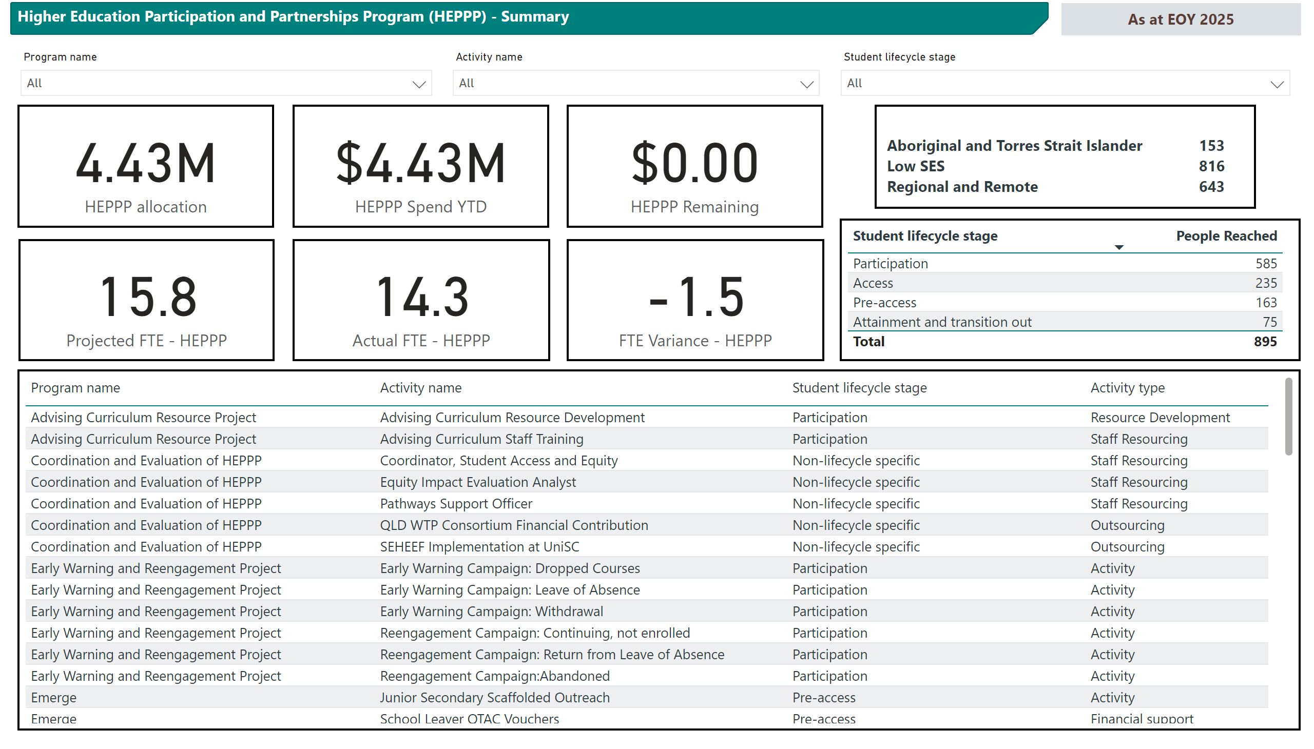
This report uses synthetic data for design and testing purposes only
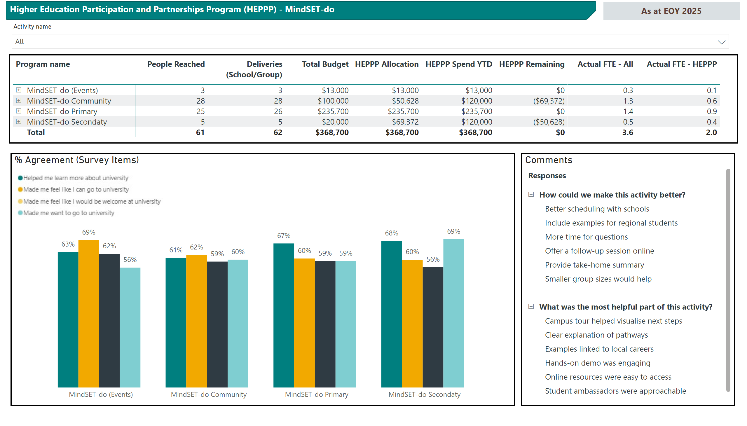
This report uses synthetic data for design and testing purposes only
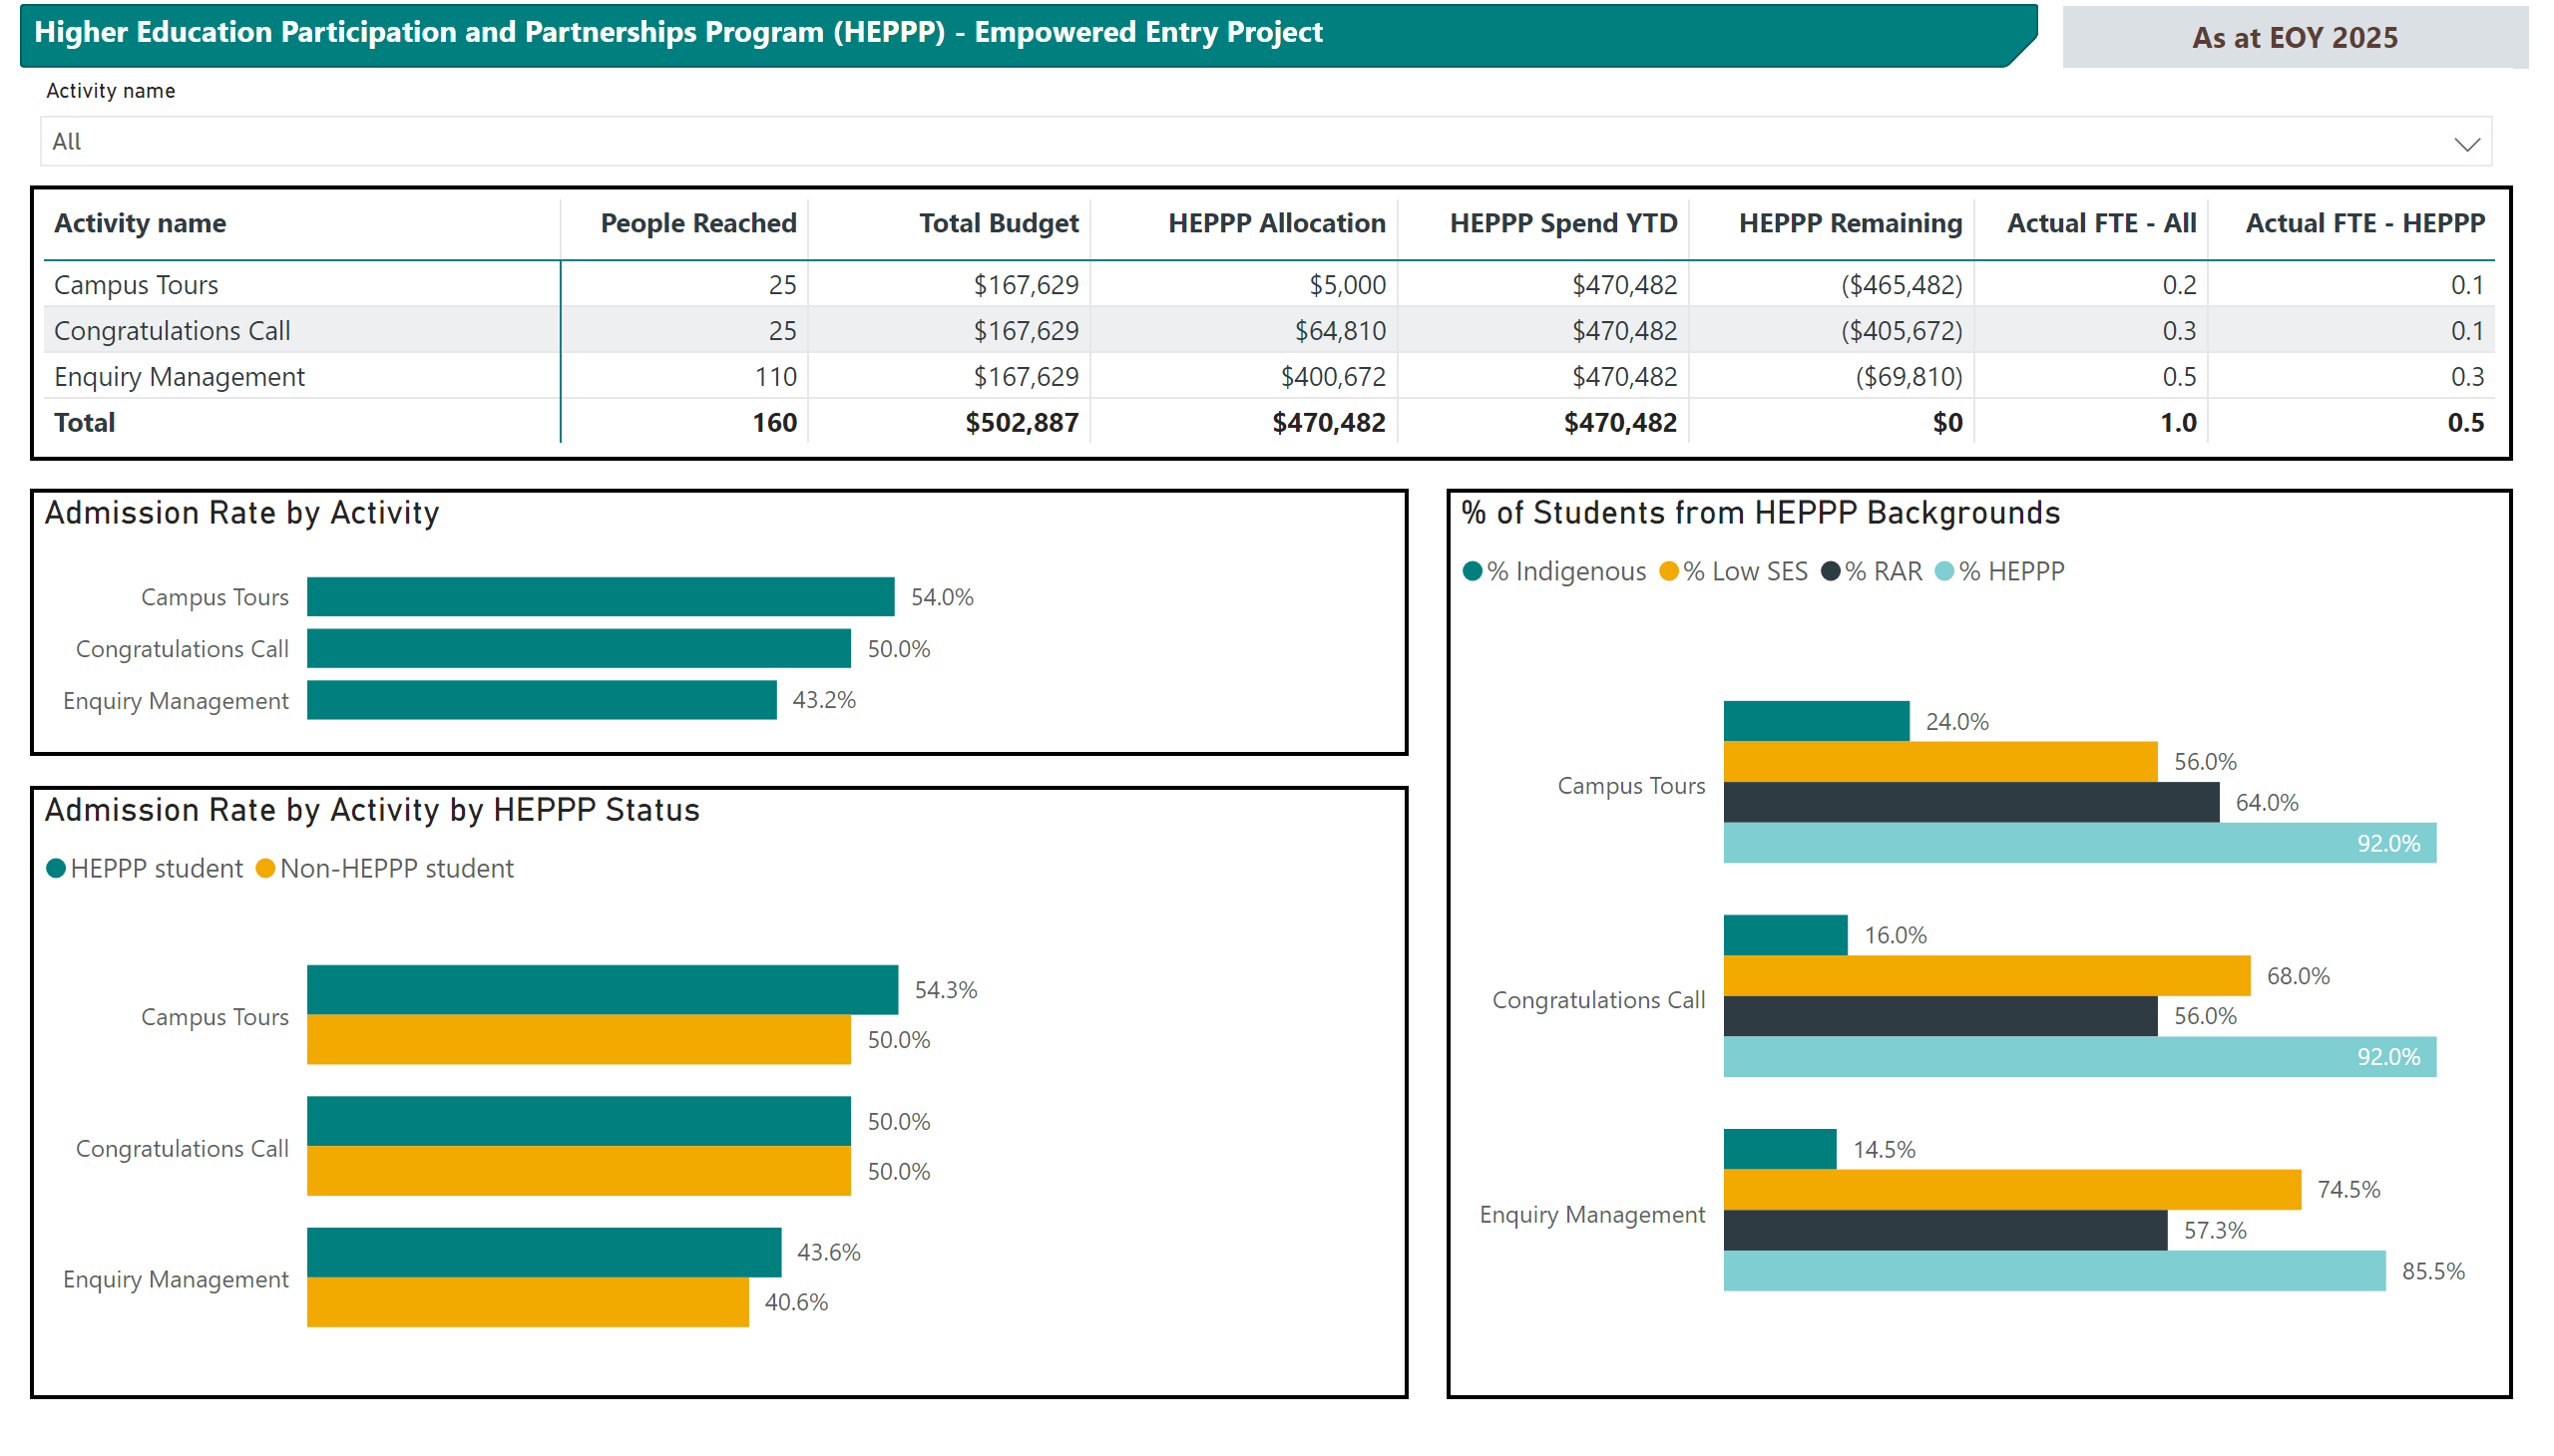
This report uses synthetic data for design and testing purposes only

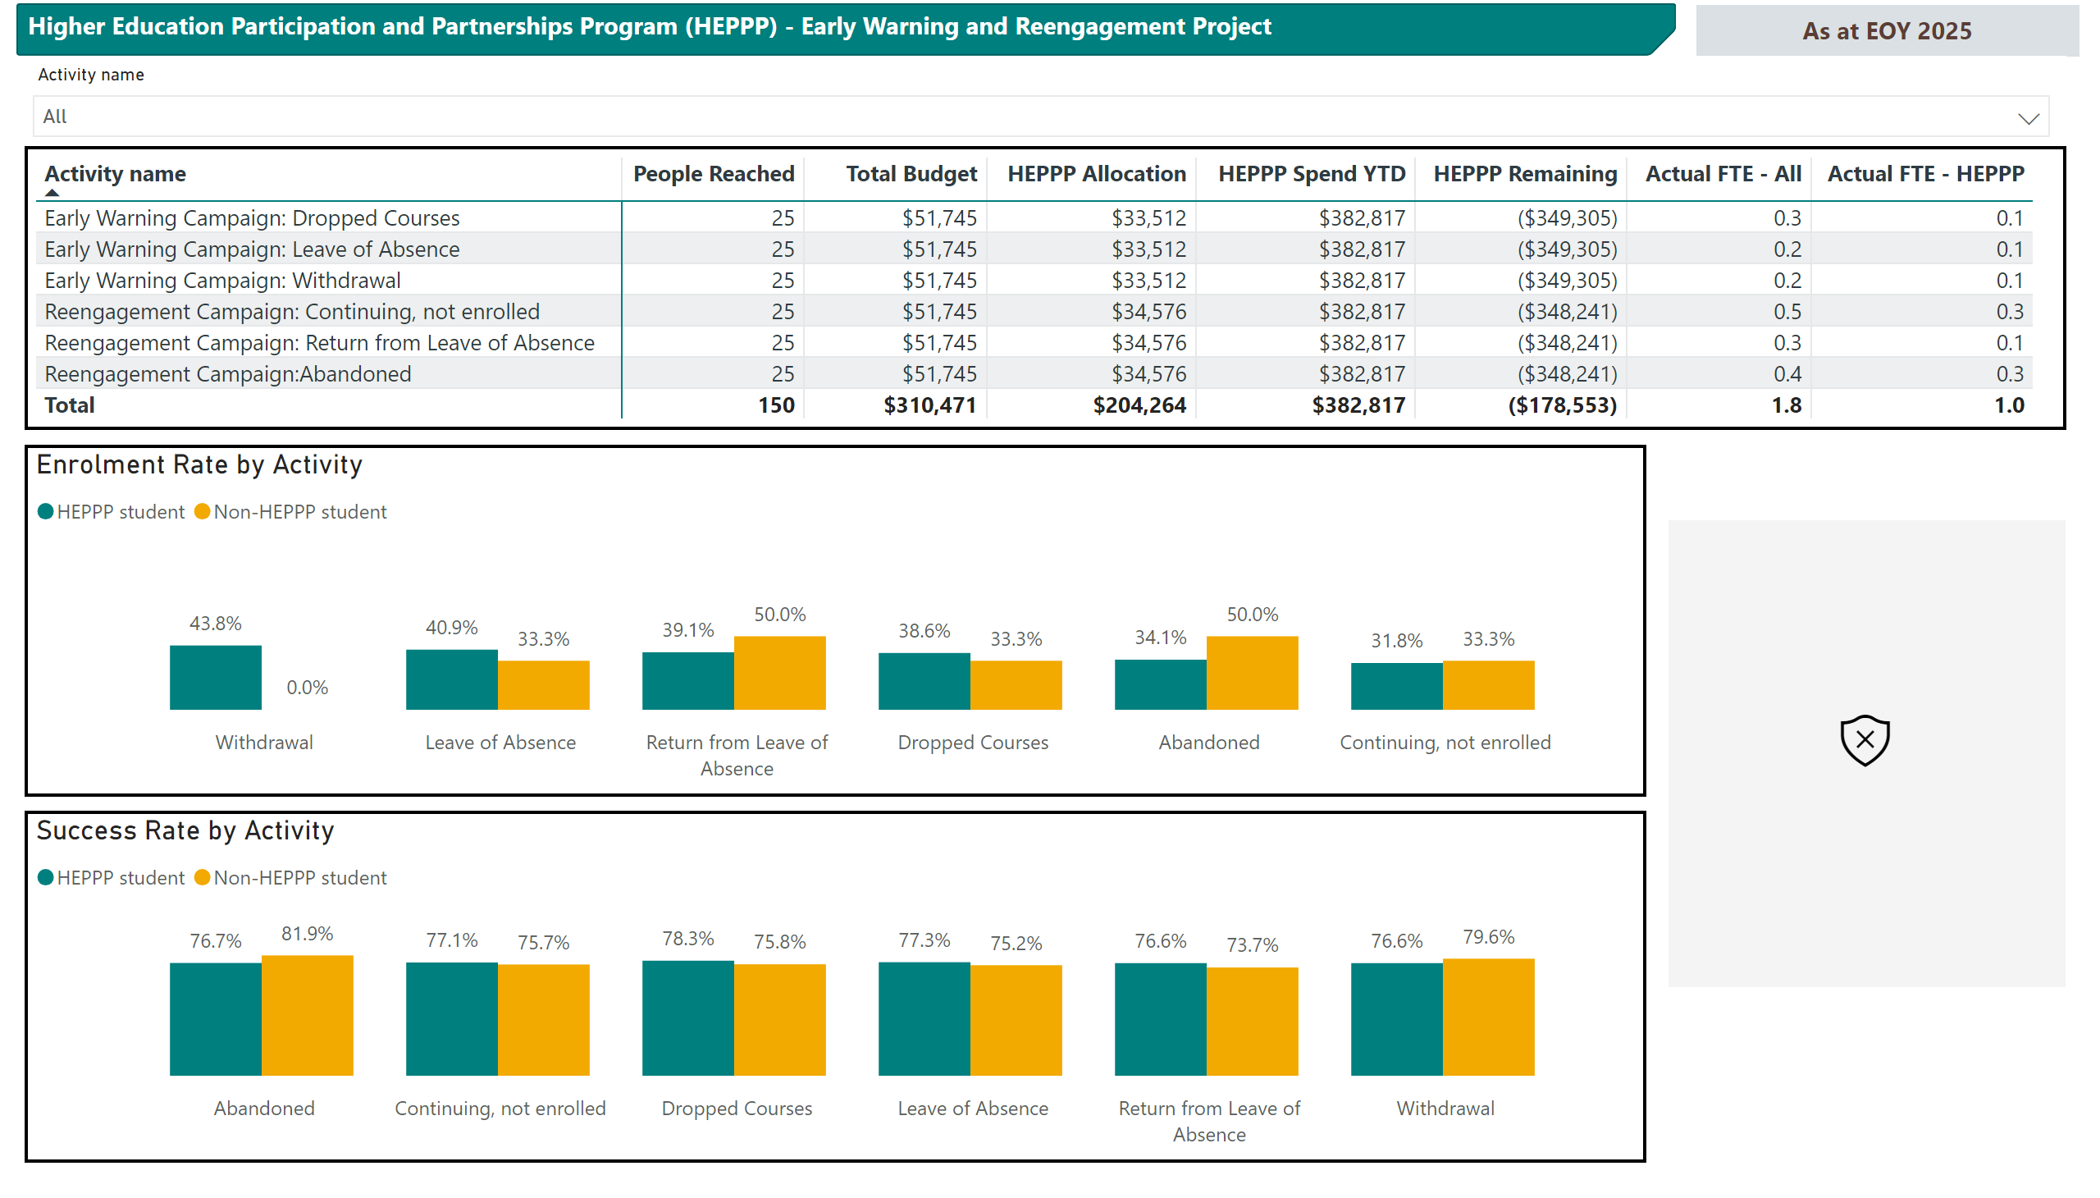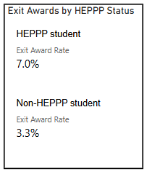
This report uses synthetic data for design and testing purposes only
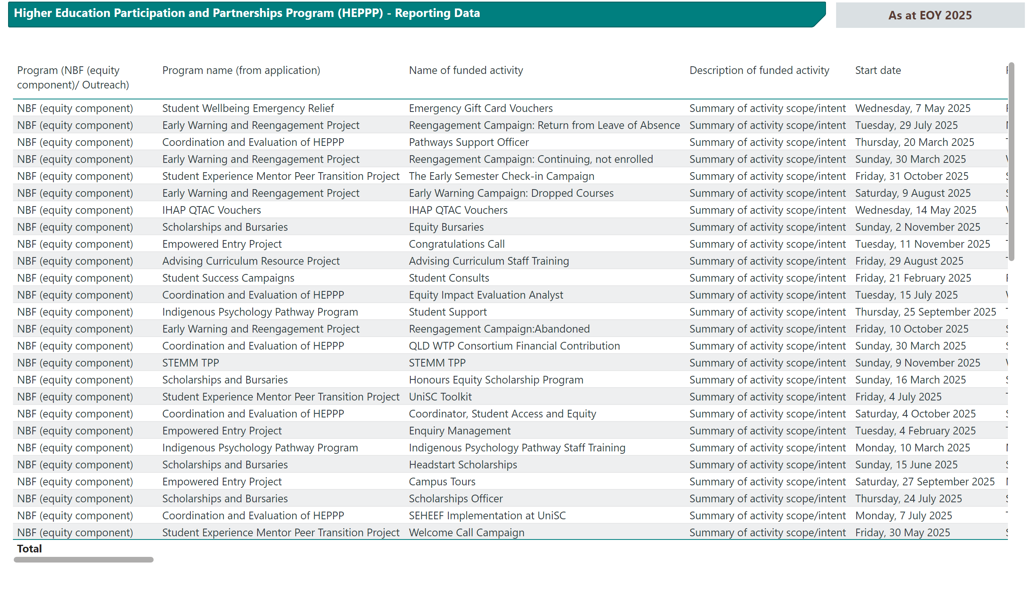
This report uses synthetic data for design and testing purposes only

Appendix 2: Data needs workshop survey
Background
UniSC has received funding from the Australian Centre for Student Equity and Success’s Capacity Building Grants program to enhance its impact evaluation capabilities. We intend to standardise HEPPP project data reporting and create a dashboard identifying relationships between HEPPP project participation and student outcomes. To achieve this, we need to map the current maturity of HEPPP project data practices to our desired state and identify other requirements for the dashboard.
For any items that are not relevant to your project, please respond with ‘n/a’.
Project Details
Name of HEPPP project:
Name of Project Lead:

Outcomes and Indicators
What are the project’s primary outcomes and supporting outcomes?
What indicators measure progress (quantitative, qualitative or both)?
How is this information currently reported or shared?

Data Quality
Which project outcomes can be directly measured, and which rely on proxies?
If proxies are used: What is the rationale for these?
What would improve confidence in these measures?

Data Sources and Formats
What data sources are used (surveys, attendance data, GPA etc)?
What formats are used (Excel, Qualtrics, CRM, SharePoint, dashboards)?

Linking and Engagement Tracking
Can you identify participants by student ID?
If student ID isn’t available, which proxies/linkable data do you use (name, email, DOB, school)?
Can engagements be assigned to a period (study period, semester, school term)?

Participant Selection and Equity Cohorts
What data do you use to identify participants’ equity status (First Nations, low SES, RR)?
If direct data is not available, which proxies do you use?
What data source identifies equity status (e.g., self-report, school records, MySchool, UniSC data)?

Reporting Level and Iterations
At what level do you want to report on your project (program vs activities)?
How do you track versions or changes over time (e.g., activity IDs, iterations)?
If applicable, what is the reporting pathway for non-HEPPP data (who, when, how)?

Funding and Resourcing
How do you track HEPPP spend across activities over time?
If applicable, can other funding contributions (operational, in-kind, external) be tracked?
Can you quantify total HEPPP-funded FTE, including casuals with irregular hours?

Challenges and Opportunities
What prevents effective data collection, storage or reporting?
What systems, processes, training, guidance or templates would help?

Non-HEPPP Data
What opportunities are there for a HEPPP dashboard to support your other data collection and reporting requirements (if applicable)?

Next Steps
At project closure we expect to deliver the following outcomes:
- All project teams are supported with implementing changes to reach desired state data collection, storage and reporting requirements.
- Dashboard is completed, including “dummy” data for 2025, and approved users are onboarded onto its use.
- HEPPP project reporting templates are revised to streamline processes and allow inclusion of 2026 data in the dashboard.
Thank you for completing these questions. Your responses will make a valuable contribution to shaping the design and development of this work.

Appendix 3: Form input summary
Application Form Fields
Question no. | Field | Description | Format | Source
1 | Program name | Title of the program | Text | Manual
2 | Lead contact name | Name | Text | Manual
3 | Lead contact email | Email address | Text | Manual
4 | Total program budget | Total funds allocated from all sources | Currency | Manual
5 | Activity name | Title of the activity | Text | Manual
6 | Activity description | Summary of activity scope/intent | Text (character limit) | Manual
7 | Activity rationale | Justification of activity | Text (character limit) | Manual
8 | Student lifecycle stage | Applicable stage for the activity | Dropdown  -Pre-access - Individual  -Pre-access - School or Group  -Access - Individual  -Access - School or Group  -Participation  -Attainment and transition out  -Non-lifecycle specific | Manual
9 | Activity type | Type of activity | Dropdown  -Information and experiences  -Skills  -Resources  -Institutional development | Manual
10 | Primary target | Intended HEPPP cohort to be supported | Dropdown  -Aboriginal and Torres Strait Islander  -Low socio-economic status  -Regional and remote status | Manual
11 | Year activity commenced | Year activity commenced | Text | Manual
12 | HEPPP funding requested | Total HEPPP funding requested for activity | Currency | Manual
13 | Projected FTE staffing | Projected total FTE for activity | Numerical | Manual
14 | Projected HEPPP FTE staffing | Projected HEPPP funded FTE for activity | Numerical | Manual
15 | Intended outcomes | Summary of outcomes in PLM | Text | Manual

Post-engagement (PE) Form Fields (new form for each activity/date)
Pre-access - School or Group and Access - School or Group Activities Only
Question no. | Field | Description | Format | Source
1 | Program name | Title of the program | Dropdown | Application form
2 | Activity name | Title of the activity | Dropdown | Application form
4 | Date | Date of activity | Date | Manual
5 | School | School involved in activity (Q3) | Text | Manual
6 | Attendees per year level | Number of attendees per year level | Numeric (Matrix) | Manual
7 | Unique individuals | Unique individuals attending activity | Numeric | Manual
8 | Number of resources | Number of resources developed | Numeric | Manual
9 | Number of courses | Number of courses revised/updated | Numeric | Manual

End of Year (EOY) Form Fields (new form for each activity/date)
Question no. | Field | Description | Format | Source
1 | Program name | Title of the program | Dropdown | Application data
2 | Activity name | Title of the activity | Dropdown | Application data
3 | All annual hours | All activity hours used to date - actual | Numeric | Manual
4 | HEPPP annual hours | HEPPP funded hours used to date - actual | Numeric | Manual
5 | Were intended outcomes met? | Outcomes as stated in AF | Dropdown  Yes  No | Manual
6 | Please expand on your answer | Explanation for Q6 | Text | Manual
7 | Key learnings (max 100 words) | Lessons learned/changes to be made | Text | Manual

Dashboard Reporting Variables (Common Fields)
Item no. | Item | Description | Format | Source
1 | Program name | Title of the program | Text | Application Form
2 | Lead Contact name | Name | Text | Application Form
3 | Lead Contact email | Email address | Text | Application Form
4 | Activity name | Title of the activity | Text | Application Form
5 | Activity description | Summary of activity scope/intent | Text | Application Form
6 | Student Lifecycle Stage | Applicable stage for the activity | Dropdown | Application Form
7 | Activity type | Type of activity | Dropdown | Application Form
8 | Primary Target | HEPPP cohort supported | Dropdown | Application Form
9 | Year activity commenced | Year activity commenced | Text | Application Form
10 | Total budget | Total funds allocated from all sources | Currency | Application Form
11 | HEPPP allocation | Approved funding under HEPPP allocation | Currency | Application Form
12 | % of HEPPP spending | Proportion of HEPPP spent on activity | Percentage | Finance dataset
13 | Actual FTE - All | Actual FTE for activity to date | Numerical | Derived from EOY Q3
14 | Actual FTE - HEPPP Funded | Actual FTE funded using HEPP to date | Numerical | Derived Item EOY Q4
15 | Projected FTE staffing | Projected total FTE for activity | Numerical | Derived Q13 Application Form
16 | Projected HEPPP FTE staffing | Projected HEPPP funded FTE for activity | Numerical | Derived Q14 Application Form
17 | HEPPP funds spent to date | Amount of HEPPP funds spent to date | Currency | Finance dataset
18 | % HEPPP funds spent to date | Percentage of HEPP funds spent to date | Currency | Derived Items 12 and 17

Dashboard Reporting Variables (Activity Specific Fields)
Item no. | Field | Definition | Primary Source | Secondary Source (if relevant)
Individuals can be identified: Pre-access - Individual; Access - Individual; Participation; Attainment and transition out
19 | ID | Student ID ELSE Contact ID | CRM | EDW (email lookup)
20 | Study Period | Study Period activity allocated to ELSE date of activity assigned to first and second half of year | CRM
21 | Year | Year activity allocated to ELSE date of activity assigned to relevant year | CRM
22 | IDSPYR | Concatenation of Student ID, Activity Study Period and Year Study Period | Derived
23 | Postcode | First non-null postcode | EDW | CRM
24 | Number of low SES students | Number of students who accessed the project/service who are classified as low SES based on SA1 value ELSE postcode | EDW | CRM
25 | Number of RAR students | Number of students who engaged with the project/service who are classified as rural and/or remote based on based SA1 value ELSE postcode | EDW | CRM
26 | Number of Indigenous students | Number of students who engaged with the project/service who self-identify as Aboriginal or Torres Strait Islander | EDW | CRM
27 | Admissions | % of students engaged who received and accepted an offer from UniSC | EDW
28 | Re-enrolment | The proportion of students enrolled in a given study period who enrol in a subsequent study period, excluding those who have completed their program of study. | EDW
29 | Success rate | Sum of EFTSL passed (HD, DN, CR, PS, PU) divided by sum of EFTSL attempted (HD, DN, CR, PS, PU, TP, FL, FA, MF, UF, WF, WN). | EDW
30 | Completion | Number of students who have met all of their academic program requirements within the associated program and are eligible to graduate. | EDW
31 | Exit award | Number of students who applied to leave their bachelor's degree early and received a diploma to recognise academic progress to date. | EDW
32 | Number of deliveries | Count of activity | CRM
33 | Number of engagements | Count of distinct incident ID | CRM
34 | Number of unique individuals | Count of distinct ID | CRM
Individuals cannot be identified: Pre-access - School or Group; Access - School or Group
35 | Number of deliveries | Calculated based on count of activity | PE Form
36 | Number of engagements | Calculated based on distinct count of concatenation (Activity, Date, School) | PE Form
37 | Number of unique individuals | Highest number of attendees by concatenated (Activity, School, Year Level) | PE Form
38 | Number of low SES students | Equal to Number of unique individuals (Item 41) | Derived from ID 37
39 | Number of RAR students | Equal to Number of unique individuals (Item 41) where school postcode equals RAR using ASGS Remoteness Areas (RA) | Derived from ID 38
Resources: Non-lifestyle specific
40 | Number of resources developed | Number of resources developed | PE Form
41 | Number of courses revised/updated | Number of courses revised/updated | PE Form

Appendix 4: HEPPP theory of change statement
HEPPP Purpose and Legislative Context
The Higher Education Participation and Partnerships Program (HEPPP) promotes equality of opportunity in higher education for students from low socioeconomic backgrounds, regional and remote areas and Indigenous communities. It is one of four programs within the Indigenous, Regional and Low Socio-Economic Status Attainment Fund (IRLSAF), outlined in the Other Grants Guidelines (Education) 2022. HEPPP funding allocations are based on each university’s proportion of low-SES, RR and Indigenous domestic undergraduate students.
Policy Foundations
The 2008 Bradley Review identified persistent under-representation of these groups in higher education and barriers including limited prior educational opportunity, low awareness of university benefits and insufficient financial, academic and mentoring supports, informing the design of HEPPP. The 2017 ACIL Allen Review of HEPPP found inconsistent program logic and evidence of impact, and recommended stronger evaluation frameworks, improved targeting and higher-impact, evidence-based interventions. In response, the Student Equity in Higher Education Evaluation Framework (SEHEEF; 2022) established standards for program logic, student lifecycle-aligned evaluation and data reporting. This Theory of Change aligns with this policy context and will be updated over time.
Strategic Aims at UniSC
UniSC’s HEPPP work aims to widen aspiration, improve access, strengthen participation and support completion for equity students across the student lifecycle. This aligns with the UniSC Strategic Plan 2025–2028, particularly its commitments to a transformative student experience, increased equity of participation and stronger regional engagement.
Theory of Change Across the Student Lifecycle
- Pre-Access: Outreach and Aspiration Building
If UniSC designs and delivers targeted outreach activities (such as campus visits, community engagement, role-model programs, curriculum-linked workshops and parent/carer information sessions) and partners with schools and community organisations, then prospective students gain accurate knowledge about university, build confidence in their academic potential and see higher education as a viable and desirable option.
This leads to increased aspiration and a stronger sense that it is possible to access university, consistent with HEPPP’s goal to widen and enable higher-education aspiration among under-represented cohorts.
- Access: Pathways, Admissions and Transition into University
If UniSC provides targeted access supports (such as enabling programs, admission advising, alternative entry pathways, guidance on application processes, culturally safe transition support and assistance with enrolment) then equity students are better able to navigate structural barriers that often limit access to university.
This results in greater application to commencement conversion by equity students, aligning with the objective to improve access to higher education for under-represented students.
- Participation: Retention, Engagement and Academic Progress
If UniSC provides targeted participation and success supports (such as academic skills development, tutoring, mentoring, transition programs, financial bursaries, culturally safe support, peer connection and early-intervention responses to disengagement) then equity students are more able to overcome financial, academic and social barriers that can disrupt study.
This leads to improved maintenance of current study load, higher success rates and higher rates of enrolment into the next teaching period. Students are better supported to stay engaged and continue progressing in their course.
- Success, Completion and Graduate Outcomes
If UniSC supports successful course completion and pathways into employment or postgraduate study (through career development learning, internships, work-integrated learning, mentoring and graduate supports), then equity students are better prepared to transition into meaningful employment and lifelong learning.
This produces higher completion rates, more equitable graduate outcomes and strengthened social and economic mobility, aligning with HEPPP’s objective to support students to “participate, remain and succeed in higher education and obtain higher-education awards”.
- Institutional Capacity: Culture, Systems and Partnerships
If UniSC strengthens internal capability, (including staff development, culturally safe practice, coordinated student-support systems, data monitoring and partnerships with schools and communities), then the University becomes systematically more effective in delivering a transformative student experience for equity students across the entire student lifecycle.
Strengthening UniSC’s internal capability advances the University towards a more mature, institution-wide approach to student engagement, success and retention. High-quality equity practice relies on coordinated processes, shared standards and improvement. Greater institutional maturity also strengthens the University’s capacity to plan, implement and evaluate equity initiatives systematically, supporting its vision of student success by design.
Theoretical Foundations
Four complementary theories explain how HEPPP initiatives support aspiration, access and success:
- Self-Determination Theory: Supports that build autonomy, competence and relatedness strengthen aspiration and persistence, .
- Social Cognitive Theory: Role models, mastery experiences and scaffolded support build self-efficacy, a strong predictor of retention and completion, , .
- Theory of Planned Behaviour: Outreach and transition programs influence attitudes, norms and perceived behavioural control, increasing intention to enrol and persist, .
- Zone of Proximal Development: Scaffolded learning (tutoring, mentoring, clear expectations) enables students to achieve tasks they could not complete independently, , , .
Further, the Student Engagement Framework argues that engagement occurs within an educational interface shaped by the sociocultural context. HEPPP initiatives reduce sociocultural incongruity, strengthen belonging and wellbeing and create supportive, culturally responsive environment.

Appendix 5: Supporting outcome measure bank
Construct | Activity Category | Student Life Stage | Outcome Measure | Answer Format
Sense of Belonging | Information and experiences | Pre-access | “This activity made me feel like I would be welcome at university” | Likert (SD-SA)
 | Skills | Pre-access | “This activity made me feel like I would be welcome at university” | Likert (SD-SA)
 | Resources | Pre-access | “This service made me feel like I would be welcome at university” | Likert (SD-SA)
 | Resources | Participation | “This service made me feel welcome in the UniSC community” | Likert (SD-SA)
Awareness | Information and experiences | Pre-access | “This activity helped me learn more about university” | Likert (SD-SA)
 | Skills | Pre-access | “This activity helped me learn more about university” | Likert (SD-SA)
Motivation | Information and experiences | Pre-access | “This activity made me want to go to university” | Likert (SD-SA)
 | Skills | Pre-access | “This activity made me want to go to university” | Likert (SD-SA)
Outcome Expectancy | Information and experiences | Pre-access | “This activity made me feel like I can go to university” | Likert (SD-SA)
 | Skills | Pre-access | “This activity made me feel like I can go to university” | Likert (SD-SA)
 | Resources | Pre-access | “This service will help me to go to university” | Likert (SD-SA)
 | Resources | Participation | “This service will help me to remain in university” | Likert (SD-SA)
Areas of Improvement | Information and experiences | All | “What was the most helpful part of this activity?” | Open text
 | Information and experiences | All | “How could we make this activity better?” | Open text
 | Skills | All | “What was the most helpful part of this activity?” | Open text
 | Skills | All | “How could we make this activity better?” | Open text
 | Resources | All | “What was the most helpful part of this service?” | Open text
 | Resources | All | “How could we make this service better?” | Open text

Higher Education Support (Other Grants) Guidelines, 2022 (Cth). https://www.education.gov.au/heppp
Department of Education, Employment and Workplace Relations. (2008). Review of Australian Higher Education: Final Report. https://www.voced.edu.au/content/ngv%3A32134
ACIL Allen Consulting. (2017). Evaluation of the Higher Education Participation and Partnership Program. https://www.education.gov.au/download/3669/heppp-evaluation-final-report-2017/18465/document/pdf
Department of Education, Skills and Employment. (2022). Student Equity in Higher Education Evaluation Framework (SEHEEF): Final Report. https://www.education.gov.au/heppp/resources/student-equity-higher-education-evaluation-framework-seheef-final-report
Clarke, J., Stoodley, I., & Nelson, K. (2013). Using a maturity model to move student engagement practices beyond the generational approach. In Proceedings of the 16th International First Year in Higher Education (FYHE) Conference. https://eprints.qut.edu.au/60019/
Muller, F. H., Thomas, A. E., Carmignola, M., Dittrich, A-K., Eckes, A., Großmann, N., Martinek, D., Wilde, M., & Bieg, S. (2021). University students’ basic psychological needs, motivation, and vitality before and during COVID-19: A Self-Determination Theory approach. Frontiers in Psychology, 12. https://doi.org/10.3389/fpsyg.2021.775804
Howard, J. L., Bureau, J. S., Guay, F., Chong, J. X. Y, & Ryan, R. M. (2021). Student motivation and associated outcomes: A meta-analysis from Self-Determination Theory. Association for Psychological Science, 16(6), 1300-1323. https://doi.org/10.1177/1745691620966789
Meng, Q., & Zhang, Q. (2023). The influence of academic self-efficacy on university students’ academic performance: The mediating effect of academic engagement. Sustainability, 15(7). https://doi.org/10.3390/su15075767
Larsen, A., & James, T. (2022). A sense of belonging in Australian higher education: the significance of self-efficacy and the student-educator relationship. Journal of University Teaching & Learning Practice, 19(4). https://open-publishing.org/journals/index.php/jutlp/article/view/587
Raciti, M., & Dale, J. (2019). The social marketing messenger is as important as the message: Learnings from a case study of widening participation in Australian higher education. In Australian Association of Social Marketing Viewpoint (Vol. 8, No. 2, pp. 1-7) Australian Association of Social Marketing.
Gegenfurtner, A., & Testers, L. (2022). Transfer of training among non-traditional students in higher education: Testing the theory of planned behaviour. Frontiers in Education, 7. https://doi.org/10.3389/feduc.2022.928996
Mergelsberg, E. L. P., Haywood, D., Mullan, B. V., Pereira, R., Smith, A., Zaccagnini, M., & Allen, P. J. (2021). Extending the Theory of Planned Behaviour to predict and increase PASS attendance and students’ performance: can academic motivation improve efficacy? Springer Nature Social Sciences, 1(29). https://doi.org/10.1007/s43545-020-00041-1
Nuis, W., Segers, M., Beausaert, S. (2023). Conceptualizing mentoring in higher education: A systematic literature review. Educational Research Review, 41. https://doi.org/10.1016/j.edurev.2023.100565
Hutson, J., Nasser, R., Marzano, M., Curtis, R., MacDonald, E., Edele, S., Hosto-Marti, B. (2022). Bridge building in higher education: Multi-modal mentoring programs to support retention and career preparedness. Creative Education, 13, 2811-2833. https://doi.org/10.4236/ce.2022.139178
Picton, C., Baker-Andresen, D., & Crimmins, G. (2025). Embedding student success: A coordinated curriculum approach. In STARS Conference Proceedings. Queensland University of Technology.
Picton, C., Jacquet, A., Simons, L., Byrne, L., Oostergo, N., Hendeson, A., & Wood, D. (2023). A third space approach to integrated academic student success advising (ASSA). Student Success, 15(1), 35-47. https://doi.org/10.5204/ssj.2855
Kahu, E. & Nelson, K. (2018). Student engagement at the educational interface: understanding the mechanisms of student success. Higher Education Research and Development, 37(1), 58-71. https://doi.org/10.1080/07294360.2017.1344197

