
ACSES CAPACITY BUILDING GRANTS PROGRAM
  - A collaboration for impact evaluation of student equity programs across the Go8

Gwilym Croucher, Kate Flynn, Mat Hardy,
Nadine Zacharias

2026

A collaboration for impact evaluation of student equity programs across the G08

January 2026

Gwilym Croucher, University of Melbourne
Kate Flynn, University of Melbourne
Mat Hardy, University of Melbourne
Nadine Zacharias, Equity by Design

Suggested citation: Croucher, G., Flynn, K., Hardy, M., Zacharias, N. (2026) A collaboration for impact evaluation of student equity programs across the G08 (Small Grants Research Program final report). Australian Centre for Student Equity and Success, Curtin University.

Australian Centre for Student Equity and Success
Tel: +61 8 9266 1573
Email: acses@curtin.edu.au
Web: www.acses.edu.au
Building 100
Curtin University
Kent St, Bentley WA 6102 | GPO Box U1987, Perth WA 6845

DISCLAIMER
Information in this publication is correct at the time of release but may be subject to change. This material does not purport to constitute legal or professional advice.
Curtin accepts no responsibility for and makes no representations, whether express or implied, as to the accuracy or reliability in any respect of any material in this publication. Except to the extent mandated otherwise by legislation, Curtin University does not accept responsibility for the consequences of any reliance which may be placed on this material by any person. Curtin will not be liable to you or to any other person for any loss or damage (including direct, consequential or economic loss or damage) however caused and whether by negligence or otherwise which may result directly or indirectly from the use of this publication.

COPYRIGHT
© Curtin University 2026
Except as permitted by the Copyright Act 1968, and unless otherwise stated, this material may not be reproduced, stored or transmitted without the permission of the copyright owner. All enquiries must be directed to Curtin University.
CRICOS Provider Code 00301J
ISBN 978-1-7644511-7-8

Acknowledgement of Country
The Australian Centre for Student Equity and Success acknowledges Indigenous peoples across Australia as the Traditional Owners of the lands on which the nation’s campuses are situated. With a history spanning more than 60,000 years as the original educators, Indigenous peoples hold a unique place in our nation. We recognise the importance of their knowledge and culture, and reflect the principles of participation, equity, and cultural respect in our work. We pay our respects to Elders past, present, and future, and consider it an honour to learn from our Indigenous colleagues, partners, and friends.

Approach

Summary
This project was aimed at building capacity for impact evaluation of student equity programs across the Group of Eight (Go8) institutions through sharing knowledge and best practices among senior practitioners and in-house evaluators at each of the universities in the group.
The initiative enhanced evaluation capability and practices of equity programs by developing a strong partnership for knowledge sharing about current evaluation approaches, findings from existing evaluation processes, and learnings from undertaking evaluations. The programs that this initiative focused on were:
- academic preparation programs (both pre- and post-enrolment)
- first-year transition programs for targeted student cohorts.
The program was developed around a series of capacity-building workshops. These provided a chance to share the design of the focus initiative via a Program Logic Model (PLM) and discuss insights from existing continuous quality improvement (CQI) data collection and evaluations.
The final workshop provided an opportunity to produce an action plan to undertake an impact evaluation of the chosen equity initiative—namely packed scholarships—that will be going forward into 2026, alongside a public report of lessons learned from the discussions of impact evaluation for equity programs.
The four workshops were facilitated by Nadine Zacharias (Equity by Design), in conjunction with the Centre for the Study of Higher Education (CSHE, Gwilym Croucher and Mat Hardy), the University of Melbourne (Kate Flynn). Jesse Parmar from the Australian Centre for Student Equity and Success (ACSES) and Chris Carter from University of Technology Sydney (UTS) delivered a session on impact evaluation as part of the final workshop. The Go8 kindly hosted and supported the initiative.

Rationale
This initiative was designed to build evaluative capacity through its collaborative design, peer-engagement, and expert support. While it was necessary for the project to support an element of explicit teaching about evaluation—including for impact evaluation—one of the key benefits of the project was the collaborative design and learning-by-doing from experts and peers, which served to develop a network of practitioners undertaking joint evaluation in 2026.
The workshop series was explicitly crafted to allow participants to share—over the course of several months and in a systematic, structured format—how they are designing equity programs and services, as well as to explore whether some designs work better than others in terms of student outcomes.
Because participants were sharing reasonably sensitive and complex information, it was ideal to work at the Go8 group level, where a Chatham House rule environment could be promoted. As there are existing arrangements and familiarity between the Go8 member universities and equity practitioners, this enabled a highly productive collaboration.
The workshop series discussions were grounded in the Student Equity in Higher Education Evaluation Framework (SEHEEF, see Figure 1) and used the SEHEEF Guidance Manual to develop PLMs, identify measurement indicators, and make assessments about which programs or activities lent themselves to a cross-institutional comparison and impact evaluation.
Figure 1: SEHEEF
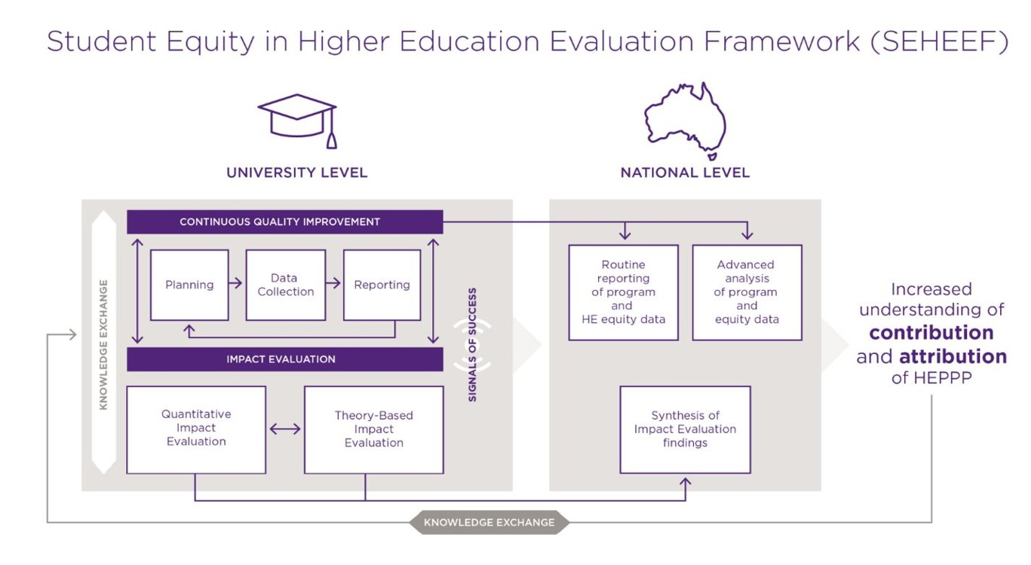
The SEHEEF was used because it is an effective tool to guide evaluation at the program level and to shift attention from a focus on resources and activities to the outcomes. It was a means to give the Go8 practitioners a common language to think and talk about their programs in an evidence-informed way​, with the goal that it can enable evidence-informed decision-making about programs, including on future funding allocations​. Importantly, the project supported a broad conversation about what works, what current capability exists, and where there are blind spots in both supporting outcomes and primary outcomes in the way that the SEHEEF is applied. ​While acknowledging that existing evaluation capability across the sector is relatively low, we found pockets of advanced practice within the Go8 member institutions. Projects such as this are a chance to significantly build on existing capability, both through joint evaluation exercises and common approaches, as well as through iterative information sharing.

Workshops and facilitators
The workshops were co-designed and facilitated by Dr Nadine Zacharias from Equity by Design and supported by the Centre for the Study of Higher Education (CSHE) and drew on the team’s deep expertise in student equity and evaluation in higher education. In designing the workshops, Nadine and the team drew on her work with the University of Western Australia (UWA) during 2024 and 2025 on equity program evaluation, including a current ACSES-funded trial of a packaged scholarship program.
In supporting the program design, the CSHE leaned on their track record in successfully delivering research and evaluation projects covering a variety of elements of higher education, including student equity and well-being.
The final workshop included a skill-building session and practitioner panel on impact evaluation facilitated by Jesse Parmar from ACSES. Elisa McGowan (UWA), Xena Irvin (UQ), and Chris Carter (UTS) were the panellists for the session and shared their experiences and challenges with impact evaluations.
Together, the team was able to contribute relevant insights from existing research on the chosen equity initiatives, especially impact evaluations undertaken in Australia and elsewhere, and provide or source other technical content knowledge required for the group to make informed decisions about evaluation design.

Timeline
The project followed the timeline:
April-May | June | September | October | November
Preparation | Kick-off workshop 1 | Workshops 2 & 3 | Synthesis workshop 4 | Wrap up
Project established, finalised workshop series design and travel arrangements | Ran full-day, in person in Canberra to compare evaluation approaches, findings, and learnings from existing evaluations. The common student equity initiatives were selected for workshops 2 and 3. | Virtual workshops (120 minutes each) where PLMs were shared and insights from existing evaluations were discussed with the participants. | A full day in person workshop was held in Melbourne to undertake comparison of case studies and evaluation design and findings. The learnings from existing practice were discussed and a draft action plan was developed for 2026. | Report writing, finalisation of action plan, project close-out.

Outputs

Initial findings from the case studies
While the workshop series largely drew on existing information and data, it enabled the group to collate relevant insights from two sets of case studies of comparable programs running at different universities. There was a sense that all were on a journey, and that program logics were not currently fully utilised to guide CQI evaluation or program design. While this was in part because the institutional context is different for each, and there are genuine differences in needs, there was a clear benefit seen in using a more systematic approach to design and evaluation, especially for upskilling the equity teams and in generating new and better data for different dimensions.
These insights are summarised below.

Academic preparation and skill building in outreach (Monash, Adelaide, UWA, UNSW)
- Low application and access rates of equity students in Go8 universities appear to be driven by limited resources, role models, and insider knowledge about university for potential students, as well as low expectations from school/community and low confidence in success at university.
- Academic performance can be impacted by complex life circumstances, especially in the senior years of high school.
- Challenges are more acute for first-in-family (FiF) students.
- The availability of role models and essential knowledge about university, as well as proactive support in the senior years of schooling, are critical to students’ ability to make informed decisions about their post-school options and submit a university application.
- Pathways programs are an important access route to selective institutions.
- Programs varied in terms of:
  - Core activities: peer mentoring (Monash); skill development workshops and one-on-one application support (Adelaide); skill development sessions and campus familiarisation (UWA); skill development workshops, online engagement, and campus familiarisation (UNSW).
  - Scale: 350-800 students (Monash), 189 participants, (Adelaide), 80 students (UWA), 4,552 students (UNSW).
  - Target cohorts: high school students in years 11 and 12, low socio-economic status (SES) and regional, rural, and remote (RRR) students (Monash); First in Family, low SES (Adelaide); high school students in years 11 and 12, high predicted ATAR students, low SES and regional, rural and remote students (UWA); high school students in years 9 and 12, low SES and regional, rural and remote students (UNSW).

Packaged scholarships / money and support (Sydney, Melbourne, Queensland, ANU)
- Low access and participation rates of equity students in Go8 universities: entry requirements, geography and financial concerns act as barriers to access.
- Financial barriers persist throughout a student’s time at university.
  - Packaged Scholarships Programs are associated with a higher offer-to-enrolment conversion rate (USyd) and reenrolment rates & improved students’ financial confidence and sense of belonging, but causal links are unclear.
- Students from equity groups are shown to experience cultural and social challenges at a selective institution.
- The ability of students to spend more time on study and have explicit opportunities to build a sense of community and belonging within the cohort, as well as tailored support to navigate university services and opportunities—especially for access to welfare support—is understood to be a key success factor.
- Programs varied in terms of:
  - Target cohorts: low SES only for MySydney, disadvantaged circumstances for Narrm, Young Achievers and other equity for UQ, HEPPP target groups for ANU.
  - Program scale (no. of commencing students, 2024/25): 759 (MySydney), 560 (Narrm), 84 (UQ), 147 (ANU).
  - Scholarship amount: $8.5k for duration of course (MySydney), $6.5k (base) for duration of course (Narrm), $7k for up to 4 years (UQ); 5 types of care items (cash & in-kind) (ANU).
  - Engagement with onboarding events: from 44% (MySydney) to 65% (UQ) to 69% (Narrm); 147 students (ANU).

Outcomes

Collaborative evaluation initiative
In the final workshop, the group developed an action plan to undertake an impact evaluation in 2026. This included consideration of funding for such an evaluation from member universities.
The group is codesigning a project that intends to add to the emerging literature on “what works” to support greater equity participation and success in higher education, especially in selective universities that have some of the lowest participation rates in the sector by students from underserved backgrounds.
The project is designed as a two-year collaboration to implement a multi-institution impact evaluation, including a sufficiently skilled researcher to draft the ethics application, design the impact evaluation protocol, and undertake the analysis, as well as a data analyst to coordinate data extraction across the Go8 institutions.

Community of practice
To continue to develop the collaboration and build capacity for equity evaluation as well as undertake joint projects, the group has formed a community of practice. The organisational support for the community will leverage existing administrative arrangements amongst members. The group is looking to secure some funds to support travel for in-person meetings once a year.

Impact

Building practitioner knowledge and capabilities
The workshop series was deliberately designed to build practitioner knowledge and capabilities in equity program evaluation. Participants engaged in the following activities:
- Explored a range of equity initiatives and evaluation practices happening across the Go8.
- Learned about the SEHEEF, CQI, and Impact Evaluation, including the role of PLMs and Theory of Change.
- Participated in a panel discussion on impact evaluation, exploring three designs of impact evaluations at UWA, UQ, and UTS.
- Investigated one student equity initiative each to identify program logic, reach, and outcomes to date.
- Showcased four outreach programs with significant skill-building activities and four money and support programs (including three Packaged Scholarships).
- Shared insights & learnings from student equity program delivery & evaluation efforts to date.
- Discovered new insights and opportunities to strengthen their student equity programs and evaluation strategies.
- Explored opportunities to work collaboratively to strengthen the impact of student equity programs across the Go8 and higher education sector.
Several participants reported that they did not have a PLM of their showcased program prior to the workshop presentation and/or had not had access to the required data to evidence the primary or supporting outcomes of the initiative. They shared that they had gained a much deeper appreciation around the importance of good quality data for program evaluation and had worked with colleagues internally to obtain it.

Individual and collective goals
As part of their case study presentation, participants were asked to reflect on the insights and learnings from existing evaluation activities, and to identify opportunities for ongoing or different evaluation approaches. These yielded interesting insights not only about evaluation but also about program design and the need to advocate for systemic changes at the institutional level.
In workshop 1 of the series, participants were asked about their goals for the capacity building project at the individual, institutional, Group of 8, and sector levels. These were the core objectives that emerged:
- connect and build professional relationships
- share (good) practice, tools, data, insights, learnings, and engage in benchmarking
- demonstrate that the Go8 have a responsibility to engage in student equity and make important contributions
- increase capacity to facilitate real impacts for student equity through evidence of what works, for whom, and why.
- grow evaluation capability by understanding how to conduct evaluations and build capability to evaluate programs
- collaborate with institutions that have a similar context and challenges for collective impact.
At the end of workshop four, participants were invited to reflect on the impact of engaging in the evaluation capacity building program. The group unanimously agreed that the primary objectives of the project had been achieved, especially in relation to skill building and networking, including meeting people from their own institution. Several participants shared that they felt reassured that their institutional program/s and approach to evaluation were on par with what others were doing. Others highlighted the increase in confidence to undertake program evaluations and their interest in working collaboratively across the group next year.

Key achievements
The fact that all eight institutions participated in the capacity building project, remained engaged throughout, and signed up for continued collaboration into 2026, is a key achievement of this initiative. Participants spoke about how much they had enjoyed getting to know colleagues who were working on similar issues elsewhere. They also identified how important it was to not only bring the different institutions together but also to connect equity practitioners with program evaluators in ways that valued both sets of skills and specialist expertise and facilitated sharing across traditional silos.

