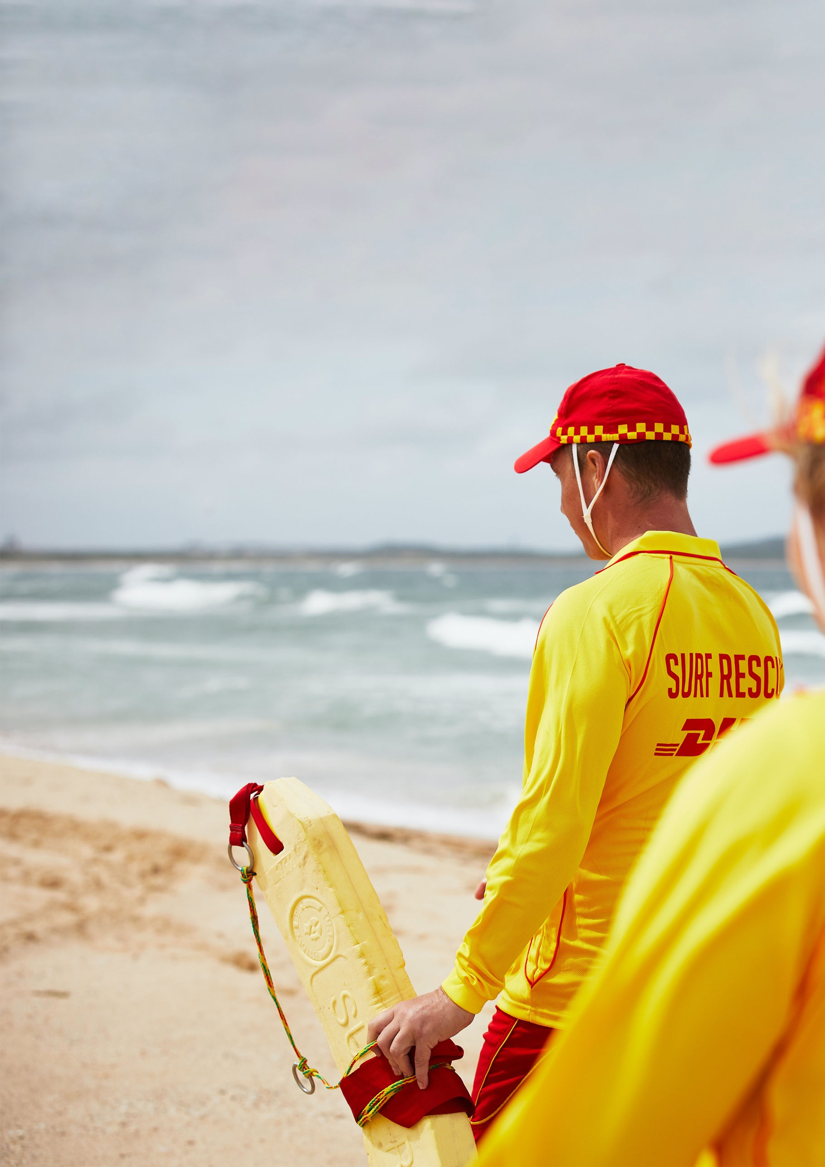

Name: _____________________
Club: ______________________

WA TRAINING OFFICER
ASSESSMENT PORTFOLIO
V3 August 2024

SLSWA Training Officer Course v2.1 August 2023 Page 1 of 33

Assessment Portfolio

This portfolio is required evidence that you need to submit to your facilitator to demonstrate competence in the SLSWA Trainers course.

Learner details
First name | Surname
Date of birth | Club

Competency record
SLSWA Course | Tick for yes, leave blank for no. | Date | Facilitator initials
SLSA award requirements met? (Age, financial) ☐
Assessment tasks
Task 1: Child Safe Awareness Course (or equivalent) ☐
Completed
Tick for yes, leave blank for no.
Task 2: Pre-Course Learning ☐
Task 3: Course Workbook ☐
Task 4: Lesson Plan ☐
Task 5: Practical (10 min delivery) ☐
Date
Facilitator name:
Facilitator signature

Contents
Assessment Portfolio 2
Contents 3
Introduction 4
Child Safe Awareness Course (or equivalent) 4
Pre-Course Workbook 4
Learners and Learning 4
How we learn 5
Online Resources 6
Trainers and Training 7
Course Workbook 8
Learners Needs 8
Key Skills of the Trainer 8
Course Evaluation Form 13

Introduction
Please complete this portfolio then submit it to SLSWA. This course gives you the WA Training Officer Award. You must then complete a Trainers Logbook in the award you wish to train in to qualify as a Trainer for that award.

Child Safe Awareness Course (or equivalent)
Please complete the SLSA - ‘SLS - Child Safe Awareness’ module found on the SLSA eLearning website in the ‘SLS – Safety and Wellbeing’ section, or equivalent such as Play By The Rules Child Protection Module, Medical Staff Child Protection Module etc. Attach proof of completion to this portfolio.

Pre-Course Workbook
Please complete this section before attending a SLSWA Trainers Course. This section is designed to give you some background information about various tools, techniques, and ideas that you can use to help you teach. View, read or discuss the various topics below then answer the questions. During the course the facilitator will clarify any items you are unsure of. Use the Learner Guide to help guide you through these activities.
You will need access to a computer and internet to view some of the material.

Pre-Course Activity 1: Pick a Demo Activity
During the Trainers Course you will be required to teach a skill that is relevant to the award you wish to train in. For example: ‘How to put on a sling’, ‘Dry demo of a tube rescue’, ‘Live patient assessment’, ‘CPR’, ‘Locked in Position’ etc. Choose an activity and make sure you are familiar with the skill and that it can be done in the training room. You will have about 10 mins to present, demonstrate and have the other participants pratice it. Keep it simple.

Skill:

Learners and Learning
What information would be useful to find out about participants either prior to or at the beginning of training?

Pre-Course Activity 2: Information about my participants?

How we learn
The videos listed in the table below explain some theories about learning. Please watch and do the following activities:

Title | Link to video
The importance of critical self-reflection (Tesia Marshik, 2015) | https://www.youtube.com/watch?v=855Now8h5Rs
The learning cycle (Kolb, 1984) | https://www.youtube.com/watch?v=ObQ2DheGOKA
Learning styles (Honey & Mumford, 1982) | https://www.youtube.com/watch?v=-92dIFiN_p8
Stages of Learning: Skill Acquisition (P. Fitts & M. Posner 2015)  ) | https://www.youtube.com/watch?v=WbYNzPORuhg

Pre-Course Activity 3: How can we present information?
List different ways you can give information to your students. In SLS, for most of the skills we teach, what is the best way of presenting them?

Pre-Course Activity 4: Learning Cycle
From the second video, what do you think are your main roles as a trainer are during the learning cycle?

Pre-Course Activity 5: Learning Styles
Having watched the third video, when running a teaching session what can you do to include different peoples learning styles? What sort of Learner is this video best suited for?

Pre-Course Activity 6: Skill Development
From the fourth Video. How much input does the trainer have at each stage? What stage would you expect candidates to reach in a typical SLS courses?

Online Resources
Up to-date guides for all courses can be found on the SLSA member’s area. To find this information go to https://members.sls.com.au and logon to your account. Select ‘Document Library’, then select ‘Education’ for a list of all member education awards. You then need to select ‘Organisation’ level - ‘Surf Life Saving WA’. For most courses there is a Learners Guide, Assessment Portfolio and Syllabus. They may also be video, session plans, PowerPoint presentations available for the course that you are interested in becoming a trainer in.

Pre-Course Activity 7: Please list here all the relevant documents for the award that you are interested in training (see appendix 5 in the Learner Guide for more information):

There are also several policies that you as trainers need to be compliant with. See the Members Area for all SLSA and SLSWA policies and guidelines.

Pre-Course Activity 8: Which SLS guidelines/policies do you think would directly apply to you in the teaching environment?

Trainers and Training

Pre-Course Activity 9: Trainer Qualities
What are the qualities of a great trainer? What would you consider to be essential and what are desirable? How do they affect the learning experience?
Skill | E or D | Affect

Course Workbook
Work through this section during the course

Learners Needs

Activity 1: Why are your Learners here?

Activity 2: Modify your Delivery to the Learners’ Needs
In small groups, refer to Pre-Course Activity 2. Is there any information you might have gained from your candidates which would make you change how you might have to deliver the course? Write down an example of what you would do:

Key Skills of the Trainer

Activity 3: Key Skills
Certain skills are required for all training sessions. In a small group, use the list you compiled in Activity 9 and compile a list of the top 4 essential skills you think a trainer should have that would be generic for all courses. Then score how well you think you perform this skill (1 – poor, 6 excellent). Write down what can you do to improve this skill.

Skill | Score | How to improve

Activity 4 – Risk Assessment
List the types of hazards and possible consequence for your chosen course. What mitigating actions could you take:
Hazard | Consequence | Action

A written risk assessment is required for all wet activities and should be kept for 7 years. Use the App or paper-based version

Activity 5: Key Content
For your lesson what are the key elements you need to cover:

Activity 6: Communication Methods
Write down what different ways you will need to communicate when organising and delivering a course:

Activity 7: Voice Projection
In pairs practice projecting your voice

Activity 8: Engagement and Trust
In small groups, discuss how to build your candidates trust in you? Identify key elements:

Activity 9: Complete a Lesson Plan
See appendix 3 in the Learner Guide for some examples.
Complete the following template or use a separate sheet and attach them to this portfolio.
Lesson Plan. Lesson Title: Duration:
No. in class: Current skill level: Location:

Equipment:

Goals:

Content
Time | Subject
 | Intro
 | Delivery Structure, how will you communicate
 | How Will Candidates Practice
 | How will feedback be measured/delivered
 | Conclusion
Common faults
Other Notes:

Activity 10: Deliver a Session
Give a demonstration of the skill you selected in Activity 1 to a small group of fellow participants.

Activity 11: Give Feedback
Give feedback to other members of the group when they present. Use the table below to record your feedback:
Area | Feedback
Goal Setting
Communication
Content
Structure of Lesson
Demonstration

Thank you for attending the course. Make sure all activates have been completed then had in this document into your course facilitator.
Please fill in a course a course feedback form

Course Evaluation Form
Course date: ____________ Venue: __________________ Your name (optional): ____________________
Trainer(s) and Assessor(s): _______________________________________________________________
Statements | Strongly agree | Agree | Not applicable | Disagree | Strongly disagree
Course Content
The course was explained to me prior to commencing and met my expectations
The course had the right balance between theory and practice
The course was the right duration and intensity
General comments on course content

Course Material
The course materials were clear and easy to follow
The activities were realistic and effective
The course materials will be a useful ongoing reference
General comments on course material

Trainers and Assessors
Knowledge was sufficient to effectively deliver the course
Kept the course interesting and interactive
Provided clear and complete answers to questions
General comments on trainers and assessors
Overall Outcomes
My knowledge and skills increased as a result of this course
This course has helped me meet or clarify my goals
Course assessment activities were fair and realistic
General comments about the overall outcomes of the course

Your evaluation of this program is very important. It enables us to improve our training programs and the quality of our service

