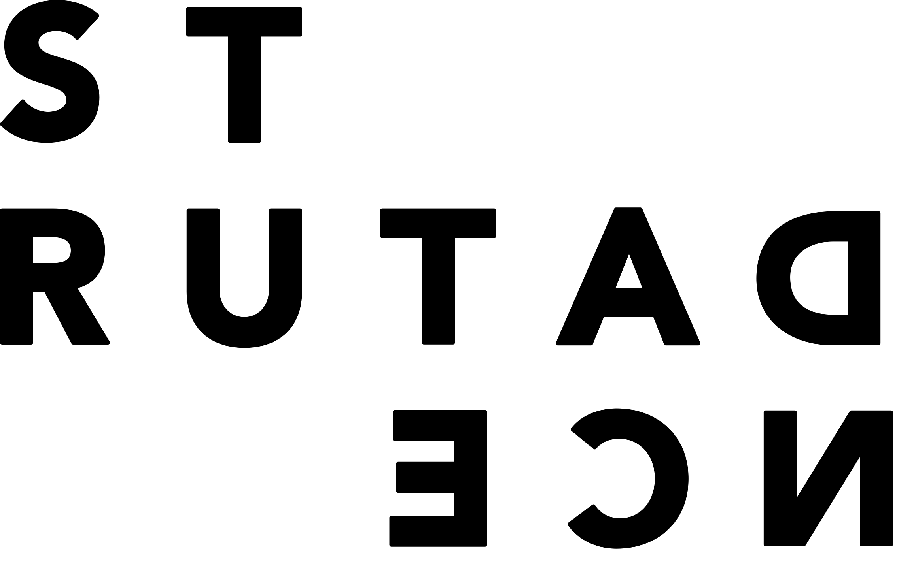

**2026 Restore**

**Application Form**

**WA Artists**

|  |  |
| --- | --- |
| Applicant name |  |
| Residential address |  |
| Email |  |
| Phone number |  |
| Name of project |  |
| Previous development/s of work (include dates, duration, stage) |  |
| Intended duration of work (approximate) |  |
| Team/Collaborators |  |
| Link to support material video |  |
| Password to video (if required) |  |
| Proposed development dates |  |
| Current STRUT Member since (date) |  |
| Living and working in WA (minimum residence of 6 of the last 12 months) |  |

**DESCRIPTION OF YOUR PROPOSED WORK – detail concept, what stage of development the work is currently in, list of potential technical requirements and where you plan to take it next.** *Up to 500 words*

**BIOGRAPHY – reflect your ability to deliver your proposal.** *Up to 300 words*

**ARTIST BIOGRAPHIES - brief biographies for each of your collaborators.** *Up to 300 words for each*

**IMAGES –** *up to 10 images*