Genome editing resources

Cas9 wt

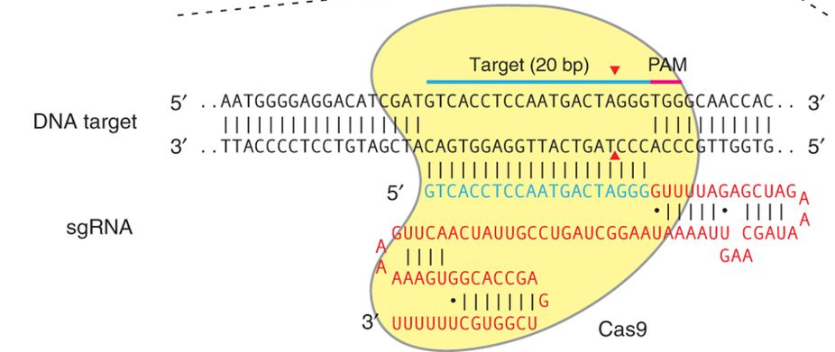

Genome engineering using the CRISPR-Cas9 system. Ran FA, Hsu PD, Wright J, Agarwala V, Scott DA, Zhang F (2013) Nat Protoc 8(11):2281–2308. doi:10.1038/nprot.2013.143

Engineered CRISPR-Cas9 nucleases with altered PAM specificities.
Kleinstiver BP, Prew MS, Tsai SQ, Topkar VV, Nguyen NT, Zheng Z, Gonzales AP, Li Z, Peterson RT, Yeh JJ, Aryee MJ, Joung JK
Nature. 2015 Jun 22. doi: 10.1038/nature14592

High-fidelity CRISPR-Cas9 nucleases with no detectable genome-wide off-target effects.
Kleinstiver BP, Pattanayak V, Prew MS, Tsai SQ, Nguyen NT, Zheng Z, Keith Joung J
Nature. 2016 Jan 6. doi: 10.1038/nature16526

In vivo engineering of oncogenic chromosomal rearrangements with the CRISPR/Cas9 system.
Maddalo D, Manchado E, Concepcion CP, Bonetti C, Vidigal JA, Han YC, Ogrodowski P, Crippa A, Rekhtman N, de Stanchina E, Lowe SW, Ventura A
Nature. 2014 Dec 18;516(7531):423-7. doi: 10.1038/nature13902. Epub 2014 Oct 22

In vivo interrogation of gene function in the mammalian brain using CRISPR-Cas9.
Swiech L, Heidenreich M, Banerjee A, Habib N, Li Y, Trombetta J, Sur M, Zhang F
Nat Biotechnol. 2014 Oct 19. doi: 10.1038/nbt.3055

Virus-Mediated Genome Editing via Homology-Directed Repair in Mitotic and Postmitotic Cells in Mammalian Brain.
Nishiyama J, Mikuni T, Yasuda R
Neuron. 2017 Oct 18. pii: S0896-6273(17)30933-9. doi: 10.1016/j.neuron.2017.10.004

SpCas9 nickase

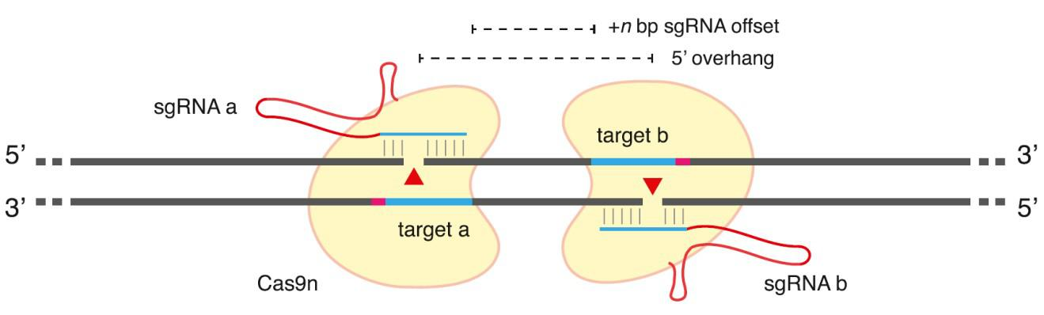

Taken from - Ran, et al. (2013b). Double Nicking by RNA-Guided CRISPR Cas9 for Enhanced Genome Editing Specificity. Cell 154, 1380.

Systematic quantification of HDR and NHEJ reveals effects of locus, nuclease, and cell type on genome-editing
Miyaoka et al
Scientific Reports 6, Article number: 23549 (2016)

CRISPR-Cas9(D10A) nickase-based genotypic and phenotypic screening to enhance genome editing.
Chiang TW, le Sage C, Larrieu D, Demir M, Jackson SP
Sci Rep. 2016 Apr 15;6:24356. doi: 10.1038/srep24356

CRISPR-Cas9(D10A) nickase-based genotypic and phenotypic screening to enhance genome editing.
Chiang TW, le Sage C, Larrieu D, Demir M, Jackson SP
Sci Rep. 2016 Apr 15;6:24356. doi: 10.1038/srep24356

Genome engineering using the CRISPR-Cas9 system.
Ran FA, Hsu PD, Wright J, Agarwala V, Scott DA, Zhang F
Nat Protoc. 2013 Nov;8(11):2281-308. doi: 10.1038/nprot.2013.143. Epub 2013 Oct 24

Multiplex Genome Engineering Using CRISPR/Cas Systems.
Cong L, Ran FA, Cox D, Lin S, Barretto R, Habib N, Hsu PD, Wu X, Jiang W, Marraffini LA, Zhang F
Science. 2013 Jan 3

S. aureus Cas9

In vivo genome editing using Staphylococcus aureus Cas9.
Ran FA, Cong L, Yan WX, Scott DA, Gootenberg JS, Kriz AJ, Zetsche B, Shalem O, Wu X, Makarova KS, Koonin EV, Sharp PA, Zhang F
Nature. 2015 Apr 1. doi: 10.1038/nature14299

Broadening the targeting range of Staphylococcus aureus CRISPR-Cas9 by modifying PAM recognition.
Kleinstiver BP, Prew MS, Tsai SQ, Nguyen NT, Topkar VV, Zheng Z, Joung JK
Nat Biotechnol. 2015 Nov 2. doi: 10.1038/nbt.3404.

Genome editing using CRISPR-Cas9 to create the HPFH genotype in HSPCs: An approach for treating sickle cell disease and beta-thalassemia.
Ye L, Wang J, Tan Y, Beyer AI, Xie F, Muench MO, Kan YW
Proc Natl Acad Sci U S A. 2016 Sep 20;113(38):10661-5. doi: 10.1073/pnas.1612075113. Epub 2016 Sep 6.

Engineered CRISPR-Cas9 nucleases with altered PAM specificities.
Kleinstiver BP, Prew MS, Tsai SQ, Topkar VV, Nguyen NT, Zheng Z, Gonzales AP, Li Z, Peterson RT, Yeh JJ, Aryee MJ, Joung JK
Nature. 2015 Jun 22. doi: 10.1038/nature14592

Epigenetic

In vivo genome editing using Staphylococcus aureus Cas9.
Ran FA, Cong L, Yan WX, Scott DA, Gootenberg JS, Kriz AJ, Zetsche B, Shalem O, Wu X, Makarova KS, Koonin EV, Sharp PA, Zhang F
Nature. 2015 Apr 1. doi: 10.1038/nature14299.

RNA-guided transcriptional silencing in vivo with S. aureus CRISPR-Cas9 repressors.
Thakore PI, Kwon JB, Nelson CE, Rouse DC, Gemberling MP, Oliver ML, Gersbach CA
Nat Commun. 2018 Apr 26;9(1):1674. doi: 10.1038/s41467-018-04048-4

CRISPR-mediated activation of a promoter or enhancer rescues obesity caused by haploinsufficiency.
Matharu N, Rattanasopha S, Tamura S, Maliskova L, Wang Y, Bernard A, Hardin A, Eckalbar WL, Vaisse C, Ahituv N
Science. 2018 Dec 13. pii: science.aau0629. doi: 10.1126/science.aau0629

SunTag system

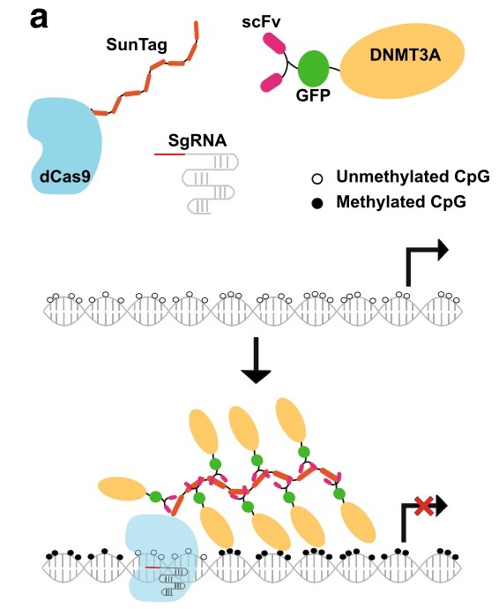

Taken from - Huang YH, Su J, Lei Y et al. DNA epigenome editing using CRISPR-Cas SunTag-directed DNMT3A. Genome Biol 2017;18:176.

A Protein-Tagging System for Signal Amplification in Gene Expression and Fluorescence Imaging.
Tanenbaum ME, Gilbert LA, Qi LS, Weissman JS, Vale RD
Cell. 2014 Oct 8. pii: S0092-8674(14)01227-6. doi: 10.1016/j.cell.2014.09.039

Targeted DNA demethylation in vivo using dCas9-peptide repeat and scFv-TET1 catalytic domain fusions.
Morita S, Noguchi H, Horii T, Nakabayashi K, Kimura M, Okamura K, Sakai A, Nakashima H, Hata K, Nakashima K, Hatada I
Nat Biotechnol. 2016 Aug 29. doi: 10.1038/nbt.3658

Base editors

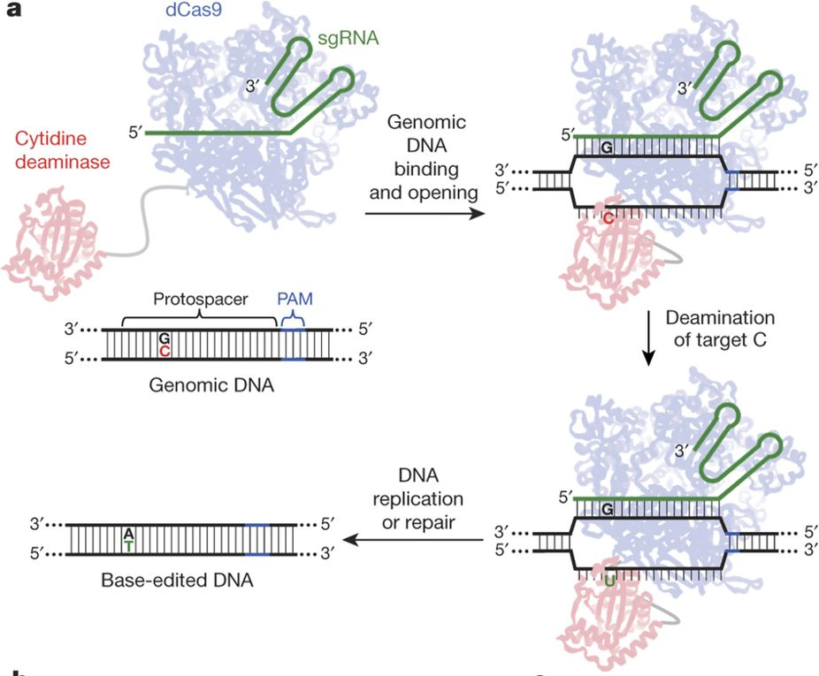

Taken from - Komor, A.C., Kim, Y.B., Packer, M.S., Zuris, J.A., and Liu, D.R. (2016). Programmable editing of a target base in genomic DNA without double-stranded DNA cleavage. Nature 533:420–424.
Letter to the Editor

Improving cytidine and adenine base editors by expression optimization and ancestral reconstruction.
Koblan LW, Doman JL, Wilson C, Levy JM, Tay T, Newby GA, Maianti JP, Raguram A, Liu DR
Nat Biotechnol. 2018 May 29. pii: nbt.4172. doi: 10.1038/nbt.417

Cas12 (Cpf1)

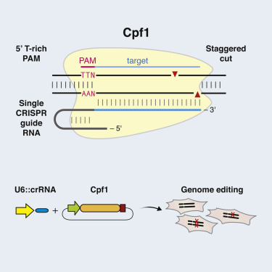

Taken from - Zetsche, B. et al. Cpf1 is a single RNA-guided endonuclease of a class 2 CRISPR-Cas system. Cell 163, 759–771 (2015).

Genome-wide specificities of CRISPR-Cas Cpf1 nucleases in human cells.
Kleinstiver BP, Tsai SQ, Prew MS, Nguyen NT, Welch MM, Lopez JM, McCaw ZR, Aryee MJ, Joung JK
Nat Biotechnol. 2016 Jun 27. doi: 10.1038/nbt.3620.

Inducible and multiplex gene regulation using CRISPR-Cpf1-based transcription factors.
Tak YE, Kleinstiver BP, Nunez JK, Hsu JY, Horng JE, Gong J, Weissman JS, Joung JK
Nat Methods. 2017 Oct 30. doi: 10.1038/nmeth.4483

Mb- and FnCpf1 nucleases are active in mammalian cells: activities and PAM preferences of four wild-type Cpf1 nucleases and of their altered PAM specificity variants.
Toth E, Czene BC, Kulcsar PI, Krausz SL, Talas A, Nyeste A, Varga E, Huszar K, Weinhardt N, Ligeti Z, Borsy AE, Fodor E, Welker E
Nucleic Acids Res. 2018 Sep 20. pii: 5103950. doi: 10.1093/nar/gky815.

Base editing with a Cpf1-cytidine deaminase fusion.
Li X, Wang Y, Liu Y, Yang B, Wang X, Wei J, Lu Z, Zhang Y, Wu J, Huang X, Yang L, Chen J
Nat Biotechnol. 2018 Mar 19. pii: nbt.4102. doi: 10.1038/nbt.4102.

Engineered Cpf1 variants with altered PAM specificities.
Gao L, Cox DBT, Yan WX, Manteiga JC, Schneider MW, Yamano T, Nishimasu H, Nureki O, Crosetto N, Zhang F
Nat Biotechnol. 2017 Jun 5. doi: 10.1038/nbt.3900.

Cas13
RNA editing

RNA editing with CRISPR-Cas13.
Cox DBT, Gootenberg JS, Abudayyeh OO, Franklin B, Kellner MJ, Joung J, Zhang F
Science. 2017 Oct 25. pii: eaaq0180. doi: 10.1126/science.aaq0180

Transcriptome Engineering with RNA-Targeting Type VI-D CRISPR Effectors.
Konermann S, Lotfy P, Brideau NJ, Oki J, Shokhirev MN, Hsu PD
Cell. 2018 Mar 8. pii: S0092-8674(18)30207-1. doi: 10.1016/j.cell.2018.02.033

