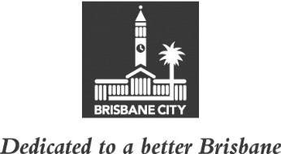
ECONOMIC DEVELOPMENT AND THE BRISBANE 2032 OLYMPIC AND PARALYMPIC GAMES COMMITTEE MINUTES
MEETING HELD ON TUESDAY 24 AUGUST 2021
AT 10.45AM
COMMITTEE MEETING ROOM 2, LEVEL 2, CITY HALL

MEMBERS PRESENT:

The Deputy Mayor, Councillor Krista Adams (Civic Cabinet Chair), Councillor Sarah Hutton (Deputy Chair), and Councillors Greg Adermann, Jared Cassidy, Kara Cook and Steven Huang.

OTHERS PRESENT:

Dy Currie, Manager Brisbane City Host Office and Chief Planner, City Planning and Economic Development, City Planning and Sustainability; Jock Power, Policy Liaison Officer, Civic Cabinet Chair’s Office, Economic Development and the Brisbane 2032 Olympic and Paralympic Games Committee; Rosemarie White, Personal Assistant to the Civic Cabinet Chair, Economic Development and the Brisbane 2032 Olympic and Paralympic Games Committee; and Jade Stopar, Council and Committee Liaison Office Manager, Governance, Council and Committee Services, City Administration and Governance.

MINUTES:

The Minutes of the meeting held on 17 August 2021, copies of which had been forwarded to each Councillor, were presented and taken as read and confirmed on the motion of the Civic Cabinet Chair, Councillor Krista Adams.

2 OTHER BUSINESS

The following matter was considered by the Committee, and the decision reached was fully set out in the Committee’s report to Council:

Committee presentation – Intellectual Property Protections.

3 GENERAL BUSINESS

The Civic Cabinet Chair answered questions of the Committee.

CONFIRMED THIS DAY OF 2021

.............................................
CIVIC CABINET CHAIR

