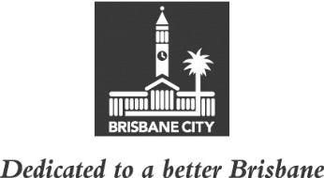
ECONOMIC DEVELOPMENT AND THE BRISBANE 2032 OLYMPIC AND PARALYMPIC GAMES
COMMITTEE MINUTES
MEETING HELD ON TUESDAY 16 AUGUST 2022
AT 10.45AM
COMMITTEE MEETING ROOM 2, LEVEL 2, CITY HALL

MEMBERS PRESENT:

The Deputy Mayor, Councillor Krista Adams (Civic Cabinet Chair), Councillor Sarah Hutton (Deputy Chair), and Councillors Greg Adermann, Jared Cassidy and Steven Huang.

OTHERS PRESENT:

Miriam Kent, General Manager, Business Growth, Trade and Talent and Brisbane Business Hub, Brisbane Economic Development Agency; Emily Moore, Event and Operations Manager, Brisbane Economic Development Agency; David Chick, Divisional Manager, City Planning and Sustainability; Lucy Smith, Policy Liaison Officer, Civic Cabinet Chair’s Office, Economic Development and the Brisbane 2032 Olympic and Paralympic Games Committee; Rosemarie White, Personal Assistant, Civic Cabinet Chair’s Office; Victor Tan, Council and Committee Coordinator, Council and Committee Liaison Office, Governance, Council and Committee Services, City Administration and Governance; and Kristy Ramirez, A/Council and Committee Officer, Council and Committee Liaison Office.

APOLOGY:

An apology was submitted on behalf of Councillor Kara Cook and she was granted a leave of absence from the meeting on the motion of the Civic Cabinet Chair.

MINUTES:

The Minutes of the meeting held on 9 August 2022, copies of which had been forwarded to each Councillor, were presented by the Civic Cabinet Chair and taken as read and confirmed by the Committee.

34 OTHER BUSINESS

The following matter was considered by the Committee, and the decision reached was fully set out in the Committee’s report to Council:

Committee presentation – Brisbane Business Hub Update.

CONFIRMED THIS DAY OF 2022

.............................................
CIVIC CABINET CHAIR

