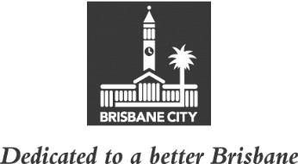
CITY STANDARDS COMMITTEE MINUTES
MEETING HELD ON TUESDAY 8 NOVEMBER 2022
AT 8.30AM
COMMITTEE MEETING ROOM 2, LEVEL 2, CITY HALL

MEMBERS PRESENT:

Councillor Kim Marx (Civic Cabinet Chair), Councillor Steven Toomey (Deputy Chair), and Councillors Greg Adermann, Peter Cumming, Sarah Hutton and Nicole Johnston.

OTHERS PRESENT:

Krysten Booth, Executive Manager, City Standards, Brisbane Infrastructure; Sam Dureau, A/ Manager, Program Planning and Integration, City Standards; Sharon Henry, Senior Revenue Analyst, Enterprise Performance Management, Corporate Finance, Organisational Services; Kate Samios, Policy Liaison Officer, Civic Cabinet Chair’s Office, City Standards Committee; Megan Hewton, Council and Committee Liaison Office Manager, Governance, Council and Committee Services, City Administration and Governance; and Ashley Bailey, A/Council and Committee Officer, Council and Committee Liaison Office.

MINUTES:

The Minutes of the meeting held on 1 November 2022, copies of which had been forwarded to each Councillor, were presented by the Civic Cabinet Chair and taken as read and confirmed by the Committee.

61 OTHER BUSINESS

The following matter was considered by the Committee, and the decision reached was fully set out in the Committee’s report to Council:

Committee presentation – Disaster Response Caravan.

62 GENERAL BUSINESS

The Civic Cabinet Chair answered questions of the Committee and took a number for future response.

CONFIRMED THIS DAY OF 2022

.............................................
CIVIC CABINET CHAIR

