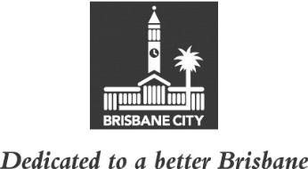
ECONOMIC DEVELOPMENT AND THE BRISBANE 2032 OLYMPIC AND PARALYMPIC GAMES
COMMITTEE MINUTES
MEETING HELD ON TUESDAY 22 NOVEMBER 2022
AT 10.45AM
COMMITTEE MEETING ROOM 2, LEVEL 2, CITY HALL

MEMBERS PRESENT:

The Deputy Mayor, Councillor Krista Adams (Civic Cabinet Chair), Councillor Sarah Hutton (Deputy Chair), and Councillors Greg Adermann, Jared Cassidy, Kara Cook and Steven Huang.

OTHERS PRESENT:

David Chick, Divisional Manager, City Planning and Sustainability; Nicole Andronicus, Manager, International Relations and Multicultural Affairs, City Planning and Sustainability; John Cowie, Manager, City Planning and Economic Development, City Planning and Sustainability; Ross Giudice, Economic Development Manager, City Planning and Economic Development; Emily Blake, Principal Officer, International Projects, International Relations and Multicultural Affairs; Anjela Chen, Multicultural Affairs Partnerships Manager, International Relations and Multicultural Affairs; Lucy Smith, Policy Liaison Officer, Civic Cabinet Chair’s Office, Economic Development and the Brisbane 2032 Olympic and Paralympic Games Committee; Rosemarie White, Personal Assistant, Civic Cabinet Chair’s Office; and Katie Edgley, A/Senior Council and Committee Officer, Governance, Council and Committee Services, City Administration and Governance.

MINUTES:

The Minutes of the meeting held on 15 November 2022, copies of which had been forwarded to each Councillor, were presented by the Civic Cabinet Chair and taken as read and confirmed by the Committee.

47 OTHER BUSINESS

The following matter was considered by the Committee, and the decision reached was fully set out in the Committee’s report to Council:

Committee presentation – Lord Mayor’s Multicultural Awards for Business.

CONFIRMED THIS DAY OF 2022

.............................................
CIVIC CABINET CHAIR

