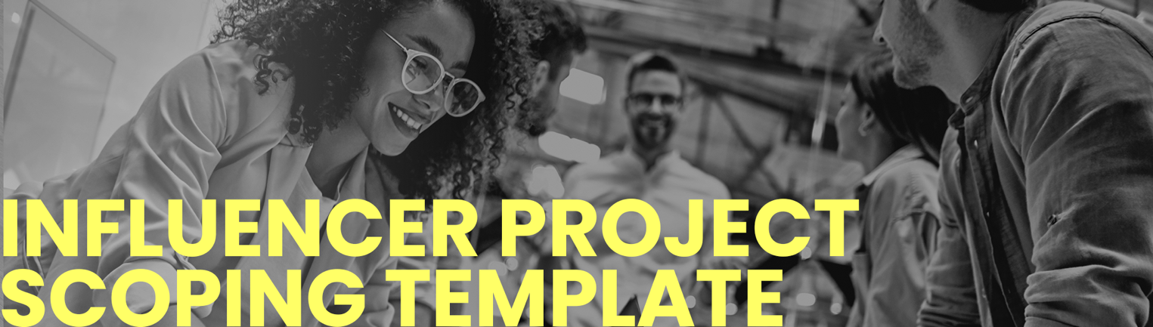

BACKGROUND
Background Info
Background information relevant to the project including:
- Broader campaign strategy
- Other campaign activities
- Company / brand strategy information if relevant

Target Audience Persona
Who are you trying to reach?

Take Out
What do you want the audience to take away from the campaign? Be as specific as you can here.

Audience Insight / Reason to Believe
What are the proof points of the campaign / project?

Messaging
What are the specific key messages supporting your campaign?

Direct Competitors
Who are the direct competitors? How are they currently targeting this audience?

SUCCESS CRITERIA
Objectives
Provide details of the broader campaign objective and the specific channel objective for this activity from your objective pyramid. What action are you wanting to drive with this influencer activity?

KPIs
What metrics will we track? And what are the expected outcomes. This can be based on past activity. If you haven’t worked with influencers in the past utilising platforms such as Vamp and Creator IQ can be useful as they can provide impact estimates based on past activity.

deliverables
Social Platforms
This should be informed by the research you carried out during the Defining Your Audience and Channel Planning phases of your strategy development.

Relevant Markets
Which markets are you looking to run the activity in?

Influencer Persona
Do you have an idea of the type of influencer you are looking to work with? It can be useful to understand:
- HCP / Patient / Caregiver / Other
- For HCPs – job experience
- Disease / therapy area
- Creator type – video / blogger / podcaster
- Sphere of influence – mega (1 million + followers), macro (100,000 – 1 million followers), micro (10,000 – 100,00 followers) or nano (10,000 followers or less)

Influencer Activity
How do you want to work with influencers?
- Consult (e.g. consult on material development)
- Invite to events / meetings (e.g. invite to an influencer summit, to attend a conference)
- Co-create content (e.g. develop content for your owned channels, or filmed content with this individual, join a panel discussion,)
- Create content (e.g. develop content to post on their own social accounts)

Vetting
Here you can include criteria that will be used to vet influencers, so you can gather early alignment.

Risk mitigation
If known at this stage, here you could identify any potential areas of risk and how you plan to mitigate this.

