2026 GSC ADVENTURER CAMPOREE

INFORMATION PACK

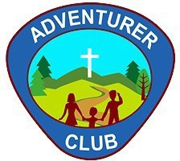


TABLE OF CONTENTS

Introduction ……………………………………………………… 3
Travel Information ………………………………………………. 4
Arriving at the Campsite ………………………………………. 5
Map of Crosslands Youth & Convention centre…………. 6
Security ……………………………………………………………. 7
Rules for Safety …………………………………………………. 8
Site Services ……………………………………………………… 9
Emergency Procedures ……………………………………….. 10
Departure …………………………………………………………. 11
Draft Program ……………………………………………………. 12

INTRODUCTION

Welcome to the 2026 Greater Sydney Conference Adventurer Camporee! We are very excited to see you there!

The aim of this guide is to ensure that all clubs and individuals have a safe, happy and memorable experience. It will provide you with information on preparing for Camporee, as well as a Code of Conduct and Rules to follow while on site. We expect to have over 600 people attend Camporee, so having information to keep yourself and others safe is our top priority!

The theme for this year’s Camporee is ‘Little Bible Heroes’ There will be a new Award that the Adventurers will receive after completion of activities, along with their Camporee patch.

Our Guest Speaker will be Pr Moses Depaz, he is currently serving as a local Church Pastor for the Victorian Conference, and previously served as the Associate Youth Director for the Greater Sydney Conference.

MAIN CONTACTS
Jacinda Ralph - Youth Departmental Assistant jacindaralph@adventist.org.au
Pr Dejan Stojkovic – Youth Director dejanstojkovic@adventist.org.au
Pr. Stanley Stuski - Associate Youth Director stanleystuski@adventist.org.au
Office number: 02 9473 9542

TRAVEL INFORMATION

Site Address:
100 Crosslands Road, Galston NSW 2159
Website: https://www.crosslands.org.au/
Directions:
FROM SYDNEY—
1. Take the Cumberland Hwy/Pennant Hills Rd/A28.
2. Turn left at Boundary Rd, at the roundabout take the 2nd exit onto New Line Rd.
3. At the next roundabout take the 2nd exit and stay on New Line Rd.
4. At the third roundabout, take the 2nd exit onto Old Northern Rd.
5. Turn right onto Galston Rd
6. At the roundabout, continue straight to stay on Galston Rd.
7. Continue straight onto Crosslands
IMPORTANT TO NOTE: The last section of Crosslands Road has hairpin bends, making it too narrow for large vehicles to navigate.
Coaches and large buses will need to use Somerville Road in Hornsby Heights instead.
As parking facilities are limited at Crosslands Youth and convention centre, we suggest that Adventurer clubs arrange for adventurers and their families to be dropped off to camporee at Crosslands reserve, using Somerville Road in Hornsby Heights and booking a Ferry Crossing with the Crosslands Youth and convention centre office.
Ferry Crossings: Direct bus drivers and families being dropped, to Crosslands Reserve (Somerville Road, Hornsby Heights)
Please make arrangements with Crosslands Youth and convention centre office to organise for their ferry to transport your group across the river.
Contact Information for Ferry bookings:
Email: office@crosslands.org.au
Phone: +61 2 9653 1041
Office Hours: Monday - Friday: 8.30 am - 5.00 pm ​​
All Ferry bookings must be made in advance.
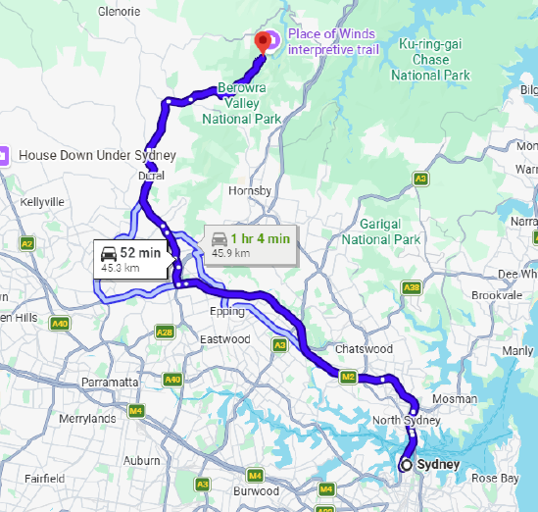
Please make sure to drive sensibly once you have arrived at Crosslands Rd.

There will be a designated parking area outside of the Campground facility.

Please observe the Campground Speed Limit, the Grounds Manager will have every right to ask you to leave the premises if speed limit is not observed.

More information about parking and vehicle movement within the campgrounds will be addressed later in this pack.

ARRIVING AT THE CAMPSITE

Arrivals
The Camporee officially starts at 7:30pm on Friday, November 6. The Registration Tent will be open from 12 noon.
Clubs please ensure all your club members arrive at your designated arrival time. This will help with traffic flow and transfers along Crosslands Road.
The main gates will close at 9pm on Friday night. If you arrive after 9pm, you will not be able to enter the campgrounds. Please make sure to arrive on time, and don’t miss the opening program.
As you enter Crosslands Rd, there will be Camporee Staff, wearing fluro vests, who will greet you and point you in the direction of the Registration Tent and camping sites. Please be respectful to all staff and listen to their instructions.

Registration
Although you would have registered online, you will still need to CHECK-IN at the Registration Tent. They will instruct you to which area you will need to camp in, and where to park your vehicle.
All those who have registered and checked-in will receive a wrist band, as a form of identification.

Parking
All vehicles will be required to park at the designated parking area on Crosslands Road, and you will be transferred with your belongings to Crosslands Youth and Convention centre.
ONLY ONE vehicle PER CLUB will be allowed to the camping spot allocated to your club, this will need to be confirmed with your local club director. This person/vehicle will be issued with a Vehicle Pass at CHECK-IN, that must be displayed on the front window of the vehicle.
This vehicle will then be required to move to the designated parking area once your camping gear has been unloaded out of the car. This should take no longer than 10 minutes. No vehicles are then permitted to move AT ANY TIME within the camp, until 12am on Sunday (after the Closing Parade).
If cars are found parked on club camping areas or in the campground with no Vehicle Pass, they will be issued with a warning by security, and if the vehicle is still not moved, they will be asked to leave the Camporee.
Please also note that sleeping in vehicles is STRICTLY PROHIBITED.

Setting up camp
Only after the car has been moved off the camping area, may you then proceed to set up your tents and camping gear. Please note that due to limited space, we strongly encourage that the size of your tent fit the number of people sleeping in it. 10-man-tents are not encouraged. The smaller, the better.

ALSO, only ONE KITCHEN MARQUEE/ GAZEBO is allowed per club.
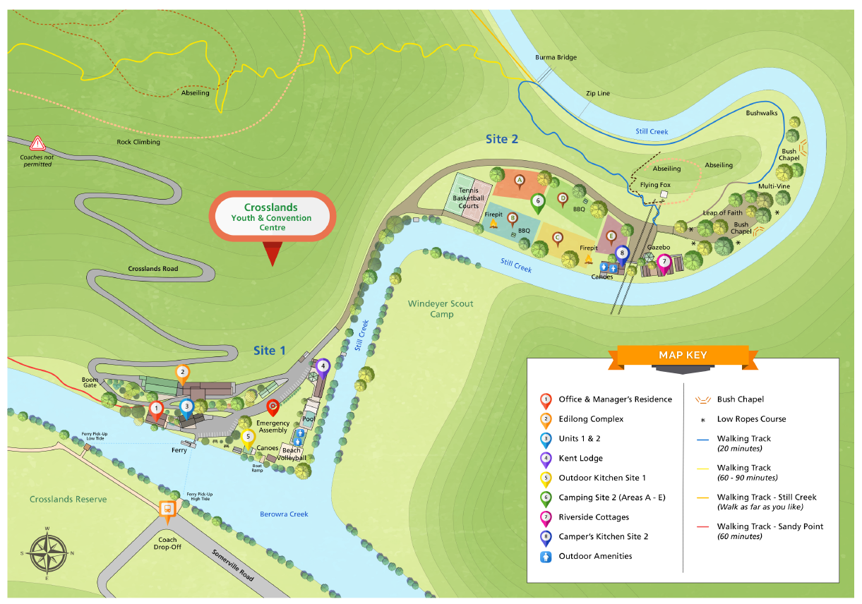
SECURITY

Site Security
A team of Volunteers will be providing 24/7 security for the area we are camping in and our car park for the duration of the Camporee. Please cooperate with them and do not be offended if you give them cause to question your actions.

Club Security
Adventurer Club Leaders must always take responsibility for always knowing the whereabouts of every person within their clubs, while on site.
Exercise basic awareness and plan to prevent your club being involved in any security or safety incident by carrying out your own club Risk assessment for your club and your site. Safety Management Plans are available on the SydneyAdventistYouth website: ADVENTURERS — SYDNEY ADVENTIST YOUTH
Make sure to use the buddy-system, where each individual is accompanied by another, or by a guardian at ALL TIMES--even when going to the bathrooms.

Theft/damage
Please do not leave any valuables openly visible in tents or cars and ensure any vehicles you have are kept locked when unattended.
The Greater Sydney Conference and the Seventh-day Adventist Church will not be held responsible or liable for any theft, damage or losses that occurs to your personal belongings.

RULES FOR SAFETY

Fires
The Sydney Adventist Youth team will designate three clubs to host a campfire for surrounding clubs, at the designated Fire pits on Saturday evening.
If your club has not been designated to host a campfire, your club is not permitted to have an open fire anywhere on site.
You will need to bring your own gas cooker, please ensure it is supervised AT ALL TIMES, and out of reach from young children. Ensure that your equipment is clean, and in good condition. Faulty equipment could lead to injury of the user and those nearby. No responsibility is taken by the camp organisers.
Each club will need to be responsible for their own camp cooking equipment.
Every club is required to have a fire extinguisher and fire blanket near their cooking area for emergencies. These should be in good working order and ready to use at all times.

Water
Bodies of water are present around the Campground. However, NO swimming is allowed, and no entry into the creeks without a PFD.
There will be a designated time for water activities on Sunday morning.
Water for cooking will be available from the standpipes located around the campsites. Note: all water on the site is suitable for drinking.

Shoes
Enclosed shoes must be worn at all times in and around the Campground. This includes going to and from the toilet and shower blocks. For your protection, no sandals, havianas, thongs, flip flops or bare feet are allowed.

Animals
No animals/pets are allowed on site during the Camporee. Only assistance animals that have been- pre-registered with the Conference may be allowed on site.
If you are found with a pet that has not been registered, you will be asked by our Security Team to leave Camporee.
Generators
We recommend that you do not bring a generator, however if you need to bring one, please make sure it is in good condition. The fumes and noise pollution it creates are a safety issue for all campers in the area.
Generators must be run outside the general camp area, and thus will require you to bring/use waterproof extender leads. Leads must not cross over roads or paths, or general walking areas within the camp.
Generators must also be kept on a flat surface and cover the grass/ground. You must protect the grass around the generator for at least two metres. Fuel and oil must be kept away from the generator for fire safety reasons.
Finally, if you bring your own generator, they will not run between 10 pm and 6 am in the morning. This will benefit all campers.

Other
• No noise after 10pm.
• No pushbikes, roller blades/skates, no balance bikes or skateboards.
• No drugs, or alcohol allowed on site.

SITE SERVICES

Toilets and showers
Access to toilets and shower blocks are available (hot water included).
Please treat facilities with care. Nothing is to be flushed down the toilet except toilet paper and human waste. Anything else will clog the toilet and could cause overflow of toilet waste.

Waste disposal
Bins are located around the Campground. Please place all rubbish in the bins and be sure to clean up your area before you go home.
District Directors will check camping areas, rooms and cottages before you leave and collect your Camporee patches and awards.

Disable facilities
If access to an accessible toilet block is required, please notify the Event Organisers as soon as possible. Accessible toilet facilities are available within the campground; however, we will need to ensure you are allocated a campsite/room as close as possible to these facilities.

Electricity
There may be a few power points available on site, such as in bathrooms and halls, however, please do not expect that you will always get access to them. There will be many people wanting to use them.
Please note:
• NO extension cords are allowed to be run into the toilet/bathroom areas. This is extremely dangerous, due to water present.
• Do not unplug other people’s equipment
• Do not leave anything being charged on the ground.
• Do not bring or plug in multi-plug power boards into sockets.

EMERGENCY PROCEDURES
Medical
A First Aid kit and designated Camporee First Aider will be available, though it is highly recommended that each club has at least one person qualified in first aid who knows how to manage minor injuries and medical problems like insect bites, sprains and small cuts.
Club Leaders are expected to bring their own first Aid kit and manage their own club’s injuries, unless otherwise unable to. If there is a medical emergency:
1. Ring 000
2. Inform Event Organisers
3. Our Traffic Control personnel must then be informed, to direct the ambulance.

Emergency Evacuation
1. The Designated Emergency Response Person will communicate the emergency to the Club Leaders.
2. A roll call must then take place in each club, to gather all members together.
3. All clubs will then be directed to the allocated emergency evacuation location.
4. Another roll call must follow.
5. Await further direction.
Lost Child
1. Parent reports this information to their local club.
2. The local club will do an initial search.
3. If still lost, the Local Club Leader must contact the Event Organiser/Reception Desk, who will then inform the Traffic Control personnel regarding the missing child and send out a team of leaders to check the grounds.
4. If the child is still not found, the Event Organiser will communicate to Club Leaders that all persons must halt all activities.
5. A roll call must then take place in each club, to gather all members together.
6. If child is still not found, the Event Organiser will call the police - 000.
DEPARTURE

Departure
The event will finish at 11.30am on Sunday, November 8th. Any time after 12pm you are welcome to leave. If you need to leave earlier than this, please communicate this to the Reception Desk. But it will only be permitted on a very strict basis.
Due to safety, we do not want cars leaving the site while the program and activities are still taking place, as mentioned earlier.
When your club is ready to leave, you need to contact your District Director for site/room inspection and then CHECK-OUT at the Registration Tent. Those who have ordered a patch will be issued the patch at the registration desk on departure.
Your site must be left clear of all equipment, pegs, waste (especially bits of plastic) before going to the Reception Desk.
Please aim to leave the site by no later than 4pm.

DRAFT PROGRAM
The following program is a guide only and should not be taken as the final program for Camporee. This draft program is designed to help you plan for the Camporee.
FRIDAY
12.00 PM Registration opens
7.30 PM Open Sabbath, Little Bible Heroes Worship, Drama pt1
9:00 PM Registration closes. Gates closed-no access to Campground
10.00 PM Lights out/ bed
SATURDAY
7:30 AM Club Directors Meeting
8:45 AM Adventurer Clubs assemble for Parade
9.00 AM Opening Parade
9.30 AM Little Bible Heroes Worship, Drama pt2
12.00 PM Lunch
1.30 PM Samuel’s Call Award
4.00 PM Club Sabbath Time
5.30 PM Evening meal
6.30 PM Little Bible Heroes Worship, Drama pt 3, Close sabbath
7.30 PM Around the world in 80 minutes
10.00 PM Lights out/bed
SUNDAY
7:30 AM Club Directors Meeting
8.30 AM Little Bible Heroes Worship, Drama pt3
9.00 AM Adventurer Clubs assemble for Parade
9:00 AM Closing Parade
9.30 AM Camporee Activities
12.00 PM Pack up & Depart
4.00 PM Campsite closed
Please be aware that Camporee is designed to be a spiritual high, and a memorable ‘God experience’ for the Adventurers. We know that parents and leaders will be setting a good example for the children to follow. This means that we expect that there will be no talking, or making of noise, while worships are taking place. Please refrain from chatting, and catching up with other parents, until after the worship program has finished. Thank you.
Also, please note that Full Parade uniforms are expected to be worn at the Parade on Saturday and Sunday morning.

