DEEP DIVE Viola Technical Book: some useful URLS:

This list, made February 2024, is by no means comprehensive or a selection of what is most recommended, and links may change over time. It is most revealing to listen to the whole work or movements for context, and do listen to other recordings. Read about the composers, the genres, sometimes you will find master classes with great players demonstrating excerpts as well. If you would like to add to or amend anything here, please email Helen Tuckey helenvla@bigpond.net.au and the list will be updated.

Page 27 Extras for experts:
A track of Lionel Tertis playing Cherry Ripe can be heard on this recording on major streaming services or CD: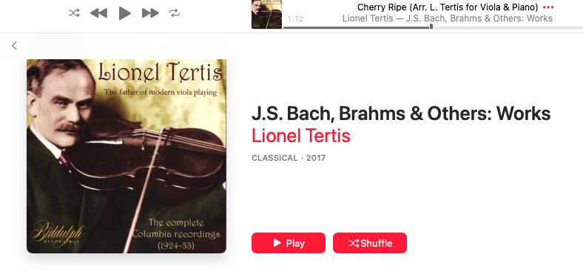
It can be interesting to compare with other various versions on YouTube, including Primrose:
https://www.youtube.com/watch?app=desktop&v=3LOVtPs447c

Page 43 4D Palaschko
About the composer:
https://en.wikipedia.org/wiki/Johannes_Palaschko
This album of original studies for viola is in the public domain:
https://imslp.org/wiki/25_Easy_and_Melodic_Studies%2C_Op.87_(Palaschko%2C_Johannes)

Page 55 5C Bizet “Carmen”
At 9’53”:
https://www.youtube.com/watch?v=l6fYxEat3Cs

Page 56 5D JS Bach - Brandenburg 6 – there are MANY recordings, here’s one with score:
At 4’21”
https://www.youtube.com/watch?v=FPONyxrkfRQ

Make on online visit to a library in Berlin to see the original score in Bach’s handwriting:
https://www.bach-digital.de/rsc/viewer/BachDigitalSource_derivate_00060187/db_amb078_page078r.jpg

Page 57 Extra for excerpts Berg, excerpts from 3 pieces for orchestra
Excerpt 1: Listen at 8’ 22” Exerpt 2: Listen at 12’ 16”
https://www.youtube.com/watch?v=q6U8AqRNyU8

Interesting video for more context by a conductor who is passionate about Berg:
https://www.youtube.com/watch?v=sF6tkYg-ZOo

Page 68 6C Maurice Vieux Septièmes from Dix ètudes pour alto
About the composer:
https://en.wikipedia.org/wiki/Maurice_Vieux

Listen here, but don’t be daunted by the tempo!
https://www.youtube.com/watch?v=nK02t_prkYk

Page 69 6D Tchaikovsky “Romeo and Juliet”
Listen at 6’34”
https://www.youtube.com/watch?v=finYYXkdYmA

Page 69 6E Richard Strauss “Till Eulenspiegels lustige Streiche”.
Listen at 3’31”
https://www.youtube.com/watch?v=K02qkwc7dxQ

Who is Till pretending to be with the viola theme? The whole story is here, with music and words.
https://www.youtube.com/watch?v=X7_3AUG-Xzk

Page 79 7B Haydn Symphony no. 96
Listen at 5’ 19” for historically informed version
https://www.youtube.com/watch?v=ovBBA0_njlo

Listen at 5’39” for a version with score
https://www.youtube.com/watch?v=J4lFVylB4xI

Find out why it’s sometimes known as Haydn’s Miracle symphony here:
https://en.wikipedia.org/wiki/Symphony_No._96_(Haydn)

Page 80 7C Berlioz “Roman Carnival” overture
Listen from the beginning with score, or start with the first time we hear this theme, at 27” in another key in the Cor Anglais, before the viola excerpt, to gain context:
https://www.youtube.com/watch?v=1ZwNPUQfF8I

Here is one presentation of the solo alone:
https://www.youtube.com/watch?v=ti1StwXjMFM

You too can play along with excerpts …
https://www.youtube.com/watch?v=C6Iv6VKdFY0

Page 80 7D Mahler 5th symphony
Listen to it all when you have the chance. If you don’t, go from the last two minutes, to give context to the excerpt you are preparing.
https://www.youtube.com/watch?v=mVjHOp2SFfU

and read more to know more:
https://en.wikipedia.org/wiki/Symphony_No._5_(Mahler)#:~:text=The%20Symphony%20No.,van%20Beethoven%27s%20Symphony%20No.

Page 92 8A Grieg Peer Gynt suite
Find a score of this - the imslp website is helpful!
Listen here:
https://www.youtube.com/watch?v=hDCUgdi2CDA

Page 93 8B Bruckner Symphony 4, second movement
There are other versions of score and music, but here is a score in Bruckner’s own writing.
Listen to whole symphony, and for this excerpt, at 21’ 38”
https://www.youtube.com/watch?v=-MiYzU8HQZQ

Read more here:
https://www.laphil.com/musicdb/pieces/3999/symphony-no-4-romantic

Page 93 8C Mozart Requiem in D minor K 626 Offertorium
Listen at 30’ 23” here:
https://www.youtube.com/watch?v=m5FXV1zrNh4

Or, Listen at 27’ 31”
https://www.youtube.com/watch?v=zCscJGr4SC8

Page 93 8D Mahler Symphony 10, first movement Andante
This solo excerpt was recorded during the Covid lock-down by Cynthia Phelps - absolutely amazing:
https://www.youtube.com/watch?v=fwKNgmln7P4

Here is a full orchestral version with score. Find the actual exam excerpt yourself, and first listen from the beginning for the first section solo, to set some context for what the second solo develops from.
https://www.youtube.com/watch?v=8qYqW-otXxI

Page 93 8E Tchaikovsky Serenade for strings op. 48, second movement, Valse (Waltz)
Listen to the lot, excerpt is at 11” 20’
https://www.youtube.com/watch?v=MICksKeZoJU

Page 97 Bartók Concerto for orchestra Sz. 116 BB 123, fourth movement, Intermezzo
Listen at 25’ 11”
https://www.youtube.com/watch?v=0DKuzKnkIro

The Concerto for orchestra, third piano concerto and viola concerto were important last works of Bartok and written in New York. Read more about this time, and listen to the viola concerto as well.

