Roof Bars – What they will fit
Universal U-Bar
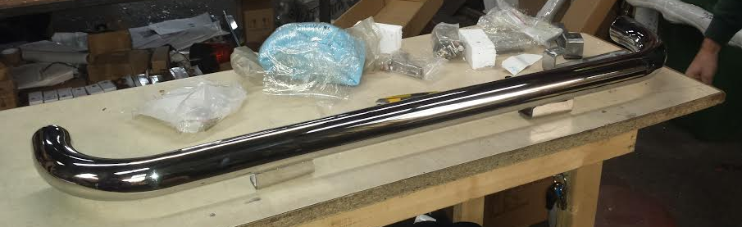
- Sold with 4 x 63mm clamp
- Fits above windscreen of high roof Transit/Sprinter/Crafter etc
- Can also fir to small truck/front spotlight bar for Renault Trafic/Ford Transit

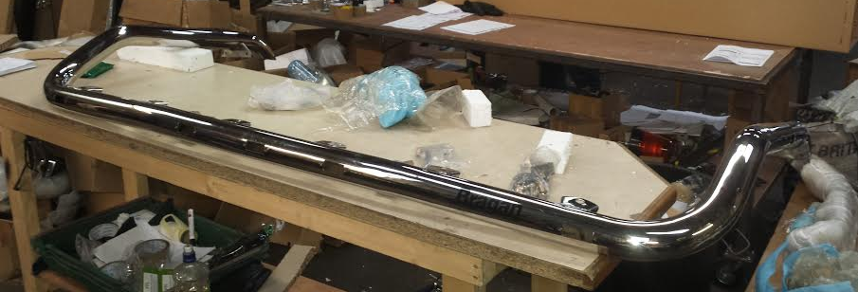
Volvo Dropdown (can fit along with air horns)

- Fits Globetrotter std and XL cab
- Man Diesel high cabs e.g. XXL

Scania Flat Cab
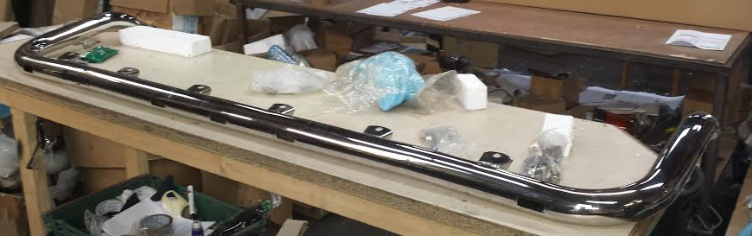

- Fits on top of most flat cabs; Mercedes Actros/Axor/Atego
- Iveco Trakker/Stralis Low cab
- DAF XF Space cab/Low cab
- DAF CF Low cab
MP4 Bar
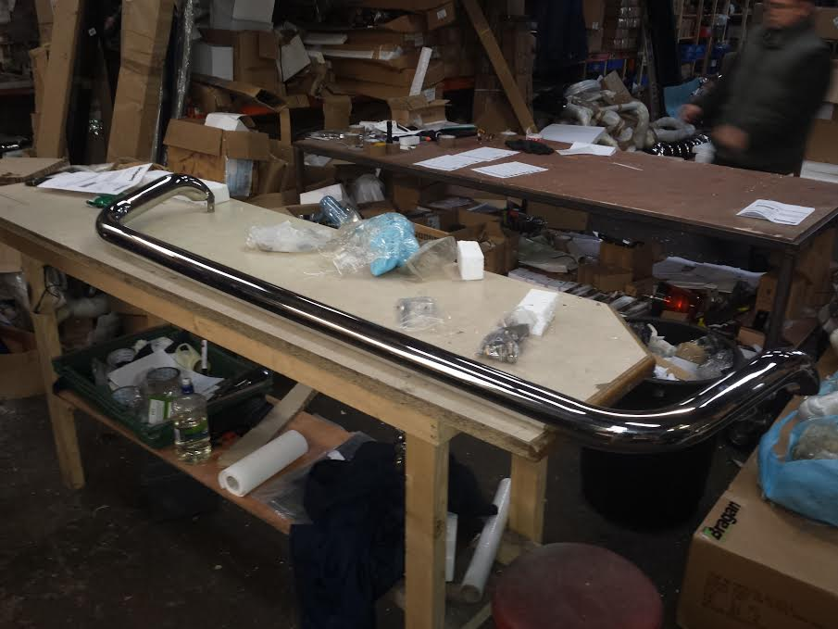
- Mercedes MP3/MP4 – high roof (Giga + Mega Space)
- Renault T-Cab (high)
- Can be used as Mercedes Axor High Cab dropdown style
- Maybe DAF CF Space as dropdown style
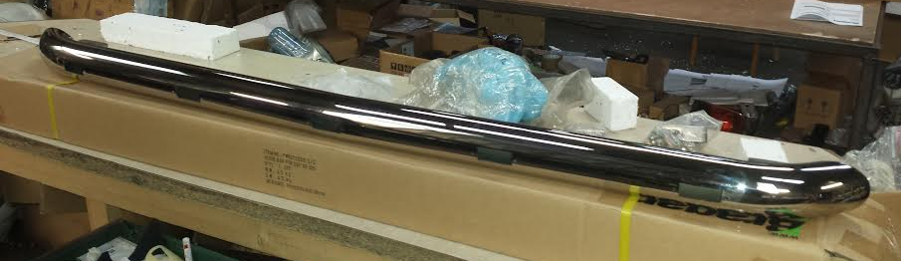
DAF Visor

- When sold with 63mm clamps can be used as rear roof light bar for all big roof vans (Transit/Trafic+Sprinter)

