- Try asking questions
- Mention price up front
- Promote a discount
Best time to post on Facebook is 3pm on a Wednesday afternoon, 12-1pm on Saturdays & Sundays, 1pm-4pm on Thursdays and Fridays
Don't post links
Example sales post using info above
Stainless steel roof bars starting at only £209.99, more than half the price of main competitors?
+ many, many more items for all major models. Multiple purchase discounts available
(Insert pictures)
Posts
It is recommended that posts are to be used in two ways
1. Directly (Sales driven posts)
2. Indirectly (Showcasing who we are as a company which then in turn creates potential new customers/sales)
Need to work these both together
Example of Direct post
"Sign up, call now , see our website"
Example of Indirect post
"Another busy day in the Bragan Warehouse, getting all the truck, van & 4x4 essentials ready to go"
AutoPost
http://www.toolsstar.com/
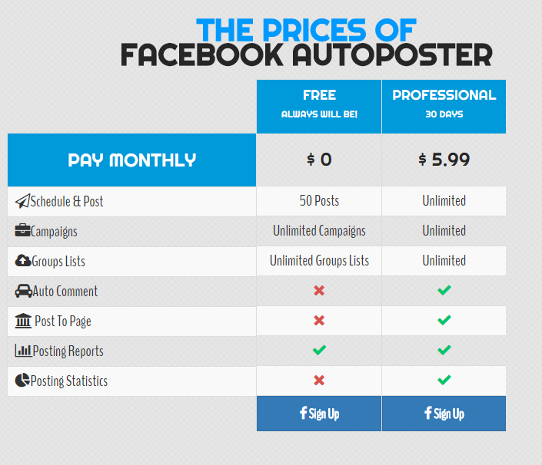

https://postcron.com/en/

