Truck | Model | Picture | Bar Used | Will air-horn fit?
Scania | Topline | 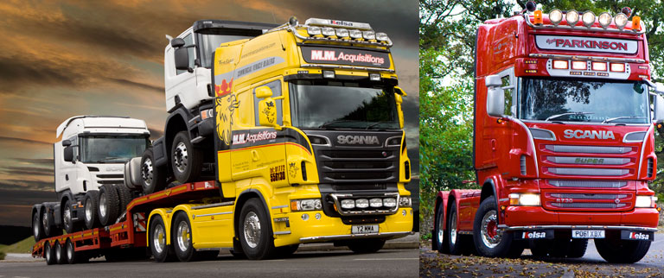 | Topline Roof  BRA2111 | No
 | Highline | 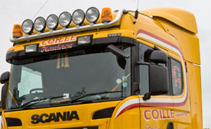 | - HighLine Roof  BRA2121 | No
 | P. Cab  (sleeper cab with bed) | 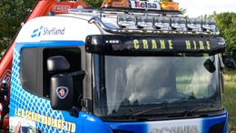 | P. Cab  BRA2131 | No
 | Flat Cab | 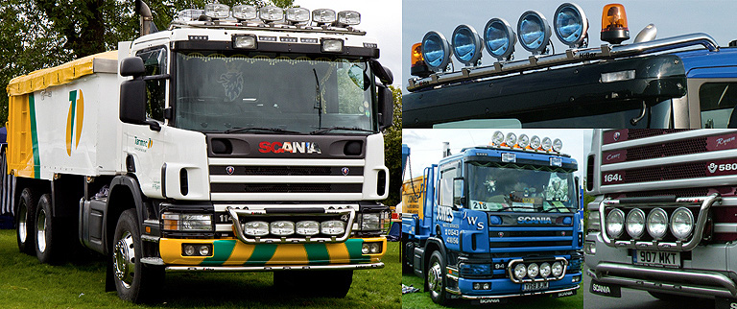 | Scania Flat Cab  BRA2141 | Yes
Man | High Cab | 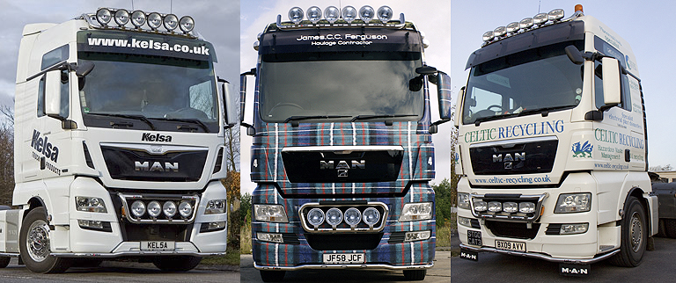 | Volvo Dropdown  BRA2211 | yes
 | Low Cab | 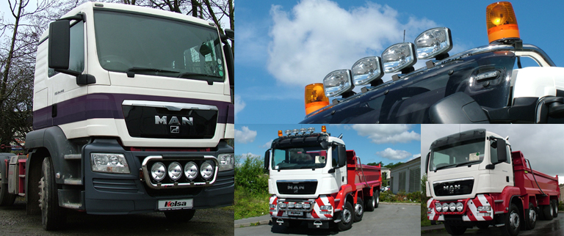 | Scania Flat cab  BRA2461

