Truck | Model | Picture | Bar Used | Will air-horn fit?
Volvo | Standard Low / Day cab  (tipper) | 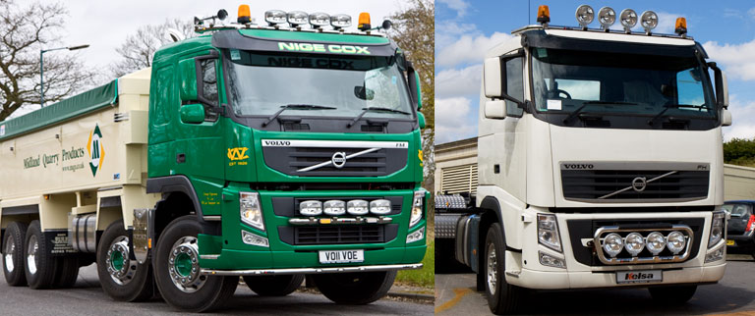 | Scania Flat cab
- FE standard cab only  - Euro6 globetrotter std only  - FH4 | Globetrotter Std | 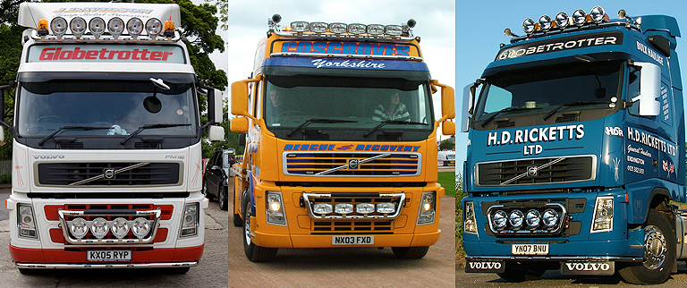 | Volvo dropdown /  Roof mounted
 | Globetrotter XL | 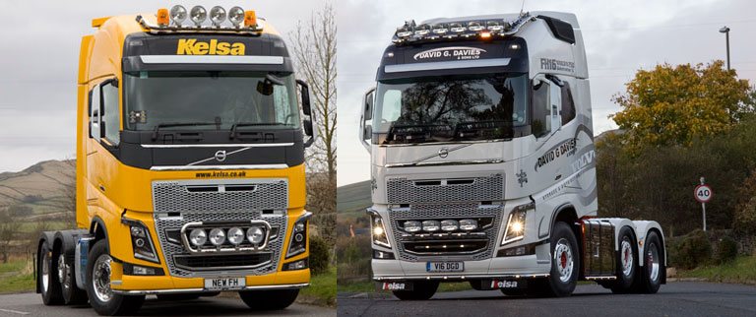 | Volvo dropdown
Iveco | Stralis Cube  (active space-high) | 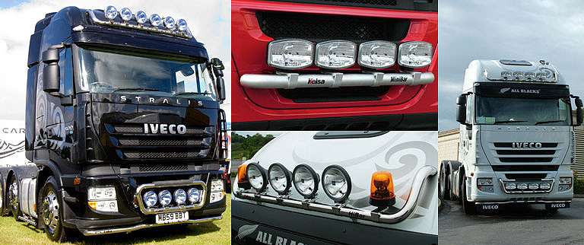 | BRA2611  Own bar
 | Trakker / Stralis Low  (Flat cab / Active Day) | 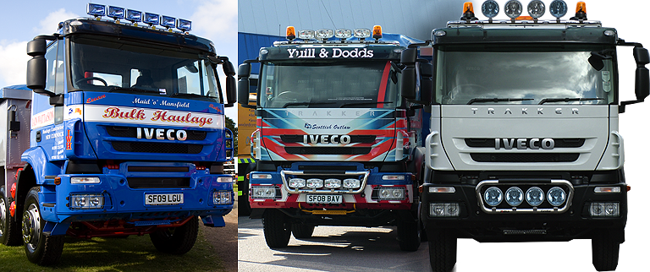 | Scania Flat cab  BRA2621

