

Notice of False and Defamatory Content

You can use our free document upload service, you'll find all the information on this page - open a new window on your browser window and copy this link into it: https://ocs.ebay.co.uk/ws/eBayISAPI.dll?OCSUploadMemberDocuments&action=signin&deptName=UK RiskPol

It is eBay's policy that a Notice of False and Defamatory Content be completed where an account holder alleges that materials about them are false and defamatory, and wishes to have such materials removed or access to them disabled. One of the reasons for this is so that the alleged false and defamatory materials can be properly identified and removed.

I, [NAME] Nigel Mullen of [ADDRESS] Rellan, Roslea, Co Fermanagh, BT927QU

do solemnly and sincerely declare as follows:

- I believe in good faith that the materials specifically identified in the Exhibits to this notice are false and defamatory under English law, and that I am the person to whom such materials are intended to refer. Please act expeditiously to remove or disable access to these materials. In the event that I cease to hold the good faith belief referred to above, I agree to immediately notify you in writing.

- I have attached photocopies or print outs of the allegedly infringing materials and I have marked the relevant portions which I believe are false and defamatory. These are attached as 'Exhibit 1'. I understand that I must clearly identify the feedback at issue in order for eBay to respond to my request.

- I may be contacted at:

Title
Name
 |  | Nigel Mullen
Address |  | Rellan, Roslea, Co. Fermanagh
Postcode |  | BT927QU
Email
 |  | sales@bragan.net
USER ID |  | bts_trading
Telephone |  | 01413567475
Fax (IF AVAILABLE)

1

I understand and agree to the following:

- Only the eBay account holder can file a Notice of False and Defamatory Content. If the Notice is not submitted by the eBay account holder, I understand that the Notice is invalid and the feedback will not be removed. eBay may request additional information from me to confirm my identify as the account holder.

- If eBay removes the identified content, it is possible that the person who left the feedback (the “poster”) will want to know why it was removed, and who requested the removal. I acknowledge and agree that eBay has my permission to provide the poster with a copy of this Notice upon request.
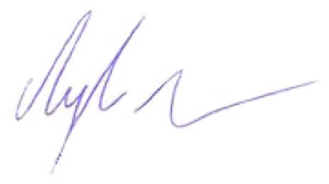

Your signature ___________________________________________________________________

Date | 12/08/2017
Date | ___________________________________________________________________

2

