FH4  (2013 on) | 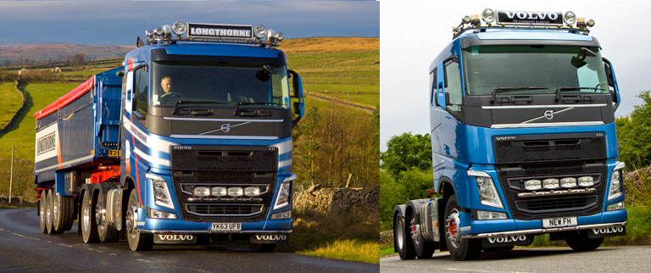  Standard/Day Cab  BRA 2251 | 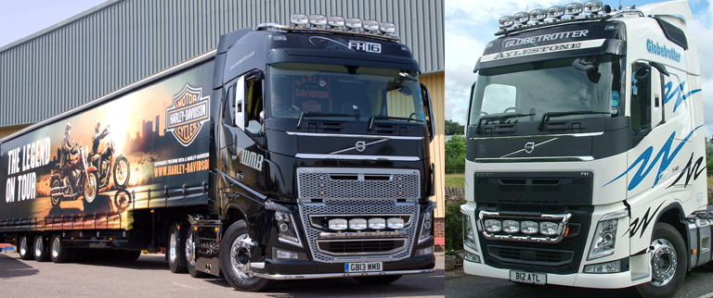  Globetrotter std  BRA2241  Has own bar | 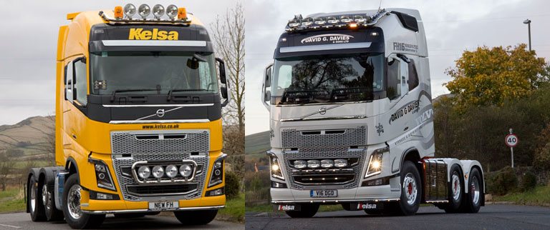  Globetrotter XL  BRA2241XL  Has own bar
Euro6 FM | 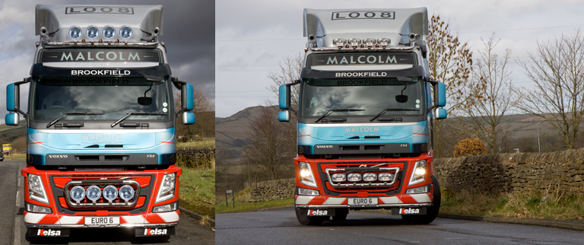  Globetrotter  BRA2211 | 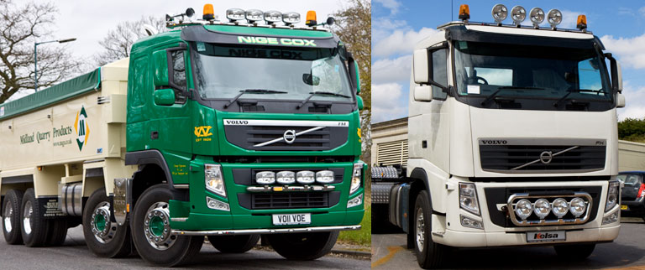  STANDARD/DAY CAB  BRA228111
FM/FH V2 facelift | Standard/Day Cab  Scania Flat cab | 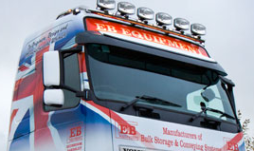  Globetrotter std  Scania Flat cab / Volvo Dropdown | Globetrotter XL + LXL  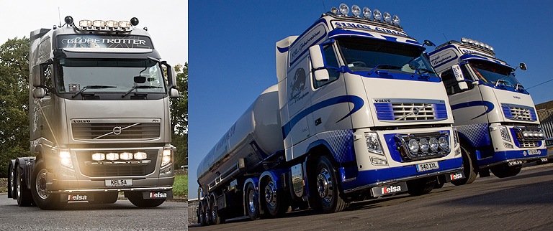  Volvo Dropdown

FM/FH Version 2 | Standard  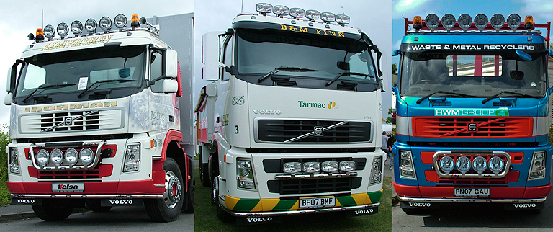  Scania Flat Cab  BRA2231 | 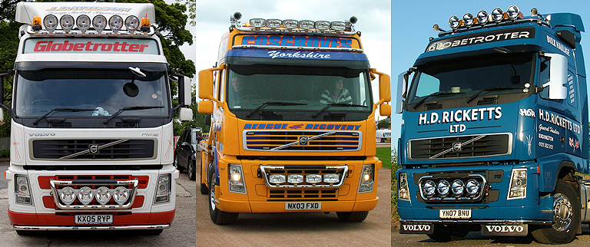  Globetrotter std  BRA2211  Volvo Dropdown | Globetrotter XL  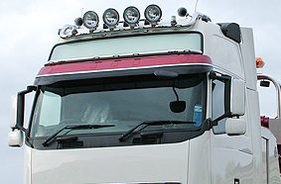  BRA2211  Volvo Dropdown
FM/FH Version 1 | Standard  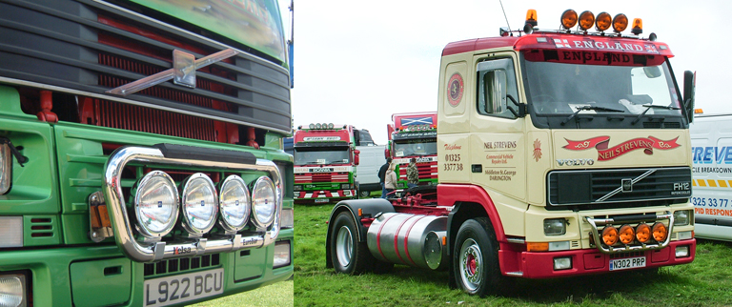  Scania flat cab | Globetrotter std  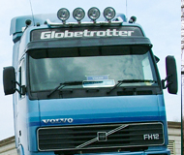  Volvo dropdown | Globetrotter XL  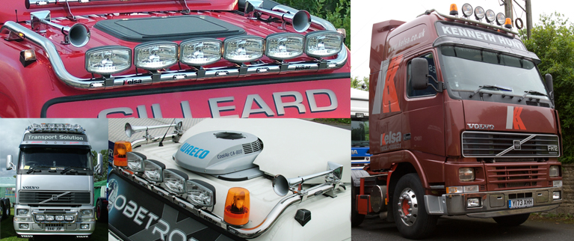  Volvo dropdown
FE | Standard with sunvisor  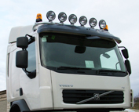  BRA2211  BRA2271 U-BAR  Scania flat cab

