Renault | Premium  (Dropdown) |  | 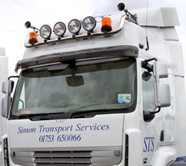 | Volvo Dropdown bar  *Also has its own visor bar – sits on top of sunvisor |  | Roof light BRA2511
 | Premium  (Roof mounted) |  | 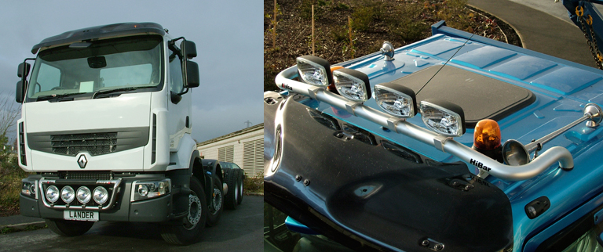 | Scania flat cab |  | BRA2511
 | Small Renault |  |  | DAF visor bar and 4 clamps
Iveco | Stralis Cube  (active space-high) |  | 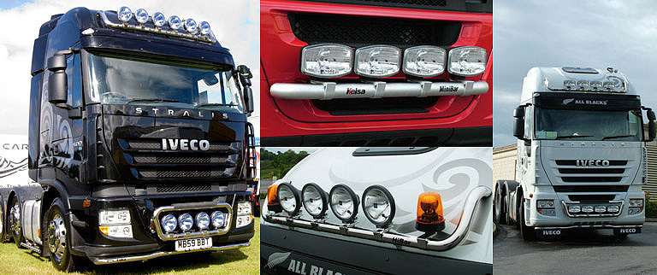 | Own bar |  | BRA2611
 |  | Trakker / Stralis Low  (Flat cab / Active Day) | 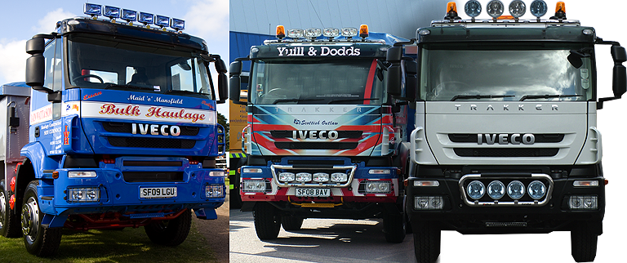 |  | Scania Flat Cab | BRA2621

