Sending Potential Sales email to Customer
- Zendesk -> Settings -> Manage -> Views -> Potential Sales
  - 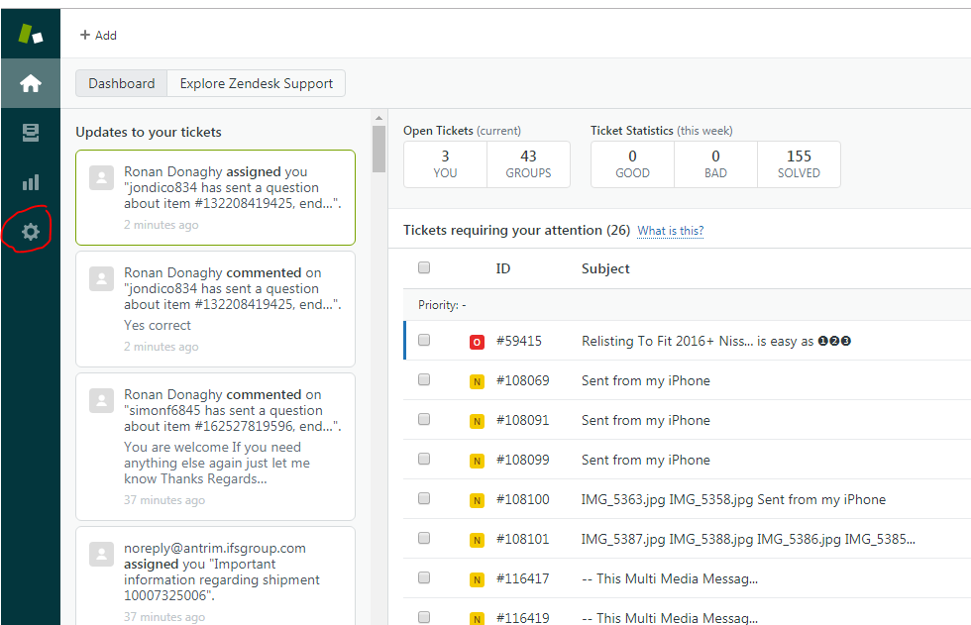
  - 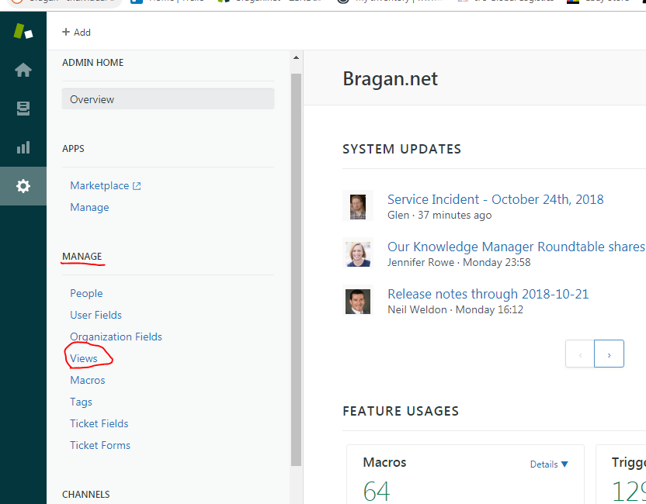
  - 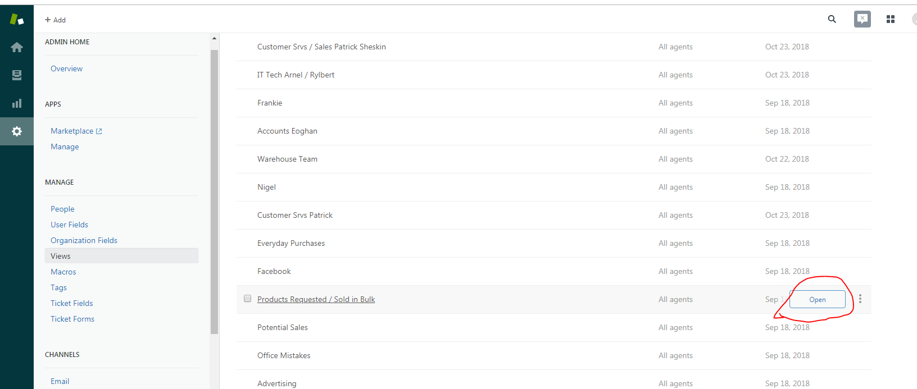

- Messaging the customer
  - Message all customers from the 16th of the previous month to 15th of this month.
  - 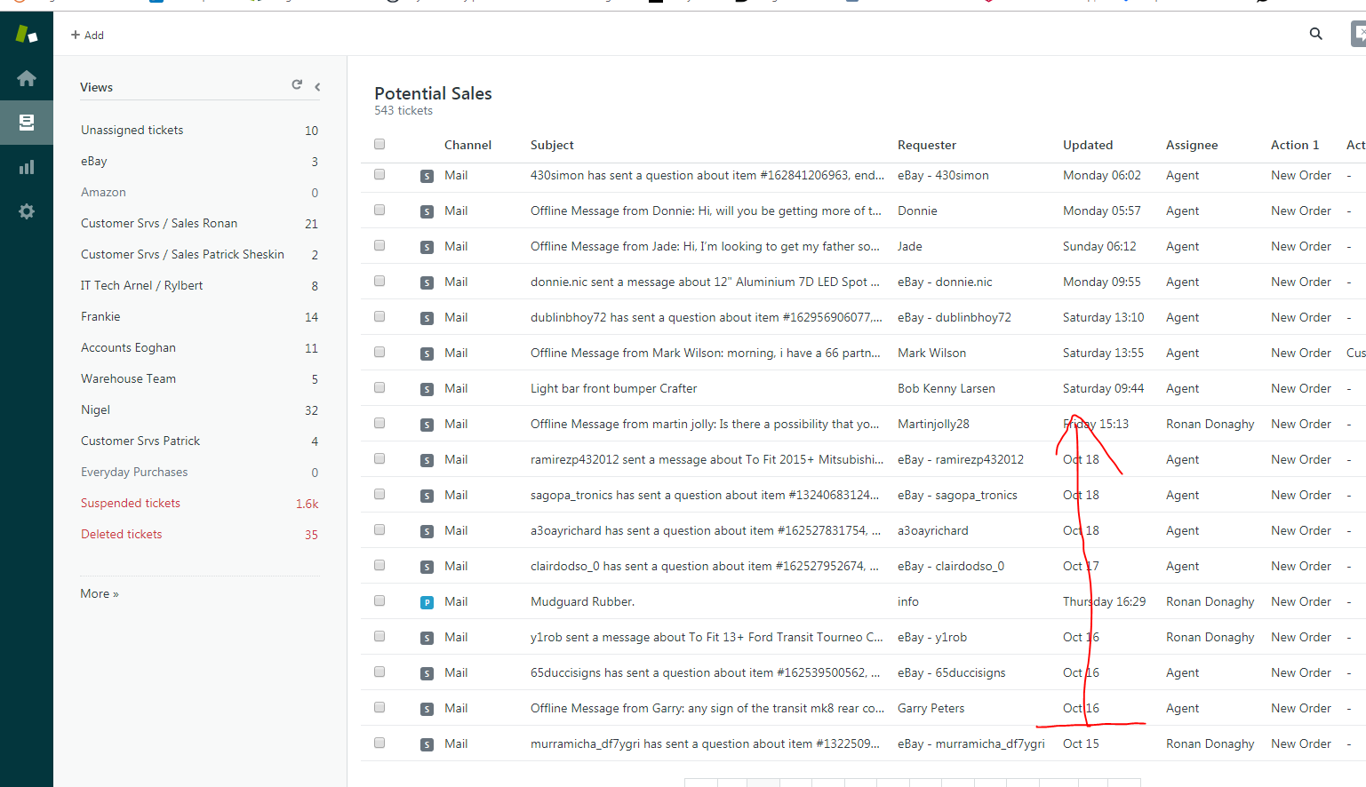
  - 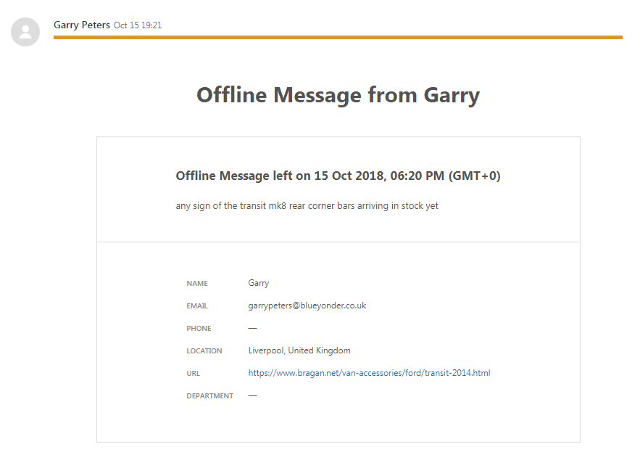
  - Use macro: ITEM NOW IN STOCK. if the item is back in stock.
  - 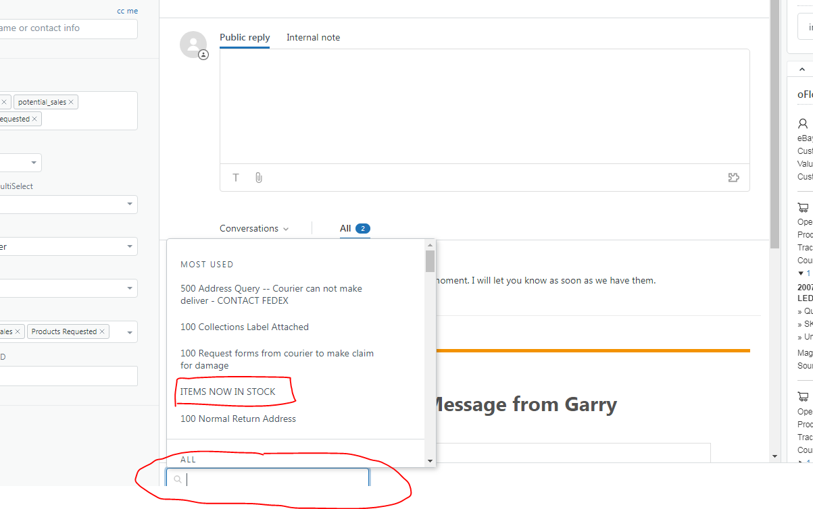
  - 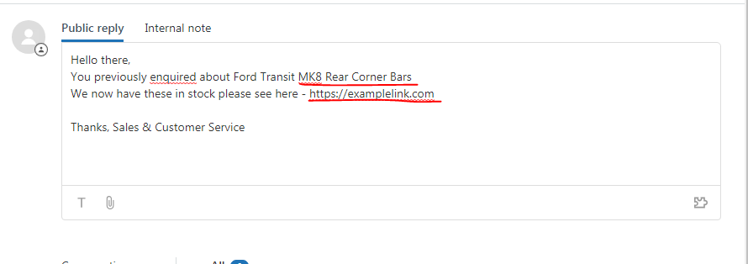
  - Submit as Solved 