Important Information Regarding Shipment Instructions
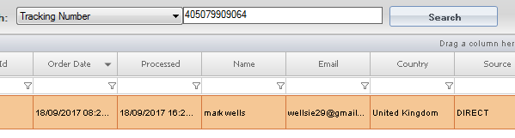
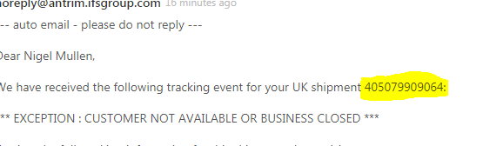
- Open email from IFS and copy tracking number into processed order in linnworks which will bring up customer details.
- Copy and paste the customer email address into the email from IFS. Remove any other CCs included in the email.
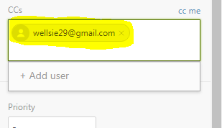

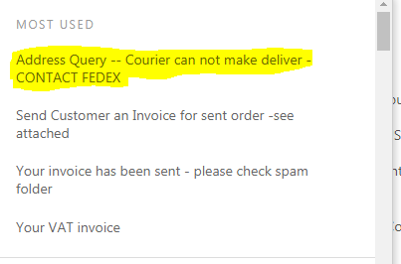
- Then select apply macro at the bottom of the email and insert “Address Query-Courier cannot make delivery CONTACT FEDEX”

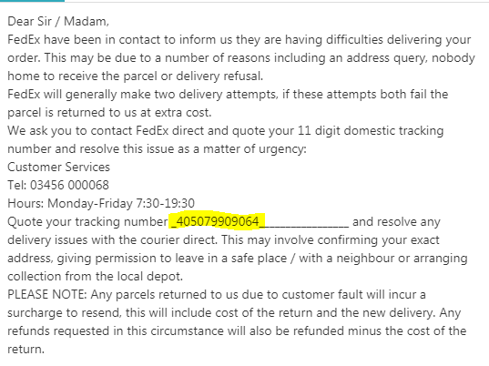
- When email is inserted add the customer tracking number to the email in the space provided and send as solved. Add tracking number here

