PERFORMANCE MANAGEMENT
NOTICE OF IMPROVEMENT NEEDED/SUBSTANDARD
PERFORMANCE

Name: Leeba | Employee ID# or SS#:
Position Number: | Agency & Division:
Work Title:

This form documents that you must make immediate improvement in the performance of your duties.
Continued poor performance as described belowmay result in an overall "Below Contributor" rating on the annual performance evaluation conducted in this performance cycle.

Description of specific performance deficiencies and improvements needed:
Failure to follow system, failure to study material on processes to onboard fully, failure to show effort on self improvement.
Improvement plan:
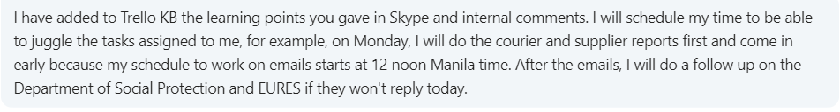

Supervisor’s Signature: |  | Date:21/05/2021
Reviewer’s Comments: | Signature: | Date:  21/05/2021
Employee’s Comments: | Signature: | Date:  21/05/2021
Note: An employee who receives at least one Improvement Needed form during the performancecycle may receive an overall "Below Contributor" rating on the performance evaluation conducted in the same performance cycle.Receipt of one or more of these forms does not automatically warrant a "Below Contributor” rating.

