Truck | Model | Picture | Bar Used | Will air-horn fit?
DAF  XF 95  XF 105  XF 106 | XF Super space Cab | 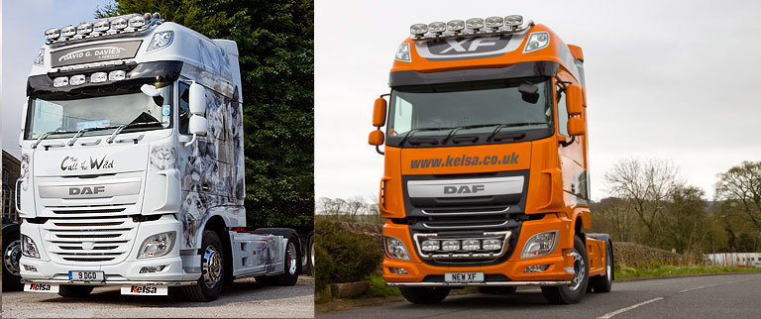 | Own Bar, but can also fit MP4 bar
 | XF Space Cab | 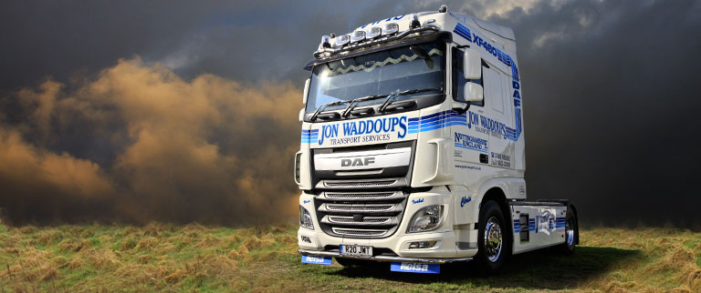 | Scania Flat Cab | Yes
 | Low Flat Cab |  | Scania Flat Cab | Yes
Years  - CF 65/75/85  2001-2008  - 2008+ | CF Space Cab  (high cab) | 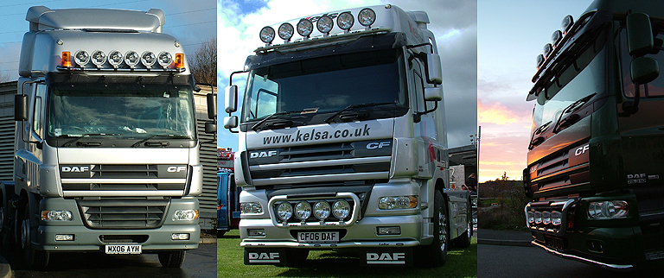 | Same as transit dropdown bar  (hold 4 spots) OR  Premium visor bar+extra bracket
 | CF Low Cab  (standard day cab) | 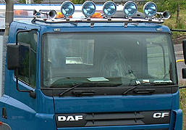 | Scania Flat Cab
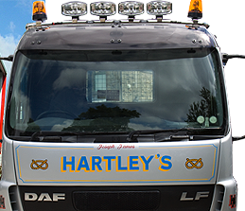
Universal roof bar(DAF Visor) will fit the DAF LF/Atego/Eurocargo and is £260 (includes 4x 9” rectangular spots + 5 LED’s + 63mm clamps)
DAF LF

