Open ZenDesk
Click ‘Add’
Enter Recipient ‘Requester’
Enter ‘Subject’ title & content
Enter ‘Folder’ & ‘Actions’
Click ‘Assignee’ dropdown
Click Management or Support
Within Management or Support – Select who you want to assign to
Enter ‘Folder’ & ‘Actions’ (If necessary)
Submit as ‘Open / Pending’
Submit as ‘Open / Pending or Solved’
NB: If you submit as solved you are closing the e-mail. Be careful when assigning an e-mail to someone as 9/10 you will need to person to see the e-mail, so you will need to submit as ‘Open / Pending’.
NB: When sending a new e-mail – please ensure you have selected which e-mail address this is to be sent from on the right-hand side under ‘Select an address’

NB: Please see instruction video on the following dropbox link - https://www.dropbox.com/s/rxld336ui2otmrx/New%20Ticket%20-%20Assigning%20a%20Ticket.mp4?dl=0

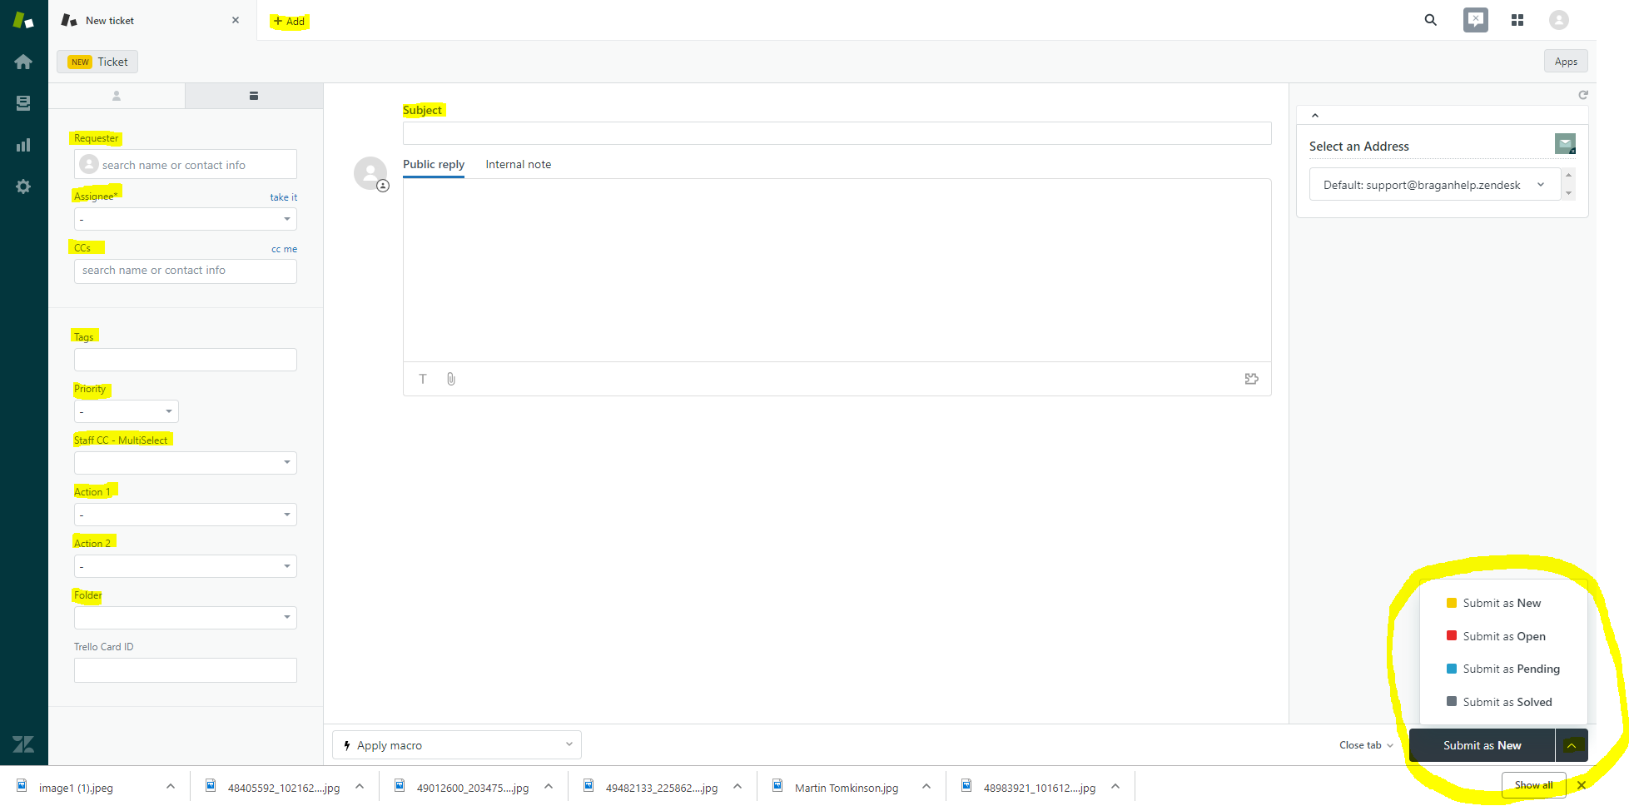
Screenshot for Sending a ‘New’ E-mail
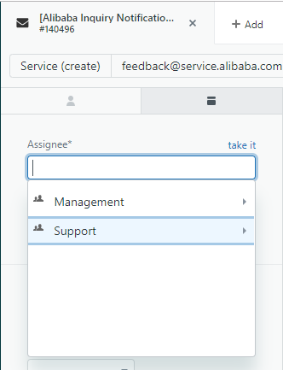
Screenshot for ‘Assigning an e-mail’
