Truck | Model | Picture | Bar Used | Will air-horn fit?
Mercedes | Actros MP2+MP3  (Long distance / Mega space cabs) | 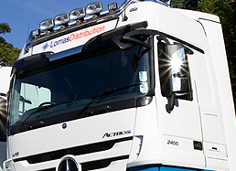 | First choice is MP4 bar but also Volvo dropdown  BRA2711  BRA2711type3
 | Actros MP4  (Giga / Big Space) | 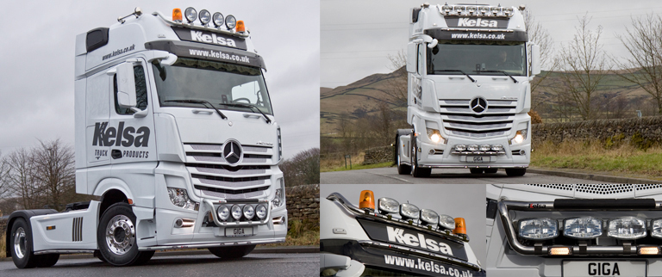 | Own bar  BRA2711
 | AROCS  Streamspace + Classic cab | 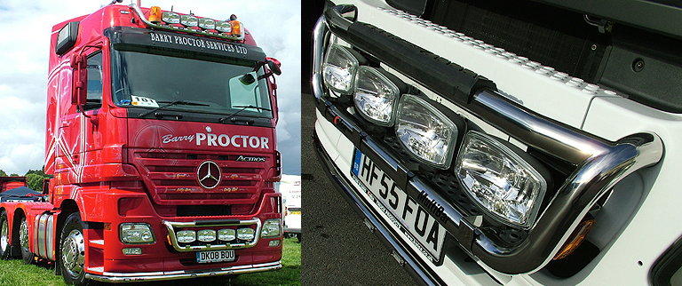 | MP4  BRA2781
 | Axor  (Low cab or higher cab) | 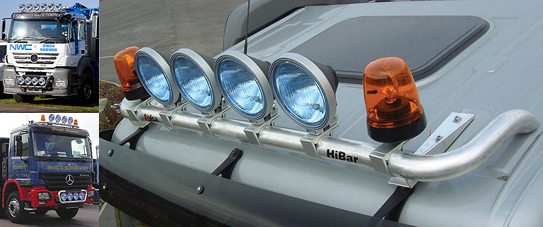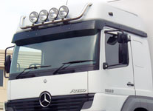 | Low - Scania Flat cab  High – MP4 bar
 | Actros  (Low cab or higher cab) | 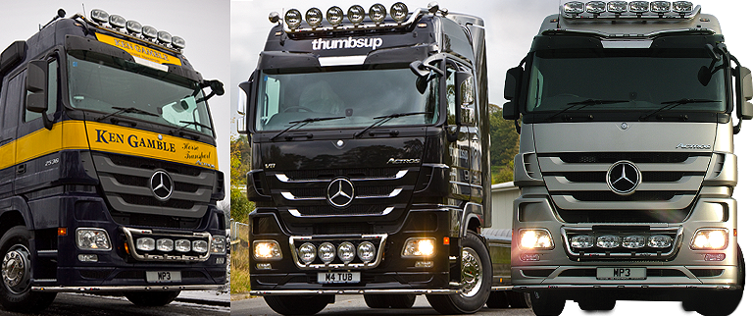 | Low - Scania Flat Cab  High – MP4 bar

