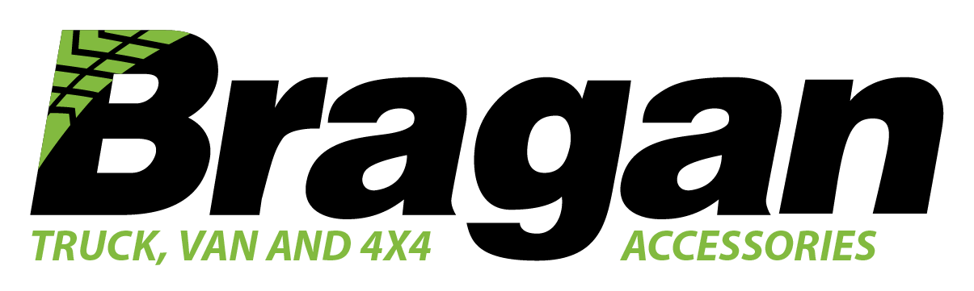

Create Positive Trustpilot Review
Standard
Operating Procedures 2021

Create Positive Trustpilot Review SOP May 2021

Table of Contents
Purpose 2
Scope 2
Responsibility 2
Objective 2
Creating Reviews 2
Reporting negative reviews 3

Purpose
Sometimes customers will leave negative reviews on Trustpilot

Scope
Offset the amount of negative reviews with more positive reviews to bring our score back up

Responsibility
??

Objective
Create positive reviews on Trustpilot that will bring our score higher and make the company more appealing to customers.

Creating Reviews
While positive reviews can boost sales, bad reviews can hurt us. Our goal is to increase Bragan positive review on Trustpilot because reviews not only have the power to influence consumer decisions but can strengthen a company’s credibility. Reviews have the power to gain customer trust, and they encourage people to interact with the company.

For us to undo the negative feedback, we must increase our positive reviews and we get someone to do this for us. Our tasks is to create the content for them to post. The positive feedback content should contain the following.

Name - UK/British Names
Subject line
Positive Review

Make it more realistic as much as possible.

Reporting negative reviews

Log in to Trustpilot

On left of screen select Reviews; Service Reviews

Find the objectionable review.

On bottom right of review, click Report – gather as much info/evidence as possible to add to the Report.

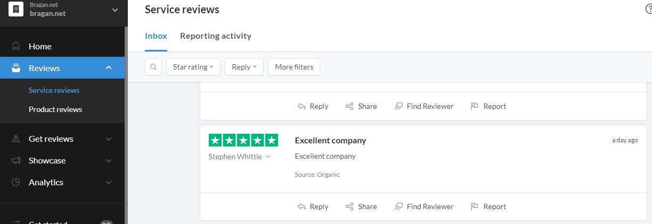

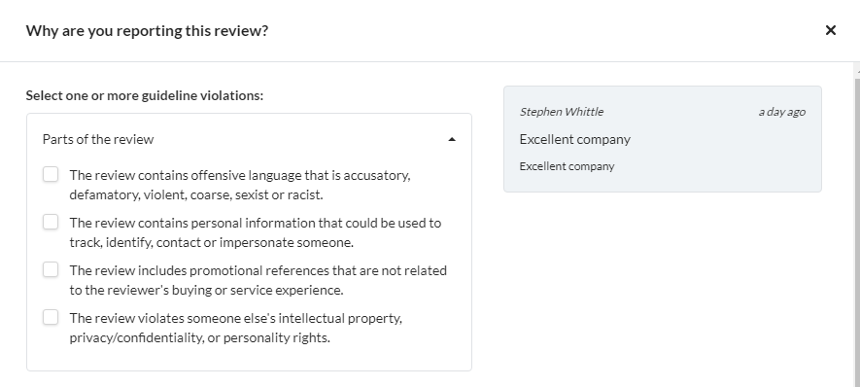
Highlight and specify the parts of the review that you are objecting to and the reasons why.

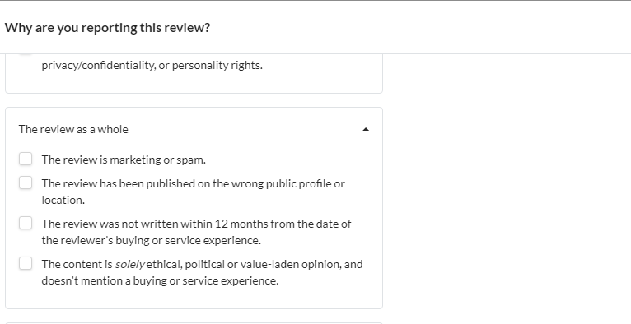
Tick all that are applicable and explain/add detail.

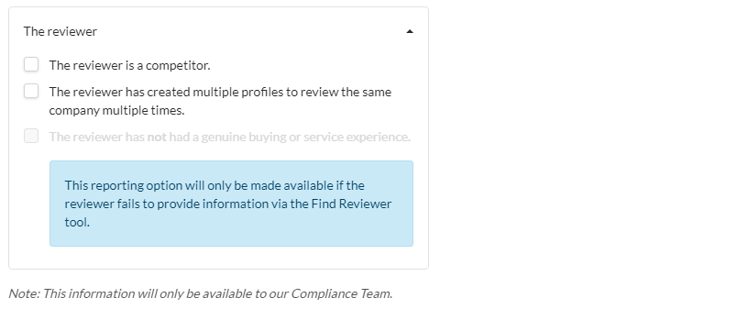

While Trustpilot are investigating the review the public will not be able to read it.

However, they can see that Bragan have reported it and read our statement.
Example of report – details relevant to specific review are not included -
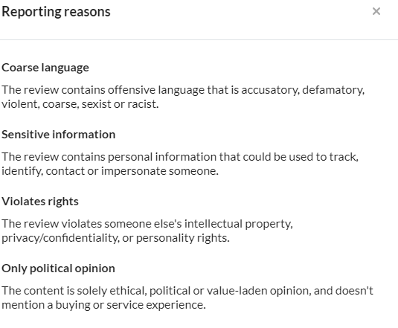
Trustpilot's Next Steps
