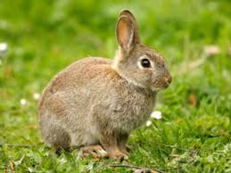
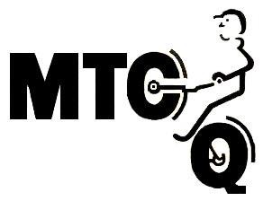
MOTORCYCLE TRIALS CLUB of QUEENSLAND inc.
Presents the

Easter Two Day Interclub Trial
2018
ENQUIRIES:
Tracey Gollagher 0424 276963 competition Secretary
AT
FREE LUNCH
AND
THANK YOU GIFT
FOR OBSERVERS:

“LEIGHTON”

1337 Nundubbermere Rd
STANTHORPE
CAMPING PERMITTED
From Friday 30th March To Monday 2nd April
Sat 31st March
Sun 1st April
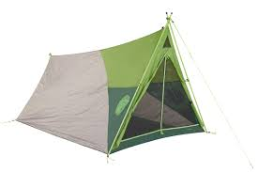
Competition riding starts 10am
FREE ENTRY
REFRESHMENTS Tea Coffee & HAMBURGERS
All day Saturday and Sunday
Breakfast Egg & Bacon Rolls Sunday morning
Proceeds going to
“Riding for Disabled”

FOR SPECTATORS
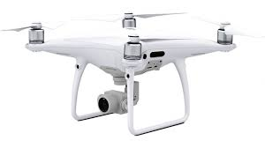

PLEASE NO DRONES
ALLOWED ON PROPERTY

Collect your Free Easter egg with each score card handed in!!!!



BYO DRINKING WATER:

DOGS ARE NOT PERMITTED ON THE PROPERTY LEASHED OR OTHERWISE:
(With the exception of Guide Dogs)

