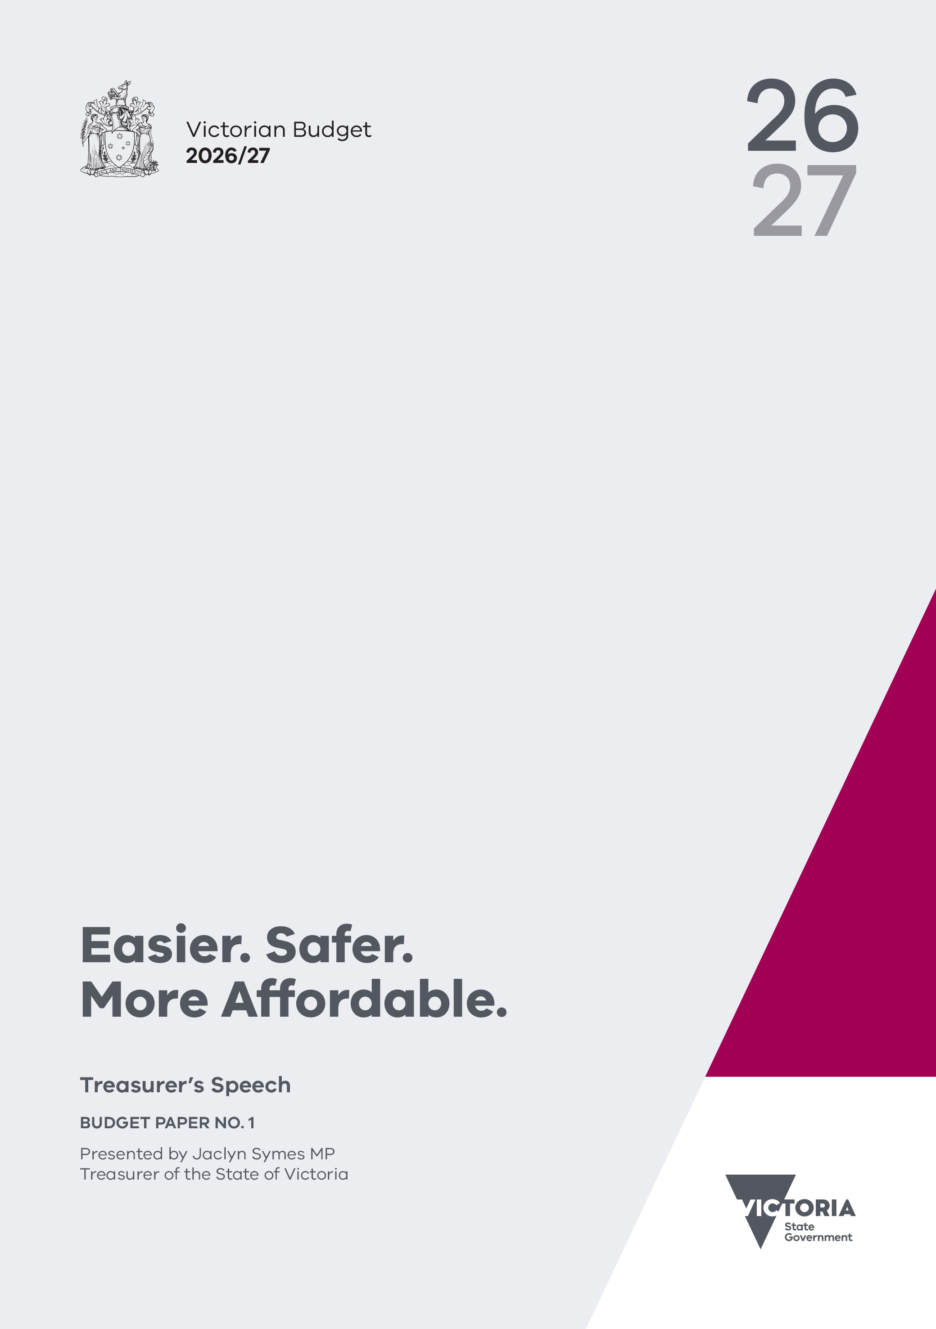
ACKNOWLEDGEMENT
OF COUNTRY

The Victorian Department of Treasury and Finance acknowledges that Aboriginal and Torres Strait Islander peoples are the First Peoples and Traditional Custodians of Australia, and the oldest continuing culture in human history. We proudly acknowledge Victoria’s Aboriginal communities and recognise the value and ongoing contribution of Aboriginal people and communities to Victorian life. We pay our respect to Elders past and present and emerging.
As we work to ensure Victorian Aboriginal communities continue to thrive, the Government acknowledges the invaluable contributions of generations that have come before us, who have fought tirelessly for the rights of their people and communities towards self-determination. We reflect on the continuing impact of government policies and practices and recognise our responsibility to work together with and for Aboriginal and Torres Strait Islander peoples towards improved cultural, social and economic outcomes.

‘lim-ba nindee thana warn-ga-ilee’
(Preserve our Dreaming Lore) – Gunnai Language
Bitja (Dixon Patten Jnr) Yorta Yorta, Gunnai,
Gunditjmara and Dhudhuroa of Bayila Creative

Authorised by the Victorian Government
1 Treasury Place, Melbourne, 3002
Printed by Valiant Doculink, Mulgrave
This publication makes reference to the 2026/27 Budget paper set which includes:
Budget Paper No. 1 – Treasurer’s Speech
Budget Paper No. 2 – Strategy and Outlook
Budget Paper No. 3 – Service Delivery
Budget Paper No. 4 – State Capital Program
Budget Paper No. 5 – Statement of Finances
(incorporating Quarterly Financial Report No. 3)

© State of Victoria 2026

You are free to re-use this work under a Creative Commons Attribution 4.0 licence, provided you credit the State of Victoria as author, indicate if changes were made and comply with the other licence terms. The licence does not apply to any branding, including Government logos.
Copyright queries may be directed to information@dtf.vic.gov.au
ISSN 2204-9185 (print)
ISSN 2204-9177 (online)
Published May 2026

VICTORIA

BUDGET SPEECH
Delivered on 5 May 2026
by Jaclyn Symes MP
Treasurer of the State of Victoria

I begin my Budget speech by acknowledging the Traditional Owners and Custodians of this land.
I pay my respects to Elders, past and present.
The Allan Labor Government is proudly committed to Truth, Treaty and Self-Determination for First Peoples.

Speaker –
For a long time in this country, there’s been this basic deal.
That if you work hard, do the right thing, and look after your family ...
You’ll have the opportunity to build a decent life.
Not an easy life. Not a perfect life – but a decent one.
You’ll have a safe home and a secure job.
Good schools and good healthcare when you need it.
You’ll be able to put enough food on the table.
And you’ll even have a bit left over to enjoy the life you’ve built.

Speaker, my parents had that deal ...
Growing up in Benalla, money at times was tight ...
Mum and Dad worked incredibly hard to support their family.
And they made many sacrifices ...
And there were times when things felt really stretched.
But my parents knew that if they worked hard enough – and if they kept going ...
They could build a good life and a strong future.
And they did.
That hard work led somewhere.
It meant stability. It meant being able to provide.
It meant home ownership ...
It meant opportunity for their kids ...
It meant confidence that – however hard things were ... You could keep moving forward.
But for too many Victorians, particularly families, that basic bargain no longer feels secure.
What was hard then, is much harder now.
Because over the past few years, global pressures that once felt distant have started landing right in people’s everyday lives.
War in Ukraine. Tariffs and instability in the global economy. War in the Middle East.
One after another, they’ve pushed pressure higher.
And working people are the ones being asked to carry it.
You hear it wherever you go.
In schools.
On the street.
On hospital wards and factory floors.
People say it in different ways, but they are often describing the same thing.
They say:
I am working hard. I am doing my best ...
But I still don’t feel like I’m getting ahead.
And they aren’t just talking about money.
Of course – it’s there in the weekly shop ...
The rent or mortgage ...
The cost of getting to work and keeping the car on the road ...
But it’s the strain of it all too ...
The extra hours. The time spent away from home ...
The constant pressure ...
The sense that even when you are doing everything right ...
Life still feels like it’s getting harder, not easier.

Speaker, this Budget is about getting to the heart of that feeling.
It is about helping with the cost of living.
It is about giving families more time in their day.
It is about strengthening the systems Victorians are relying on more than ever before.
It is about building a stronger economy, a more secure future, and opportunity for every Victorian ...
It doesn’t solve every issue that families are facing ...
Or stop the wars and shocks and impacts from overseas ...
But at its core ...
It helps to restore that basic deal:
That if people work hard, they deserve a decent life.
It’s a Labor Budget –
One that makes life Easier ... Safer ... and More Affordable for every Victorian.

Speaker, one of the clearest places families are feeling pressure right now is in the cost of getting around.
Getting to work.
Getting the kids to school.
Getting to appointments.
And right now, Trump’s war in the Middle East is not some distant event for Victorians.
It drove up fuel prices.
It is adding to the cost of doing business.
And it is putting even more pressure on household budgets that were already stretched.
Families in Victoria are carrying more burden every day.
And when the cost of getting around rises, the effect is immediate.
And it leaves families with less room to cover everything else they need.
For many families, especially in regional Victoria, the car is not optional.
It is how they keep life moving.
And that is why this Budget helps there first.
We have already acted to keep fuel prices fair ...
With daily price caps, Servo Saver, and strong action against operators who try to rip Victorians off.
And now, for those who have to drive, we are rebating some of the costs of running a car –
Giving Victorians 20 per cent back on the cost of their rego this financial year.
That means up to $186 back for a driver with one car.
And up to $372 back for a family with two cars.
That is practical help.
Help that families will feel straight away.
But reducing the cost of getting around goes beyond the car.
That is why we acted in April, making public transport free for a month.
And we have already seen the impact.
More people on the network.
Fewer cars on the road.
And less pressure at the pump.
When you talk to people on trains, trams and buses, they will tell you what it means.
It saves them money.
Which is why this Budget builds on that work.
Free public transport has been extended by an extra month.
And we are cutting fares in half, across the state, for the rest of the year.
Metro.
V/Line.
Trams.
Local buses.
Half-price transport, for every Victorian.
And we’re investing almost $100 million for more buses, more often ...
With new and upgraded routes in growing suburbs, and better connections to train stations, universities and jobs.
That means more services to La Trobe and RMIT in the north, a new bus network for Melton South, and better links from Dandenong to Chadstone and Monash.
It will put money back in people’s pockets.
It will take pressure off family budgets.
And it will make the most of the record investments this government has made in public transport right across the state.
Because at a time like this, government should not stand back.
It should step in.
It should ease pressure.
And it should deliver relief that families can feel straight away.

Speaker, we know the pressure families are facing is not narrow.
It touches transport, healthcare, schooling, household bills, and the time it takes to hold everything together.
Government can’t solve everything – we know that.
But we can make life just a little bit easier.
It is why we are continuing free public transport for every child in Victoria.
It is why we are continuing free dental checkups in schools and expanding the Glasses for Kids program.
Because if a child cannot see the board, they cannot learn properly.
Since it began, Glasses for Kids has delivered more than 68 000 eye tests and 13 700 pairs of glasses.
We are continuing Free Kinder.
Building and upgrading more public schools, because every family deserves a great local school close to home ...
And we are backing the people who care for some of Victoria’s most vulnerable children ...
Foster carers, kinship carers and permanent carers step up to provide care, stability and a safe home ... and they deserve support to keep doing it ...
That is why this Budget increases care allowances – delivering around $400 more a year at the lowest level and up to around $1 700 more at the highest.
This year, we are also spending more on our health system than ever ...
That means easier care through Urgent Care Clinics –
The Virtual ED –
Chemist Care Now –
And it means expanding our world-class care, especially in the west.
New post-natal beds, more sonography appointments at Joan Kirner, and more special care nursery cots for babies with complex needs.
$95 million to open the upgraded Werribee Mercy Hospital Emergency Department ... doubling capacity and allowing local doctors and nurses to treat 25 000 more patients every year once fully operational.
We’re also investing in a fast track for kids’ care so they can get the surgery or the specialist care they need – more quickly ...
Because Victorian families deserve to know that when they need care, it will be there.
And because no family should ever have to worry about where their next meal is coming from, this Budget continues our Government’s commitment to ensuring food relief providers and support organisations can continue providing vital support to Victorians in need.

Speaker, the reason that this Budget can go so far and do so much to help families with the cost of living, to save them time, and to keep them safe – is simple ...
We have made responsible economic choices.
We have made disciplined decisions, cut inefficiencies, consolidated entities, and kept our focus on what matters most –
Protecting frontline services and building the strength Victoria needs to weather uncertain times.
This Budget confirms Victoria’s first operating surplus in seven years, the only surplus on the eastern seaboard –
A higher than forecast $727 million operating surplus in the current year.
And surpluses averaging $1.7 billion being maintained over the budget and forward estimates period.
Debt as a share of the economy is on track to decline from 2026-27 ...
And with this Budget, net debt is lower in every year over the forwards, compared to the budget update ...
Importantly, we have also helped grow the economy.
Despite everything going on in the world – Victoria’s economy remains resilient…
Over the past decade, it has grown faster than any other state in the country.
Our economy is estimated to be almost 15 per cent larger in real terms in 2025-26 than it was before the pandemic.
Business investment has grown by 44 per cent since 2020, the strongest in the nation.
Since June 2020, more than 123 000 net new businesses have been created in Victoria – again, the largest percentage growth of any state.
Over the last three years, 300 000 Victorians have found work, a higher percentage increase than the rest of Australia.
And since the peak impacts of the pandemic, 646 000 more Victorians are in jobs – yet again, the strongest absolute increase in the nation.
That strength must mean something in people’s lives:
More security.
More opportunity.
More secure work.
More homes in our state.
That is why Victoria continues to lead the nation in delivering new homes each year ...
With more than 16 000 social and affordable homes being delivered ...
More than 12 000 underway or complete ...
And another 7 000 to come through the Social Housing Growth Fund.
We have looked after the economy so that we can look after Victorians.
And because we have built that strength, we can help families now – and keep building for what comes next.
Strong economic management is not separate from helping families.
Labor’s Budgets have built the productive infrastructure Victoria needs and created thousands of jobs as a result.
Roads, rail and tunnels that provide for a growing population and give families more time – and the economy more opportunity.
Easing congestion with level crossing removals; better connecting regional Victoria through the Regional Rail Revival; opening a new link with West Gate Tunnel; and transforming commutes by switching on the Metro Tunnel.
Construction of the North East Link continues at pace – closing our critical missing link.
Melbourne Airport Rail is turning Sunshine into a Superhub.
And the SRL will transform the way we move around the city – and will deliver thousands of new homes.
This Budget invests a record $1.04 billion to rebuild, repair and resurface roads across Victoria – enough to get rid of 200 000 potholes, 200 000 graffiti tags, and much more.
This is the biggest roads blitz in the state’s history – with 70 per cent of the funds going to regional Victoria.
Labor has invested nearly $3 billion over the past three years – the largest sustained investment in road maintenance in Victoria’s history.
Because better roads do more than get people from A to B.
They make the trip safer.
They make it easier for parents, tradies, and regional communities to get where they need to go, sooner.
That is what investment looks like when it is real – not abstract, but felt in the trip to work, the school run, and the journey home.
Because government investment should not live on a balance sheet – it should make life work better for people.
We also have to ensure that every Victorian feels safe ...
Safe at home.
Safe in their communities.
Safe where they work, study and travel.
That is why this Budget continues to back Victoria Police with more resources, better tools, and more officers where they are needed most.
It includes $62 million to recruit 200 police reservists for station reception and front-counter duties, freeing up more frontline police.
It includes $79 million for police IT systems – so officers spend less time on paperwork and more time in the community. And giving police faster access to accurate data on firearms, weapons and the private security industry.
But keeping communities safe is not only about response.
It’s about prevention.
That is why this Budget invests $33 million in the Violence Reduction Unit ...
Backing early intervention, lived-experience mentoring, school support, and community programs that help keep young people engaged and away from crime.
Because when a young person stays connected to school, support and community, we get better outcomes for them – and safer communities for everyone.
More police.
Stronger prevention.
Safer communities.
That is what this Budget does.

Speaker – helping families through this moment matters.
But our job is so much bigger than that.
We’re making sure the future being built in this state is a future that every Victorian can see themselves in.
A future where the young people training in our Free TAFEs are the ones working on offshore wind ...
Installing solar panels on rooftops ...
Building the next generation of trams, trains and advanced manufacturing ...
Working in the data centres, clean energy projects and biotech facilities of the future ...
And earning decent wages from it, in good, steady jobs ...
That is how you build security.
That is how you build the future.
A future where Victorian families are not just protected from change – but part of it, and better off because of it.

Speaker, this Budget is not only about the big picture.
It is also about the difference good governments can make locally.
What our investment means – and how it is felt and seen – in the towns, suburbs and communities people call home ...
Almost $4 million for Rochester’s pool.
$19 million to open Pakenham Community Hospital.
A new school gym and classrooms at Wales Street Primary in Thornbury.
A brand-new CFA station in Mirboo North.
A new pump track in Haddon.
Toilet facilities for Coburg Reserve.
Different places.
Different projects.
But the same idea behind every one of them:
Backing local communities.
Building on what makes them strong.
And making sure every part of Victoria can share in the future we are building.
Because, Speaker, we should be proud of this state.
In tough times it’s easy to feel pessimistic, but there is lots to be positive about –
This is a strong state. A capable state. A state people can believe in.
You can see it in the growing economy and the businesses choosing to invest here.
In the workers choosing to build their lives here.
In the families choosing to make their future here.
In uncertain times, that matters.
And that strength is something we can use ...
To support families.
To keep services strong.
To back jobs.
To keep building.

Speaker – at the end of the day, this Budget is about people’s lives ...
A cheaper trip to work.
A lower rego bill.
A child getting to school for free.
A family saving money on dental care, glasses, kinder or energy bills.
A parent getting home earlier.
A household with a bit more room at the end of the week.
That is what this Budget is all about – real help, right now.
And real confidence in what comes next.
Because if people are working hard to build a decent life –
They deserve a government working just as hard to make sure they have it.
That is what this Labor Budget does.
It makes life Easier ... Safer ... and More Affordable.
And it builds a stronger Victoria for the future.

I commend the Bill to the House.



